***Circuit Collective Phase 2 Report***

***1st Part - MVP Functionality and Overview***

**Brief Summary of Iteration 1:**

Iteration 1 focused mainly on developing the minimal viable product for the software. This included developing the basis for storing data within the database, implementing a search feature, and adding a login for the software. This ensured that game stock could be added to the database, while also adding security and ability to locate games easily within the database.

**List of Implemented User Stories:**

Search Bar

*As a manager, I want an up to date stock catalogue, so software can keep track of which videogames are currently available.*

Priority: 10 - *Must Have*

Track Stock

*As an employee, I want a search bar, so software allows me to search games directly.*

Priority: 10 - *Must Have*

Login Password

*As a user, I want to log in securely using the universal password.*

Priority: 20 - *Should Have*

**Major Known Gaps or Limitations in the MVP:**

The known gaps and limitations for the MVP are as follows:

* Stock tracking requires a manual entry, would be nice to allow for automatic updates based on how many products have been entered.
* Data in an entry row is erased when it's edited, data should remain in the row so the user doesn't have to re enter data.

***2nd Part - Demonstration of MVP***

**Written Walkthrough:**

The landing page. On the top left is a basic login button which takes you to the login page. On the far right is a search bar and on the bottom is the list of games as well as their metadata (In this case there are none).

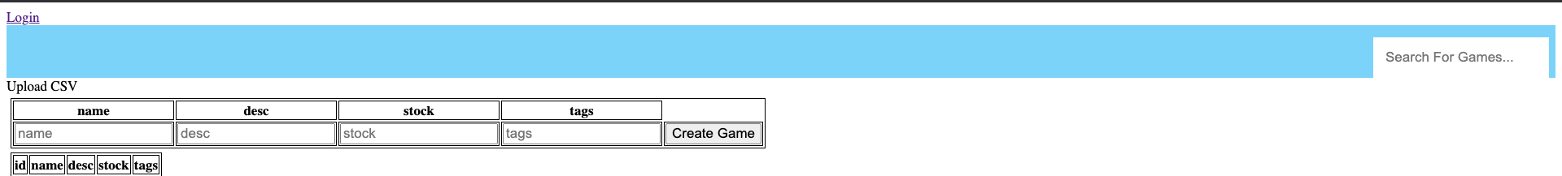

The first step of using the program is to login so that we can add, remove and edit games.

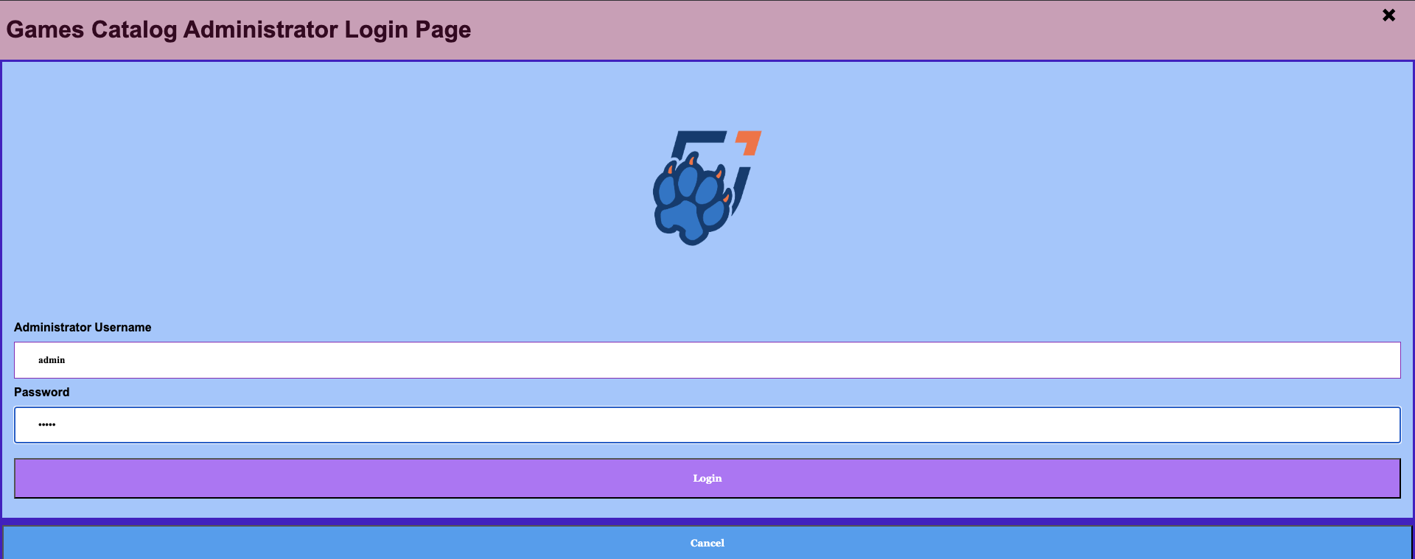

Upon logging in, the user is redirected to the home page where we can now import a CSV file of our data. For this demo we will use the following data:

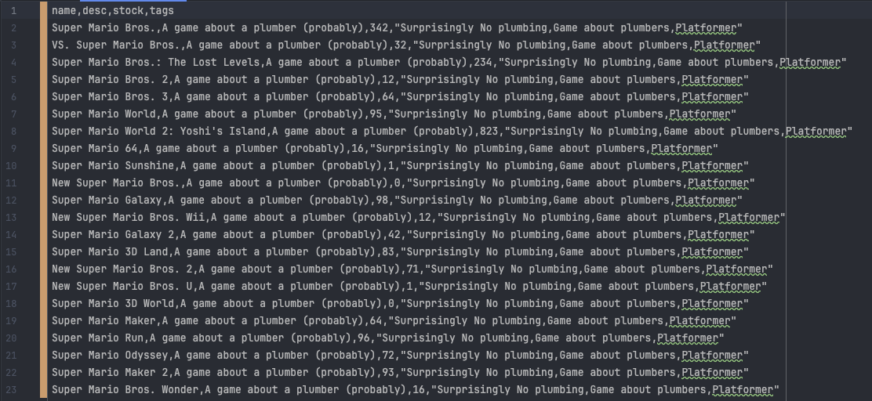

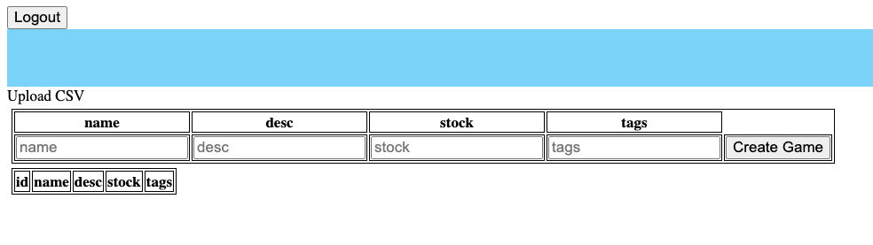

Step three is to click “Upload CSV” and select the file from the prompt that is opened. After doing so, the list is automatically updated.

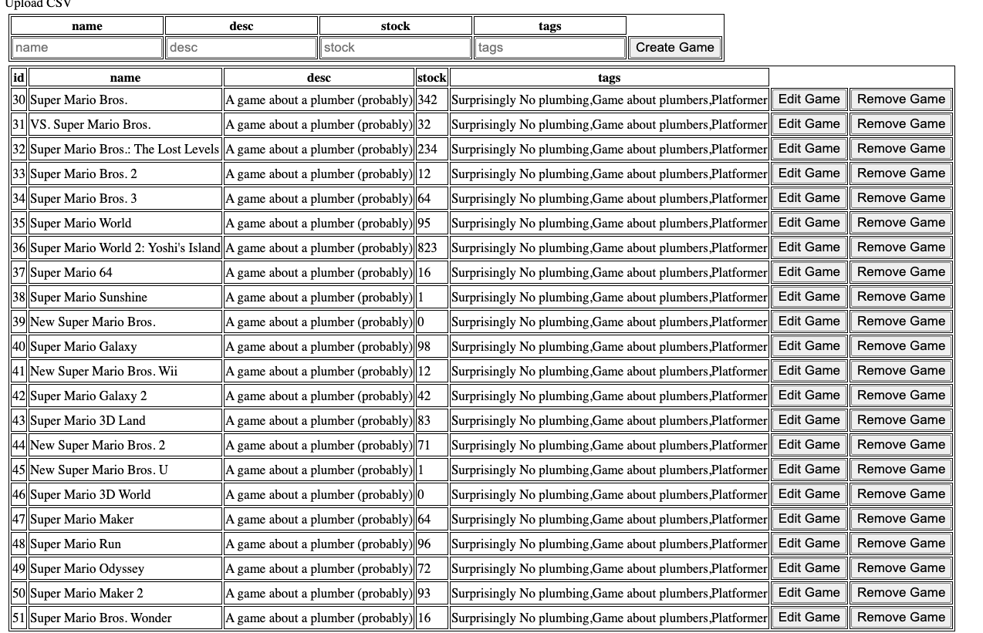

From here we can click “edit game” next to any game to edit it (here we’ll edit 42 to have a different name, description, stock and tags). Here is what it looks like while we edit it as well as after editing it:



Here is a demo of the search functionality. Notice that it matches games that contain all words in the search query as well as anything close enough (typo on the word world is intentional to demonstrate fuzzy search capabilities).

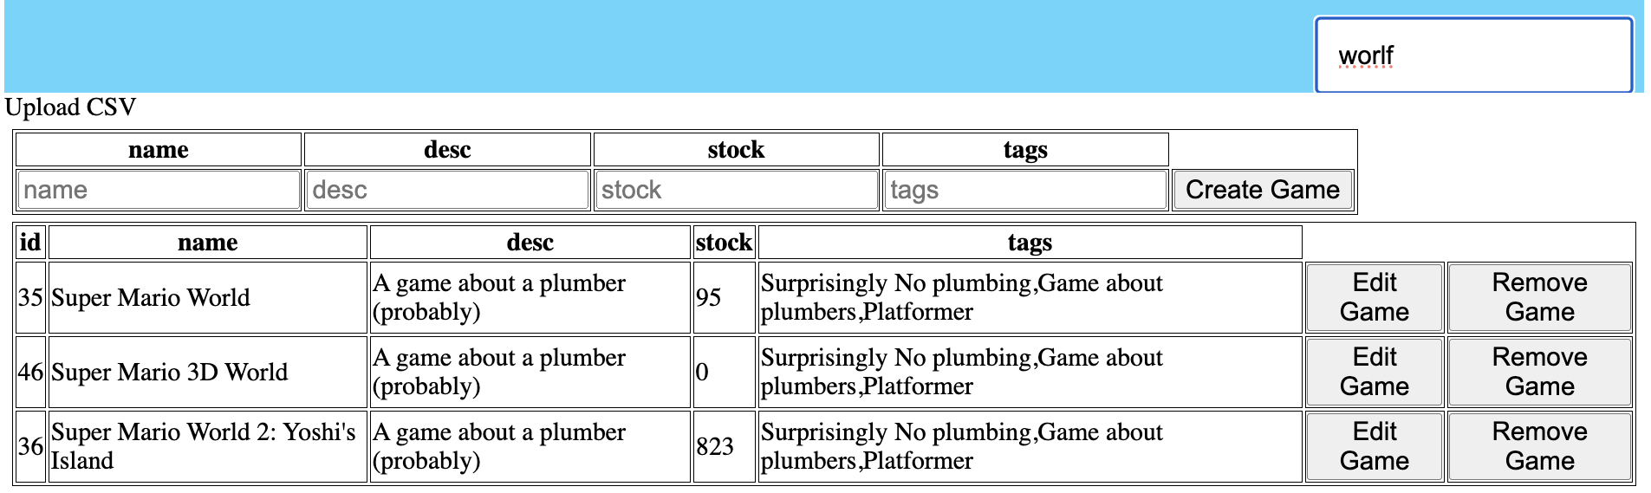

Removing a game is as simple as pressing the remove game button. All changes are automatically saved and persist through reloads of the webpage as well as restarts of the backend. After we are done working, we can optionally logout with the button located at the top of the page. This takes us back to the login page with a logout message:

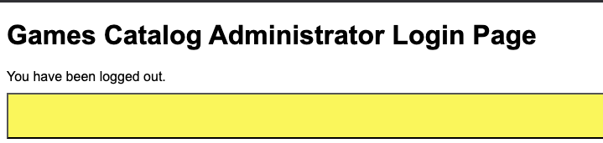

***3rd Part - Repository and Project Board Review***

**Updated Kanban Board:**

Screenshot of our updated Kanban board:

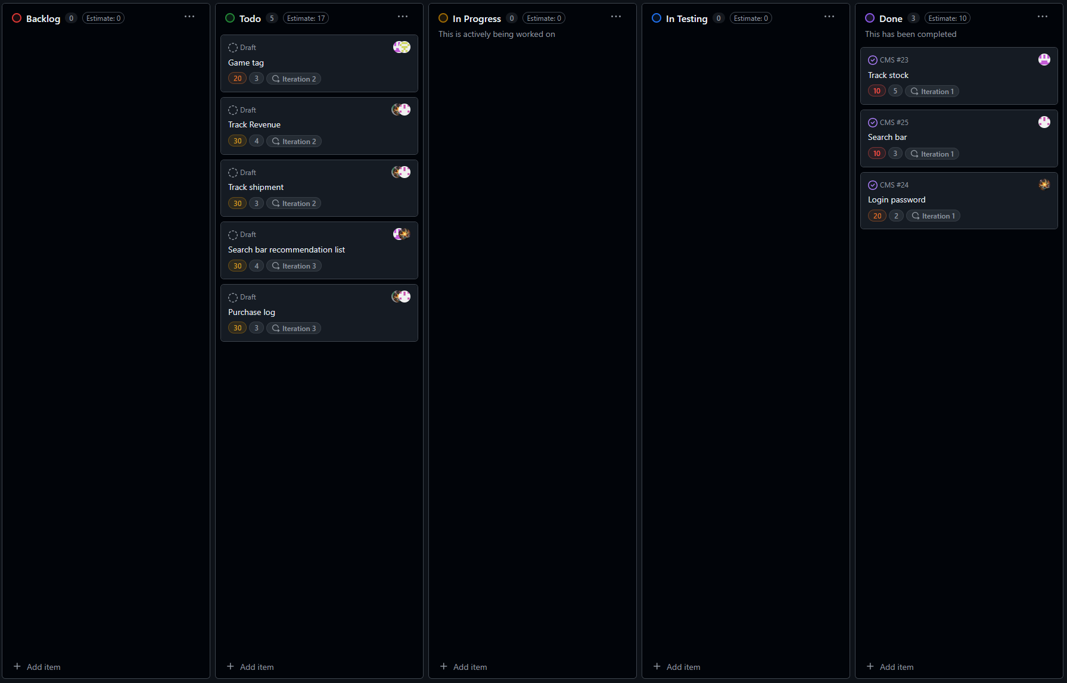

**Updated Github Repository:**

Screenshot of our updated Github Repository:

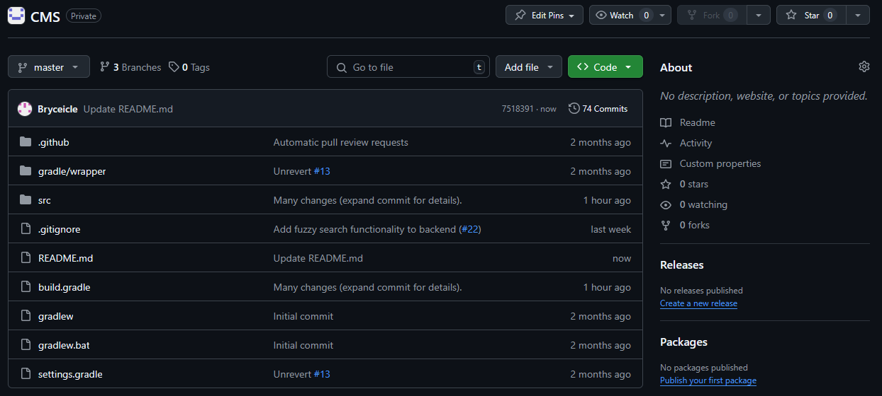

**Updated README File:**

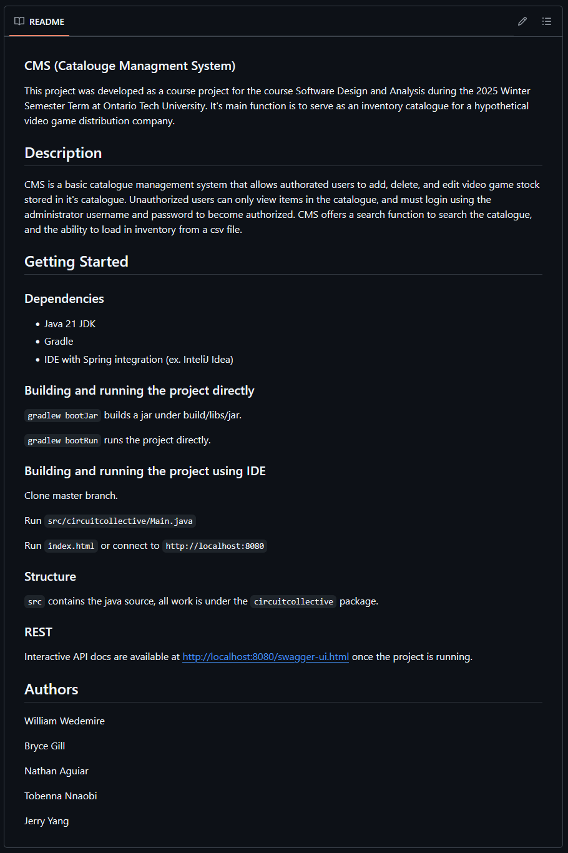

***4th Part - Challenges and Next Steps***

**Major Technical or Process-Related Challenges:**

In iteration 1, our team, Circuit Collective, has encountered several technical and process-related challenges since its formation. These issues have been either addressed or have reached their resolution before and during Phase 2.

The first challenge that we experienced was merging problems within the GitHub Repository. While attempting to integrate one of the branches our team was working on, there was a conflict in the branches that we found was caused by a function in the master branch overlapping with its branch versions in the main.js and load_file.js files. We were able to fix the issue within 30 minutes, however it highlighted the need for more frequent branch commits and QA. Moving forward into iteration 2, we’re going to be implementing more frequent commits and QA to avoid this issue.

The second challenge we experienced was getting the login/logout feature to work. Over the past few weeks, our team has worked hard to create and complete the login/logout feature for the administrator game catalogue database. While the overall front-end and back-end code are functional on their own, connecting both aspects of the project became a struggle since the login we have created is custom-made and is significantly different from the default login page the Spring dependency provides. Currently, we are still optimizing this feature for better functionality.

The third challenge we experienced was the file uploading, reading, and parsing features not functioning. During the software development process of our product, we had numerous issues with the file uploader and reader feature in the game catalogue database. While the feature was already at its completion and functioning correctly, as intended, it became non-functional after a code-refactoring process involving the API pathways to the CSV parser. While the feature's optimization has reached completion, the process requires approximately 3 days of optimization to fix the code.

Finally, the fourth and final challenge we encountered was team dynamic-related issues. During Phase 2, our team experienced significant problems regarding our team dynamic. While there is a lack of time to discuss the interpersonal challenges of our team in detail due to time constraints, many of our conflicts almost led to verbal fights among team members. While these interpersonal issues will be addressed and discussed among us, this was by far the most concerning challenge we have encountered since the formation of Circuit Collective.

**Goals for the Next Iteration:**

For the next iteration, the team will focus on expanding out from the minimal viable product and adding new features that focus more on the “should haves”. These include adding the ability to tag games, the ability to track shipments, and the ability to track revenue analytics over time. These features, while important, were not absolutely necessary to the functionality of the software which resulted in them being set to be done in iteration two. These features will help the customer monitor several important aspects for physical stock including several key features to assist in management of stock for the customer.