This is the document that will outline what the entire project will look like from the ground up. If required we could make child branches to this document however at this point in time we’ll just be working from this document.

The main objective to this project is to create a city that is beautiful. Defining a beautiful city is a tough task, we’ll attempt to do that later. But broadly, a city in which one would want to live because of the inherent beauty of the city and not just the opportunities the city provides. We also look at making the city as pedestrian and cyclist friendly as possible as opposed to an automotive friendly city.

The city will be designed to fit to a maximum of a 15x15 square kilometres. This is because of my belief that cities shouldn’t be endless sprawls, but be beautiful and encapsulated, all beautiful things know where they start and where they end.

Currently we’ll try to create an outline to how the city should be designed and on what aspects.

The main things we have to worry about at this point in time is the following:

1. ~~The City Design: There are three city designs that come to my mind. One is the grid. The second is the Hub and Spoke. The third is a triangle design.~~

~~We could go on further, using more shapes to design cities, but I’d like to limit myself to the above three at the present moment.~~

* 1. ~~The grid: It looks like a square excel table and, to my knowledge, there is a city in India called Gandhinagar that was designed in this fashion. We have a set of parallel roads that create a grid shape, which could be further subdivided, but the main design block is the 1x1 sq. km.~~
  2. ~~The hub-and-spoke (Concentric Circles): (I apologize for my lack of usage of Jargon, but I wasn’t able to find the right word on Google, and this seemed like the most intuitive way to call it) This is the way Paris was designed by Haussmann. You have a central location around which you have spokes of roads going out, the spokes are further interconnected by roads that connect the different spokes. This design makes a city appear like a spider web.~~
  3. ~~The Triangles: This idea seems the most innovative to me, and I cannot think of a real-life example at the moment. You have a set of concentric(?) triangles as drawn below.~~

~~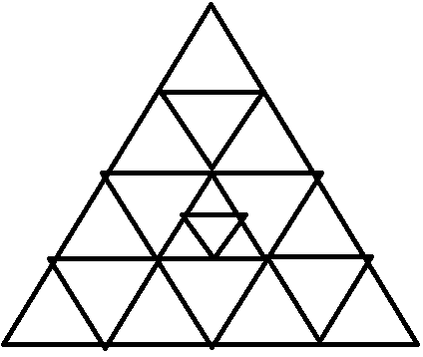~~

~~It’ll be interesting to think about how this layout would be better than the other two.~~

The next order of business is to down select to the most appropriate design choice for the city (each would be limited to 15kmsx15kms). We have to think of advantages and disadvantages to each city design, based on which we will select the city design.

PS. You could recommend a different design choice, but you’ll have to provide your reasoning over why its better than the above two.

1. Basic Infrastructure:
   1. Transportation, Connectivity & Roads
   2. Energy Demand management
   3. Water and Sewage Handling (We should really go down to the basic details)
   4. Telecommunications and Internet Connectivity

For now, this is the first order of business. We have to get over the above 2 points; these are essential to how we proceed with designing the rest of the city

City Design:

We have chosen to select the city to be a grid at this moment. It will look like our regular old grid. It’s simpler to manage and we have equalised special resources. We don’t have to worry about how much space there is in between circles in the case of the hub and spoke (Concentric circles). Road transportation is also made easier in the case of the grid city.

The City will in essence look like what is below. That is a lot of space. We will also have to decide in which manner we want to begin the construction of the city.

|  |  |  |  |  |  |  |  |  |  |  |  |  |  |  |
| --- | --- | --- | --- | --- | --- | --- | --- | --- | --- | --- | --- | --- | --- | --- |
|  |  |  |  |  |  |  |  |  |  |  |  |  |  |  |
|  |  |  |  |  |  |  |  |  |  |  |  |  |  |  |
|  |  |  |  |  |  |  |  |  |  |  |  |  |  |  |
|  |  |  |  |  |  |  |  |  |  |  |  |  |  |  |
|  |  |  |  |  |  |  |  |  |  |  |  |  |  |  |
|  |  |  |  |  |  |  |  |  |  |  |  |  |  |  |
|  |  |  |  |  |  |  |  |  |  |  |  |  |  |  |
|  |  |  |  |  |  |  |  |  |  |  |  |  |  |  |
|  |  |  |  |  |  |  |  |  |  |  |  |  |  |  |
|  |  |  |  |  |  |  |  |  |  |  |  |  |  |  |
|  |  |  |  |  |  |  |  |  |  |  |  |  |  |  |
|  |  |  |  |  |  |  |  |  |  |  |  |  |  |  |
|  |  |  |  |  |  |  |  |  |  |  |  |  |  |  |
|  |  |  |  |  |  |  |  |  |  |  |  |  |  |  |
|  |  |  |  |  |  |  |  |  |  |  |  |  |  |  |

Road design:

Now we also have to decide what the roads will look like. It is essential that the roads are made as Pedestrian and Cyclist friendly as possible, and not made to feel like they are made for cars, it makes the city lose its charm. We have to have 4 lane roads and a maximum 6 lanes on roads it is deemed necessary, which will see maximum traffic. This is for the simple reason that wider roads will promote more cars, we will in effect never be able to solve the problem of traffic in cities without promoting public transportation and smaller forms of transportation, such as walking and cycling. Thus, we will be having two lanes reserved on either side for cycling and walking respectively. The cycling lanes should be sufficient to allow for cyclists to travel both ways. We must make cycling the least painful of activities within the city. This will, hopefully, result in generating Amsterdam like interest in cycling.

The road should in effect look like the following

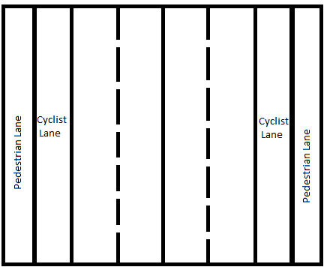

Each road lane should be a maximum of 3 meters wide. We want to ensure that the car drivers drive slowly, at a maximum of 40 kmph within city limits. This would reduce the number and severity of crashes as people will be more careful given the space for error is reduced.

Each cyclist lane should be 3 meters wide and there should be a gap of approximately 1 meter between the cyclist lane and the main roads. This will give sufficient distance between cyclists and the road traffic

The pedestrian lane should be 2 meters wide and the cyclist lane should also be at a distance of at least 1 meter. Between the cyclist and the pedestrian lane, trees indigenous to the area should be planted to avoid the possibility of collision between the two.

Effectively the entire transportation network will have a maximum width of 2*2 + 1*2 + 3*2+1*2+3*4 +1 meters, which is equivalent to 27 meters. This is huge and has to be reduced. However, since these are main roads, I believe it is acceptable to have these on the 15*15 km road grids.