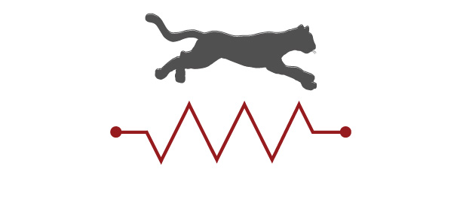
CIRCUITSCAPE User Guide

Brad McRae and Viral Shah
Version 3.5- Updated October 8, 2013

How to cite this document:
McRae, B.H., and Shah, V.B. 2009. Circuitscape User Guide. ONLINE. The University of California, Santa Barbara. Available at: http://www.circuitscape.org.

First time users:
Please see the section on memory management before running large grids (> 1 million cells).

1. Introduction
Circuitscape is an open-source program that uses circuit theory to predict connectivity in heterogeneous landscapes for individual movement, gene flow, and conservation planning. Circuit theory complements common analytic connectivity models because of its theoretical basis in random walk theory and its ability to evaluate contributions of multiple dispersal pathways. Landscapes are represented as conductive surfaces, with low resistances assigned to habitats that are most permeable to movement or best promote gene flow, and high resistances assigned to poor dispersal habitat or to movement barriers. Effective resistances, current densities, and voltages calculated across the landscapes can then be related to ecological processes, such as individual movement and gene flow. More detail about the model, its parameterization, and potential applications in ecology, evolution, and conservation planning can be found in McRae (2006) and McRae et al. (2008).

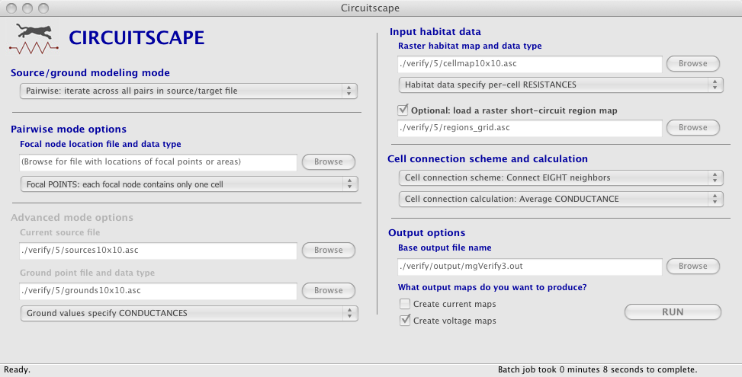

Before You Start
Whatever software you use, connectivity modeling involves a great deal of research, data compilation, GIS analyses, and careful interpretation of results. Defining areas to connect, parameterizing resistance models, and other modeling decisions you will need to make are not trivial. Before diving in, we strongly recommend that users first acquaint themselves with the process and challenges of connectivity modeling by consulting published resources. Good places to start include overviews on the Corridor Design and Connecting Landscapes websites. Spear et al. (2010), Beier et al. (2011) and Zeller et al. (2012) also offer helpful advice on resistance mapping and connectivity analysis in general.

Circuitscape can now be called directly from an ArcGIS toolbox. Look for it on the downloads page.

Lastly, users interested in mapping important connectivity areas may wish to consider Linkage Mapper, which maps least-cost corridors. Linkage Mapper now also hybridizes least-cost corridor modeling with Circuitscape (see the Pinchpoint Mapper tool within the Linkage Mapper toolkit).

How Circuitscape Works
Circuitscape may be called through its graphical user interface (above), from an ArcGIS toolbox, or from the command line. Users supply the program with a raster habitat map, which is either coded in resistances (with higher values denoting greater resistance to movement) or conductances (the reciprocal of resistance; higher values indicate greater ease of movement).

Every grid cell with finite resistance is represented as a node in a graph, and is connected to either its four first-order or eight second-order neighboring habitat cells. Cells with infinite resistance (zero conductance) are dropped. Habitat patches, or collections of cells, can be assigned zero resistance (infinite conductance) using a separate “short-circuit region” file. These collections of cells are collapsed into a single node.

Circuitscape operates in one of four modes: pairwise, one-to-all, all-to-one, and advanced. In the pairwise mode, connectivity is calculated between all pairs of focal nodes (points or regions between which connectivity is to be modeled) supplied to the program in a single input file. For each pair of focal nodes, one node will arbitrarily be connected to a 1-amp current source, while the other will be connected to ground. If there are n focal nodes, there will be n(n - 1)/2 calculations unless you’re using focal points and not mapping currents or voltages. In the latter case, we can do it in n calculations (much faster).

The one-to-all mode is similar to the pairwise mode, and takes the same input files. However, instead of iterating across all focal node pairs, this mode iterates across all focal nodes. In each iteration, one focal node is connected to a 1-amp current source, while all remaining focal nodes are connected to ground. If there are n focal nodes, there will be n calculations.

The all-to-one mode is similar to the one-to-all mode, and takes the same input files. However, in this mode Circuitscape connects one focal node to ground and all remaining focal nodes to 1-amp current sources. It then repeats the process for each focal node; if there are n focal nodes, there will be n calculations. This mode can be a good alternative to the pairwise mode when the goal is to map important connectivity areas among multiple habitat patches, since it will run faster and use less memory.

In the advanced mode, the user defines any number of current sources and any number of grounds on the landscape, which are all activated simultaneously. Sources represent points where current is injected into the landscape, whereas grounds represent areas where current flows out of the system. Source nodes can have different strengths (i.e. inject more or less current into the landscape), and ground nodes can be tied to ground with any resistance. Current sources and grounds are supplied in separate input files. Outputs include maps of current density flowing through each raster cell, and voltages at each raster cell.

Circuitscape generates output maps that show the current density and voltage at each grid cell in the landscape under each configuration. Additionally, Circuitscape writes an output file reporting effective resistances between all pairs of focal nodes in the pairwise mode, and between each node and ground in the one-to-all mode. Resistances in the all-to-one mode are undefined, so a results file is written with zeros indicating successful solves.

How Circuitscape works in the pairwise, one-to-all, and all-to-one modes:
Resistance or conductance grid
Grid of short-circuit regions
Focal points and/or regions (grid or list)

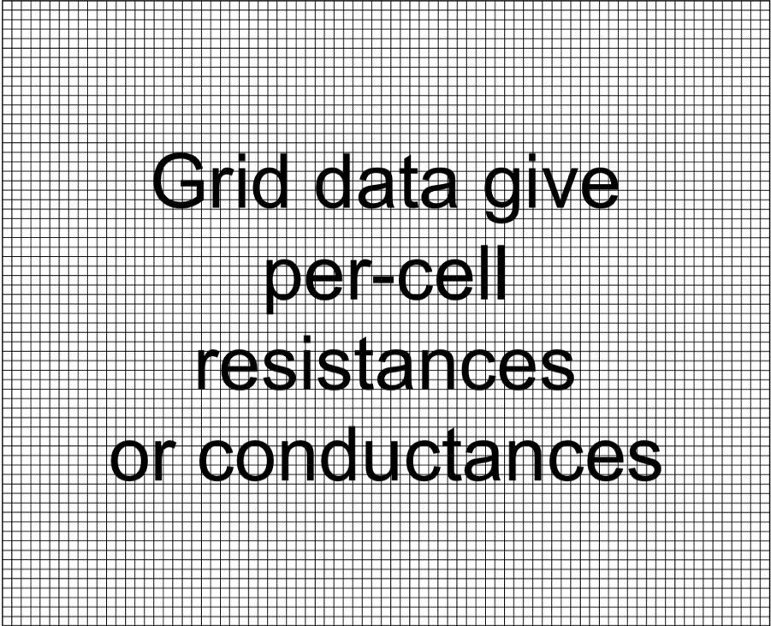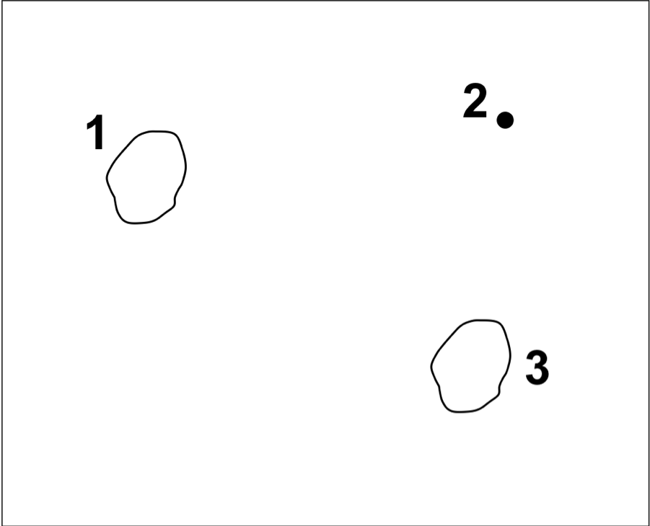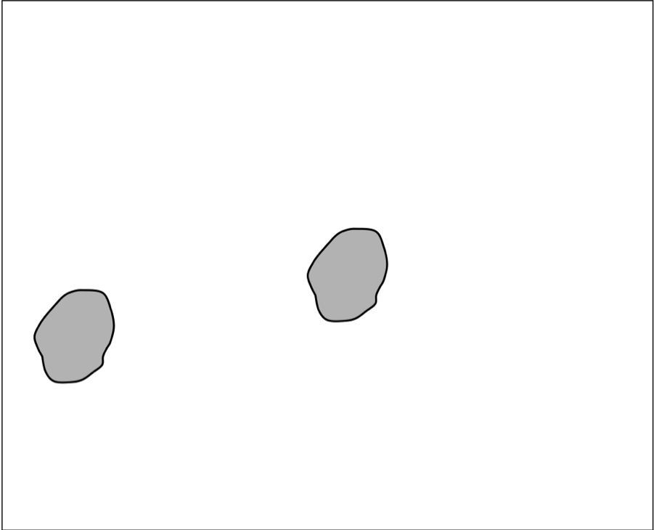

Fig. 1. Example input files for pairwise and one-to-all modes. Input files in this example include a habitat map specifying per-cell resistances or conductances, a focal node location file (with two focal regions and one focal point in this case), and an optional short-circuit region map.
Nodes 1 and 2 activated
Nodes 2 and 3 activated
Nodes 1 and 3 activated

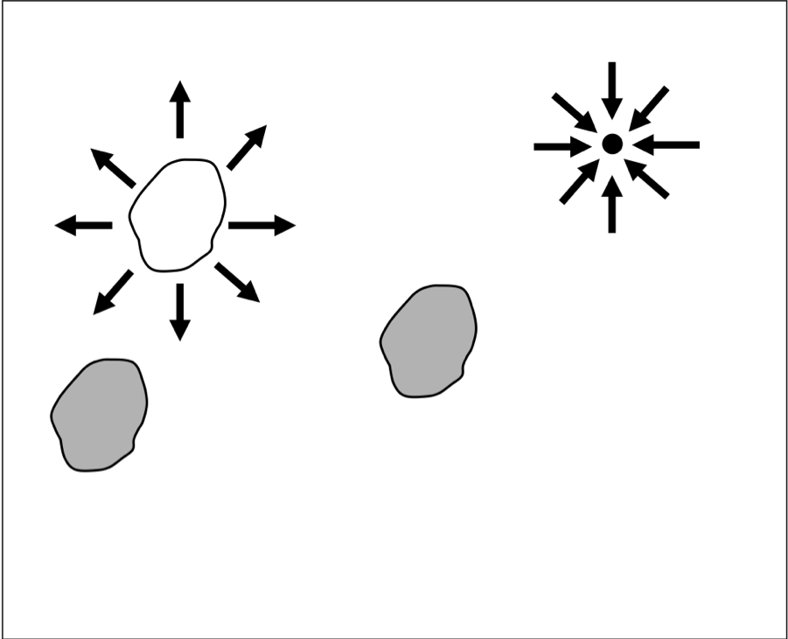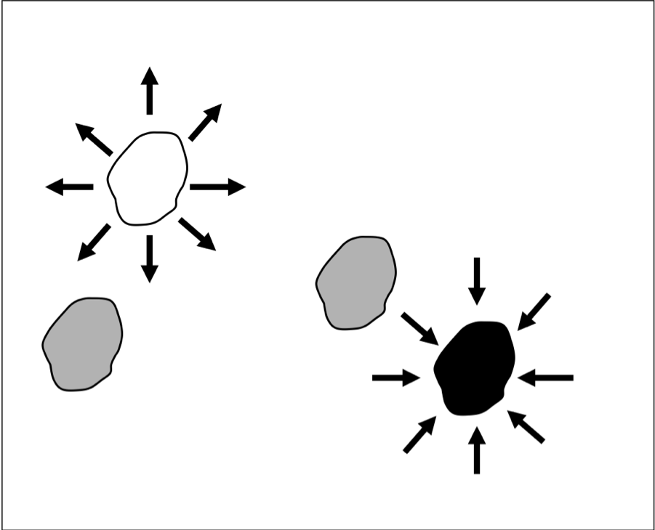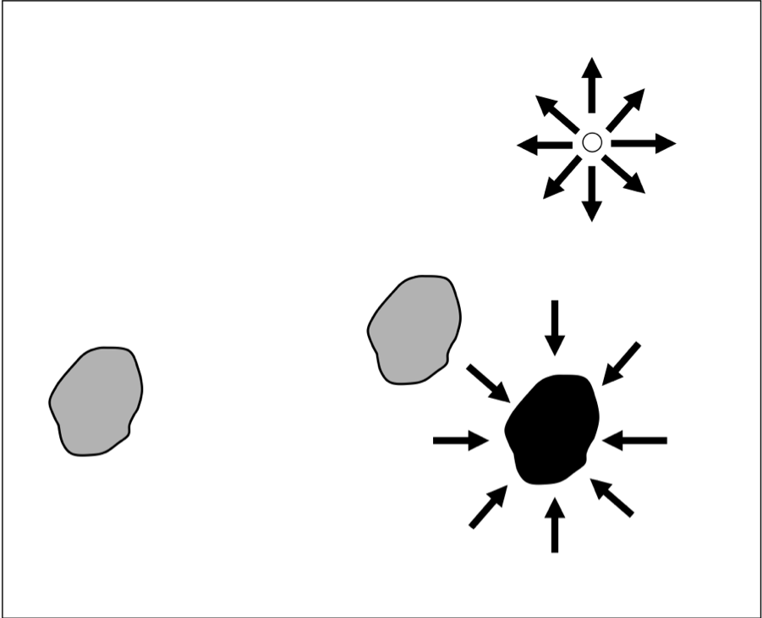

Fig. 2. Schematic describing pairwise mode analyses that would result from the input files shown in Fig. 1. Three sets of pairwise calculations—involving focal nodes 1 and 2, nodes 1 and 3, and nodes 2 and 3—would be conducted. For each pair, one node would be connected to a 1-amp current source, and the other to ground. Note that focal region nodes become short-circuit regions when they are activated (e.g., node 1 in scenario 1), but these regions are not present when the nodes are not activated (e.g., node 1 in scenario 3).
Node 1 = source
Nodes 2 & 3 = ground
Node 3 = source
Nodes 1 & 2 = ground

Node 2 = source
Nodes 1 & 3 = ground

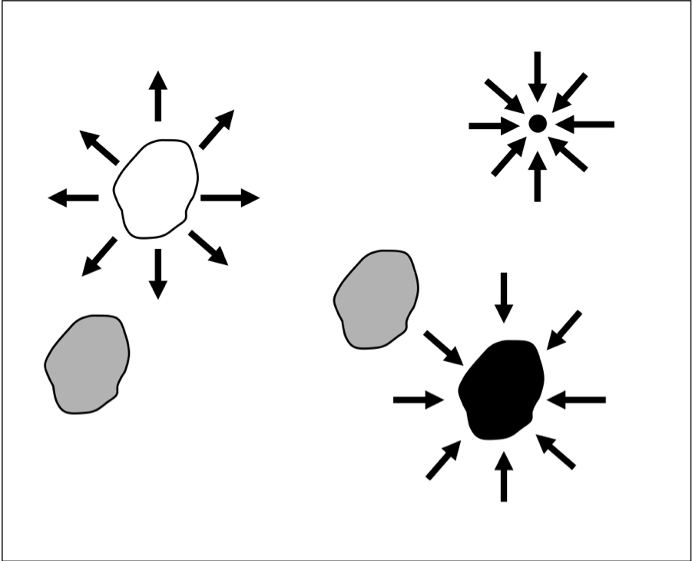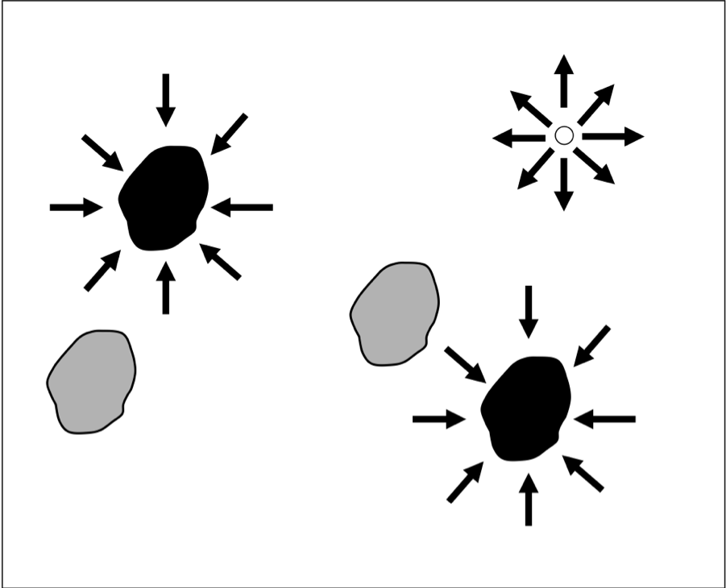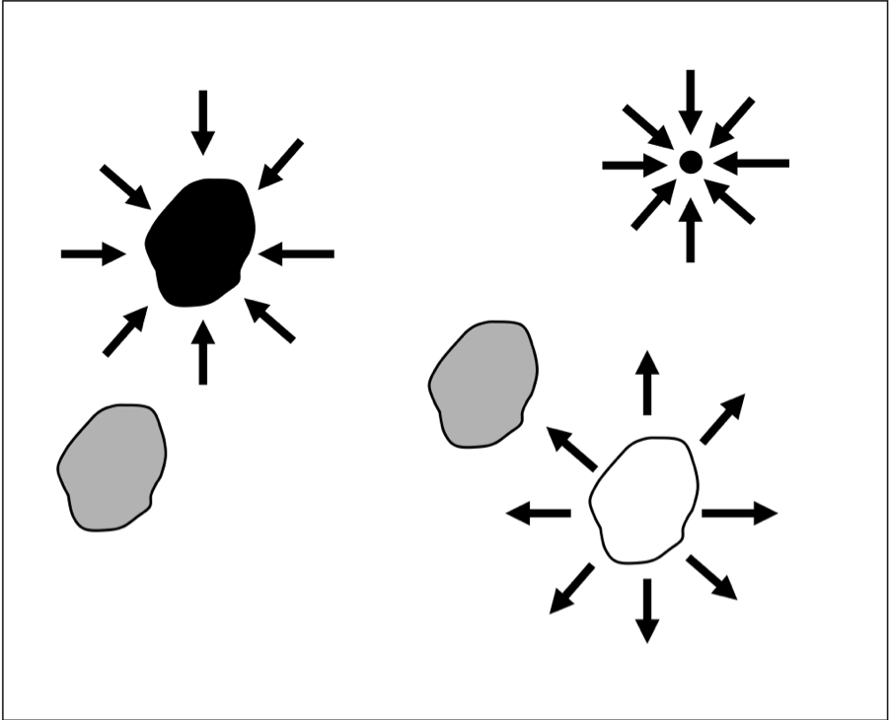

Fig. 3. Schematic describing one-to-all mode analyses that would result from the input files shown in Fig. 1. Three sets of calculations—involving focal nodes 1, 2, and 3—would be conducted. For each, one node would be connected to a 1-amp current source, and the other two would be connected to ground. The all-to-one mode is similar, with arrow directions reversed; that is, one node is connected to ground while the remaining nodes are connected to 1-amp current sources.

How Circuitscape works in the advanced mode:
Current source file
(grid or list)
Ground file
(grid or list)
Grid of short-circuit regions

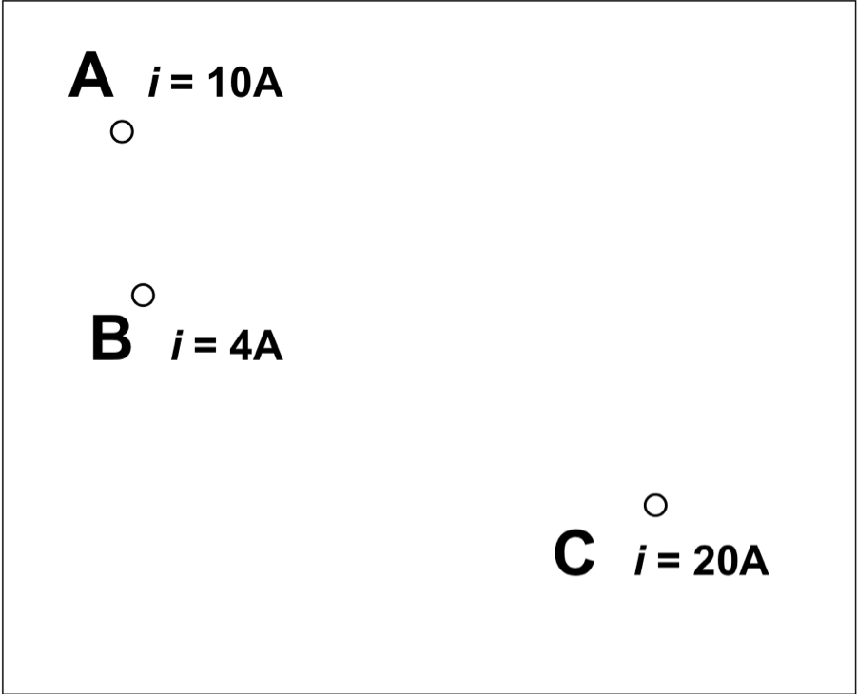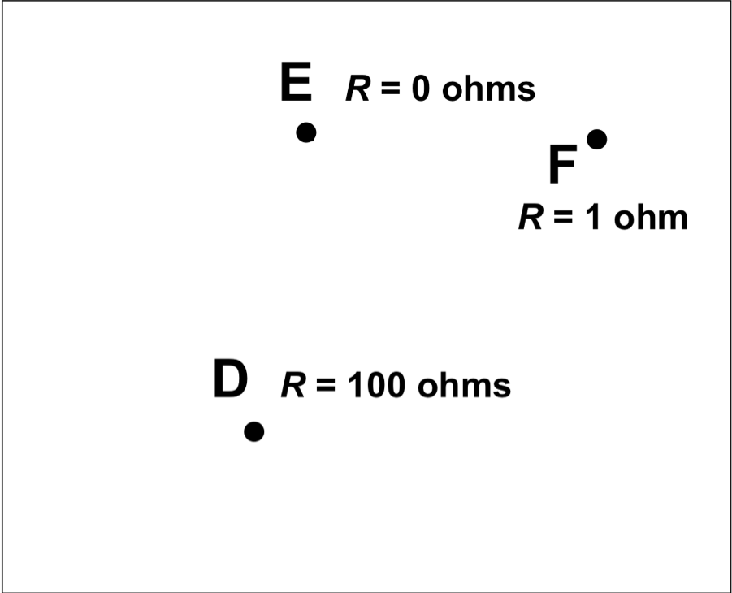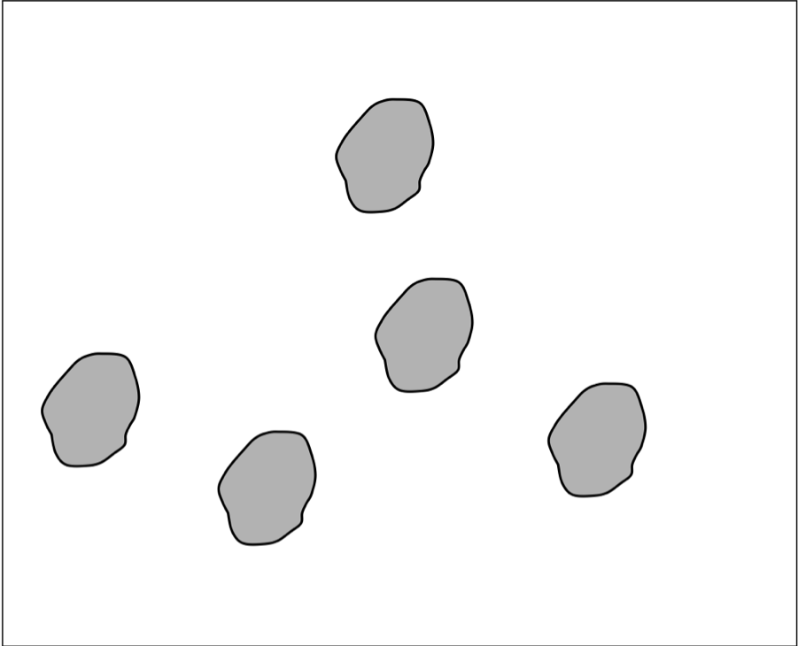

Fig. 4. Example input files for advanced mode, which requires independent current source and ground files. Note that current sources in this example have different “strengths,” and ground nodes are connected to ground with differing levels of resistance. This example also includes an optional grid of five short-circuit regions.
Effective current source configuration
Effective ground
node configuration
Result: all sources and grounds activated

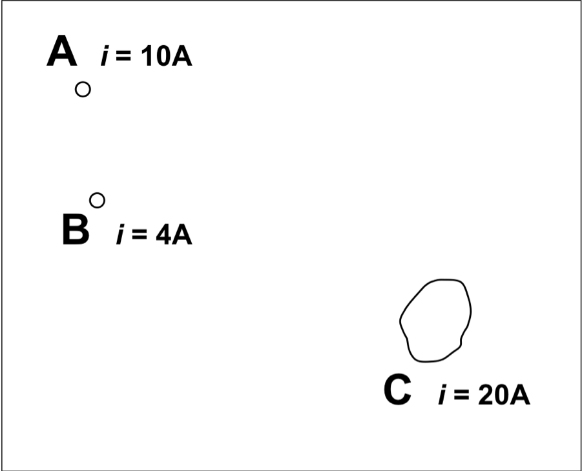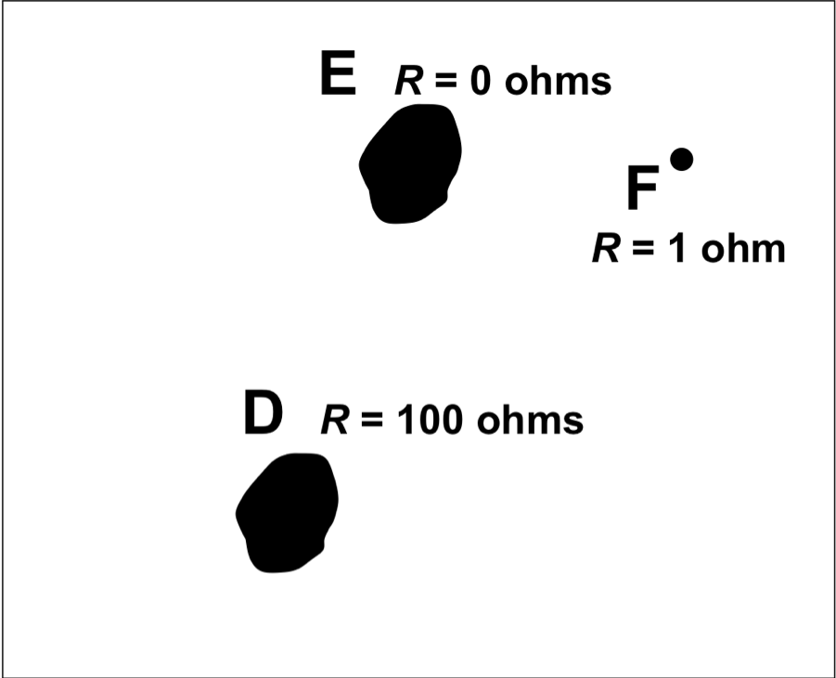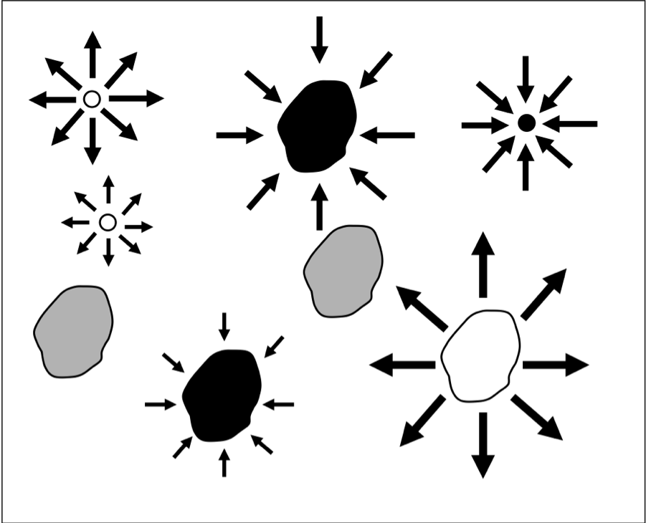

Fig. 5. The first two panels show the “effective” configuration resulting from the input files in Fig. 4. Because current source C and grounds D and E overlap with short-circuit regions, these short-circuit regions effectively become sources or grounds themselves. The rightmost panel shows a schematic of the resulting analysis, with all sources (white points and polygons) and grounds (black points and polygons) activated simultaneously. Note that sources may be negative, and ground nodes can actually contribute current to the system when negative sources are present.

2. Installing Circuitscape
Windows and Mac OS X
Download and run the appropriate setup package. This will install Circuitscape and create an “examples” directory in the installation directory with example input files on Windows. Mac users should download this directory separately.

Linux
Instructions to install and run Circuitscape on Linux can be found on the Circuitscape website . Using Linux is the best way to run very large (up to ~100 million cell) landscapes.

3. The graphical user interface
To start the user interface using Windows, run Circuitscape as you would any other installed program. In Mac OS X, double-click on Circuitscape.app. The user interface shown above will appear.

Source/ground modeling mode
Choose your modeling mode
Circuitscape is run in one of four modes: pairwise, one-to-all, all-to-one, and advanced. Under the pairwise mode, resistance, current and voltage will be calculated iteratively between all pairs of focal nodes (Figs. 1 and 2), the locations of which are supplied in a single file. In the one-to-all mode, resistance, current and voltage will be calculated between one focal node and ground, with all remaining focal nodes set to ground (Figs. 1 and 3). Circuitscape will then repeat this for each focal node. In the all-to-one mode, one focal node will be connected to ground with all others connected to 1-amp current sources (Figs. 1 and 3), repeating this for each focal node. Under the advanced mode, any number of sources and grounds can be activated simultaneously (Figs. 4 and 5). Current sources and grounds are entered in separate files.

Pairwise, one-to-all, and all-to-one mode options
Focal node location and data type
This file specifies locations of nodes between which effective resistance and current flow are to be calculated (See Figs. 1 and 2). Files may be text lists of coordinates or Arc/Info ASCII grids. When a grid is used, it must have the same cell size and extent as the habitat grid. The value stored in each grid cell location refers to the focal node ID (see ASCII grid format in the Input File Format section below); a single ID can occupy more than one cell in the grid if the “focal regions” option is selected (see below). Each focal node should have a unique positive integer ID. Cells that do not contain focal nodes should be coded with NODATA values. When a text list is used, the value field references the focal node ID (see Text list format in the Input File Format section below); a single ID can occupy more than one pair of coordinates (and more than one cell in the underlying habitat grid) if the “focal regions” option is selected. Examples are in the examples directory (located where Circuitscape is installed, e.g. C:\Program Files\Circuitscape) and can also be found on the Circuitscape downloads page.

Choose one: nodes represent focal POINTS or focal REGIONS
Focal nodes may occur at points (single cells on the habitat grid) or across regions. For the latter, at least one identifier must occur across multiple cells; these cells will then be collapsed into a single node, as they are when short-circuit region files are used (see below). The difference is that a focal region will be “burned in” to the habitat grid only for pairwise calculations that include that focal node. As with short-circuit regions, focal regions need not be made up of contiguous cells. For large grids or large numbers of focal nodes, this option may require more computation time.

Advanced mode options
Current source file
This file specifies locations and strengths, in amps, of current sources (Figs. 4 and 5). Either an ASCII grid or a text list may be used. When a grid file is used, it must have the same cell size and extent as the habitat grid. Cells that do not contain current sources should be coded with NODATA values. Note: current sources may be positive or negative (i.e., they may inject current into the grid or pull current out. Similarly, grounds may either serve as a sink for current or may contribute current if there are negative current sources in the grid). Examples are in the examples directory.

Ground point file and data type
This file specifies locations of ground nodes and resistances or conductances of resistors tying them to ground (Figs. 4 and 5). Either an ASCII grid or a text list may be used. Grids must have the same cell size and extent as the habitat grid, and cells that do not contain grounds should be coded with NODATA values. Note that if a direct (R = 0) ground connection conflicts with a current source, the ground will be removed unless the ‘remove source whenever a source and ground conflict’ item in the Options menu is checked. Examples are in the examples directory.

Choose ground data type: RESISTANCE or CONDUCTANCE
The ground data type indicates whether values in the ground file are in resistances or conductances. To tie cells directly to ground, select resistances as the data type and set values in the corresponding ground point file to zero.

Input habitat data
Raster habitat map and data type
The raster habitat map specifies the ability of each cell in the landscape to carry current. These maps should be in standard Arc/Info ASCII grid format as exported by ArcGIS or another standard GIS package (format is described below).
Choose habitat data type: RESISTANCE or CONDUCTANCE
This choice specifies whether habitat map files are coded in resistances (with higher values denoting greater resistance to movement) or conductances (the reciprocal of resistance; higher values indicate greater ease of movement).

Zero and infinite values for conductances and resistances represent special cases. Infinite resistances are coded as NODATA values (see file format description in the Input File Format section below) in input resistance grids, or as zero or NODATA in input conductance grids; these are treated as complete barriers, and are disconnected from all other cells. Cells with zero resistance or infinite conductance can be specified using separate short-circuit region files as described below.

Optional: load a raster short-circuit region map
This file provides locations of short-circuit regions, stored in Arc/Info ASCII grid format. Short-circuit regions act as areas of zero resistance, essentially providing patches through which current is given a “free ride” as it flows across the landscape. Each short-circuit region should have a unique positive integer identifier; cells within each region are merged into a single node with all other cells in the region, including non-adjacent cells (i.e., regions need not be contiguous). Non-short-circuit-region areas should be stored as NODATA values. The file must have the same cell size and extent as the habitat grid.

Cell connection scheme and calculation
Choose to connect cells to their FOUR or EIGHT neighbors
Circuitscape creates a graph (network) by connecting cells to their four or eight immediate neighbors, as specified by the user. Choose four neighbors to connect cells to their four cardinal neighbors only, or eight neighbors to also connect diagonally adjacent cells.

Choose how to calculate connections between neighbors
This choice determines whether cells are connected by their average resistance or by their average conductance. The distinction is particularly important when connecting cells with zero or infinite values. When average resistances are used, first-order neighbors connected by resistors with resistance given by: R_{ab} = (R_{a} + R_{b}) / 2, and second-order (diagonal) neighbors are connected by resistors with resistance given by: R_{ab} = √2 * (R_{a} + R_{b}) / 2, where Ra and Rb are the resistances of the neighboring cells. When average conductances are used, first-order neighbors connected by resistors with conductance (the reciprocal of resistance) given by: G_{ab} = (G_{a} + G_{b}) / 2, and second –order (diagonal) neighbors are connected by resistors with resistance given by: G_{ab} = (G_{a} + G_{b}) / (2*√2), where Ga and Gb are the conductances of the neighboring cells. (As noted above, resistance and conductance are reciprocals of each other, i.e., G_{ab} = 1 / R_{ab}.)

Output options
Base output filename
Prompts user to browse and choose a directory path and base file name for output files. Resistances, current maps, voltage maps, and user interface settings will all use this base name, along with appropriate suffixes and extensions.

Create current maps
Generates current maps for every pair of focal nodes in the pairwise mode, or for the current source and ground configuration specified in the advanced mode. Current maps have the same dimension as the original input files, with values at each node (cell) representing the amount of current flowing through the node. In the pairwise mode, a current map file will be created for each focal node pair, and a cumulative (additive) file will be also written. Pairwise current maps will be identical regardless of which node is the source and which is the ground due to symmetry. For the advanced modeling mode, a single map will be written showing current densities at each cell resulting from the current source and ground configurations in the input files. These files can be imported into a GIS and displayed as in Fig. 6 (Log transforming values will be helpful and can be done automatically using the “Options” submenu. We used the color ramp in the Grid Tools extension for ArcView 3.x by Jeff Jenness for Fig. 6. Similar color ramps can be constructed in ArcMap and QGIS.) Such maps can be used to identify areas which contribute most to connectivity between interest points (McRae et al. 2008).

Create voltage maps
For the pairwise modeling mode, voltage maps specify node voltages that would be observed for each focal node pair if one node were connected to a 1 amp current source and the other to ground. For the advanced modeling mode, voltage maps specify voltages at each cell resulting from the current source and ground configurations in the input files.

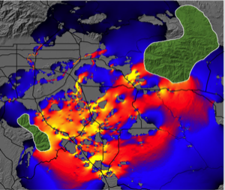
Fig. 6. Current map used to predict important connective habitat between core habitat areas (green polygons, entered as focal regions) for mountain lions. Current densities were log-transformed before color ramp was applied. Warmer colors indicate areas with higher current density. “Pinch points,” or areas where connectivity is most tenuous, are shown in yellow. Research Collaborators: Brett Dickson and Rick Hopkins, Live Oak Associates.

The menu bar

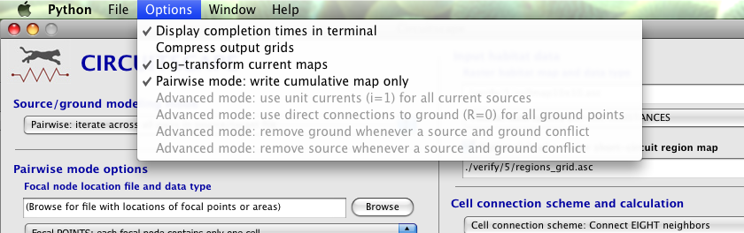

File >> Load settings from last run
Loads settings automatically saved the last time the “Run” button was clicked.

File >> Load settings from file
Allows user to browse for a configuration file (.ini extension) with previously saved settings. These can include settings automatically saved in the user-specified output directory upon clicking the “Run” button, or those saved manually using the “Save settings” function.

File >> Save settings
Allows the user to save settings they have entered in the user interface for future retrieval as a configuration file (.ini extension). This option is useful for creating run configurations for use in batch mode.

File >> Verify code
Allows the user to verify that their installation is working properly. Datasets in the “verify” directory will be used, and effective resistances and current maps will be checked against known correct values. If verification fails, see the terminal (Windows) or run the console utility (Mac) to see details.

File >> Run in batch mode
Using batch mode, you can specify any number of configurations to run by loading configuration files saved in a single directory. This can be useful for running large numbers of analyses. The configuration files can be created in the user interface and saved under “Save settings” as described above.

Options>> Display completion times in terminal
Writes names of operations and completion times for each to terminal screen.

Options>> Compress output grids
Output ASCII grids are automatically compressed using the gzip file format. This can be useful when many large maps will be written.

Options>> Log-transform current maps
Values in output current maps will reflect a log10 transform of current densities, which is useful for visualizing them in a GIS. Cells with zero current will be recoded with NODATA values.

Options>> Pairwise mode: write cumulative map only
Maps of current flow between each pair of focal nodes will be calculated, but only one summed map of current from all pairwise calculations will be written to disk.

Options>> Pairwise mode: Run in low memory mode
This option will use less memory in the pairwise mode when focal points are used, but will also run somewhat slower.

Options>> Advanced mode: use unit currents (i=1) for all current sources
All current sources will be set to 1 amp, regardless of the value specified in the current source input file.

Options>> Advanced mode: use direct connections to ground (R=0) for all ground points
All ground cells will be tied directly to ground, regardless of the value specified in the input ground file.

Options>> Advanced mode: remove ground whenever a source and ground conflict
Whenever a cell is connected both to a current source and to ground, the ground connection will be removed.

Options>> Advanced mode: remove source whenever a source and ground conflict
Whenever a cell is connected both to a current source and to ground, the current source will be removed.

NEW FEATURES: the following options are in the beta stage of development (not exhaustively tested yet). Please let us know if you have problems:

Options>> Read mask file
When checked, a dialog will open to select a raster mask file in ASCII grid format. Cells with negative, zero, or NODATA values in the mask will be dropped from the corresponding habitat map. Positive integer cells will be retained. File should only contain integers and have a .asc extension. See example file “mask.asc” in the examples directory.

Options>> One-to-all and All-to-One modes: Read source strength file
When checked, a dialog will open to select a text list of focal node IDs and corresponding source strengths. For any focal node in this list, the amount of current injected into that node when it is a source node will be set to the strength specified in the list. All nodes not in the list will defaul to 1 Amp. This should be in the same file format as the Text List File Format given below, but with two columns (ID followed by source strength). File should have a .txt extension. See example file “source_strength_list.txt” in the examples directory.

Options>> Read file with focal node pairs to include/exclude
When checked, a dialog will open to select a matrix identifying which pairs of focal nodes to connect. The file specifies minimum and maximum values in the matrix to consider a pair connected. This can be useful when used with a distance matrix to only run analyses between points separated by a minimum distance, or by a distance equal to or less than a maximum distance. Note: any focal node not in the matrix will be dropped from analyses. Entries on the diagonal are ignored. For example, in the following matrix, only pairs with entries between 2 and 50 are connected. Pairs (1,2), (2,4), and (3,4) will not be analyzed. Focal node 5 will be dropped entirely:

min 2
max 50
0 1 2 3 4 5
1 0 100 6.67 7 1
2 100 0 11 1 60
3 6.67 11 0 -1 100
4 7 1 -1 0 0
5 1 60 100 0 0

This affects all modes except the Advanced Mode. Files should be in tab-delimited text with a .txt extension. See example file “matrix_of_pairs_to_include_and_exclude.txt” in the examples directory.

4. Running Circuitscape from the command line
On Linux machines, running Circuitscape from the command line can be useful, especially when running over a network. Whether Circuitscape is called from the command line or the graphical user interface, settings (such as input file names) are passed to the main Circuitscape module using a configuration file. The configuration file has a .ini extension, and can be edited and saved from the user interface on Linux, Windows, or Mac operating systems. The file may also be edited directly in a standard text editor.

To call Circuitscape from the command line in Linux, use the command ‘python cs_run.py [config file]’ where [config file] is the name (and path, if the file is in a different directory) of the configuration file.

5. Input file formats
ASCII file format
All input maps can all be stored in Arc/Info ASCII grid format, as exported by standard GIS packages (see examples in examples directory; these may be viewed with standard text editors). ASCII grids must be saved with a “.asc” extension. For focal nodes, the value stored in each grid location refers to the focal node ID, and a single ID can occupy more than one cell in the grid if the “focal regions” option is selected (ID’s must be positive). For current sources, the grid value specifies the source strength in amps. For grounds, the grid value specifies either the resistance or conductance of the resistor tying each ground node to ground, depending on user choice.

The format is as follows:

Header:
ncols <Number of columns>
nrows <Number of rows>
xllcorner <X coordinate of lower left corner>
yllcorner <Y coordinate of lower left corner>
cellsize <size of each cell>
NODATA value <Code for cells with no habitat, focal nodes, current sources or grounds>

Body (grid data):
Numeric data only. Columns are delimited with tabs and rows are delimited with new line characters.

Examples (these can also be found in the examples directory)
Below is a 10 x10 habitat map, coded in resistances. Cells with infinite resistance are shown in bold, and cells with low resistance (arbitrarily chosen as those with <20 ohms per cell) are shown in green:

ncols 10
nrows 10
xllcorner 1
yllcorner 1
cellsize 1
NODATA_value -9999
130 168 153 -9999 14 12 13 107 140 171
104 3 2 -9999 13 158 12 14 13 114
124 2 2 12 -9999 -9999 13 161 4 5
184 5 4 14 13 14 -9999 13 4 4
105 143 103 169 -9999 115 10 -9999 166 14
187 1 163 188 121 142 14 175 -9999 10
198 11 110 115 149 2 2 164 3 -9999
100 11 193 14 12 4 2 1 11 13
-9999 11 12 11 10 12 167 157 181 157
-9999 -9999 122 134 12 157 192 184 190 172

Below is a 10 x 10 focal region map. Here, habitat cells with very low resistance (<10 ohms) from the map above have been coded as focal regions- so these are now the “habitat polygons” that we will be connected in circuit analyses. All cells within each focal region will be collapsed into a single node (even the non-contiguous cell in region #1) when that region is activated in pairwise, one-to-all, or all-to-one analyses. This format is identical to the short-circuit region file format.

ncols 10
nrows 10
xllcorner 1
yllcorner 1
cellsize 1
NODATA_value -9999
-9999 -9999 -9999 -9999 -9999 -9999 -9999 -9999 -9999 -9999
-9999 1 1 -9999 -9999 -9999 -9999 -9999 -9999 -9999
-9999 1 1 -9999 -9999 -9999 -9999 -9999 3 3
-9999 1 1 -9999 -9999 -9999 -9999 -9999 3 3
-9999 -9999 -9999 -9999 -9999 -9999 -9999 -9999 -9999 -9999
-9999 1 -9999 -9999 -9999 -9999 -9999 -9999 -9999 -9999
-9999 -9999 -9999 -9999 2 2 -9999 -9999 -9999 -9999
-9999 -9999 -9999 -9999 2 2 2 -9999 -9999 -9999
-9999 -9999 -9999 -9999 -9999 -9999 -9999 -9999 -9999 -9999
-9999 -9999 -9999 -9999 -9999 -9999 -9999 -9999 -9999 -9999

Note that regions 1 and 2 are well-connected by a low-resistance corridor in the habitat map above. Region 3 is connected by low resistance corridors to the other two regions only if cells are connected to their eight neighbors. In the four-neighbor case, region 3 would be completely isolated.

Text list file format
Focal nodes, current sources, and grounds can also be stored as text lists (these must be saved with a “.txt” extension). For each node referenced in a text list, a value and X and Y coordinates are specified as shown below.

Value1 X1 Y1
Value2 X2 Y2
…
Note: X and Y are geographical coordinates, not row and column numbers.

Example text list (a partial list of the cell locations in the focal region map above; coordinates are for cell centroids):

1 2.5 9.5
1 3.5 9.5
1 2.5 8.5
1 3.5 8.5
1 2.5 7.5
1 3.5 7.5
1 2.5 5.5
2 6.5 4.5
…

For focal nodes under the pairwise, one-to-all, and all-to-one modes, the value field references the focal node ID; values should be positive, and a single ID can occupy more than one pair of coordinates (and more than one cell in the underlying habitat grid) if the “focal regions” option is selected. For current sources, the value field references the source strength in amps. For grounds, the value field references either the resistance or conductance of the resistor tying each ground node to ground, depending on user choice.

Here are pairwise resistances written to the output directory for the eight neighbor case (using per-cell resistances and average resistances for cell connection calculations; this can be replicated by loading eight_neighbor_example.ini from the examples directory). The first row and column contain the focal node ID’s:

0. 1. 2. 3.
1. 0. 11.93688471 15.03634473
2. 11.93688471 0. 11.57640568
3. 15.03634473 11.57640568 0.

Here are pairwise resistances written to the output directory for the four neighbor case, in which focal node 3 was completely isolated (-1 indicates infinite resistance):

0. 1. 2. 3.
1. 0. 33.55792693 -1
2. 33.55792693 0. -1
3. -1 -1 0.

For convenience, resistances are also written to a separate file in a 3-column format, e.g.:

1. 2. 33.55792693
1. 3. -1
2. 3. -1

5. Computational limitations, speed, and landscape size
We have tested this code on landscapes with up to 100 million cells. Increasing numbers of connections using diagonal (eight neighbor) connections will decrease the size of landscapes that can be analyzed. Also, increasing landscape size or numbers of focal nodes will increase computation time. We anticipate future improvements will increase the program’s speed. Note that due to the matrix algebra involved with solving many pairs of focal nodes, Circuitscape will run much faster when focal points, rather than focal regions, are used.

Important note: memory limitations
Insufficient RAM is the main cause of program errors. Windows and Mac systems will be particularly limited because no more than 2GB of memory can be addressed by any one process, limiting solvable landscapes to approximately 2-6 million cells, depending on the properties of the grid. Larger grids can be solved on Linux systems with large amounts of RAM (versions that can use more memory on 64-bit Windows and Mac are awaiting 64-bit Python releases).

There are several ways to increase the solvable grid size. These include closing all other programs (especially those that require lots of RAM such as ArcGIS), setting imperable areas of your habitat map to NODATA, using focal points instead of regions in pairwise mode, connecting cells to their four neighbors only, and not creating current maps. Also, the one-to-all and all-to-one modes typically use less memory (and run more quickly) than the pairwise mode. In particular, the all-to-one mode can be a good alternative to the pairwise mode when the goal is to produce a cumulative map of important connectivity areas among multiple habitat patches. Still, coarsening your grids (using larger cell sizes) may be necessary; doing so often produces results that are qualitatively similar to those obtained with smaller cell sizes. See McRae et al. 2008 for details of effects of using coarser grids.

6. Further Reading
Beier, P., W. Spencer, R. Baldwin, and B.H. McRae. 2011. Best science practices for developing regional connectivity maps. Conservation Biology 25(5): 879-892

McRae, B.H. 2006. Isolation by resistance. Evolution 60:1551-1561.

McRae, B.H. and P. Beier. 2007. Circuit theory predicts Gene flow in plant and animal populations. Proceedings of the National Academy of Sciences of the USA 104:19885-19890.

McRae, B.H., B.G. Dickson, T.H. Keitt, and V.B. Shah. 2008. Using circuit theory to model connectivity in ecology and conservation. Ecology 10: 2712-2724.

Shah, V.B. 2007. An Interactive System for Combinatorial Scientific Computing with an Emphasis on Programmer Productivity. PhD thesis, University of California, Santa Barbara.

Shah,V.B. and B.H. McRae. 2008. Circuitscape: a tool for landscape ecology. In: G. Varoquaux, T. Vaught, J. Millman (Eds.). Proceedings of the 7th Python in Science Conference (SciPy 2008), pp. 62-66.

Spear, S.F., N. Balkenhol, M.-J. Fortin, B.H. McRae and K. Scribner. 2010. Use of resistance surfaces for landscape genetic studies: Considerations of parameterization and analysis. Molecular Ecology 19(17): 3576-3591.

Zeller K.A., McGarigal K., and Whiteley A.R. 2012. Estimating landscape resistance to movement: a review. Landscape Ecology 27: 777–797.

