Circuitscape for ArcGIS toolbox installation
Brad McRae

This toolbox works with ArcGIS 10.0 and later. Circuitscape 3.5.8 or later must be installed separately on your machine.

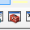
To add this toolbox to your ArcCatalog and ArcMap toolbox windows, first save the contents of the zipped folder to an accessible location. Then close all ArcGIS applications and start ArcCatalog. If the ArcToolbox window is not visible, open it by clicking on Geoprocessing >> ArcToolbox or click the ArcToolbox button:

Then, right-click the ArcToolbox entry and click Add Toolbox as illustrated in Fig. 1. Browse to the location containing the Circuitscape toolbox add and select the toolbox.
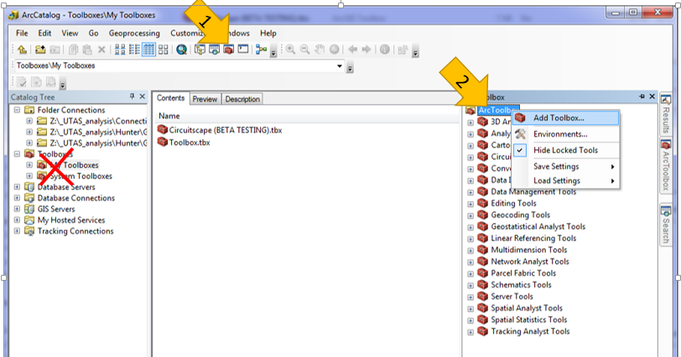

Fig. 1 Adding the Circuitscape ArcToolbox (thanks to Alex Lechner for the graphic). See ArcGIS online help for more info.

HELPFUL HINT: You can re-load finished or canceled run settings using the Results tab in ArcMap (Fig. 2). This can be VERY helpful when for repeating runs and for viewing messages from past runs.

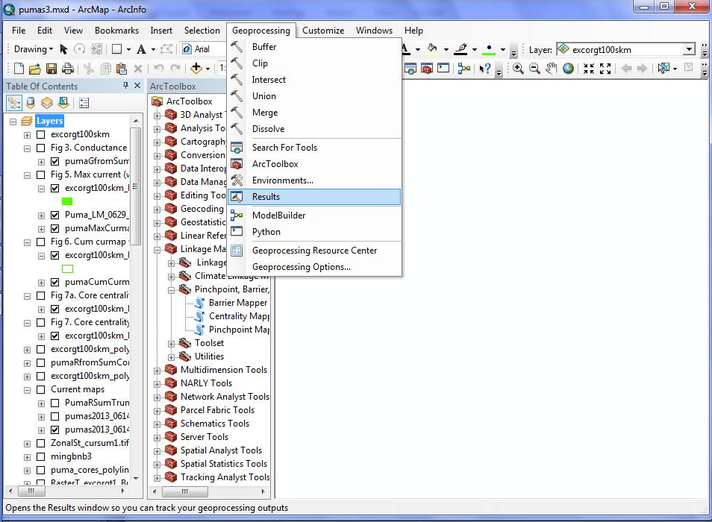

1

2

Fig. 2. The Results window in ArcMap allows you to see messages and re-load inputs from previous runs. See ArcGIS online help for more info.

