Circuitscape for ArcGIS toolbox installation
Brad McRae

The Circuitscape for ArcGIS Toolbox is a companion to Circuitscape that allows you to call Circuitscape directly from ArcMap without exporting files.

This toolbox works with ArcGIS 10.0 and later. Circuitscape 3.5.8 or later (available from www.circuitscape.org) must be installed separately on your machine.

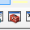
To add this toolbox to your ArcCatalog and ArcMap toolbox windows, first save the contents of the zipped folder to an accessible location. Then close all ArcGIS applications and start ArcCatalog. If the ArcToolbox window is not visible, open it by clicking on Geoprocessing >> ArcToolbox or click the ArcToolbox button:

Then, right-click the ArcToolbox entry and click Add Toolbox as illustrated in Fig. 1. Browse to the location containing the Circuitscape toolbox add and select the toolbox.
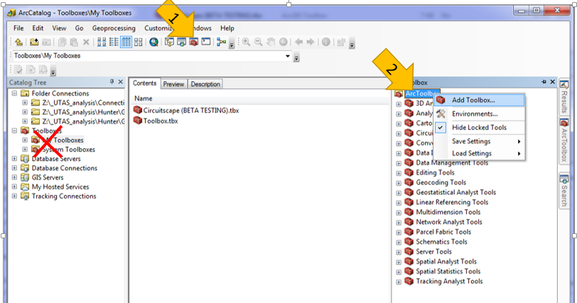

Fig. 1 Adding the Circuitscape ArcToolbox (thanks to Alex Lechner for the graphic). See ArcGIS online help for more info.

HELPFUL HINT: You can re-load finished or canceled run settings using the Results tab in ArcMap (Fig. 2). This can be VERY helpful when for repeating runs and for viewing messages from past runs.

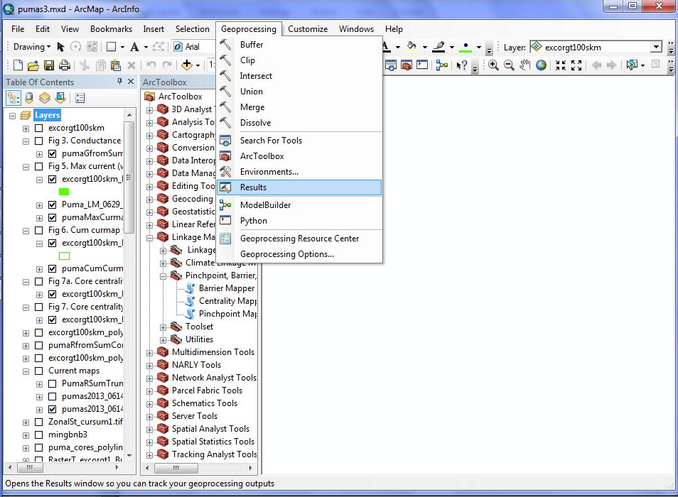

1

2

Fig. 2. The Results window in ArcMap allows you to see messages and re-load inputs from previous runs. See ArcGIS online help for more info.

We don’t yet have a user guide specific to this toolbox, but choices in the toolbox map pretty well to those in the regular Circuitscape GUI, and are described in the Circuitscape User Guide available at www.circuitscape.org.

Please email Brad McRae (mcrae@circuitscape.org) with suggestions of how to improve this documentation or the toolbox.

