CVD MR

2024-02-19

Full MR script for one exposure and multiple outcomes.

The next two chunks are for reading in the exposure data and the outcome data. Add your own file names.

Preprocess the data: The exposure data is filtered and clumped to identify instruments. Then one harmonised dataframe is created from exposure and outcome.

Run the main MR analysis and also all the essential follow-up analyses.

As described by Yuri:

“First, a series of univariable 2SMR analyses were performed based on the inverse variance weighted (IVW) estimator (Burgess et al., 2013), pooling SNP-exposure/SNP-outcome estimates inversely weighted by their standard error. Since IVW assumes that all SNPs are valid instruments or that the sum of the directional bias is zero, the robustness of significant results was tested in sensitivity analyses based on weighted median and MR-Egger estimators. The weighted median (Bowden et al., 2016) estimator is the median of the weighted empirical distribution function of individual SNP ratio estimates, providing consistent effect estimates even if half of the instruments are invalid. The MR-Egger regression (Bowden et al., 2015) consists of a weighted linear regression similar to IVW relying on the InSIDE assumption (the magnitude of any pleiotropic effects should not correlate with the magnitude of the main effect), providing valid effect estimate even if all SNPs are invalid instruments under the ‘NOME’ assumption (uncertainty in the SNPexposure association estimates is negligible) (Bowden et al., 2017). At least 10 genetic instruments are recommended (Bowden et al., 2015) to run adequately powered MR-Egger analyses. Furthermore, heterogeneity among included SNPs was tested via Cochran’s Q test, single SNP, and leave-one-out SNP analyses. The presence of potential horizontal pleiotropy (a genetic instrument for exposure influencing the outcome by mechanisms other than exposure) was tested using the MR-Egger intercept (Bowden et al., 2017) and the MR-PRESSO (pleiotropy residual sum and outlier) method (Verbanck et al., 2018) (supplemental methods). Finally, we performed reversed univariable 2SMR analyses testing the potential causal impact of depression liability on AC circulating levels.”

# Main results (basic OR)

| outcome | exposure | nsnp | Inverse variance weighted | | | | Weighted median | | | | MR Egger | | | |
| --- | --- | --- | --- | --- | --- | --- | --- | --- | --- | --- | --- | --- | --- | --- |
| or | or.lci95 | or.uci95 | pval | or | or.lci95 | or.uci95 | pval | or | or.lci95 | or.uci95 | pval |
| ALLSTROKE | DEP | 362 | 1.15 | 1.09 | 1.21 | 9.47e-08 | 1.13 | 1.07 | 1.21 | 7.39e-05 | 1.32 | 1.07 | 1.64 | 1.13e-02 |
| IS | DEP | 362 | 1.16 | 1.10 | 1.22 | 1.52e-07 | 1.14 | 1.06 | 1.22 | 2.97e-04 | 1.23 | 0.97 | 1.56 | 8.24e-02 |
| CES | DEP | 360 | 1.11 | 0.99 | 1.23 | 6.86e-02 | 1.06 | 0.91 | 1.24 | 4.30e-01 | 1.36 | 0.85 | 2.17 | 2.06e-01 |
| LAS | DEP | 358 | 1.14 | 0.99 | 1.31 | 7.32e-02 | 1.13 | 0.92 | 1.38 | 2.48e-01 | 2.33 | 1.23 | 4.42 | 1.01e-02 |
| SVD | DEP | 358 | 1.34 | 1.16 | 1.55 | 4.76e-05 | 1.46 | 1.20 | 1.77 | 1.18e-04 | 1.96 | 1.05 | 3.66 | 3.56e-02 |
| CAD | DEP | 348 | 1.29 | 1.23 | 1.36 | 3.76e-22 | 1.29 | 1.23 | 1.36 | 7.90e-23 | 1.53 | 1.22 | 1.92 | 2.43e-04 |
| CAC | DEP | 365 | 1.06 | 0.94 | 1.20 | 3.38e-01 | 1.01 | 0.85 | 1.20 | 9.00e-01 | 0.99 | 0.58 | 1.71 | 9.78e-01 |
| CIMT | DEP | 365 | 1.00 | 1.00 | 1.01 | 8.28e-01 | 1.00 | 0.99 | 1.01 | 1.00e+00 | 1.00 | 0.98 | 1.02 | 7.81e-01 |

Note that we didn’t expect an effect for CES (mostly genes specific to heart development) and indeed the estimate is not significant.

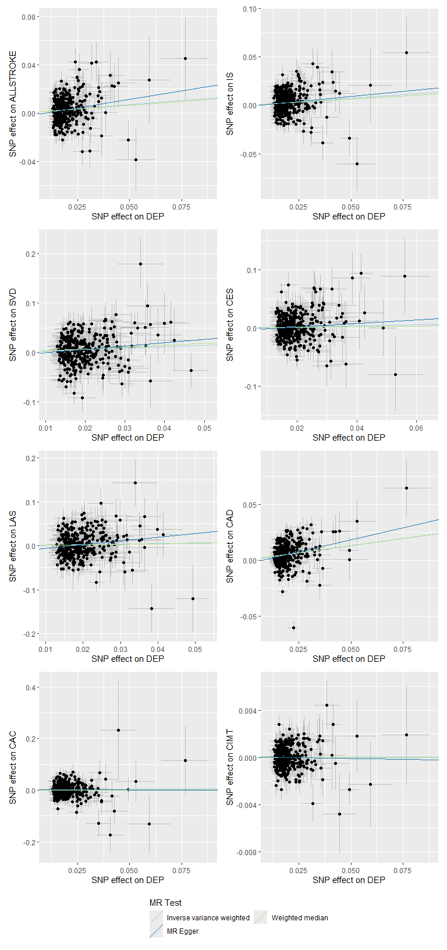

# MR more analyses

## Instrument strength

| Outcome | N SNPs | F-statistics | |
| --- | --- | --- | --- |
| min | max |
| ALLSTROKE | 362 | 28.9036 | 198.2734 |
| IS | 362 | 28.9036 | 198.2734 |
| CES | 360 | 28.9036 | 198.2734 |
| LAS | 358 | 28.9036 | 198.2734 |
| SVD | 358 | 28.9036 | 198.2734 |
| CAD | 348 | 28.9285 | 197.1083 |
| CAC | 365 | 28.9036 | 198.2734 |
| CIMT | 365 | 28.9036 | 198.2734 |

Probably these make sense..? There is large overlap in the SNPs involved for each outcome, so the SNP with the weakest and the SNP with the strongest effect on the exposure could feasibly be the same for all stroke outcomes.

# Heterogeneity

## Cochran’s Q

A significant Cochran’s Q indicates presence of an outlier.

|  | | Cochran's Q | | | | | |
| --- | --- | --- | --- | --- | --- | --- | --- |
| outcome | exposure | MR Egger | | | Inverse variance weighted | | |
| Q | df | pvalue | Q | df | pvalue |
| ALLSTROKE | DEP | 567 | 360 | 1.75e-11 | 570 | 361 | 1.30e-11 |
| IS | DEP | 566 | 360 | 2.34e-11 | 566 | 361 | 2.71e-11 |
| CES | DEP | 423 | 358 | 1.03e-02 | 424 | 359 | 1.05e-02 |
| LAS | DEP | 408 | 356 | 2.91e-02 | 414 | 357 | 1.99e-02 |
| SVD | DEP | 470 | 356 | 4.75e-05 | 472 | 357 | 4.28e-05 |
| CAD | DEP | 983 | 346 | 1.94e-62 | 990 | 347 | 4.01e-63 |
| CAC | DEP | 393 | 363 | 1.34e-01 | 393 | 364 | 1.42e-01 |
| CIMT | DEP | 421 | 363 | 1.99e-02 | 421 | 364 | 2.14e-02 |

## Leave one out analysis

$ALLSTROKE  
$ALLSTROKE$v3kGW8.7mNsA8

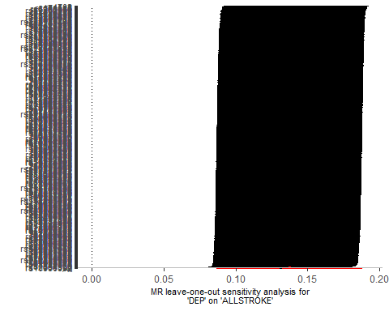

attr(,"split_type")  
[1] "data.frame"  
attr(,"split_labels")  
 id.exposure id.outcome  
1 v3kGW8 7mNsA8  
  
$IS  
$IS$v3kGW8.gYxmey

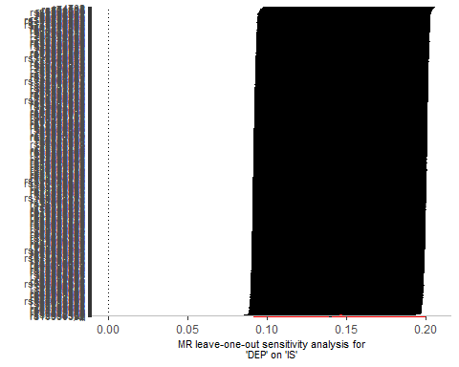

attr(,"split_type")  
[1] "data.frame"  
attr(,"split_labels")  
 id.exposure id.outcome  
1 v3kGW8 gYxmey  
  
$CES  
$CES$v3kGW8.a4pcPh

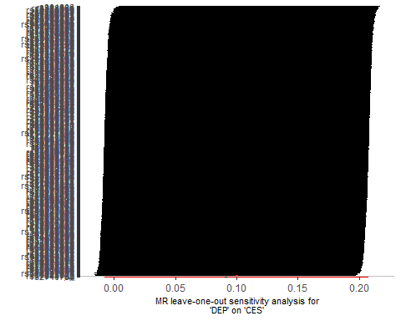

attr(,"split_type")  
[1] "data.frame"  
attr(,"split_labels")  
 id.exposure id.outcome  
1 v3kGW8 a4pcPh  
  
$LAS  
$LAS$v3kGW8.bpulR3

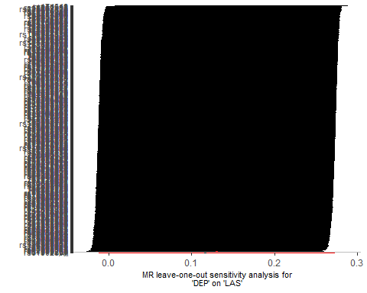

attr(,"split_type")  
[1] "data.frame"  
attr(,"split_labels")  
 id.exposure id.outcome  
1 v3kGW8 bpulR3  
  
$SVD  
$SVD$v3kGW8.KeIQy5

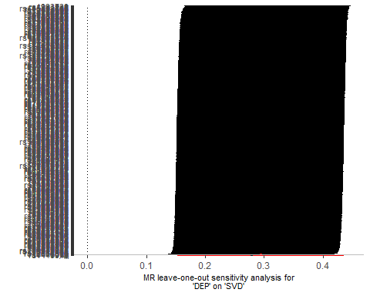

attr(,"split_type")  
[1] "data.frame"  
attr(,"split_labels")  
 id.exposure id.outcome  
1 v3kGW8 KeIQy5  
  
$CAD  
$CAD$v3kGW8.AEKi7w

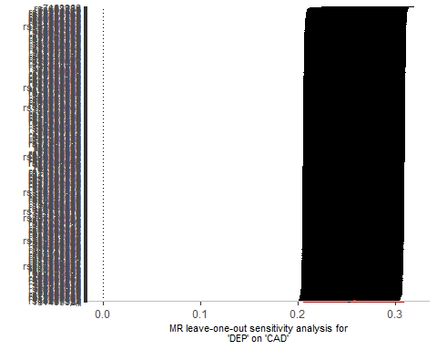

attr(,"split_type")  
[1] "data.frame"  
attr(,"split_labels")  
 id.exposure id.outcome  
1 v3kGW8 AEKi7w  
  
$CAC  
$CAC$e7VlWv.JiGy5p

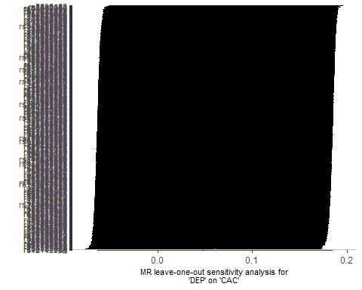

attr(,"split_type")  
[1] "data.frame"  
attr(,"split_labels")  
 id.exposure id.outcome  
1 e7VlWv JiGy5p  
  
$CIMT  
$CIMT$e7VlWv.fv9RyK

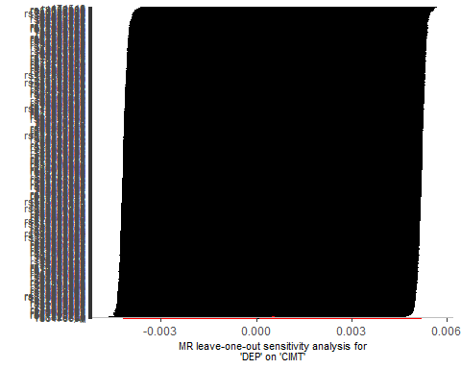

attr(,"split_type")  
[1] "data.frame"  
attr(,"split_labels")  
 id.exposure id.outcome  
1 e7VlWv fv9RyK

## Single SNP analysis

$ALLSTROKE  
$ALLSTROKE$v3kGW8.7mNsA8

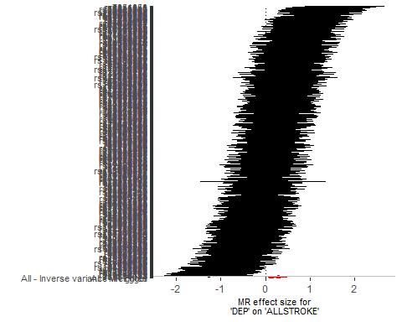

attr(,"split_type")  
[1] "data.frame"  
attr(,"split_labels")  
 id.exposure id.outcome  
1 v3kGW8 7mNsA8  
  
$IS  
$IS$v3kGW8.gYxmey

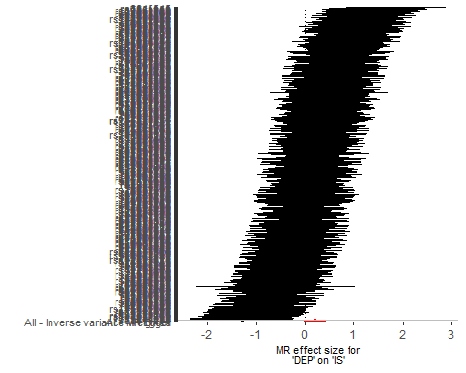

attr(,"split_type")  
[1] "data.frame"  
attr(,"split_labels")  
 id.exposure id.outcome  
1 v3kGW8 gYxmey  
  
$CES  
$CES$v3kGW8.a4pcPh

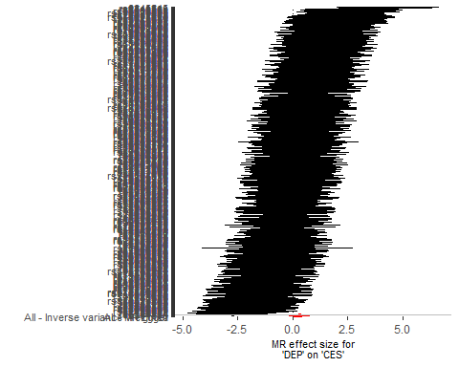

attr(,"split_type")  
[1] "data.frame"  
attr(,"split_labels")  
 id.exposure id.outcome  
1 v3kGW8 a4pcPh  
  
$LAS  
$LAS$v3kGW8.bpulR3

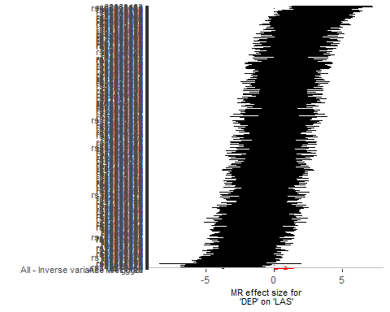

attr(,"split_type")  
[1] "data.frame"  
attr(,"split_labels")  
 id.exposure id.outcome  
1 v3kGW8 bpulR3  
  
$SVD  
$SVD$v3kGW8.KeIQy5

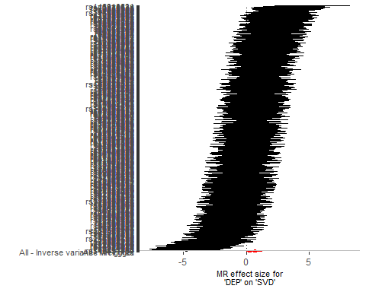

attr(,"split_type")  
[1] "data.frame"  
attr(,"split_labels")  
 id.exposure id.outcome  
1 v3kGW8 KeIQy5  
  
$CAD  
$CAD$v3kGW8.AEKi7w

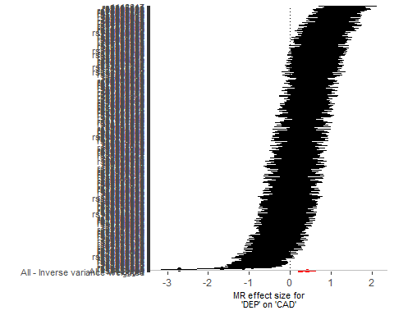

attr(,"split_type")  
[1] "data.frame"  
attr(,"split_labels")  
 id.exposure id.outcome  
1 v3kGW8 AEKi7w  
  
$CAC  
$CAC$e7VlWv.JiGy5p

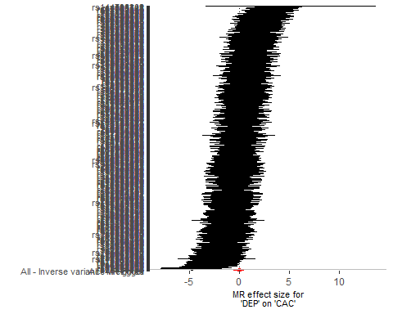

attr(,"split_type")  
[1] "data.frame"  
attr(,"split_labels")  
 id.exposure id.outcome  
1 e7VlWv JiGy5p  
  
$CIMT  
$CIMT$e7VlWv.fv9RyK

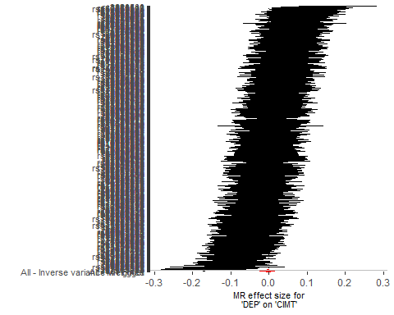

attr(,"split_type")  
[1] "data.frame"  
attr(,"split_labels")  
 id.exposure id.outcome  
1 e7VlWv fv9RyK

# Horizontal Pleiotropy

## MR-Egger Intercept

| outcome | exposure | egger_intercept | se | pval |
| --- | --- | --- | --- | --- |
| ALLSTROKE | DEP | -0.00282 | 0.00211 | 1.82e-01 |
| IS | DEP | -0.00123 | 0.00229 | 5.93e-01 |
| CES | DEP | -0.00400 | 0.00457 | 3.82e-01 |
| LAS | DEP | -0.01389 | 0.00619 | 2.54e-02 |
| SVD | DEP | -0.00738 | 0.00606 | 2.23e-01 |
| CAD | DEP | -0.00329 | 0.00218 | 1.33e-01 |
| CAC | DEP | 0.00133 | 0.00530 | 8.02e-01 |
| CIMT | DEP | 0.00007 | 0.00020 | 7.36e-01 |

## MR presso

| Outcome | Exposure | N SNPs | GlobalTest | | OutlierCorrected | | | DistortionTest | |
| --- | --- | --- | --- | --- | --- | --- | --- | --- | --- |
| RSS | pvalue | estimate | se | pvalue | Coefficient | pvalue |
| ALLSTROKE | DEP | 362 | 423.12 | 0.019 |  |  | NA |  |  |
| IS | DEP | 362 | 423.12 | 0.026 |  |  | NA |  |  |
| CES | DEP | 360 | 423.12 | 0.018 |  |  | NA |  |  |
| LAS | DEP | 358 | 423.12 | 0.027 | 0.0001849824 | 0.002369745 | 9.38e-01 | 181.22223 | 0.131 |
| SVD | DEP | 358 | 423.12 | 0.020 |  |  | NA |  |  |
| CAD | DEP | 348 | 423.12 | 0.019 | 0.0006936575 | 0.002353149 | 7.68e-01 | -25.00455 | 0.950 |
| CAC | DEP | 365 | 423.12 | 0.016 | 0.0001849824 | 0.002369745 | 9.38e-01 | 181.22223 | 0.119 |
| CIMT | DEP | 365 | 423.12 | 0.029 | 0.0007848148 | 0.002378461 | 7.42e-01 | -33.71537 | 0.947 |