beta = 4
white_threshold = 0.5
white_region_loss_coef = 5
black_region_loss_coef = 0.1
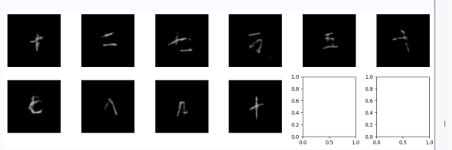
beta = 0
white_threshold = 0.5
white_region_loss_coef = 5
black_region_loss_coef = 0.1
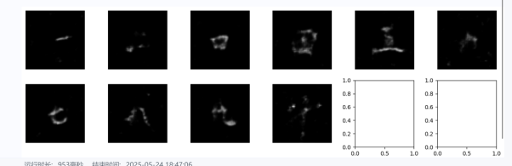
beta = 10
white_threshold = 0.5
white_region_loss_coef = 5
black_region_loss_coef = 0.1
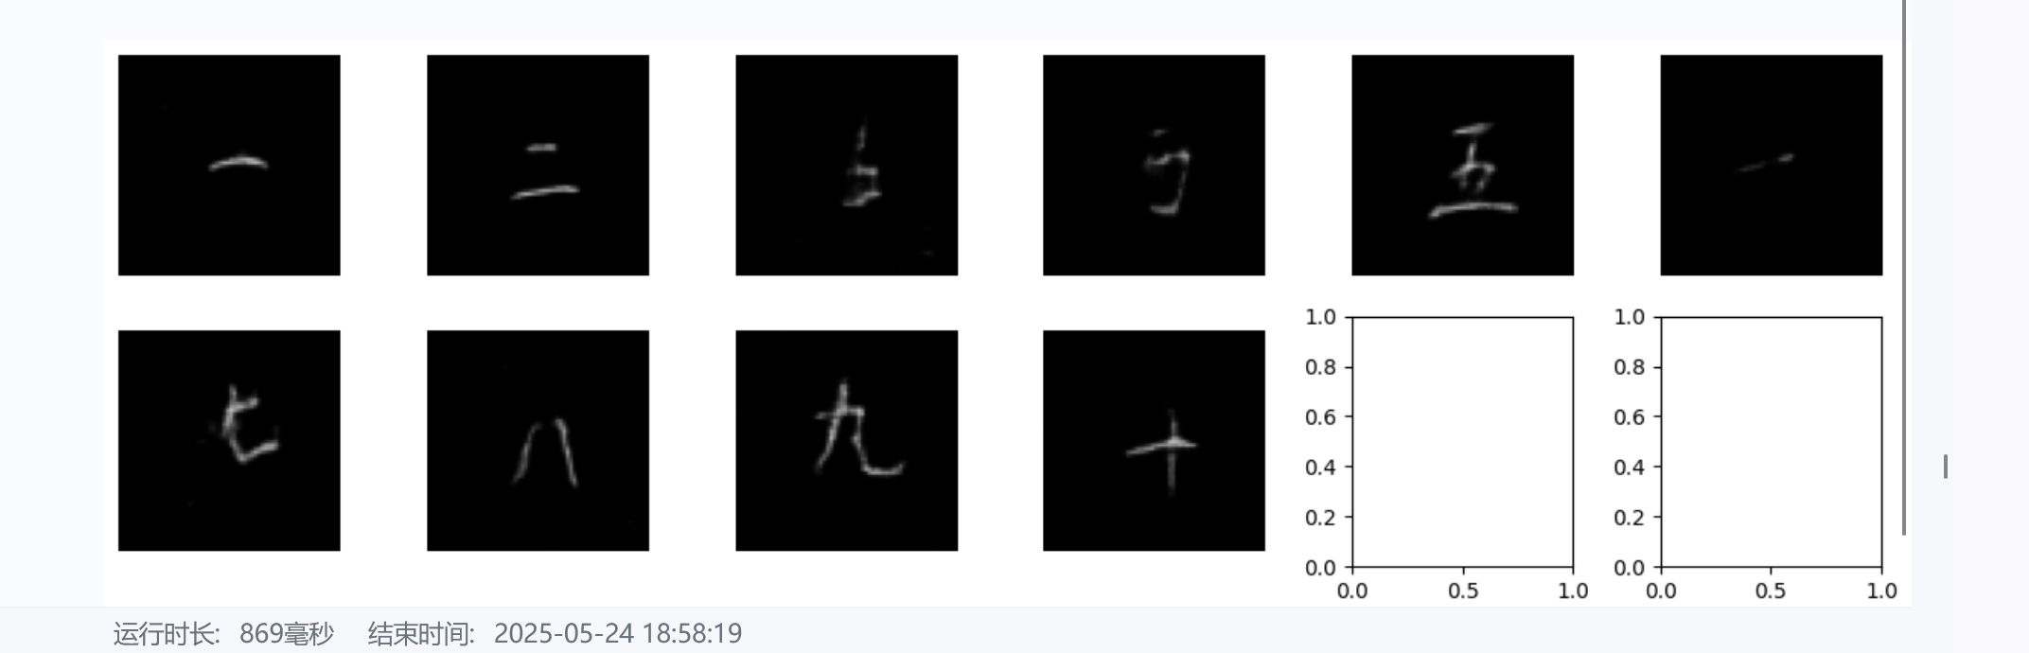
beta = 10
white_threshold = 0.4
white_region_loss_coef = 7
black_region_loss_coef = 0.1

beta = 10
white_threshold = 0.5
white_region_loss_coef = 10
black_region_loss_coef = 0.1
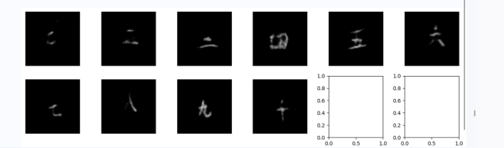
beta = 10
white_threshold = 0.3
white_region_loss_coef = 20
black_region_loss_coef = 0.1
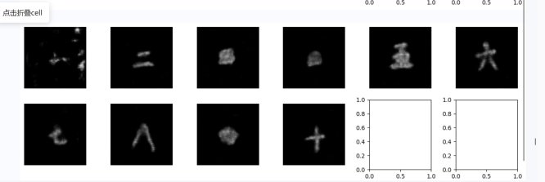
beta = 10
white_threshold = 0.5
white_region_loss_coef = 20
black_region_loss_coef = 0.1
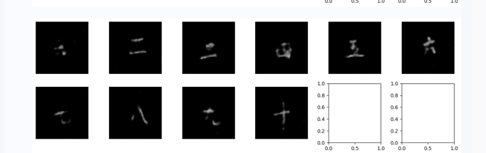
beta = 8
white_threshold = 0.35
white_region_loss_coef = 15
black_region_loss_coef = 0.05
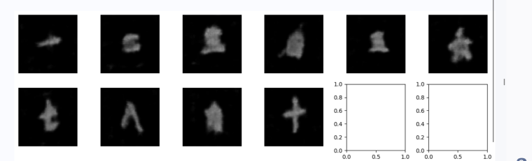
beta = 2
white_threshold = 0.45
white_region_loss_coef = 8
black_region_loss_coef = 0.01
