6.
(1)π SNO(SPJ.JNO=’J1’)
(2)π SNO(SPJ.JNO=’J1’∧SPJ.PNO=’P1’)
(3))π SNO(P ⋈SPJ ⋈(SPJ.JNO=’J1’∧SPJ.PNO=P.PNO∧P.COLOR=’红’)
(4)πJNO(J)-πJNO(S⋈P⋈SPJ⋈(S.CITY=’天津’∧S.SNO=SPJ.SNO∧SPJ.PNO=P.PNO∧P.COLOR=’ 红’))
- 联系：将多个表通过满足条件的公共字段进行连接的方式，自然连接是特殊的等值联系；
区别：自然联系默认去重，不需要显式的条件。
- 五种基本运算：并，差，笛卡尔积，投影，选择；
交：

连接：

除：
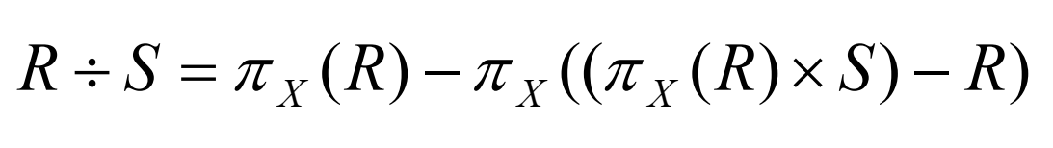
ppt题目
- π cid, aid, pid(Customers ⋈Orders ⋈products ⋈Agents ⋈((Customers.City= Agents.City)∧ ( Agents.City = products.City)))
- π cid, aid, pid(Customers ⋈Orders ⋈products ⋈Agents ⋈((Customers.City≠ Agents.City)∧ ( Agents.City ≠ products.City) ∧ (products.City ≠ Customers.City)))
- π Pname ( Customers ⋈Orders ⋈products ⋈Agents((Customers.City = '杭州') ∧ (Orders.Aid = Agents.aID) ∧ (Agents.City = '上海')))
- π aid1, aid2 ( Agents ⋈Agents ⋈(aid1 ≠ aid2 ∧ Agents.City = Agents.City))
- π aname( Agents ⋈Orders ⋈((Agents.Aid = Orders.Aid) ∧(Orders.Cid = 'c002')∧ (Orders.Pid = (Orders.Pid)) ÷ π Pid ( Orders ⋈ ((Orders.Cid = 'c002')))))
- πcid,aid,pid(Customers⋈Orders⋈products⋈Agents⋈((Customers.City=Agents.City)∨(Agents.City= products.City) ∨ (products.City = Customers.City)))
- π aid ( Customers ⋈Orders ⋈products ⋈ (Customers.City = '上海') ∧ (Orders.cid = Customers.CID) ∧(Orders.Pid = products.Pid) ∧ (Orders.Qty *products.Price > 500)))
- π cid ( Orders ÷ π Aid ( Orders ))

