**Technical University of Cluj-Napoca**

**Faculty of Electronics, Telecommunications and Information Technology**

**PROJECT**

**CAD TECHNIQUES**

**Student: Cîrnaț** **Ștefan-Darian**

**Year: II-ro**

**Specialization: Electronic Engineering , Telecommunications and Information Technology**

**Group: 2126**

**Contained**

**1. Project theme 3**

**1.1 Requirement 3**

**1.2 Design specifications 3**

**2. Block diagram 4**

**3. Wiring diagram of the circuit 5**

**4. Dimensioning of components (theoretical substantiation) 5**

**4.1 Sensor polarization in current 5**

**4.2 Convert your domain 9**

**4.3 Setting threshold voltages 11**

**4.4 LED modeling 15**

**4.5 Central Relay 19**

**5. Circuit simulation 20**

**5.1 Voltage on temperature sensor 20**

**5.2 Voltage dome conversion 22**

**5.3 Simulation of thresholds 22**

**5.4 LED simulation 24**

**5.5 Monte-Carlo Analysis 24**

**5.6 Worst-Case Analysis 26**

**6. Bibliography 28**

# Project theme

The theme of the project is to make a circuit for temperature control in a greenhouse.

## Requirement

Design a temperature control system in a greenhouse. Knowing that the temperature sensor used can measure the temperature linearly within the range specified in column E table, the system shall be designed so that the temperature in the enclosure remain within the range specified in column F. The temperature sensor will polarize in the current. The linear variation of the electrical resistance of the temp sensor is specified in column G and must be converted to a voltage variation in the range [0÷(Vcc- 2V)]. In the premises, the temperature is maintained within the specified range by means of a boiler controlled by a comparator and an electromagnetic magnetic relay. The central heating-relay assembly will be modeled using a resistor. The status of the boiler (on/off) is signalled by an LED, with the color specified in the table.

## Design specifications

|  |  |  |  |  |
| --- | --- | --- | --- | --- |
| **Measurable** **temperature range** | **Temperature in the premises**  **[ ̊C]** | **Sensor** resistance  **[kΩ]** | **VCC** | **LED**  color |
| -30 .. +40 | -10...+20 | 13k - 23k | 13 | .MOV |

# Block diagram

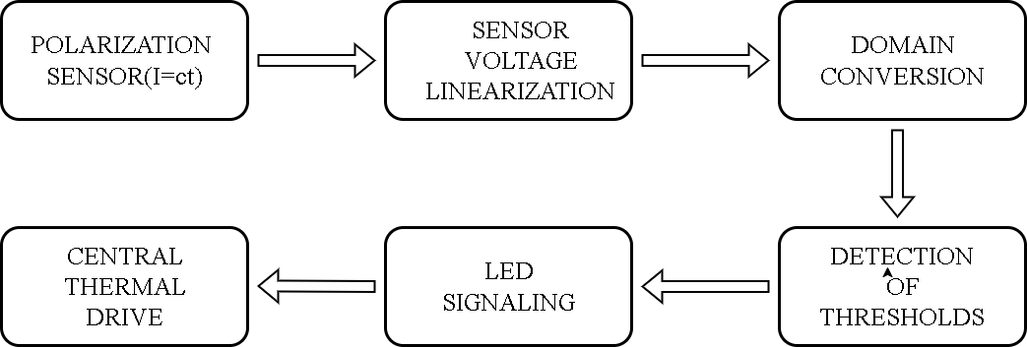

# Wiring diagram of the circuit

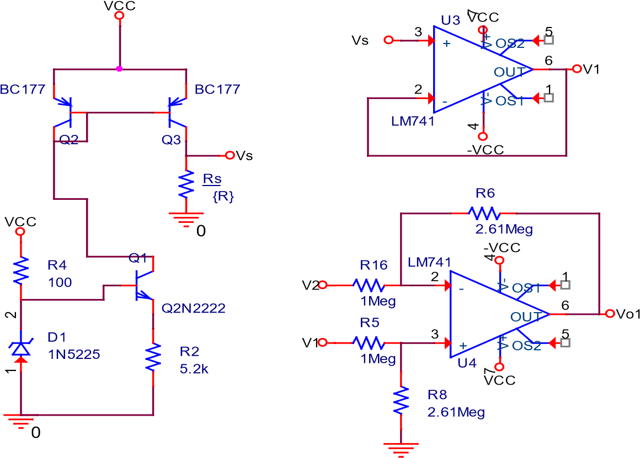

0

R11 VCC

Vo

Q4

Q2N2222

diodes1

LED

Power station

k

1

Rlim

301

0

Vo1

VCC

U5

LM741

+

3

-

2

V+

7

V-

4

OUT

6

~~1~~

BONE

1

~~2~~

BONE

5

Vref

R12

k

442

1

Meg

Vo

0

PARAMETERS: Vref 0

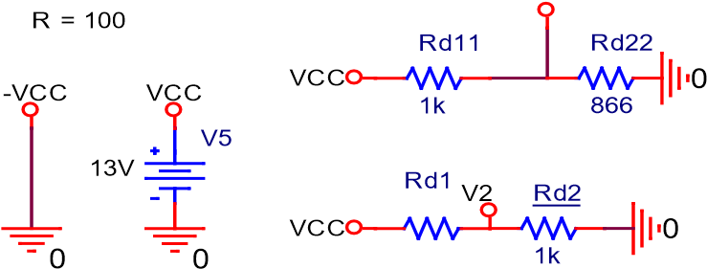

1k

# Dimensioning of components (theoretical substantiation)

## Sensor polarization in current

The sensor is simulated using a resistance with values in the range [13k – 23k] [Ohm]. To do this we will sweep the resistance in this range.

The polarization of the sensor is done with a current source taken from course 12 of the CEF subject (link in bibliography). And the sizing of the components is based on the calculation of the maximum current that can pass through the sensor without exceeding the range of (0, Vcc − 2), using the following formula:

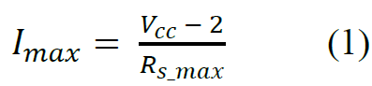

After calculations, a maximum current of 0.478mA is obtained.

The circuit for the voltage source is shown in the image below:

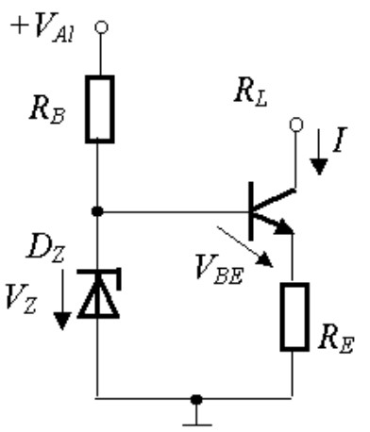

We will size the current source after this forum:

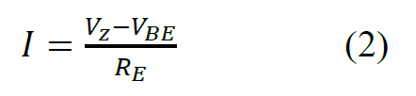

Following the calculations, we obtained a resistance value RREE = 5.02kk [OOhmm]. In this calculation, we considered Zener diodes with the following code: 1N5225 (rated voltage VV zz = 3.0V), VV BBEE = 0.6 VV, and I is the maximum current calculated above.

After sizing the current source, we will enter this current into a current mirror (with a ratio of 1:1).

Thus, the circuit that performs the polarization of the resistive sensor is shown below:

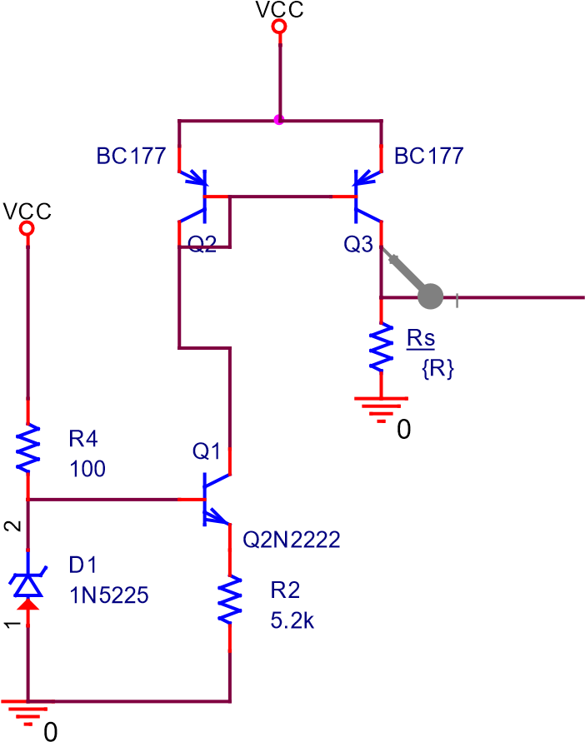

Fig. 1: Power source and current mirror

We chose a resistance (R2 – belongs to a standardized series) 0.2k Ohms higher so as not to reach the maximum current calculated above.

Following a DC Sweep simulation, there is a very small variation in sensor transparency of about 0.04mA (the current marker is fixed as shown in Fig. 1):

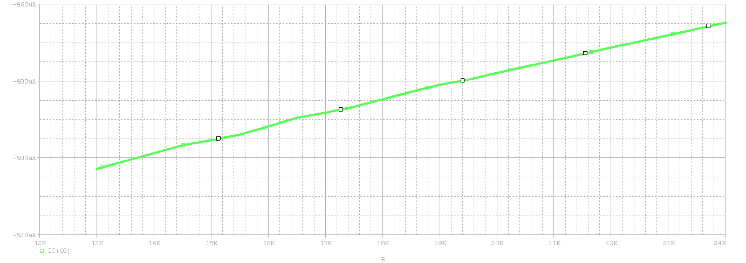

Fig.2: Current through sensor when resistance value changes

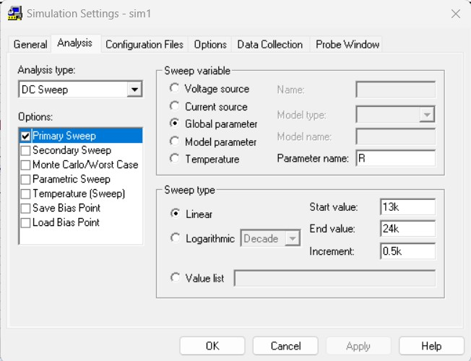

Fig. 3: Simulation settings

Next, the voltage across the sensor will be fed into a voltage repeater the scheme of which is shown below.

V1

U3

LM741

+

3

-

2

V+

7

V-

4

OUT

6

OS1

1

BONE

~~2~~

5

-

VCC

V

VCC

Fig.4 Voltage repeater

The voltage measured on the sensor when scanning the value of its resistance is shown in the graph below:

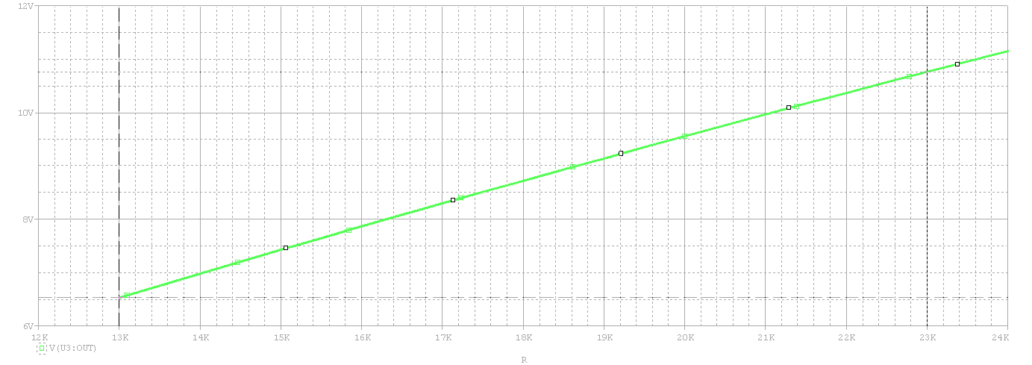

Fig.5 Measured sensor voltage

As can be seen, the characteristic is linear, which was expected, and the voltage values are drained in the range of 6.53-10.76 [V].

## Convert your domain

We will convert the range using the differential amplifier, which has 2 input positions: one is the voltage on the sensor, shown in Fig. 5, and the other is a DC voltage of 6.5V which is chosen according to the minimum value of thevoltage measured on the sensor (6.53V in my case) in order to obtain a range of this value be as close as possible to 0V.

The circuit that converts the domain is taken from the Electronic Devices courses (the course "OPERATIONAL AMPLIFIERS" to be exact). To obtain the DC voltage of 6.5V we used a voltage diffir diffir, being also a very simple method, and we dimensioned the resistors according to the formula (3) . The 2 circuits (diff. and voltage divider) are shown below:

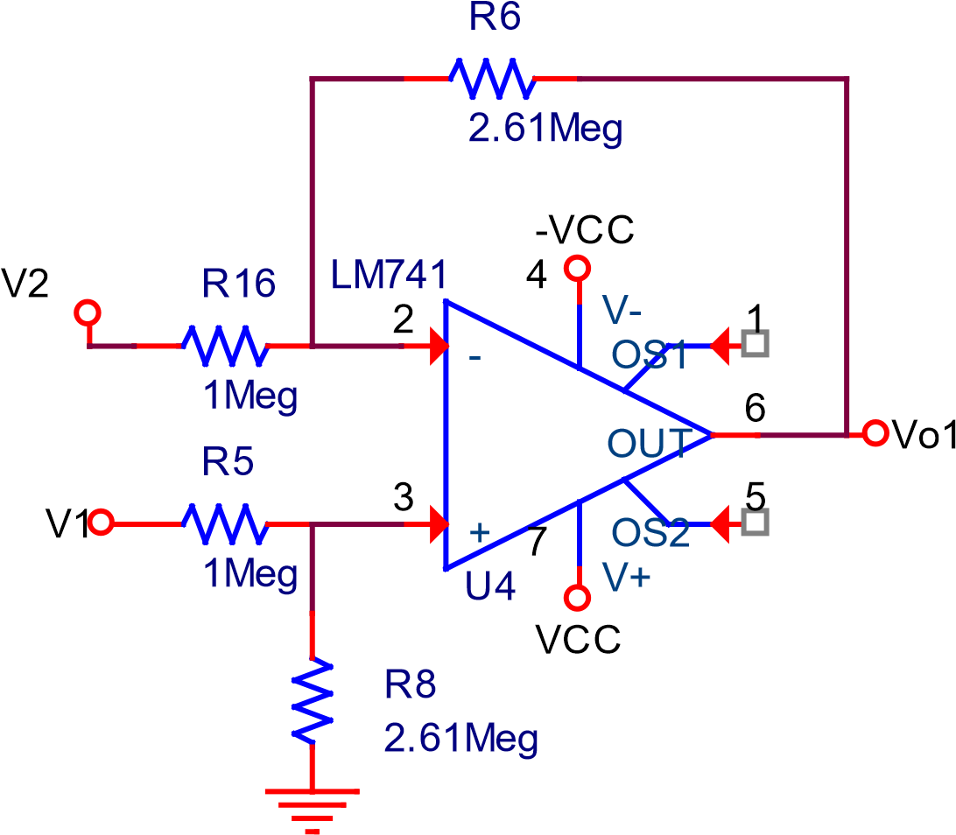

0

Rd1

V2 Rd2

VCC0

1k

1k

Fig. 6 Operational amplifier and voltage divider

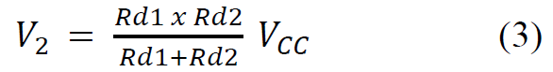

To size the resistances of the differential amplifier we used formula (4) which

is taken from the same DE course. From n calculations, we obtained the ratio RR 8 = RR 6 = 2.6

RR5 RR16 required to convert the range measured on the sensor to the range (0 , VVCCCC − 2) V, using formula (4). We considered a very high value of resistors in AO diff. to limit the incoming current as much as possible.



V1 – the voltage from the voltage repeater outputvoltage from the

V2 − 6.5V voltage obtained from the voltage divider

## Setting threshold voltages

In order to establish the threshold voltages, we need to know the resistance of the sensor to the starting and shutdown temperatures of the boiler. In the specifications the measurable temperature plat is 70 oo C (−30oo ... +40oo). Applying the simple rule of 3 (5) get a percentage of 14.28% to calculate the resistance from 10oC to 10oC.We need to measure this way, because the boiler starts at −20oC and stops at 20oC.

**

To calculate resistance to certain temperatures, use the formula (6), where p is the percentage of the formula (5) multiplied by a constant (1<c≤ 7) to arrive at 100%.



Having found out the resistance of the sensor to certain temperatures, it remains to calculate the voltage at its terminals with Ohm's Law, knowing the current(given by the current source and calculated) above). To simplify the understanding of setting voltage thresholds I will make a table.

Tab. 1. Voltage value across the sensor as a function of temperature

|  |  |  |  |  |  |  |  |  |
| --- | --- | --- | --- | --- | --- | --- | --- | --- |
| **p[%]** | **0** | **14.28** | **28.56** | **42.84** | **57.12** | **71.4** | **85.68** | **100** |
| TTooCC | -30 | -20 | -10 | 0 | 10 | 20 | 30 | 40 |
| **R[kΩ]** | 13 | 14.428 | 15.856 | 17.284 | 18.712 | 20.14 | 21.568 | 22.996 |
| Vcalc[**V]** | 0.078 | 1.742 | 3.38 | 4.989 | 6.552 | 8.086 | 9.594 | 11.076 |
| Vreal**[V]** | 0.088 | 1.76 | 3.404 | 5.004 | 6.579 | 8.126 | 9.635 | 11.128 |
| **LED** | ON | ON | ON | ON | ON | ON | OFF | OFF |

Vcalc – represents the voltage calculated at the output of the differential AO using formula (4) and considering VV2 in the formula as the voltage across the sensor at the output from the repeater.

Vreal − represents the actual (measured) voltage across the sensor (See Fig. 7).

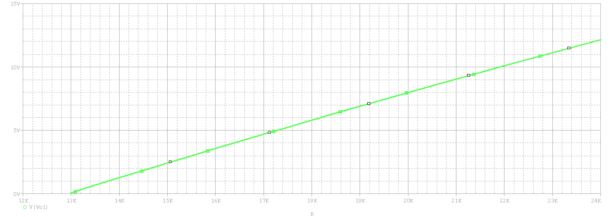

Fig. 7. Voltage on sensor after domain conversion

With this data presented in Table 1., it is observed that threshold voltages have the values 3,404V (at −10 oo DC) and 8,126V (at +20ooDC) respectively.

To obtain these 2 thresholds we will use tocall an inverting comparator with hysteresis taken from the Electronic Devices course ("Operaționale_2020 Amplifiers" – series A).

**R**

**1**

V

i

**+**

**Is**

**-**

**Is**

V

A

**R**

**P**

V

Ref

Vo

0

**+**

**Is**

You

V

threshold

-

up

**-**

**Is**

V

threshold

-

low

1

*P*

*Ref*

*P*

*RR*

*V*

*R*

+

⋅

Fig.6 Noninverting comparator with hysteresis

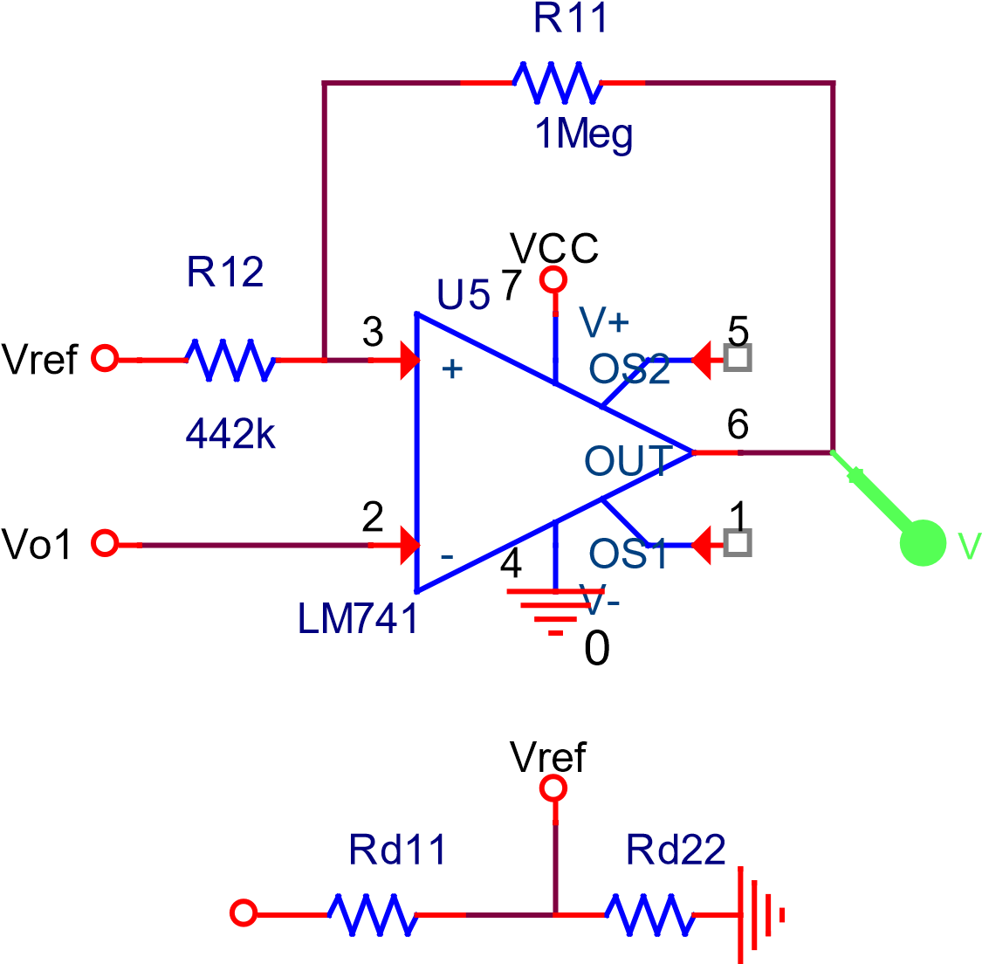VCC 0

1k 866

Fig. 7 Hysteresis comparator and voltage divider for Vref

For calculating the resistance values we used the following formulas (7) and (8) from the Electronic Devices course ("Operaționale_2020 Amplifiers" – series A), and for the voltage divider formula (9).

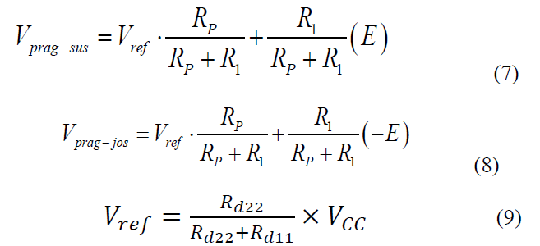

From the project specifications we know that we must maintain an enclosure temperature within the range (−10oC... +20oC). To achieve this we arbitrarily chose a reference voltage of 6V (Vref) and one of the resistors of 1k Ohm (Rp), then, knowing the thresholds (3.404V and 8.126V, respectively), we also determined the value of resistance R1 in Fig. 6 as 0.436kOhm. Since this value is not in one of the standardized series, we chose a value as close as possible that can be seen in Fig.7 (0.442kOhm). Again, we want as little current as possible at the entrance to the Comparator and multiplied the order of the calculated resistances until we reached the value of 1MOhm for Rp, respectively 442kOhm for R1.

In Fig. 8 we can see the calculations made and the values obtained.

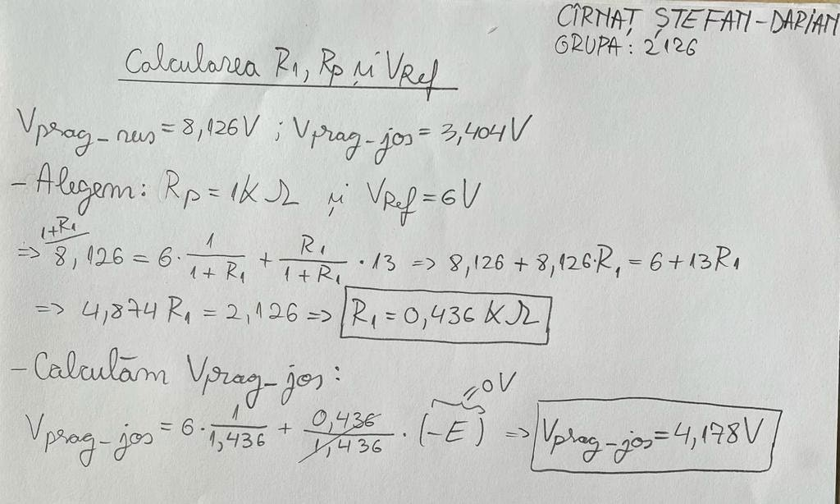

Fig. 8 Determination of thresholds

It can also be seen that the lower threshold has a voltage value of 4.178V, which does not bother, because this would mean that the plant will start a little before that the temperature reaches −10ooCC.

## LED modeling

In the project specifications, the color of the LED to be modeled is MOV. Thus, we chose the LED with catalog sheet [x] produced by the company Luckylight.

For modeling I followed the laboratory tutor from CAD Techniques (laboratory 7).

Next I will add more screenshots with the steps taken.

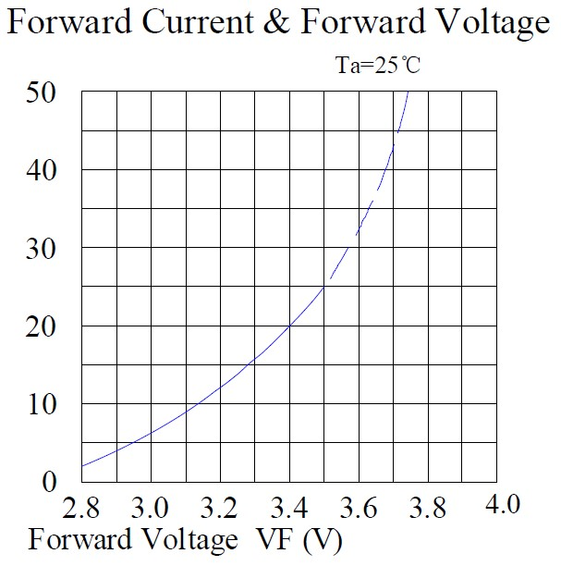

Fig. 9 Feature taken from catalog sheet

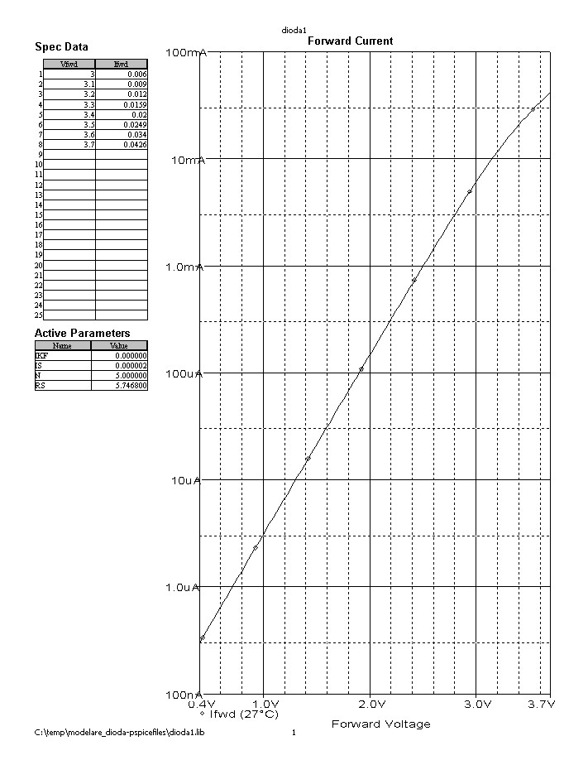

Fig. 10 Values taken from catalog sheet

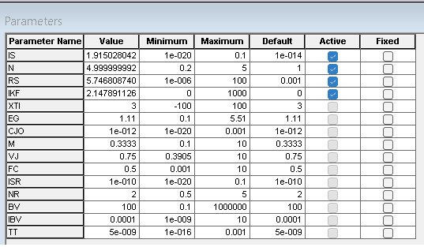

Fig. 11 Parameters resulting from the simulation tool

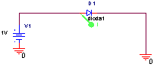

Fig. 12 Circuit used for LED testing

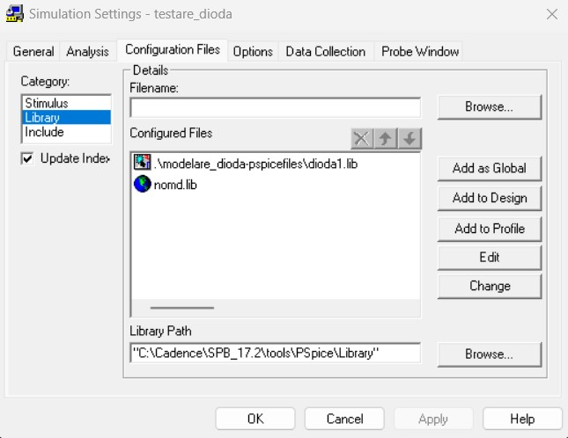

Fig. 13 Adding the newly created library to the simulation profile

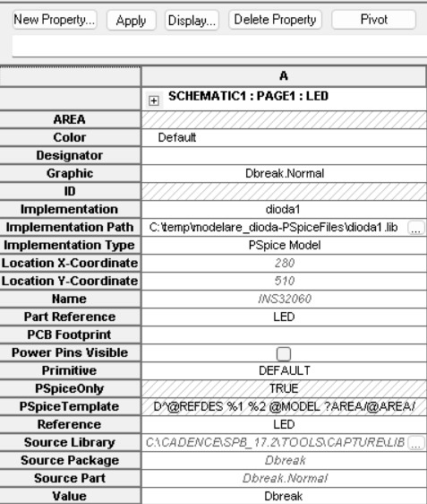

Fig. 14 Introducing the newly created library into the diode model

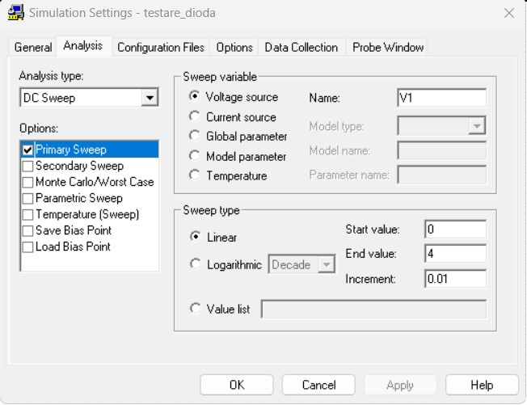

Fig. 15 LED simulation settings

## Central Relay

The circuit simulating the relay driving the boiler is composed of a bipolar transistor Q2N2222 that has a resistance representing the resistance of the boiler and the voltage source connected in collector. The base terminal of the transistor is connected to the output of the hysteresis comparator, being driven by it, and the emitter is connected to grounding.

In addition, at the exit of the comparator there is a MOV LED , sized as follows

catalog sheet, which has a current-limiting resistance(Rlim = 300Ohm) and indicates the operation of the boiler.

Q4

Q2N2222

VCC

0

Vo

diodes1

LED

Power station

k

1

Rlim

301

0

Fig.16 Relay circuit and thermal power plant

# Circuit simulation

## Voltage on temperature sensor

We will perform a DC Sweep analysis to see how the variation in sensor resistance influences the measured voltage on it. In Fig. 17 you can see the simulation settings, where you can see the resistance sweep simulating the sensor starting from 13k Ohms up to 23k Ohms with an increment of 0.3k Ohms.

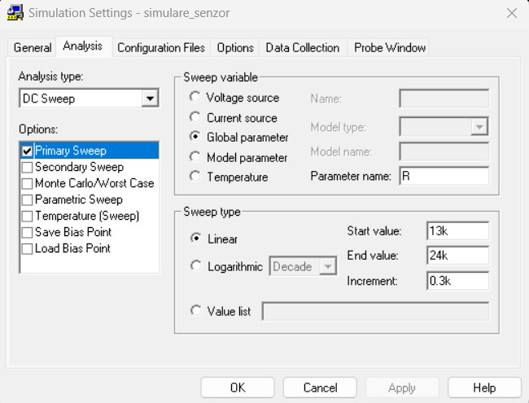

Fig. 17 Sensor simulation settings

We now expect to see a linear variation characteristic (Fig. 18) of voltage across the sensor, which will be converted to the range specified in the project requirement.

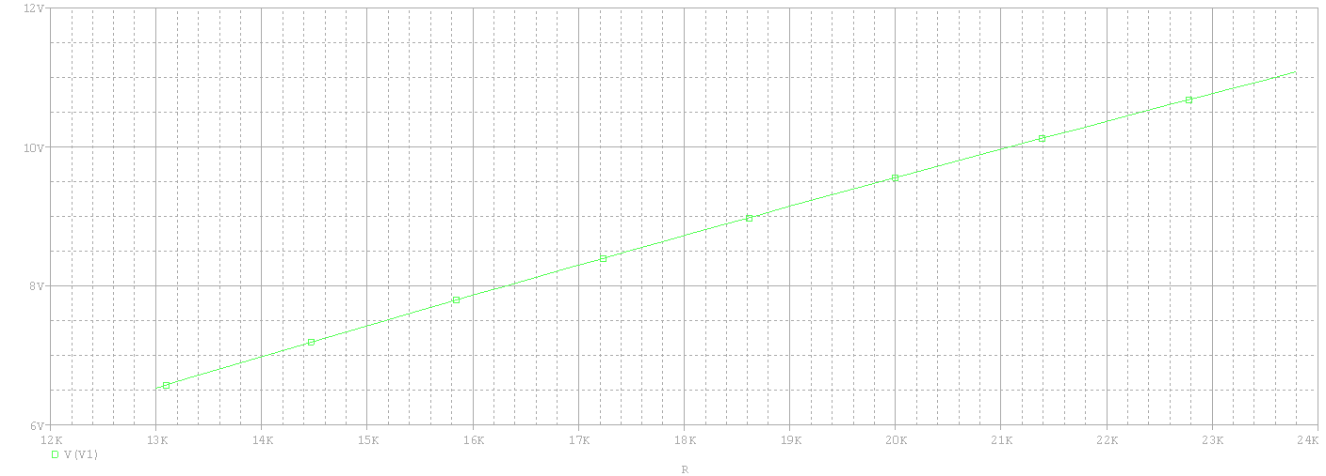

Fig. 18 Sensor voltage variation

We increased the simulation range to 24k Ohms to be able to read the voltage on the sensor as clearly as possible. Thus, the voltage across the sensor is now in the range (6.53V- 10.766V) very similar to that required in the project requirements.

## Voltage dome conversion

Conversion of the voltage range on the sensor to the range specified in the requirement can be achieved with a differential amplifier. In Fig. 6 you can see this circuit along with the sizing of its components.

To simulate the operation of this circuit, we will use the same data as in Fig. 17.

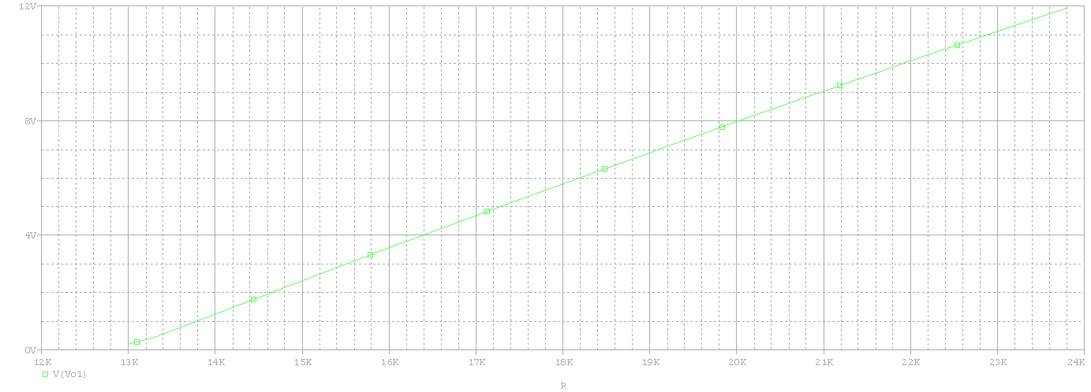

Fig. 19 Voltage range after conversion

From Fig. 19 It can be seen that the new domain is between (0.19V – 11.1V), being similar to the one in the requirement. It does not reach the 0V tense because V 1 and V2 in the formula (4) They can never be equal.

## Simulation of thresholds

In order to function properly, the circuit needs 2 thresholds (asymmetrical) The theoretical part of calcuation and sizing of thresholds was made above (Fig. 8).

Due to the fact that the simulator does not allow us to visualize the hysteresis in the same simulation, we will do 2 simulations: one in which we will scan the resistance of the sensor upwards and one in which we're going to swing the other way around.

The simulation settings are identical as in Fig. 17.

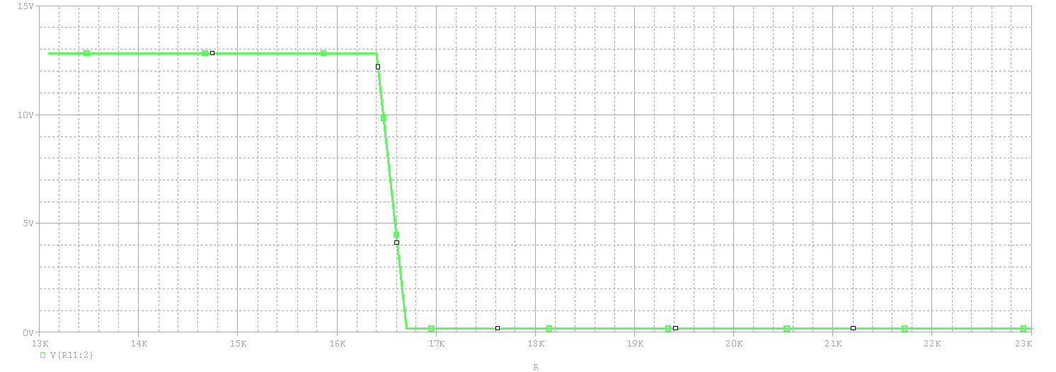

Fig. 20 Left threshold of hysteresis

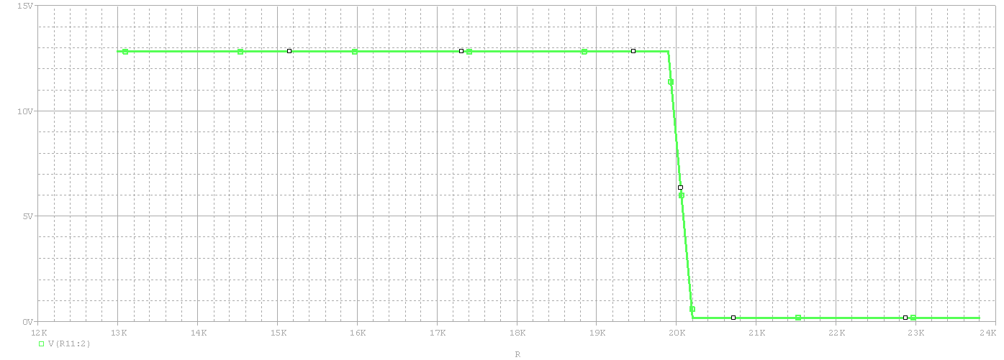

Fig. 21 Right threshold of hysteresis

As can be seen in Fig. 20, the left threshold is reached when the voltage on the sensor is about 4V and the resistance value is 16.4k Ohm, which is not bad, even if it is not the calculated threshold, because this means that the boiler will start at a temperature of −10oC.

In Fig. 21 it is seen that the 2nd threshold is reached at the voltage determined in Fig. 8., the boiler turning off when the temperature reaches +20oC and the resistance of approx. 20k Ohms.

## LED simulation

To check the functioning of the LED we will measure the current passing through it, at the variation of the resistance of the temperature sensor. In the figure below it is seen that the LED is on (I>0A) when the boiler is turned on ( the temperature is not in the desired range) and is off (I~0A) when the boiler is not operating (temperature belongs to desired range).

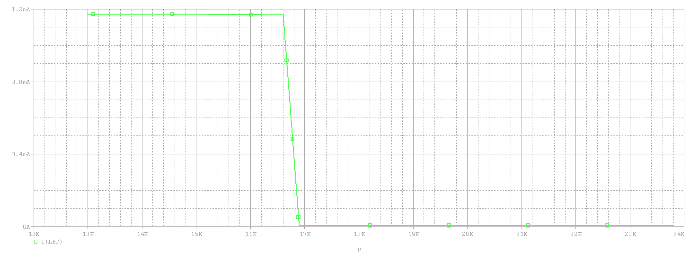

Fig. 22 LED current

## Monte-Carlo Analysis

Monte-Carlo analysis is the best way to analyze a circuit statistically and show you how it behaves when certain components vary. It also gives us an almost real picture of circuit operation in series production, where each component has a certain tolerance.

In the circuit required in the specifications, I consider that a very large influence has the resistance that sets the polarization current of the sensor, more precisely R2 in the electrical diagram of the circuit.

If we perform a Monte-Carlo simulation and set the parameter TOLERANCE = 10% for this resistance, we will see that the do menu of the voltage measured on the sensor changes (Fig. 24).

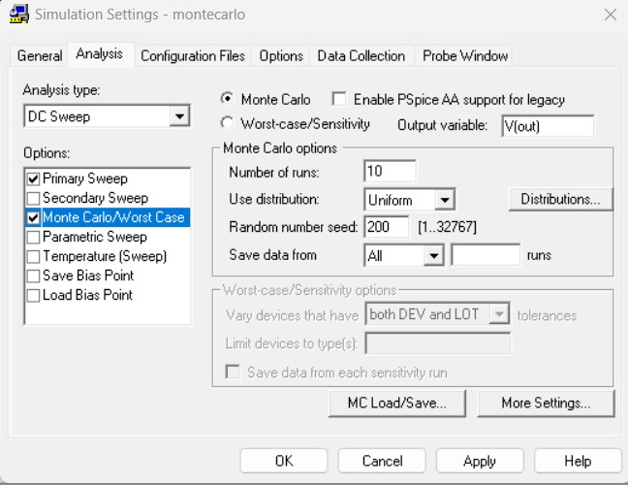

Fig. 23 Monte-Carlo simulation settings

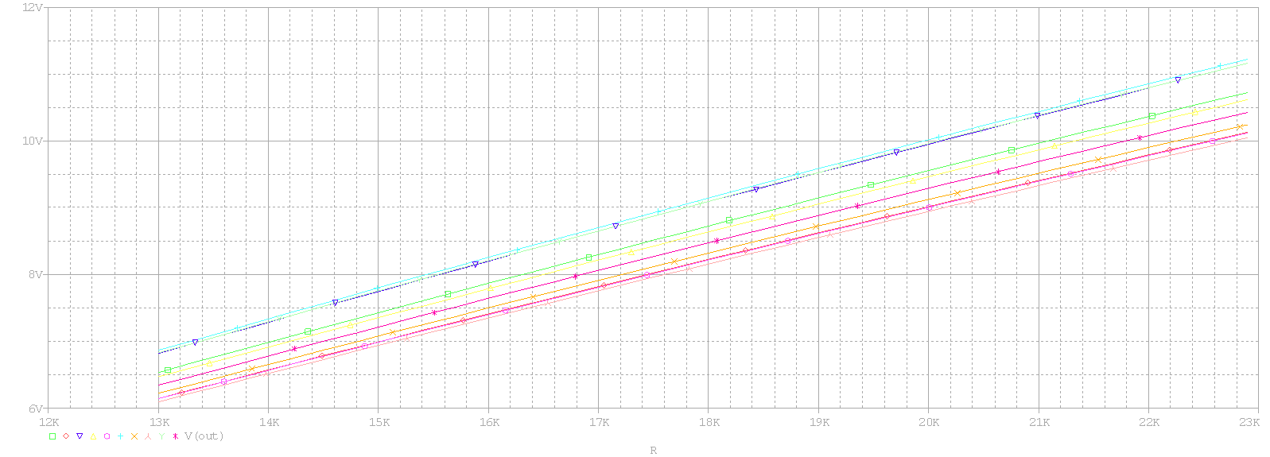

Fig. 24 Change in measured sensor voltage

The DC Sweep simulation settings are the same as in Fig. 17.

Also, the voltage range that has been converted to vary in the range

(0, VCC − 2) increased, reaching (Vcc − 0. x )[V], i.e. more than 1V dthe previous maximum. This is shown in the figure below .

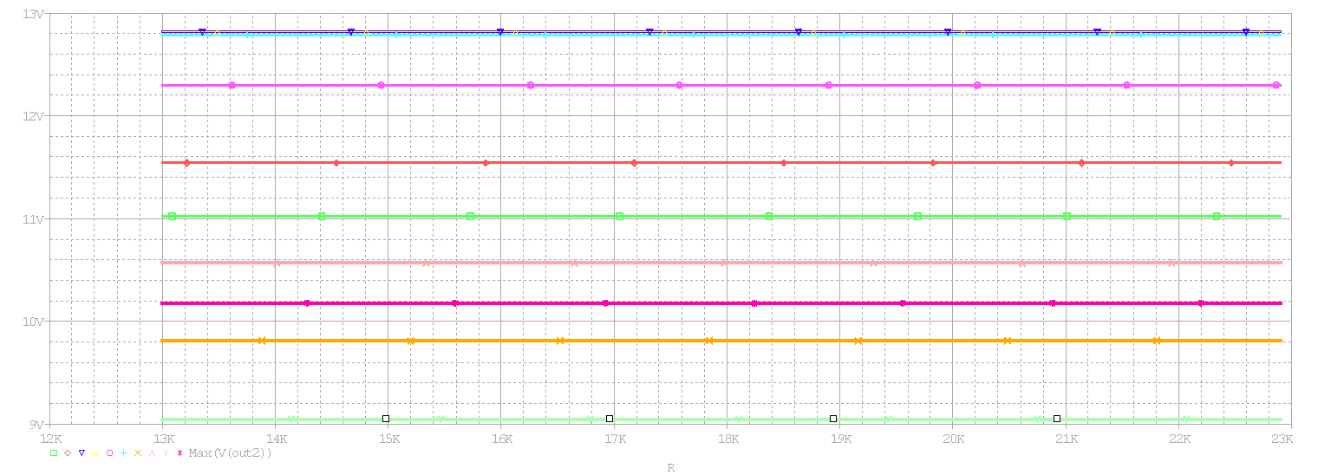

Fig. 25 Maximum voltage measured at AO-diff output doing domain conversion

## Worst-Case Analysis

This analysis shows which circuit components are critical to circuit operation. This analysis is also performed for sensor resistance.

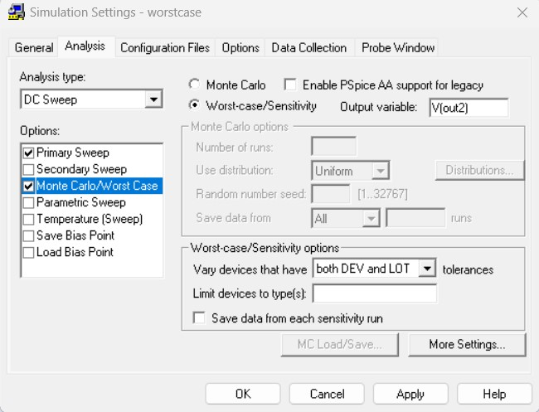

Fig. 26 Worst-Case analysis settings

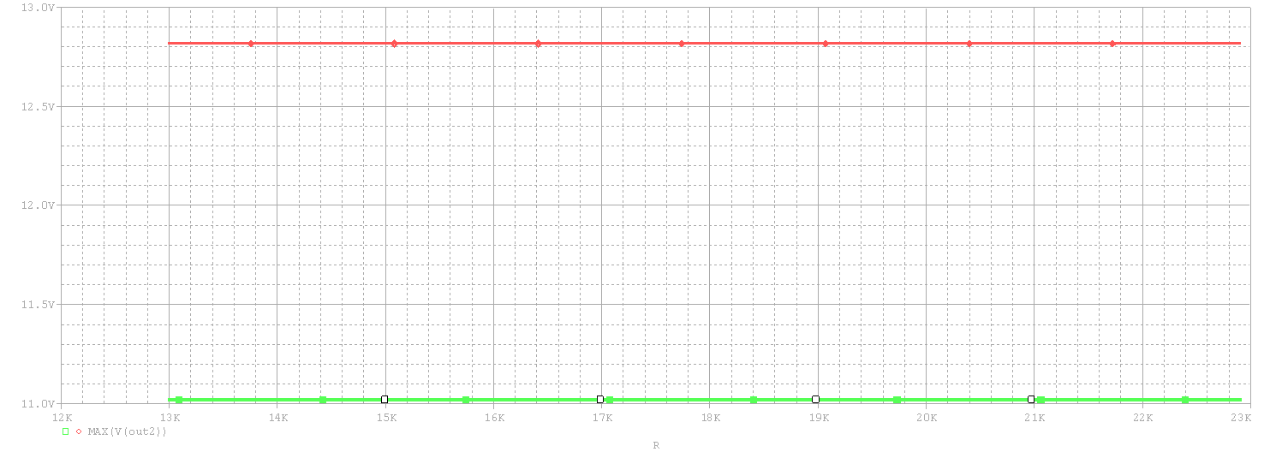

Fig. 27 Characteristic following Worst-Case analysis

In Fig. 27 it is observed how much the sensor tolerance (10% in this case) influences the maximum output voltage in the differential amplifier in Fig. 6 that performs the conversion of the voltage range.

# Bibliography

1. (2023) The IEEE website, [https://3dstar.ro/calculator-divider-voltage](https://3dstar.ro/calculator-divizor-tensiune)
2. (2023) The IEEE website, <http://www.bel.utcluj.ro/dce/didactic/cef/>
3. (2023) The IEEE website, <http://www.bel.utcluj.ro/dce/didactic/de/de.htm>
4. (2023) The IEEE website, [https://site](https://sites.google.com/site/bazeleelectronicii/home/rezistoare/2-resistor-colour-code) [s.google.com/site/bazeleelectronicii/home/rezistoare/2-resistor](https://sites.google.com/site/bazeleelectronicii/home/rezistoare/2-resistor-colour-code) [colour-code](https://sites.google.com/site/bazeleelectronicii/home/rezistoare/2-resistor-colour-code)
5. (2020) The IEEE website,<https://www.pspice.com/>
6. Laboratory tutor from CAD Techniques
7. "Q2N2222 data sheet", ETC
8. "LM741 data sheet", Texas Instruments, Texas, USA
9. "BC177 data sheet", STMicroelectronics
10. "1N5225 data sheet", General Semiconductor