

School of Physics and Astronomy
Year 3 FInal Project Report
Session 2018-2019

Name: | ---------
Student Number: | ------------
Degree Programme: | MPhys
Project Title: | Lithopanspermia
Supervisor: | -------------------
Assessor

Declaration:
I have read and understand Appendix 2 in the Student Handbook: “Some advice on the avoidance of plagiarism”.
I hereby declare that the attached report is exclusively my own work, that no part of the work has previously been submitted for assessment (although do note that material in “Interim Report” may be re-used in the final “Project Report” as it is considered part of the same assessment), and that I have not knowingly allowed it to be copied by another person.

Abstract
A model of a falling snowball was produced in Python with the Chelyabinsk impact event used as a reference in order to investigate whether life encased within a meteor could survive an impact with Earth. A map plotting meteor craters, fossils, and geological features dating from 550-450 million years ago was also produced in order to look for correlations. The aims were to explore whether life could have arrived from Venus to Earth via the process of Lithopanspermia from 550-450 million years ago. It is hoped that this could explain many of the aspects of Earth’s history of life which are not fully understood, such as the Cambrian explosion, and also the puzzling nature of the Drake equation which predicts life should be much more prevalent in our universe than it seems to be. It was found that it is likely that life could survive such an impact; the model showing behaviour very similar to the Chelyabinsk impactor. Furthermore there are many points of correlation between the fossil record and meteor impacts, as well as some between these and global mass wasting- though the correlation with global mass wasting is weak enough so that this could be simply explained by changes in the environment leading to more diversification events, rather than by L-Chondrite impacts containing life. The evidence for correlation is thus not conclusive. More changes to the code could be made in the future, such as accounting for entry angle. It is concluded that more research should be done in other areas regarding the Venus Hypothesis, such as exploring whether Venus had a reducing atmosphere during the time, necessary for abiogenesis, or whether Venus even needs to be invoked to explain the Cambrian explosion given the availability of other theories such as Oxygenation.

Introduction

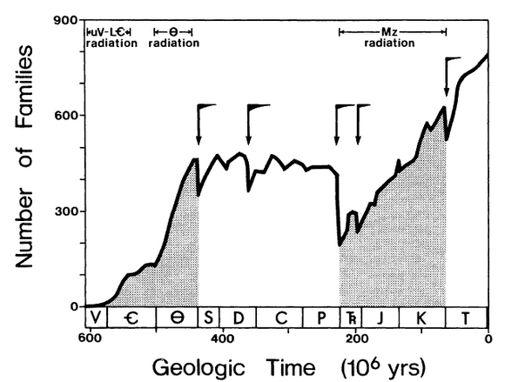
The problem of how life began on Earth has yet to be solved, and there are still plenty of mysteries regarding the evolution of life. One of the biggest problems facing our understanding of evolution has been the Cambrian explosion. Around ~540 million years ago ,the late Vendian period, there was a diversification event unparalleled in Earth’s history. In this diversification event, All 34 of the animal phyla known on Earth suddenly appear in the fossil records, with the records lacking in transitional fossils. A event occurred right after, around ~470 million years ago, known as the Great Ordovician Biodiversification Event, a continuation of the Cambrian explosion. In the Mesozoic era there was another radiation event in which no new phyla emerged, but the number of families, genus, and species increased (Erwin 1987). Both of these events are associated with intense, prolonged radiation. The Drake equation also suggests that life should be much more prevalent than it is, and this implies that there are extra conditions for life to arise that we do not yet understand.

Figure 1: Historical graph of number of families vs. geological times from 600 million years ago to the present (Erwin 1987). The uV-LE radiation period represents the Upper Vendian to Lower Cambrian, and θ the Ordovician event. The Mz period represents the Mesozoic radiation period. In all 3 periods, the number of families increased dramatically.

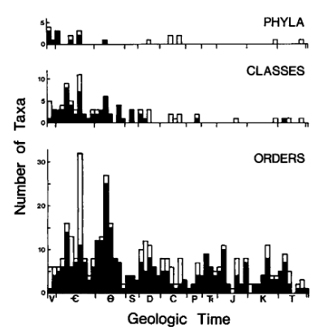

Figure 2: Historical graph of number of taxa other than family (Phyla, Class, Order) vs. Geological time (Erwin 1987). Labels still apply. Very few phyla and classes appear after the Ordovician, and the number of Orders arising during this time is far greater.
One hypothesis the explains many of these problems is the Venus Hypothesis, working through the mechanism of Lithopanspermia. The hypothesis suggests that Life had evolved on Venus and was carried over to Earth through spallated material due to an L-Chondrite meteor impact, caused by a breakup of a parent asteroid during the same time as the Cambrian explosion. This would explain the lack of transitional fossils in the record, and the ‘filling in’ of these classes during the Mesozoic would be much more easily explained by environmental changes since there is seemingly no difference in radiation. It would also mean there are more conditions for life to appear than scientists thought, making the Drake equation redundant.

According to Pollack (1979) the Venusian atmosphere may have had a reducing atmosphere in the past. If the region Venus formed in was cool enough, there could have been enough water incorporated into its formational rocks, and hence more water vapour would have formed its early atmosphere. When temperatures were lower, the CO2 content of the atmosphere could have been buffered by carbonate rocks, hence forming a reducing atmosphere. It is known that the processes that form organic compounds from inorganic compounds require a reducing atmosphere. If this were the case up to ~550 million years ago, then Venus may have had the correct conditions for life to evolve. This, combined with the increased amounts of radiation on Venus, could have lead to much more diverse life than was evolving on Earth. Had this life somehow reached Earth, it may explain the lack of transitional fossils in the record between the pre-Cambrian and the Cambrian periods. Given that Venus experiences twice the intensity of solar radiation and solar wind experienced on Earth, and given the lack of a magnetosphere, as well as very long day lengths, evolution on Venus would be much faster than on Earth.
At ~470 million years ago, the same time as the Great Ordovician Biodiversification Event, an L-Chondrite parent asteroid, an extremely large body, broke up, leading to bombardments of L-Chondrite meteorites being trapped by Earth’s gravity. The rate of impacts on Earth during this period would have increased greatly, with evidence for this in literature (Korochantseva 2007). Given records of extraterrestrial Chromite and Osmium isotopes in mid-Ordovician strata in Baltoscandia and China, along with the fossils that appear there, the two events may be linked (Schmitz 2008). Changes in environment caused by the impacts could have generated diversity in the fossil record in these areas, especially if larger projectiles were involved as literature suggests. If this were the case, we would expect to see sites of global mass wasting where L-Chondrite impacts have occurred, as (Parnell 2009) suggests. Venus would also have been impacted by these meteorites. Venusian material may have been ejected at some point during these impacts via spall ejection (Melosh 1988) and the material would contain traces of L-chondrite meteorite.
Supposing that there was life on Venus during this time, upper layer soil containing life forms could have been ejected into space this way. The spalled material would suffer much shock damage and heating, and life contained in the material, were it to reach Earth, would have to undergo prolonged radiation as well as the vacuum of space. There are multiple examples of life on Earth surviving in these conditions through anhydrobiosis; Tardigrades for 10 days (Jönson 2008), Lichen for 16 days (Sancho 2008), and Bacillus Endospores (Nicholson 2000); Dormant spores have an incredible longevity and are capable of self-repair, as well as high resistance to radiation. In the exposure to space vacuum spores can survive up to 10 days without protection, but the chances of survival are highly increased if the spores are embedded in chemical protectants such as sugars or salt crystals- with 80% surviving for 6 years in the presence of glucose. The increased day length of Venus would give an evolutionary advantage to extended hibernation periods with high resistance to extreme temperatures and levels of radiation. (Melosh 1988) suggests that upper layer Venusian soil could be ejected with enough kinetic energy to reach space, with conditions within ejected rocks being survivable for extremophiles.
105 of the 53000 meteorites on Earth have been identified as Martian in origin (Worth 2013). This demonstrates that material from other planets in the solar system can be launched into space through natural means and reach Earth. Supposing that this material reached Earth’s atmosphere and survived, it would then have to undergo entry and impact. The aim of this report is to explore this narrative through examining the fossil record, geological features of the Earth. In particular, correlation is being looked for between sites of global mass wasting, meteoric craters, and Ordovician fossils. Global mass wasting overlapping with fossils and craters would give substance to the idea that life has come to Earth through meteors in the past, whereas global mass wasting overlapping with craters would also give evidence of environmental changes due to meteors. A model of a falling snowball through Earth’s atmosphere was produced to investigate whether for whether some of the presumptions necessary for this hypothesis are realistic, such as whether life encased in a meteor could survive re-entry and impact.
In 2013 a large L-Chondrite meteor was seen exploding over Chelyabinsk, Russia, before its remnants collided with ice. This produced a 500 Kiloton airburst (Brown 2013) and contained organic compounds (Olga 2013). It produced a meteoric flare, where visible light is generated from ablation processes It is estimated that the diameter of the largest fragment was 3-5m; a crater in the ice formed with a diameter of ~6m. This meteor’s trajectory and breakup (Borovička 2013) will be used as a reference for the model in this paper as it follows clearly the 4 stages of meteor flight (Ceplecha 1998) and had a similar size to what boulders ejected from Venus would have. Furthermore there were organic compounds contained within this L-Chondrite meteor, and so it can be assumed that this would be the kind of meteor in which life would survive.

Method
A model was produced of an ice-meteorite falling to Earth. The meteorite was modelled as a sphere of ice. Euler’s method was used to calculate the position, acceleration, mass, radius, work done, pressure, temperature, and velocity, at each time step. As the meteorite fell, outer layers would become warmer and melt away, and inner layers would remain cold. There are two possibilities henceforth: either the meteorite becomes small enough so that there is no more melting and it falls to earth, or the meteorite explodes in an airburst leading to fragments falling to the ground. In the model, the drag coefficient for a sphere was estimated as 0.07 as this was found to be a reasonable value for most spheres, and also would make the model antifragile. A starting temperature of the ice of -50 degrees centigrade was used with sublimation assumed. An exponential relation between pressure and height was found, data for temperature height relations was found for up to 140000m, and energy calculations took into account kinetic, potential, and thermal energy. This model assumes instantaneous heating. Appendix 1 shows the code used.
For the iterations used in the results, a starting height of 140000m was used as this was the maximum height for height vs. temperature relations. A 1000 m/s initially velocity was used as this is a reasonable entry velocity for a meteor of this smaller size. A radius of 2m was used for the meteor initially consistent with the spall ejection predictions from Melosh (1988).
For testing meteoric-flares, the compressive strength of ice was compared to the force against the meteor and if the force was greater than the compressive strength a breakup was assumed. In the case of a breakup, the Chelyabinsk case can be referred to in which an airburst occurred and many of the fragments survived intact.
The modelling of a collision directly used data for the Chelyabinsk meteor. A large hemisphere of ice was supposed to be sublimated on impact. If the kinetic energy of the meteor was less than the energy needed to sublimate the ice, then the meteor would survive intact and be cushioned by the fall. Otherwise, it was assumed that the meteor would break up and any life inside would disintegrate. Dynamic pressure was used to this end.
A map was produced of Earth’s impact craters 550-450 Million years ago, along with fossils dated around this time as well as areas of global mass wasting produced at this time. The craters’ ages and locations were collected using the Earth Impact Database. The fossils’ ages and locations were collected using fossilmuseum, and sites of global mass wasting are cited from Parnell (2009). If there is a correlation between fossils and craters, this would give some evidence for meteors containing the life that was fossilised. Furthermore, global mass wasting sites correlating with fossils and craters would suggest that environmental changes were caused by meteor impacts during the time.

Results
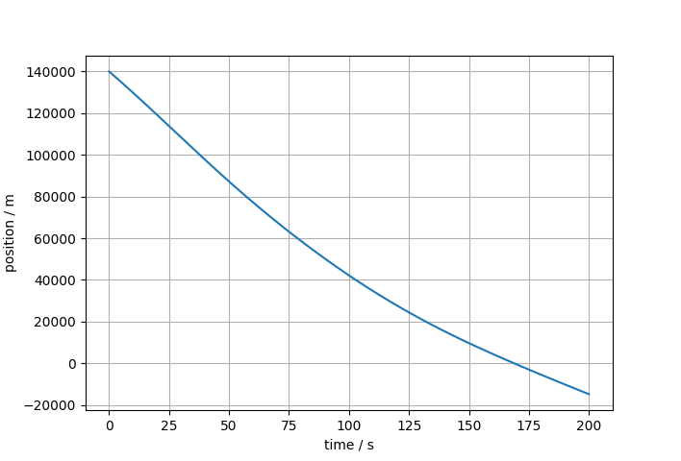
Figure 3: Graph of time against position. There is a fast initial fall followed by a decrease in speed
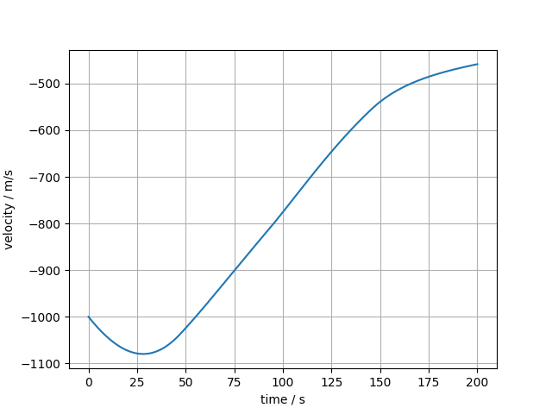

Figure 4: Graph of velocity against time. Velocity initially increases, before decreasing rapidly and then flowing off as a more terminal velocity is reached.

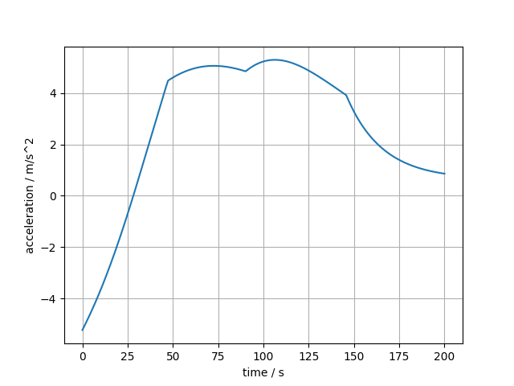
Figure 5: Graph of acceleration against time. Initially velocity increases, with acceleration constantly decreasing past 0 as the velocity begins to decrease, then there are 3 sudden blips in acceleration.

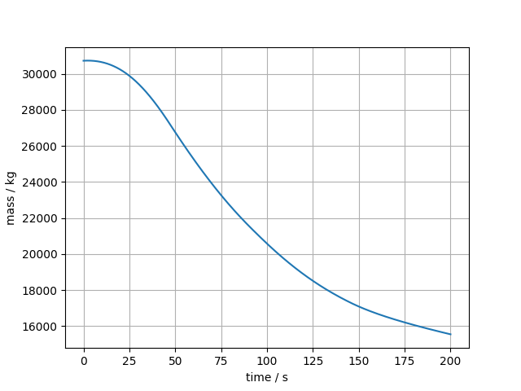

Figure 6: Graph of mass against time. Mass is consistently decreasing, with it only slowly decreasing initially, followed by a fast decrease, followed by it tapering off into a more terminal mass.
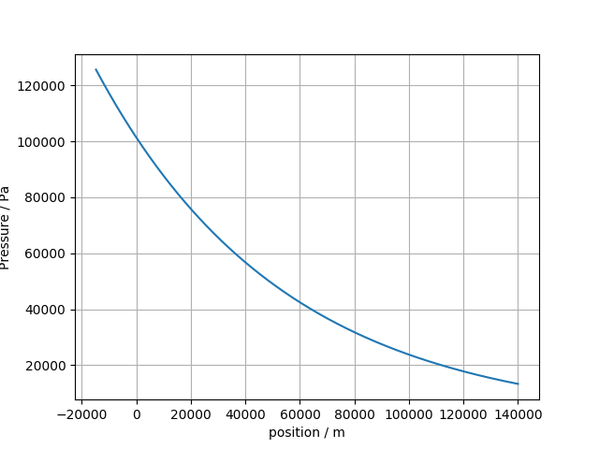
Figure 7: Graph of pressure against position. The relationship was derived from the well known exponential calculation for pressure vs. height.
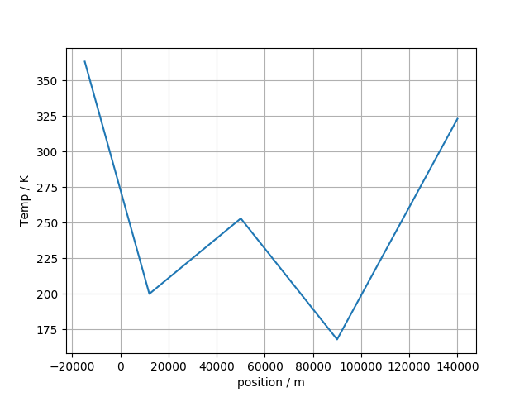
Figure 8: Graph of temperature against position. This was taken from government data for the different levels of the atmosphere. From 0 to 12000m is the troposphere, from 12000 to 50000m is the stratosphere, from 50000m to 90000m is the mesosphere, and above 90000m is the thermosphere.
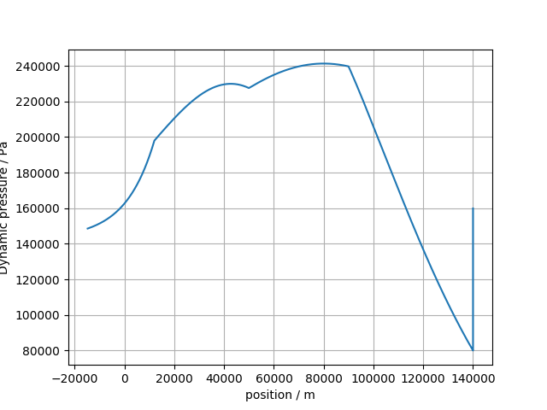
Figure 9: Graph of dynamic pressure (the measure of pressure due to fluid flow) against position. There is a strong increase in the beginning, with 3 blips as with the acceleration graph.

In the code, mass change is calculated from changes in thermal energy, which are hereby the result of changes in kinetic and potential energy. Simple well known relations of force (acceleration) and energy(mass) are used in the code.
The model shows expected behaviour: the meteorite falls over time and decelerates rapidly as mass decreases and when air resistance is very high, coming to a terminal velocity with a much reduced mass. More deceleration leads to a greater decrease in mass. In the beginning there is an increase in velocity and not much decrease in mass- this is because in higher parts of the atmosphere there is very little air resistance as shown by the pressure-height graph. The acceleration and dynamic pressure graphs show seemingly odd behaviour – but this is explained easily. The meteor breaks up during the flight, and this causes fluctuations in both acceleration and dynamic pressure of the main body. This explains why acceleration and dynamic pressure fluctuations happen at the same times. Overall the mass decreases by almost half over the duration of the flight – but this is likely to be an incorrect estimate because the meteor breaks up.

In the collision it is seen that the kinetic energy of the Chelyabinsk meteor fragment is nowhere near enough to sublimate all of the water – it would be cushioned easily by the fall.

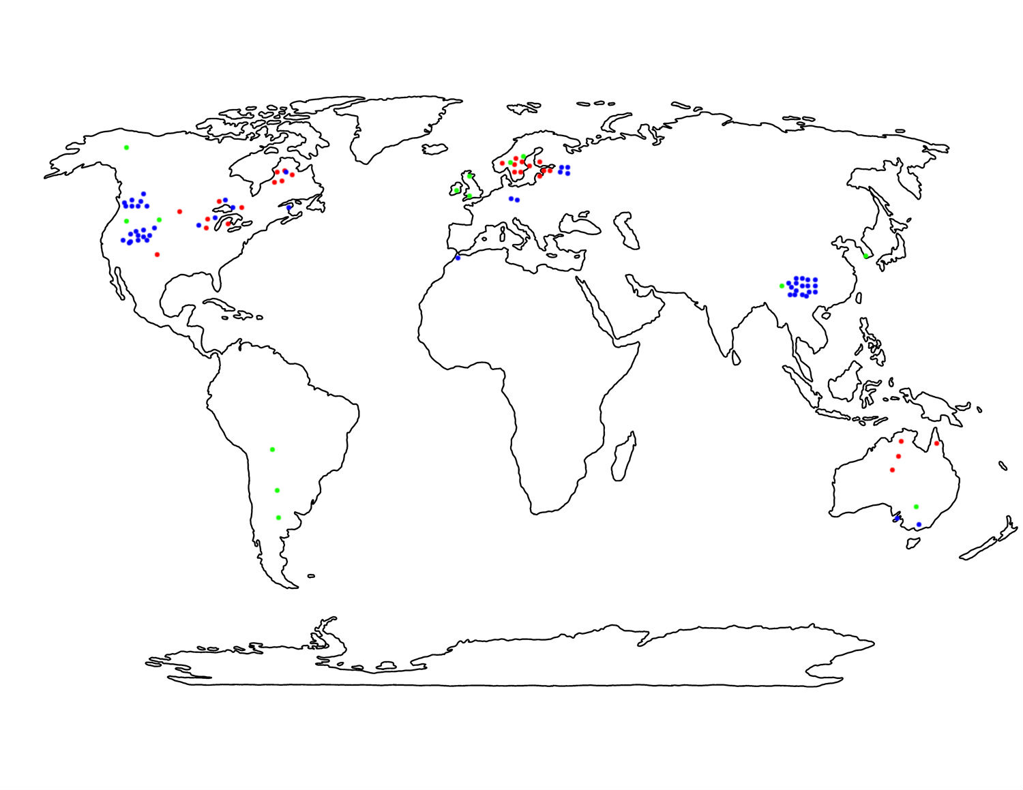
Figure 5 – Map of the world with meteor craters, global mass wasting sites, and fossils from 550-450 mya plotted on. Blue represents fossils, red represents craters, and green represents global mass wasting sites.

Discussion
The model demonstrates that, for a ‘snowball’ meteorite scenario, a 2m radius meteorite could enter Earth’s atmosphere at a high speed and yet still survive the heating upon entry. The inner layers of the meteorite would remain cool and were there life inside it would likely survive. However it would be likely to break up multiple times during the flight and fragmented meteors are hard to predict and model. The solution was to simply model the collision of the largest fragment of a similar size (the Chelyabinsk meteor fragment). This is justified by the fact that in our model, the trajectory and points of fragmentation match the Chelyabinsk event with great similarity. During the collision it was found that the fragment would easily survive, and thus it is likely that life inside a meteor of this size entering earth could survive more often than not. However this model still has issues. It does not account for meteor breakup, flaring, or different trajectories, though this information is more interesting than important. It does not affect the fact that it is almost certain that life would survive. It would also be very complex to model and thus it is probably not necessary. Instead, time would be better spent doing more research into other areas of the Venus Hypothesis, such as modelling orbits of the meteors, or investigating the capacities of extremophiles to survive space. In retrospect, the likelihood that life could survive a spall ejection is a good indicator that life can survive atmospheric re-entry.
The map shows that in North-West America / Canada and Baltoscandia meteor impacts from the period of 550-450 million years ago share the same locations as fossils from the same period which do not seem to have transitional precursors. The lack of craters in the area of China, where there are plenty of fossils may seem contradictory to the narrative, but literature shows that L-Chondrite material is found in the geological strata along with these fossils in this area, as well as in the same locations in Baltoscandia. The global mass wasting sites, theorised by Parnell (2009) to have been caused by the L-Chondrite impacts, paint a less clear picture. Many of the sites do not coincide with craters or fossils of life which supposedly would have been carried from Venus to Earth via L-Chondrite meteorites. Therefore the map does not give any reason to believe that most global mass wasting during Ordovician was caused by L-Chondrite impacts, though it may have caused some in China, North-West America / Canada, and Baltoscandia. An attempt was made to plot these sites on a map of Pangea, as Pangea would not have yet broken up on this time scale and it would be very telling if some of the clusters were close to each other (E.G., ChangJiang & North West America). However because of the lack of reliable estimates for what the geography of Pangea would have looked like, this was abandoned. It is left for the future when perhaps more accurate estimates of Pangean geography can be made.

Conclusion
There is evidence in this paper provided to show that there is a correlation between locations of meteor craters and fossils from the late Vendian-Ordovician periods as well as with some mass wasting sites. However this does not provide conclusive evidence of a link. Furthermore, though alternate hypotheses regarding the Cambrian explosion’s unprecedented increase in evolutionary complexity are not yet satisfying (E.G., the oxygenation event), it is still not conclusive that invoking Venus is necessary. Further research into the validity of other explanations for the Cambrian is necessary, and there are still many questions to be answered about the Venus Hypothesis – such as whether life would have been able to survive the travel through the vacuum of space, and whether the atmosphere of Venus really was reducing enough for life at the time. It would also be interesting to improve the ‘snowball’ model somewhat by accounting for flaring, breakup models, and different trajectories, which would affect the pressure and temperature changes in the meteor, thereby changing the rate of survival of organisms within the meteor, though this is not necessary to determine whether life would survive encased inside of the meteor.

References
- Erwin, D. H., Valentine, J. W. & Sepkoski, J. J. A Comparative-Study of Diversification Events - the Early Paleozoic Versus the Mesozoic. Evolution 41, 1177-1186, doi:Doi 10.2307/2409086 (1987)
- E.V. Korochantseva e al. L-chondrite asteroid breakup tied to Ordovician meteorite shower by multiple isochron 40 Ar- 39 Ar dating 113 Meteoritics & Planetary Science 42, Nr 1, 113–130 (2007)
- Pollack, J.B. Climate Change on the Terrestrial Planets. Icarus 37, 479-553 (1979)
- Schmitz, B. et al. Asteroid breakup linked to the Great Ordovician Biodiversification Event. Nat Geosci 1, 49-53, doi:10.1038/ngeo.2007.37 (2008)
- Melosh H.J. The Rocky Road to Panspermia. Nature 332, 687-688, doi:DOI 10.1038/332687a0 (1988)
- K. I. Jönsson, E.Rabbow, R. O. Schill, M. Harms-Ringdahl, P. Rettberg. Tardigrades surive exposure to space in low Earth conditions. Current Biology Volume 18, Issue 17, 9 September 2008, R729-R731, doi: https://doi.org/10.1016/j.cub.2008.06.048
- Leopoldo G. Sancho, Rosa de la Torre, Gerda Horneck, Carmen Ascaso, Asunción de los Rios, Ana Pintado, J. Wierzchos, M. Schuster. Lichens Survive in Space: Results from the 2005 LICHENS Experiment Astrobiology Volume 7 Issue 3 2008 doi: https://doi.org/10.1089/ast.2006.0046
- Wayne L. Nicholson, Nobuo Munakata, Gerda Horneck, Henry J. Melosh, Peter Setlow. Resistance of Bacillus Endospores to Extreme Terrestrial and Extraterrestrial Environments Microbiology and Molecular Biology Reviews Sept.2000 548-572 doi: 10.1128/MMBR.64.3.548-572.2000
- Worth, R. J., Sigurdsson, S. & House, C. H. Seeding Life on the Moons of the Outer Planets via Lithopanspermia. Astrobiology 13, 1155-1165, doi:10.1089/ast.2013.1028 (2013)
- Parnell, J. Global mass wasting at continental margins during Ordovician high meteorite influx. Nat Geosci 2, 57-61, doi:10.1038/Ngeo386 (2009).
- Borovička, J. et al. The trajectory, structure and origin of the Chelyabinsk asteroidal impactor ISSN: 0028-0836 , 1476-4687; DOI: 10.1038/nature12671 Nature. , 2013, Vol.503(7475), p.235-237
- Brown, P G. et al. A 500-kiloton airburst over Chelyabinsk and an enhanced hazard from small impactors ISSN: 0028-0836 , 1476-4687; DOI: 10.1038/nature12741 Nature. , 2013, Vol.503(7475), p.238-241
- Olga P. Popova. et al. Chelyabinsk Airburst, Damage Assessment, Meteorite Recovery, and Characterization Science 29 Nov 2013: Vol. 342, Issue 6162, pp. 1069-1073 DOI: 10.1126/science.1242642
- Z. Ceplecha et al. ISSN: 0038-6308 , 1572-9672; DOI: 10.1023/A:1005069928850 Space science reviews. , 1998, Vol.84(3-4), p.327-471

