Aws ec2 – service
Describe-instances – operation
--filters – parameter
--query – parameter
--output text – parameter
--region us-east-2 - parameter

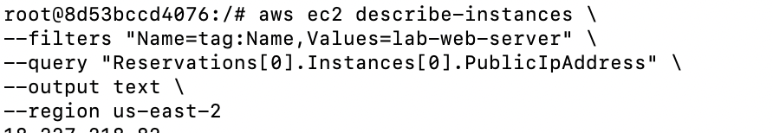

- 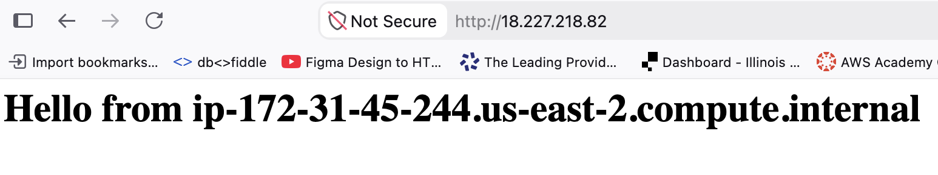
3.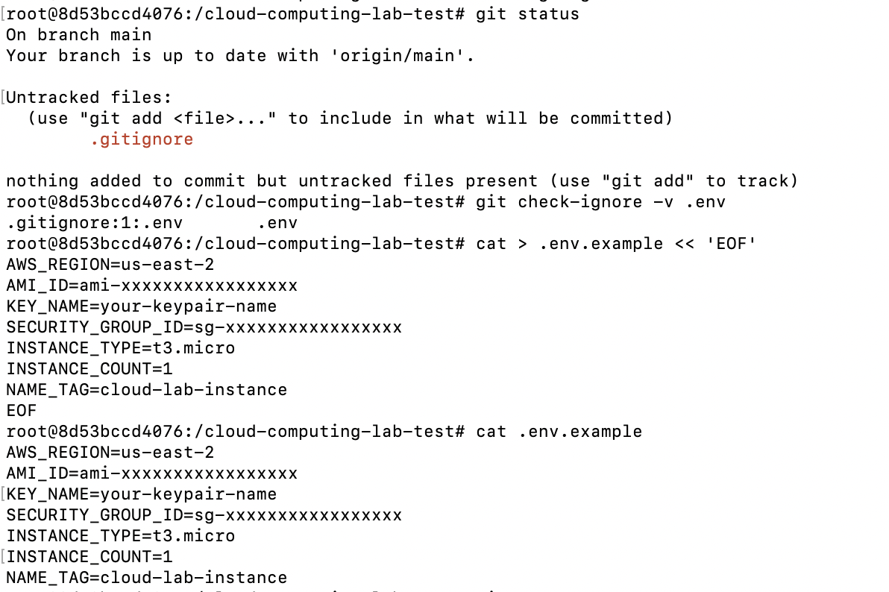
4. 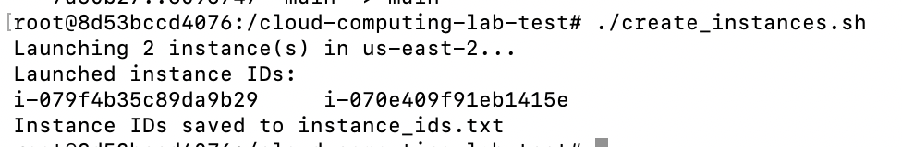
5. 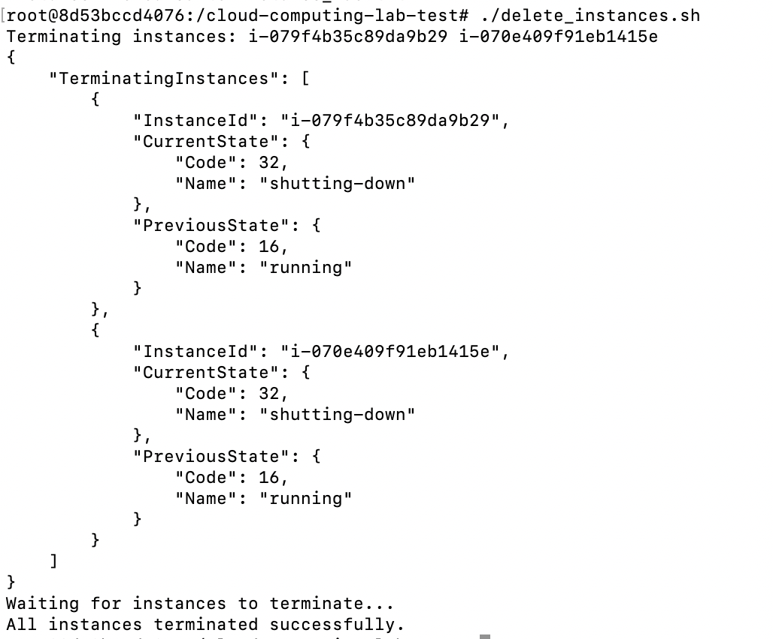

6. Reflection Question:
Environment files are excluded from git, even in private repositories, because the commits will expose secrets and secure information in the git history. Even If the repository is private it could be compromised, changed to public, or cloned somewhere else that is less secure. Creating and comitting the env.example helps to avoid confusion while keeping the files secure.

