

INVENTORY AND SALES SYSTEM FOR PAOLO
PAOLO D.A. MATTING AND ACCESSORIES

In Partial fulfillment of the requirements in IT12/L
System Integration and Architecture

Presented By:
Roque, Charles Jayson R.
Cirunay, Niño Angelo C.

Presented To:
MELJOHN V. ABORDE
IT 12/L Subject Teacher

October 12, 2026
TABLE OF CONTENTS
Chapter 1: The Company
Company Profile ………………………………………………………… | 1
Organizational Chart …………………………………………………… | 2
Business Environment ………………………………………………….. | 3
Description of the Existing System …………………………………….. | 4
Data Flow Diagram …………………………………………………….. | 9
Chapter 2: The Problem
Statement of the Problem ………………………………………………. | 11
Feasibility Study ………………………………………………………… | 13
Scopes and Limitations ………………………………………………… | 25
Chapter 3: The Solution
Methodology ……………………………………………………………. | 27
System Objectives ………………………………………………………. | 29
System Requirements …………………………………………………… | 30
Entity-Relationship Diagram ………………………………………… | 33
Use Case Diagram ……………………………………………………… | 34
Data Dictionary ………………………………………………………… | 34
Security Plan …………………………………………………………… | 38
Implementation Plan …………………………………………………… | 39
System Prototypes ……………………………………………………… | 41
Chapter 4: The Implementation
User Acceptance | 44
Results and Discussion | 45
Chapter 5: The Source Code | 46
Appendices
Appendix A Letter to the Company | 55
Appendix B Company Forms | 56
Appendix C Data Gathering Evidence | 59
Appendix D Test Plan | 61

LIST OF TABLES
Table 1. Technical Feasibility Table ………………………………….. | 14
Table 1.1. Technical Feasibility Table ………………………………... | 15
Table 2. Development Team Estimated Cost ………………………... | 16
Table 3. Hardware and Software Cost ………………………………. | 17
Table 4. Effort Cost …………………………………………………… | 17
Table 5: Project Implementation Plan ………………………………. | 18
Table 5.1: Project Implementation Plan ……………………………. | 19
Table 6: Alternative Evaluation - Operational ……………………… | 20
Table 6.1: Alternative Evaluation - Operational ……………………. | 21
Table 7: Alternative Evaluation - Technical ………………………… | 21
Table 8: Alternative Evaluation - Schedule ………………………… | 22
Table 9: Alternative Evaluation …………………………………….. | 22
Table 9.1: Alternative Evaluation …………………………………… | 23
Table 10: Alternative Evaluation …………………………………… | 24
Table 11: Non-Functional Requirements …………………………… | 32
Table 12: tbl_Sale ……………………………………………………. | 34
Table 13: tbl_Payment_Method ……………………………………. | 35
Table 14: tbl_Category ……………………………………………… | 35
Table 15: tbl_Product ……………………………………………….. | 35
Table 15.1: tbl_Product …………………………………………….. | 36
Table 16: tbl_Stock_in ………………………………………………... | 36
Table 16.1: tbl_Stock_in ……………………………………………… | 37
Table 17: tbl_Status …………………………………………………... | 37
Table 18. Hardware Requirement …………………………………… | 40
Table 19. Software Requirement …………………………………….. | 40

LIST OF FIGURES
Figure 1. Proposed Organizational Chart …………………………….. | 2
Figure 2. Context Diagram ……………………………………………... | 9
Figure 3. Level 0 Data Flow Diagram …………………………………. | 10
Figure 4: Entity relationship Diagram(ERD) …………………………. | 33
Figure 5: Use-Case Diagram …………………………………………… | 34
Figure 6: Login Window ………………………………………………... | 41
Figure 7: Dashboard ……………………………………………………. | 41
Figure 8: Point of Sale (POS) …………………………………………... | 42
Figure 9: Transaction …………………………………………………… | 42
Figure 10: Inventory ……………………………………………………. | 43
Figure 11: Database Backup and Restore …………………………….. | 43

Chapter 1 :
THE COMPANY

Company Profile

Established in 2021 as a joint enterprise by Mr. and Mrs. Pabelonia, the business was founded with the primary goal of achieving long-term financial stability to reliably support their family's daily needs and future aspirations. Operating within the automotive aftermarket industry, the company built its reputation around a highly focused core specialization: retail sales of essential car accessories and custom floor matting services designed to enhance vehicle functionality, driver comfort, and interior protection.

Driven by strong initial success and consistent customer demand, the business continues to actively pursue expansion by scaling up its inventory capacity and broadening its commercial reach. Mr. and Mrs. Pabelonia are continually sourcing and introducing new product lines directly related to auto care, safety, and customization, allowing them to better serve their growing clientele and ensure the long-term sustainability of their family business.

Paolo Paolo D.A. Matting and Accessories operates in the automotive aftermarket industry. Its primary activities include the retail sale of car accessories and custom floor matting services. The business serves customers through its physical storefront and online sales channels. Retail sale of car accessories and related automotive products. Custom floor matting and fitting services for customer vehicles. Online selling and order fulfillment for products sold through digital platforms. Packaging and dispatch of online customer orders through courier services.

Organizational Chart
Paolo Paolo D.A. Matting and Accessories have a triangle like format, the owner handles the cashiery, inventory and other stuffs, the Accessory Installer and the Packer handles the labors, The accessory installer handles the matting of the cars, meanwhile the packer handles the packaging of products sold online.

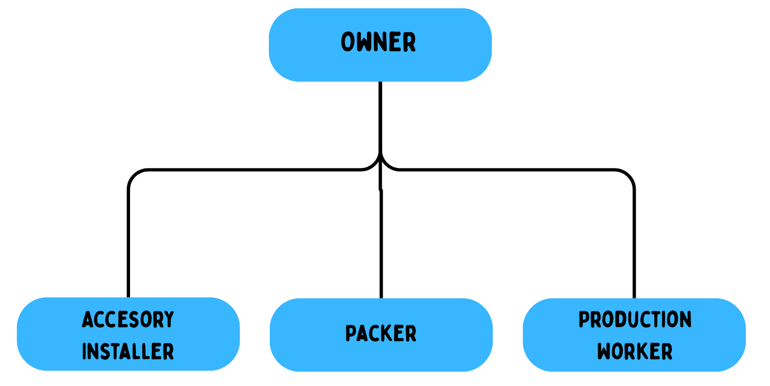
Figure 1. Proposed Organizational Chart
Roles and Responsibilities

The Owners maintain overall authority and directly manage the daily operations of Paolo Paolo D.A. Matting and Accessories. Their responsibilities include monitoring monthly sales performance, tracking and verifying inventory levels, communicating with suppliers, managing purchasing and procurement, reviewing business expenses, and handling employee payroll.

The Accessory Installer is responsible for fitting and securely installing matting and accessories inside customer vehicles. The employee performs preliminary checks, ensures accurate placement, takes care of the customer's vehicle during installation, and conducts final quality inspections.

The Packer is responsible for preparing and securely packaging merchandise sold through online channels. The employee verifies order contents against the order or invoice information, checks item condition before packaging, applies protective materials, and prepares orders for courier dispatch.

The Production Worker is responsible for measuring, cutting, shaping, customizing, and checking raw matting materials. If this role is not a current employee, it should be treated as a proposed or future role rather than included as one of the company's current two employees.

Business Environment
Paolo Paolo D.A. Matting and Accessories is a family-managed automotive aftermarket business that sells car accessories and provides custom floor matting services. Established in 2021, the business is managed by Mr. and Mrs. Pabelonia, who oversee its daily operations, including sales transactions, inventory monitoring, purchasing, financial transactions, and employee supervision.
The business operates through a physical storefront while also maintaining an existing online selling channel. At the physical storefront, customers may purchase available car accessories or request custom floor matting services. For custom matting services, the Accessory Installer prepares, fits, and installs the appropriate matting materials based on the customer's vehicle and requirements. Payments for storefront purchases and services are processed directly at the store.
The business also conducts online selling activities separately from its physical storefront operations. Online orders are handled through the company's existing online selling process, where products are prepared and packaged by the Packer before being dispatched through available courier services. Since the online store already uses an existing system, its online sales transactions, order processing, packaging, and courier activities are separate from the physical storefront operations addressed by the proposed system.
Products sold by Paolo Paolo D.A. Matting and Accessories are acquired from different wholesale stores and suppliers rather than from a single fixed supplier. The owners compare product prices, availability, and condition before purchasing items for the business. Newly acquired products are physically inspected and counted before being placed on store shelves or in designated storage areas. Products with low remaining quantities are identified by the owners for future replenishment.
The daily operations of the physical storefront involve the owners and authorized employees working together to serve customers and maintain available products. The owners supervise the overall business operations and monitor sales and inventory, while the Accessory Installer performs the physical fitting and installation of car accessories and custom floor matting. Although the business also performs purchasing, online selling, packaging, and other operational activities, the proposed system will focus specifically on supporting the physical storefront through Inventory, Sales, Reports, Security, and Backup and Recovery.
Description of the Existing System
Inventory
The inventory process begins with the owner checking the automotive parts and products displayed on the store shelves and kept in storage. These include engine oil, oil filters, air filters, wiper blades, steering wheel covers, and ready-made vehicle floor mats. The owner manually counts the remaining items by piece to determine product availability and identify products that require replenishment. For packaged engine oil, each bottle or container is counted as one piece. Once additional stock is needed, the owner visits suppliers and wholesale establishments, particularly in Uyanguren, to purchase the required products.
When purchasing products in person, the owner checks whether their descriptions and specifications match the items needed by the store. For engine oil, the inspection includes the brand, oil grade, container size, and condition of the packaging. For automotive parts and accessories, the owner checks the product type, size, and vehicle compatibility where applicable. Products are also inspected for visible damage, leaks, broken seals, or missing components. Only products that meet the required specifications and are in acceptable condition are purchased.
For products purchased online, the owner checks different online marketplaces for availability and reviews the product descriptions, specifications, quantities, and prices before placing an order. Upon delivery, the owner examines the package for visible damage or signs of tampering. Before opening it, the owner takes photographs and records the unpacking process to document the condition of the package and its contents upon arrival.
After opening the package, the owner compares the delivered products with the order confirmation or supplier’s invoice. This serves as the basis for checking whether the product descriptions, quantities, and specifications match the order. The owner also inspects the items for damage or defects. If products are incorrect, incomplete, or damaged, the owner contacts the seller to request a replacement or resolve the discrepancy. If a suitable replacement cannot be provided, the owner requests a refund. Products that match the order and are in acceptable condition are accepted for storage or display.
Before placing accepted products on the shelves or in storage, the owner manually counts them piece by piece and compares the actual quantities with the purchasing records. The accepted quantities are then recorded manually to update the available inventory. Although physical inspection remains necessary, repeated counting and manual record updates make it time-consuming to determine current stock levels and identify products that need replenishment.

Sales
Paolo Paolo D.A. Matting and Accessories conducts sales through its single physical branch and online selling channels. Physical-store transactions are handled by the Owner or Cashier, while the Accessory Installer performs custom matting and installation work. Online orders involve the Owner and Packer. Physical-store sales are processed through direct communication with customers, manual calculations, paper sales documents, and handwritten transaction records.
For physical-store product sales, the customer identifies the required automotive part or accessory, such as engine oil, an oil filter, an air filter, a wiper blade, a steering wheel cover, or a ready-made vehicle floor mat. The customer specifies the quantity and applicable product requirements. For engine oil, these may include the brand, oil grade, and container size. For other parts and accessories, the product type, size, and vehicle compatibility are clarified where applicable. The Owner or Cashier physically checks the shelves and storage area to confirm availability. If the requested product is unavailable, the customer is informed. If it is available, the item is retrieved and its quantity and selling price are confirmed.
The Owner or Cashier manually calculates the purchase total by multiplying each product’s quantity by its unit price and adding the resulting amounts. The customer pays through cash or GCash. For cash payments, the Owner or Cashier counts the money received and compares it with the amount due. If the payment exceeds the purchase total, the corresponding change is calculated and returned. For GCash payments, the Owner or Cashier checks the received transaction in the designated account and matches its amount and reference number with the customer’s payment details before completing the sale. GCash provides an inbox and transaction history for checking transactions. GCash transaction guidance
After payment verification, the purchased products are released and the appropriate sales document is issued. The transaction is manually recorded using the sales document and order log. The sales document identifies the transaction date, document number, product description, quantity, unit price, amount per item, and total amount. These fields follow the structure illustrated in the BIR’s published invoice examples. BIR sample invoices Payment information, including the payment method, cash received, change, or GCash reference number, is recorded in the corresponding transaction record.
Custom vehicle matting services follow a separate process. The customer provides the vehicle make, model, and year, together with the preferred matting material, color, and areas to be covered. The Owner or Cashier confirms the requested work, checks the availability of the necessary materials, and explains the agreed price. The Accessory Installer measures or adjusts the matting to fit the vehicle and performs the required fitting and installation. Upon completion, the installed matting is checked for fit and placement before the vehicle is returned to the customer.
The Owner or Cashier handles payment for the matting service using the same cash or GCash verification procedure. The service transaction is manually documented by recording the date, description of the work performed, agreed amount, and payment information. Vehicle specifications and customization instructions are maintained in the order log when needed to identify the customer’s requirements.
For online sales, the customer places an order through Shopee. The Owner reviews the requested product, specifications, and quantity and checks stock availability before preparing the order. The Packer retrieves the ordered items, compares them with the order details, checks their condition, and applies suitable protective packaging. The completed package is handed over to a courier, such as J&T Express, for delivery. Online payment and delivery arrangements are handled through the existing online selling process.
After a completed product sale, the Owner manually updates the inventory records by deducting the quantity sold. For example, if ten bottles of engine oil are available and a customer purchases two, the recorded remaining quantity becomes eight. Physical-store transactions therefore require separate tasks for checking availability, calculating totals, verifying payments, preparing sales documents, recording transactions, and updating stock quantities. Retrieving a previous sale also requires locating its paper document or handwritten entry. These repeated recording and searching activities can delay sales recording and transaction retrieval.

Reports and Financial Records
The reporting process is performed by the Owner as part of the monthly review of the business. At the end of each month, the owner gathers and reviews the available sales records, inventory information, and expense records to summarize the overall condition and performance of the business.
The Owner reviews the sales transactions recorded throughout the month, including sales from the physical store and online selling channels. The owner summarizes the total products sold and the corresponding sales amounts to determine the business's total sales for the month. The Owner checks the remaining products on the store shelves and in storage and summarizes the available inventory at the end of the month. The owner reviews the quantities of the remaining items to determine which products are still in stock and how much inventory remains after the month's sales.
The Owner reviews the expenses incurred during the month, including the costs of purchasing additional inventory and other operational expenses. These expenses are consolidated with the sales information to determine the amount spent by the business during the month. After summarizing the monthly sales and expenses, the Owner calculates the current profit of the business. The owner compares the total sales for the month against the inventory acquisition costs and other recorded operating expenses to determine the remaining profit for the period.
The Owner reviews the summarized sales, remaining inventory, expenses, and current profit to assess the business's performance for the month. The monthly review provides the owner with an overview of how much the business sold, what products remain available, how much was spent, and the current profit generated during the period After completing the monthly review, the Owner prepares a Monthly Report containing the summarized information gathered from the business records. The report presents the total monthly sales, products sold, remaining inventory on the shelves and in storage, inventory acquisition costs, operating expenses, and current monthly profit. The Monthly Report serves as a consolidated summary of the business's activities and financial performance for the month. It allows the owner to review the amount of sales generated, the quantity of products remaining, the expenses incurred, and the current profit in one report rather than reviewing each physical receipt, manual sales record, inventory count, and digital order log separately.
Data Flow Diagram

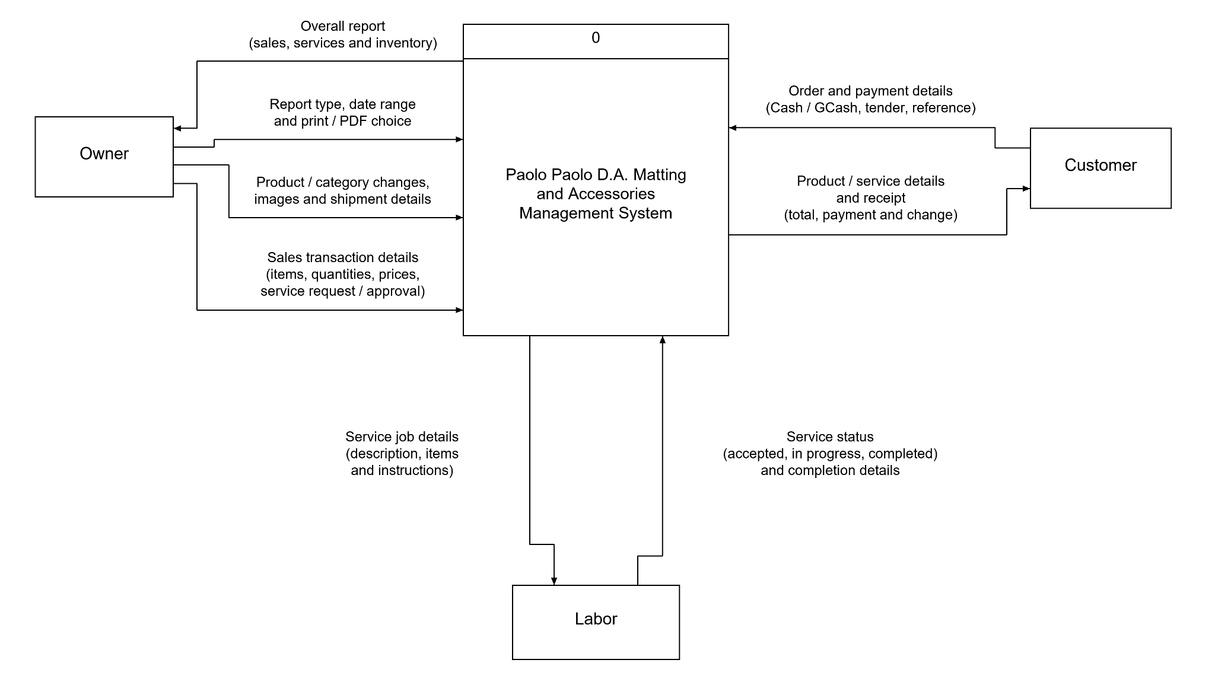
Figure 2. Context Diagram

Figure 3. Level 0 Data Flow Diagram

Chapter 2 :
THE PROBLEM
This chapter discusses the problems in manual inventory monitoring, sales recording, and report preparation at Paolo Paolo D.A. Matting and Accessories. It also presents the feasibility, scope, and limitations of the proposed Inventory, Sales, and Reporting System.

Statement of the Problem
Paolo Paolo D.A. Matting and Accessories relies primarily on manual procedures in managing the inventory, sales transactions, and business reports of its physical storefront. Sales transactions are recorded using paper receipts and manual records, inventory is monitored through physical checking and counting, and business reports are prepared by gathering and calculating information from separate records. Although the business also operates an online store, its online operations already utilize an existing system and are therefore not included in the problems addressed by the proposed system. The owners rely on manual records to monitor the transactions and activities occurring within the physical storefront. As these records are manually created, maintained, and reviewed, the current procedures can result in tedious inventory monitoring, delayed sales recording and transaction retrieval, and tedious preparation of business reports. Based on these conditions, the following problems were identified:

1. Tedious process in Inventory Monitoring
The owners monitor automotive parts and products, including engine oil, car accessories, and matting products, by physically checking and counting items on shelves and in storage. Incoming quantities and quantities sold are recorded manually to update available stock. Determining the current quantity of a product requires checking the physical items and reviewing the corresponding records. These repeated counting and recording activities make it time-consuming to establish stock availability and identify products requiring replenishment. Physical inspection of incoming items remains necessary to verify their quantity and condition.

2. Delayed in Sales Recording
Physical-store sales involve manually calculating transaction totals, preparing receipts, recording sales details, and updating inventory quantities after each completed transaction. Maintaining sales and stock information through separate manual entries requires repeated recording and checking. When previous transaction details are needed, the owners must locate and review the corresponding paper receipts or handwritten records. These procedures can delay the recording of completed sales and the retrieval of information needed to verify earlier transactions.

3. Tedious Business Report Preparation
The owners prepare storefront sales and inventory reports by gathering information from paper receipts, handwritten sales records, and physical stock counts. Sales amounts and quantities sold must be manually summarized, while inventory records must be compared with the remaining products on shelves and in storage. Consolidating and checking these separate sources requires additional time and effort before the owners can review the store’s performance and stock position. Manual transcription and calculation also create opportunities for omitted transactions, incorrect totals, and inconsistencies in the resulting reports.

These identified problems show that the physical storefront operations of the company rely heavily on manual recording, physical inventory verification, separate transaction records, and manual calculations. While these procedures allow the physical store to perform its daily activities, they can make inventory monitoring tedious, cause delays in managing and retrieving sales transactions, and make the preparation of business reports time-consuming.

Therefore, there is a need for a computerized management system that can centralize and organize the physical storefront's inventory and sales records while reducing repetitive manual recording and calculations. The proposed Paolo Paolo D.A. Matting and Accessories Management System aims to improve the efficiency, accuracy, organization, security, and accessibility of storefront business information. The proposed system will focus on Inventory, Sales, Reports, Security, and Backup and Recovery.

Feasibility Study

Operational Feasibility
The proposed system is operationally feasible because it is designed around the existing physical storefront operations of Paolo Paolo D.A. Matting and Accessories. The system will support the activities performed by the owners and authorized users in managing storefront sales, inventory, and business reports while reducing repetitive manual recording and calculations.
The owners will be able to monitor available stock quantities, record incoming inventory, process storefront sales transactions, retrieve previous transaction records, and generate sales and inventory reports through a centralized system. Completed sales transactions will automatically update the corresponding inventory quantities, reducing the need to manually update separate inventory records after each sale.
The system will also provide security through user authentication and access control to help prevent unauthorized access to business records. Backup and recovery functionality will be provided to help protect stored system data and allow records to be restored when necessary. The owners and intended users have expressed willingness to undergo training and learn how to operate a computer-based system. This supports the operational readiness of the business to adopt the proposed solution. The company's online store will not be integrated into the proposed system because its online operations already utilize an existing system.

Technical Feasibility
The proposed system is technically feasible because the business can use a standard desktop or laptop computer capable of running the management application and its database. The proposed solution will use accessible technologies and will avoid unnecessary technical complexity.
The proposed technology stack includes PHP 8.2, MySQL, XAMPP, and standard computer hardware. The system will use a centralized database to store and manage information related to storefront sales, products, inventory, user accounts, and other records required for report generation.
The system will also implement user authentication and access control to restrict system access to authorized users. Database backup and recovery functionality will be provided to help protect business records from accidental data loss and allow stored information to be restored when necessary.
Basic system orientation and documentation will be provided to help the owners and authorized users understand and operate the software.

Table 1. Technical Feasibility Table
Technical component | Available technology or specification | Feasibility assessment
Computer hardware | AMD A10-9700, 7535HS, 15.2 GB usable RAM, approximately 104 GB free storage | Available for developing and running the system locally.
Operating system | Windows 11, 64-bit | Supports the current application and database setup.
Application framework | Laravel 13 with PHP 8.5 | Available and used to implement inventory, sales, and reporting functions.
Table 1.1. Technical Feasibility Table
Database | Microsoft SQL Server Express; database named it12 | Installed locally; database connectivity has been verified.
Database drivers | Microsoft ODBC Driver and PHP SQLSRV/PDO_SQLSRV extensions | Available through the project’s PHP launcher.
User interface | Laravel Blade, Tailwind CSS, and Alpine.js | Supports browser access with locally stored interface assets.
Local operation | Local application server started through start.bat | Core system functions can operate without internet access when the local server and database are running.
Reports and backups | PDF report generation and local database backups | Supported by the existing project. Internet is required for Google Drive uploads.
Development tools | Composer, Node.js, npm, and Git | Support dependency installation, interface builds, and source management.
Service and labor features | Included in the proposed data flow diagram | Additional implementation and testing are required.
source:https://learn.microsoft.com/en-us/sql/sql-server/install/hardware-and-software-requirements-for-installing-sql-server-2025
source:https://laravel.com/framework/docs/13.x/deployment
source:https://learn.microsoft.com/en-us/sql/connect/php/system-requirements-for-the-php-sql-driver

Economic Feasibility
The proposed system requires an initial investment for system development, computer hardware, software environment, user training, and other project-related expenses. However, the system is expected to reduce the time and effort required for manual storefront record-keeping, inventory monitoring, sales transaction retrieval, and business report preparation.
Because the proposed system focuses specifically on the physical storefront, its functions will be limited to the essential requirements of Inventory, Sales, Reports, Security, and Backup and Recovery. Limiting the system to these essential functions avoids unnecessary development complexity and helps keep the proposed solution appropriate for the current operational needs of the business.

Table 2. Development Team Estimated Cost
Human Resource | No. | Rate/Hour | Hours | Total Amount
Programmer / Web Developer | 1 | Php 270.00 | 480 | Php 129,600.00
Project Manager / System Analyst | 1 | Php 330.00 | 480 | Php 158,400.00
TOTAL |  |  | 960 | Php 288,000.00
Source: https://www.stackspace.co/blog/custom-software-cost-philippines-2026-guide

Table 3. Hardware and Software Cost
Hardware / Software | Qty. | Price | Total
Computer package (AMD A320 motherboard, AMD A10-9700, 8GB DDR4 RAM, 15.6-inch LED monitor, A4Tech keyboard and mouse, 500W AVR, computer table) | 1 | Php 16,500.00 | Php 16,500.00
Thermal Receipt Printer | 1 | Php 4,500.00 | Php 4,500.00
Windows 11 Pro | — | Included | —
XAMPP | — | No Additional Cost | —
MySQL | — | No Additional Cost | —
PHP | — | No Additional Cost | —
Composer | — | No Additional Cost | —
Google Chrome | — | No Additional Cost | —
TOTAL SPECIFIED COST |  |  | Php 21,000.00
Source: https://davaocomputer.com/store/products/intel-packages-ssd/
Source: https://www.carousell.ph/thermal-receipt-printer/q/

Table 4. Effort Cost
Activity | Cost
Meeting Meals (Php 150/pax × 5 meetings × 2 persons) | Php 1,500.00
Printing Cost | Php 1,000.00
Transportation | Php 1,600.00
TOTAL AMOUNT | Php 4,100.00

Schedule Feasibility
The proposed system is schedule-feasible because its development will follow an Agile Iterative Development Approach, where the system will be developed progressively through multiple versions. Instead of developing all system functions simultaneously, each version will focus on implementing and improving specific functions of the system.
Each iteration will involve planning, design, development, testing, review, and refinement. Completed functions will be evaluated before proceeding to succeeding versions, allowing identified errors, user feedback, and necessary improvements to be addressed throughout development.

The development will progressively cover the five major areas of the proposed system: Inventory, Sales, Reports, Security, and Backup and Recovery. Earlier versions will establish the fundamental system functions, while succeeding versions will integrate additional functions and improve previously developed features until the final system is completed.

Table 5. Project Implementation Plan
Activities | Weeks |  |  |  |  |  |  |  |  |  |  |  | Responsibility
Activities | 1 | 2 | 3 | 4 | 5 | 6 | 7 | 8 | 9 | 10 | 11 | 12 | Responsibility
Planning |  |  |  |  |  |  |  |  |  |  |  |  | Project Manager  (90 Hrs)
Requirements Gathering |  |  |  |  |  |  |  |  |  |  |  |  | Project Manager  (90 Hrs)
Analysis |  |  |  |  |  |  |  |  |  |  |  |  | Project Manager  (90 Hrs)
System Design |  |  |  |  |  |  |  |  |  |  |  |  | Programmer  (80 Hrs)
Table 5.1. Project Implementation Plan
Activities | Weeks |  |  |  |  |  |  |  |  |  |  |  | Responsibility
Activities | 1 | 2 | 3 | 4 | 5 | 6 | 7 | 8 | 9 | 10 | 11 | 12 | Responsibility
Development |  |  |  |  |  |  |  |  |  |  |  |  | Programmer  (320 Hrs)
Testing |  |  |  |  |  |  |  |  |  |  |  |  | Programmer  (80 Hrs)
Implementation |  |  |  |  |  |  |  |  |  |  |  |  | Project Manager  (50 Hrs)
Documentation |  |  |  |  |  |  |  |  |  |  |  |  | Project Manager  (160 Hrs)

Discussion of Alternatives

Alternative 1: Continue Using the Existing Manual System
The first alternative is to continue using the existing manual procedures for the physical storefront, including paper-based sales receipts, manual sales records, and physical inventory counting. This option requires no additional technology investment or software training. However, it retains the current challenges involving tedious inventory monitoring, delayed sales recording and transaction retrieval, tedious business report preparation, and dependence on manually maintained records..

Alternative 2: Use Separate Digital Tools
The second alternative is to use separate digital tools, such as spreadsheets or standalone applications, for storefront sales, inventory, and report preparation. This approach can reduce some manual calculations and provide digital records. However, using separate tools may result in duplicated data entry and difficulty maintaining consistent information because sales, inventory, and reports are not maintained within one centralized system.

Alternative 3: Implement the Proposed Management System
The third alternative is to implement the proposed Paolo Paolo D.A. Matting and Accessories Management System for the company's physical storefront. The system will provide an integrated computerized solution for Inventory, Sales, Reports, Security, and Backup and Recovery.
Storefront sales transactions will be connected with inventory records so that completed sales can automatically update available stock quantities. Recorded sales and inventory information will serve as the basis for generating business reports. User authentication and access control will protect system functions and records, while backup and recovery functionality will provide additional protection against accidental data loss.
This alternative provides a centralized approach to managing the physical storefront without replacing or interfering with the company's existing online selling system.
Table 6. Alternative Evaluation - Operational
Criteria | Weight | First Alternative | Second Alternative | Third Alternative
Operational Feasibility | 50% | Continue using paper receipts, manual sales records, and physical inventory counting. This requires no new computerized system but retains tedious inventory monitoring, delayed sales recording and retrieval, and tedious report preparation. | Use separate digital tools such as spreadsheets for storefront sales and inventory. This reduces some manual recording but requires separate files and does not provide full integration between sales, inventory, reporting, security, | Implement the proposed Paolo Paolo D.A. Matting and Accessories Management System for the physical storefront. The system centralizes storefront sales, inventory monitoring, business reports, user security, and database backup and recovery into one
Table 6.1. Alternative Evaluation - Operational
Criteria | Weight | First Alternative | Second Alternative | Third Alternative
Operational Feasibility | 50% | Score: 50  Weighted Score: 25% | and backup.  Score: 75  Weighted Score: 37.5% | integrated workflow.  Score: 100  Weighted Score: 50%

Table 7: Alternative Evaluation - Technical
Criteria | Weight | First Alternative | Second Alternative | Third Alternative
Technical Feasibility | 20% | Rely entirely on existing paper logs, physical order receipts, and manual record-keeping without requiring hardware or software additions.  Score: 80  Weighted Score: 16% | Utilize generic spreadsheet applications or standalone desktop software running on basic office computers without a centralized database backend.  Score: 85  Weighted Score: 17% | Implement the system using PHP 8.5 with a MySQL database on XAMPP, running on standard PC hardware with a thermal receipt printer and Windows 11 Pro. Tailored to the staff's basic technical skill level with hands-on training.  Score: 100  Weighted Score: 20%

Table 8: Alternative Evaluation - Schedule
Criteria | Weight | First Alternative | Second Alternative | Third Alternative
Schedule Feasibility | 10% | Immediate availability as current manual processes are already in place, requiring less than a week for basic paper tracking adjustments.  Score: 95  Weighted Score: 9.5% | Initial setup, spreadsheet customization, and orientation for staff takes approximately 2 weeks.  Score: 85  Weighted Score: 8.5% | Full system analysis, design, development, testing, implementation, and documentation completed within a structured 12-week development schedule.  Score: 90  Weighted Score: 9%

Table 9: Alternative Evaluation
Criteria | Weight | First Alternative | Second Alternative | Third Alternative
Operational Feasibility | 50% | Score: 50  Weighted Score: 25% | Score: 75  Weighted Score: 38% | Score: 100  Weighted Score: 50%
Technical Feasibility | 20% | Score: 80  Weighted Score: 16% | Score: 85  Weighted Score: 17% | Score: 100  Weighted Score: 20%
Schedule Feasibility | 10% | Score: 95  Weighted Score: 9.5% | Score: 85  Weighted Score: 8% | Score: 90  Weighted Score: 9%
Table 9.1: Alternative Evaluation
Criteria | Weight | First Alternative | Second Alternative | Third Alternative
Economic Feasibility | 20% | Present-value benefit: None  Present Cost-Value: None  Pay-off years:  Immediate  Score: 100  Weighted Score: 20% | Present-value benefit: Low  Present Cost-Value: Php 5,000.00  Pay-off years:  6 months  Score: 85  Weighted Score: 17% | Present-value Benefit: High operational time savings and error reduction  Present Cost-value: Php 313,100.00 (Dev: Php 288,000.00, Hardware/Software: 21,000, Effort: 4,100)  Pay-off years: 1.5 - 2 years (systems ROI)  Score: 90  Weighted Score: 18%
Total | 100% | 70.5% | 80.0% | 97.0%
Rank |  | 3 | 2 | 1

Table 10: Alternative Evaluation
Alternatives | Short Term Benefit | Long Term Benefit
First Alternatives | No system development time or learning curve required for staff | Zero software development and IT maintenance costs
Second Alternatives | Quick transition to basic digital order logging for storefront and online-selling sales | Low maintenance cost for standalone spreadsheet files
Third Alternatives | Provides a centralized system for recording storefront sales, monitoring inventory, generating reports, controlling user access, and protecting system data through backup and recovery | Reduces repetitive manual recording, improves the accuracy and accessibility of storefront sales and inventory information, simplifies business report preparation, provides controlled access to business records, and supports recovery of stored data when necessary

The proposed management system provides an integrated solution to the identified problems of the physical storefront. Continuing with the existing manual procedures requires no additional system investment but retains the existing difficulties in inventory monitoring, sales recording and retrieval, and report preparation. Separate digital tools can provide some improvements but may require records to be maintained independently. The proposed system provides a centralized approach by integrating Inventory, Sales, Reports, Security, and Backup and Recovery within one system.

Scopes and Limitations

Scope
The proposed Paolo Paolo D.A. Matting and Accessories Management System is designed specifically for the company's physical storefront operations. The system will computerize and centralize the recording and management of storefront inventory and sales information while providing reporting, security, and data backup capabilities.
The proposed system will consist of the following major functions:
Inventory Management. The system will allow authorized users to record and manage car accessories, custom floor matting materials, and other related automotive products. It will monitor available stock quantities, record incoming stocks, and maintain inventory information. Completed sales transactions will automatically update the corresponding available inventory quantities.
Sales Management. The system will allow authorized users to process and record sales transactions conducted at the physical storefront. It will record purchased products or applicable custom matting transactions, calculate transaction totals, record payment information, update inventory after completed sales, and generate sales receipts.
Reports. The system will generate reports using recorded storefront sales and inventory information. Authorized users will be able to generate reports based on available system data and selected date ranges and will be able to view and print generated reports.
Security. The system will provide user authentication and access control. Users will be required to provide valid account credentials before accessing the system, and access to system functions will be based on the user's authorized role.
Backup and Recovery. The system will provide functionality for creating database backups and restoring stored business records when recovery is necessary.
The system will provide a centralized source of information for the physical storefront and will reduce dependence on manual sales records, physical inventory logs, and manually prepared reports.
Limitations
The proposed system will be limited to the physical storefront operations of Paolo Paolo D.A. Matting and Accessories.
The company's online store, online sales transactions, online order processing, packaging, courier dispatch, and other online selling activities will not be included in the proposed system because the company already uses an existing system for its online operations.
The proposed system will not include payroll management, purchasing or procurement management, supplier management, operational expense management, or complete accounting and financial management.
The system will not replace the physical work required for custom matting and accessory installation. The Accessory Installer will continue to perform the physical fitting and installation of products and custom matting in customer vehicles.
Physical verification of incoming inventory will remain necessary. The system can record stock quantities entered by authorized users, but it cannot independently determine the actual physical quantity, condition, or quality of products received. The owners or authorized personnel must continue to physically inspect and count incoming products before recording them in the system.
The accuracy of sales, inventory, and report information will depend on the correct and consistent entry of information by authorized users. Backup and recovery functionality can protect stored system data but cannot recover information that was never properly recorded in the system..

Chapter 3 :
THE SOLUTION

This chapter presents the software methodology, system objectives, system requirements, system design, prototypes, security plan, and implementation plan that will guide the development and deployment of the proposed Paolo Paolo D.A. Matting and Accessories Management System.

Methodology

The proposed system will adopt an Agile Software Development Methodology using an iterative and version-based approach. Agile is an iterative and incremental approach that emphasizes continuous development, testing, user involvement, feedback, and improvement throughout the software development process. Instead of developing the entire system at once, the project will be divided into manageable versions, allowing system functions to be developed, tested, evaluated, and improved progressively.

The development will focus on five major areas: Inventory, Sales, Reports, Security, and Backup and Recovery. These functions are intended specifically for the physical storefront operations of Paolo Paolo D.A. Matting and Accessories. The company's online store and its related operations will not be included because the online store already utilizes an existing system.

The development process will begin with requirements gathering and preparation of the requirements for each version. The group will identify and prioritize the functions required by the owners and intended users of the physical storefront. The requirements will include user authentication and access control, product and inventory monitoring, storefront sales processing, report generation, and database backup and restoration.

During each iteration, the group will select a set of requirements to be implemented in the current version. Each iteration will involve planning, system and interface design, database design, development, integration, testing, evaluation, and refinement. Functions completed in earlier versions will remain integrated with the succeeding versions so that the system gradually develops into a complete solution.

The initial version will establish the basic security and inventory functions required by the system. Succeeding versions will introduce and improve inventory monitoring, storefront sales processing, report generation, and backup and recovery. Later versions will focus on integrating the completed functions, correcting identified errors, improving usability, and preparing the system for final implementation.

User feedback will be considered throughout the development process. After a version has been developed, the implemented functions will be presented to the intended users for evaluation. Comments concerning functionality, usability, accuracy, and workflow will be documented and considered during refinement or the succeeding development version.

Testing and quality assurance will also be performed throughout development rather than only after the entire system has been completed. Individual functions will undergo functional testing, while interactions between Sales and Inventory will undergo integration testing. Security functions such as authentication and access restrictions will also be tested. Database backup and restoration procedures will be verified to determine whether stored information can be properly backed up and recovered.

After the development iterations have been completed, the group will conduct system-wide integration testing and User Acceptance Testing (UAT). The intended users will perform representative storefront operations to determine whether the completed system satisfies the identified requirements. Problems identified during testing will be documented, prioritized, and corrected before final implementation.

Finally, the implementation stage will involve installing the approved system on the target computer, configuring the required database and software environment, verifying the installation, preparing the initial system data, and training the intended users. Documentation will be maintained throughout development to record system requirements, design decisions, implemented functions, testing results, revisions, and implementation procedures.

System Objectives

To develop an Inventory Management module.
This module will allow authorized users to record and update product information, monitor available stock quantities, and record incoming stocks. It will provide updated inventory information that can be used during storefront sales transactions and report generation.

To develop a Sales Management module.
This module will allow authorized users to process and record physical storefront sales transactions. It will calculate transaction totals, record purchased products and payment information, automatically deduct sold quantities from inventory, and generate sales receipts.

To develop a Reports module.
This module will generate reports based on recorded storefront sales and inventory information. It will allow authorized users to view sales reports according to selected date ranges, review current inventory information, and print generated reports.

To implement Security through user authentication and access control.
This feature will require authorized users to log in using valid credentials before accessing the system. Access to system functions will depend on the assigned role. The Admin/Owner will have access to the complete storefront system, while the Cashier will have access to the functions required for processing storefront sales.

To implement Database Backup and Recovery.
This feature will allow authorized users to create backups of the system database and restore a valid backup when data recovery is necessary.

System Requirements

Functional Requirements

Security and User Authentication
- Only authorized users shall be permitted to access the system.
- The system shall require a valid username and password before access is granted.
- The system shall identify the user's assigned role after successful authentication.
- The system shall restrict access to functions according to the user's assigned role.
- The Admin/Owner shall have access to Inventory, Sales, Reports, and Backup and Recovery.
- The Cashier shall have access to the functions necessary for processing storefront sales transactions.

Sales Transaction
- The Admin/Owner and Cashier shall be able to process storefront sales transactions.
- The system shall allow authorized users to select available products and specify the quantity being purchased.
- The system shall calculate the total amount of the transaction.
- The system shall record the applicable payment method.
- The system shall calculate the appropriate change when applicable.
- The system shall prevent the sale of quantities greater than the available stock.
- The system shall automatically deduct sold quantities from inventory after a completed transaction.
- The system shall record completed sales transactions.
- The system shall generate a sales receipt after a transaction is completed.
- Recorded sales information shall be available for report generation.

Inventory
- The Admin/Owner shall be able to add and update product information.
- The system shall display the current available quantity of each product.
- The Admin/Owner shall be able to record incoming stock.
- The system shall update available stock quantities when incoming stock is recorded.
- The system shall automatically reduce available stock quantities when a storefront sale is completed.
- The system shall provide inventory information for report generation.

Reports
- The Admin/Owner shall be able to generate reports.
- The system shall generate sales reports using recorded storefront sales transactions.
- The system shall allow sales reports to be generated according to a selected date range.
- The system shall generate inventory reports showing current stock information.
- The system shall allow authorized users to view generated reports.
- The system shall allow generated reports to be printed.
- Reports shall use information recorded in the system as their source.

Backup and Recovery
- The Admin/Owner shall be able to create a backup of the system database.
- The system shall provide a function for restoring the database from a valid backup.
- Backup and recovery functions shall only be accessible to the Admin/Owner.
- The system shall notify the user whether a backup or restoration operation has been completed successfully or has failed.

Non-Functional Requirements
Table 11: Non-Functional Requirements
ID | Category | Non-functional Requirement
NFR-01 | Security | Only authenticated users shall be permitted to access the system.
NFR-02 | Authorization | Users shall only access functions permitted by their assigned role.
NFR-03 | Performance | Normal system operations shall respond without unreasonable delay under the expected workload.
NFR-04 | Reliability | The system shall preserve sales and inventory data accurately when transactions are processed.
NFR-05 | Data Integrity | Required fields and valid data types shall be enforced before records are saved.
NFR-06 | Usability | The interface shall provide clear navigation among the system's major functions.
NFR-07 | Backup and Recovery | The system shall provide a means to back up and restore the database.
NFR-08 | Maintainability | The system shall use organized modules and database structures to support future maintenance.

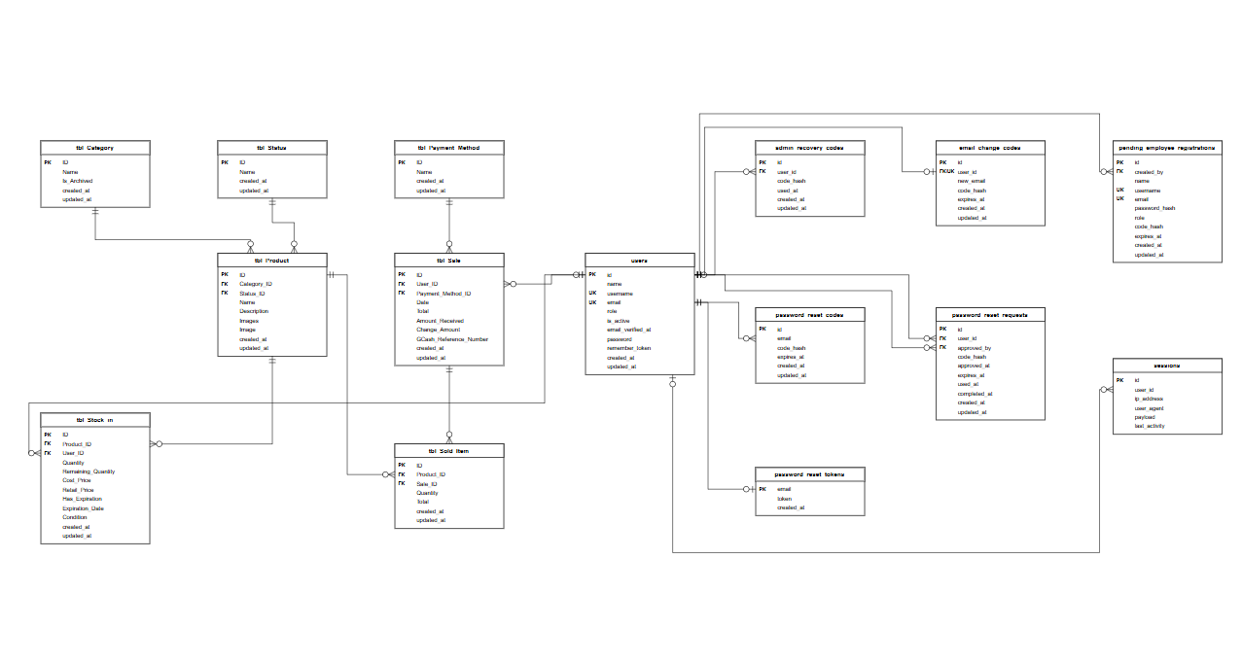
Figure 4: Entity relationship Diagram(ERD)
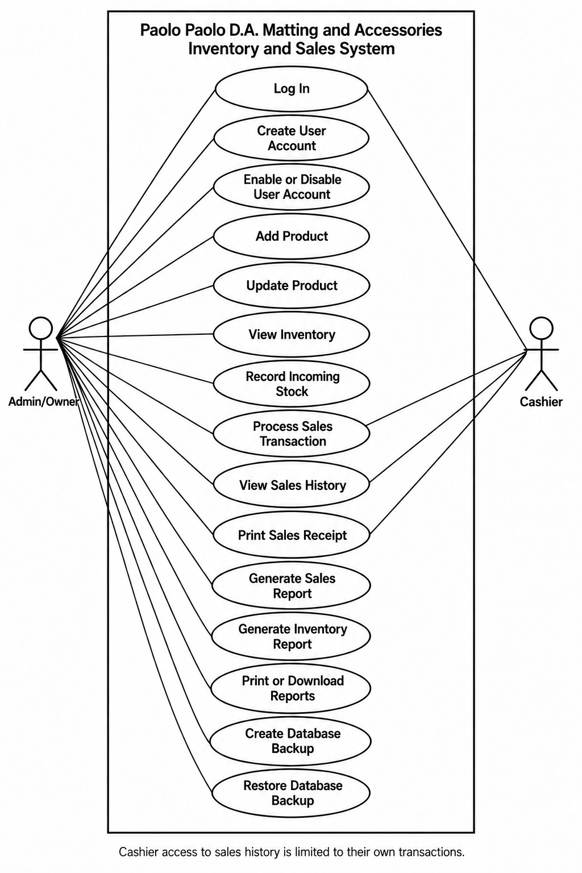
Figure 5: Use-Case Diagram

Data Dictionary
Table 12: tbl_Sale
Field Name | Data Type | Description | Size | Format | Required | PK/FK | Reference to
Sale_ID | int | Primary key | 11 |  | yes | PK
User_ID | int | The user who does the sale | 11 |  | yes | FK | tbl_User
Payment_Method_ID | int | Method of payment used | 11 |  | yes | FK | tbl_Payment_Method
Total | decimal | Total amount | 11,2 |  | yes

Table 13: tbl_Payment_Method
Field Name | Data Type | Description | Size | Format | Required | PK/FK | Reference to
Payment_Method_ID | int | Primary key | 11 |  | yes | PK
Name | varchar | Name of the payment method | 100 |  | yes

Table 14: tbl_Category
Field Name | Data Type | Description | Size | Format | Required | PK/FK | Reference to
Category_ID | int | Primary key | 11 |  | yes | PK
Name | varchar | Name of the category | 100 |  | yes

Table 15: tbl_Product
Field Name | Data Type | Description | Size | Format | Required | PK/FK | Reference to
Product_ID | int | Primary key | 11 |  | yes | PK

Table 15.1: tbl_Product
Field Name | Data Type | Description | Size | Format | Required | PK/FK | Reference to
Name | varchar | Name of the product | 100 |  | yes
Category_ID | int | Category of the product | 11 |  | yes | FK | tbl_Category
Status_ID | int | Active or archived | 11 |  | yes | FK | tbl_Status

Table 16: tbl_Stock_in
Field Name | Data Type | Description | Size | Format | Required | PK/FK | Reference to
Stock_in_ID | int | Primary key | 11 |  | yes | PK
Product_ID | int | What product is stocked in | 11 |  | yes | FK | tbl_Product

Table 16.1: tbl_Stock_in
Field Name | Data Type | Description | Size | Format | Required | PK/FK | Reference to
Quantity | int | Quantity of the product | 11 |  | yes
Cost_price | decimal | Price bought from the supplier | 11,2 |  | yes
Retail_price | decimal | Selling price to customers | 11,2 |  | yes

Table 17: tbl_Status
Field Name | Data Type | Description | Size | Format | Required | PK/FK | Reference to
Status_ID | int | Primary key | 11 |  | yesy | PK
Name | varchar | Name of the status | 100 |  | yes

Security Plan

The proposed Paolo Paolo D.A. Matting and Accessories Management System will implement user authentication and role-based access control to ensure that only authorized users can access the system and its functions. Two user roles will be implemented: Admin/Owner and Cashier.

The Admin/Owner will have access to the Inventory, Sales, Reports, and Backup and Recovery functions of the system. The Cashier will have access only to the functions necessary for processing and recording physical storefront sales transactions. Access restrictions will be applied according to the assigned user role.

Users will be required to provide a valid username and password before accessing the system. Passwords will be securely stored using PHP password hashing rather than plain-text storage. Session management will also be implemented to automatically end inactive sessions after a defined period to reduce the risk of unauthorized access when the system is left unattended.

Input validation and parameterized database queries will be implemented to help protect the system against invalid input and common database-related security risks such as SQL injection.

The system will operate through a local XAMPP web server on the designated storefront computer. Access to the computer will also be protected through the operating system's user authentication.

Database backups will be created periodically and stored in a separate storage location such as an external storage device. The Admin/Owner will be responsible for creating backups and restoring a valid backup when data recovery is necessary.

Implementation Plan

The implementation plan describes the activities required to deploy the proposed Paolo Paolo D.A. Matting and Accessories Management System for the physical storefront. Implementation will be conducted after the major system functions have been developed, integrated, tested, and approved for deployment.

The project team will prepare the required hardware and software, configure the local server and database, install the developed system, enter the initial business records, test the installed system, and provide basic training to the intended users.

The designated computer will be prepared for system operation together with the thermal receipt printer used for storefront sales transactions. The software environment will be configured using XAMPP, Apache, MySQL, and PHP 8.5.

The MySQL database will contain the tables necessary for authorized users, product information, categories, inventory records, storefront sales transactions, sold items, payment methods, and other records necessary for report generation and system operation.

After installation, the project team will verify that the application, database, authentication functions, inventory functions, sales processing, report generation, receipt printing, and backup and recovery functions operate properly. Initial product and inventory information will then be entered into the system.

The Admin/Owner and Cashier will be provided with basic system orientation based on the functions available to their respective roles..

Table 18. Hardware Requirement
Hardware / Software | Qty.
Computer package (AMD A320 motherboard, AMD A10-9700, 8GB DDR4 RAM, 15.6-inch LED monitor, A4Tech keyboard and mouse, 500W AVR, computer table) | 1
Thermal Receipt Printer | 1

Table 19. Software Requirement
Hardware / Software | Qty.
Windows 11 Pro | 1
XAMPP | 1
MySQL | 1
PHP | 1
Composer | 1
Google Chrome | 1

System Prototypes
Login Window
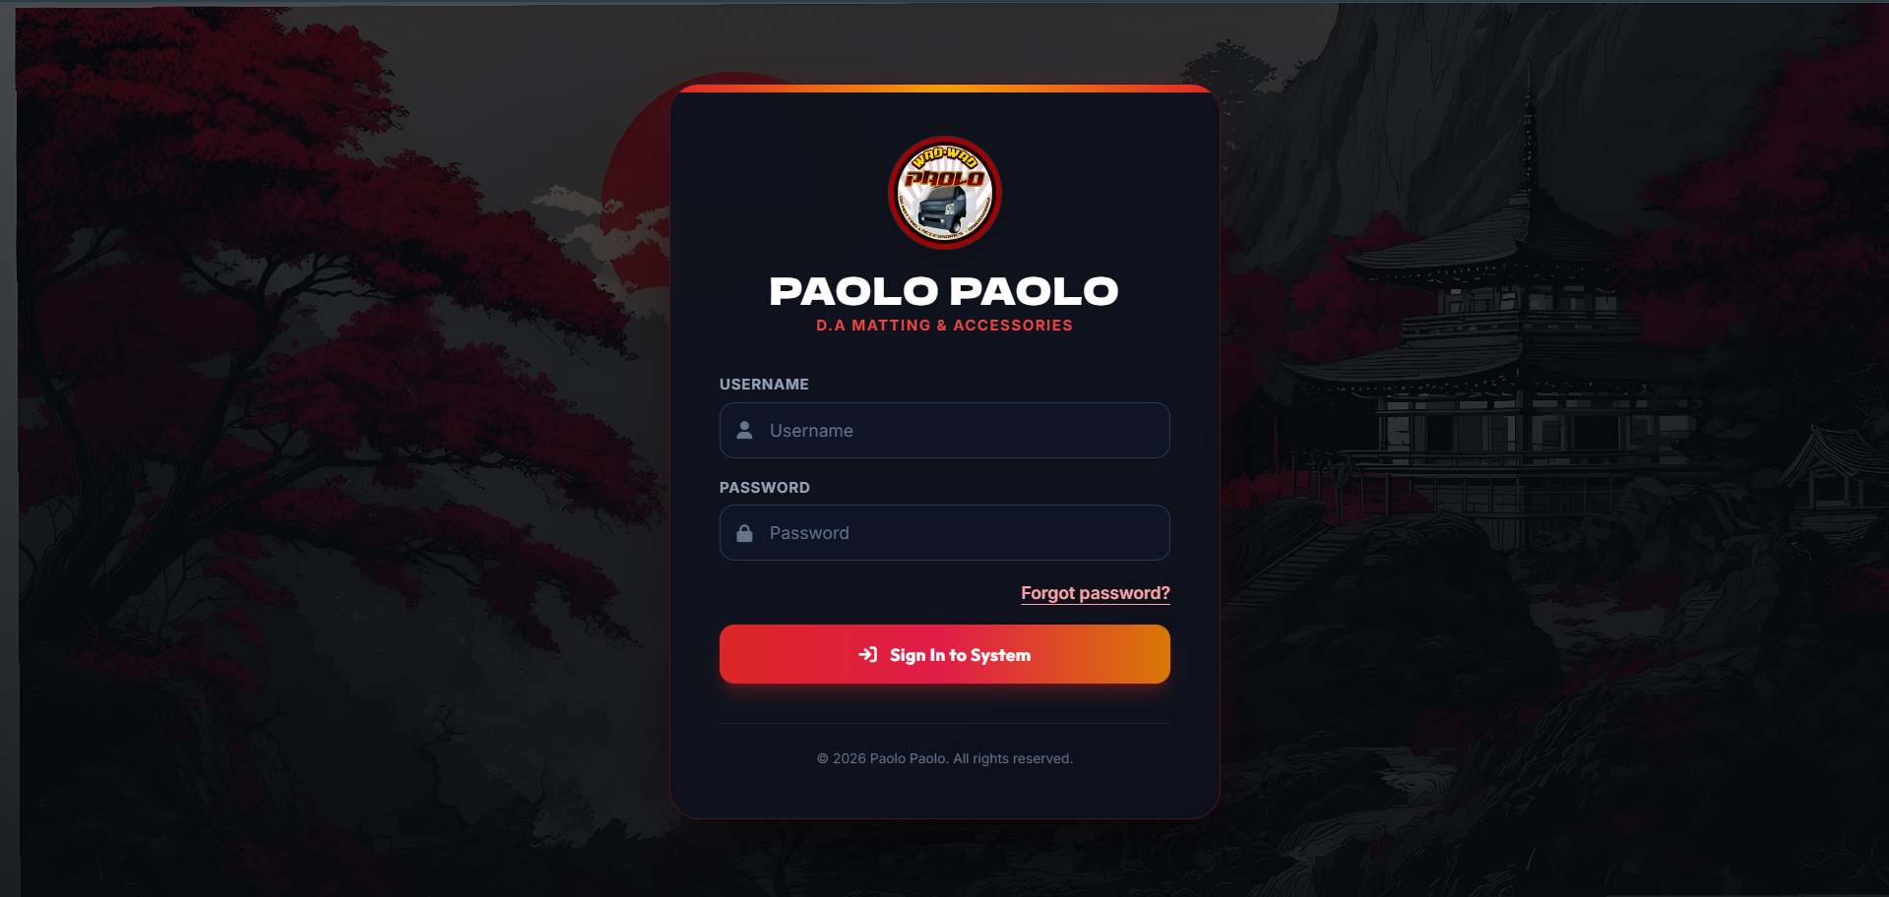
Figure 6: Login Window
The Login window verifies users’ usernames and passwords, then redirects authorized users to the appropriate interface based on their assigned role.

Dashboard
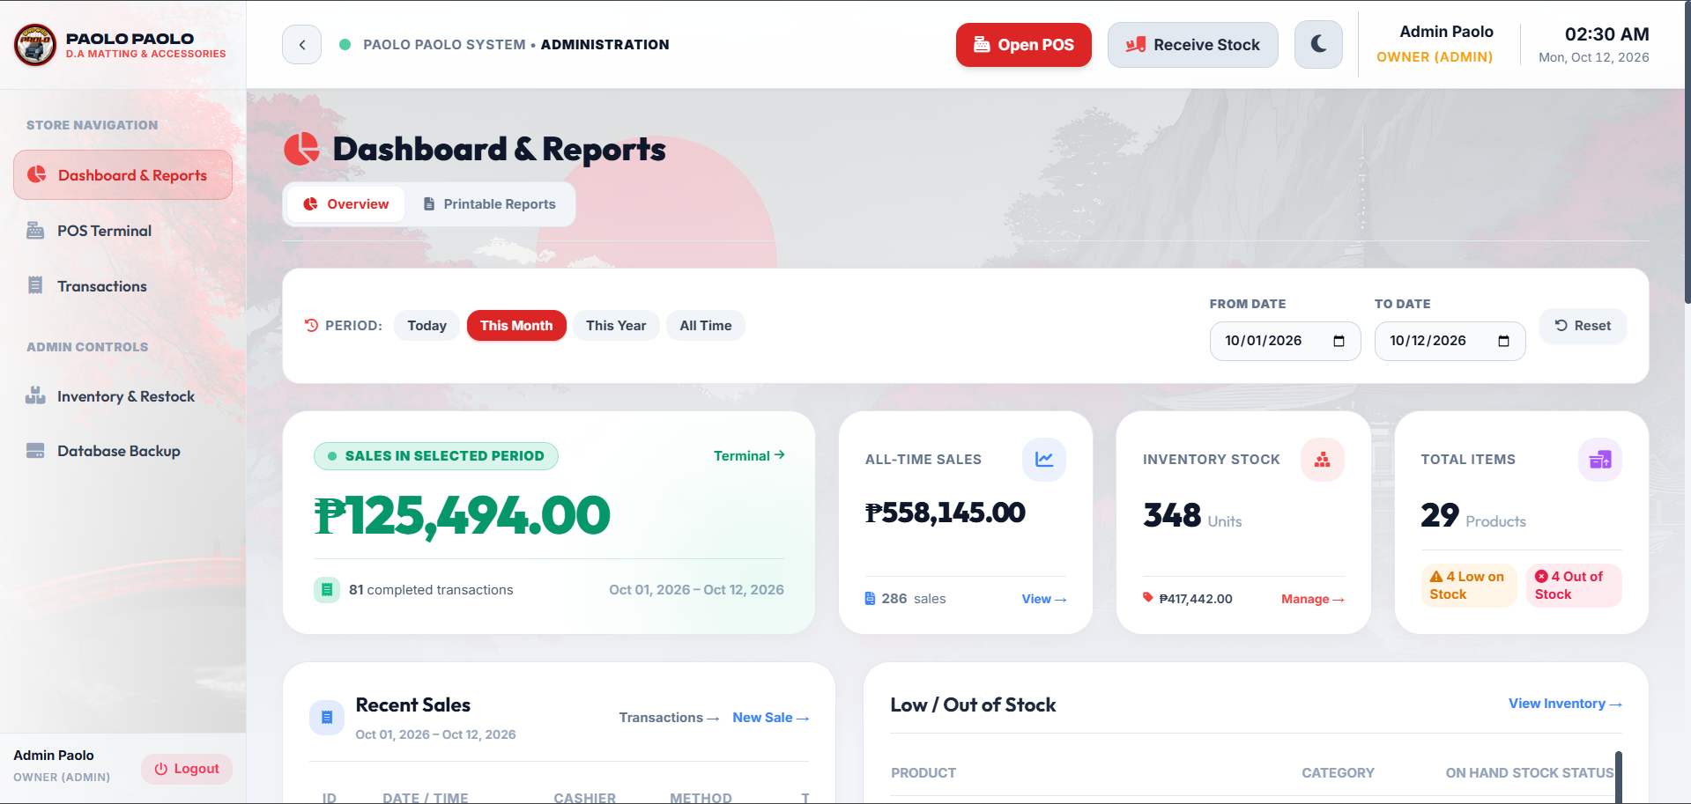
Figure 7: Dashboard
The Dashboard provides an overview of the business activities, including today's sales, total sales, transactions, inventory stock, and recent activities.
Point of Sale (POS)
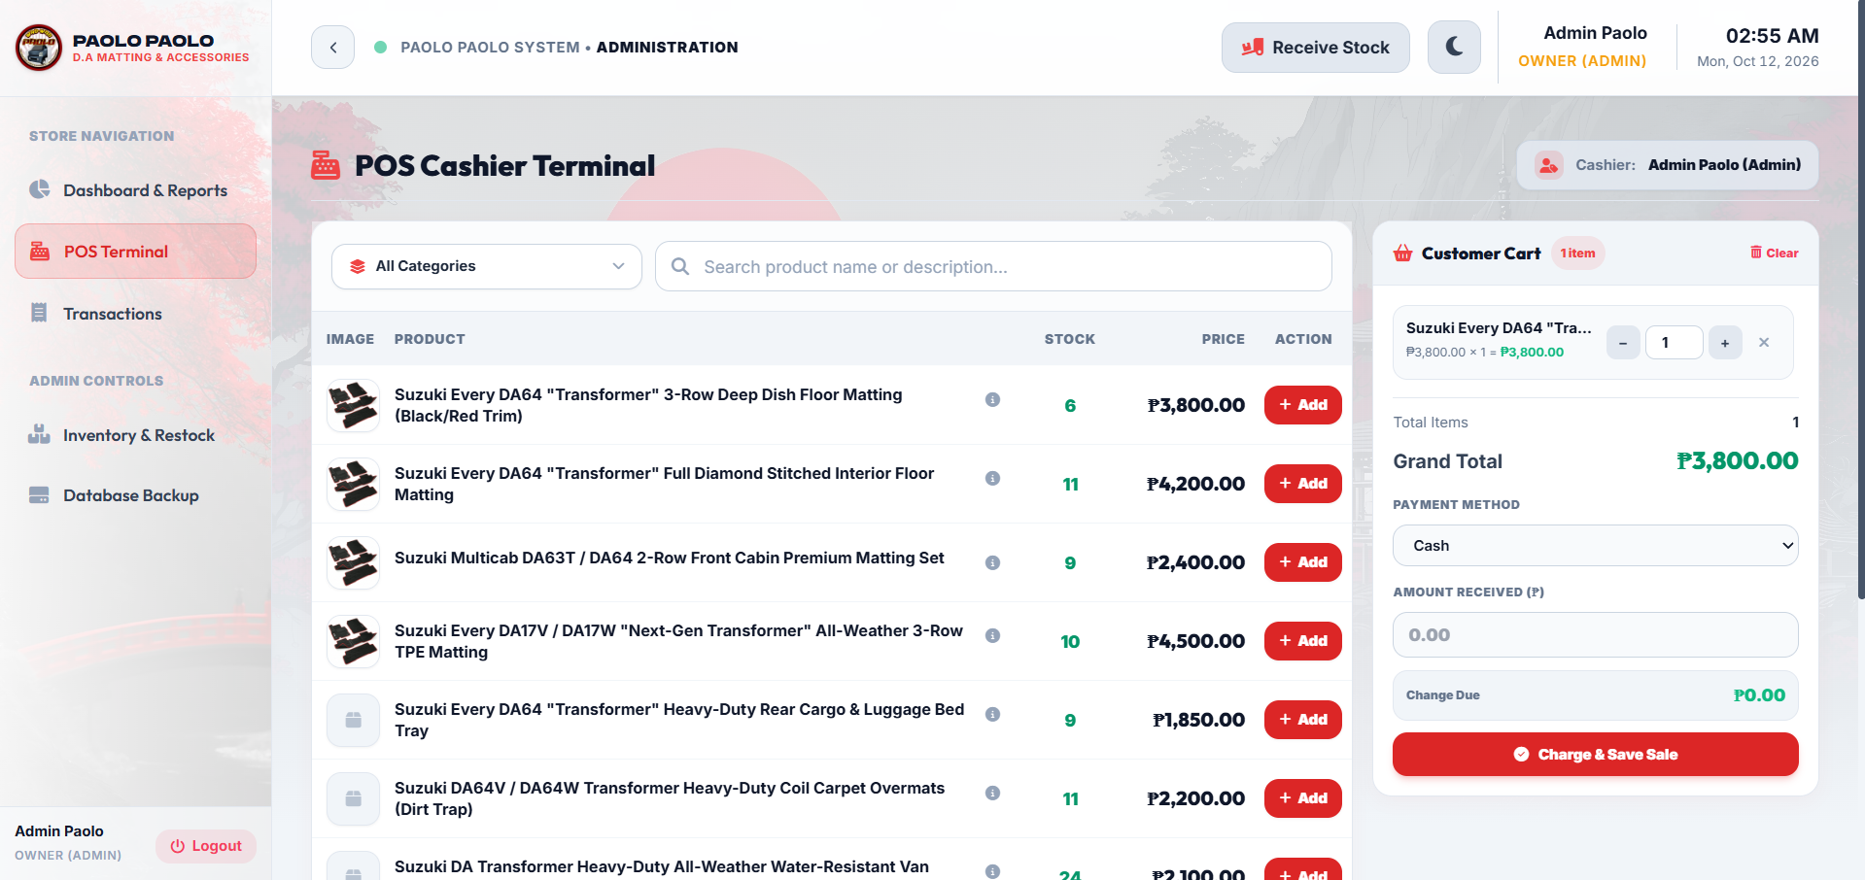
Figure 8: Point of Sale (POS)
The POS window is used to process customer transactions. It allows the cashier to search and select products, view available stock, add products to the cart, and complete sales transactions.

Transaction
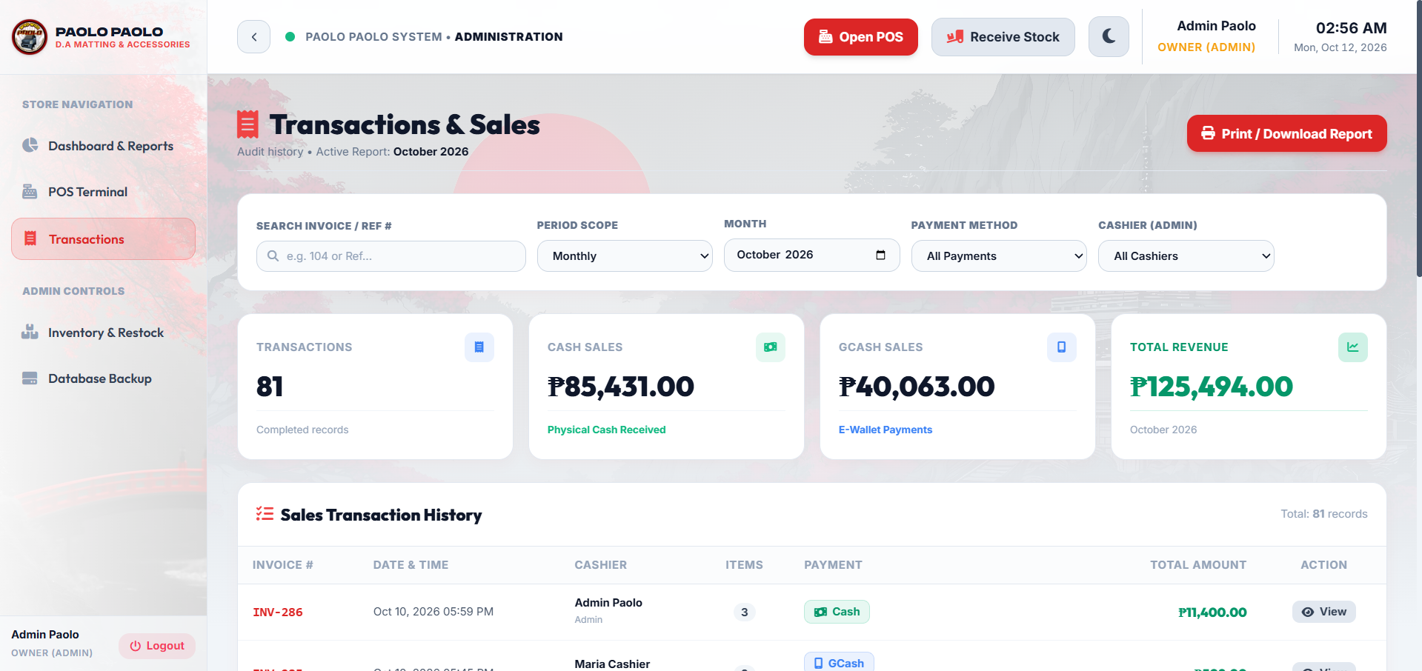
Figure 9: Transaction
The transaction window displays the transactions for each user. It allows the user to view their own sales and print or download it as PDF.
Inventory
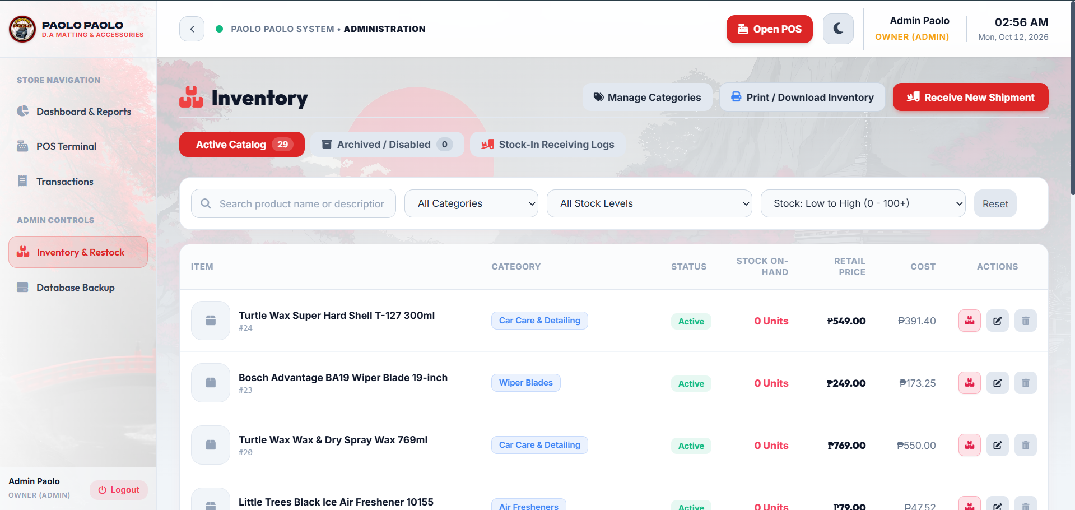
Figure 10: Inventory
The Inventory window is used to manage products and monitor stock. It allows authorized users to add products, search and filter items, manage active and archived products, and receive new stock.

Database Backup and Restore
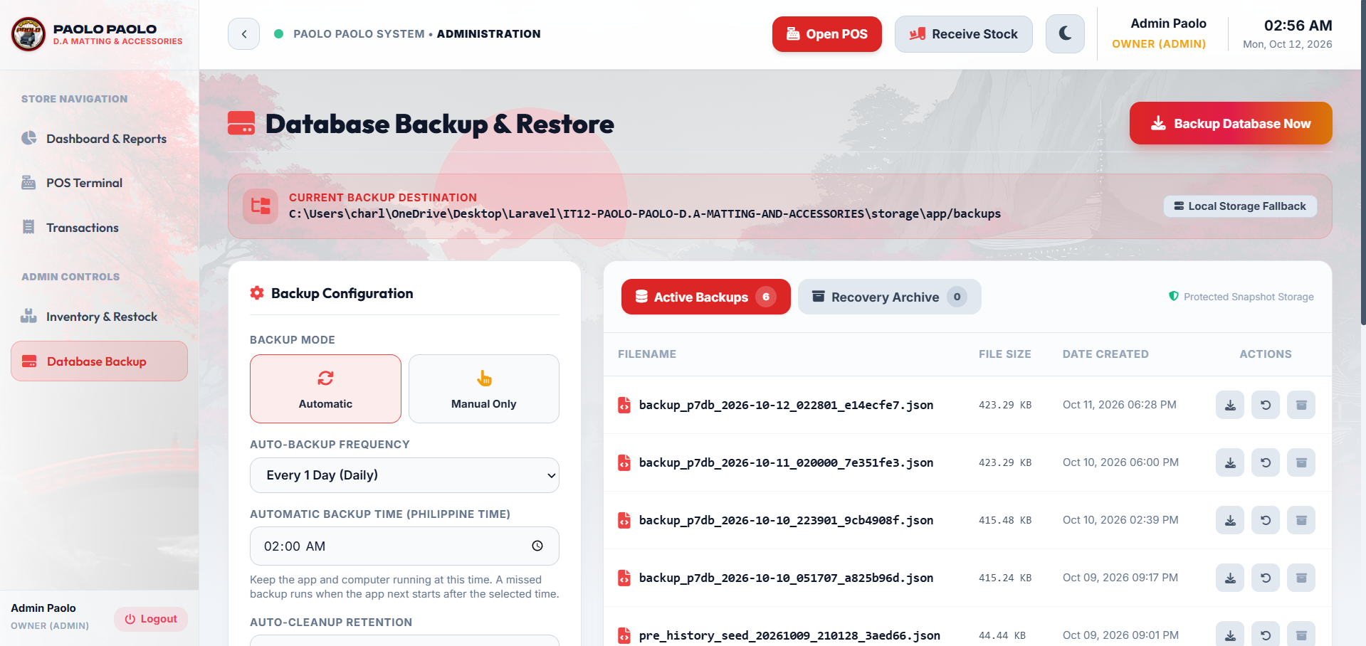
Figure 11: Database Backup and Restore
The Database Backup and Restore window allows the administrator to create database backups, manage stored backup files, and restore previous backups when needed.
Chapter 4 :
THE IMPLEMENTATION
This chapter presents the implementation of the Paolo Paolo D.A. Matting and Accessories Management System. It discusses the implemented functions, system testing, and user acceptance evaluation. The results are examined in relation to the identified problems in inventory monitoring, sales recording, and report preparation.

User Acceptance
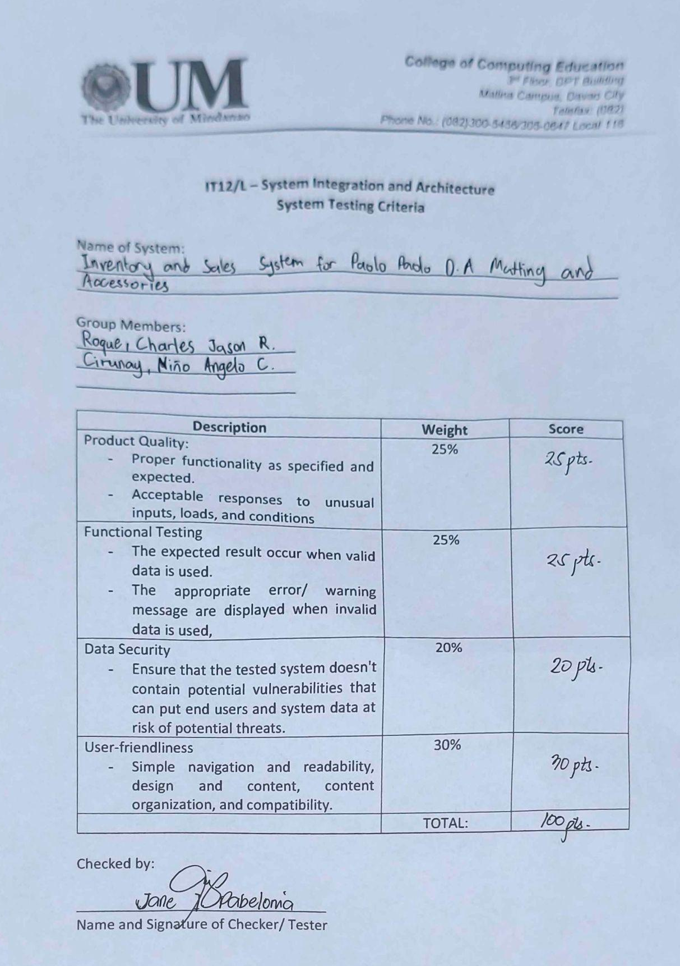
Result and Discussion
The system testing evaluation for the Inventory and Sales System for Paolo Paolo D.A. Matting and Accessories yielded an overall score of 100%. The evaluation covered four criteria: Product Quality (25%), Functional Testing (25%), Data Security (20%), and User-Friendliness (30%). The system received full marks in each criterion, reflecting a positive assessment of its functionality, handling of valid and invalid inputs, data protection, and interface design under the conditions covered by the evaluation. These results provide a basis for assessing the system’s suitability for supporting the company’s physical storefront operations.

The evaluation highlights the system’s role in managing inventory records, sales transactions, and report generation. These functions were developed to address difficulties associated with handwritten transaction records, repeated manual calculations, separate inventory entries, and the consolidation of information for business reports. Integrating these activities within one application allows product information, incoming stock, completed sales, and reporting data to be maintained in a centralized location. These capabilities are relevant to Paolo Paolo D.A. Matting and Accessories, where updated inventory information helps monitor the availability of engine oil, car accessories, matting products, and other automotive items. Accessible transaction records and organized reports also support the owner in reviewing storefront sales and stock information.

The overall score of 100% indicates that the system satisfied the criteria applied during the evaluation. Continued maintenance and review remain valuable as the system is used in daily operations. User feedback can guide future improvements in navigation, functionality, and data protection, while regular backups support the preservation of stored records. Physical inspection and counting remain necessary to verify actual stock quantities and product condition, and accurate information depends on correct and consistent data entry. Overall, the evaluation supports a positive assessment of the system as a solution for organizing storefront inventory, recording sales transactions, and preparing business reports according to the company’s operational needs.
Chapter 5
THE SOURCE CODE
This chapter presents selected source code of the Inventory and Sales System for Paolo Paolo D.A. Matting and Accessories. The listings explain how the application controls access, maintains product and stock records, processes storefront sales, prepares reports, prints receipts, and supports password recovery and database restoration.
The application uses PHP and the Laravel framework. Controllers process requests, models access database records, Blade templates display interfaces, and middleware enforces access restrictions. The current project includes SQL Server connection and snapshot support. Its dependency file requires PHP 8.3 or later within the supported version range and Laravel 13.8 or later within version 13.
Area | Main source files | Responsibility
Authentication | AuthenticatedSessionController.php  EnsureUserRole.php | Login, session renewal and access control
Inventory | Product.php  ProductController.php  StockInController.php | Product details, stock thresholds and incoming batches
Sales | PosController.php  TransactionController.php | Checkout, stock deductions and sales history
Reports | ReportController.php | Sales summaries and inventory information
Recovery | AccountRecoveryService.php  BackupController.php | Recovery codes and password-protected restore
Receipt | pos/receipt.blade.php | Thermal receipt display and printing

Each listing identifies its source file and line range. These are selected excerpts; declarations and surrounding statements remain in the project. Blank lines are removed for space. The listings cover product sales. Online orders, payroll and physical installation work are outside their scope.
5.1 User Authentication and Access Control
A login request authenticates the username and password before renewing the session identifier. Administrators are directed to the dashboard, while operational users are directed to the POS interface. The login request also checks account activity and verification status.
Listing 1 Authentication and role based redirection
Source: app/Http/Controllers/Auth/AuthenticatedSessionController.php
Lines 25 to 40 Selected source excerpt
public function store(LoginRequest $request): RedirectResponse
{
$request->authenticate();
$request->session()->regenerate();
$user = $request->user();
if ($user && $user->isAdmin()) {
return redirect()->intended(route('dashboard', absolute: false));
}
// Operational staff (Cashier, Packer, Installer, Worker) go straight to POS Terminal
session()->forget('url.intended');
return redirect()->route('pos.index');
}
Administrative modules are protected at the route level. Authentication and active-account middleware are applied before role restrictions, so hiding a menu alone does not grant or remove permission.
Listing 2 Administrator route restriction
Source: routes/web.php
Lines 49 to 54 Selected source excerpt
Route::middleware(['role:Admin'])->group(function () {
Route::get('/dashboard', [DashboardController::class, 'index'])
->name('dashboard');
Route::get('/security', [SecurityController::class, 'index'])
->name('security.index');
The project also applies login lockouts after repeated failed attempts. Account disabling is enforced during authentication and subsequent protected requests.
5.2 Product Records and Stock Thresholds
Inventory quantities are calculated from remaining stock batches that are in good condition and have not expired. Damaged, defective, depleted and expired batches are excluded from sellable stock.
Listing 3 Sellable stock calculation
Source: app/Models/Product.php
Lines 83 to 99 Selected source excerpt
public function sellableStockIns()
{
return $this->stockIns()
->where('Remaining_Quantity', '>', 0)
->where('Condition', 'Good')
->where(function ($query) {
$query
->where('Has_Expiration', false)
->orWhereNull('Expiration_Date')
->orWhereDate('Expiration_Date', '>=', today()->toDateString());
});
}
public function getStockQuantityAttribute(): float
{
return (float) $this->sellableStockIns()->sum('Remaining_Quantity');
}
The low-stock threshold is stored with each product. Editing a product updates this saved value; when the field is omitted, the existing threshold is retained. Validation requires a non-negative integer.
Listing 4 Saving an edited stock threshold
Source: app/Http/Controllers/ProductController.php
Lines 424 to 432 Selected source excerpt
$product->update([
'Name' => $validated['Name'],
'Description' => $validated['Description'] ?? null,
'Low_Stock_Threshold' => $validated['Low_Stock_Threshold'] ?? $product->low_stock_threshold,
'Category_ID' => $validated['Category_ID'],
'Status_ID' => $validated['Status_ID'],
'Image' => $currentImages[0] ?? null,
'Images' => $currentImages,
]);
5.3 Recording Incoming Stock
A stock-in transaction records the product, responsible user, received quantity, cost and retail prices, expiration information and condition. The received quantity becomes the batch remaining quantity when the record is created.
Listing 5 Creating a stock batch
Source: app/Http/Controllers/StockInController.php
Lines 185 to 199 Selected source excerpt
$hasExpiration = $request->boolean('Has_Expiration');
$stockIn = StockIn::create([
'Product_ID' => $product->ID,
'User_ID' => $processor->id,
'Quantity' => $validated['Quantity'],
'Remaining_Quantity' => $validated['Quantity'],
'Cost_Price' => $validated['Cost_Price'],
'Retail_Price' => $validated['Retail_Price'],
'Has_Expiration' => $hasExpiration,
'Expiration_Date' => $hasExpiration
? ($validated['Expiration_Date'] ?? null)
: null,
'Condition' => $validated['Condition'] ?? 'Good',
]);
Before this code runs, the controller validates required fields, numeric quantities and prices, allowed product conditions, and any required expiration date. New products and their batches are created inside a database transaction. The product and batch records are therefore committed together.
Physical inspection remains the responsibility of the owner or authorized employee. The application records the quantity and condition entered after inspection; it does not independently examine delivered products.
5.4 Checking Available Stock and Allocating Batches
Checkout locks eligible batches in ascending batch-ID order during the database transaction. First-in, first-out allocation follows batch creation order.
Listing 6 Selecting and locking sellable batches
Source: app/Http/Controllers/PosController.php
Lines 159 to 176 Selected source excerpt
$batches = StockIn::where('Product_ID', $product->ID)
->where('Remaining_Quantity', '>', 0)
->where('Condition', 'Good')
->where(function ($query) {
$query
->where('Has_Expiration', false)
->orWhereNull('Expiration_Date')
->orWhereDate(
'Expiration_Date',
'>=',
today()->toDateString()
);
})
->orderBy('ID', 'asc')
->lockForUpdate()
->get();
$available = (float) $batches->sum('Remaining_Quantity');
Requests exceeding sellable stock are rejected. Accepted quantities are allocated from the earliest eligible batch before continuing to later batches.
Listing 7 Allocating stock across batches
Source: app/Http/Controllers/PosController.php
Lines 191 to 210 Selected source excerpt
$remainingToAllocate = $qty;
$fifoAllocations = [];
foreach ($batches as $batch) {
if ($remainingToAllocate <= 0) {
break;
}
$availableInBatch = (float) $batch->Remaining_Quantity;
$take = min($availableInBatch, $remainingToAllocate);
if ($take > 0) {
$fifoAllocations[] = [
'batch' => $batch,
'quantity' => $take,
];
$remainingToAllocate -= $take;
}
}
5.5 Saving Sales and Deducting Stock
Checkout calculates totals on the server and validates payment before saving. Cash received must cover the total; change is the excess received. GCash payments require an exact matching amount and a 13-digit reference. Staff still verify that the payment was actually received in the GCash account.
Listing 8 Recording a sale and reducing batch balances
Source: app/Http/Controllers/PosController.php
Lines 259 to 288 Selected source excerpt
$sale = Sale::create([
'Date' => Carbon::now('Asia/Manila'),
'Total' => $total,
'Amount_Received' => $amountTendered,
'Change_Amount' => $change,
'GCash_Reference_Number' => $gcashReference,
'User_ID' => $cashierId,
'Payment_Method_ID' => $paymentMethod->ID,
]);
foreach ($itemsToSave as $item) {
SoldItem::create([
'Product_ID' => $item['product_id'],
'Quantity' => $item['quantity'],
'Total' => $item['total'],
'Sale_ID' => $sale->ID,
]);
foreach ($item['fifo_allocations'] as $allocation) {
$batch = $allocation['batch'];
$quantityUsed = (float) $allocation['quantity'];
$batch->Remaining_Quantity = max(
0,
(float) $batch->Remaining_Quantity - $quantityUsed
);
$batch->save();
}
}
The sale header, sold items and stock deductions execute within the same database transaction. The completed transaction supplies its stored information to sales history, reporting and receipt output.
5.6 Reports and Sales History
The Reports module summarizes recorded sales and prepares inventory information. Sales summaries are computed from the same filtered query used to retrieve transaction records, keeping the displayed totals consistent with the selected scope and period.
Listing 9 Filtered sales totals
Source: app/Http/Controllers/ReportController.php
Lines 118 to 129 Selected source excerpt
$this->applySalePeriod($salesQuery, $period, $month, $year, $week);
$totalTransactions = (clone $salesQuery)->count();
$totalSales = (float) (clone $salesQuery)->sum('Total');
$cashSales = (float) (clone $salesQuery)
->whereHas('paymentMethod', fn($q) => $q->where('Name', 'Cash'))
->sum('Total');
$gcashSales = (float) (clone $salesQuery)
->whereHas('paymentMethod', fn($q) => $q->where('Name', 'GCash'))
->sum('Total');
The report controller supports weekly, monthly, yearly and overall periods. Printing and PDF output use the generated report data.
Listing 10 Restricting employee sales history
Source: app/Http/Controllers/TransactionController.php
Lines 167 to 180 Selected source excerpt
private function buildQuery(Request $request, array $filters): Builder
{
$query = Sale::query();
// Cashier filter (Admin can view all or filter by staff; Employee is restricted to own sales)
if (auth()->user() && auth()->user()->isAdmin()) {
if (!empty($filters['cashier_id']) && $filters['cashier_id'] !== 'all') {
$query->where('User_ID', $filters['cashier_id']);
}
} else {
$query->where('User_ID', auth()->id());
}
// Apply Date / Period
The administrator can review all transactions or filter by user. Non-administrative users are restricted to their own sales. Receipt access applies a corresponding ownership check.
5.7 Password Recovery and Database Restoration
Password recovery uses a private saved recovery code. The generated code contains 16 random characters arranged in four groups. Its hash is stored; the displayed code must be saved privately by its owner.
Listing 11 Generating and hashing a recovery code
Source: app/Services/AccountRecoveryService.php
Lines 41 to 56 Selected source excerpt
public function generate(User $user): string
{
return DB::transaction(function () use ($user) {
User::whereKey($user->id)->lockForUpdate()->firstOrFail();
$alphabet = 'ABCDEFGHJKLMNPQRSTUVWXYZ23456789';
$code = '';
for ($index = 0; $index < 16; $index++) {
$code .= $alphabet[random_int(0, strlen($alphabet) - 1)];
}
$code = implode('-', str_split($code, 4));
AccountRecoveryCode::where('user_id', $user->id)->delete();
AccountRecoveryCode::create(['user_id' => $user->id, 'code_hash' => Hash::make($code), 'attempts' => 0]);
return $code;
});
}
Resetting a password replaces the recovery code and removes the account's existing database sessions. Five failed attempts trigger a 15-minute lock. A reset grant lasts ten minutes.
Listing 12 Confirming the administrator password before restore
Source: app/Http/Controllers/BackupController.php
Lines 458 to 467 Selected source excerpt
public function restoreBackup(Request $request)
{
$request->validateWithBag('restoreBackup', [
'current_password' => 'required|string|current_password',
'backup_file' => 'nullable|file|extensions:sql,json',
'existing_file' => 'nullable|string',
], [
'current_password.required' => 'Enter your administrator password to restore a backup.',
'current_password.current_password' => 'The administrator password is incorrect.',
]);
The administrator-only restore route checks the selected backup and uses the snapshot service for SQL Server or JSON restoration. Recovery codes must be regenerated after restoration.
5.8 Thermal Receipt Output
The receipt template displays stored transaction details, purchased items, payment information and totals. It supports 80 mm and 58 mm thermal paper. Printing hides the on-screen controls and removes screen-only margins and decoration.
Listing 13 Selecting the smaller thermal paper layout
Source: resources/views/pos/receipt.blade.php
Lines 19 to 23 Selected source excerpt
body[data-paper-width="58"] {
--paper-width: 58mm;
--side-padding: 5mm;
--receipt-font-size: 8pt;
}
Listing 14 Thermal printing styles
Source: resources/views/pos/receipt.blade.php
Lines 74 to 79 Selected source excerpt
@media print {
html, body { margin: 0 !important; padding: 0 !important; background: #fff; }
body { width: var(--paper-width); }
.no-print { display: none !important; }
.receipt-paper { margin: 0; box-shadow: none; }
}
Listing 15 Displaying receipt payment totals
Source: resources/views/pos/receipt.blade.php
Lines 136 to 140 Selected source excerpt
<div class="row total bold"><span>TOTAL:</span><span>₱{{ number_format($sale->Total, 2) }}</span></div>
@if(strtolower($sale->paymentMethod->Name ?? '') === 'cash')
<div class="row"><span>Amount Received:</span><span>₱{{ number_format($sale->Amount_Received, 2) }}</span></div>
<div class="row"><span>Change:</span><span>₱{{ number_format($sale->Change_Amount, 2) }}</span></div>
@endif
The operator selects the matching printer paper size, uses 100 percent scale, removes margins, and disables browser headers and footers. The receipt has no logo and the action is labelled Print Receipt.
APPENDIX A
LETTER TO THE COMPANY
Date: ____________________
Mr. and Mrs. Pabelonia
Owners
Paolo Paolo D.A. Matting and Accessories
Company address: ______________________________
Subject: Request for Permission to Conduct a System Study
Dear Mr. and Mrs. Pabelonia:
We are students of the University of Mindanao enrolled in IT12/L, System Integration and Architecture. We respectfully request permission to conduct a study of the physical storefront inventory and sales processes of Paolo Paolo D.A. Matting and Accessories as part of our course requirements.
Our project, Inventory and Sales System for Paolo Paolo D.A. Matting and Accessories, focuses on inventory monitoring, storefront sales recording, report preparation, user access, and database backup and recovery. With your permission, we would like to interview the owner or authorized staff, observe the relevant workflow, and review sample business forms needed to understand these processes.
We will coordinate the schedule with you to avoid disrupting business activities. Information will be used for the academic study. Photographs and copies of records will be taken only with permission, and personal details, passwords, payment references and other sensitive information will be removed from materials included in the documentation.
We would also appreciate your feedback during the demonstration and evaluation of the developed system. Thank you for considering our request.
Respectfully yours,
Charles Jayson R. Roque
Niño Angelo C. Cirunay
Student Researchers
Noted by: __________________________
Meljohn V. Aborde
IT12/L Subject Teacher
Company acknowledgement
Name and signature: _______________________ Date: ____________
APPENDIX B
COMPANY FORMS
B.1 Sample Sales Transaction Record
The following examples illustrate the fields used to document storefront transactions and incoming stock. Product names reflect the automotive items discussed in Chapter 1. All quantities, prices, dates and document numbers below are illustrative.
Paolo Paolo D.A. Matting and Accessories
SAMPLE SALES RECORD
Document No.: SAMPLE-001 Date: ____________________
Processed by: Authorized Cashier Payment: Cash
Product description | Qty. | Unit price PHP | Amount PHP
Engine oil bottle | 2 | 250.00 | 500.00
Oil filter | 1 | 180.00 | 180.00
Wiper blade | 1 | 220.00 | 220.00

Total amount: PHP 900.00
Amount received: PHP 1,000.00
Change: PHP 100.00
GCash reference: Not applicable
Customer name or other details, when needed: ____________________
For a GCash transaction, the amount received must match the total and the payment reference must contain 13 digits. Record the actual reference only after confirming the received payment. The example above is a cash transaction.
This is an example of an operational transaction record for academic illustration. Replace it with a permitted copy of the company's actual form when available.
APPENDIX B COMPANY FORMS
B.2 Sample Incoming Stock Record
Stock-in No.: SAMPLE-SI-001 Date received: ____________________
Supplier or purchase reference: ______________________________
Received and inspected by: _________________________________
Product | Qty. received | Unit cost PHP | Retail price PHP | Condition
Engine oil bottle | 12 | 200.00 | 250.00 | Good
Oil filter | 6 | 140.00 | 180.00 | Good
Wiper blade | 8 | 170.00 | 220.00 | Good

Unit of counting: Piece. Each engine oil bottle is one piece.
Total pieces received: 26
Purchase cost total: PHP 4,600.00
Expected retail value: PHP 5,840.00
Receiving Inspection
Inspection point | Record or result
Quantity compared with order or supplier document | _______________________________
Brand, product type, size and vehicle compatibility | _______________________________
Packaging, seals, leaks and visible damage | _______________________________
Expiration date, if applicable | _______________________________
Discrepancy and action taken | _______________________________

Accepted by: ___________________ Checked by: ___________________
The stock-in record is entered only after actual quantity and condition have been checked. Illustrative values above do not represent a real delivery.
APPENDIX B COMPANY FORMS
B.3 Sample Inventory Monitoring Record
Stock verification date: ____________________
Prepared by: ____________________
Counting basis: Pieces of sellable product
Product | Recorded stock | Physical count | Difference | Threshold
Engine oil bottle | 10 | 10 | 0 | 5
Oil filter | 4 | 4 | 0 | 5
Wiper blade | 0 | 0 | 0 | 3

Example interpretation: Engine oil is above its threshold. Oil filters are low in stock because four pieces remain against a threshold of five. Wiper blades are out of stock. Thresholds are editable product settings and the values in this form are examples.
Reconciliation and Follow-up
Reason for any difference: ____________________________________
_________________________________________________________
Corrective action or replenishment note: _________________________
_________________________________________________________
Approved by: ____________________ Date: ____________________
Physical counts verify the recorded balances. Damage, defects, expired items and unrecorded movement must be investigated before a correction is entered. This example supports manual verification; it is not an additional purchasing or supplier-management module.
APPENDIX C
DATA GATHERING EVIDENCE
C.1 Interview and Observation Record
Complete this record using the actual interview notes, photographs and permitted copies of company records. Record the activity details and attach the corresponding evidence.
Activity date and time: _______________________________________
Location or interview method: __________________________________
Company representative and role: _______________________________
Researcher or interviewer: ____________________________________
Permission to record or photograph: ____________________________
Interview Guide
1. Which automotive products are monitored, and what unit is used to count each item?
2. How are incoming products compared with the order or supplier document?
3. How are damaged, defective or expired products identified and recorded?
4. How does the owner determine when a product needs replenishment?
5. What fields are actually written in the sales document and transaction log?
6. How are cash amounts and received GCash payments verified?
7. When and how are sold quantities deducted from inventory records?
8. Which sales and inventory reports are prepared, and how often?
9. Which tasks require owner access and which are performed by the cashier?
10. What problems occur when finding past transactions or preparing reports?
Responses or notes attachment: ________________________________
Confirmed by the representative: _______________________________
APPENDIX C DATA GATHERING EVIDENCE
C.2 Evidence Register
ID | Evidence to attach | Date and source | Attachment or permission
C-01 | Interview notes confirmed by owner or authorized staff | ____________ | ____________
C-02 | Observation notes of stock checking and receiving | ____________ | ____________
C-03 | Permitted photograph of shelves or storage | ____________ | ____________
C-04 | Redacted sample sales document or manual order log | ____________ | ____________
C-05 | Redacted stock record or supplier document | ____________ | ____________
C-06 | System demonstration or feedback record | ____________ | ____________

C.3 Evidence Caption and Attachment
Evidence ID: ____________________
Caption or activity: _________________________________________
Date and location: __________________________________________
What the evidence shows: ____________________________________
Source and permission: ______________________________________
Attach an actual permitted photograph or scanned record here.
Attach evidence of the existing business process described in Chapter 1. Remove private information from photographs and copied records.
APPENDIX D
TEST PLAN
D.1 Purpose and Test Environment
The test plan verifies that the developed system supports the physical storefront requirements described in Chapters 2 and 3. Testing covers Inventory, Sales, Reports, Security, thermal receipt output, and Backup and Recovery.
Use a separate test database and test accounts for Admin/Owner and Cashier. Prepare good, damaged, defective and expired batches; sample Cash and GCash transactions; a thermal printer with supported paper; and a disposable backup destination. Confirm that the selected SQL Server connection, PHP driver and local server are working before execution.
D.2 Test Procedure and Responsibilities
The researchers prepare the data and execute functional, integration and access-control tests. The owner or authorized representative performs the acceptance review. Record the actual result, date, tester and supporting screenshot or output for every case. Log failed cases as defects, correct them, and repeat the affected tests.
Backup restoration tests must run against a disposable database. Take a verified baseline backup before the test, compare restored values with the baseline, and confirm that the test does not change live business records.
D.3 Entry and Completion Criteria
Testing starts when the application launches, test users can sign in, required tables exist, and sample records and backups are available. Testing is complete when all planned cases have results, critical defects are resolved and retested, totals and stock balances reconcile, access restrictions hold, and the owner or representative records acceptance.
Acceptance criteria follow the evaluation form used in Chapter 4: Product Quality 25 percent, Functional Testing 25 percent, Data Security 20 percent, and User-Friendliness 30 percent, for a total of 100 percent. Record any new evaluation separately from the existing assessment.
Test date: __________ Build or version: __________
Database: __________ Tester: ____________________
Record column: enter Pass or Fail and the evidence reference after execution.
APPENDIX D TEST PLAN
D.4 Authentication and Inventory Tests
Case | Procedure or input | Expected result | Result and evidence
TP-01 | Sign in with an active, verified Admin account. | Login succeeds and the dashboard opens. | ________  ________
TP-02 | Enter a wrong password three times; retry during the lockout. | Errors are displayed and the temporary login lockout is enforced. | ________  ________
TP-03 | Disable a test employee account, then attempt login and a protected request. | The disabled account cannot use protected functions. | ________  ________
TP-04 | As Cashier, open Inventory, Reports, Security and Backup URLs directly. | Administrative routes refuse access; POS remains available. | ________  ________
TP-05 | Add a product with required details; repeat with a missing required value. | Valid details save; invalid data shows a validation error. | ________  ________
TP-06 | Receive 12 good units of an existing product. | One batch is recorded and sellable stock increases by 12. | ________  ________
TP-07 | Edit the stock threshold to 7; reload and sign in again; try a negative value. | The saved value remains 7; negative thresholds are rejected. | ________  ________
TP-08 | Filter inventory by date, price and stock; sort names and values both ways. | Displayed rows match filters and ascending or descending order. | ________  ________

Execution date: __________ Tester: ____________________
Defect or retest references: ______________________________
APPENDIX D TEST PLAN
D.5 Sales and Payment Tests
Case | Procedure or input | Expected result | Result and evidence
TP-09 | Sell goods totaling PHP 900 and receive PHP 1,000 cash. | Sale total is PHP 900; change is PHP 100; stock decreases correctly. | ________  ________
TP-10 | Attempt the same sale with PHP 800 cash. | Underpayment is rejected; no sale or stock deduction is saved. | ________  ________
TP-11 | Use GCash, the exact total and a 13-digit test reference. | Transaction saves the payment method and reference with zero change. | ________  ________
TP-12 | Submit GCash references with 12 digits, 14 digits or letters. | Each invalid reference is rejected without saving a sale. | ________  ________
TP-13 | Use a valid reference but a GCash amount different from the total. | The mismatched payment amount is rejected. | ________  ________
TP-14 | Request more than available sellable stock. | Insufficient-stock message appears; stock and sales remain unchanged. | ________  ________
TP-15 | Prepare two good batches with 3 and 5 units; sell 4 units. | FIFO uses all 3 units of the first batch and 1 of the next; 4 remain. | ________  ________
TP-16 | Prepare damaged, defective, expired and zero-quantity batches. | Those batches are excluded from sellable stock and checkout. | ________  ________

Execution date: __________ Tester: ____________________
Defect or retest references: ______________________________
APPENDIX D TEST PLAN
D.6 Reports Recovery and Offline Tests
Case | Procedure or input | Expected result | Result and evidence
TP-17 | As Cashier, inspect history and request another user's receipt URL. | Only own transactions are listed; another user's receipt is refused. | ________  ________
TP-18 | Generate weekly, monthly, yearly and overall sales reports. | Included dates, counts and totals agree with the test sales records. | ________  ________
TP-19 | Generate the inventory report with stock and category filters. | Quantities, thresholds and report rows agree with eligible records. | ________  ________
TP-20 | Print or export reports and print a receipt at 58 mm and 80 mm. | Outputs match stored totals; receipt text fits and controls are hidden. | ________  ________
TP-21 | Reset a test password using its saved recovery code; retry the old code. | New password works; old code fails; a replacement code is issued. | ________  ________
TP-22 | Enter an incorrect recovery code five times; test an expired reset grant. | The 15-minute lock and ten-minute reset-grant expiry are enforced. | ________  ________
TP-23 | Create a backup to the disposable destination; inspect the resulting file. | A nonempty backup is saved and can be selected for restoration. | ________  ________
TP-24 | In the test database, try wrong restore password, invalid file, then a valid backup. | Invalid attempts fail; valid restore recovers baseline data and clears recovery codes. | ________  ________
TP-25 | With dependencies installed, disconnect internet, launch locally and perform a test sale. | Local login, inventory, sale and receipt functions remain usable. | ________  ________

Execution date: __________ Tester: ____________________
Defect or retest references: ______________________________
Acceptance decision: Accepted / Accepted with revisions / Not accepted
Representative and signature: ____________________ Date: __________

