The Score Has a Past

Final Report
- Introduction
CS201 homework scores cluster near full marks, so the gradebook says little about how students reach them. Our project reads the course's online-judge submission log to show that process: when the work happens, whether retries help, and what a final 100 hides.
1.1 Motivation and context
CS201 is an introductory programming course whose homework is graded by an online judge (OJ). Students may resubmit as often as they like before the deadline. In 36 of 43 problem slots, every student who attempted the problem ended at full marks. The final score hides the first try, the retries and the hour of the work, which are the parts of learning that students, teaching assistants (TAs) and instructors can act on.
1.2 Research questions
- When does homework work happen, and is a busy period many students, or a few students submitting again and again?
- Do retries pay off, and does that depend on the homework, the time since the previous attempt, or the point in the homework window?
- What does a near-perfect final score hide about how students got there?
- Does the way students submit relate to their midterm score?
1.3 Intended audience
CS201 students, who can use patterns to plan their own work; TAs and instructors, who can time support and review difficult problems; and visitors to the course showcase, who need the story without the statistics vocabulary.
1.4 Why visualization
The log holds thousands of timestamped events nested as student, homework, problem and attempt. Our questions concern timing patterns, distributions, sequences and uncertainty, which a table of averages hides. Visualization lets a viewer see bursts in time, compare first and best scores problem by problem, and judge an association together with its interval. Interaction lets them move from an overview to one homework or one problem.
- Method
We collected our own data from four course sources, cleaned and aggregated it in Python, and built every view programmatically with D3.
Source | Records used | Key attributes | Used in
CS201 online judge, read-only snapshot, 13 Oct 2026 14:13 Beijing | 3,622 course submissions from a 42-student roster; 3,359 inside five homework windows (HW1–HW5, 39 submitters, 43 problem slots) | timestamp (temporal); homework, problem, judge status (categorical); attempt order (ordinal); score 0–100 (quantitative) | Figures 1–4, 11, 12
OJ read-only query, 21 Sep 2026 | 2,101 pre-exam HW1–HW3 submissions, 1,507 of them from matched students | per-student submission count, mean first-try score, final-24h share | Figures 5–7
Canvas gradebook excerpt, supplied 21 Sep 2026 | 26 midterm grades among 41 eligible students | raw midterm score | Figures 5–10
Course Pulse platform export, 21 Sep 2026 | daily account metrics from 8 Sep; 11 of the 26 students with recorded use | active time, recorded days, resource opens | Figures 08–10

- Acquisition. All database access used read-only transactions that ended in rollback; nothing in production was changed. Raw exports, names and linkage keys stay outside the public repository.
- Cleaning and filtering. The pipeline validates unique keys, roster membership, problem links, score bounds and totals, and stops on any failure. It removes one confirmed test account, converts time, and keeps each submission only inside its own configured homework window.
- Transformation. Scores are normalized. Each student–problem history is ordered by time to derive the first try, the best within two and three tries, and the best observed. For retries, judge errors are skipped, the first valid score is a baseline, an eligible retry is a resubmission while the running best is below 100, and a new best must be strictly higher. The 3,359 submissions split into 1,356 first scores, 13 judge errors, 645 submissions after full credit and 1,345 eligible retries, of which 547 set a new best. Time is grouped into four-hour calendar cells, five equal phases per homework window, and five gap bins since the previous attempt.
- Privacy. Only aggregates are published. Any cell, phase or group with fewer than five distinct students is withheld, with a second cell hidden when one mask could otherwise be recovered.
- Statistics. For the 26 matched students, three pre-exam behaviours are related to the midterm score with Spearman ρ. Intervals come from 5,000 paired student bootstrap draws; robustness uses a leave-one-out range and two subsets (n = 23 students who attempted every problem; n = 24 after omitting two records whose homework scores disagree between sources).
- Implementation. Data preparation uses Python 3.13 in a locked uv environment. Matplotlib renders twelve static publication figures (PNG, SVG, PDF; desktop and mobile). The website is native HTML, CSS and JavaScript with D3, SVG. Each film frame is a pure function of the timeline position, so any moment can be paused, scrubbed or linked to. Python and Node tests check the aggregates, routes, links and poster claims.
- Results
The website is a playable data film: the Core route tells the story in five figures (01, 03, 11, 12, 06, about 3½ minutes) and the Showcase route presents all twelve. Each figure pauses on a complete reading view that viewers can explore and that links to its tables, methods and downloads.
3.1 When the work arrives
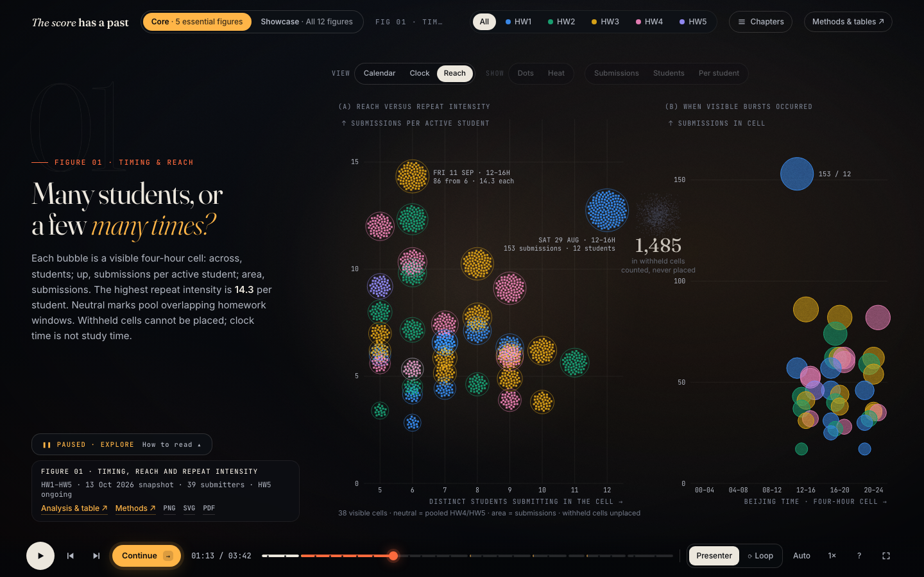
Figure 1 reading view: visible four-hour windows by students and submissions per student, beside their time of day
Each bubble is a four-hour window with at least five students: across, students submitting; up, submissions per student; area, submissions. Viewers switch between a calendar, a spiral clock and this reach view, choose dots or heat, and change the measure. The largest visible window held 153 submissions from 12 students; the most intense held 86 from only 6, or 14.3 each. Every published window falls between noon and midnight, while 1,485 submissions sit in 118 windows with fewer than five students.
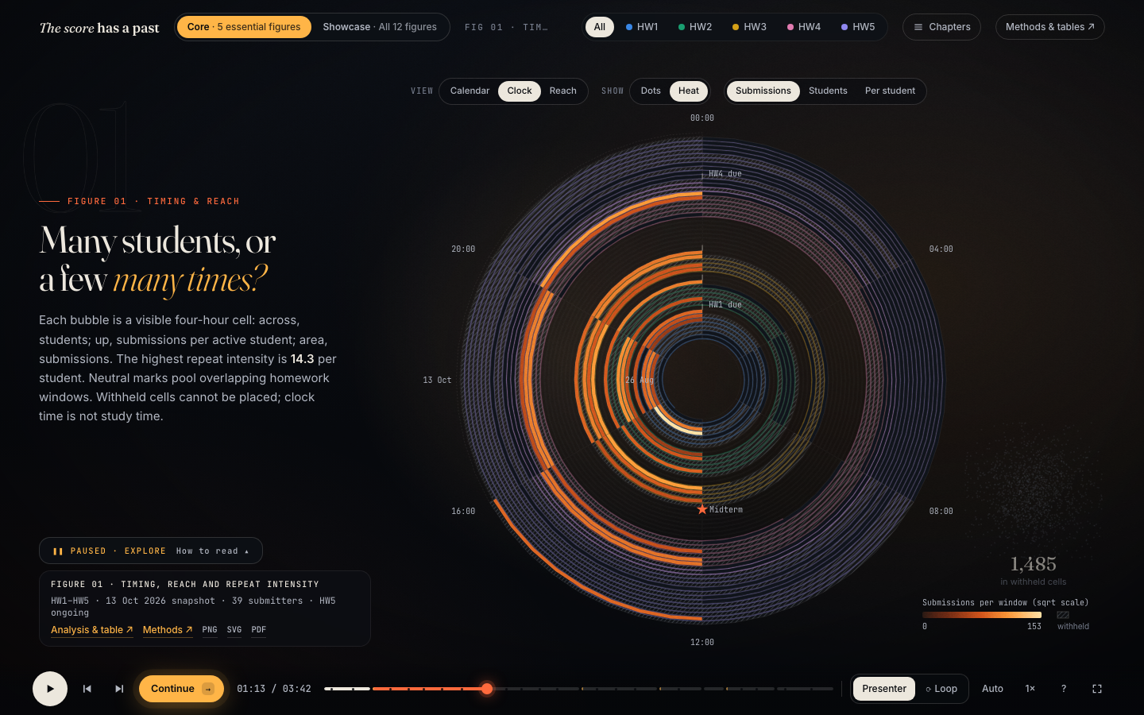
Figure 1 as a spiral clock: one turn per day from 26 Aug at the centre, angle = time of day, one dot per submission
3.2 What the 100 hides?
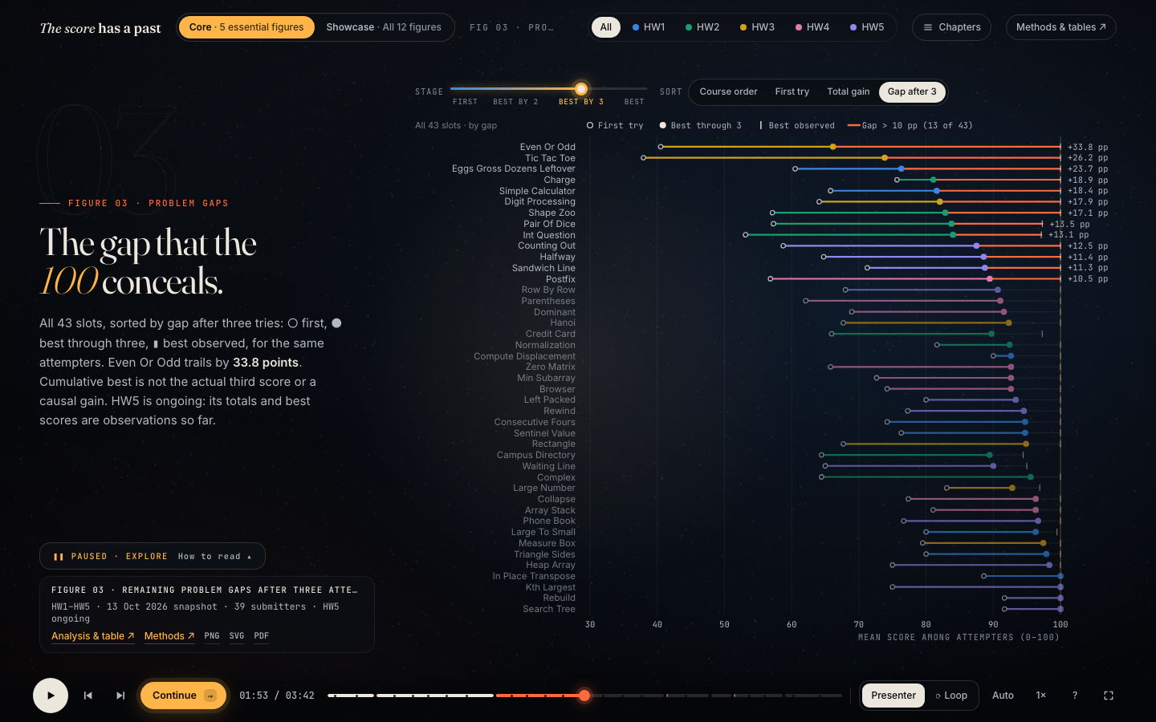
Figure 3 reading view: first try, best through three and best observed for all 43 problem slots, sorted by the remaining gap
For each of the 43 problem slots, the same students' mean first try, best within three tries and best observed. A stage control replays the climb, a sort re-ranks problems by course order, first try, total gain or gap, and clicking a problem carries it into Figure 11. After three tries, 13 slots still trail their best by more than 10 points, up to 33.8 for Even Or Odd; the lowest first try is 37.9 (Tic Tac Toe).
3.3 Do retries pay off?
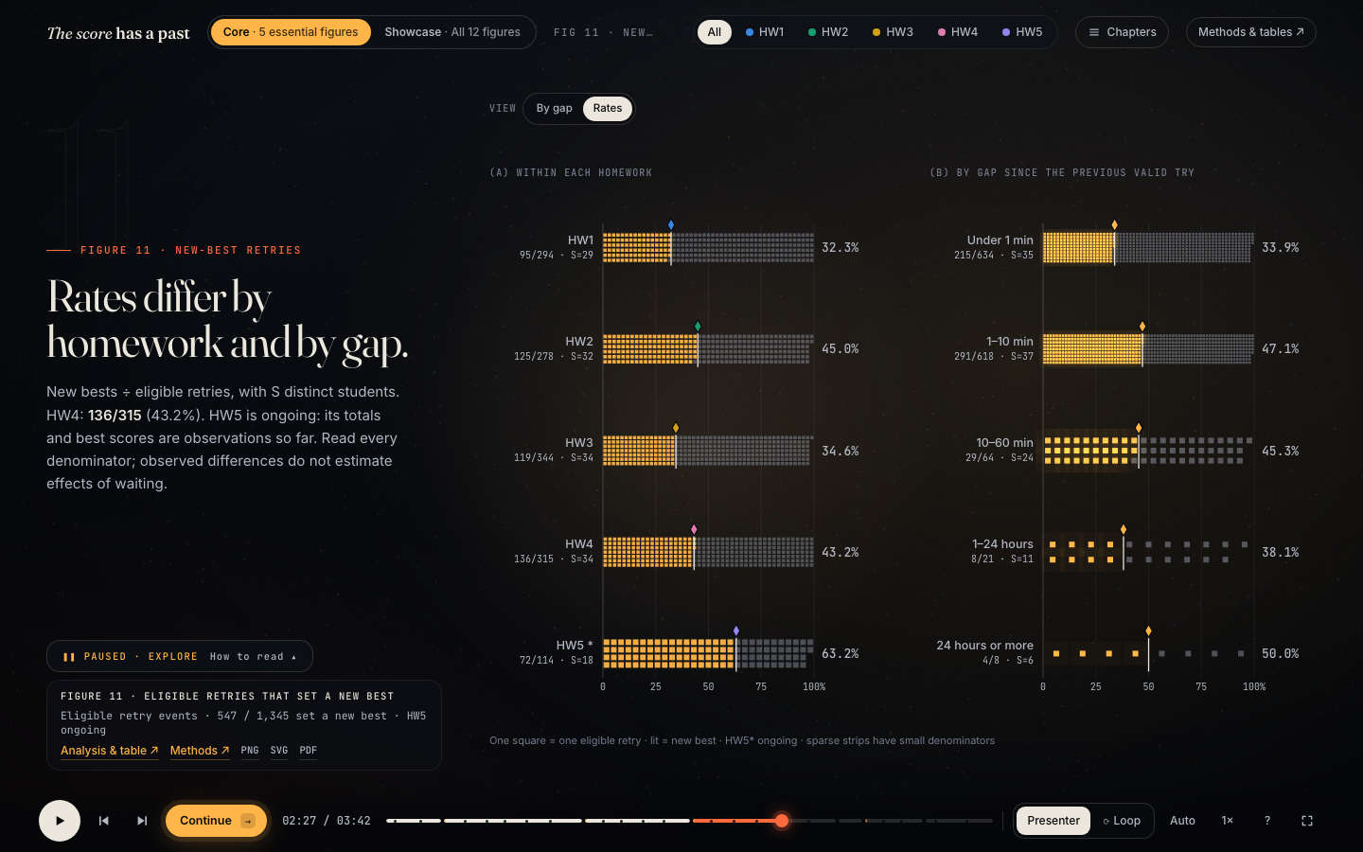
Figure 11 reading view: share of eligible retries setting a new best, by homework and by gap since the previous try
One square is one eligible retry; lit squares set a new best. Of 1,345 eligible retries, 547 (40.7%) did, from 32.3% in HW1 to 45.0% in HW2 (HW5's 63.2% is provisional). Retries within a minute of the previous one made up 47% of the total and improved least often: 33.9%, against 47.1% after 1–10 minutes. The problem view places each problem by retry count and rate; the problem picked in Figure 03 stays ringed.
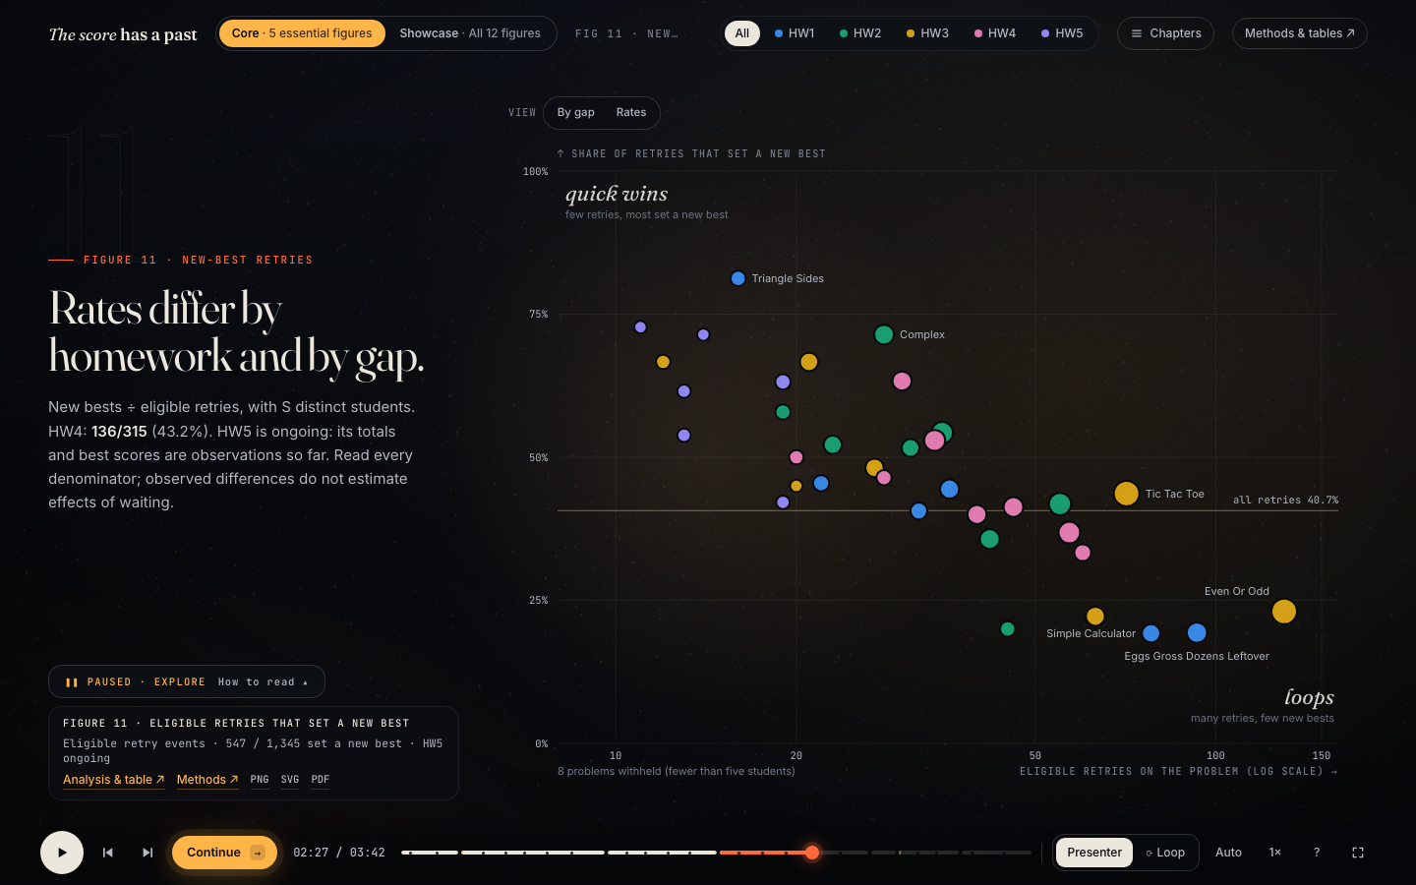
Figure 11 problem view: each problem by eligible retries (log scale) and share setting a new best
3.4 When in the window?
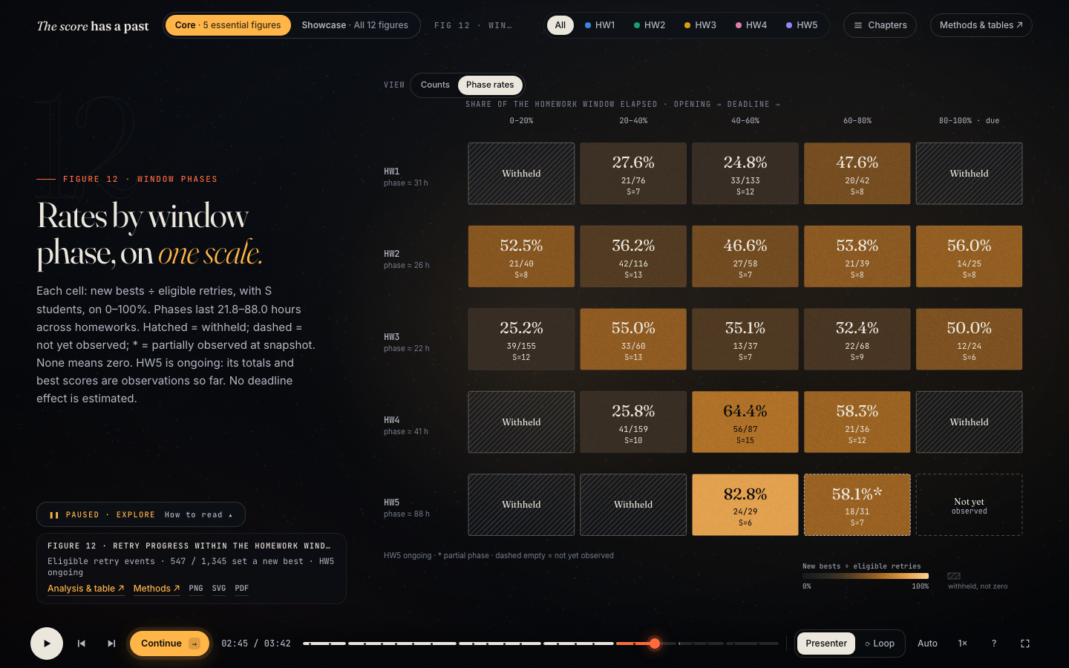
Figure 12 reading view: new-best rate in five equal phases of each homework window
Each homework window is cut into five equal phases on one 0–100% scale, with counts and students per cell; viewers switch between counts and rates. Visible rates run from 24.8% to 82.8%, and no single pattern repeats across homeworks. Six cells are withheld and HW5's last phase is not yet observed; neither is drawn as zero.
3.5 Does it travel with the exam?
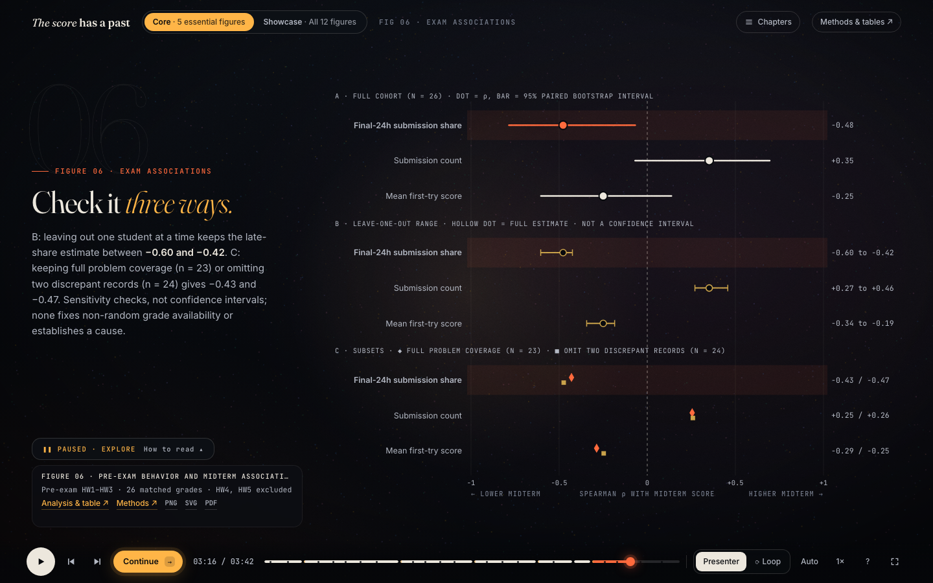
Figure 6 reading view: Spearman correlations with bootstrap intervals, leave-one-out ranges and subset checks
For 26 students with supplied grades, three pre-exam behaviours are correlated with the midterm score, then checked by leaving out each student and by two subsets; hovering a row gives its values. The share of submissions sent in the final 24 hours has ρ = −0.48 (95% interval −0.78 to −0.07), the only interval entirely below zero, and stays between −0.60 and −0.42 without any one student. Submission count (+0.35) and mean first-try score (−0.25) cross zero.
3.6 Interactions across the site
Interaction | Where | What it lets viewers do
Choose the content route | Header: Core (5 figures) or Showcase (12) | Take the short story or the full tour
Homework lens (coordinated highlight) | Header; applies to every homework chart | Follow one homework through all views
Change the view or measure | Figure 01 calendar, clock, reach; Figures 11–12 gap, rates, problems, counts | Ask a different question of the same data
Sort | Figure 03: course order, first try, total gain, gap after three | Re-rank problems by what the task needs
Select and link | Click a problem in Figure 03; it stays ringed in Figure 11 | Trace one problem from score gap to retries
Details on demand | Hover any mark | Exact counts, denominators and students
Navigate the story | Play, pause, scrub, chapters, keyboard, deep links; Presenter, Auto, Loop | Present live and stop on any frame
Evidence links | Each figure's evidence dock | Open its analysis, methods, tables and downloads

- Discussion
4.1 What & Why & How
The design works best where it shows a number together with its denominator and uncertainty, and is weakest where privacy rules or a small sample hide part of the picture.
Figure | What (data and attributes) | Why (user task) | How (idiom, marks, channels)
Timing | Four-hour windows: students and submissions (quantitative), time of day (cyclic), homework (categorical) | Find bursts; tell many students from a few students repeating | Bubble scatter (position, area); spiral clock (angle = time of day, radius = day), a non-linear temporal idiom; calendar heatmap (luminance)
Gaps | Per problem: first try, best within three, best observed (quantitative); homework | Compare start and finish; rank the remaining gaps | Dot-and-line plot on one score axis; ordered rows; orange length = gap
Retries | Eligible retries and new bests by homework and gap bin (ordinal) | Compare rates while seeing their denominators | Unit waffle and 100% strips (count, length); problem scatter (log position, area = students)
Phases | Rate by homework × window phase; withheld, partial and unobserved states | Locate when in the window retries progress | Heat matrix with one sequential scale; hatching and dotted outlines for states
Exam | ρ, bootstrap interval, leave-one-out range, subset ρ | Judge direction, uncertainty and robustness | Forest plot on a shared −1 to +1 axis; marker shape per check; colour only for the clear result

4.2 Strengths
- The figures form one story, from when work happens, to whether retries help, to what the final score hides and how it relates to the exam.
- Uncertainty and privacy stay visible: intervals, robustness checks, n of N and student counts, and withheld cells drawn as labelled states rather than zeros.
- Interactions serve tasks: the lens compares one homework everywhere, sorting re-ranks problems, and a selected problem carries from Figure 03 into Figure 11. Every chart also has an accessible table on an evidence page that works without JavaScript.
- One public aggregate drives the film, the static figures and the poster, and tests check the numbers and the claims built on them.
4.3 Weaknesses and limitations
- Privacy suppression withholds 1,485 of 3,359 submissions (44%) from the timing view, so morning and late-night work is under-represented.
- The data are observational and small: 26 of 41 midterm grades, a non-random excerpt, and HW5 still open at the snapshot. Associations are not causes, submissions are not effort, and gaps between submissions are not study time.
- Cinematic transitions can compete with reading. We hold on every reading view, offer reduced-motion fades and page long views on small screens, but the film still asks more attention than a static dashboard.
- The five homework colours are backed by labels and marker shapes, but their pairwise colour-vision separation has not been fully validated.
- Our planned reader study with timed tasks has not been run, so effectiveness rests on our own checks.
Possible improvements. Refresh the data after HW5 closes and with the full grade list; run the reader study; and add brushing of a time range in Figure 01, linked to the retry views.
- Conclusion
The same final 100 is reached along very different paths, and the timing of the work is the one process measure that travelled with the midterm.
- When. Every publishable burst fell between noon and midnight. A busy window can be many students (153 submissions from 12) or a few repeating (86 from 6, 14.3 each).
- Retries. About four in ten eligible retries set a new best (547 of 1,345). Resubmissions within a minute, nearly half of all retries, improved least often (33.9%), and timing within the window showed no single pattern.
- What the 100 hides. First tries averaged as low as 37.9 on some problems, and 13 of 43 problems were still more than 10 points short after three tries.
- The exam. Among 26 supplied grades, a larger share of submissions in the final 24 hours went with a lower midterm score (ρ = −0.48), stable when any one student is left out. Submission count and first-try score were inconclusive.
For students, the project turns a gradebook of 100s into a picture of how those 100s were earned, and it raises questions worth testing: whether pausing before a retry, or starting before the final day, helps. For TAs and instructors, it shows which problems leave large gaps and when repeated attempts pile up. All of this is observational evidence from one course, communicated with its denominators, intervals and privacy limits visible.
- Roles and responsibilities
Member | Responsibilities
Zaozao Wang | Data acquisition (online-judge snapshot and queries, grade excerpt, Course Pulse export), cleaning, aggregation, privacy rules and statistical analysis; Led the poster.
Zhengxiang Liu | Visualization design and the D3 implementation of the data film and its interactions; Led the report and presentation.

