UPGRADING KUIPER V4 DEPLOYMENT TO NEW DUAL-STACK DEPLOYMENT

This guide covers upgrading an existing IPv4 Autoscale deployment to dual-stack (IPv4 + IPv6) Autoscale deployment.
Existing IPv4 solution is deployed using previous code: https://bitbucket-eng-bgl1.cisco.com/bitbucket/projects/VCB/repos/cloud_autoscale/browse/AWS/FTDV?at=feature%2Fkuiper_poc

And is migrated to Dualstack solution using new code:
<link>

GROUND RULES
- Update within same Topology only. Update IPv4 Single-arm to Dual-Stack Single-arm , IPv4 Dual-arm to Dualstack Dual-arm.
- The upgrade is verified with old Deployment VPC having only those resources in it created by the CloudFormation Stacks. Presence of additional resources created manually within VPC might interfere with Upgrade.
- Existing IPv4 FMCv can handle registration and configuration of Dualstack FTDvs
- Upgrading of Cloud WAN and other dependent resources/service to Dualstack should be done manually

EXISTING IPv4 SETUP DETAILS
Autoscale Group has 3 IPv4 FTDs registered to IPv4 FMCv and fully configured

UPGRADE STEPS

GIT CLONE NEW CODE REPOSITORY
Git clone Autoscale Repository on branch “kuiper_ipv6_poc” to local.
Link - https://bitbucket-eng-bgl1.cisco.com/bitbucket/projects/VCB/repos/cloud_autoscale/browse/AWS/FTDV/GWLB-Autoscale-Deploy-Steps.md?at=refs%2Fheads%2Ffeature%2Fkuiper_ipv6_poc
Templates: Cloud_Autoscale/AWS/FTDV/templates
Lambda functions: Cloud_Autoscale/AWS/FTDV/lambda-python-files
Sample configuration: Cloud_Autoscale/AWS/FTDV/sample-configuration-jsons

INFRASTRUCTURE STACK UPDATE
Upgrade the Infrastructure Stack first using “Update Stack” option
- Update stack > Create a Change Set > Replace Existing Template > Upload a template file > Choose the new Infra template "infrastructure_gwlb.yaml" > Next
- Under “Specify change set details”, change “Parameters” as given below -
  - Parameters : Set "Dual Stack" to "True". DO NOT CHANGE ANY OTHER PARAMETERS ELSE INFRA RESOURCES WILL BE REPLACED AND FURTHER STEPS WILL FAIL.
- Next > Next
- Under “Review Change Set” Parameters diff should look as shown below-
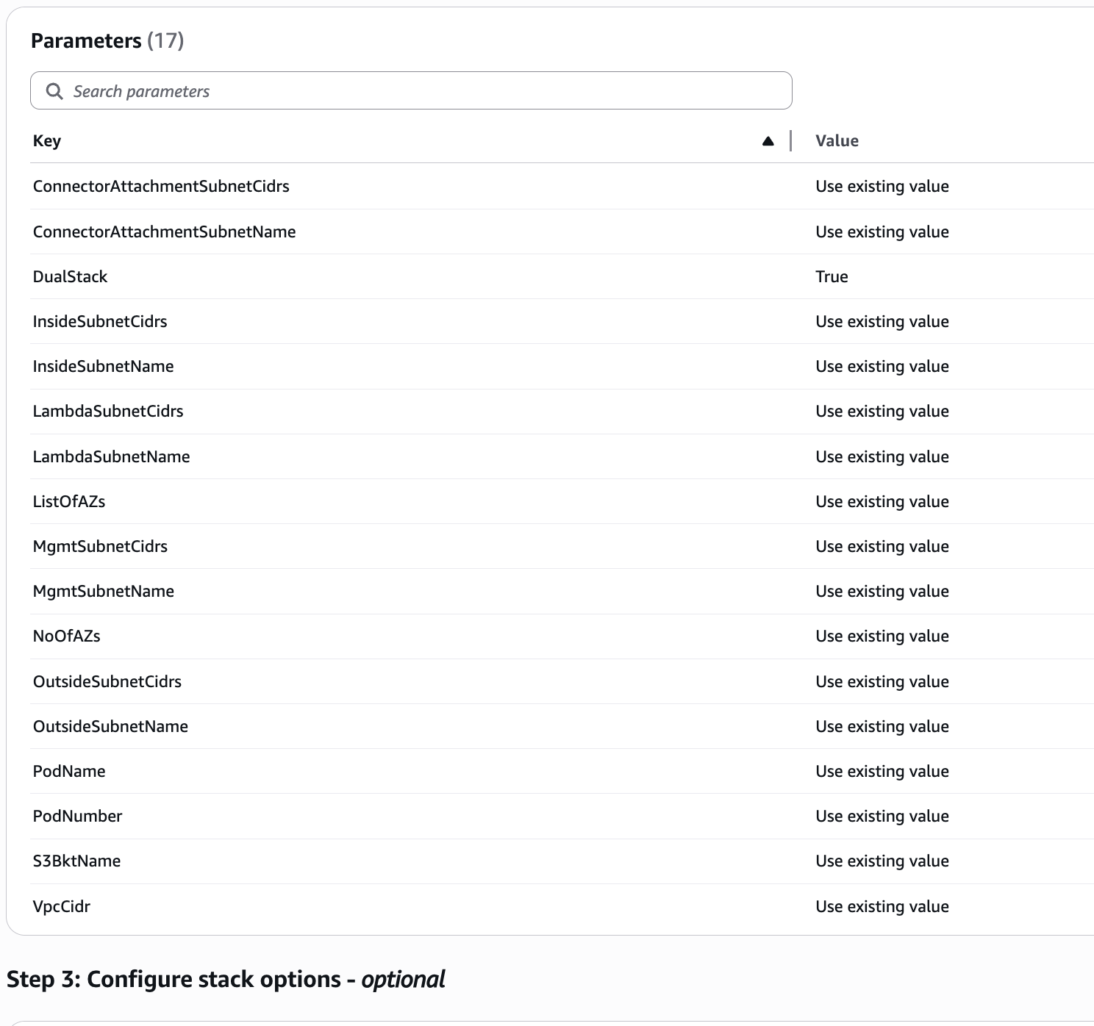
Figure: [Infrastructure Stack] - Review Change Set Parameters Diff

- Create Change Set
- Execute Change Set. Select Options -
  - Behavior on provisioning failure = "Roll back all stack resources"
  - "Delete all newly created resources"
- If successfully updated, 44 Resources will be present (previously 40)
- VPC and Subnets have IPv6 CIDRs added, Security Groups and Routing Tables have IPv6 entries created. Egress-only IGW is created.
- If Update fails, all newly created resources will be deleted and Stack rolls back to previous stable state.

FMCv NEW OBJECT CREATION
  - [Existing FMCv] - Create a new empty Device Group.
  - [Existing FMCv] - Associate new Device Group to existing Access Policy.
  - [Existing FMCv - Let Security Zones be as is
  - [Existing FMCv] - [DUAL-ARM ONLY] Create object "IPv6-Application- CIDRs" specifying all Application IPv6 CIDRs for East-West Traffic

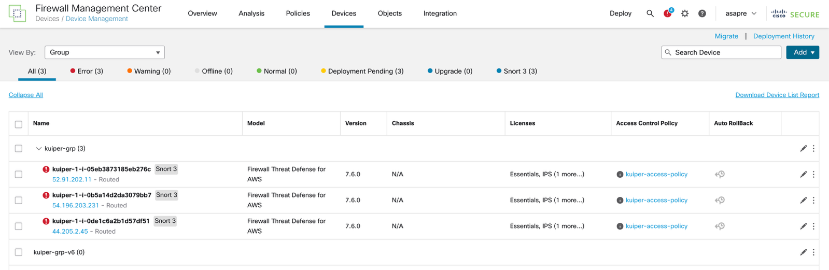
Figure: FMCv – Empty Device Group “kuiper-grp-v6” created
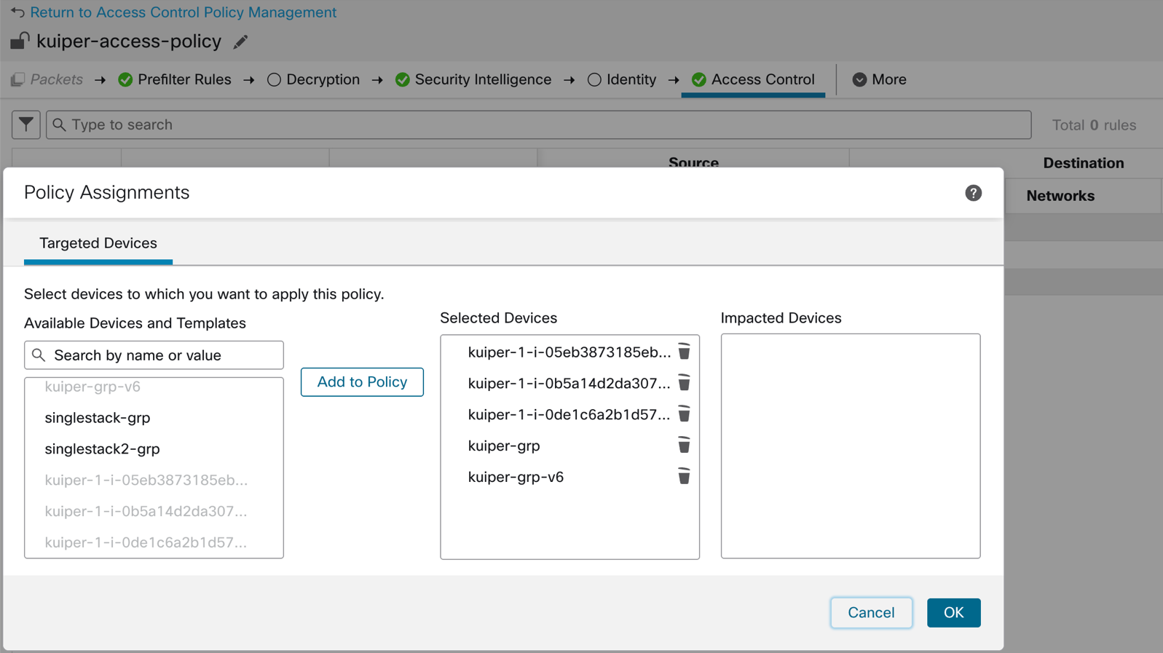

Figure: FMCv – Associate new Device group “kuiper-grp-v6” to existing Access Policy

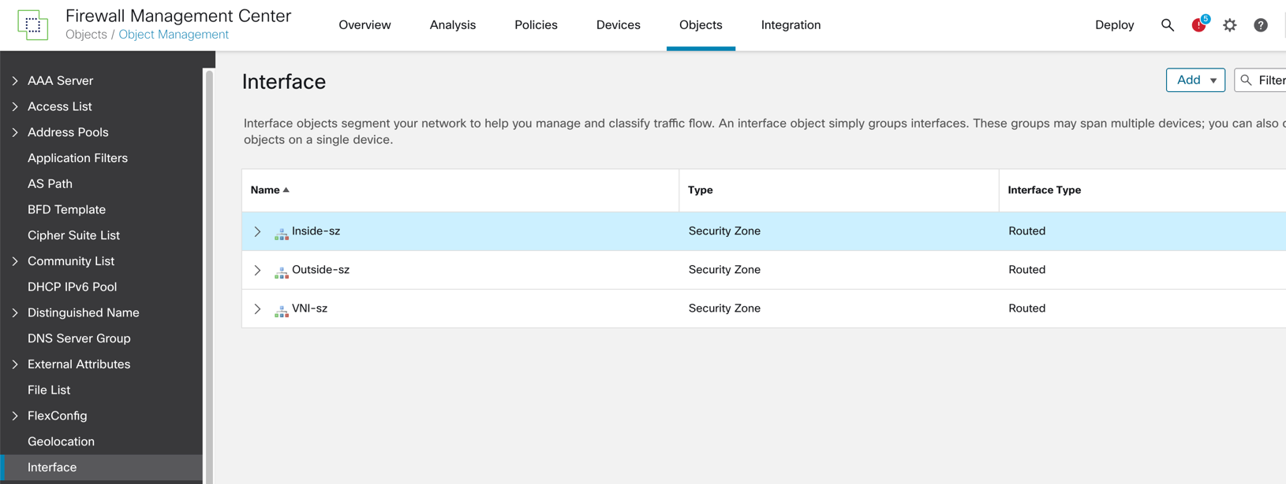
Figure: FMCv – Security Zone Objects for Inside, Outside, VNI Interfaces (existing)

Figure: FMCv – “IPv6-Application-CIDRs” Network Object created

NOTE DOWN FMCv OBJECT VALUES FROM EXISTING CONFIGURATION.JSON
Note down values in "AWS > Manager Lambda > Code > Configuration.json" somewhere, since this file will be over-written when updated Lambda Code Zips are uploaded to Lambda functions

AUTOSCALE STACK UPDATE
- Update stack > Create a Change Set > Replace Existing Template > Upload a template file > Choose the new Autoscale template "deploy_ngfw_autoscale_with_gwlb.yaml" > Next
- Under “Specify change set details”, change “Parameters” as given below -
  - Parameters: Set "Dual Stack" to "True"
  - Parameters: Set "FMC Device Group Name” to new Device Group created in FMCv
  - DO NOT CHANGE ANY OTHER PARAMETERS ELSE RESOURCES WILL BE REPLACED AND FURTHER STEPS MAY FAIL.
- Next > Tick mark all 3 Acknowledgements > Next
- Under “Review Change Set” Parameters diff should look as shown below-

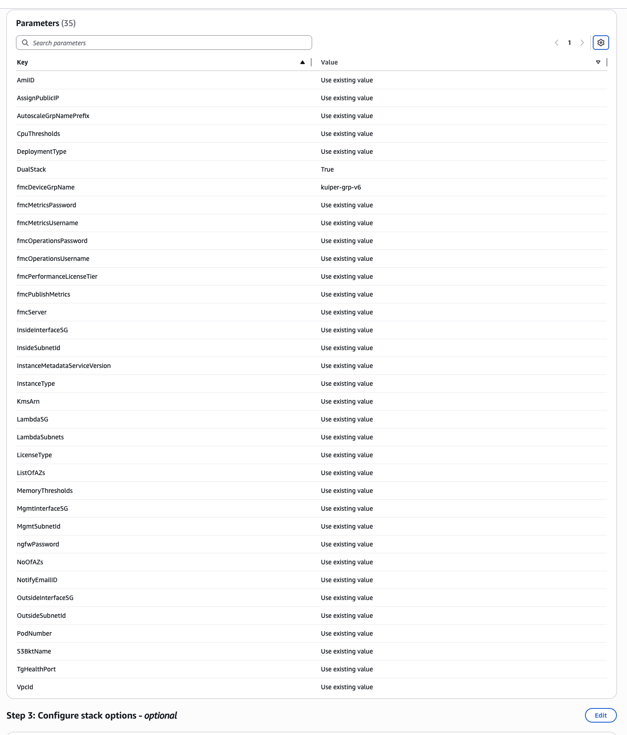
Figure: [Autoscale Stack] - Review Change Set Parameters Diff

- Create Change Set
- Execute Change Set. Select Options -
  - Behavior on provisioning failure = "Roll back all stack resources"
  - "Delete all newly created resources"
- Once UPDATE is Successful, verify that Autoscaling Group is associated with “Latest” Launch Template version (having Dualstack UserData). If not, manually associate Autoscaling Group to latest Launch Template version. Set default Launch Template version to “Latest”.

GENERATE AND UPLOAD NEW ZIP FILES TO S3 BUCKET
- In a terminal, navigate to “Cloud_Autoscale/AWS/FTDV” within the new code repository
- Run command "python3 make.py build". This will Generate Zip files for the Lambda functions in a new directory “target”
- Replace old function Zip files in S3 Bucket
  - Go to the Autoscale Bucket under AWS > S3 > Buckets.
  - Delete old function Zip files “autoscale_manager.zip”, “lifecycle_ftdv.zip”, “custom_metric_fmc.zip” from Bucket
  - Upload the 3 newly-generated function Zip files with same name to Bucket
  - Let existing Layer “autoscale_layer.zip” in Bucket be as it is
- Update the Zip files to respective Lambda functions
  - Go to AWS > Lambda > Functions > Manager Lambda Function
  - Upload from > .zip file
  - Select newly-generated Zip file “autoscale_manager.zip”
  - Similarly upload “lifecycle_ftdv.zip” to Lifecyle Lambda and “custom_metric_fmc.zip” to Custom Metric Publisher Lambda

UPDATE CONFIGURATION.JSON WITH FMCv OBJECT VALUES
- Go to Manager Lambda Function > Code
- [DUAL-ARM ONLY] Update files “Configuration-schema.json”, “Configuration.json” with content from “sample-configuration-jsons/gwlb-dual-arm-Configuration-schema.json” and “sample-configuration-jsons/gwlb-dual-arm-Configuration.json” in new code repository. (Default content in JSON files is for Single-arm)
- Update Configuration.json’s fields with existing FMCv object values for: Interface Names, Security Zones, Access Policy, Interface Config
- Enter a new value (other than existing Platform Policy in FMCv) for "fmcPlatformPolicyName", since Lambda creates new Platform Policy for Dualstack devices.
- [DUAL-ARM ONLY] Enter a new value (other than existing NAT Policy in FMCv) for "fmcNatPolicyName", since Lambda creates new NAT policy for Dualstack devices.
- Click “Deploy” after doing changes

BRING UP NEW FTDv DEVICES IN AUTOSCALE GROUP
- Increase Autoscale Group’s Desired Capacity by 1, to bring up a Dualstack-configured FTDv
- Monitor Instance’s Tags – A fully-configured FTDv Instance’s Tags should reflect
  - “NGFWvConnectionStatus” = "AVAILABLE"
  - “NGFWvRegistrationStatus = "DONE"
  - NGFWvConfigurationStatus = "DONE"
  - NGFWvConfigDeployStatus = "DONE"
- If any of these tags are not as expected, check the CloudWatch Logs of
Autoscale Manager Lambda for error messages
- After 1 FTDv is correctly configured, increase Desired Capacity such that no. of New Dualstack FTDvs = no. of Old IPv4 FTDvs

CLEANUP FMCv OBJECTS AND OLD IPV4 FTDvs
- [AWS] - Decrease Autoscale Group Desired Capacity to original value. All old IPv4 FTDvs will Scale-in and Terminate
- [FMCv] - Delete old Device Group, old Platform Policy and old NAT Policy (DUAL-ARM ONLY). If any old IPv4 FTDvs are not deleted automatically from FMCv, delete these as well.

