   
CMX Mobile Application SDK Stress Testing

Cisco Systems, Inc.

Version 2.0

Table of Contents

1. Introduction 1

2. Tools Installation 1

2.1. JMeter 1

3. Simulator Installation 1

3.1. MSE Simulator 1

3.2. CMX Mobile Client Simulator 1

4. Starting Test 1

4.1. MSE Simulator 1

4.1.1. MSE Simulator Configuration 2

4.1.2. Running MSE Simulator 5

4.1.3. Multiple MSE Simulator Instances 5

4.2. CMX Mobile Client Simulator 6

4.2.1. CMX Moblie Client Simulator Configuration 6

4.2.2. Running CMX Moblie Client Simulator 9

4.2.3. Multiple CMX Moblie Client Simulator Instances 9

5. Verifying Test 10

5.1. MSE Simulator 10

5.2. CMX Mobile Client Simulator 10

5.3. CMX Mobile Application Server 10

6. Monitoring Test 12

6.1. MSE Simulator 12

6.2. CMX Mobile Client Simulator 12

6.3. CMX Mobile Application Server 12

# Introduction

CMX Mobile Application SDK is stress tested using two sets of simulators. There is a simulator for MSE which will send the initial venue configuration data and client movement updates for a specified number of clients. The second simulator will simulate a specified number of clients doing a registration followed by continuous location requests for current client position.

# Tools Installation

The stress testing requires JMeter for the MSE simulator and client simulator

## JMeter

Download JMeter from <http://jmeter.apache.org/download_jmeter.cgi>. There is a binary bundle which can be downloaded and extracted onto the system.

# Simulator Installation

After JMeter is installed the simulators can then be installed

## MSE Simulator

The simulator is a jmx file named *cmx_mse.jmx.* This file needs to be copied to any directory with permissions to allow for reading the file by the same user JMeter will be running as.

## CMX Mobile Client Simulator

The simulator is a jmx file named *cmx_mobile_client.jmx.* This file needs to be copied to any directory with permissions to allow for reading the file by the same user JMeter will be running as.

# Starting Test

The MSE simulator needs to be run first to setup the CMX Mobile Application Server. This is needed to load the venue information such as the floor, points of interest and maps data. After loading the initial configuration the simulator will then start to generate client movement traffic. Once completed the CMX Mobile Client simulator can be started.

## MSE Simulator

The MSE Simulator will first send the configuration information for the venue. After doing this initial setup then the simulator will start sending movement events for all the clients defined in the client devices file. The position of the client will be moved from an X,Y of 1,1 to 100,100 before starting again a 1,1. The X and Y positions will be the same number so X of 20 results in Y being 20.

### MSE Simulator Configuration

The simulator is started by using JMeter. After starting JMeter you can open the JMX file and make configuration changes as needed in the UI. First start jmeter running the jmeter command from the installed bin directory.

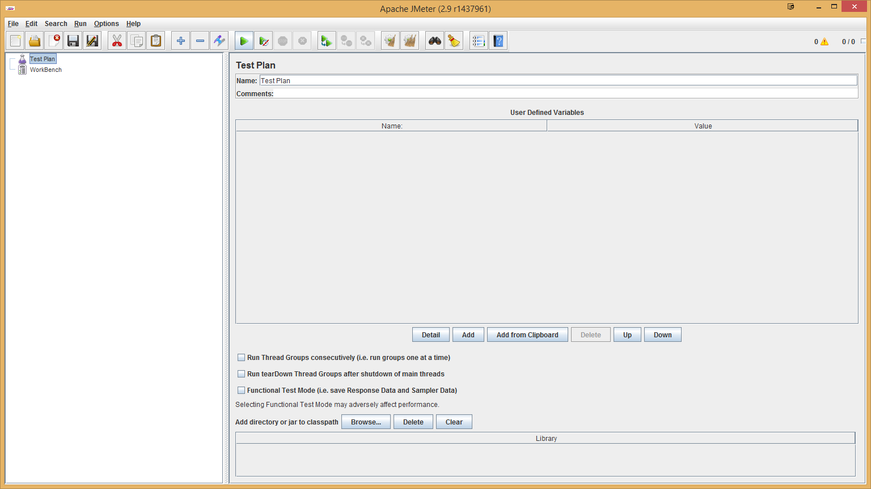

Load the test by opening the JMX test script *cmx_mse.jmx*.

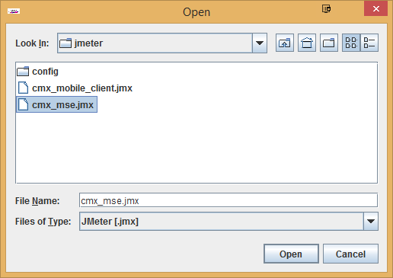

When the file is opened the Test Plan will be loaded with some default options. The options can be modified to match the current setup and desired configuration settings. The options for the CMX Mobile App Server can be changed by selecting the **CMX Mobile App Server Variables** config element. Make sure to enter the correct IP address of the server in the Value column for the variables.

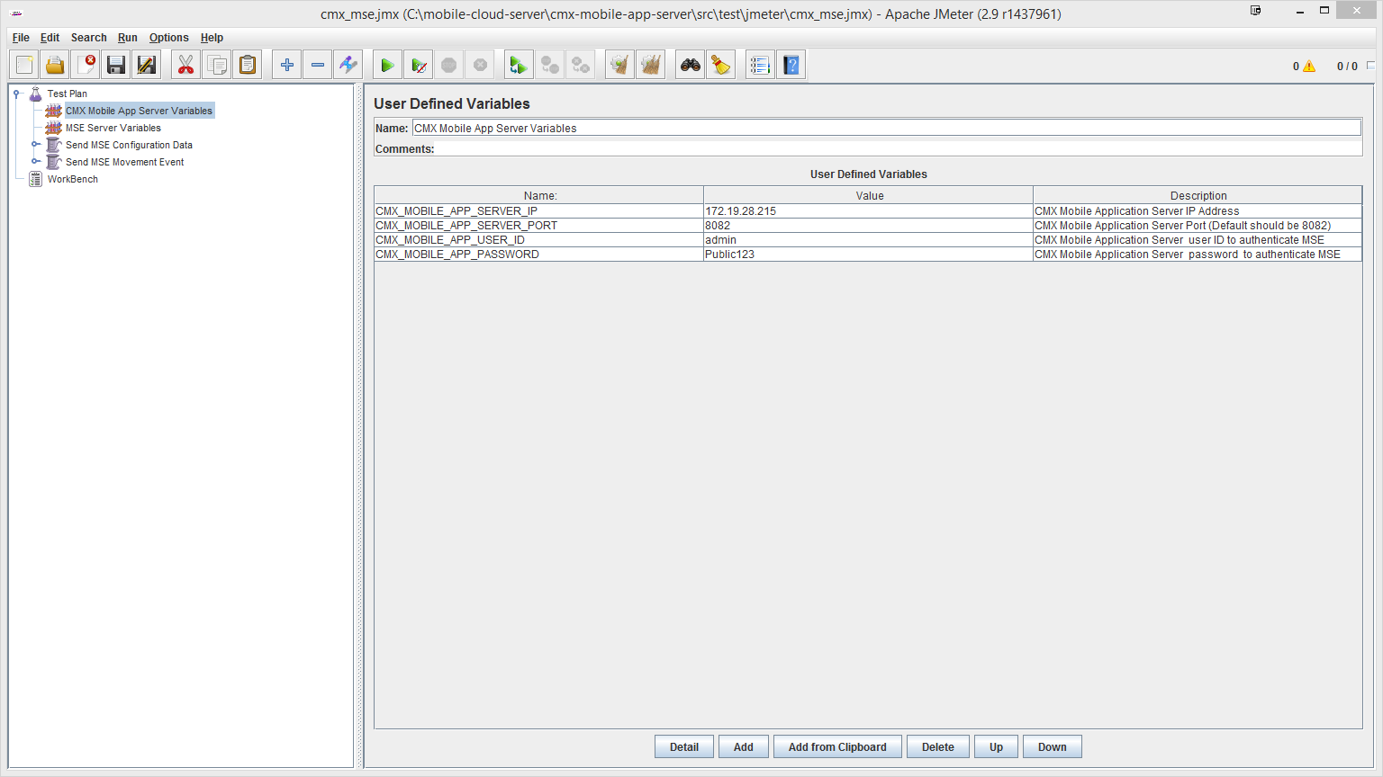

The options for the MSE Server can be changed by selecting the **MSE Server Variables** config element. The number of threads can be adjusted and client devices file can be changed. All the clients in the file will be used no matter the number of threads used. The threads will loop through the entire file and repeat from the start when sending movement events.

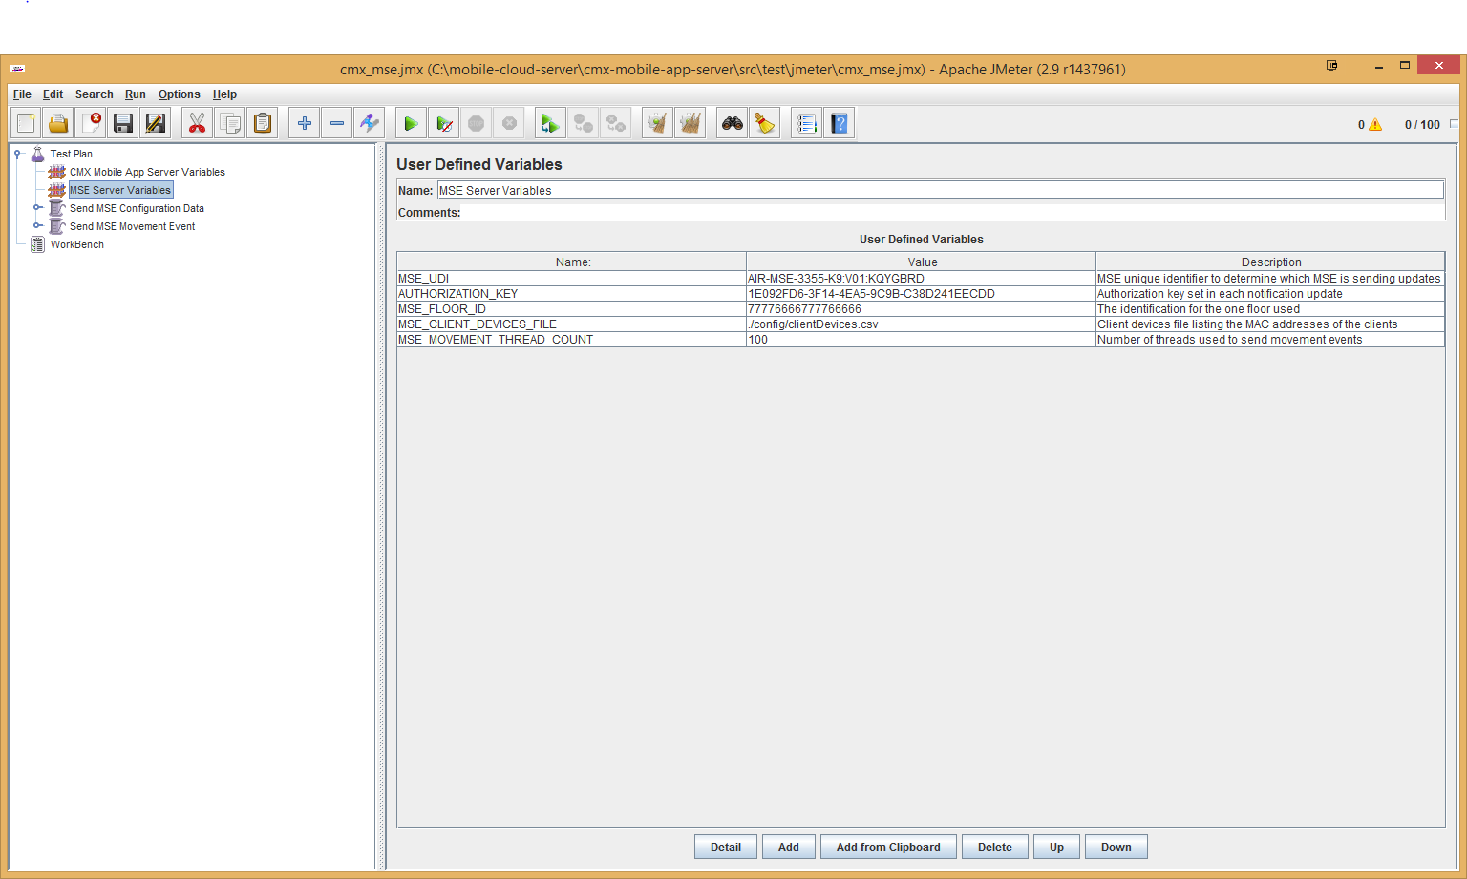

Save any changes by selecting **File -> Save** option and exit JMeter by selecting **File -> Exit**.

### Running MSE Simulator

The test can be run using the JMeter user interface but the better option is to run from the command line. The following will run the jmeter script cmx_mse.jmx and the –n option indicates JMeter to run in non-GUI mode.

*jmeter –n -t cmx_mse.jmx*

### Multiple MSE Simulator Instances

Multiple instances of the MSE simulator can be run to allow for increased number of clients to run simultaneouily. The simulator allows for multiple instances to run by changing the client devices file. The file is changed by selecting the **MSE Server Variables** config element. The **MSE_CLIENT_DEVICES_FILE** variable is used to determine which devices file to load. Changing this file to another file will load in those client MAC addresses listed in the file.

## CMX Mobile Client Simulator

The CMX Mobile Client Simulator will first register with the CMX Mobiel Application Server. The registration will return a device key to be used to query for client location. The client will then repeatedly query for the client location for a specified number of attempts. Then the simulator will repeat with the next client in the thread.

### CMX Moblie Client Simulator Configuration

The simulator is started by using JMeter. After starting JMeter you can open the JMX file and make configuration changes as needed in the UI. First start jmeter running the jmeter command from the installed bin directory



Load the test by opening the JMX test script *cmx_mobile_client.jmx*.

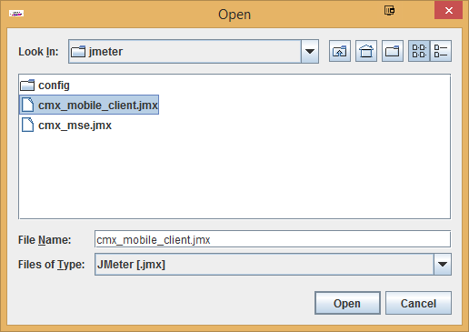

When the file is opened the Test Plan will be loaded with some default options. The options can be modified to match the current setup and desired configuration settings. The options for the CMX Mobile App Server can be changed by selecting the **CMX Mobile App Server Variables** config element. Make sure to enter the correct IP address of the server in the Value column for the variables.

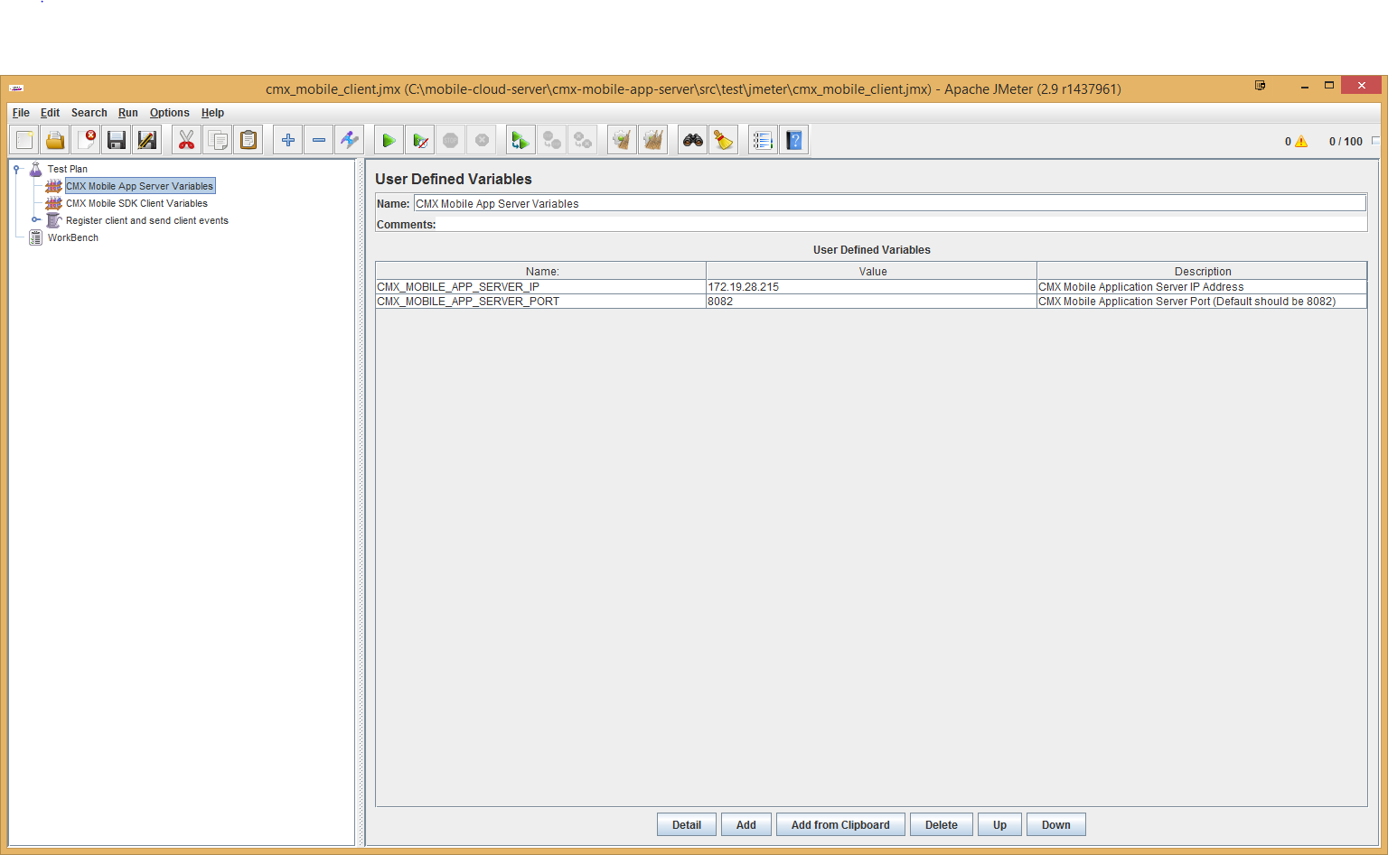

The options for the Mobile SDK Client can be changed by selecting the **CMX Mobile SDK Client Variables** config element. The number of threads can be adjusted and client devices file can be changed. All the clients in the file will be used no matter the number of threads used. The threads will loop through the entire file and repeat from the start when sending movement events. The variable **CMX_MOBILE_SDK_CLIENT_THREAD_COUNT** indicates the number of threads to run and for each thread the request rate is equivalent to 10 clients. The default settings is 100 threads which is 1,000 clients.

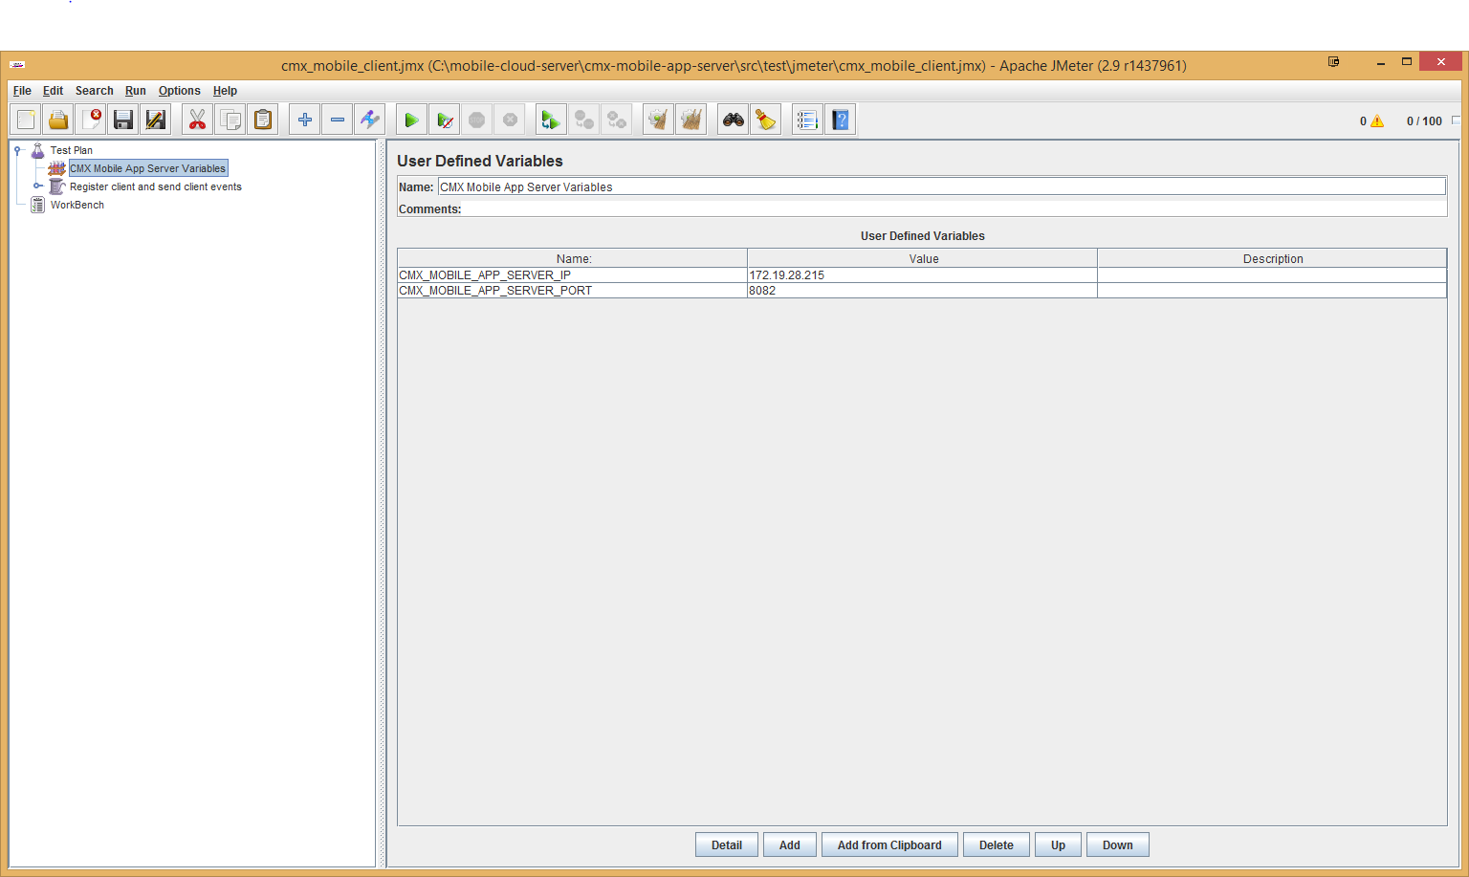

Save any changes by selecting **File -> Save** option and exit JMeter by selecting **File -> Exit**.

### Running CMX Moblie Client Simulator

The test can be run using the JMeter user interface but the better option is to run from the command line. The following will run the jmeter script cmx_mobile_client.jmx and the –n option indicates JMeter to run in non-GUI mode.

*jmeter –n -t cmx_mobile_client.jmx*

### Multiple CMX Moblie Client Simulator Instances

Multiple instances of the CMX Mobile Client simulator can be run to allow for increased number of clients to run simultaneouily. The simulator allows for multiple instances to run by changing the client devices file. The file is changed by selecting the **CMX Mobile SDK Client Variables** config element. The **CMX_MOBILE_SDK_CLIENT_DEVICES_FILE** variable is used to determine which devices file to load. Changing this file to another file will load in those client MAC addresses listed in the file.

# Verifying Test

The test will continue to execute even if failures are occurring. This allows the test to run even if intermittent issues occur while running. Veficiation of the test can be done to make sure the issue is not just an intermittent issue.

## MSE Simulator

When sending the test is running every 30 seconds the command line will display a summary result for the current running test.

*summary + 63393 in 30.1s = 2106.8/s Avg: 47 Min: 3 Max: 318 Err: 0 (0.00%) Active: 100 Started: 100 Finished: 0*

*summary = 357268 in 190s = 1884.9/s Avg: 52 Min: 3 Max: 927 Err: 0 (0.00%)*

## CMX Mobile Client Simulator

When sending the test is running every 30 seconds the command line will display a summary result for the current running test.

*summary + 63393 in 30.1s = 2106.8/s Avg: 47 Min: 3 Max: 318 Err: 0 (0.00%) Active: 100 Started: 100 Finished: 0*

*summary = 357268 in 190s = 1884.9/s Avg: 52 Min: 3 Max: 927 Err: 0 (0.00%)*

## CMX Mobile Application Server

The MSE Simulator can be verified to be working properly on the CMX Mobile Application Server by checking the configuration and location events count. Change to the directory /opt/cmx-mobile-app-server/bin directory on the CMX Mobile App Server. Run the command ./getServerConfig.sh. The configuration should display the Venue ID defined for the test.

*[ INFO] 2014-09-16 18:54:59,399 - ------- Venue Information -------*

*[ INFO] 2014-09-16 18:54:59,401 - Venue Name: CiscoTestVenue*

*[ INFO] 2014-09-16 18:54:59,401 - Venue Description: Cisco Test Venue*

*[ INFO] 2014-09-16 18:54:59,401 - Venue ID: 666677776666*

*[ INFO] 2014-09-16 18:54:59,401 - MSE IP Address:*

*[ INFO] 2014-09-16 18:54:59,406 - Created Date: 31 Dec 1970 16:00:00.00*

*[ INFO] 2014-09-16 18:54:59,406 - Last Update Date: 31 Dec 1970 16:00:00.00*

*[ INFO] 2014-09-16 18:54:59,406 - MSE UDI ID: AIR-MSE-3355-K9:V01:KQYGBRD*

*[ INFO] 2014-09-16 18:54:59,406 - Latitude: 0*

*[ INFO] 2014-09-16 18:54:59,406 - Longitude: 0*

*[ INFO] 2014-09-16 18:54:59,406 - Mobile Push Notification Message:*

*[ INFO] 2014-09-16 18:54:59,409 - ------- Floor Information -------*

*[ INFO] 2014-09-16 18:54:59,409 - Floor Name: Main Floor*

*[ INFO] 2014-09-16 18:54:59,409 - Floor Description: Main Floor Description*

*[ INFO] 2014-09-16 18:54:59,409 - Floor ID: 11116666*

*[ INFO] 2014-09-16 18:54:59,409 - Created Date: 31 Dec 1970 16:00:00.00*

*[ INFO] 2014-09-16 18:54:59,409 - Last Update Date: 31 Dec 1970 16:00:00.00*

*[ INFO] 2014-09-16 18:54:59,409 - POI Count For Floor: 0*

*[ INFO] 2014-09-16 18:54:59,409 - POI Count For Floor: 0*

*[ INFO] 2014-09-16 18:54:59,409 - Floor Count For Venue: 1*

*[ INFO] 2014-09-16 18:54:59,409 - POI Count For Venue: 0*

*[ INFO] 2014-09-16 18:54:59,410 - ------- Total Venue Information -------*

*[ INFO] 2014-09-16 18:54:59,410 - Venue Count: 1*

*[ INFO] 2014-09-16 18:54:59,410 - Floor Count Total: 1*

*[ INFO] 2014-09-16 18:54:59,410 - POI Count Total: 0*

To verify the location events are being properly sent run the command ./getServerStats.sh. The stats should display the location events count and last updated time. The time should be recent indicating events are being sent.

*[ INFO] 2014-09-16 18:57:46,023 - ------- Context Aware Service Stats --------*

*[ INFO] 2014-09-16 18:57:46,023 - Location Event Last Updated : 16 Sep 2014 18:31:30*

*[ INFO] 2014-09-16 18:57:46,023 - Total Location Events : 811836*

*[ INFO] 2014-09-16 18:57:46,023 - Location Events Per Second : 81*

The CMX Mobile Client Simulator can be verified to be working properly on the CMX Mobile Application Server by checking the client count, location and registration requests. Change to the directory /opt/cmx-mobile-app-server/bin directory on the CMX Mobile App Server. Run the command ./getServerStats.sh. The stats should display a client count increasing to match the number of clients in the devices file.

*[ INFO] 2014-09-16 18:57:42,992 - ------- Wireless Client Information --------*

*[ INFO] 2014-09-16 18:57:43,056 - Tracked Associated Clients : 0*

*[ INFO] 2014-09-16 18:57:43,063 - Tracked Clients : 5631*

The stats should display the location and register requests count and last updated time. The time should be recent indicating requests are being sent.

*[ INFO] 2014-09-16 18:57:46,024 - ------------- Mobile App Stats -------------*

*[ INFO] 2014-09-16 18:57:46,024 - Last Location Request : 16 Sep 2014 18:57:45*

*[ INFO] 2014-09-16 18:57:46,024 - Total Location Requests : 4686071*

*[ INFO] 2014-09-16 18:57:46,024 - Location Requests Per Second : 470*

*[ INFO] 2014-09-16 18:57:46,024 -*

*[ INFO] 2014-09-16 18:57:46,024 - Last Register Request : 16 Sep 2014 18:57:45*

*[ INFO] 2014-09-16 18:57:46,024 - Total Register Requests : 46913*

*[ INFO] 2014-09-16 18:57:46,024 - Register Requests Per Second : 4*

# Monitoring Test

The tests need to be periodicaly checked and monitored if still running.

## MSE Simulator

The MSE simulator should be checked periodically to determine the test is still running and has not stopped. It is possible the test may have stopped due to an error. Command line output should still be occuring every 30 seconds.

*summary + 63393 in 30.1s = 2106.8/s Avg: 47 Min: 3 Max: 318 Err: 0 (0.00%) Active: 100 Started: 100 Finished: 0*

*summary = 357268 in 190s = 1884.9/s Avg: 52 Min: 3 Max: 927 Err: 0 (0.00%)*

## CMX Mobile Client Simulator

The CMX Mobile Client simulator should be checked periodically to determine the test is still running and has not stopped. It is possible the test may have stopped due to an error. Command line output should still be occuring every 30 seconds.

*summary + 63393 in 30.1s = 2106.8/s Avg: 47 Min: 3 Max: 318 Err: 0 (0.00%) Active: 100 Started: 100 Finished: 0*

*summary = 357268 in 190s = 1884.9/s Avg: 52 Min: 3 Max: 927 Err: 0 (0.00%)*

## CMX Mobile Application Server

While the test is running the CPU and memory for the CMX Mobile Application Server is expected to rise. These should be monitored along with the network throughput of the system. If the CPU were to suddenly drop then this is an indication the test has stopped on the simulators or worse case the server has an issue. Also check if location events and location requests are still being sent by using the getServerStats.sh command.

The stats should display the location events count and last updated time. The time should be recent indicating events are being sent.

*[ INFO] 2014-09-16 18:57:46,023 - ------- Context Aware Service Stats --------*

*[ INFO] 2014-09-16 18:57:46,023 - Location Event Last Updated : 16 Sep 2014 18:31:30*

*[ INFO] 2014-09-16 18:57:46,023 - Total Location Events : 811836*

*[ INFO] 2014-09-16 18:57:46,023 - Location Events Per Second : 81*

The stats should display the location and register requests count and last updated time. The time should be recent indicating requests are being sent.

*[ INFO] 2014-09-16 18:57:46,024 - ------------- Mobile App Stats -------------*

*[ INFO] 2014-09-16 18:57:46,024 - Last Location Request : 16 Sep 2014 18:57:45*

*[ INFO] 2014-09-16 18:57:46,024 - Total Location Requests : 4686071*

*[ INFO] 2014-09-16 18:57:46,024 - Location Requests Per Second : 470*

*[ INFO] 2014-09-16 18:57:46,024 -*

*[ INFO] 2014-09-16 18:57:46,024 - Last Register Request : 16 Sep 2014 18:57:45*

*[ INFO] 2014-09-16 18:57:46,024 - Total Register Requests : 46913*

*[ INFO] 2014-09-16 18:57:46,024 - Register Requests Per Second : 4*