Cisco CMX SDK v0.9

Requirements

Mac
XCode version 5.x.

IOS
A device (iPhone/iPod/iPad) running iOS 6 or iOS 7.

Installing the SDK
Installation of the CMX SDK is very simple. Simply extract the archive called CMX SDK v0.9 (iOS).zip. After the extract process has been completed, you will get the following tree structure :
- 3rdParty : contains external library used by the CMX SDK.
- CMX : contains binary version of the SDK (framework) and the documentation (docset).
- XCode templates : contains the XCode template used to create new CMX application.

Installing the documentation
Copy com.cisco.documentation.Cisco-CMX-SDK-v0.9.docset file to ~/Library/Developer/Shared/Documentation/DocSets

Installating the template
- Create a folder called CMX in ~/Library/Developer/XCode/Templates
- Copy CMX Application (using SDK v0.8.2).xctemplate folder to ~/Library/Developer/XCode/Templates/CMX

Creating a new application

Using XCode 5, create a new project (File > New > Project...), choose the CMX Application template then press Next.
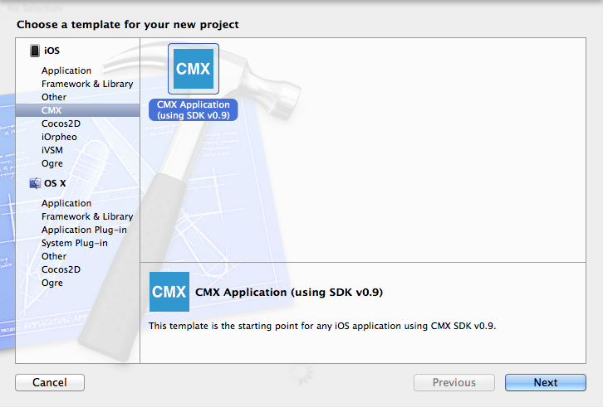
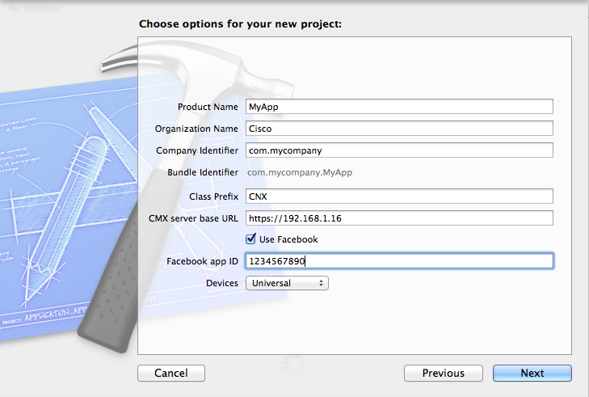
Fill the form with your own name/identifier/server URL/Facebook app ID.
Then create the project. You'll get the following project :
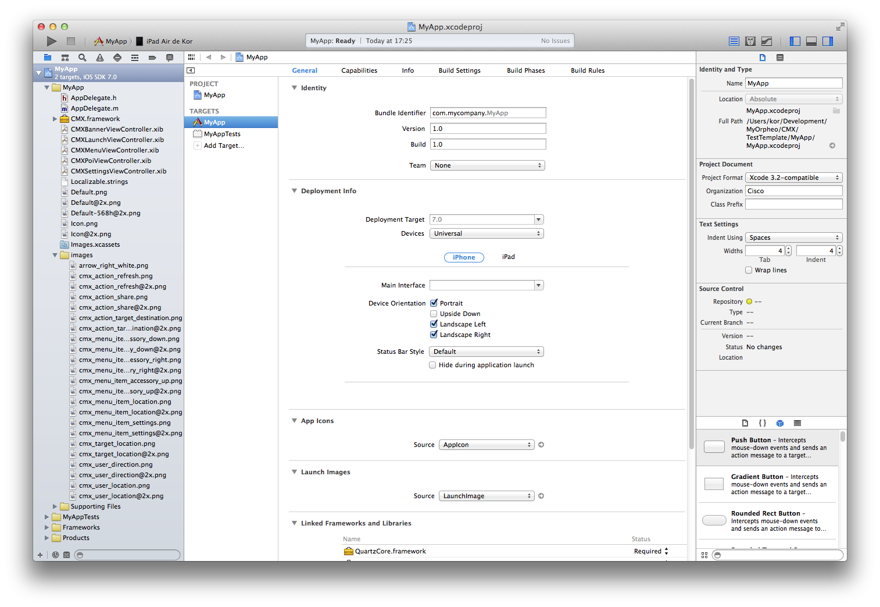

Select your target device, then build the project (Product > Build).
