|  |  |  |
| --- | --- | --- |
| Cisco_logo | Document Number | EDCS-EDCS-1170262 |
| Created By | Edgar Magana |

CTO – OpenStack Admin Guide

This document provides an administration guide for OpenStack Operators using Cygnet OpenStack to facilitate administration processes.

This is a working document. Do not take anything verbatim until CTO oversight have signed off

Reviewers

|  |  |
| --- | --- |
| * Department | * Name/Title |
| VP CTO | Lew Tucker |
| Development Engineering | [Dan Florea](mailto:nxos-arch-team@cisco.com) |
| Customer Solutions | Daneyon Hansen |
| Development Engineering | Edgar Magana |

The departments and/or individuals listed above should be notified in advance and given a sufficient time period to review this document. The Project Team determines requirements for approval according to the scope of the project.

Modification History

|  |  |  |  |
| --- | --- | --- | --- |
| * Revision | * Date | * Originator | * Comments |
| 1 | June 19, 2012 | Edgar Magana | Initial Draft |
| 2 | June 20, 2012 | Edgar Magana | Adding Services, Interfaces and Quotas |
| 3 | June 21, 2012 | Edgar Magana | Glance Images |
| 4 | June 24, 2012 | Edgar Magana | Figures Captions, Dashboard update and Adding Glance Images |
| 5 | June 25, 2012 | Edgar Magana | Removing some user-specific staff |
| 6 | June 26, 2012 | Dan Florea and Edgar Magana | Mayor Editing |
| 7 |  |  |  |

Table of Contents

CTO – OpenStack Admin Guide 1

Reviewers 1

Modification History 1

1 Introduction 3

1.1 Openstack User Interface (UI) - Dashboard 3

1.2 Customizing Dashboard 4

1.2.1 Changing the Site Title 4

1.2.2 Changing the Logo 4

2 Openstack Admin Operations 6

2.1 Managing Projects (Tenants) 6

2.2 Managing Users 7

2.3 Instances Administration 8

2.4 Services 9

2.5 System Quotas 10

2.5.1 Modifying System Quotas 11

2.6 Images 12

2.6.1 Overview Images 12

2.6.2 Deleting Images 13

2.6.3 Adding Images 14

2.6.4 Listing Images 15

3 EC2 API Comparison Matrix 16

3.1 General API Support 16

3.2 Amazon EC2 High Level Feature Support 16

3.3 Amazon EC2 API Compatability 17

4 FAQs 20

5 Support 21

6 Glossary 22

7 Apendix A 23

7.1 Hardware Monitoring OIDs 23

7.2 Services Monitoring Openstack 31

8 References 33

# Introduction

OpenStack is a global collaboration of developers and cloud computing technologists producing the ubiquitous open source cloud computing platform for public and private clouds. The project aims to deliver solutions for all types of clouds by being simple to implement, massively scalable, and feature rich. The technology consists of a series of [interrelated projects](http://openstack.org/projects/) delivering various components for a cloud infrastructure solution.[[1]](#footnote-1)

OpenStack provides a tool to orchestrate a cloud, including running instances, managing networks, and controlling access to the cloud through users and projects. It provides the software that can control an Infrastructure as a Service (IaaS) cloud computing platform. It is similar in scope to Amazon EC2 Cloud Servers. OpenStack Compute does not include any virtualization software; rather it defines drivers that interact with underlying virtualization mechanisms that run on your host operating system, and exposes functionality over a web-based API.[[2]](#footnote-2)

OpenStack can be used by many different projects (tenants) in the same system (sharing resources). Earlier versions of OpenStack used the term "project" instead of "tenant". Because of this legacy terminology, these terms are used interchangeably. The goal of this document is to provide a simple guide to help cloud computing administrators get familiar with Openstack administrative operations.

This administration guide assumes the successful deployment of OpenStack based on the installation process indicated in the OpenStack Installation Guide [1].

# Openstack User Interface (UI) - Dashboard

Openstack offers a user-friendly UI known as the Dashboard and based on an OpenStack project code named Horizon. The Dashboard offers two different views: the Admin System Panel and the Project Panel. The Admin System Panel is exclusively for administration activities such as creating projects or users and registering images. The Project Panel is specific to project administration (tenants); it helps project users manage compute servers and create new instances and volumes. This guide focuses on the Admin System Panel.

The OpenStack Dashboard is a web-based interface compatible with Firefox 13 (recommended), IE 7 and Crome 19. To acess the Dahsboard simply open your browser and type the IP address of the Horizon host server, if DNS is enable in your network the host name may be used. Figure 1 illustrates the OpenStack Dashboard Log In screen.

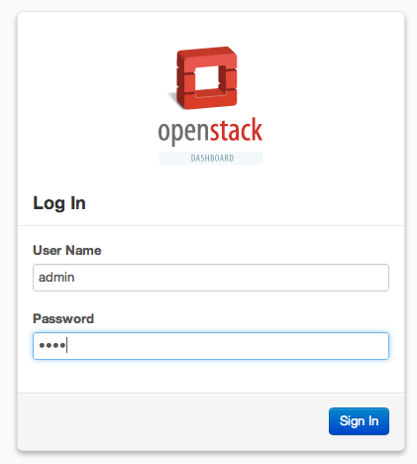

Figure 1. Openstack Log In User Interface

## Customizing Dashboard

### Changing the Site Title

The site’s title for the dashboard (i.e. Openstack) can be overwritten. To do this, add the attribute “SITE\_BRANDING” to the local\_settings.py file with the the desired name. For example: SITE\_BRANDING=<desired\_name>

The local\_settings.py file can be found in the Horizon directory path:

**#/etc/openstack-dashboard/local\_settings.py**

### Changing the Logo

To override the OpenStack Logo image, replace the image in the following file:

**/usr/share/openstack-dashboard/openstack\_dashboard/static/dashboard/img/logo.png**

The dimensions should be width: 108px and height: 121px. To activate the new logo, the package openstack-dashboard-ubuntu-theme should be unistalled by running:

**# apt-get remove openstack-dashboard-ubuntu-theme**

The following screenshot shows the OpenStack login screen with a customized logo:

**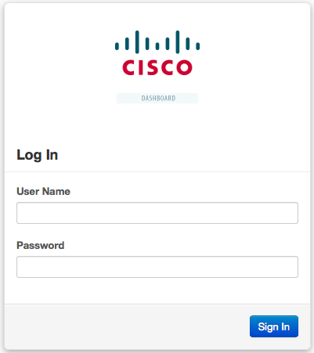**

Figure 2. Customized Openstack Log In UI

# Openstack Admin Operations

## Managing Projects (Tenants)

Openstack uses role-based access control to provide different access levels. By default, there are two roles: the admin role and the project-users role. This guide focuses on the admin role.

Administrators need to create projects and project users. In order to create a new project, first select the section named **“Project”** on the system panel. Then select “**Create New Project**” on the right top corner, as shown in the following figure:

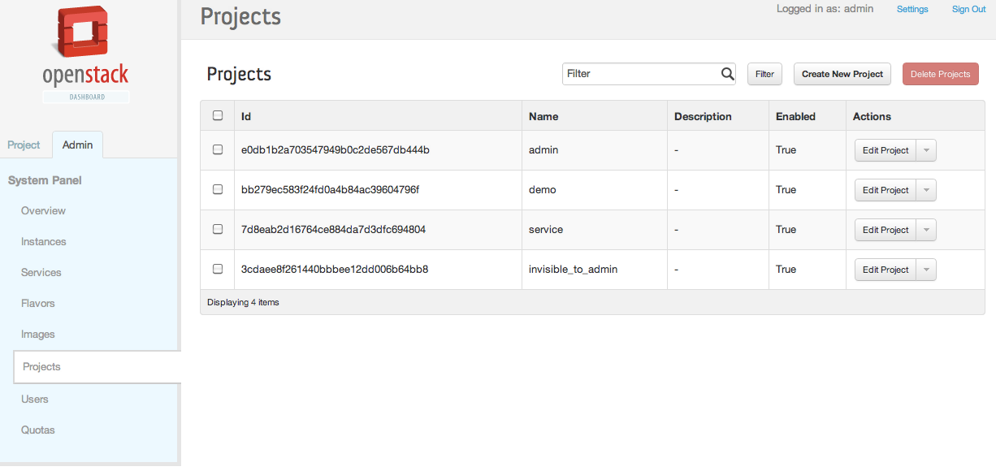

Figure 3. List of Projects Information

After filling in the required fields, the project is ready to be created by clicking the “**Create Project**” button as shown below.

*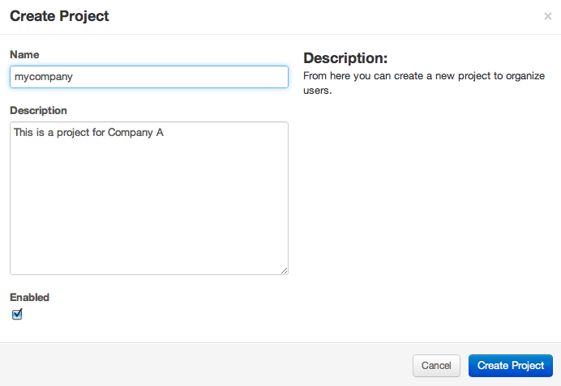*

Figure 4. Required Project Information

## Managing Users

The next step after creating the projects is to create users and assign them to their corresponding projects. Select the “**Users**” section in the System Panel and click on **“Create User”** to create any number of users. The next figure shows a project with a number of users created.

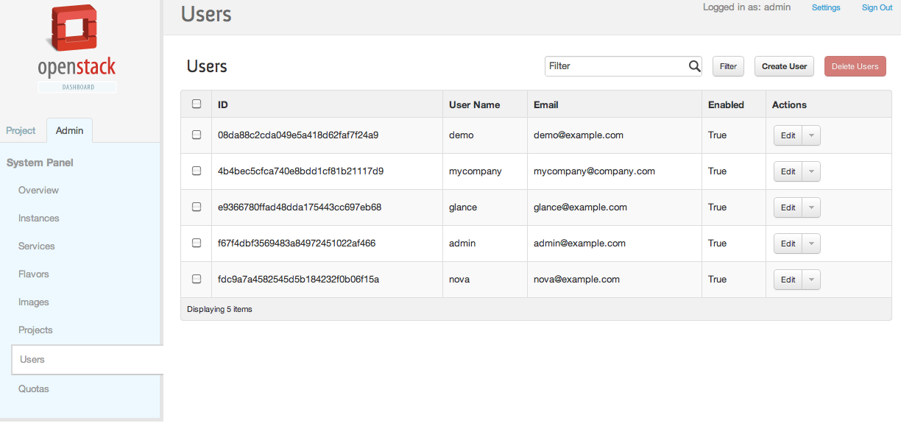

Figure 5. List of Users Created

When creating a user, one of the most important steps is to associate the user to a project. As the next screenshot shows, the project is defined in the **“Primary Project”** field. Once the user has been created, the only two actions available are “Delete” and “Disable”. ”Delete” completely deletes the user from the system. “Disable” denies any operation for that user but leaves the account in the system.

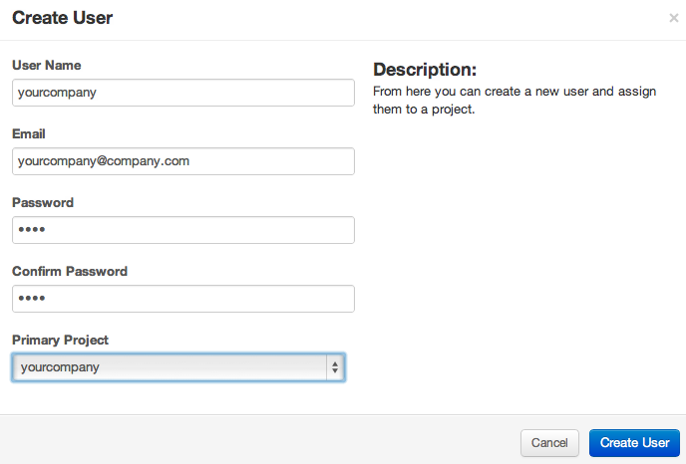

Figure 6. Required User Information

## Instances Administration

OpenStack Operators can view the status of all instances (VMs) running in the Openstack deployment and, if needed, even terminate any of them regardless their corresponding ownership (projects). As the following figure shows, the “Instances” section in the System Panel allows viewing the tenant (project) that created the instance, the compute host where the instance is running, as well as the instance name, IP Address, Size, Status and State.

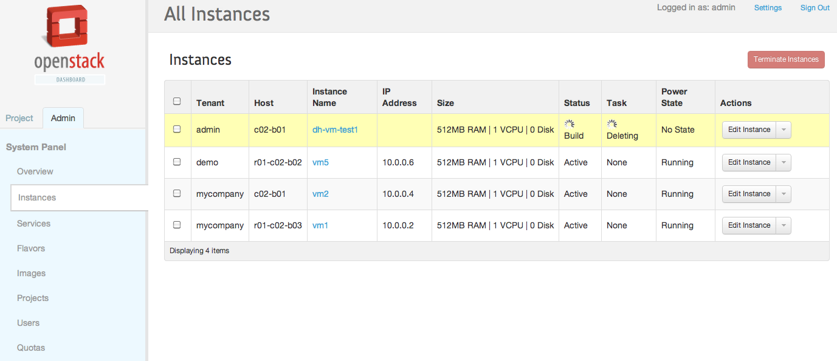

Figure 7. List of all running instances

There are a few actions available for the Cloud Operator to control instances. Selecting the “Edit Instances” button at the end of each instance tuple will display the rest of the actions available. Actions include opening a VNC console to the VM, reading the instances log, creating a snapshot of the instance, and pausing, suspending, rebooting or terminating instances.

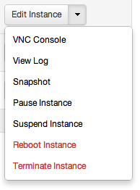

Figure 8. Available operations per instance

## Services

Openstack is a set of different components working together based on a messaging infrastructure. These components, known as services, may run in the same host or may be distributed. The “Services” section of the Admin System Panel provides a consolidated view of each available service regardless of where the service is located. It allows operators to view services status and also provides search capabilities. The following figure shows an example Services screen.

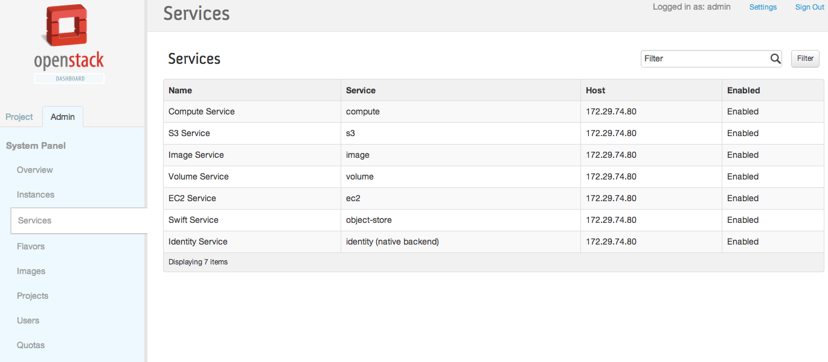

Figure 9. List of Services and Status

## System Quotas

Quotas define the number of resources available for each project. For example, operators may define quotas to limit the size and capacity of projects. As shown below, the “Quotas” section in the System Panel displays the default quota values. Note that the “Quotas” section is read-only.

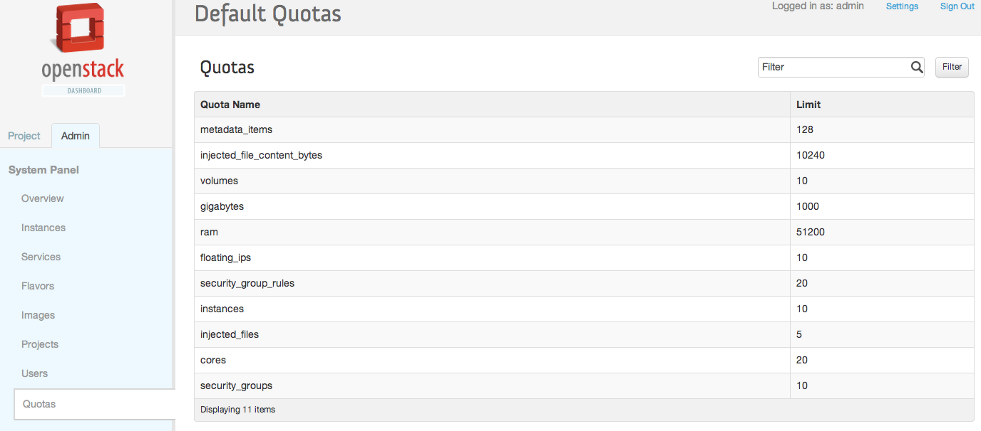

Figure 10. Default Openstack Essex Quotas

### Modifying System Quotas

The system quotas are customizable per project. Operators may change these quotas from the “Projects” section by selecting “Edit Project” followed by the “Modify Quotas” option. The next screenshot shows these steps.

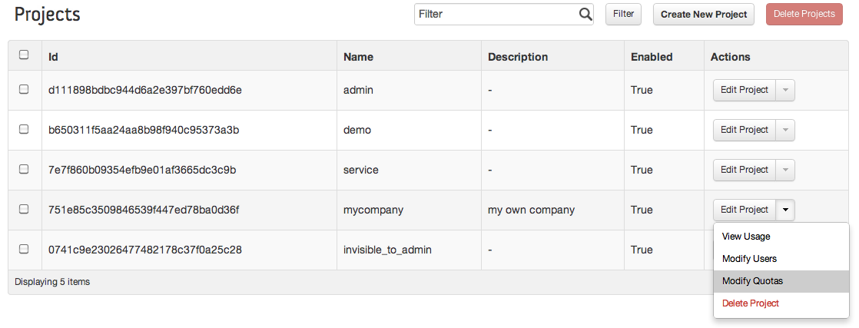

Figure 11. Available operations per project

The UI will open a new screen where operators can modify the default quotas. The default quotas do not need to be modified unless cloud operators specifically want to assign different values. Some common quotas modified by administrators are increaseing/decreseing the number of floating IPs available or modifying the maximum size of the volumes that can be created by users of projects. The various quotas that can be modified are shown in the figure below.

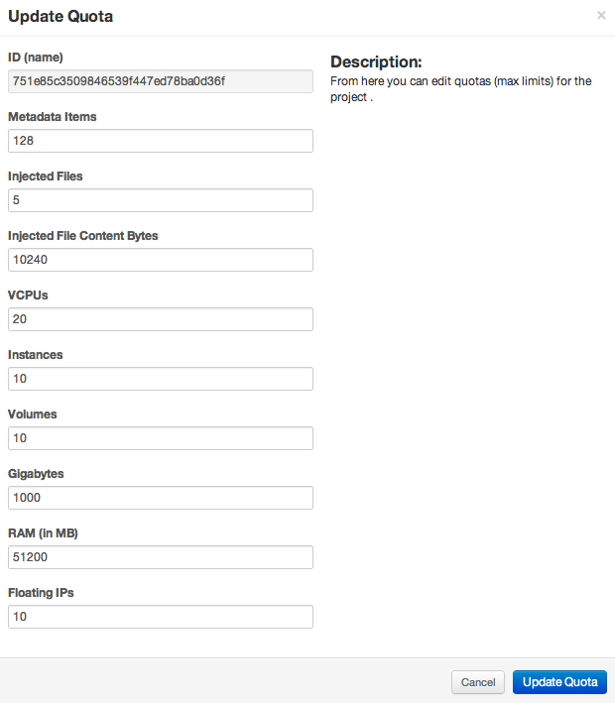

Figure 12. Quotas customization

## Images

An image is a file containing information about a virtual disk that completely replicates all information about a working computer at a point in time including operating system information and file system information. OpenStack integrates Glance as the image service. It is in charge of fetching all available images on to the host machine. The OpenStack compute service then boots the images it finds on the host machine.

The Openstack Dashboard has limited integration with the full set of Glance APIs [REFERENCE]. Basically, it just provides an overview of the already uploaded images and lets the OpenStack administrator delete any of the images.

### Overview Images

On the System Admin Panel select the section “Images”. The complete list of available images will be displayed. Then, just select the name of the desired image and the information will be displayed.

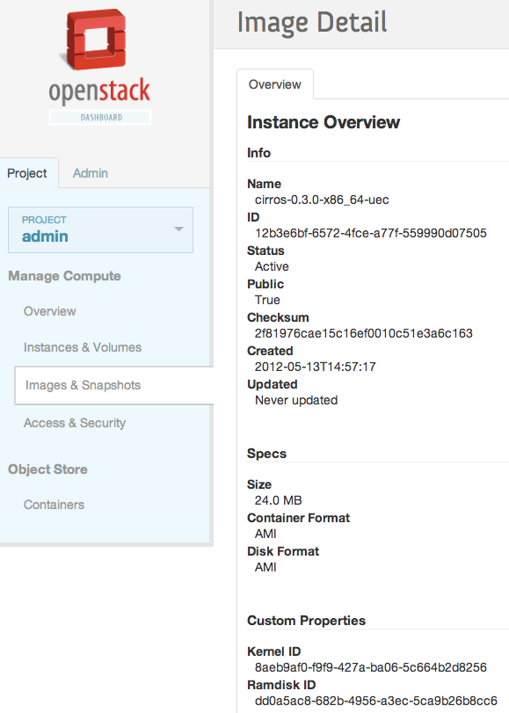

Figure 13. Glance Images details

### Deleting Images

In the “Images” section, select the name of the image that should be deleted and click the red “Delete Images” button in the top right corner.

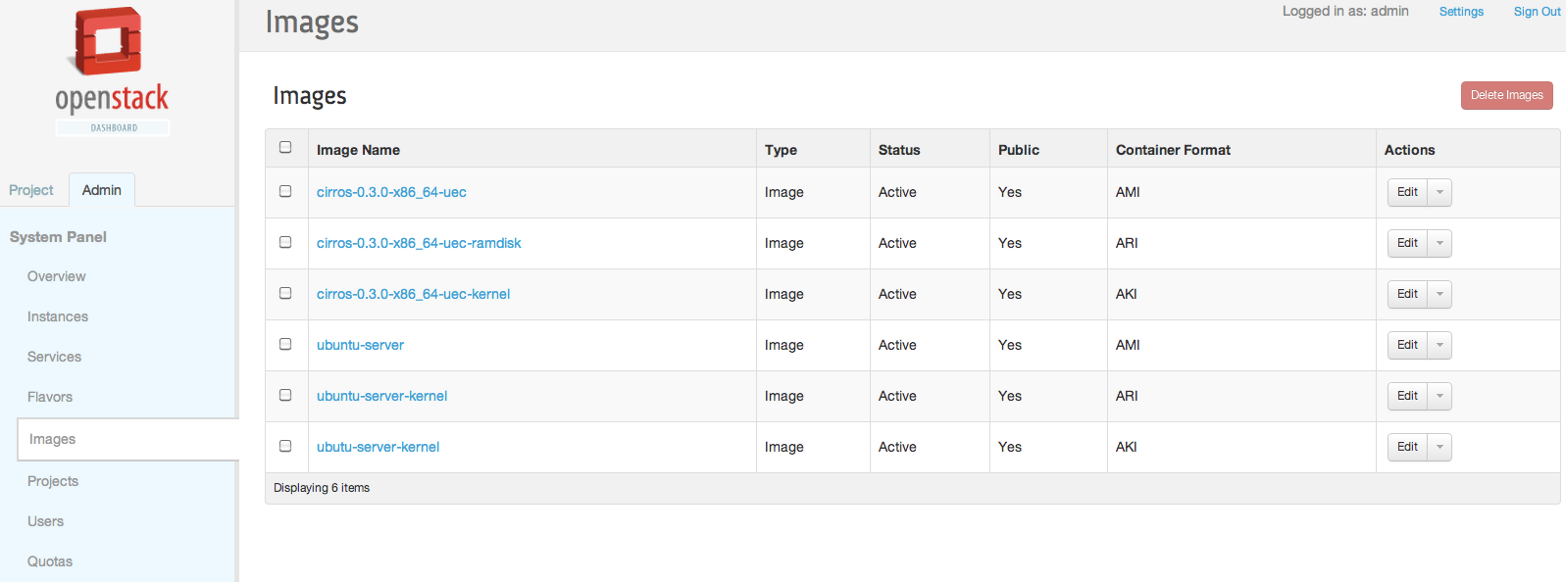

Figure 14. List of Glance Images Available

### Adding Images

Images are files containing information about a virtual disk previously formatted and configured. Uploading images to the Image Service Glance can only be done through the command line.

Two formats are supported by Glance:

1. AMI (Amazon Machine Image)
2. QCOW (Qemu Copy On Write).

Operating system images may be downloaded from a variety of free sources on the internet or from your EC2 account.

Once you have your image, the first step is to identify the type of image you want to import. This information is usually included in the place you downloaded the image from. In case you have a raw iso image and want to convert it to a qcow image, you can take a look at the oz image builder (https://github.com/rackerjoe/oz-image-build). The repository also features links to various qcow2 images.

Once you have identified the image, follow the instructions below appropriate for your image type:

#### Adding AMI (Amazon Machine Image) Images

The files required for the AMO format are the kernel (vmlinuz), ramdisk (initrd) and file disk (.img). The following steps will upload a test image known as cirros. Cirros Image Files:

cirros-0.3.0-x86\_64-blank.img

cirros-0.3.0-x86\_64-initrd

cirros-0.3.0-x86\_64-vmlinuz

From the cloud controller execute the following commands:

# ADMIN\_USER=admin

# ADMIN\_TENANT=admin

# TOKEN=$(keystone --os\_tenant\_name $ADMIN\_TENANT --os\_username $ADMIN\_USER --os\_password $ADMIN\_PASSWORD --os\_auth\_url http://$KEYSTONE\_IP:5000/v2.0 token-get | grep ' id ' | get\_field 2)

# KERNEL\_ID=$(glance --os-auth-token $TOKEN --os-image-url http://$GLANCE\_HOSTPORT image-create --name "$IMAGE\_NAME-kernel" --public --container-format aki --disk-format aki < "cirros-0.3.0-x86\_64-vmlinuz" | grep ' id ' | get\_field 2)

# RAMDISK\_ID=$(glance --os-auth-token $TOKEN --os-image-url http://$GLANCE\_HOSTPORT image-create --name "$IMAGE\_NAME-ramdisk" --public --container-format ari --disk-format ari < "cirros-0.3.0-x86\_64-initrd" | grep ' id ' | get\_field 2)

# glance --os-auth-token $TOKEN --os-image-url http://$GLANCE\_HOSTPORT image-create --name "cirros" --public --container-format ami --disk-format ami ${KERNEL\_ID:+--property kernel\_id=$KERNEL\_ID} ${RAMDISK\_ID:+--property ramdisk\_id=$RAMDISK\_ID} < " cirros-0.3.0-x86\_64-blank.img"

#### Adding QCOW (Qemu Copy On Write) Images

These images do not require any kernel or ramdisk images, you can simply import them as:

# ADMIN\_USER=admin

# ADMIN\_TENANT=admin

# TOKEN=$(keystone --os\_tenant\_name $ADMIN\_TENANT --os\_username $ADMIN\_USER --os\_password $ADMIN\_PASSWORD --os\_auth\_url http://$KEYSTONE\_IP:5000/v2.0 token-get | grep ' id ' | get\_field 2)

# glance --os-auth-token $TOKEN --os-image-url http://$GLANCE\_HOSTPORT image-create --name "cirros" --public --container-format bare –dosk-format qcow2 < centos60\_x86\_64.qcow2

### Listing Images

The list of all the available images can be retrieved as explained in section 2.6.1 “Overview Images” or using NOVA APIs.

The following command will display the available images.

# **nova image-list**

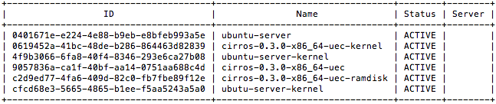

Figure 15. Listing of all available images

# EC2 API Comparison Matrix

This section attempts to enumerate how [OpenStack](http://wiki.openstack.org/OpenStack) compare in regards to EC2 API support. This information is based on OpenStack Essex release and [EC2 (API Version 2012-03-01)](http://aws.amazon.com/archives/Amazon-EC2/2886303838316017).

## General API Support

|  |  |
| --- | --- |
| **General Features** | [**OpenStack**](http://wiki.openstack.org/OpenStack) |
| EC2 Query API | Y |
| EC2 Soap API | N |
| OpenStack API / Rackspace API | Y |
| SSL Between Components | N |
| Horizontal Component Scalability | Y |
| Web-based UI | Y |
| Command line interface | Y |

## Amazon EC2 High Level Feature Support

|  |  |
| --- | --- |
| **EC2 feature** | [**OpenStack**](http://wiki.openstack.org/OpenStack) |
| Shared AMIs | Y |
| Parameterized launch (user-data) | Y |
| Instance metadata | Y |
| Public AMI's | Y |
| Launch/Terminate Instance | Y |
| Reboot Instance | Y |
| Start/Stop Persisted Instance | Y |
| Retrieve Console Output | Y |
| Paid AMI's | N |
| Multiple Instance Types | Y |
| Instance Launch Time | Y |
| Elastic IP's | Y |
| Availability Zones | Y |
| Region Support | Y |
| User selectable kernels | Y |
| Elastic Block Store | Y |
| Booting without a ramdisk | Y |
| Windows Support | Y |
| Reserved Instances | N |
| Auto Scaling | N |
| Elastic Load Balancing | N |
| [CloudWatch](http://wiki.openstack.org/CloudWatch) | N |
| Virtual Private Cloud (IPSec) | N |
| Shared Snapshots | N |
| AMI's backed by EBS | Y |
| Spot Instances | N |
| Sticky session in Elastic LB | N |
| Specify IP address for inst in VPC | N |
| Tags | N |
| Filters | N |
| Idempotent [RunInstance](http://wiki.openstack.org/RunInstance) Calls | N |
| Import keypair | Y |
| SSL termination | N |

## Amazon EC2 API Compatability

|  |  |
| --- | --- |
| **EC2 API method** | [**OpenStack**](http://wiki.openstack.org/OpenStack) |
| AllocateAddress | Y |
| AssociateAddress | Y |
| AttachVolume | Y |
| AuthorizeSecurityGroupIngress | Y |
| BundleInstance | N |
| CancelBundleTask | N |
| CancelSpotInstanceRequests | N |
| ConfirmProductInstance | N |
| CreateImage | N |
| CreateKeyPair | Y |
| CreatePlacementGroup | N |
| CreateSecurityGroup | Y |
| CreateSnapshot | Y |
| CreateSpotDatafeedSubscription | N |
| CreateTags | N |
| CreateVolume | Y |
| DeleteKeyPair | Y |
| DeletePlacementGroup | N |
| DeleteSecurityGroup | Y |
| DeleteSnapshot | Y |
| DeleteSpotDatafeedSubscription | N |
| DeleteTags | N |
| DeleteVolume | Y |
| DeregisterImage | Y |
| DescribeAddresses | Y |
| DescribeAvailabilityZones | Y |
| DescribeBundleTasks | N |
| DescribeImageAttribute | Y |
| DescribeImages | Y |
| DescribeInstanceAttribute | N |
| DescribeInstances | Y |
| DescribeKeyPairs | Y |
| DescribePlacementGroups | N |
| DescribeRegions | Y |
| DescribeReservedInstances | N |
| DescribeReservedInstancesOfferings | N |
| DescribeSecurityGroups | Y |
| DescribeSnapshotAttribute | N |
| DescribeSnapshots | Y |
| DescribeSpotDatafeedSubscription | N |
| DescribeSpotInstanceRequests | N |
| DescribeSpotPriceHistory | N |
| DescribeTags | N |
| DescribeVolumes | Y |
| DetachVolume | Y |
| DisassociateAddress | Y |
| GetConsoleOutput | Y |
| GetPasswordData | N |
| ImportKeyPair | Y |
| ModifyImageAttribute | Y |
| ModifyInstanceAttribute | N |
| ModifySnapshotAttribute | N |
| MonitorInstances | N |
| PurchaseReservedInstancesOffering | N |
| RebootInstances | Y |
| RegisterImage | Y |
| ReleaseAddress | Y |
| RequestSpotInstances | N |
| ResetImageAttribute | N |
| ResetInstanceAttribute | N |
| ResetSnapshotAttribute | N |
| RevokeSecurityGroupIngress | Y |
| RunInstances | Y |
| StartInstances | Y |
| StopInstances | Y |
| TerminateInstances | Y |
| UnmonitorInstances | N |

# 

# FAQs

To be completed

# Support

Any issues or discrepancies above please mail: [eperdomo@cisco.com](mailto:eperdomo@cisco.com) (Edgar Magana) and [openstack-support@cisco.com](mailto:openstack-support@cisco.com)

Related OpenStack Documentation

=============================================

Openstack Essex Administration Guides

http://docs.openstack.org/

Openstack Essex API Guides

http://docs.openstack.org/api/

Openstack Essex Developer Documentation

<http://docs.openstack.org/developer/>

====================================================================

Copyright (C) 2012 Cisco Systems, Inc. All rights reserved.

Cisco and Cisco Systems are registered trademarks of Cisco Systems,

Inc., in the U.S. and certain other countries. All other trademarks

mentioned in this document are the property of their respective owners.

====================================================================

# Glossary

The following list describes acronyms and definitions for terms used throughout this document:

1. **HA**: High Availability
2. **FO**: Failover. A term used to indicate a failed active node is taken out of service and replaced automatically by another dedicated node that was previously in a standby mode of operation.
3. **UI**: User Interface

# Apendix A

## Hardware Monitoring OIDs

|  |  |  |
| --- | --- | --- |
| **Component** | **OID** | **Response Values** |
| **Faults** |  |  |
| cucsFaultEntry | 1.3.6.1.4.1.9.9.719.1.1.1.1 | list |
| cucsFaultDn | 1.3.6.1.4.1.9.9.719.1.1.1.1.2 | list |
| cucsFaultRn | 1.3.6.1.4.1.9.9.719.1.1.1.1.3 | list (Append Fault Id from cucsFaultDn        for single return: STRING) |
| cucsFaultAffectedObjectId | 1.3.6.1.4.1.9.9.719.1.1.1.1.4 | list (Append Fault Id from cucsFaultDn        for single return: OID ) |
| cucsFaultAffectedObjectDn | 1.3.6.1.4.1.9.9.719.1.1.1.1.5 | list (Append Fault Id from cucsFaultDn        for single return: STRING ) |
| cucsFaultProbableCause | 1.3.6.1.4.1.9.9.719.1.1.1.1.7 | list (Append Fault Id from cucsFaultDn        for single return: INTEGER) |
| cucsFaultCode | 1.3.6.1.4.1.9.9.719.1.1.1.1.9 | list (Append Fault Id from cucsFaultDn        for single return: INTEGER) |
| cucsFaultCreationTime | 1.3.6.1.4.1.9.9.719.1.1.1.1.10 | list (Append Fault Id from cucsFaultDn        for single return: HEX-STRING) |
| cucsFaultDescription | 1.3.6.1.4.1.9.9.719.1.1.1.1.11 | list (Append Fault Id from cucsFaultDn        for single return: STRING ) |
| cucsFaultSeverity | 1.3.6.1.4.1.9.9.719.1.1.1.1.20 | list (Append Fault Id from cucsFaultDn        for single return: INTEGER) |
| cucsFaultType | 1.3.6.1.4.1.9.9.719.1.1.1.1.22 | list (Append Fault Id from cucsFaultDn        for single return: INTEGER) |
|  |  |  |
| **CPU Utilization** |  |  |
| cucsProcessorUnitPerf | 1.3.6.1.4.1.9.9.719.1.41.9.1.11 | unknown(0),  ok(1),  upperNonRecoverable(2),  upperCritical(3),  upperNonCritical(4),  lowerNonCritical(5),  lowerCritical(6),  lowerNonRecoverable(7),  notSupported(100) |
|  |  |  |

|  |  |  |
| --- | --- | --- |
|  |  |  |
| **Power Events** |  |  |
| cucsEquipmentPsuOperState | 1.3.6.1.4.1.9.9.719.1.15.56.1.7 | unknown(0),  operable(1),  inoperable(2),  degraded(3),  poweredOff(4),  powerProblem(5),  removed(6),  voltageProblem(7),  thermalProblem(8),  performanceProblem(9),  accessibilityProblem(10),  identityUnestablishable(11),  biosPostTimeout(12),  disabled(13),  malformedFru(14),  fabricConnProblem(51),  fabricUnsupportedConn(52),  config(81),  equipmentProblem(82),  decomissioning(83),  chassisLimitExceeded(84),  notSupported(100),  discovery(101),  discoveryFailed(102),  identify(103),  postFailure(104),  upgradeProblem(105),  peerCommProblem(106),  autoUpgrade(107) |
| cucsEquipmentPsuOperability | 1.3.6.1.4.1.9.9.719.1.15.56.1.8 | unknown(0),  operable(1),  inoperable(2),  degraded(3),  poweredOff(4),  powerProblem(5),  removed(6),  voltageProblem(7),  thermalProblem(8),  performanceProblem(9),  accessibilityProblem(10),  identityUnestablishable(11),  biosPostTimeout(12),  disabled(13),  malformedFru(14),  fabricConnProblem(51),  fabricUnsupportedConn(52),  config(81),  equipmentProblem(82),  decomissioning(83),  chassisLimitExceeded(84),  notSupported(100),  discovery(101),  discoveryFailed(102),  identify(103),  postFailure(104),  upgradeProblem(105),  peerCommProblem(106),  autoUpgrade(107) |
| cucsEquipmentPsuThermal | 1.3.6.1.4.1.9.9.719.1.15.56.1.14 | unknown(0),  ok(1),  upperNonRecoverable(2),  upperCritical(3),  upperNonCritical(4),  lowerNonCritical(5),  lowerCritical(6),  lowerNonRecoverable(7),  notSupported(100) |
| cucsEquipmentPsuPower | 1.3.6.1.4.1.9.9.719.1.15.56.1.10 | unknown(0),  on(1),  test(2),  off(3),  online(4),  offline(5),  offduty(6),  degraded(7),  powerSave(8),  error(9),  ok(10),  failed(11),  notSupported(100) |
|  |  |  |
| **Fan Enclosure Event** |  |  |
| cucsEquipmentFanOperState | 1.3.6.1.4.1.9.9.719.1.15.12.1.9 | unknown(0),  operable(1),  inoperable(2),  degraded(3),  poweredOff(4),  powerProblem(5),  removed(6),  voltageProblem(7),  thermalProblem(8),  performanceProblem(9),  accessibilityProblem(10),  identityUnestablishable(11),  biosPostTimeout(12),  disabled(13),  malformedFru(14),  fabricConnProblem(51),  fabricUnsupportedConn(52),  config(81),  equipmentProblem(82),  decomissioning(83),  chassisLimitExceeded(84),  notSupported(100),  discovery(101),  discoveryFailed(102),  identify(103),  postFailure(104),  upgradeProblem(105),  peerCommProblem(106),  autoUpgrade(107) |
| cucsEquipmentFanOperability | 1.3.6.1.4.1.9.9.719.1.15.12.1.10 | unknown(0),  operable(1),  inoperable(2),  degraded(3),  poweredOff(4),  powerProblem(5),  removed(6),  voltageProblem(7),  thermalProblem(8),  performanceProblem(9),  accessibilityProblem(10),  identityUnestablishable(11),  biosPostTimeout(12),  disabled(13),  malformedFru(14),  fabricConnProblem(51),  fabricUnsupportedConn(52),  config(81),  equipmentProblem(82),  decomissioning(83),  chassisLimitExceeded(84),  notSupported(100),  discovery(101),  discoveryFailed(102),  identify(103),  postFailure(104),  upgradeProblem(105),  peerCommProblem(106),  autoUpgrade(107) |
| cucsEquipmentFanPerf | 1.3.6.1.4.1.9.9.719.1.15.12.1.11 | unknown(0),  ok(1),  upperNonRecoverable(2),  upperCritical(3),  upperNonCritical(4),  lowerNonCritical(5),  lowerCritical(6),  lowerNonRecoverable(7),  notSupported(100) |
| cucsEquipmentFanPower | 1.3.6.1.4.1.9.9.719.1.15.12.1.12 | unknown(0),  on(1),  test(2),  off(3),  online(4),  offline(5),  offduty(6),  degraded(7),  powerSave(8),  error(9),  ok(10),  failed(11),  notSupported(100) |
| cucsEquipmentFanThermal | 1.3.6.1.4.1.9.9.719.1.15.12.1.16 | unknown(0),  ok(1),  upperNonRecoverable(2),  upperCritical(3),  upperNonCritical(4),  lowerNonCritical(5),  lowerCritical(6),  lowerNonRecoverable(7),  notSupported(100) |
|  |  |  |
| **Memory Events** |  |  |
| cucsMemoryUnitOperState | 1.3.6.1.4.1.9.9.719.1.30.11.1.13 | unknown(0),  operable(1),  inoperable(2),  degraded(3),  poweredOff(4),  powerProblem(5),  removed(6),  voltageProblem(7),  thermalProblem(8),  performanceProblem(9),  accessibilityProblem(10),  identityUnestablishable(11),  biosPostTimeout(12),  disabled(13),  malformedFru(14),  fabricConnProblem(51),  fabricUnsupportedConn(52),  config(81),  equipmentProblem(82),  decomissioning(83),  chassisLimitExceeded(84),  notSupported(100),  discovery(101),  discoveryFailed(102),  identify(103),  postFailure(104),  upgradeProblem(105),  peerCommProblem(106),  autoUpgrade(107) |
| cucsMemoryUnitOperability | 1.3.6.1.4.1.9.9.719.1.30.11.1.14 | unknown(0),  operable(1),  inoperable(2),  degraded(3),  poweredOff(4),  powerProblem(5),  removed(6),  voltageProblem(7),  thermalProblem(8),  performanceProblem(9),  accessibilityProblem(10),  identityUnestablishable(11),  biosPostTimeout(12),  disabled(13),  malformedFru(14),  fabricConnProblem(51),  fabricUnsupportedConn(52),  config(81),  equipmentProblem(82),  decomissioning(83),  chassisLimitExceeded(84),  notSupported(100),  discovery(101),  discoveryFailed(102),  identify(103),  postFailure(104),  upgradeProblem(105),  peerCommProblem(106),  autoUpgrade(107) |
| cucsMemoryUnitPerf | 1.3.6.1.4.1.9.9.719.1.30.11.1.15 | unknown(0),  ok(1),  upperNonRecoverable(2),  upperCritical(3),  upperNonCritical(4),  lowerNonCritical(5),  lowerCritical(6),  lowerNonRecoverable(7),  notSupported(100) |
| cucsMemoryUnitPower | 1.3.6.1.4.1.9.9.719.1.30.11.1.16 | unknown(0),  on(1),  test(2),  off(3),  online(4),  offline(5),  offduty(6),  degraded(7),  powerSave(8),  error(9),  ok(10),  failed(11),  notSupported(100) |
| cucsMemoryUnitThermal | 1.3.6.1.4.1.9.9.719.1.30.11.1.22 | unknown(0),  ok(1),  upperNonRecoverable(2),  upperCritical(3),  upperNonCritical(4),  lowerNonCritical(5),  lowerCritical(6),  lowerNonRecoverable(7),  notSupported(100) |
|  |  |  |
| **Processor Device Event** |  |  |
| cucsProcessorUnitOperState | 1.3.6.1.4.1.9.9.719.1.41.9.1.9 | unknown(0),  ok(1),  upperNonRecoverable(2),  upperCritical(3),  upperNonCritical(4),  lowerNonCritical(5),  lowerCritical(6),  lowerNonRecoverable(7),  notSupported(100) |
| cucsProcessorUnitOperability | 1.3.6.1.4.1.9.9.719.1.41.9.1.10 | unknown(0),  operable(1),  inoperable(2),  degraded(3),  poweredOff(4),  powerProblem(5),  removed(6),  voltageProblem(7),  thermalProblem(8),  performanceProblem(9),  accessibilityProblem(10),  identityUnestablishable(11),  biosPostTimeout(12),  disabled(13),  malformedFru(14),  fabricConnProblem(51),  fabricUnsupportedConn(52),  config(81),  equipmentProblem(82),  decomissioning(83),  chassisLimitExceeded(84),  notSupported(100),  discovery(101),  discoveryFailed(102),  identify(103),  postFailure(104),  upgradeProblem(105),  peerCommProblem(106),  autoUpgrade(107) |
| cucsProcessorUnitPerf | 1.3.6.1.4.1.9.9.719.1.41.9.1.11 | unknown(0),  ok(1),  upperNonRecoverable(2),  upperCritical(3),  upperNonCritical(4),  lowerNonCritical(5),  lowerCritical(6),  lowerNonRecoverable(7),  notSupported(100) |
| cucsProcessorUnitPower | 1.3.6.1.4.1.9.9.719.1.41.9.1.12 | unknown(0),  on(1),  test(2),  off(3),  online(4),  offline(5),  offduty(6),  degraded(7),  powerSave(8),  error(9),  ok(10),  failed(11),  notSupported(100) |
| cucsProcessorUnitThermal | 1.3.6.1.4.1.9.9.719.1.41.9.1.19 | unknown(0),  ok(1),  upperNonRecoverable(2),  upperCritical(3),  upperNonCritical(4),  lowerNonCritical(5),  lowerCritical(6),  lowerNonRecoverable(7),  notSupported(100) |

## Services Monitoring Openstack

|  |
| --- |
| **Controller Node** |
| nova-api |
| nova-cert |
| nova-network |
| nova-scheduler |
| nova-novncproxy |
| nova-consoleauth |
| nova-volume |
| keystone-all |
| glance-registry |
| glance-api |
| dnsmasq |
| libvirtd |
| apache2 |
| ntp |
| lvm2 |
| rabbitmq |
| memcached |
| mysql |
|  |

|  |
| --- |
| **Compute Node** |
| nova-compute |
| libvirtd |
| ntp |
| lvm2 |
|  |

|  |
| --- |
| **Storage Node** |
| swift-container-updater |
| swift-container-auditor |
| swift-container-server |
| swift-container-sync |
| swift-container-replicator |
| swift-object-replicator |
| swift-object-auditor |
| swift-object-updater |
| swift-object-server |
| swift-account-server |
| swift-account-reaper |
| swift-account-auditor |
| swift-account-replicator |
| swift-proxy-server |

# References

[1] OpenStack Installation Guide

End of Document

1. Description from http://OpenStack.org/, 06/26/2012. [↑](#footnote-ref-1)
2. Adapted from [http://nova.OpenStack.org/nova.concepts.html](http://nova.openstack.org/nova.concepts.html), 06/26/2012. [↑](#footnote-ref-2)