|  |  |  |
| --- | --- | --- |
| Cisco_logo | Document Number | EDCS-EDCS-TBD |
| Created By | Edgar Magana |

CTO – OpenStack Installation Guide

This document provides an installation guide for OpenStack Administrators using Cygnet OpenStack Distro.

This is a working document. Do not take anything verbatim until CTO oversight have signed off

Reviewers

|  |  |
| --- | --- |
| * Department | * Name/Title |
| VP CTO | Lew Tucker |
| Development Engineering | [Dan Florea](mailto:nxos-arch-team@cisco.com) |
| Customer Solutions | Daneyon Hansen |
| Development Engineering | Edgar Magana |

The departments and/or individuals listed above should be notified in advance and given a sufficient time period to review this document. The Project Team determines requirements for approval according to the scope of the project.

Modification History

|  |  |  |  |
| --- | --- | --- | --- |
| * Revision | * Date | * Originator | * Comments |
| 1 | June 24, 2012 | Edgar Magana | Initial Draft |
| 2 |  |  |  |
| 3 |  |  |  |
| 4 |  |  |  |
| 5 |  |  |  |
| 6 |  |  |  |
| 7 |  |  |  |

Table of Contents

CTO – OpenStack Installation Guide 1

Reviewers 1

Modification History 1

1 Introduction 3

1.1 Cobbler Node and Puppet Master Installation 3

2 Openstack … 6

2.1 Access… 6

3 FAQs 7

4 Support 7

5 Glossary 8

6 References 9

Appendix A 10

# Introduction

OpenStack is a global collaboration of developers and cloud computing technologists producing the ubiquitous open source cloud computing platform for public and private clouds. The project aims to deliver solutions for all types of clouds by being simple to implement, massively scalable, and feature rich. The technology consists of a series of [interrelated projects](http://openstack.org/projects/) delivering various components for a cloud infrastructure solution.

OpenStack provides a tool to orchestrate a cloud, including running instances, managing networks, and controlling access to the cloud through users and projects. It provides the software that can control an Infrastructure as a Service (IaaS) cloud computing platform. It is similar in scope to Amazon EC2 Cloud Servers. OpenStack Compute does not include any virtualization software; rather it defines drivers that interact with underlying virtualization mechanisms that run on your host operating system, and exposes functionality over a web-based API.

The goal of this document is to help cloud computing administrators to get familiar with Openstack administrative operations in a very simple way.

## Cobbler Node and Puppet Master Installation

Openstack offers a user-friendly UI based on the project horizon (code name). Basically, offers two different views, the Admin System Panel and the Project Panel. The first one is exclusively for administration

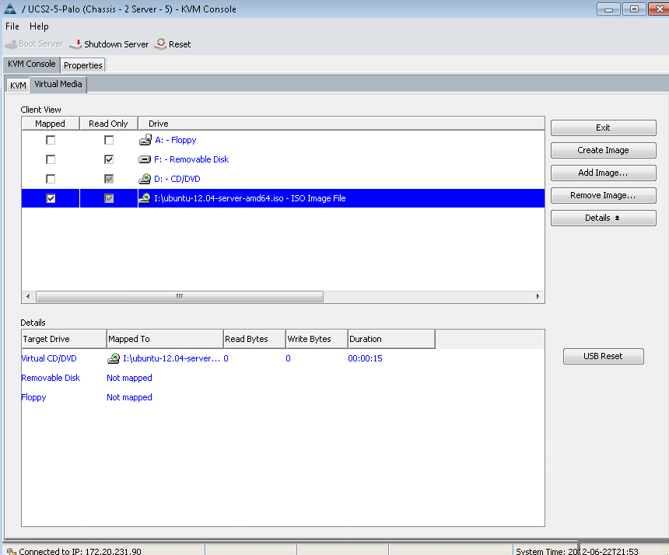

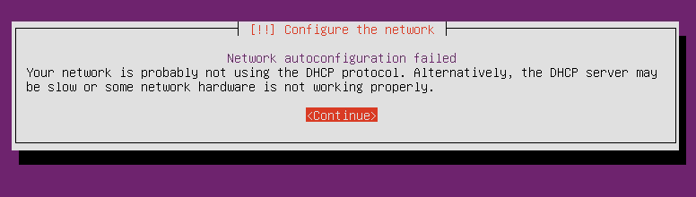

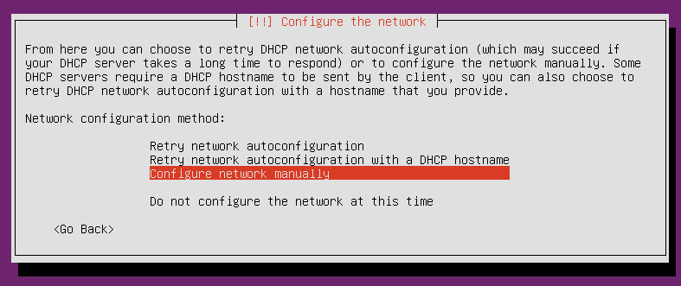

# Openstack …

OpenStack …

## Access…

# FAQs

1. … To be completed

# Support

Any issues or discrepancies above please mail: [eperdomo@cisco.com](mailto:eperdomo@cisco.com) (Edgar Magana)

Related OpenStack Documentation

=============================================

Openstack Essex Administration Guides

http://docs.openstack.org/

Openstack Essex API Guides

http://docs.openstack.org/api/

Openstack Essex Developer Documentation

<http://docs.openstack.org/developer/>

====================================================================

Copyright (C) 2012 Cisco Systems, Inc. All rights reserved.

Cisco and Cisco Systems are registered trademarks of Cisco Systems,

Inc., in the U.S. and certain other countries. All other trademarks

mentioned in this document are the property of their respective owners.

====================================================================

# Glossary

The following list describes acronyms and definitions for terms used throughout this document:

1. **HA**: High Availability
2. **FO**: Failover. A term used to indicate a failed active node is taken out of service and replaced automatically by another dedicated node that was previously in a standby mode of operation.

# References

[1] **…**

# Appendix A

**A.1 Bla bla bla …**

End of Document