Iowa State University
Electrical and Computer Engineering

  - EE 2300

Lab 1 Report – Basic Operational Amplifier Circuits

Date of Experiment: January 27, 2026
Date of Report Submission: February 08, 2026
Names of Group Members: Sayon Saha, Aaron Kammlah

Sayon Saha

Introduction
In this lab, we started working with different variations of op amp circuits. We started with a non-inverting and a inverting op amp circuit, where we calculated the expected gain of each circuit and compared it with our measured gain. For the non-inverting amp, we also observed the transfer characteristics on the oscilloscope. For the inverting amp, we calculated the gain with two different values for the frequency resistor. After that, we built a circuit with and without a unity-gain buffer set up and observed the difference between each setup. Then we built a integrating amplifier circuit and observed the input and output traces on the oscilloscope. We used three types of inputs for this which include Square Wave input, Ramp input and Sinusoidal input. After that, we built a differential op amp circuit, after which we measured the differential mode gain for each source while the other was grounded, then measured the common mode gain too. Then we compared them with our calculated values. Then we built a summing amplifier to create a digital-to-analog converter (DAC). We first had to figure out the resistor ratios and values, then choose specific values for each resistor to built the circuit. In the end, we built an instrumentation amp circuit to observe the common mode and differential mode gain, which we also observed traces for on the oscilloscope.

Experiment 1. Non-Inverting Amplifier
The table below lists the measurement results.

Parameter | Value
Calculated Gain (V/V) | 16
Measured v_{i} (V) | 0.5
Measured v_{o} (V) | 7.97
Measured Gain (V/V) | 15.94

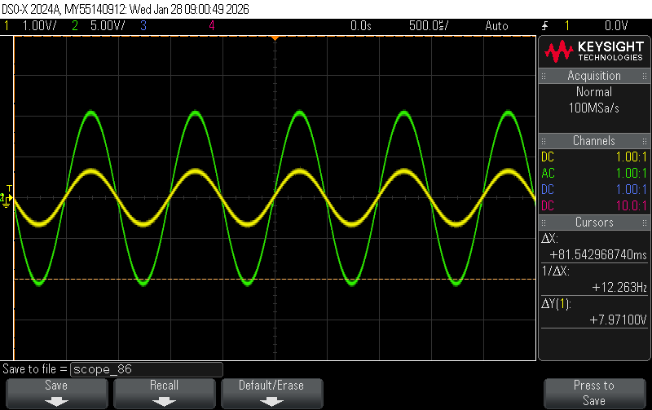
Figure 1-1. Oscilloscope trace of v_{i} (yellow) and v_{o} (green).

Experiment 2. Observing the Transfer Characteristic

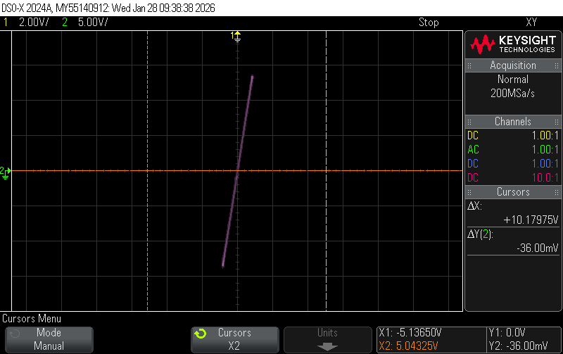
Figure 2-1. X-Y Plot of the input and output with no clipping.

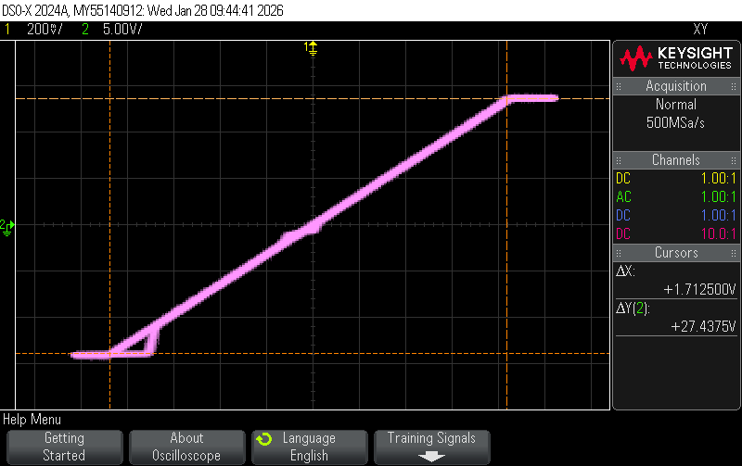
Figure 2-2. X-Y Plot of the input and output with clipping.

In figure 2-1, the op amp is operating in its linear region. The y-axis represents the output voltage (v₀) and the x-axis represents the input voltage (v_{i}). The slope v₀/ v_{i} represents the gain of the op amp. In figure 2-1, v₀ is under the source voltage of the op amp which is ±15 V. So, we don’t see any clipping.

As for figure 2-2, we see the line flattens out at the top and bottom. This shows that the output is exceeding the source voltage and is being clipped. But the gain/slope is still close to 16. But the input voltage keeps increasing. This happens because even if the output voltage is 16 times the input voltage, it can never exceed the supply voltage of the op amp.

Experiment 3. Inverting Amplifier
Figure 3-1. Schematic of the integrating amplifier used for this experiment. The amplifier uses an LMC660 op amp with $±8$ V supplies and $R_{1}=10 kΩ$, $R_{2}=100 kΩ$ potentiometer.

The table below lists all of the measurement values. All work for calculating the expected gain is attached to the end of this report.

Parameter | Value ($R_{2}=50 kΩ)$ | Value (Max. Gain)
Measured $R_{2}$ (k$Ω$) | 49.288 | 59.7
Calculated Gain (V/V) | -22.72 | -27.14
Measured v_{i} (V) | 0.195 | 0.195
Measured v_{o} (V) | 4.40 | 5.37
Measured Gain (V/V) | 22.56 | 27.54

The gains we calculated are negative but close to the values we measured, which are positive. This indicates a phase shift of 180 degrees. The values we measured came out positive because the multimeter doesn’t calculate the sign, only the magnitude.

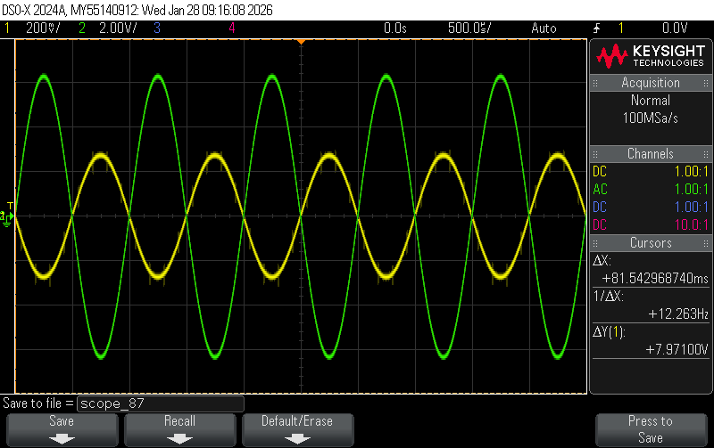
Figure 3-2. Oscilloscope trace of v_{i} (yellow) and v_{o} (green) with $R_{2}=50 kΩ$.

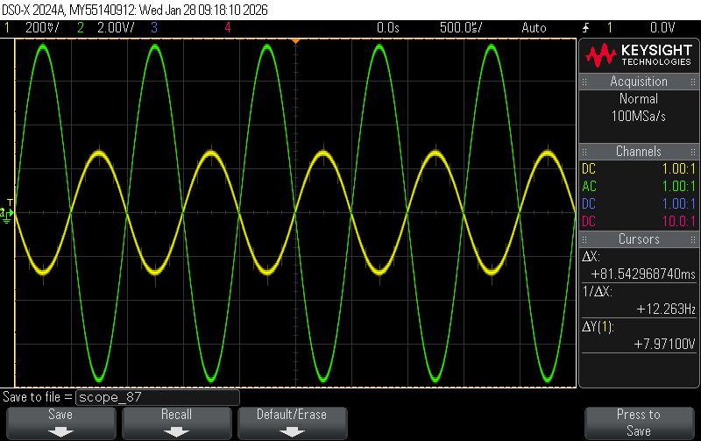
Figure 3-3. Oscilloscope trace of v_{i} (yellow) and v_{o} (green) with $R_{2}$ set for maximum gain.
If we were to put the potentiometer at the input instead of the frequency resistor, then that potentiometer would control the input voltage. It would either increase or decrease the input voltage which would in turn also impact on the output voltage. A higher potentiometer value would lower the overall gain, whereas a lower potentiometer value would increase the overall gain.

Experiment 4. Unity-Gain Buffer
Figure 4-1. Schematic of (a) voltage divider loaded by a diode and (b) same voltage divider but with a unity-gain buffer inserted between the divider and the diode.

The table below lists the measurement results.

Parameter | Resistor Pair ($R_{1}/R_{2})$
Parameter | $$2.2/6.8 kΩ$$ | $$4.7/4.7 kΩ$$ | $$6.8/2.2 kΩ$$
Calculated $V_{A}$ with no diode (V) | 11.33 | 7.5 | 3.67
Calculated $V_{A}$ of Circuit (a) (V) | 5.66 | 4.09 | 2.76
Measured $V_{A}$ of Circuit (a) (V) | 5.47 | 3.59 | 2.54
Measured $V_{A}$ of Circuit (b) (V) | 11.3 | 7.46 | 3.65
Measured $V_{B}$ of Circuit (b) (V) | 11.3 | 7.46 | 3.65

Without the unity gain buffer, the led and resistor branch draws current, thus reducing the V_{A.} But with the unity gain buffer, the load on V_{A} is reduced as the op amp takes significantly reduced current, thus the V_{A} remains almost the same as the values we calculated without the diode.

Experiment 5. Integrating Amplifier

Figure. 5-1. Schematic of the integrating amplifier used for this experiment. The amplifier uses an LMC660 op amp with $±8$ V supplies and $R_{1}=10 kΩ$, $R_{2}=470 kΩ$, and $C=0.1 μF$.

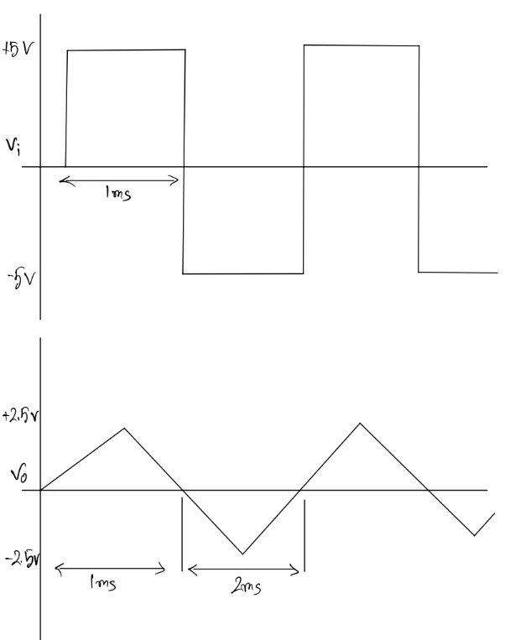
Figure 5-2. Sketch of the expected integrator output for a square-wave input.

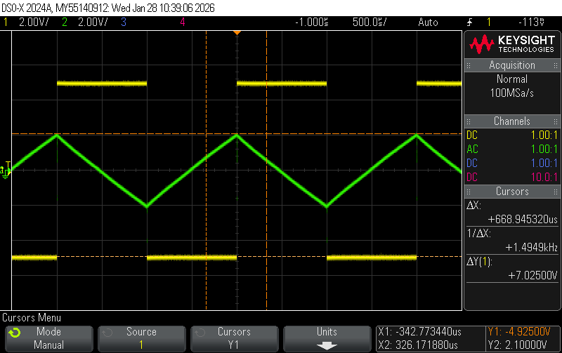
Figure 5-3. Oscilloscope trace of v_{i} (yellow) and v_{o} (green) using a square-wave as the input.

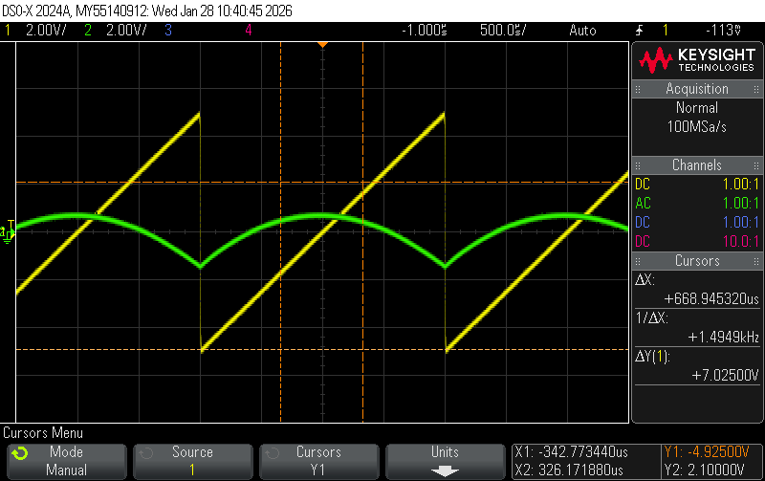
Figure 5-4. Oscilloscope trace of v_{i} (yellow) and v_{o} (green) using a ramp as the input.

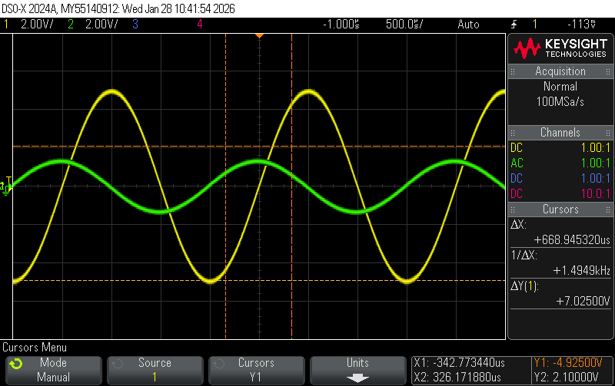
Figure 5-5. Oscilloscope trace of v_{i} (yellow) and v_{o} (green) using a sine-wave as the input.

The output signals are the integrals of the input signals.
In 5.3, the input signal is a square wave going from +5V to -5V. This constant shit between positive or negative voltage produces an integral which looks like a triangle because of the output voltage constantly and linearly increasing and decreasing.
In 5.4, the input signal is a ramp, which produces a straight line that is constantly changing. The integral of this linear line is a quadratic curve which can be seen in the output voltage.
In 5.5, the input signal is a sine wave, as such the output signal is also a sine wave but with a phase shift. The integral of a sine wave is another sine wave with a noticeable phase shift and a different amplitude.

Experiment 6. Simple Difference Amplifier
Figure 6-1. Schematic of the difference amplifier used for this experiment. The amplifier uses an LMC660 op amp with $±8$ V supplies and $R_{1}=1 kΩ$, $R_{2}=10 kΩ$, $R_{3}=2.2 kΩ$, and $R_{4}=22 kΩ$.

The table below lists the measured resistor values.

 | Measured Resistance (k$Ω$)
$$R_{1}$$ | 0.985
$$R_{2}$$ | 9.79
$$R_{3}$$ | 2.168
$$R_{4}$$ | 21.7

The table below lists the measurement results.

Parameter | Value ($v_{b}$ grounded) | Value ($v_{a}$ grounded) | Value (with $v_{a}=v_{b}$)
Calculated Gain | 9.945 | 9.939 | 0.006
Measured Gain | 9.95 | 9.95 | 6.95*10⁻³

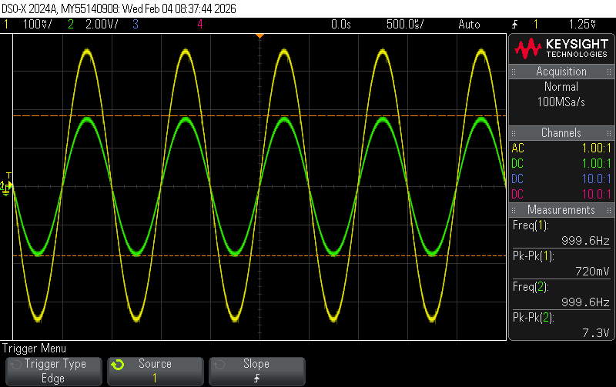
Figure 6-2. Oscilloscope trace of v_{a} (yellow) and v_{o} (green) with v_{b} grounded.

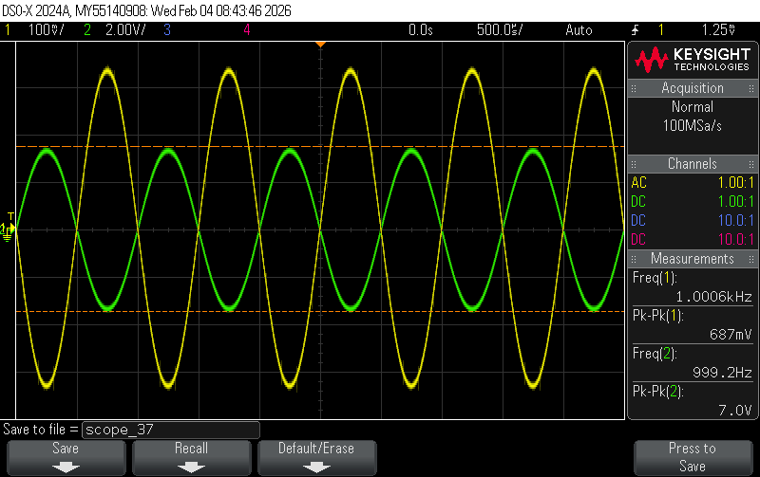
Figure 6-3. Oscilloscope trace of v_{b} (yellow) and v_{o} (green) with v_{a} grounded.

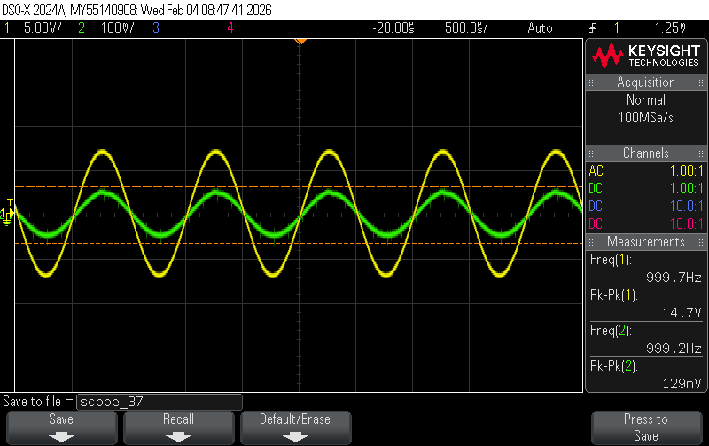
Figure 6-4. Oscilloscope trace of v_{i} (yellow) and v_{o} (green) with v_{a}=v_{b}.

The output is not zero when the outputs are connected because the circuit components are not exactly ideal. For example, in an ideal differential op amp circuit the ratios R₂/R₁ and R₄/R₃ are supposed to be equal. But in this real-life circuit, that is not the case.
Also, the op amp is not ideal either, as it has a small offset voltage. For these non-ideal properties the output voltage is not zero.

Experiment 7. Summing Amplifier
Figure 7-1. Schematic of summing amplifier used for this experiment.

The required resistor ratios are given below:

$$\frac{R_{f}}{R_{D2}}=4$$
$$\frac{R_{f}}{R_{D1}}=2$$
$$\frac{R_{f}}{R_{D0}}=1$$

To obtain these ratios, the following resistor values were chosen:

 | Measured Resistance (k$Ω$)
$$R_{f}$$ | 3.91
$$R_{D2}$$ | 0.984
$$R_{D1}$$ | 1.965
$$R_{D0}$$ | 3.9

The table below lists the measured output voltage for all 8 input combinations:

$v_{D2}$ (V) | $v_{D1}$ (V) | $v_{D0}$ (V) | $v_{o}$ (V)
0 | 0 | 0 | 0
0 | 0 | 1 | -1.02
0 | 1 | 0 | -2.01
0 | 1 | 1 | -3.05
1 | 0 | 0 | -4.05
1 | 0 | 1 | -5.08
1 | 1 | 0 | -6.09
1 | 1 | 1 | -7.11

To design this circuit, we first use three test values (101=-5, 110=-6, 011=-3) to figure out the resistor ratios by plugging the values into the output voltage equation for a summing amplifier. After we achieved the ratios (R_{f}/R_{D2} = 4, R_{f}/R_{D1} = 2, R_{f}/R_{D0} = 1), we set R_{f} = 4 kΩ and figured out the other values (R_{D2} = 1 kΩ, R_{D1} = 2 kΩ, R_{D0} = 4 kΩ).

To achieve those values, we used a set of 1 kΩ resistors in series for each one. One challenge that we faced was figuring out the combinations at first to get out desired resistor value ratio. This had an easy solution, where we just used a lot of 1 kΩ resistors.

Experiment 8. Instrumentation Amplifier
Figure 8-1. Schematic of the instrumentation amplifier used for this experiment. The amplifier uses an LMC660 op amp with $±8$ V supplies and $R_{1}=10 kΩ$, $R_{2}=10 kΩ$, $R_{3}=1 kΩ$, and $R_{4}=10 kΩ$.

The table below lists the measurement results:

Parameter | Value ($v_{b}$ grounded)
Calculated Differential Gain (V/V) | 30
Measured Differential Gain (V/V) | 29.75
Measured Common-Mode Gain (V/V) | 0

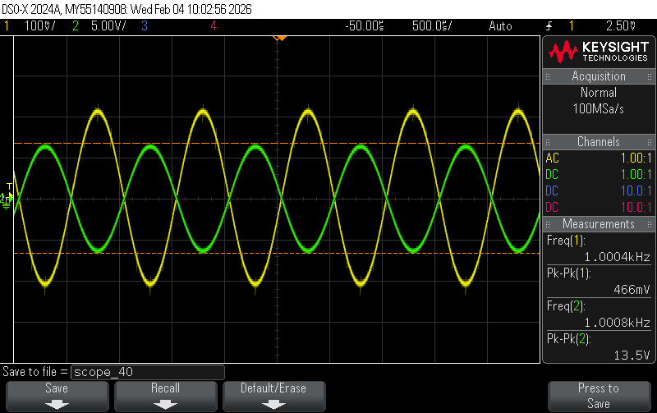
Figure 8-2. Oscilloscope trace of v_{i} (yellow) and v_{o} (green) showing differential gain (with v₂ grounded).

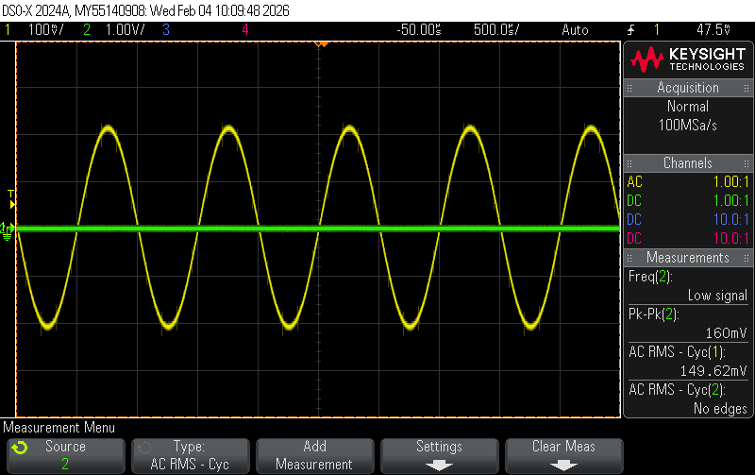
Figure 8-3. Oscilloscope trace of v_{i} (yellow) and v_{o} (green) showing common-mode gain (with v₁=v₂).

Conclusion
In this lab, we went over most things related to circuits we went through in 201. We built different op amp circuits, calculated different elements and measured them to see if they match our calculations. We also observed the input and output voltages on the oscilloscope and identified different properties of them.

The biggest problem in this lab that I faced was getting reacquainted with some of features of the lab equipment and how to understand them. Alongside that, we faced problems figuring out the resistor values that we would need to build the DAC in experiment 7. But we managed to figure out an easy solution to that by using the 1 kΩ resistors only. Aside from these, the lab went pretty smoothly and I was able to go over what I learnt in 201 again.

Calculations:
