Iowa State University
Electrical and Computer Engineering

EE 2300

Lab 2 Report – Non-Ideal Effects in Operational Amplifiers

Date of Experiment: February 10, 2026 & February 17, 2026
Date of Report Submission: February 24, 2026
Name of Group Members: Sayon Saha, Aaron Kammlah
Sayon Saha

Introduction
In this lab, we started working with non-ideal effects in op amps and also started building active filters with their help. In the first experiment, we built a simple non-inverting op amp circuit and measured the high and low voltage limits to compare them with the guaranteed values from the datasheet. We also saw how introducing a DC offset and a single source affects the output of the amp, In the next experiment, we built a non-inverting amp circuit to measure the output current limits of two different amps and compare them with the datasheet values. In the third experiment, we started observing the gain-bandwidth product characteristics of two different op amps. We also used the loopinator app for the first time to generate bode plots to observe cutoff frequencies. We also built our first active filter and used loopinator again to generate a bode plot for that. In the fourth experiment, we observed the slew rate for three different op amps. In experiment five, we again used the LM324 and LMC660 to observe the input bias current and offset voltage.

Experiment 1. Power Supplies and Output Voltage Limits
Figure 1-1. Schematic of the amplifier used to study the output voltage limitations. $R_{1}=15 kΩ$ and $R_{2}=1 kΩ$.
The table below lists values obtained from the datasheet as well as all measurement values.

Parameter | LM324 | LMC660
Max. Guaranteed Low Voltage Limit (V) | 20 mV | 0.3V
Min. Guaranteed High Voltage Limit (V) | Vcc – 1.5 | -0.3V
Measured High Voltage Limit (V) | 6.56 V | 7.81 V
Measured Low Voltage Limit (V) | -7.37 V | -8 V

The following plots show the clipped output voltage of the LM324 op amp.

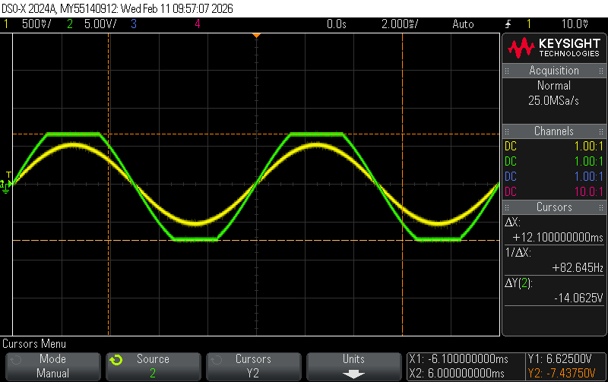
Figure 1-2. Oscilloscope trace of v_{i} (yellow) and clipped v_{o} (green) for the LM324.

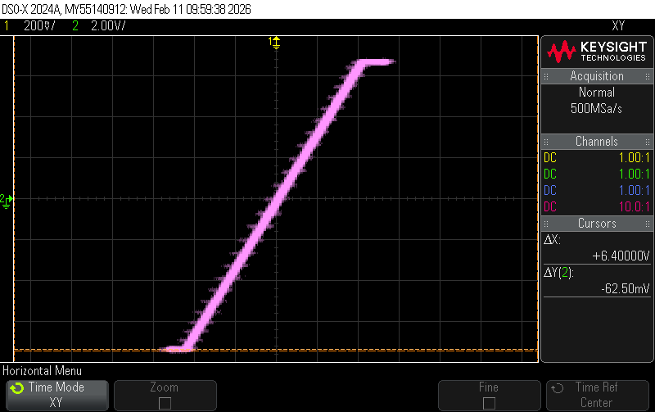
Figure 1-3. X-Y mode capture of the voltage transfer characteristic of LM324 with clipping.

The following plots show the clipped output voltage of the LMC660 op amp.

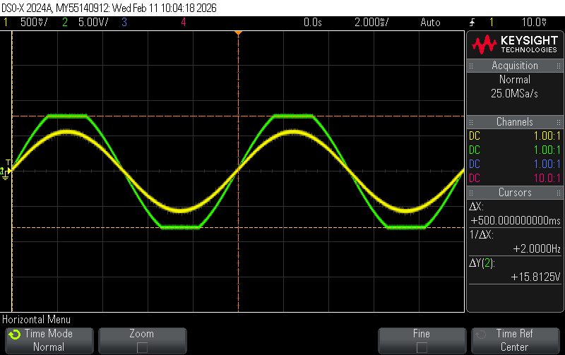
Figure 1-4. Oscilloscope trace of v_{i} (yellow) and clipped v_{o} (green) for the LMC660.

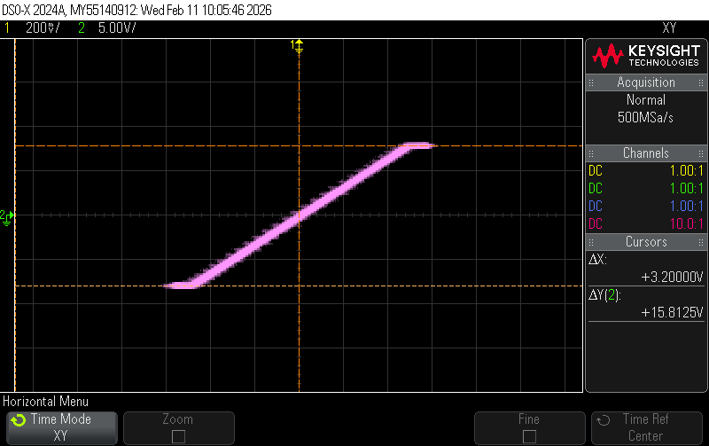
Figure 1-5. X-Y mode capture of the voltage transfer characteristic of LMC660 with clipping.

For the LM324, the measured high output voltage limit was significantly lower than the positive supply rail. With ±8 V supplies, the output saturated at approximately 6.56 V on the high end and -7.37 V on the low side. According to the datasheet, LM324 is not rail-to-rail and typically cannot swing closer than about 1.5 V to the positive supply rail. Though on the negative side, the amp can swing closer to the negative rail.

For the LMC660, it is a rail-to-trail op amp and as such its data sheet suggested that both outputs should swing closer to the rails. And we also noticed that in our measured values, where the values were approximately 7.81 V and -8 V, they were close to the rail values.

Between the two op amps, the LMC660 shows a much wider output swing range than LM324. This LM324 shows noticeable limitations near the positive rail.

Finally, the LMC660 is operated from a single 15 V supply. The figures below show the effect of adding the correct DC offset voltage to the input.

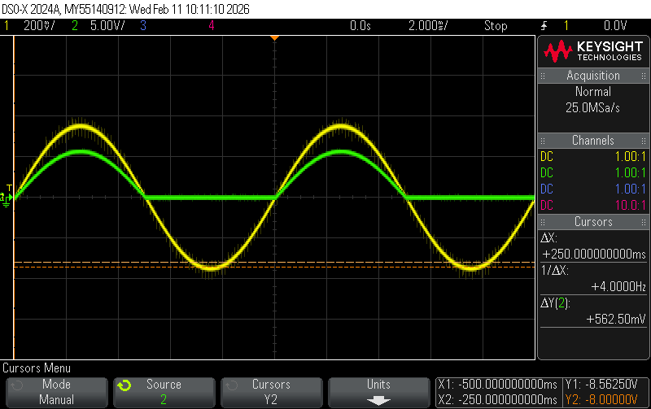
Figure 1-6. Oscilloscope trace of v_{i} (yellow) and distorted v_{o} (green), with incorrect DC offset of 0 V, for the LMC660 operating from a single supply.

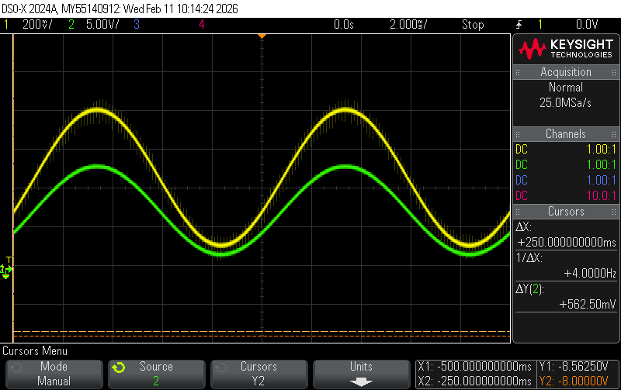
Figure 1-7. Oscilloscope trace of v_{i} (yellow) and v_{o} (green), with correct DC offset of 0.47 V, for the LMC660 operating from a single supply.
When operating the LMC660 from a single +15 V, the output voltage can only swing between 0 V and 15 V. As such, the amp cannot produce any negative voltage. And as such, the output must be centered within the range to avoid clipping. Now, the non-inverting amplifiers gain is,
A = 1 + (R₂/R₁) = 16
And the DC component of the input is amplified by this gain,
V_{DC,out} = 16 * V_{DC,in}
To center the output at the midpoint (7.5 V) of the supply range, we need,
V_{DC,in} = 7.5/16 = 0.47 V
That’s why we use an input DC offset of 0.47 V.

To avoid clipping V_{out} has to be within 0 V and 15 V.
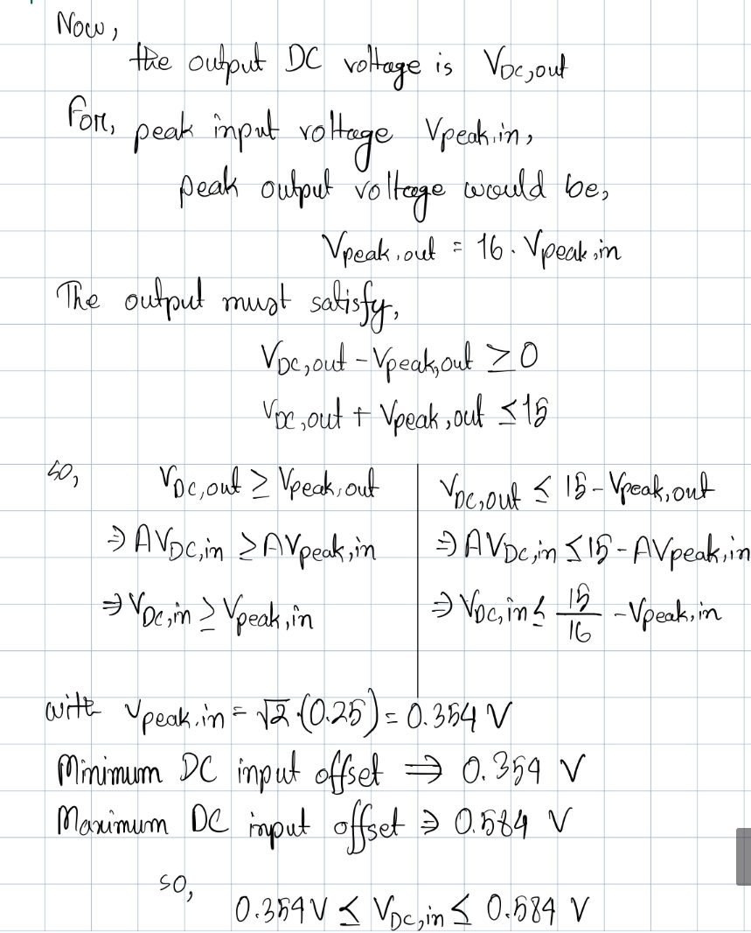

Experiment 2. Output Current Limits
Figure 2-1. Schematic of the inverting amplifier used to measure the output current limits of the LM324 and LMC660 op amps. Component values are $R_{1}=1 kΩ$ and $R_{2}=10 kΩ$. The load resistance is realized using a $1 kΩ$ potentiometer.
The table below shows the measured output current for two separate LM324 op amp chips and two separate LM660 op amp chips.

Parameter | Chip #1 | Chip #2
Measured $I_{o}$ for LM324 (mA) | 47.4 mA | 48.2 mA
Measured $I_{o}$ for LMC660 (mA) | 38.3 mA | 38.9 mA

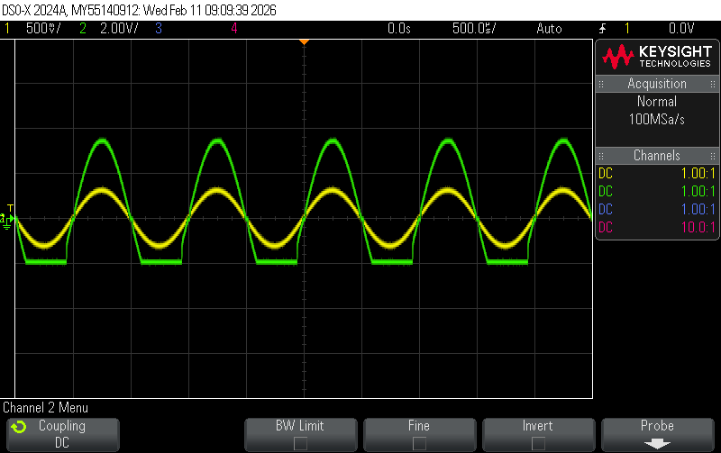
Figure 2-2. Oscilloscope trace of v_{i} (yellow) and distorted v_{o} (green) for the LM324 showing distortion caused by current limiting.
Yes, the current listed in the table above represents the maximum output current that the op amp can deliver before current limiting occurs. In this experiment, the load resistance was gradually reduced, and the output current depends on that,

I_{o} = V₀/R_{L}

At one point, further decrease in load resistance did not increase the current anymore. Instead, the output voltage started to drop. This indicated that the op amp had reached its maximum internal current limit. Therefore, the measured values correspond to the maximum source or sink current.

From the datasheet, the LM324 can typically output approximately 40-50 mA current, and our measured value of 47.4-48.2 mA is well within that range. In the same way, the LMC660 datasheet indicates that this op amp can output 30-40 mA current, which puts our measured values of 38.3-38.9 mA in range.

When the load resistance is large, the op amp operates as it normally should and the output voltage followed the expected waveform in such a case. As the load resistance decreased, the required output current increased. Once the required current exceeded the op amp’s maximum output capability, the output voltage deviated from the expected waveform. The output voltage became distorted. The distortion is not symmetrical. Because the internal output of the op amp does not source or sink current equally.

Experiment 3. Gain-Bandwidth Product
Figure 3-1. Schematic of amplifier used to investigate the gain-bandwidth product. The amplifier uses the LMC660 op amp with $±8$ V supplies. $R_{1}=100 kΩ$, $R_{2}=1 kΩ$, $R_{3}=1 kΩ$, and $R_{4}=100 kΩ$.
The typical band-bandwidth project for the LMC660 is shown below.

Typical Gain-Bandwidth Product (MHz) | 1.4 MHz

The table below lists the measured gain-bandwidth product for several different gains.
Parameter | Value
Nominal Gain: 101 V/V
Measured Gain at 100 Hz (V/V) | 101.53 V/V
Measured Corner Frequency (Hz) | 17.4 kHz
Gain-Bandwidth Product (MHz) | 1.76 MHz
Nominal Gain: 221 V/V
Measured Gain at 100 Hz (V/V) | 227 V/V
Measured Corner Frequency (Hz) | 7.7kHz
Gain-Bandwidth Product (MHz) | 1.75MHz
Nominal Gain: 471 V/V
Measured Gain at 100 Hz (V/V) | 483.3 V/V
Measured Corner Frequency (Hz) | 3650 Hz
Gain-Bandwidth Product (MHz) | 1.76 MHz

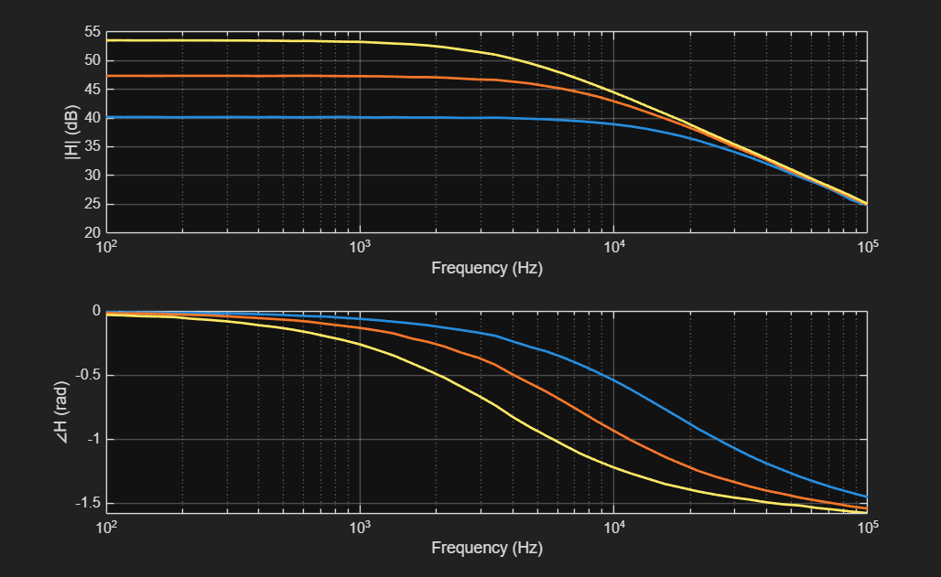
Figure 3-2. Measured magnitude response of three different non-inverting amplifiers with gain of 101 V/V, 221 V/V, and 471 V/V.

The typical gain-bandwidth product of an LMC660 according to the datasheet is approximately 1.4MHz. Based on our measured values, the GBW products from the circuit is within 1.75-1.76MHz. These values are consistent with one another. This confirmed the expected single-pole frequency response behavior of the op amp.

Based on the loopinator results, the magnitude responses were flat at low frequencies, and the gain began to decrease at a specific corner frequency. Beyond that frequency, the gain decreased at approximately -20dB/decade. The phase also shifts towards -90 degrees at higher frequencies. This behavior indicates a first-order low pass response.
Figure 3-3. Schematic of low-pass inverting amplifier using the LMC660 op amp with $±8$ V supplies. $R_{1}=1 kΩ$, $R_{2}=22 kΩ$, and $C=0.1 nF$.

The table below lists the calculated and measured low-frequency gain and cutoff frequency of the filter.

Parameter | Calculated | Measured
Gain at 100 Hz (V/V) | -22 | 21
Corner Frequency (kHz) | 72.3 | 39

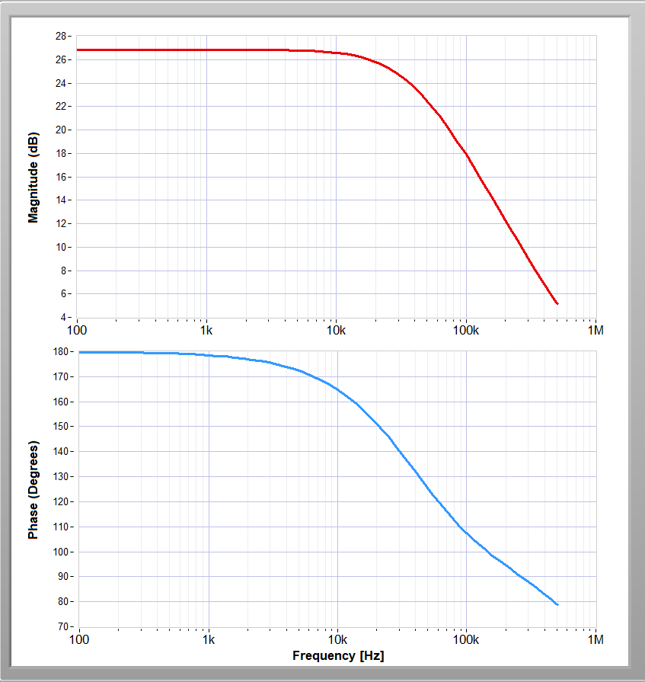
Figure 3-4. Frequency response (magnitude and phase) of low-pass inverting amplifier.

The calculated low frequency gain of the inverting active low-pass filter is -22 V/V, which is very close to our measured value of 21V/V. The sign is different because the multimeter measures the absolute values of the voltages and as such any negative is stripped away. As for the corner frequency, we got 39kHz as measured values which is close to half of our calculated value of 72.3kHz. The measured frequency where there was -3dB/decade decrease in the bode plot was also at around 40kHz. This discrepancy might have happened because of non-ideal effects of the equipment like tolerance levels.
Also, in this experiment, we used 0.2Vrms instead of 1Vrms, as instructed by the TAs in the lab.

Experiment 4. Slew Rate
The table below lists the measured slew rates for three different op amps.

Amplifier | Typical Slew Rate (V/$μs$) | Measured Slew Rate (V/$μs$)
LM324 | 0.5 | 0.39
LMC660 | 1.1 | 1.67
TL082 | 12 | 11.5

For LM324 the typical slew rate we found in the datasheet was 0.5V/μs, and the measured value we got was 0.39V/μs, which was a bit lower than the typical value. For LMC660 the typical value from the datasheet was 1.1V/μs, and the measured value we got was a bit higher at 1.67V/μs. In the same way, for TL082, which is designed for higher speed applications, the typical slew rate we found was 12V/μs, and our measured value sat a bit lower at 11.5V/μs.

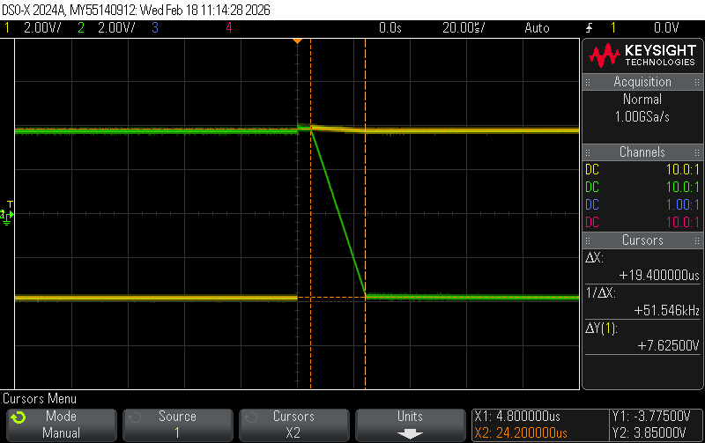
Figure 4-1. Oscilloscope trace showing slew rate limiting of the LM324.

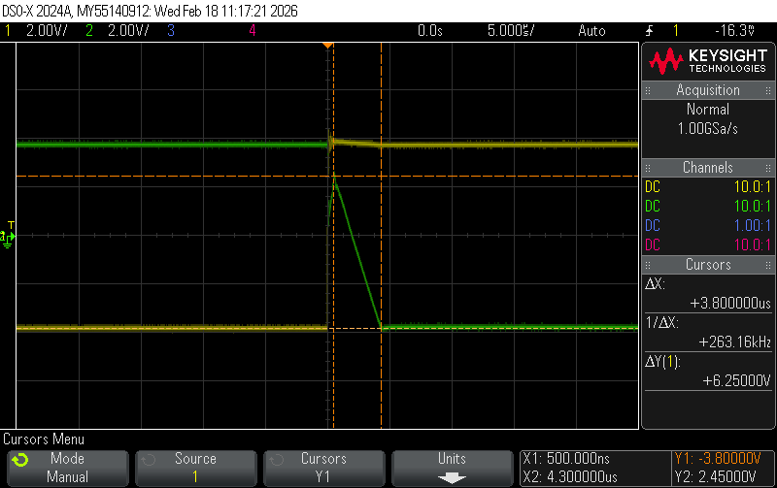
Figure 4-2. Oscilloscope trace showing slew rate limiting of the LMC660.

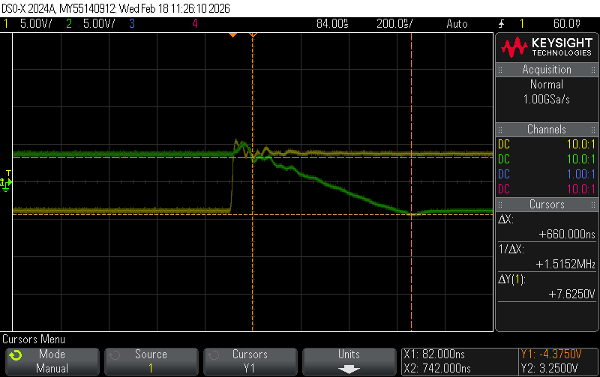
Figure 4-3. Oscilloscope trace showing slew rate limiting of the TL082.

Experiment 5. Offset Voltage and Bias Current
Figure 5-1. Schematic of amplifier used to estimate the input offset voltage and input bias current. $R_{1}=1 kΩ$, $R_{2}=470 kΩ$, and $R_{3}=R_{1}∥R_{2}$.

The table below lists the measured component values used for this experiment.

Component | Value ($kΩ$)
$R_{1}$ | 0.976 k
$R_{2}$ | 463.18 k
$R_{3}$ | 0.976 k

The table below lists the measured voltages for the LM324 op amp.

Parameters – LM324 | Value
Measured Gain (V/V) | -474.57
Measured Output Voltage with $R_{3}$, $V_{01}$ (V) | 0.4
Measured Output Voltage without $R_{3}$, $V_{02}$ (V) | 0.36
$V_{02}-V_{01}$ (V) | -0.04

The table below lists the estimated input offset voltage and input bias current, along with the limits obtained from the datasheet for the LM324.

Parameters – LM324 | Value
Maximum Guaranteed Input Offset Voltage (mV) | ±7
Maximum Guaranteed Input Bias Current (nA) | 250
Measured Input Offset Voltage (mV) | -0.84
Measured Input Bias Current (nA) | -86.3

The table below lists the measured voltages for the LMC660 op amp.

Parameters – LMC660 | Value
Measured Gain (V/V) | -474.57
Measured Output Voltage with $R_{3}$, $V_{01}$ (V) | 0.2
Measured Output Voltage without $R_{3}$, $V_{02}$ (V) | 0.19
$V_{02}-V_{01}$ (V) | -0.01

The table below lists the estimated input offset voltage and input bias current, along with the limits obtained from the datasheet for the LMC660.

Parameters – LMC660 | Value
Maximum Guaranteed Input Offset Voltage (mV) | ±6
Maximum Guaranteed Input Bias Current (nA) | ±0.002
Measured Input Offset Voltage (mV) | -0.42
Measured Input Bias Current (nA) | -22

The input offset voltages for both the op amps were well within their respective datasheet values, For the LM324, the measured offset voltage was approximately 0.84mV, which was well under the maximum guaranteed value of ±7mV. For the LMC660, the measured offset voltage was about 0.42mV, also well below the ±6mV maximum rating.

The measured input bias current for LM324 was -86.3mA, which was well under the maximum guaranteed in the datasheet. But the measured input bias for LMC660 was significantly larger than its datasheet value. It shows that due to extremely small true bias current of the device, noise likely dominated the result. This could’ve happened also because of our wrong measurement of V₀₂.

Input offset voltage and bias current become important in high-gain DC amplifiers, precision measurement systems, sensor interfaces, and circuits with large input resistances.

Figure 5-2. Schematic of amplifier used to explore the effect of input offset voltage on sinusoid. $R_{1}=330 kΩ$, $R_{2}=1 kΩ$, $R_{3}=1 kΩ$, and $R_{4}=330 kΩ$.

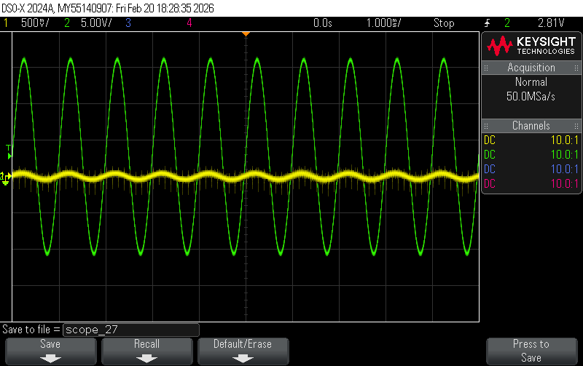
Figure 5-3. Oscilloscope trace of v_{i} (yellow) and v_{o} (green) showing the effects of input offset voltage and bias current on the output of high-gain amplifiers.

Conclusion
In this lab, we didn’t have any problems in most of the experiments. But in experiment 3, after building the active filter, our loopinator bode plot had a sudden spike which was fixed when our TAs told us to use 0.2Vrms instead of 1Vrms in the loopinator. But then rose the problem of our calculated corner frequency not matching up with our measured value. This probably happened because of non-ideal properties of the equipment. We also faced a problem with the LMC660 op amp in experiment 5 where our measured input bias current was much bigger that the maximum amount mentioned in the datasheet. Otherwise, all other values and all other experiments went without any problems.

Calculations
