Iowa State University
Electrical and Computer Engineering

  - EE 2300

Lab 3 Report – First-Order Filters

Date of Experiment: February 24, 2026
Date of Report Submission: March 02, 2026
Name of Group Members: Sayon Saha, Aaron Kammlah

Sayon Saha

Introduction
In this lab, we went over first-order passive and active filters. In experiment 1, we built a low-pass RC filter, then we calculated and measured the cutoff frequency and low-frequency gain and compared them. In experiment 2, we did the same thing but for a RC high-pass system this time round. We measured the cutoff frequency and the high-frequency gain and compared them with our calculations. In experiment 3, we built a low-pass active filter and compared our measured cutoff-frequency and low-frequency gain to our calculated values. Then in experiment 4, we built a RL low-pass filter and measured its cutoff-frequency and passband gain to compare it with our calculated values. Then to figure out why there was a noticeable difference there, we used the LCR machine to figure out the DCR value and observed how it affected the circuit in reality. Finally, in experiment 5, we designed and built a active high-pass RC circuit according to gain and cutoff-frequency specification and simulated it on LTSpice. Then we compared our simulated values with our measured values after building the physical circuit.

Experiment 1. RC Low-Pass Filter
Figure 1-1. Schematic of RC low-pass filter used for this experiment. $R=1 kΩ$ and $C=0.1 μF$.

H(s) = w_{p}/(s+ w_{p})

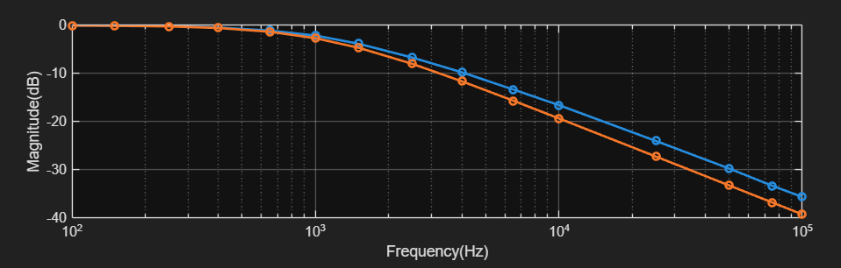
Figure 1-2. Plot of measured and calculated magnitude response.

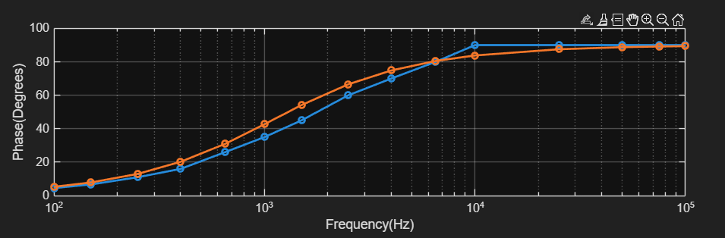
Figure 1-3. Plot of measured and calculated phase response.

The table below shows the measured cutoff frequency and DC gain.

Parameter | Value
Calculated Cutoff Frequency (kHz) | 1.083
Calculated Low-Frequency Gain (dB) | 0
Measured Cutoff Frequency (kHz) | 1.1
Measured Low-Frequency Gain (dB) | -0.06

The calculated cutoff frequency I got was 1.083 kHz, which is around 1.6% less than the measured value of 1.1kHz. As for the calculated low-frequency gain, the measured value was -0.06dB which is pretty close to the calculated value of 0. The miniscule differences are because of mostly the non-ideal characteristics of the components and the tolerances.

Experiment 2. RC High-Pass Filter
Figure 2-1. Schematic of RC high-pass filter used for this experiment. $R=1.5 kΩ$ and $C=0.1 μF$.

H(s) = s/(s+ w_{p})

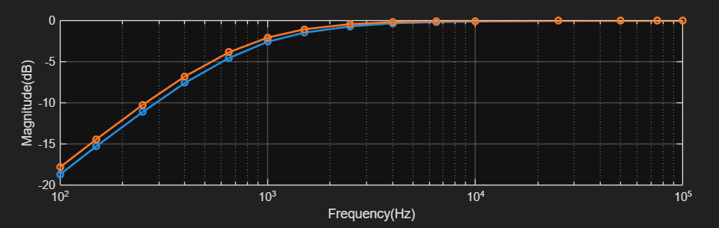
Figure 2-2. Plot of measured and calculated magnitude response.

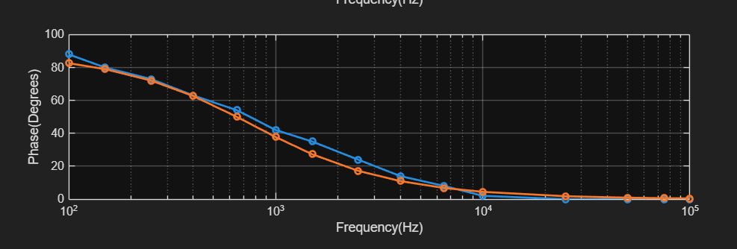
Figure 2-3. Plot of measured and calculated phase response.

The table below shows the measured cutoff frequency and high-frequency gain.

Parameter | Value
Calculated Cutoff Frequency (kHz) | 0.773
Calculated High-Frequency Gain (dB) | 0
Measured Cutoff Frequency (kHz) | 0.9
Measured High-Frequency Gain (dB) | 0

The calculated and measured cutoff frequency are close to each other with a comparatively small difference of around 0.2kHz, while the calculated and measured high-frequency gain are exactly the same. The difference in cutoff frequency could’ve been the result of non-ideal characteristics of the components.

Experiment 3. Active Low-Pass Filter
Figure 3-1. Schematic of active low-pass filter used for this experiment. The filter uses the LMC660 op amp with $±8$ V supplies. $R_{1}=1 kΩ$, $R_{2}=10 kΩ$, and $C=10 nF$.

H(s) = -(R₂/R₁)(w_{p}/(s+w_{p}))
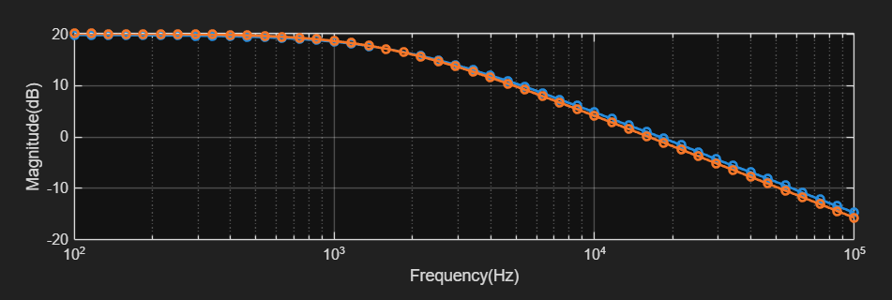
Figure 3-2. Plot of measured and calculated magnitude response.

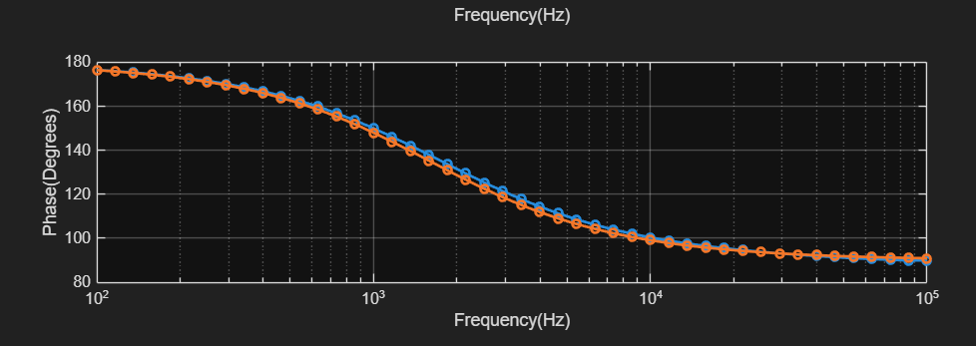
Figure 3-3. Plot of measured and calculated phase response.

The table below shows the measured cutoff frequency and high-frequency gain.

Parameter | Value
Calculated Cutoff Frequency (kHz) | 1.7
Calculated Low-Frequency Gain (dB) | 19.96
Measured Cutoff Frequency (kHz) | 1.9
Measured Low-Frequency Gain (dB) | 19.89

The calculated and measured values for cutoff frequency are within 0.2kHz of each other, which is close. The calculated low-frequency value is almost the same as the measured value. The slight difference in cutoff frequency can be because of the non-ideal characteristics and the tolerance values of the components used.

Experiment 4. RL Low-Pass Filter
Figure 4-1. Schematic of ideal RL low-pass filter. $L=60 mH$ and $R=680 Ω$.

H(s) = w_{p}/(s+ w_{p}), where w_{p} = R/L

The table below shows the calculated cutoff frequency and passband gain.

Parameter | Value
Calculated passband gain (V/V) | 1
Calculated cutoff frequency (kHz) | 1.8

The following table shows the measured passband gain.

Parameter | Value
Measured v_{i} at 10 Hz (V) | 2.29
Measured v_{o} at 10 Hz (V) | 1.77
Measured passband gain (V/V) | 0.773

The following table shows the measured cutoff frequency.

Parameter | Value
Measured v_{i} at f_{c} (V) | 2.4
Measured v_{o} at f_{c} (V) | 1.55
Measured cutoff frequency (kHz) | 2.6

The following table shows the measured component values and the expected non-ideal cutoff frequency and passband gain.

Parameter | Value
LCR Measurement Frequency (kHz) | 2
Measured Total Inductance (mH) | 58.38
Measured Total DCR ($Ω$) | 163.23
Measured Value of $R$ ($Ω)$ | 673.25
Calculated Non-Ideal Cutoff Frequency (kHz) | 2.28
Calculated Non-Ideal Passband Gain (V/V) | 0.805

The non-ideal transfer function would be,
H(s) = (R/L) / (s+((R+R_{DCR)} / L))
The ideal RL low-pass filter assumes the inductor has no internal resistance, which gives a passband gain of 1. However, real inductors have an internal resistance R_{DCR}. This forms a voltage divider with the load resistor R. This reduced DC gain to 0.805, which was much closer to our measured value of 0.773. Also, the cutoff frequency depends on the total resistance, and as such when the total resistance increases because of the series R and R_{DCR}, the cutoff frequency also increases to 2.28kHz which was much closer to our measured value of 2.6kHz.

The frequency at which $v_{o}$ equals $\left|H\left(0\right)\right|/\sqrt{2}$ is the cutoff frequency is because this is the frequency at which the power drops to half of its passband value. Power is proportional to voltage squared, and as such,
(1/sqrt(2))² = ½
This is why this frequency is defined as the cutoff frequency.

Experiment 5. Design of an Active High-Pass Filter
To design this circuit, I first used the cutoff frequency of 1kHz and Gain of -5V/V, in the standard equation for high-pass active filter. From there, I found a ratio for the resistors R₂=5R₁ and a ratio for the capacitor and feedback resistor. Then I chose a 104 capacitor from my lab kit and used those ratios to figure out that I would need an 8kΩ feedback resistor and a 1.6kΩ source resistor. So, I put a 1.5kΩ and a 100Ω resistor in series to get 1.6kΩ, while for the feedback I put two 1kΩ, two 100kΩ and a 6.8kΩ resistor in series to get 8kΩ. I put the capacitor in series with the source resistor to make it a high-pass filter.
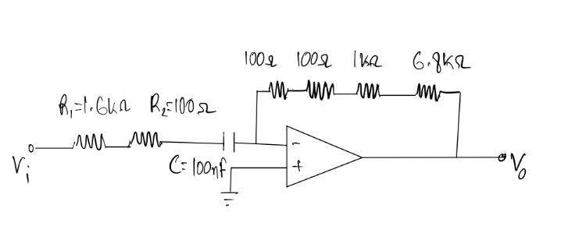
Figure 5-1. Schematic of the high-pass filter designed for this experiment.

The table below shows the simulated and measured characteristics of the design.

Parameter | Target | Simulated | Measured
Passband Gain (V/V) | -5 ±10% | 5.01 | 4.77
Cutoff Frequency (kHz) | 1 ±10% | 1.001 | 0.997

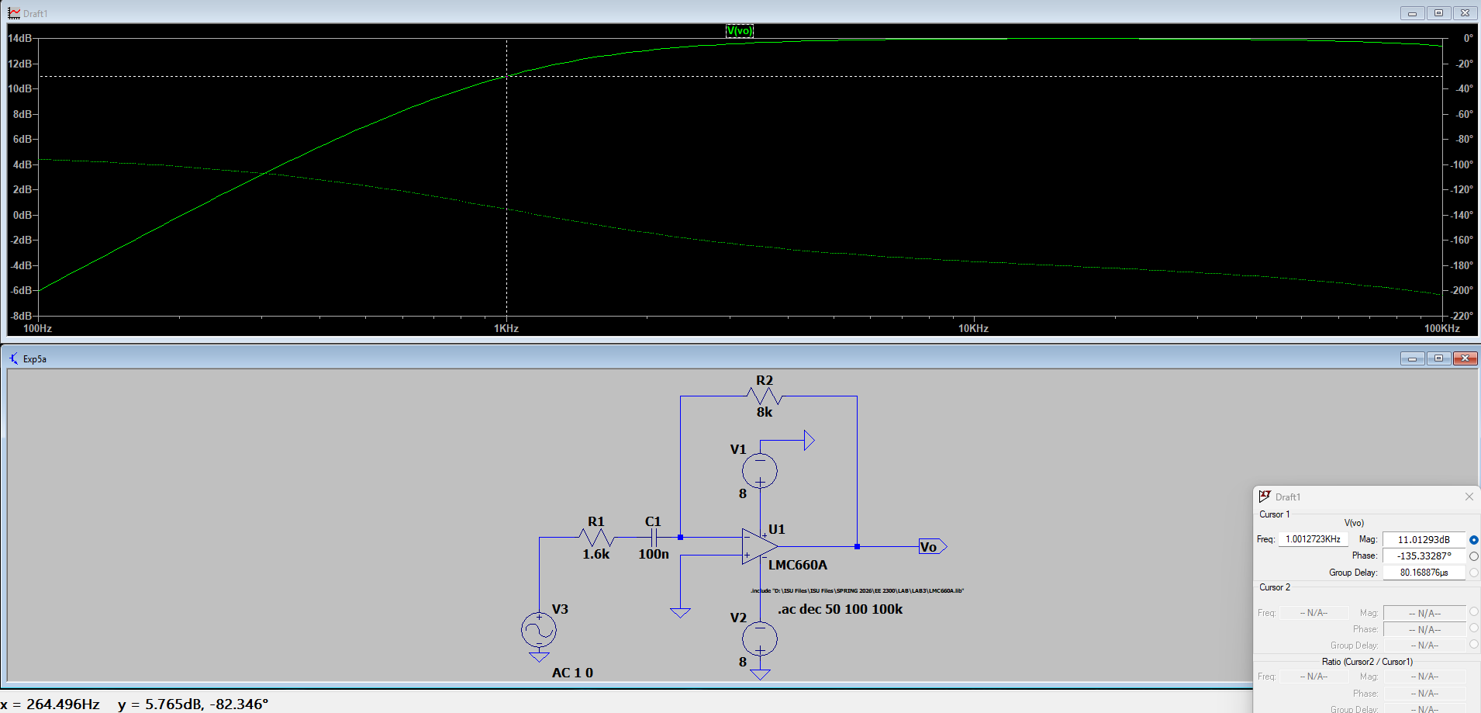
Figure 5-2. Screenshot of simulated frequency response (magnitude and phase) from LTSpice.

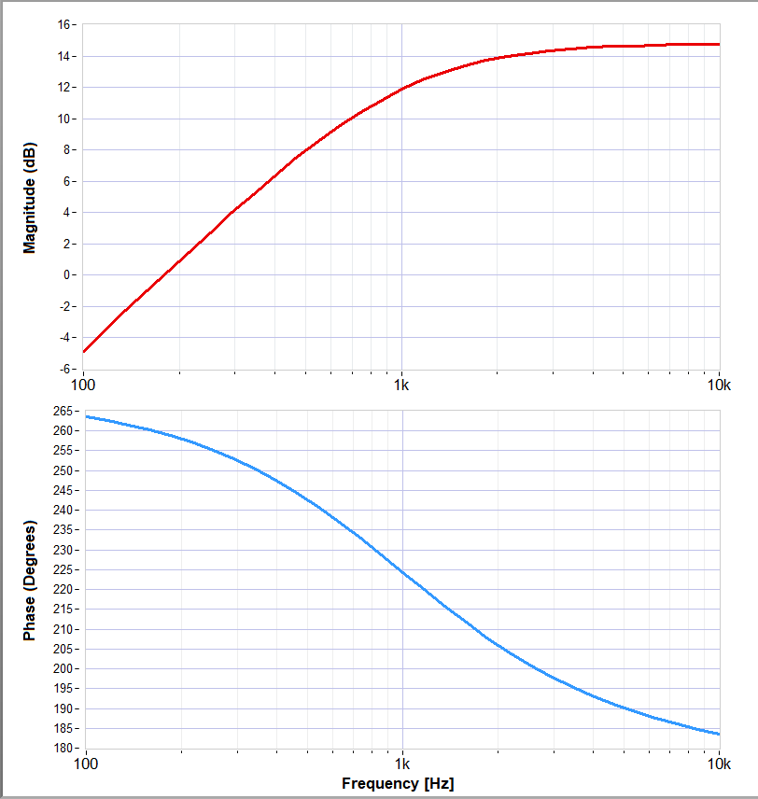
Figure 5-3. Measured frequency response (magnitude and phase).

Oscilloscope Trace:
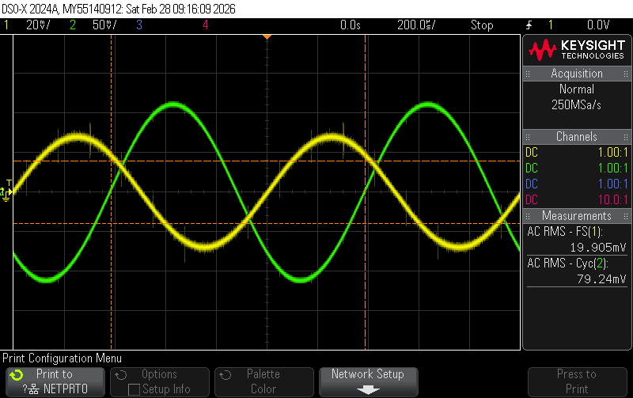

The results I got from simulating and measuring the circuit I designed were very close to each other. The main difference was in the passband gain, but that could’ve happened because of the tolerances of the physical components. Both the values from simulating and measuring the circuit fell within the 10% tolerance range of the design specification. There were no other errors that were noticeable.

Conclusion
In this lab, we didn’t face any major trouble except that the excel sheet was not initially working. So, we created our own CSV files and simulated them on MATLAB during the lab. Other than that, we did have some minor issues with measuring the capacitance and DCR values in experiment 4, but it was resolved when we redid the experiment again after changing the frequency in the LCR much closer to the one we were using.

Calculations