Iowa State University
Electrical and Computer Engineering

  - EE 2300

Lab 4 Report – Second-Order Filters

Date of Experiment: March 03, 2026
Date of Report Submission: March 09, 2026
Name of Group Members: Sayon Saha, Aaron Kammlah

Sayon Saha

Introduction
In this lab, we started working with second-order filters. For experiment 1, we first built a first-order low pass active filter and then combined two of those filters in cascading configuration to create a second-order version of the filter. We measured the cutoff frequency; passband gain and quality factor for the circuit and compared them without calculated values. For experiment 2, we built three different passive RLC filters, low-pass, high-pass and bandpass. Then we measured the passband gain, cutoff frequency and quality factor for each and compared them with our calculated values. We also used csv files from the loopinators to create MATLAB plots of magnitude and phase with two different resistors to compare them. For experiment three, we designed a low-pass Sallen-Key filter within certain specifications.

Experiment 1. Low-Q Low-Pass Active Filters
Figure 1-1. Schematic of first-order low-pass filter with $R_{1}=4.7 kΩ$, $R_{2}=10 kΩ$, and $C_{1}=10 nF$.

The table below shows the calculated and measured cutoff frequency and pass-band gain for the first-order system.

 | Calculated | Measured
Cutoff Frequency (kHz) | 1.624 | 1.58
Passband Gain (dB) | 6.48 | 6.34

The measured values I got for cutoff frequency and passband gain closely matched the calculated values. The calculated cutoff frequency was 1.624 kHz which was a bit higher than the measured value, and the calculated passband gain was 6.48 dB which was pretty close to the measured value. This slight difference can be attributed to component tolerances of the resistors and capacitor.
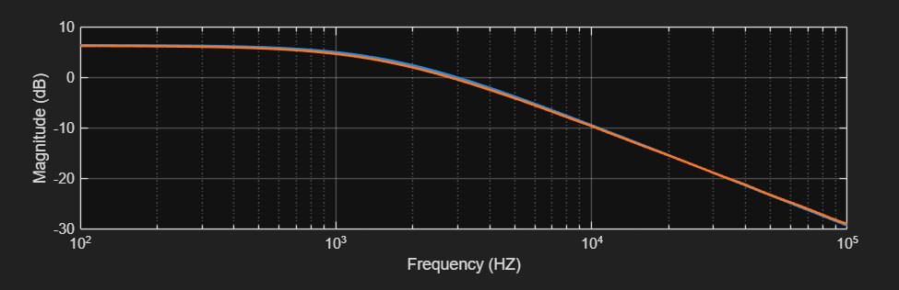
Figure 1-2. Plot of measured and calculated magnitude response.

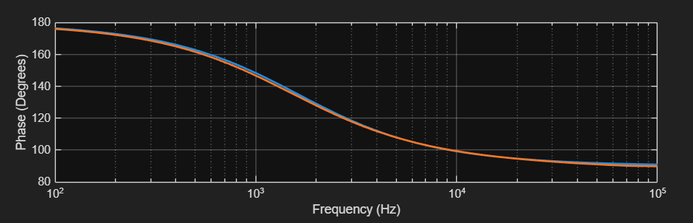
Figure 1-3. Plot of measured and calculated phase response.

Figure 1-4. Schematic of secpmd-order low-pass filter with $R_{1}=4.7 kΩ$, $R_{2}=10 kΩ$, and $C_{1}=10 nF$.

The table below shows the calculated and measured cutoff frequency, pass-band gain, and quality factor for the second-order system.

 | Calculated | Measured
Cutoff Frequency (kHz) | 1.05 | 1.2
Passband Gain (dB) | 13.1 | 12.94
Quality Factor | 0.5 | 0.5

The measurements are reasonably close to the calculated values. The measured cutoff frequency was 1.2 kHz which was a bit higher than the calculated value of 1.05 kHz. The calculated passband again was also slightly higher than the measured value. The quality factor was the same. The slight differences can be attributed to the component tolerance values again.

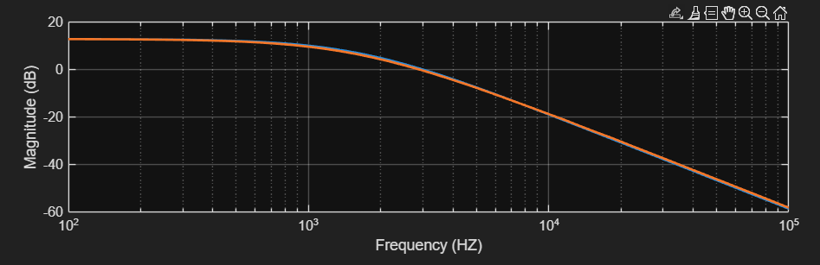
Figure 1-2. Plot of measured and calculated magnitude response.

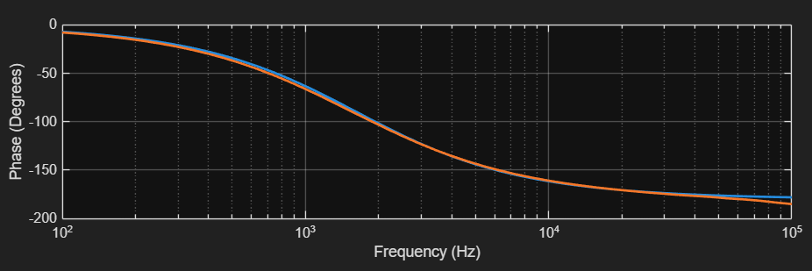
Figure 1-3. Plot of measured and calculated phase response.

Experiment 2. High-Q Second-Order RLC Filters
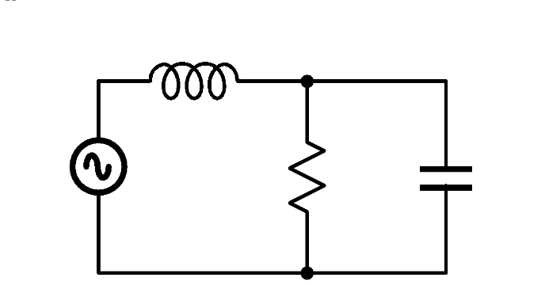

Figure 2-1. Schematic of the low-pass RLC filter with $L=15 mH$, $C=0.1 μF$ and $R$ of $150 Ω$ or $1.5 kΩ$.

The table below shows the calculated and measured values for cutoff frequency, pass-band gain, and quality factor for the band-pass filter with $R=1.5 kΩ$.

 | Calculated | Measured
Cutoff Frequency (kHz) | 6.31 | 6.1
Passband Gain (dB) | 0 | -0.26
Quality Factor | 3.87 | 3.88

The measured values agree with the calculated values with slight deviations. The calculated cutoff frequency of 6.31 kHz was close to the measured value of 6.1 kHz. The passband gain ideally should be 0 dB, but we got -0.26 dB because of real components non-ideal characteristics. The quality factor was almost the same in the calculated and measured case. The slight deviations were because of non-ideal characteristics of the components.

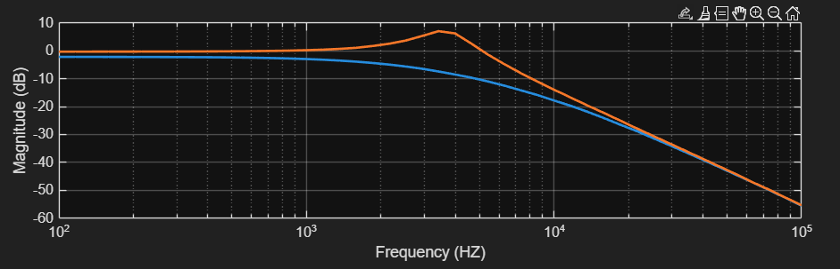
Figure 2-2. Plot of measured magnitude response of high-pass filter for $R=150 Ω$ and $R=1.5 kΩ$.

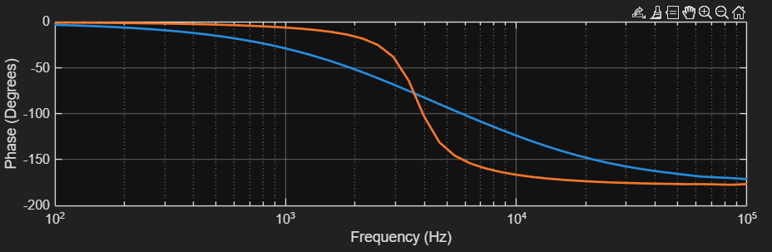
Figure 2-3. Plot of measured phase response of high-pass filter for $R=150 Ω$ and $R=1.5 kΩ$.

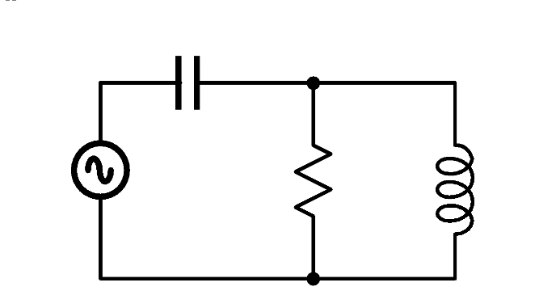
Figure 2-4. Schematic of the high-pass RLC filter with $L=15 mH$, $C=0.1 μF$ and $R$ of $150 Ω$ or $1.5 kΩ$.

The table below shows the calculated and measured values for cutoff frequency, pass-band gain, and quality factor for the high-pass filter with $R=1.5 kΩ$.

 | Calculated | Measured
Cutoff Frequency (kHz) | 2.7 | 2.5
Passband Gain (dB) | 0 | -0.205
Quality Factor | 3.87 | 1.8

The calculated values are again close to the measured ones except the quality factor. The cutoff frequency and passband gain agree in both cases. But there is a noticeable difference between the calculated and the measured quality factor. This happened because of the inductor DCR. As we were measuring the output voltage across the inductor which brings the DCR into consideration in a physical circuit, and in ideal cases like calculating we didn’t consider the DCR, major differences can be noticed in the quality factor values. Again, non-ideal characteristics only compound these differences.

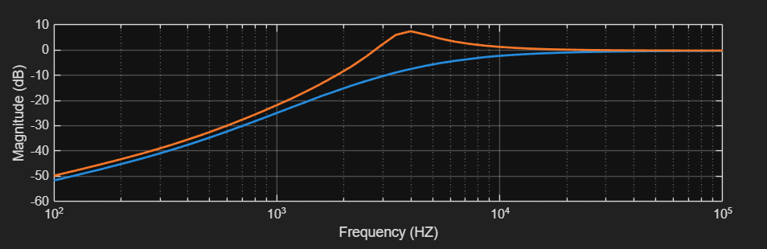
Figure 2-5. Plot of measured magnitude response of high-pass filter for $R=150 Ω$ and $R=1.5 kΩ$.

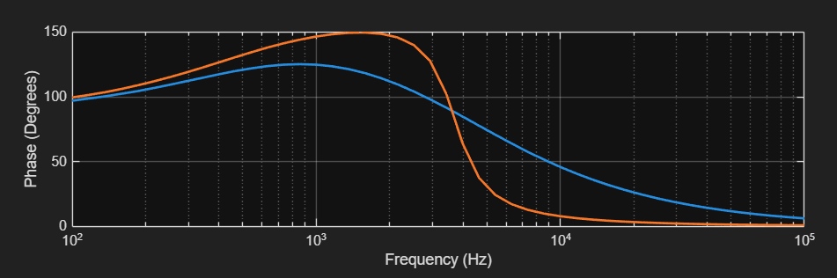
Figure 2-6. Plot of measured phase response of high-pass filter for $R=150 Ω$ and $R=1.5 kΩ$.

Figure 2-4. Schematic of the band-pass RLC filter with $L=15 mH$, $C=0.1 μF$ and $R$ of $150 Ω$ or $1.5 kΩ$.

The table below shows the calculated and measured values for cutoff frequency, pass-band gain, and quality factor for the band-pass filter with $R=1.5 kΩ$.

 | Calculated | Measured
Cutoff Frequency (kHz) | 3.28 and 5.03 | 3.28 and 5.03
Passband Gain (dB) | 0 | -5.093
Quality Factor | 3.87 | 2.27

In this circuit all the measured values except the cutoff are significantly different from the calculated values. As we can see, our calculated passband gain value represents the ideal value of 0 dB, but when we measured it for the physical circuit, we got -5.093dB. This is a major difference, so is the difference between the calculated and measured quality factors. A major contributor to this is the DCR of the inductor not being considered when calculating using the ideal equations. The non-ideal characteristics also play a part.

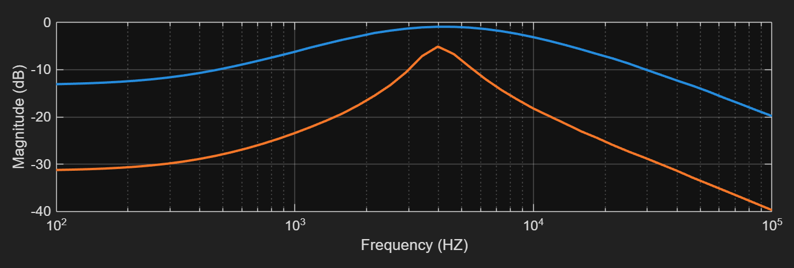
Figure 2-5. Plot of measured magnitude response of band-pass filter for $R=150 Ω$ and $R=1.5 kΩ$.

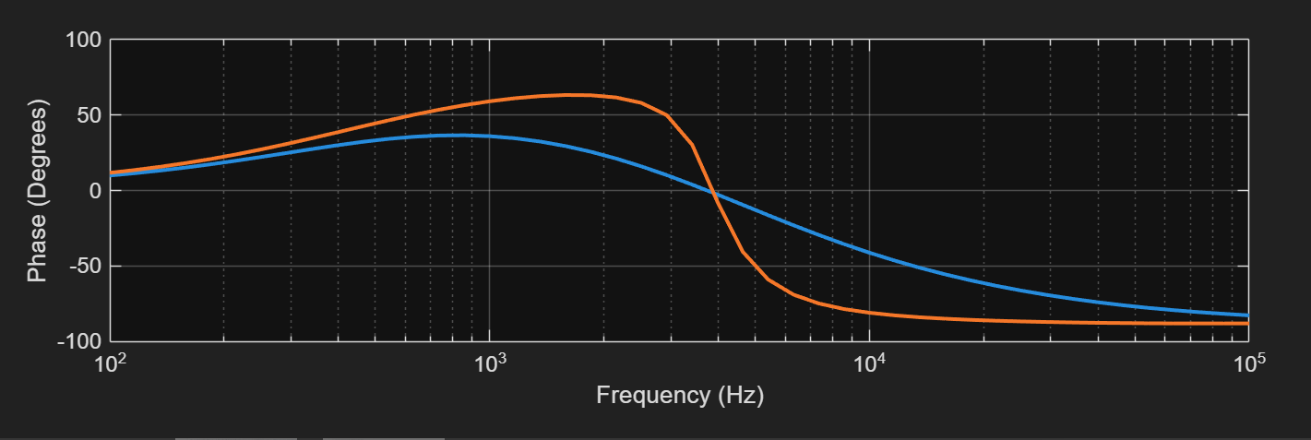
Figure 2-6. Plot of measured phase response of band-pass filter for $R=150 Ω$ and $R=1.5 kΩ$.

Experiment 3. Active Filter Design
To design the circuit, I first used the standard equations to find out n, which must be at least equal to 4Q^2. There we got n=2, which is the ratio of the capacitors. Then I used n to figure out k and m, where m is the ratio of the resistor values. Then I fixed a capacitor (C2) to 0.1μF and calculated the other component values from there.
Then I put two 0.1μF capacitors in parallel to get C1 = 0.2μF, and as both the resistors required the same value, for each I put one 1kΩ, one 100Ω and one 22Ω resistor in series to get as close to 1125Ω as possible. I put them in the standard configuration for a Sallen-Key filter.
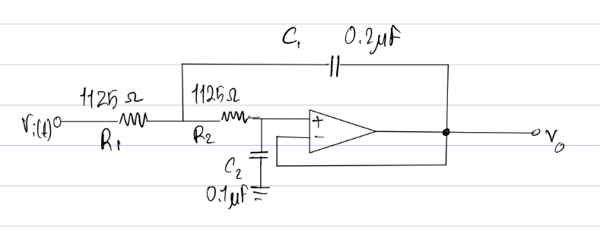
Figure 3-1. Schematic of the high-pass filter designed for this experiment.

The table below shows the simulated and measured characteristics of the design.

Parameter | Target | Simulated | Measured
Passband Gain | 1 V/V ±5% | 1 | 0.99
Cutoff Frequency | 1 kHz ±10% | 1.028 | 0.928
Quality Factor | $1/\sqrt{2}$ ±10% | 0.707 | 0.712

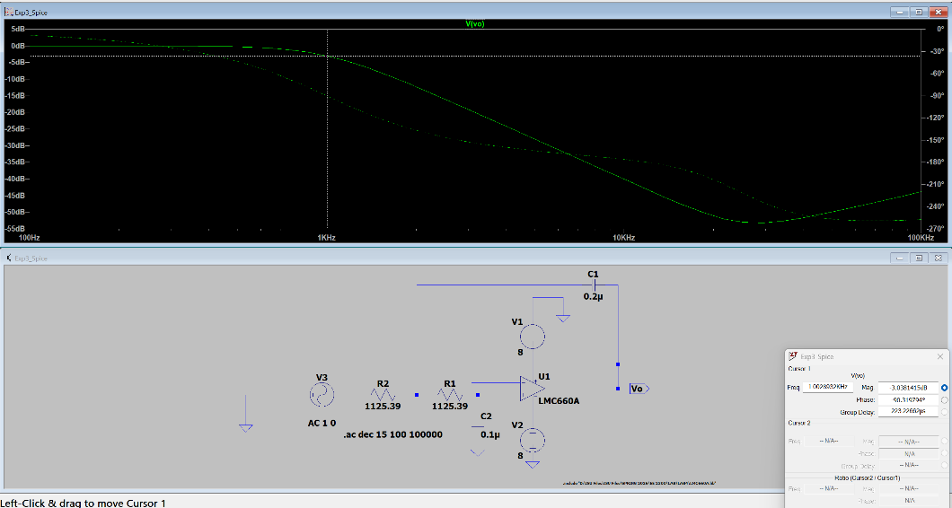
Figure 3-2. Screenshot of simulated frequency response (magnitude and phase) from LTSpice.

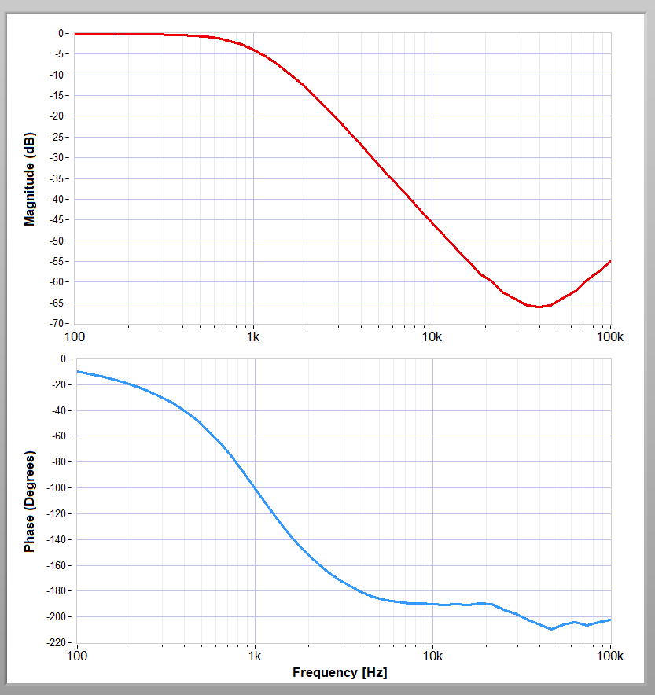
Figure 3-3. Measured frequency response (magnitude and phase).

Conclusion
In this lab, we didn’t face much problem except the last parts of experiment 2, where our calculations portrayed very different quality factors and passband gain values from the ones we measured, especially for the bandpass filter. But later, we figured out that it was due to the DCR values of the inductor.

Calculations
