Iowa State University
Electrical and Computer Engineering

  - EE 2300

Lab 5 Report – Linear Oscillators

Date of Experiment: March 10, 2026
Date of Report Submission: March 21, 2026
Name of Group Members: Sayon Saha, Aaron Kammlah

Sayon Saha

Introduction
In this lab, we started working with oscillators. In the first experiment, we built a Wien-Bridge oscillator and measured the frequency while the output was not clipped and then when it was clipped. Then we compared the measured values with the calculated value. For experiment 2, we designed a similar Wien-Bridge oscillator to achieve target frequencies. In experiment 3, we built a Phase Shift oscillator and measured the oscillation frequency to compare it with the calculated value. Then we built a Quadrature oscillator and compared the measured oscillation frequency with the calculated one.

Experiment 1. Wein-Bridge Oscillator
The table below lists the measured and calculated oscillation frequencies of the Wien-Bridge oscillator in Hz.

 | Frequency (Hz)
Expected Frequency | 1.59k
Measured Frequency (Undistorted) | 1.51k
Measured Frequency (Clipped) | 1.49k

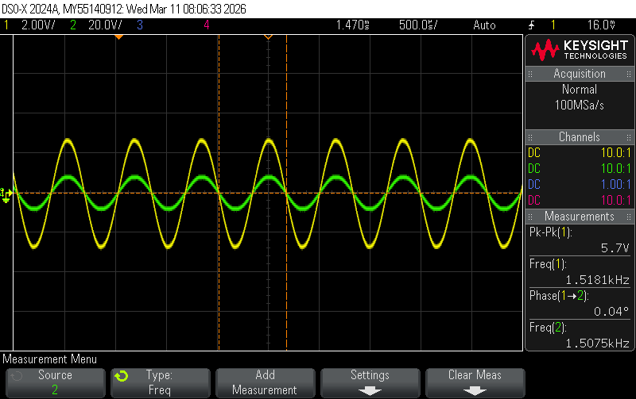
Figure 1-1. Plot of undistorted output voltage of the Wien-Bridge oscillator.

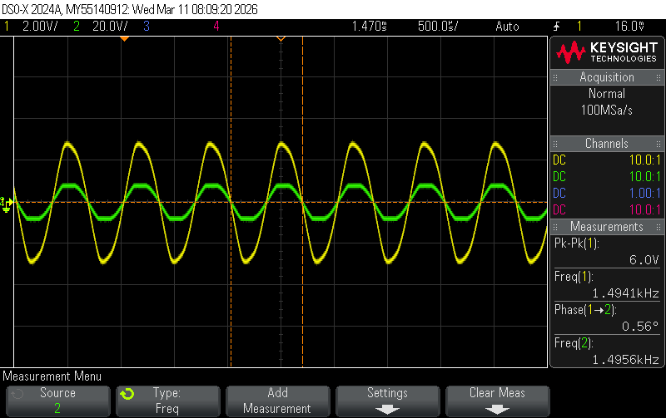
Figure 1-1. Plot of clipped output voltage of the Wien-Bridge oscillator.

The measured and calculated values were close to each other, with the slight differences being due to component tolerances and non-ideal characteristics.

Experiment 2. Design of Wien-Bridge Oscillator
To design the circuit, I first used the standard equations for the Wien-Bridge oscillator and used the target frequency to figure out the component values. I set my capacitor value to 0.1µF and found the resistor value to be 320Ω, so I used one 220Ω and one 100Ω resistor in series to achieve that. We also set the potentiometer we used as a feedback resistor close to 2kΩ.
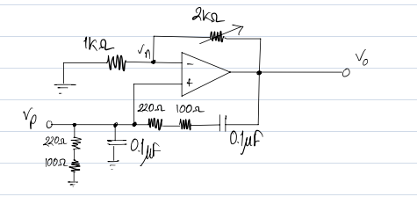
Figure 2-1. Schematic of the Wien-Bridge oscillator.

The table below lists the measured oscillation frequency.
 | Frequency (Hz)
Expected Frequency | 5 kHz ± 10%
Simulated Frequency | 4.87kHz
Measured Frequency | 4.995 kHz

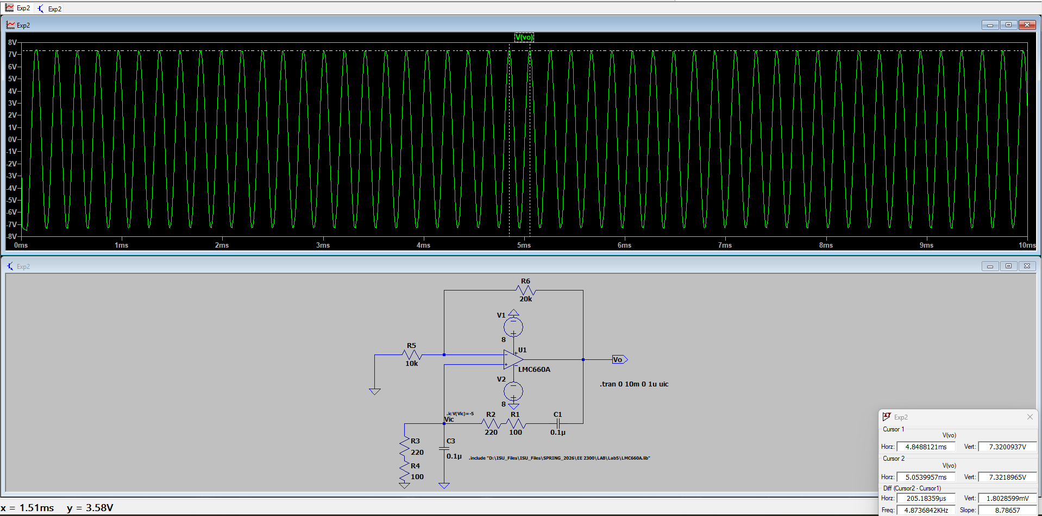
Figure 2-1. Plot of simulated oscillator output.

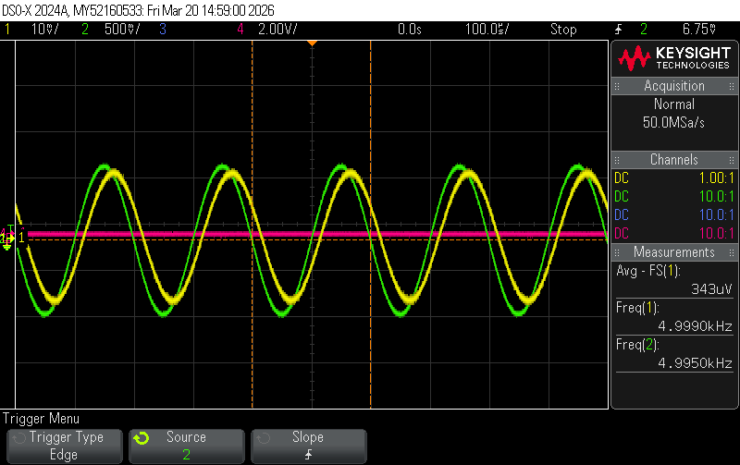
Figure 2-1. Plot of measured oscillator output voltage.

Experiment 3. Phase Shift Oscillator
The table below lists the measured and calculated oscillation frequencies of the phase-shift oscillator in Hz.

 | Frequency (Hz)
Expected Frequency | 918.88
Measured Frequency (Undistorted) | 851
Measured Frequency (Clipped) | 721

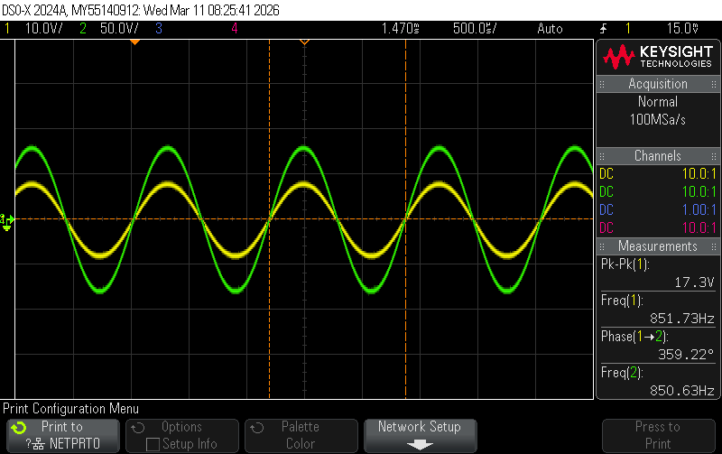
Figure 1-1. Plot of undistorted output voltage of the phase-shift oscillator.

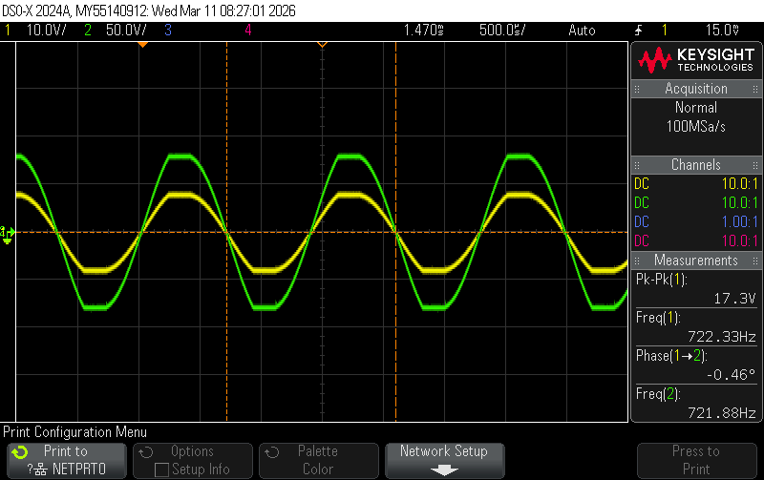
Figure 1-1. Plot of clipped output voltage of the phase-shift oscillator.

The calculated and measured were close, with there being a significant drop in oscillation frequency when the output was capped.

Experiment 4. Quadrature Oscillator
The table below lists the measured and calculated oscillation frequencies of the Quadrature oscillator in Hz.

 | Frequency (Hz)
Expected Frequency | 1.446k
Measured Frequency (Undistorted) | 1.29k
Measured Frequency (Clipped) | 868

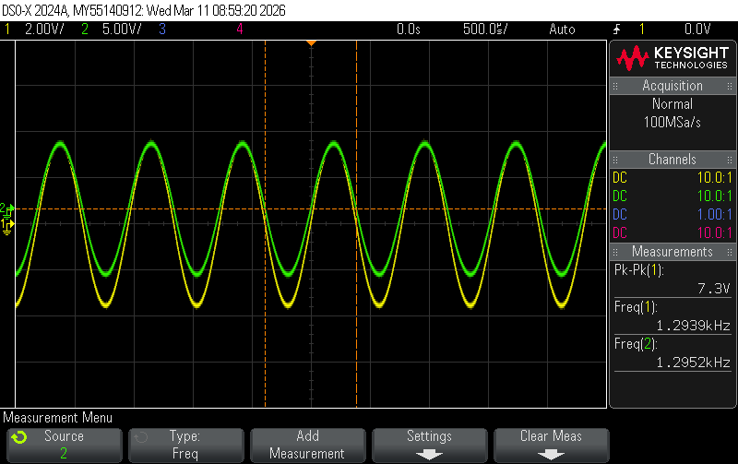
Figure 1-1. Plot of undistorted output voltage of the Quadrature oscillator.

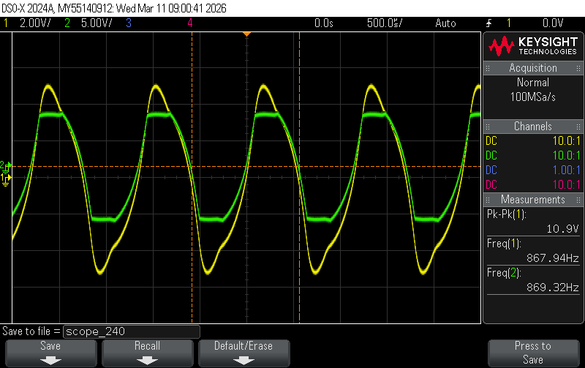
Figure 1-1. Plot of clipped output voltage of the Quadrature oscillator.

Again, the non-capped measured and calculated oscillation frequency were close to each other, but the capped oscillation frequency dropped by a considerable amount.

Conclusion
During the lab, we didn’t face any major issues. The potentiometer was a bit hard to get to the desired value, especially when we were using the 103 potentiometers in experiment 2, Other than that, we didn’t face any problems, and everything went smoothly. The oscilloscope traces also turned out to be exactly what we expected.

Calculations

