Iowa State University
Electrical and Computer Engineering

  - EE 2300

Lab 6 Report – Comparators & a non-linear oscillator

Date of Experiment: March 24. 2026
Date of Report Submission: March 30, 2026
Name of Group Members: Sayon Saha, Aaron Kammlah

Sayon Saha
Introduction
In this lab, we started working with comparators and non-linear oscillators. In experiment 1, we built a non-inverting comparator in stages, and each time analyzed the input and output voltage on the oscillator both in normal and XY mode. We also calculated the higher threshold and lower threshold voltages of the circuit in part c. For experiment 3, we built an inverting comparator and did the same analysis as experiment 1. For experiment 3, we built a non-linear oscillator first without a potentiometer and then with one. We monitored the input and output voltage both times. We also calculated the expected higher threshold and lower threshold voltage along with the oscillation frequency.
Experiment 1. Non-inverting Comparator
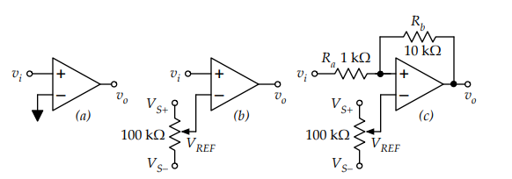

Calculated V_{TL}: 3 V Measured value: 3 V
Calculated V_{TH}: 1.4 V Measured value: 1.37 V

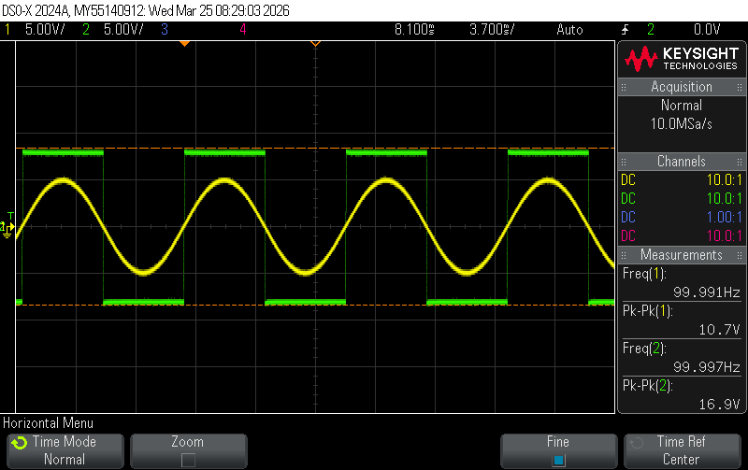
Figure 1-1. Plot of input and output for a
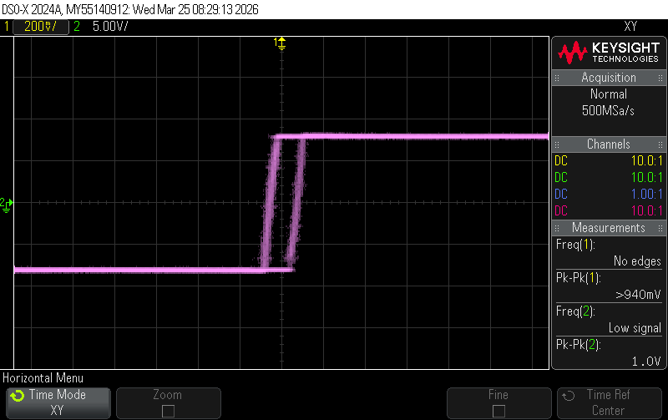
Figure 1-2. Plot of XY mode for a
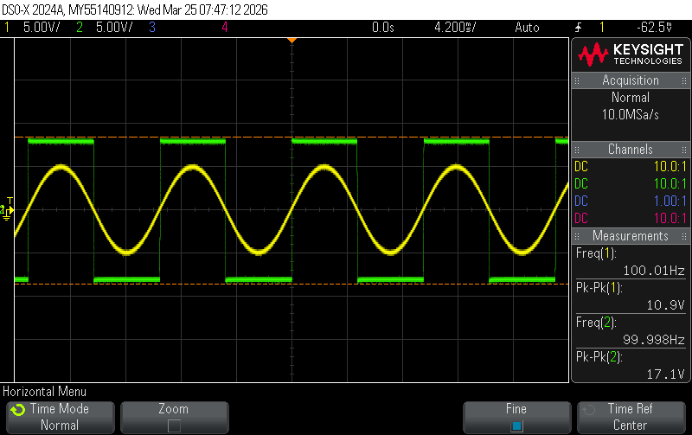
Figure 1-3. Plot of input and output for b
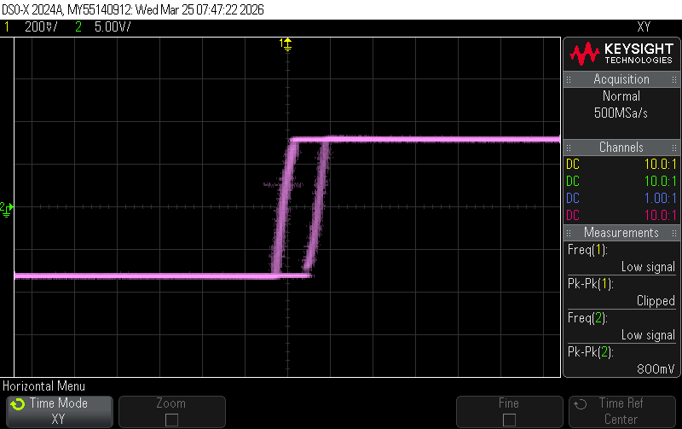
Figure 1-4. Plot of XY mode for b
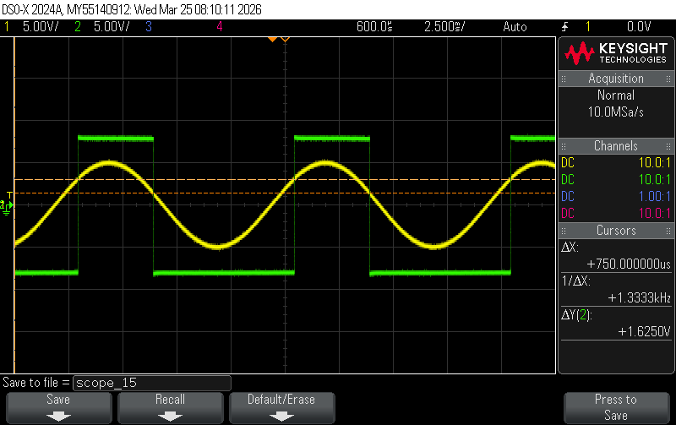
Figure 1-5. Plot of input and output for c
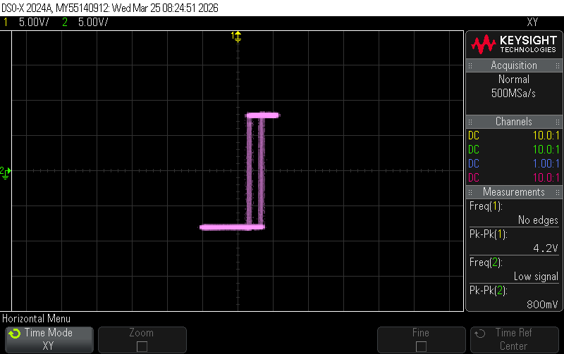
Figure 1-6. Plot of XY mode for c

The part a and b traces for this experiment are almost identical, but a noticeable shift can be seen in part c when added the feedback loop, especially in XY mode.
The calculated and measured values are also almost identical.

Experiment 2. Inverting Comparator
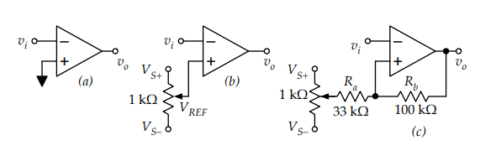
Calculated V_{TL}: 3.49 V Measured value: 3.68 V
Calculated V_{TH}: -0.48 V Measured value: 0.312 V

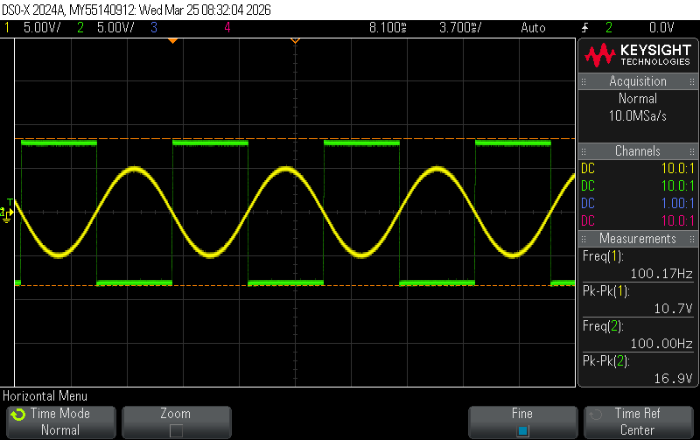
Figure 2-1. Plot of input and output for a
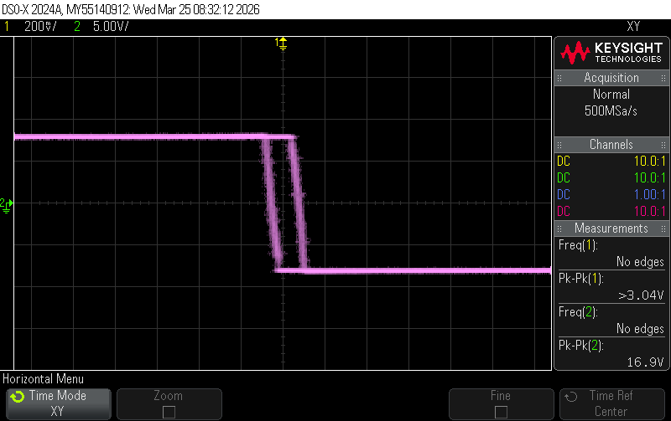
Figure 2-2. Plot of XY mode for a
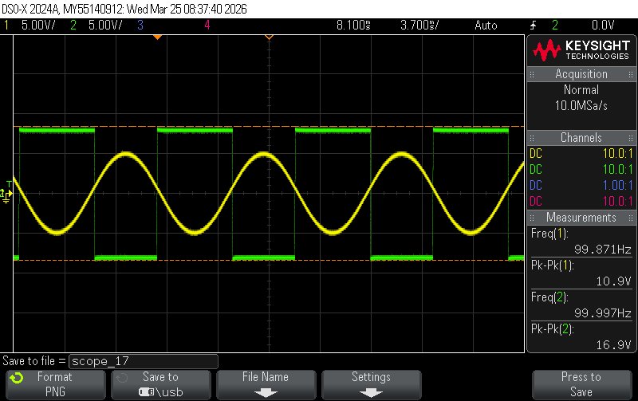
Figure 2-3. Plot of input and output for b
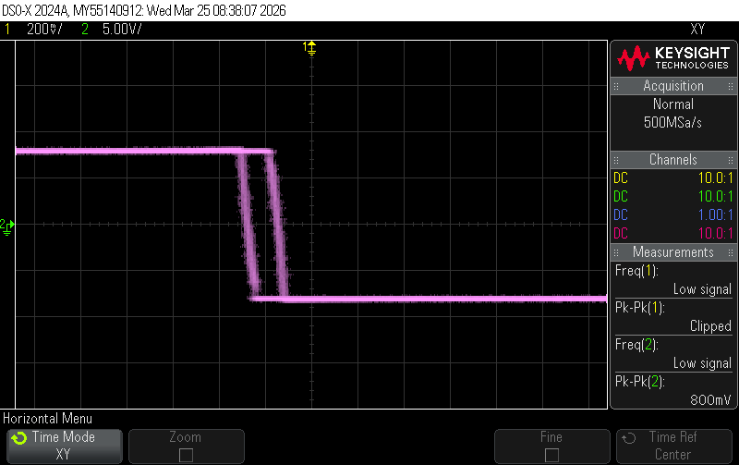
Figure 2-4. Plot of XY mode for b
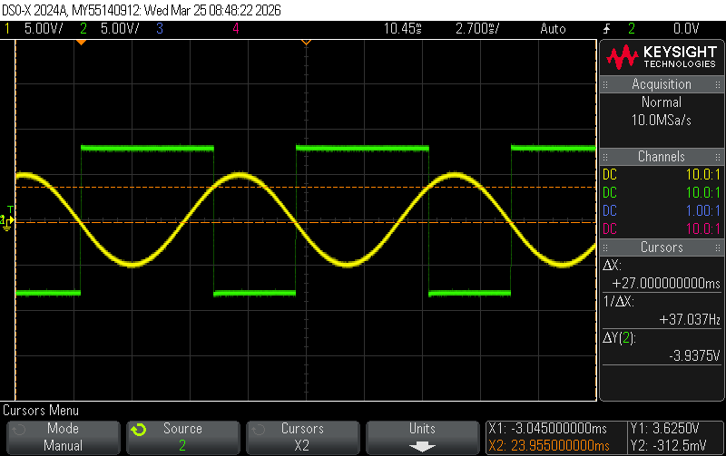
Figure 2-5. Plot of input and output for c
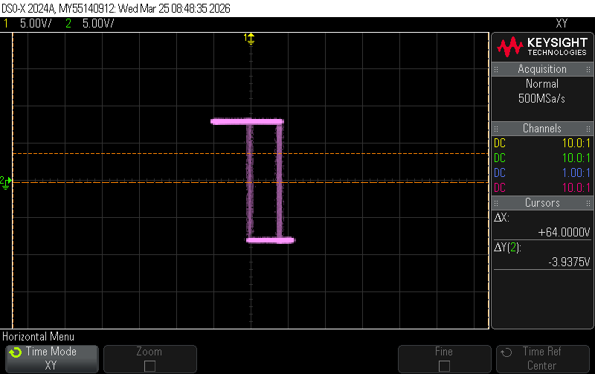
Figure 2-6. Plot of XY mode for c

Same as experiment 1, in part a and part b of this experiment, we find almost identical traces. But in part c, we see a noticeable change when we added in the feedback loop. The calculated and measured values for higher threshold and lower threshold voltages are almost the same too.

Experiment 3. Non-linear Oscillator
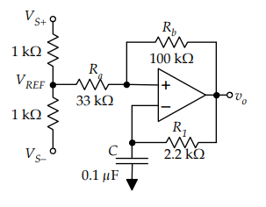
Calculated V_{TH}: 1.98 V Measured value: 2 V
Calculated V_{TL}: -1.98 V Measured value: -2.1 V
Calculated f_{osc}: 4.48 kHz Measured value: 5.2 kHZ

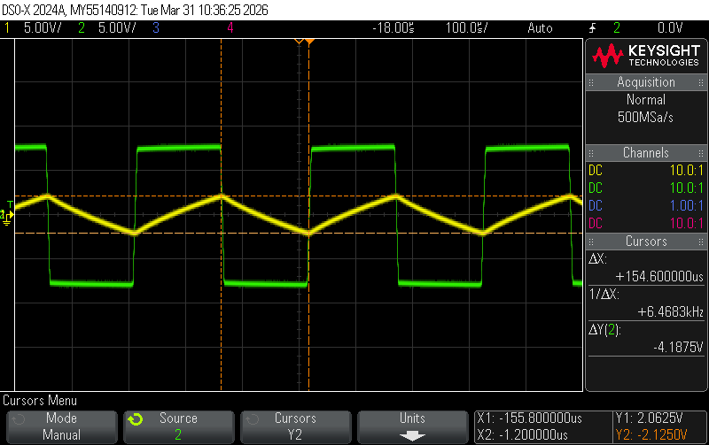
Figure 1-1. Plot of input and output without potentiometer

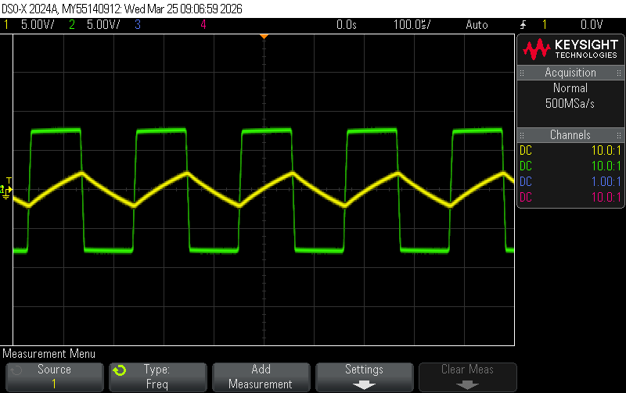
Figure 1-1. Plot of input and output with potentiometer

The calculated and measured values were close. The calculated and measured higher thresholds and lower thresholds were withing 5% of each other. The oscillation frequency was also close to the calculated one.

Conclusion
In this lab we didn’t face any major problems. Our initial measurement of V_{TH} and V_{TL} were wrong because of cursor misplacement. They didn’t agree with our calculations. That issue was addressed when we redid the experiment and placed the cursors where they needed to be. Other than that, the experiments were completed without any complications.

Calculation