Iowa State University
Electrical and Computer Engineering

  - EE 2300

Lab 7 Report – Diodes

Date of Experiment: March 31. 2026
Date of Report Submission: April 06, 2026
Name of Group Members: Sayon Saha, Aaron Kammlah

Sayon Saha

Introduction
In this lab we started working with diodes in different configurations and their characteristics. In experiment 1, we took a diode, and two different LEDs to observe their characteristics on the parameter analyzer, once in forward bias and once in reverse bias. In experiment 2, we built a simple circuit with a diode and observed the diode voltage and diode current at different source voltages. Finally in experiment 3, we built 4 different circuits with multiple diodes in different configurations and measured the current through some of the circuit components to compare them with our calculated ones.

Experiment 1. Diode I-V Characteristics with the Parameter Analyzer

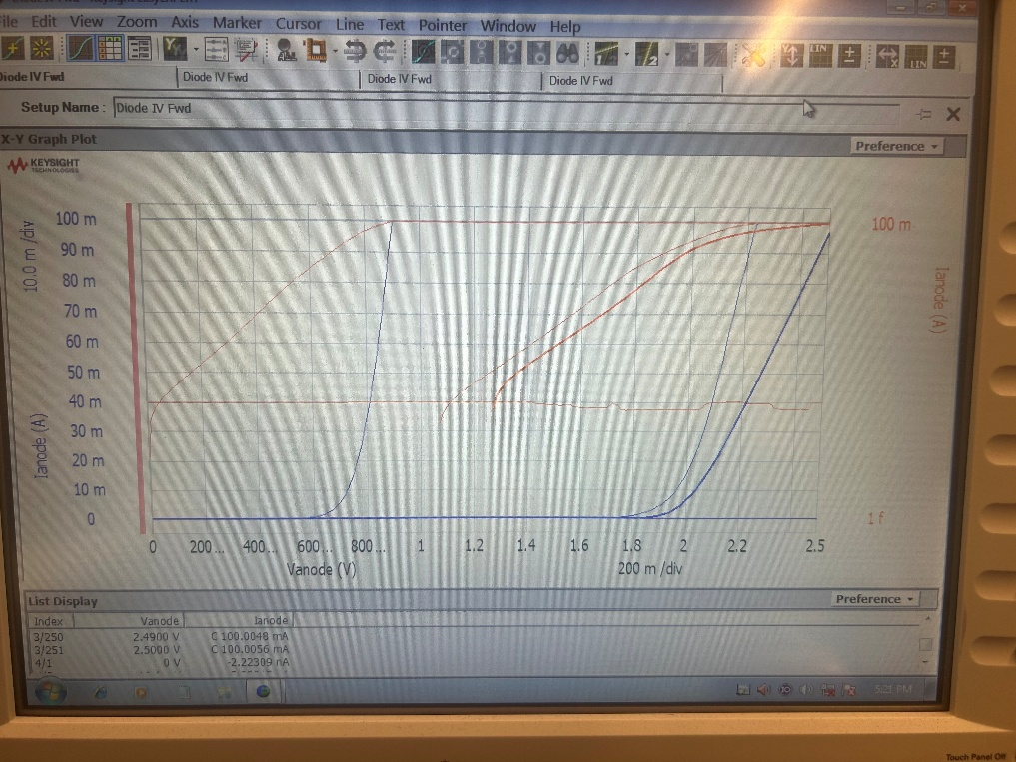
Figure 1-1. I-V characteristics of 1N4006 diode and red LED.

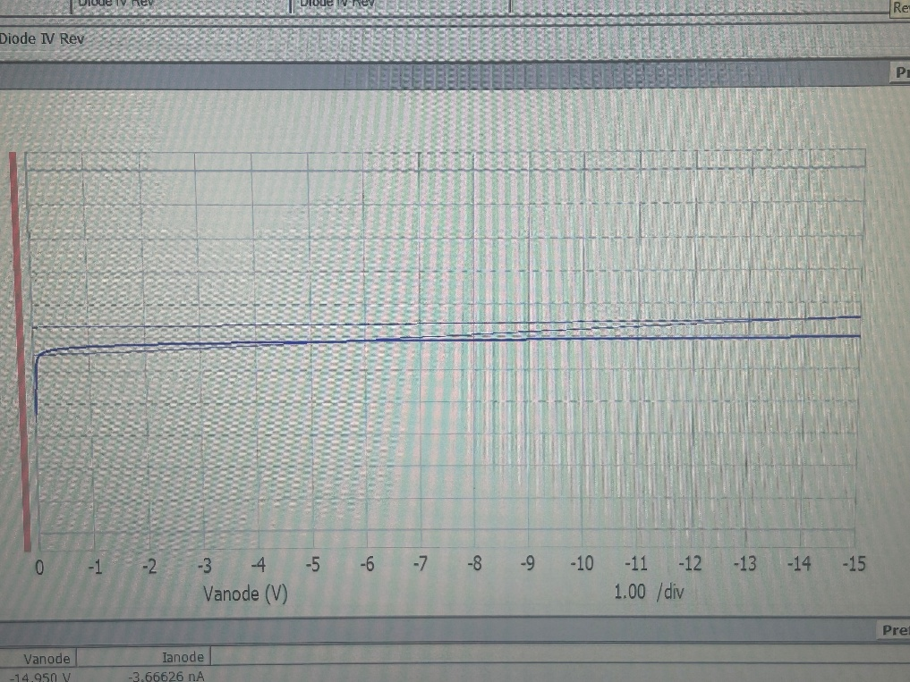
Figure 1-2. Reverse I-V characteristics of 1N4006 diode.

The observed I-V characteristics matched the expected results we had for both silicon diodes and LEDs in both forward and reverse bias.

In the forward bias test, the silicon diode turned on at a relatively small voltage and reached high current rather quickly. The curve rose sharply at around 0.6 to 0.8 V, which was consistent with expected silicon diode behavior. The red LED and greed LED required noticeably larger forward voltages before significant current began to flow. From the plot, the LED curves began conducting around 2 to 2.3 V. This agrees with what we would expect from LEDs which are made from semiconductors with larger band gaps. There is a slight difference in how each LED curves though, or rather their slope. This can be related to them emitting different colors.

In the reverse bias test, the current stayed very small, almost flat throughout the test range. This indicated that the diode was blocking reverse currents. The reverse current was also close to 0 compared to the forward currents. This matched the expected behavior of a silicon diode. As for the LEDs, they behaved slightly differently from the silicon diodes but still followed the expected characteristics of a semiconductor. They both showed very small current in reverse bias, blocking most of the reverse currents.

Experiment 2. Diode I-V Characteristics at the Lab Bench

The table below shows the measured voltage and calculated current of the 1N4006 diode.

$V_{S}$ (V) | $v_{D}$ (V) | $i_{D}$ (mA) | $V_{S}$ (V) | $v_{D}$ (V) | $i_{D}$ (mA)
-10 | -10 | 0 | 3 | 0.68 | 4.9
-8 | -8 | 0 | 4 | 0.7 | 7
-6 | -6 | 0 | 5 | 0.711 | 9.2
-4 | -4 | 0 | 6 | 0.72 | 11.3
-2 | -2 | 0 | 7 | 0.727 | 13.4
0 | -0.005 | 0 | 8 | 0.734 | 15.5
1 | 0.6 | 0.85 | 9 | 0.739 | 17.7
2 | 0.66 | 3 | 10 | 0.744 | 19.8

This experiment went without any issues. We measured the expected diode voltages and calculated the diode currents for the different source voltages, and they all matched our expectations.

Experiment 3. Simple Diode Circuits

The table below shows the measured and calculated currents.
Condition | Calculated |  |  | Measured
Condition | $$i_{D1}$$ | $$i_{R2}$$ | $$i_{D2}$$ | $$i_{D1}$$ | $$i_{R2}$$ | $$i_{D2}$$
1 V | 0.1mA | 0.1mA | 0A | 0.147 mA | 0.146 mA | 0.55 uA
5 V | 1.73mA | 1.16mA | 0.56mA | 1.8 mA | 1.154 mA | 0.6 mA

According to my calculations, when the source voltage was 1 V, the second diode D₂ was turned off. In case of the source voltage being 5 V, both the diodes were turned on.

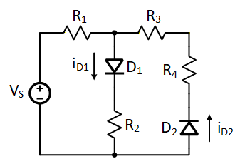

The table below shows the measured and calculated currents.
Condition | Calculated |  | Measured
Condition | $$i_{D1}$$ | $$i_{D2}$$ | $$i_{D1}$$ | $$i_{D2}$$
-5 V | 0mA | 0.56mA | 0 | 0.58 mA
5 V | 2.15mA | 0mA | 2.27 mA | 0

According to my calculations, when the source voltage was -5 V, the first diode D₁ was turned off whereas when the source voltage was 5 V, the second diode D₂ was turned off.

The table below shows the calculated currents.
Condition | Calculated
Condition | $$i_{D1}$$ | $$i_{D2}$$ | $$i_{R1}$$ | $$i_{R2}$$ | $$i_{R3}$$
$V_{S1}=$ 10 V $V_{S2}$ = 5 V | 7.8 mA | 0.43 mA | 6.2 mA | 1.64 mA | 1.21 mA

The table below shows the measured currents.
Condition | Measured
Condition | $$i_{D1}$$ | $$i_{D2}$$ | $$i_{R1}$$ | $$i_{R2}$$ | $$i_{R3}$$
$V_{S1}=$ 10 V $V_{S2}$ = 5 V | 8 mA | 0.47 mA | 6.28 mA | 1.7 mA | 1.3 mA

According to my calculations, both the diodes were turned on.

The table below shows the calculated currents.
Condition | Calculated
Condition | $$i_{D1}$$ | $$i_{D2}$$ | $$i_{D3}$$ | $$i_{R1}$$ | $$i_{R3}$$
1 V | 0.2 mA | 0 | 0 | 0.2 mA | 0
5 V | 4.01 mA | 1.14 mA | 0.4 mA | 2.87 mA | 0.73 mA

The table below shows the measured currents.
Condition | Measured
Condition | $$i_{D1}$$ | $$i_{D2}$$ | $$i_{D3}$$ | $$i_{R1}$$ | $$i_{R3}$$
1 V | 0.28 mA | 0.009mA | 0 | 0.28 mA | 0.009mA
5 V | 4.1 mA | 1.17 mA | 0.47 mA | 2.9 mA | 0.69 mA

According to my calculations, the third diode D₃ was turned off when the source voltage was 1 V. And when the source voltage was 5 V, all three diodes were turned on.

Conclusion
In this lab, we observed what we learned about diodes and their characteristics. The experiments we did proved the theories. During the lab, we didn’t face any complications and all the measured values also closely matched out calculations.
Calculations
