Iowa State University
Electrical And Computer Engineering

EE 230
LAB 8 REPORT

April 21, 2026

Sayon Saha
Aaron Kammlah

Sayon Saha

Introduction
In this lab, we started working on BJT transistors. At first, we took 4 different transistors, including the PN2222 and PN2907 transistors, and used them in the parameter analyzer to find their B_{F} values and get the i_{C}-V_{CE} traces. We compared the value with our measured one and recorded them for use in the next experiments. Then we built 3 different circuits with the PN2222 and one with the PN2907, and measured the base, collector and emitter current along with the base-emitter voltage and collector-emitter voltage. Then we compared those values with our calculated values. Then we made a BJT switch with the PN2222 and collected data across 25 different V_{i} and visualized the behavior through graphs. Finally, we built an amplifier circuit with a PN2222 to light up a LED and observed how adding the BJT improved the performance, and then we proceeded to build an amplifier with a BJT.

A Quick measure of β_{F} and i_{C} – v_{CE} characteristics with the parameter analyzer

Circuits | Calculated Values
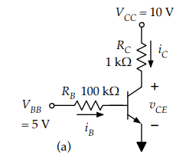 | Collector Current, i_{C} = 9.2 mA  Base Current, i_{B} = 0.043 mA  Forward current gain, B_{F} = 213.95  B_{F} = i_{c}/i_{b} = 213.95
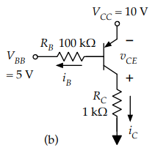 | Collector Current, i_{C} = 7 mA  Base Current, i_{B} = 0.043 mA  Forward current gain, B_{F} = 162.79  B_{F} = i_{c}/i_{b} = 162.79

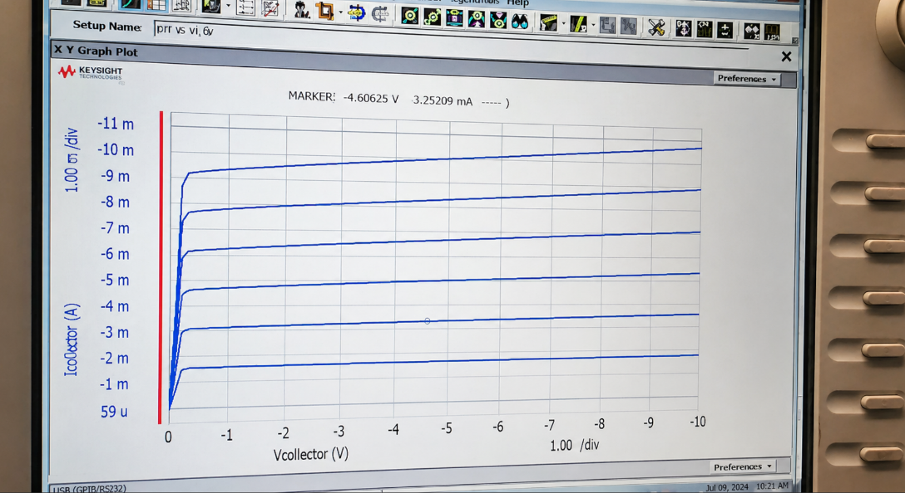
Figure 1: i_{C} –v_{CE} curves for PN2222

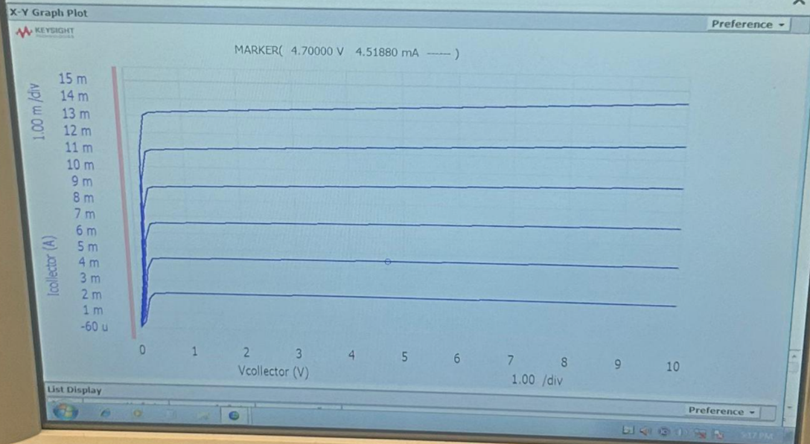
Figure 2: i_{C} –v_{CE} curves for PN2906

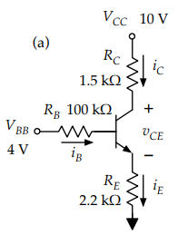
Simple BJT Circuits
 | i_{B} | i_{C} | i_{E} | v_{BE} | v_{CE}
Measured | 0.0055 mA | 1.27 mA | 1.82 mA | 0.63 V | 5.28 V
Calculated | 0.00576 mA | 1.232 mA | 1.238 mA | 0.7 V | 5,43 V

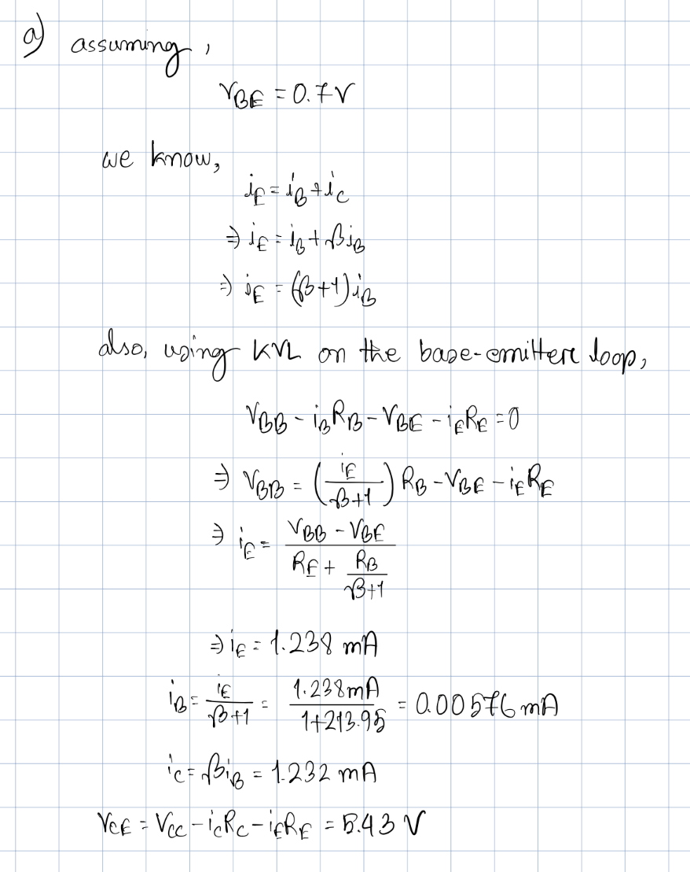

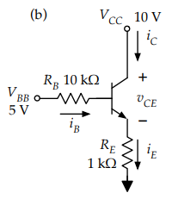

 | i_{B} | i_{C} | i_{E} | v_{BE} | v_{CE}
Measured | 0.018 mA | 4.082 mA | 4.16 mA | 0.66 V | 5.83 V
Calculated | 0.0191 mA | 4.090 mA | 4.109 mA | 0.7 V | 5.89 V

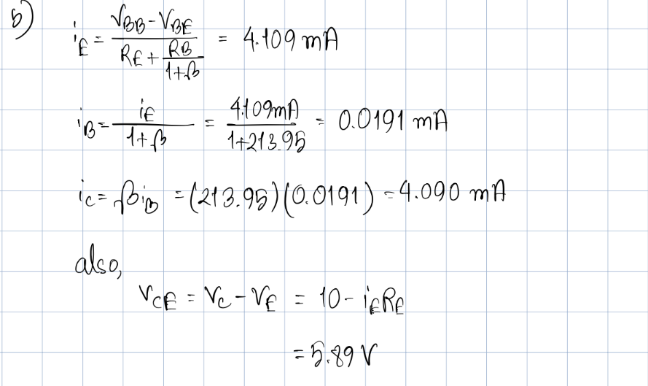
 | i_{B} | i_{C} | i_{E} | v_{BE} | v_{CE}
Measured | 1.68 mA | 2.6 mA | 4.28 mA | 0.726 | 0.096 V
Calculated | 1.80 mA | 2.04 mA | 4.3 mA | 0.7 V | 0.2 V
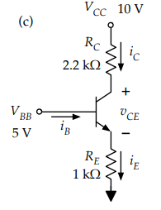

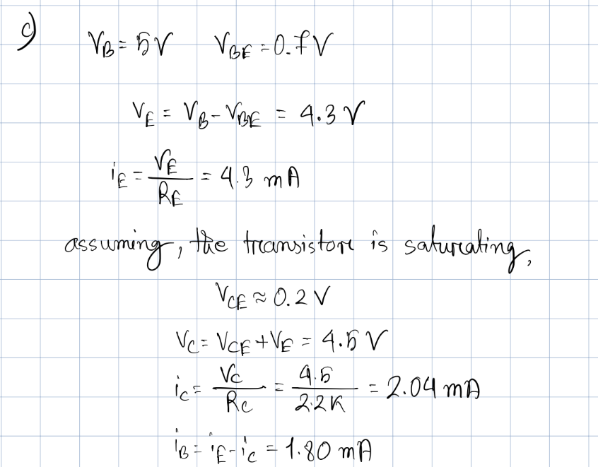

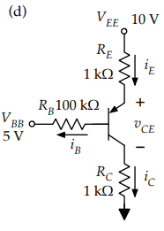
 | i_{B} | i_{C} | i_{E} | v_{BE} | v_{CE}
Measured | 0.016 mA | 2.7 mA | 2.7 mA | -0.66 V | -4.59 V
Calculated | 0.0163 mA | 2.65 mA | 2.67 mA | -0.7 V | -4.68 V

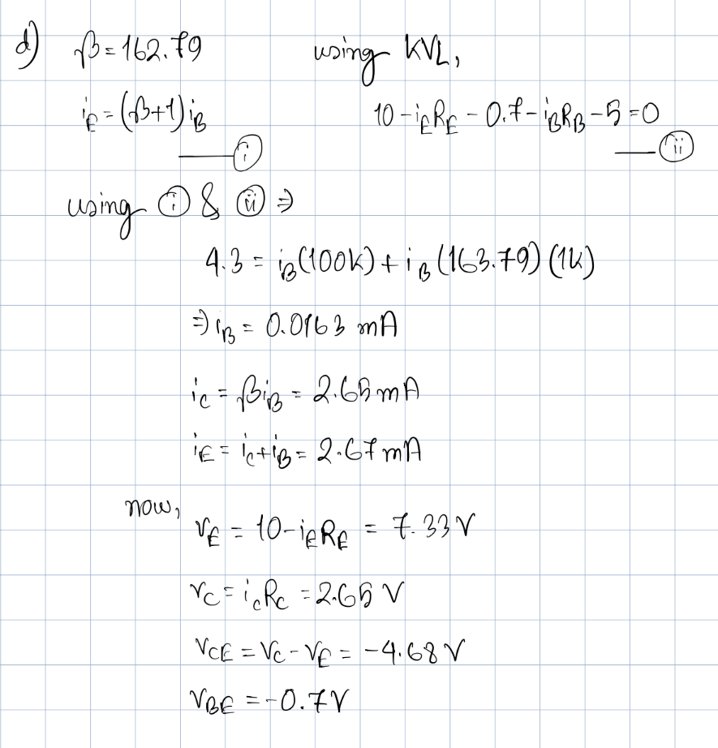

C BJT as a switch
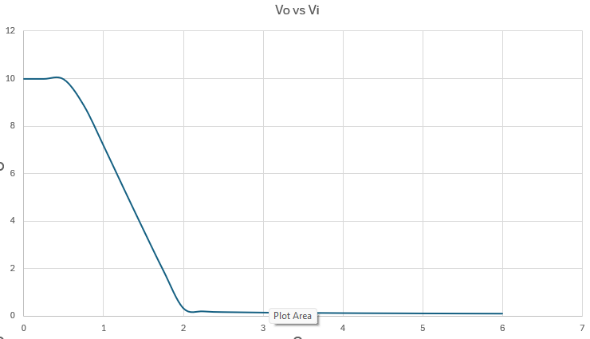

Figure 4: Transfer Characteristics, plot of v_{o} vs v_{i}
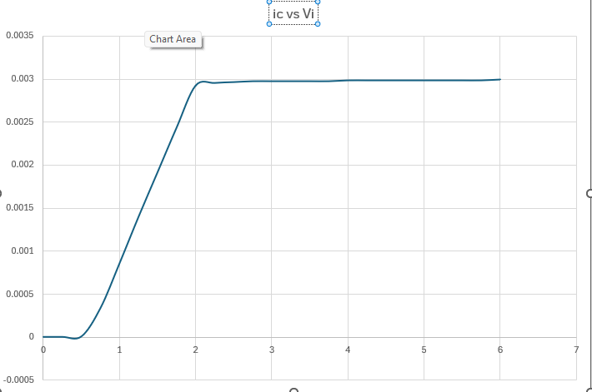

Figure 5: Plot of i_{c} vs v_{i}
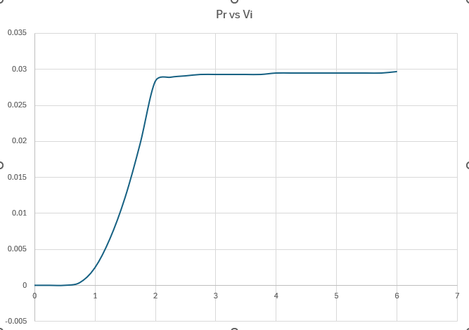

Figure 6: Plot of P_{R} vs v_{i}

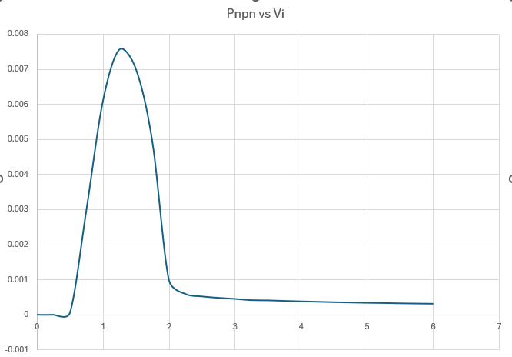

Figure 7: Plot of P_{npn} vs v_{i}

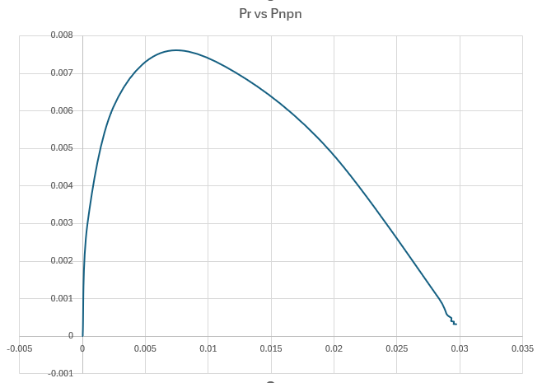

Figure 8: Plot of P_{R} vs P_{npn}

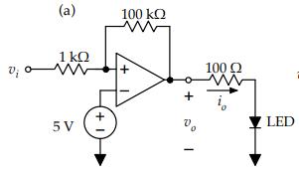

Measured Output Voltage, v_{o} = 7.57 V

Measured Output Current, i_{o} = 0.757 mA

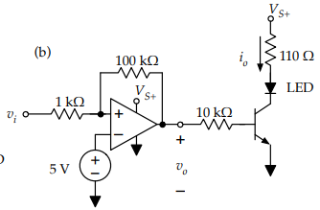

Measured Output Voltage, v_{o} = 9.95 V

Measured Output Current, i_{o} = 72.7 mA

In part a, the voltage and current are lower than ideal because the op-amp is directly driving the LED load. The amp cannot source a large output current. As such when the LED and resistor demand current, the output voltage drops below the 10 V supply rail. But in part b, the transistor output stage fixes this problem by letting the op amp supply only a small base current while the transistor supplies the larger LED current.

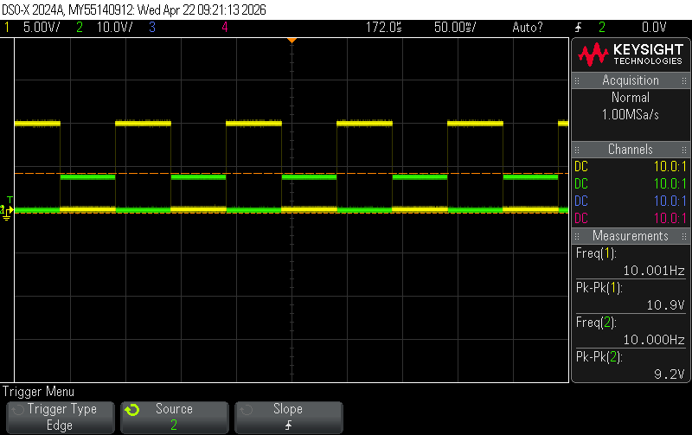
Figure 9: Oscilloscope Trace

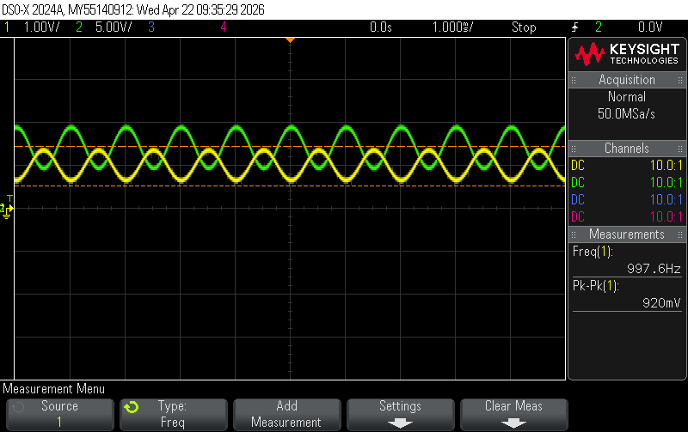
D BJT as an amplifier
Figure 10: Oscilloscope Trace

Gain = 6.72

Conclusion
In this lab, we didn’t face any major problems. All the experiments were completed without any issues, and all our measured values were very close to our calculated values, they were all within 5% of our calculated values. The plots we derived from excel also matched our expectations. The lab helped us visualize the theory we learned about BJTs.

