Iowa State University
Electrical And Computer Engineering

EE 230
LAB 9 REPORT

May 05, 2026

Sayon Saha
Aaron Kammlah

Introduction
In this lab, we started working with MOSFETS. At first, we used the parameter analyzer to get the V_{T} and K values from the slopes and intersection points on the graph it generated. Then, we built 4 different MOSFET circuit configurations, 2 in saturation and 2 in triode region, we measured i_{d}, V_{DS} and V_{GS} for each circuit and then compared them with our calculated values. Then we built two MOS inverter circuits and measured the output voltage for them across 25 different inputs and acquired their plots. For the 4th experiment, we built a circuit which used a MOSFET as a switch and also included a comparator. Finally, we observed how a MOSFET behaves on the oscilloscope when it is used as an amplifier.

Parameter Analyzer
To begin, the $V_{T}$ and $K$ values for an NMOS and PMOS in the CD4007 array were computed. These values are presented in the below table. We decided to use QxN and QxP for the NMOS and PMOS devices, respectively.

Device | Calculated $V_{T}$ | Calculated $K$
CD4007 NMOS | +1.27 V | 4.51*10⁻⁴
CD4007 PMOS | -1.47 V | 5.57*10⁻⁴

Next, $i_{D}-v_{DS}$ curves were obtained for each of these devices. These are shown below. The NMOS and PMOS devices for the CD4007 were tested with six $v_{GS}$ values ranging between $0 V$ and $6 V$.

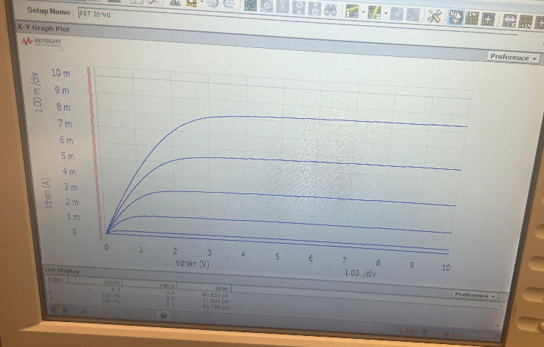
Figure 1: $i_{D}$ vs. $v_{DS}$ for an NMOS in the CD4007 array

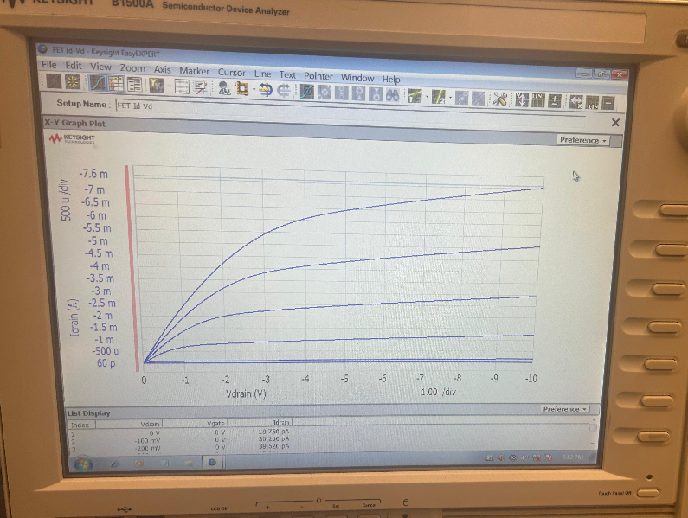
Figure 2: $i_{D}$vs. $v_{DS}$ for a PMOS in the CD4007 array

$i_{D}$ vs. $v_{DS}$ curves are convenient for visually confirming our transistors work, but are not great for characterizing them. So, we also made $\sqrt{i_{D}}$ vs. $v_{GS}$ plots for both of the transistors.

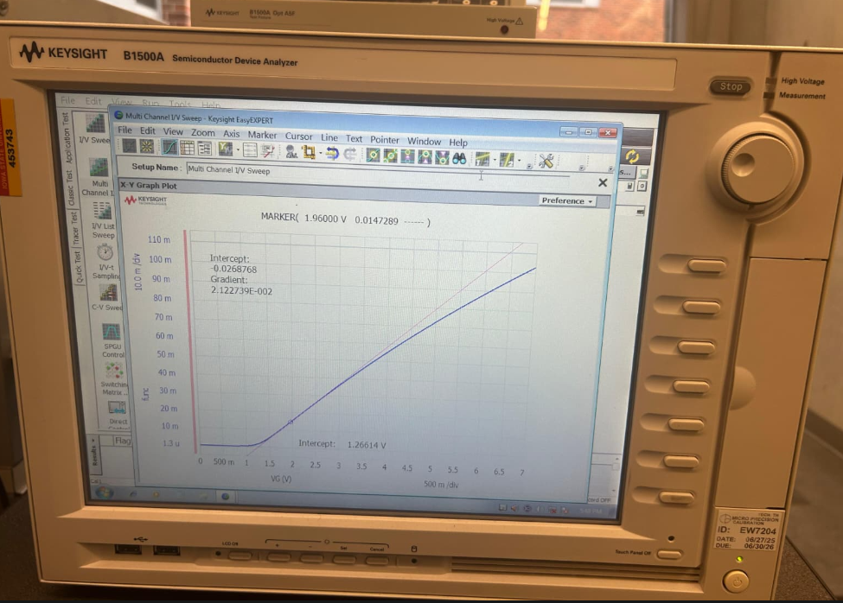
Figure 3: $\sqrt{i_{D}}$ vs. $v_{GS}$ for an NMOS in the CD4007 array

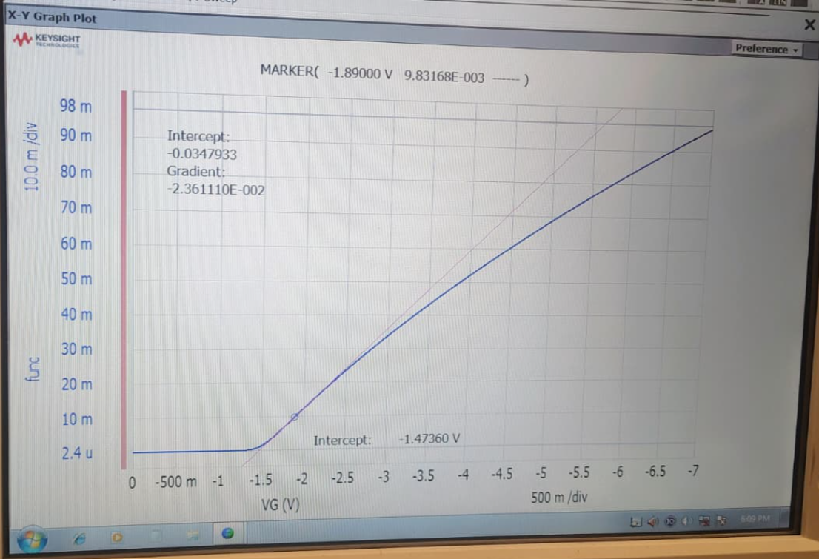
Figure 4: $\sqrt{i_{D}} vs v_{GS}$ for a PMOS in the CD4007 array

For a MOSFET operating in saturation:
$$i_{D}=K(v_{GS}-V_{T})^{2}$$
Taking the square root:
$$\sqrt{i_{D}}=\sqrt{K}(v_{GS}-V_{T})$$
This transforms the equation into a linear relationship between $\sqrt{i_{D}}$and $v_{GS}$:
- Slope $m=\sqrt{K}$
- X-intercept $=V_{T}$

The values for V_{T} and K are obtained from the square-root method and are reasonably close to those obtained from the parameter analyzer. However, the analyzer provided more accurate results with respect to physical devices and their limitations.

A DC MOS Circuit
After characterizing an n- and p-channel device, the below circuits were built, measured, and analyzed.
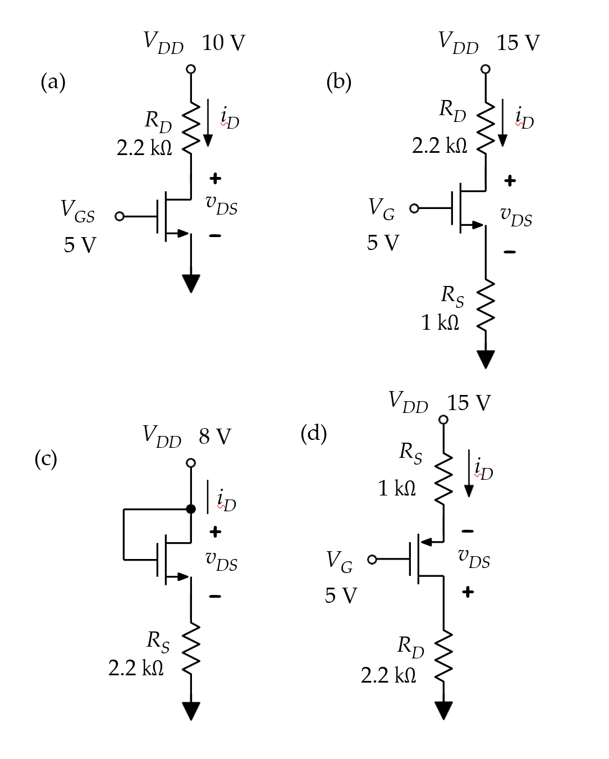
Circuit 1

The table below shows the measured and calculated voltages and currents for each circuit.

Circuit | Calculated |  |  | Measured
Circuit | $$i_{D}$$ | $$v_{GS}$$ | $$v_{DS}$$ | $$i_{D}$$ | $$v_{GS}$$ | $$v_{DS}$$
A | 3.89 mA 5 V 1.43 V |  |  | 4 mA 5.01 V 1.53 V
B | 1.76 mA 3.24 V 9.37 V |  |  | 1.1 mA 3.88 V 11.41 V
C | 2.08 mA 3.42 V 3.42 V |  |  | 1.3 mA 5.16 V 5.16 V
D | 4.35 mA -6.1 V -1.08 V |  |  | 3.89 mA -6.1 V -2.45 V

Among the given circuits, circuit A operates in the triode region, circuit B and circuit C operate in the saturation region, and circuit D operates in the triode region too. From my calculations for circuit C, there is a clear discrepancy between the calculated and measured values for V_{GS} and V_{DS}. This was due to us choosing the wrong node when we were measuring the values.

B MOS Inverter
Two applications of a MOSFET as an inverter were then explored. The following two circuits were used:
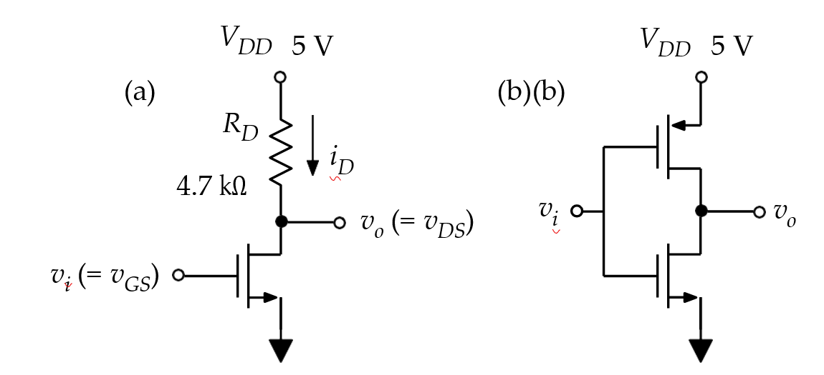

Circuit 2

The transfer characteristic of each circuit was measured by sweeping the input voltage and measuring the output. These are shown below.

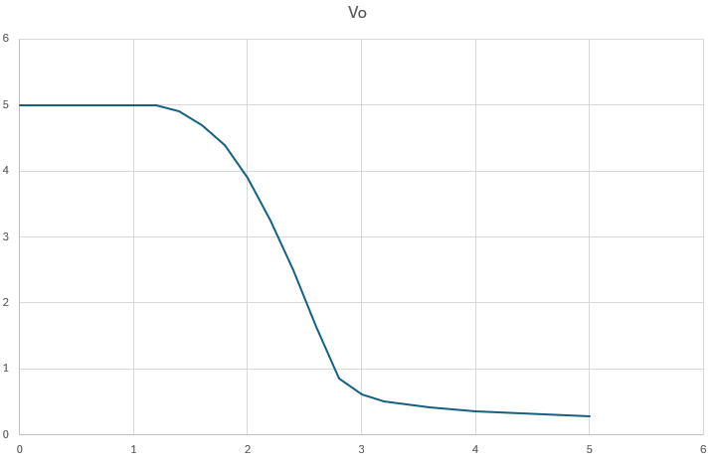
Figure 5: $V_{o} vs V_{in}$ of Circuit A

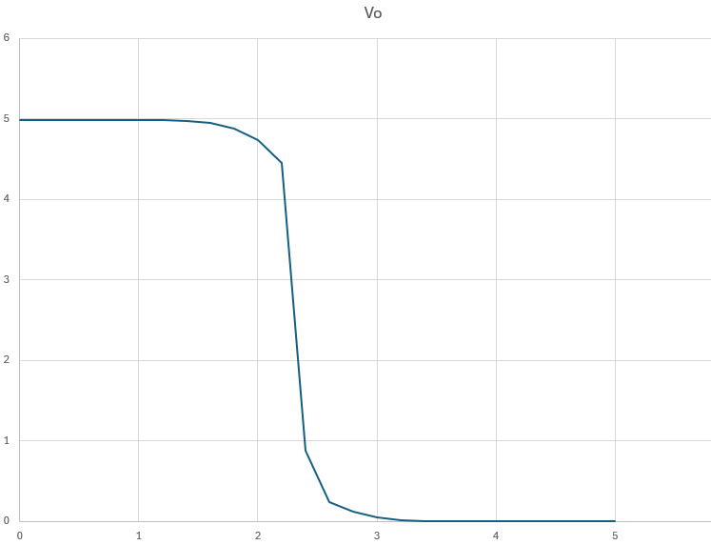
Figure 6: $V_{o} vs V_{in}$ of Circuit B

Both inverter circuits showed the expected inverting behavior: when $v_{i}$was low, $v_{o}$was close to $5V$, and as $v_{i}$increased, $v_{o}$decreased.

For the resistively loaded NMOS inverter (Circuit A), the transition was gradual, and the output did not reach $0V$(around $0.3V$). This is because the resistor and NMOS form a voltage divider when the transistor is on.

For the CMOS inverter (Circuit B), the transition was much sharper, and the output went from nearly $5V$to nearly $0V$. This happens because one transistor is always off while the other is on, pulling the output strongly to either $V_{DD}$or ground. Both circuits had similar maximum output voltages (around 5 V), but the CMOS inverter had a lower minimum output voltage and a sharper switch.

When $v_{i}$is high, the NMOS inverter uses more power because there is continuous current through the resistor and transistor. The CMOS inverter uses much less power since there is no direct path from $V_{DD}$to ground in steady state.

C MOSFET as a Switch
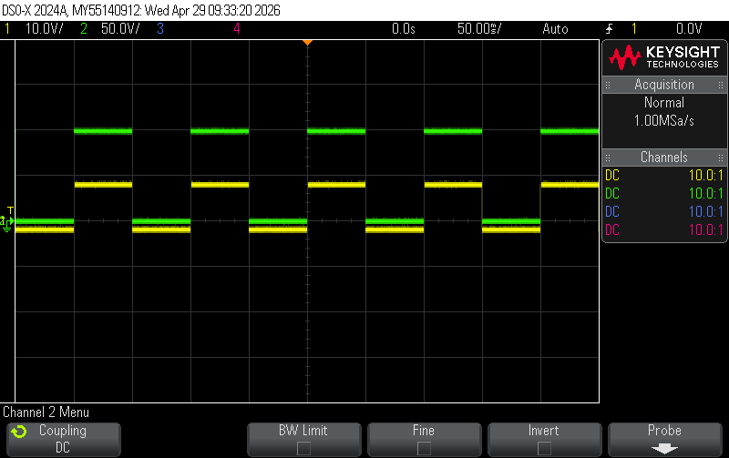
Figure 7: Oscilloscope trace of $v_{DS}$

D NMOS Amplifier
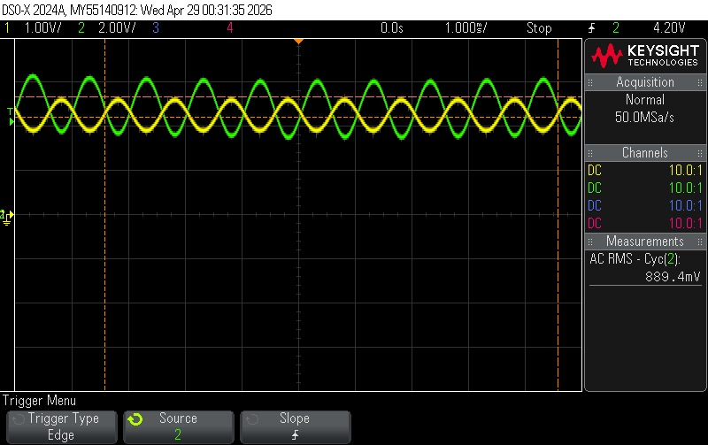
Figure 8: Oscilloscope trace of output and input voltages
In this circuit, the NMOS inverter is being used as an amplifier by biasing it in its linear (active) region. The DC offset is adjusted so that V_{DS} is around 5 V, which places the transistor around the middle of its operating curve. This allows small changes in the input voltage to produce larger changes in the output voltage.
When the AC input signal is applied, it slightly varies $v_{GS}$around this bias point. Because the transistor is operating in a region where its current changes significantly with $v_{GS}$, these small input variations cause larger changes in the drain current $i_{D}$. This, in turn, produces larger voltage swings across the drain resistor, resulting in an amplified output.
The output waveform is inverted relative to the input. This happens because an increase in $v_{GS}$increases $i_{D}$, which increases the voltage drop across the resistor and therefore reduces $v_{o}$. So, when the input goes up, the output goes down, and vice versa.
From the oscilloscope trace, the output signal clearly has a larger amplitude than the input, confirming amplification. The sinusoidal shape is preserved, which shows the circuit operating in a reasonably linear region around the bias point.

Conclusion
We didn’t face any major issues during the lab. Almost all our calculated values closely agreed with our measured ones. Though, for circuit C in experiment A, our calculated values were a bit smaller than the measured values for V_{GS} and V_{DS}, but that was due to us getting the wrong node when measuring.

