**Project: SwiftTrading**

**Team: SwiftTrading**

1. **Intro.**

The name of our project is “**SwiftTrading**”. It is an online

Electronic Trading platform for Equities. We will provide relatively complete function for an Equities Trading. We assume that there is only one trader in our system and he has unlimited money. The trader can view the real time market data and submit orders and quotes to a hypothetical exchange. Then the trader can view the performance over a certain period of time. We will provide full suite of strategies (Good Till Cancelled, Fill or Kill and etc). Also we will allow market orders, limit orders and etc.

1. **Feature.**
2. The trader can see the real time market data
3. the trader can search the demand stock information
4. the trader can add the favorite stock into the favor list
5. the trader can do trade manually including buy orders, sell order, cancelled order
6. the system can carry out the strategy the user specified including short position and long position
7. the system can demonstrate the performance of the strategy of trade in the certain time period
8. the user can do both limit order and market order
9. **Technology.**

Java HTML5 CSS JS Jquery angular MySQL activemq JUnit Mockito spring spring MVC Mybatis tomcat bootstrap

1. **System Architecture.**

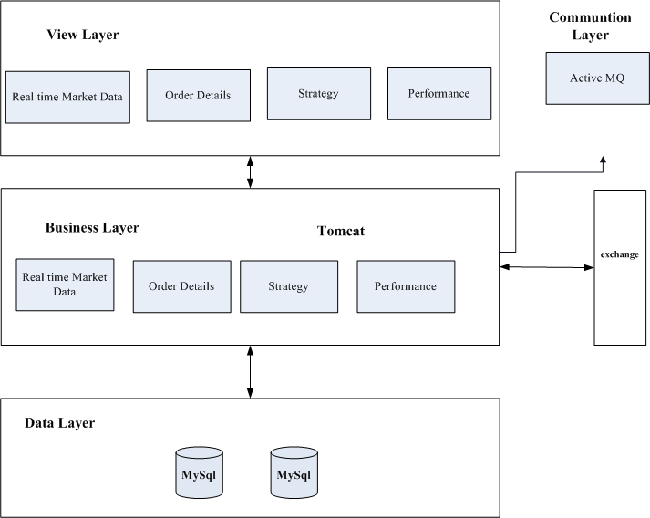

1. **E-R.**

