Description of the data set / summary of its attributes:

`work_year`: The year the salary was paid.

`experience_level`: The experience level in the job during the year

`employment_type`: The type of employment for the role

`job_title`: The role worked in during the year.

`salary`: The total gross salary amount paid.

`salary_currency`: The currency of the salary paid as an ISO 4217 currency code.

`salaryinusd`: The salary in USD

`employee_residence`: Employee's primary country of residence in during the work year as an ISO 3166 country code.

`remote_ratio`: The overall amount of work done remotely

`company_location`: The country of the employer's main office or contracting branch

`company_size`: The median number of people that worked for the company during the year

Plan for Data Exploration:

* Look for the information of the DataSet and the datatypes of its features.
* Determine whether the DataSet has NA values, and if so fill them with the necessary values (mean, median, 0, previous value, etc).
* Filter/Delete the columns that don’t seem necessary for the analysis.
* Normalize/Standardize Data.
* Look for outliers with visualization tools and statistic methods.
* Create visualizations.

Actions taken for data cleaning and feature engineering:

* Explored the dataset for missing values.
* Some column names renamed to be more informative.
* Some records’ data replaced with more informative categorical values.
* Dropped records where the year wasn’t 2022 or 2023.
* Encoded some columns with get_dummies() to be later fitted with the Standard Scaler method of scikit-learn.
* Checked the skewness level for the continuous variable (salary).
* Left without doing the log transformation (skew = 0.5080).
* Did PCA() on the predictor features of the dataset already encoded with a 95% of n_components.

Key Findings and Insights:

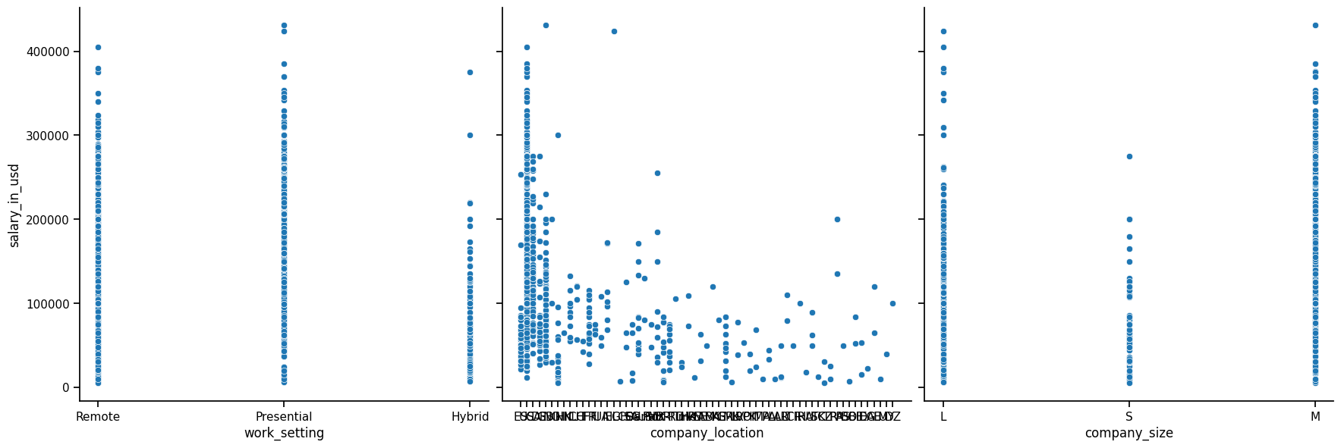Fig 1. Salary in USD vs ExpLevel, EmploymentType & JobTitle.

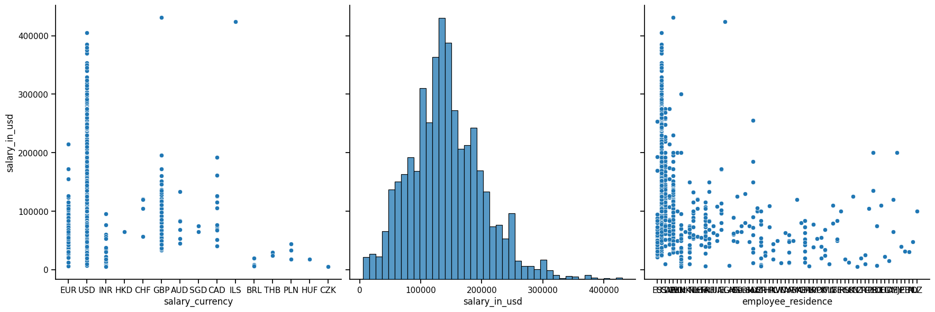Fig 2. Salary in USD vs WorkSetting, CompLocation, CompSize.

Fig 3. Salary in USD vs Currency, EmployeeResidence & Salary in USD distribution.

Table 1. Average USD Salary through 2022 & 2023, by Work Setting.

|  |  |  |  |
| --- | --- | --- | --- |
|  | Hybrid | Presential | Remote |
| 2022 | 84.56087k USD | 134.7192k USD | 135.6311k USD |
| 2023 | 72.0535k USD | 152.3935k USD | 146.3801k USD |

Fig 4. Highest corr factors with salary.

Fig 5. Most common job titles.

Fig 6. Salary in USD boxplot.

19 outliers were found following the z-score analysis. All of which had a z-score higher than 3 which in turn represented a salary higher than 324,000 usd.

3 Hypothesis about this Data:

Impact of Experience on Salary: Null Hypothesis (H0): There is no significant difference in salary across different experience levels. Alternative Hypothesis (H1): There is a significant difference in salary in at least one of the experience levels..

Remote Work and Salary: H0: There is no correlation between remote_ratio and salary_in_usd. H1: There is a significant correlation between remote_ratio and salary_in_usd.

Company Size and Salary: H0: The median salary does not differ significantly among different company sizes. H1: The median salary differs significantly among different company sizes.

Employee Residence vs Company Location: H0: There is no significant difference in salary between employees working in their country of residence and those working for companies in different countries. H1: There is a significant difference in salary between employees working in their country of residence and those working for companies in different countries.

Employment Type and Salary: H0: The type of employment (employment_type) has no significant effect on salary_in_usd. H1: The type of employment (employment_type) has a significant effect on salary_in_usd.

Significance test for one of the Hypotheses:

Impact of Experience on Salary: H0: There is no significant difference in salary across different experience levels (Mid-Level, Senior, Expert). H1: There is a significant difference in salary in at least one of the experience levels.

H0: salary average is the same across the 3 different experience levels

H1: salary average is significantly different in at least one of the experience levels.

Decision Criteria: significance level 5% ~ 0.05.

Our data is 2 tailed, we’ll divide our Alpha = 0.05 by 2. Alpha = 0.025.

If our p-value is les than 0.05 we’ll reject the null hypothesis and accept that ther is a significant difference in salary in at least one experience level.

We’ll use ANOVA and f-score statistic.

The DataFrame is filtered by excluding the Entry-Level experience_level records.

Fig 7. Experience Levels and Salaries boxplot.

Fig 8. Analysis of Variance result table p-value (PR(>F)) 2.04e-92.

The P-Value is way smaller than the Alpha of 0.05 therefore we reject the null hypothesis and conclude that there is a significant difference in salary in at least one of the experience levels.

Next steps in analyzing this data:

One way that we could further analyze the data is by making even more comparissons within the features and for a greater understanding of the employee distribution worldwide it could be valuable to créate a choropleth map.

The data quality was really prime, I chose this dataset because I’d found it interesting, but I had no idea that the Wrangling and Cleaning was already done, I had a blast diving into the hidden meaning of the data and I love how much Iearned from this course.