Networking with Linux
A Practical Journal Submitted in Fulfilment of the Degree of

MASTER
In
COMPUTERAPPLICTION Year 2025-2026
By

Mr. Aditya Chavan

(Seat No. 8222167)

Under the Guidance of

Mrs. Sweety Patil


Institute of Distance and Open Learning Vidya Nagari, Kalina, Santacruz East – 400098.
University of Mumbai

PCP Center
[Vidyavardhini's College Of Engineering & Technology]



Institute of Distance and Open Learning Vidyanagari, Kalina, Santacruz (E) -400098

CERTIFICATE

This to certify that, Aditya Chavan appearing Master in Computer Application (Semester II) Seat No. 8222167 has satisfactory completed the prescribed Practical of Networking with Linux as laid down by the University of Mumbai for the academic year 2025- 26

Teacher in charge Examiners Coordinator IDOL, MCA
University of Mumbai
Date: - Place: -

Index

Practical No | Practical | Sign.
1. | Installation of NS3 (Network Simulator)
2. | Installation of NetAnim
3. | Installation of Wireshark
4. | Program to simulate traffic betwwn 2 nodes means the same
5. | Program to simulate star topology
6. | Program to simulate bus topology
7. | Program to simulate mesh topology
8. | Program to simulate hybrid topology
9. | Program to simulate UDP server client
10. | Program to simulate DHCP server and n client

Practical No:- 1 Aim: Installation of NS3 (Network Simulator).
Network Simulation is the software which tells the behaviour of computer networks. It is common useful method to calculate different network topologies exclusive of real-world implementation.
For NS3 installation on Ubuntu 18 version. We have to execute following commands Step 1: sudo apt update
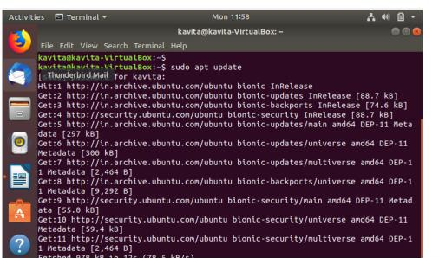

Step 2:sudo apt install g++ python3 python3-dev pkg-config sqlite3 cmake python3-setuptools git qtbase5-dev qtchooser qt5-qmake qtbase5-dev-tools gir1.2-goocanvas-2.0 python3-gi python3-gi-cairo python3-pygraphviz gir1.2-gtk-3.0 ipython3 openmpi-bin openmpi-common openmpi-doc libopenmpi-dev autoconf cvs bzr unrar gsl-bin libgsl-dev libgslcblas0 wireshark tcpdump sqlite sqlite3 libsqlite3-dev libxml2 libxml2-dev libc6-dev libc6-dev-i386 libclang-dev llvm-dev automake python3-pip libxml2 libxml2-dev libboost-all-dev

Step 3: Download ns-allinone-3.36.1.tar.bz2 from the website nsnam.org. https://www.nsnam.org/releases/ns-allinone-3.36.1.tar.bz2
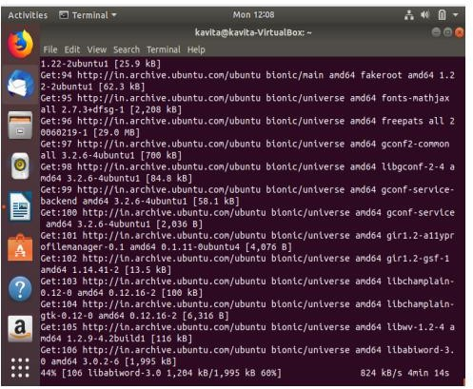

Step 4: Unzip the above file content to the home folder (in my case, its /home)
- Check your home folder and do it accordingly.
To unzip use the GUI with Right click and extract and select the /home folder. Else you can use the command

$ tar jxvf ns-allinone-3.36.1.tar.bz2
Step 5: Step 4: Go to the folder

$ cd ns-allinone-3.36.1/

$ ./build.py --enable-examples --enable-tests

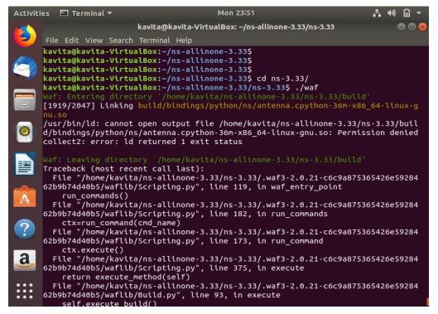

Step 6:Once the installation is done. You can run the example as shown
$ cd ns-3.36.1/

$ ./ns3 run hello-simulator Hello Simulator

Practical No:- 2
Aim: Installation of NetAnim.
NetAnim is the network Animator that comes with NS3.During compilation of process of NS3 NetAnim may not be compiled .so we need to compile NetAnim. It is an offline network animator tool that now comes with NS3 that nsallinone3. All versions. By using NetAnim we can animate NS3 simulator, using the xml file trace the output in the simulation. NetAnim is the software which execute xml file to generate graphical output on NS3 simulator

Method1:
NetAnim can be downloaded from the
URL http://code.nsnam.org/jabraham3/netanim-3.104

Method 2:
Step 1:
sudo apt-get install NetAnim
The above command is case sensitive (NetAnim)

Step 2:
To run once it’s installed NetAnim file.xml
If you already has a file.xml.

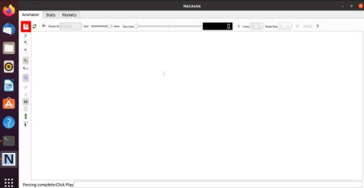

Step 3:Select xml file
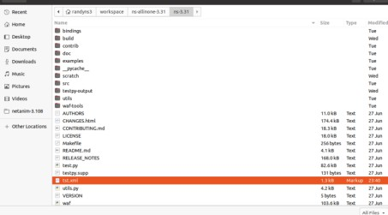

Step4: Run the simulation by clicking
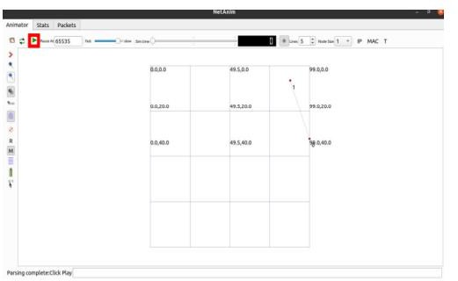

Practical No:- 3
Aim: Installation of Wireshark.
It is the network protocol for analayzing freely available packages.Wireshark is network packet analyzer.It is used to check incoming and outgoing packets in the network and save it offline analysis.It works on Windows,linux,macOS,FreeBSD etc.
Step 1: Update the system by using sudo apt update
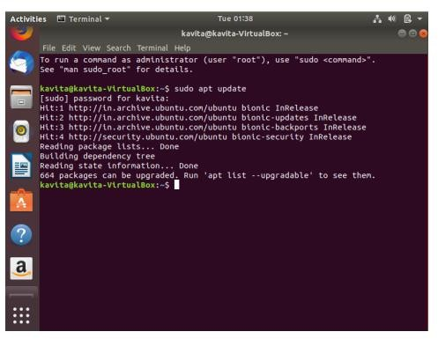
Step2: Install wireshark using sudo apt install wireshark

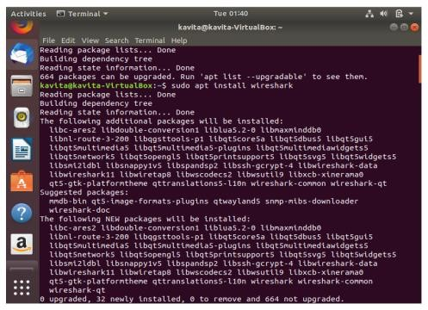
Step3: Add user in wireshark by using usermod -aG wireshark $(whoami) Reboot the system-sudo reboot
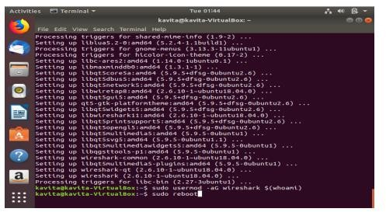

Step4: To run Wireshark type the command (CI) on terminal Wireshark
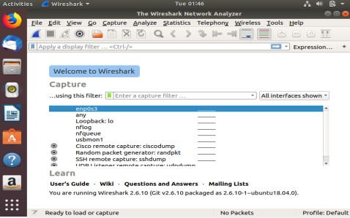

Step5: To run Wireshark using GUI go to application and then Wireshark
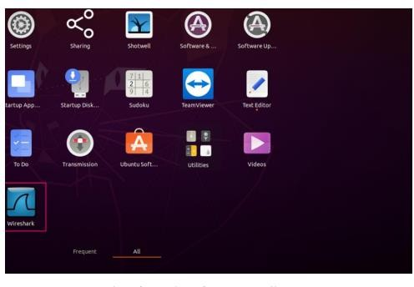

Practical No:- 4
Aim: Program to simulate traffic betwwn 2 nodes means the same

Node 1 (Server) import java.io.*; import java.net.*;
public class TrafficSimulatorServer { public static void main(String[] args) {
int port = 12345; try {
ServerSocket serverSocket = new ServerSocket(port); System.out.println("Server listening on port " + port); Socket clientSocket = serverSocket.accept(); System.out.println("Connection established with client");

BufferedReader in = new BufferedReader(new InputStreamReader(clientSocket.getInputStream()));
BufferedWriter out = new BufferedWriter(new OutputStreamWriter(clientSocket.getOutputStream()));
String message;
while ((message = in.readLine()) != null) { System.out.println("Received from client: " + message);
out.write("Server response: " + message + "\n"); out.flush();
}
clientSocket.close(); serverSocket.close();
} catch (IOException e) { e.printStackTrace();
}
}
}

Node 2 (Client) import java.io.*;
import java.net.*;
public class TrafficSimulatorClient { public static void main(String[] args) {
String serverAddress = "localhost"; int port = 12345;
try {
Socket socket = new Socket(serverAddress, port);
System.out.println("Connected to server"); BufferedReader in = new BufferedReader(new
InputStreamReader(socket.getInputStream()));
BufferedWriter out = new BufferedWriter(new OutputStreamWriter(socket.getOutputStream()));
BufferedReader consoleReader = new BufferedReader(new InputStreamReader(System.in));
String userInput;
while ((userInput = consoleReader.readLine()) != null) { out.write(userInput + "\n");
out.flush();
String serverResponse = in.readLine(); System.out.println("Server says: " + serverResponse);
}
socket.close();
} catch (IOException e) { e.printStackTrace();
}
}
}

Practical No:- 5 Aim: Program to simulate star topology
import java.io.*; import java.net.*;
import java.util.ArrayList; import java.util.List;

public class StarTopologyHub {
private List<Socket> connectedNodes = new ArrayList<>();

public static void main(String[] args) {
new StarTopologyHub().startHub(12345);
}

public void startHub(int port) { try {
ServerSocket serverSocket = new ServerSocket(port); System.out.println("Hub is running on port " + port);

while (true) {
Socket clientSocket = serverSocket.accept(); connectedNodes.add(clientSocket);

System.out.println("Node connected: " + clientSocket.getInetAddress());

// Start a new thread to handle messages from the connected node new Thread(() -> handleNodeMessages(clientSocket)).start();
}
} catch (IOException e) { e.printStackTrace();
}
}

private void handleNodeMessages(Socket nodeSocket) { try {
BufferedReader in = new BufferedReader(new InputStreamReader(nodeSocket.getInputStream()));

String message;
while ((message = in.readLine()) != null) { System.out.println("Message received from " +
nodeSocket.getInetAddress() + ": " + message);

// Broadcast the message to all connected nodes broadcastMessage(nodeSocket, message);
}

// Remove the disconnected node connectedNodes.remove(nodeSocket);
System.out.println("Node disconnected: " + nodeSocket.getInetAddress());

} catch (IOException e) { e.printStackTrace();
}
}

private void broadcastMessage(Socket sender, String message) { for (Socket nodeSocket : connectedNodes) {
if (nodeSocket != sender) { try {
BufferedWriter out = new BufferedWriter(new OutputStreamWriter(nodeSocket.getOutputStream()));
out.write("Broadcast from " + sender.getInetAddress() + ": " + message + "\n");
out.flush();
} catch (IOException e) { e.printStackTrace();
}
}
}
}
}
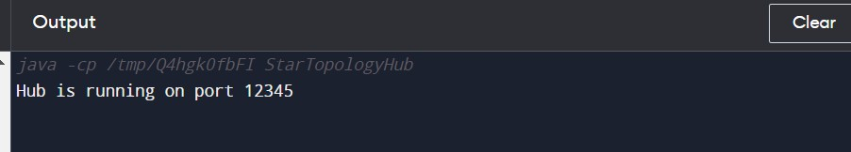
Output:

Practical No:- 6 Aim: Program to simulate bus topology
import java.io.*; import java.net.*;
import java.util.ArrayList; import java.util.List;

public class BusTopologyBus {
private List<Socket> connectedNodes = new ArrayList<>();

public static void main(String[] args) {
new BusTopologyBus().startBus(12345);
}

public void startBus(int port) { try {
ServerSocket serverSocket = new ServerSocket(port); System.out.println("Bus is running on port " + port);

while (true) {
Socket clientSocket = serverSocket.accept(); connectedNodes.add(clientSocket);

System.out.println("Node connected: " + clientSocket.getInetAddress());

// Start a new thread to handle messages from the connected node new Thread(() -> handleNodeMessages(clientSocket)).start();
}
} catch (IOException e) { e.printStackTrace();
}
}

private void handleNodeMessages(Socket nodeSocket) { try {
BufferedReader in = new BufferedReader(new InputStreamReader(nodeSocket.getInputStream()));

String message;
while ((message = in.readLine()) != null) { System.out.println("Message received from " +
nodeSocket.getInetAddress() + ": " + message);

// Broadcast the message to all connected nodes (except the sender) broadcastMessage(nodeSocket, message);
}

// Remove the disconnected node connectedNodes.remove(nodeSocket);
System.out.println("Node disconnected: " + nodeSocket.getInetAddress());

} catch (IOException e) { e.printStackTrace();
}
}

private void broadcastMessage(Socket sender, String message) { for (Socket nodeSocket : connectedNodes) {
if (nodeSocket != sender) { try {
BufferedWriter out = new BufferedWriter(new OutputStreamWriter(nodeSocket.getOutputStream()));
out.write("Broadcast from " + sender.getInetAddress() + ": " + message + "\n");
out.flush();
} catch (IOException e) { e.printStackTrace();
}
}
}
}
}

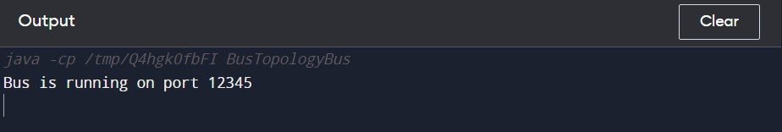
Output

Practical No:- 7 Aim: Program to simulate mesh topology
import java.util.ArrayList; import java.util.List;
class MeshNode { private int nodeId;
private List<MeshNode> neighbors; public MeshNode(int nodeId) {
this.nodeId = nodeId; this.neighbors = new ArrayList<>();
}
public void addNeighbor(MeshNode neighbor) { neighbors.add(neighbor); neighbor.neighbors.add(this);
}
public void sendMessage(String message) {
System.out.println("Node " + nodeId + " received message: " + message);
}
public int getId() { return nodeId;
}
}
public class MeshTopology { private List<MeshNode> nodes;
public MeshTopology(List<MeshNode> nodes) { this.nodes = nodes;

}
public void sendMessage(int senderNodeId, int receiverNodeId, String message) {
MeshNode senderNode = getNodeById(senderNodeId); MeshNode receiverNode = getNodeById(receiverNodeId);

if (senderNode != null && receiverNode != null && senderNode != receiverNode) {
System.out.println("Sending message from Node " + senderNodeId + " to Node " + receiverNodeId);
receiverNode.sendMessage(message);
} else { System.out.println("Invalid sender or receiver node IDs.");
}
} private MeshNode getNodeById(int nodeId) { for (MeshNode node : nodes) {
if (nodeId == node.getId()) { return node;
}
}
return null;
}
}

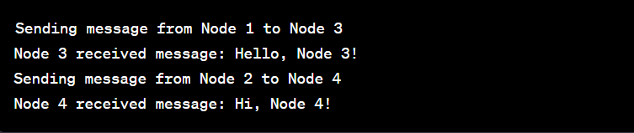
Output

Practical No:- 8 Aim: Program to simulate hybrid topology
import java.util.ArrayList; import java.util.List;

class Node {
private int nodeId;
private List<Node> neighbors;

public Node(int nodeId) { this.nodeId = nodeId;
this.neighbors = new ArrayList<>();
}
public void addNeighbor(Node neighbor) {
neighbors.add(neighbor);
}
public void sendMessage(String message) {
System.out.println("Node " + nodeId + " received message: " + message);
}
public int getId() { return nodeId;
}
}
public class HybridTopologySimulation { public static void main(String[] args) {
// Create nodes
Node node1 = new Node(1);

Node node2 = new Node(2); Node node3 = new Node(3); Node node4 = new Node(4); Node node5 = new Node(5);

// Connect nodes to form a star topology node1.addNeighbor(node2); node1.addNeighbor(node3); node1.addNeighbor(node4);
// Connect nodes to form a ring topology node2.addNeighbor(node3); node3.addNeighbor(node4); node4.addNeighbor(node5); node5.addNeighbor(node2);
// Simulate sending messages node1.sendMessage("Hello, Node 2!");
node3.sendMessage("Hi, Node 4!");
node5.sendMessage("Greetings, Node 2!");
}
}
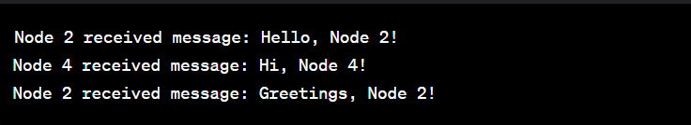
Output

Practical No:- 9
Aim: Program to simulate UDP server client UDP Server
import java.net.*; public class UDPServer {
public static void main(String[] args) { try {
DatagramSocket socket = new DatagramSocket(9876); byte[] receiveData = new byte[1024];
while (true) {
DatagramPacket receivePacket = new DatagramPacket(receiveData, receiveData.length);
socket.receive(receivePacket);
String message = new String(receivePacket.getData(), 0, receivePacket.getLength());
System.out.println("Received from client: " + message);
// Send a response back to the client
InetAddress clientAddress = receivePacket.getAddress(); int clientPort = receivePacket.getPort();
String response = "Server says: Message received!"; byte[] sendData = response.getBytes();
DatagramPacket sendPacket = new DatagramPacket(sendData, sendData.length, clientAddress, clientPort);
socket.send(sendPacket);
}
} catch (Exception e) { e.printStackTrace();
}
}
}
Output UDP server

UDP Client
import java.net.*; public class UDPClient {
public static void main(String[] args) { try {
DatagramSocket socket = new DatagramSocket();
InetAddress serverAddress = InetAddress.getByName("localhost"); int serverPort = 9876;
String message = "Hello, Server!"; byte[] sendData = message.getBytes();
DatagramPacket sendPacket = new DatagramPacket(sendData, sendData.length, serverAddress, serverPort);
socket.send(sendPacket);

byte[] receiveData = new byte[1024];
DatagramPacket receivePacket = new DatagramPacket(receiveData, receiveData.length);
socket.receive(receivePacket);

String response = new String(receivePacket.getData(), 0, receivePacket.getLength());
System.out.println("Server response: " + response); socket.close();
} catch (Exception e) { e.printStackTrace();
}
}
}
Output

Practical No:- 10
Aim: Program to simulate DHCP server and n client DHCPServer.java

import java.util.ArrayList; import java.util.List; import java.util.Random;

class DHCPServer {
private List<String> availableIPs; private List<String> leasedIPs;

public DHCPServer() {
availableIPs = new ArrayList<>(); leasedIPs = new ArrayList<>(); initializeAvailableIPs();
}

private void initializeAvailableIPs() { for (int i = 1; i <= 10; i++) {
availableIPs.add("192.168.0." + i);
}
}

public String leaseIP() {
if (availableIPs.isEmpty()) {
System.out.println("No available IP addresses.");

return null;
}

Random random = new Random();
int randomIndex = random.nextInt(availableIPs.size()); String leasedIP = availableIPs.remove(randomIndex); leasedIPs.add(leasedIP);

System.out.println("IP address " + leasedIP + " leased to a client.");

return leasedIP;
}

public void releaseIP(String ipAddress) { if (leasedIPs.contains(ipAddress)) { leasedIPs.remove(ipAddress);
availableIPs.add(ipAddress);
System.out.println("IP address " + ipAddress + " released.");
} else {
System.out.println("Invalid IP address: " + ipAddress);
}
}
}

class DHCPClient {
private String ipAddress;

public void assignIPAddress(String ipAddress) { this.ipAddress = ipAddress;
System.out.println("Client received IP address: " + ipAddress);
}

public void releaseIPAddress(DHCPServer dhcpServer) { System.out.println("Client releasing IP address: " + ipAddress); dhcpServer.releaseIP(ipAddress);
ipAddress = null;
}
}

public class DHCPExample {
public static void main(String[] args) { DHCPServer dhcpServer = new DHCPServer();

// Simulate multiple clients leasing and releasing IP addresses DHCPClient client1 = new DHCPClient(); client1.assignIPAddress(dhcpServer.leaseIP());

DHCPClient client2 = new DHCPClient(); client2.assignIPAddress(dhcpServer.leaseIP());

DHCPClient client3 = new DHCPClient(); client3.assignIPAddress(dhcpServer.leaseIP());

// Release IP addresses client1.releaseIPAddress(dhcpServer); client2.releaseIPAddress(dhcpServer); client3.releaseIPAddress(dhcpServer);
}
}

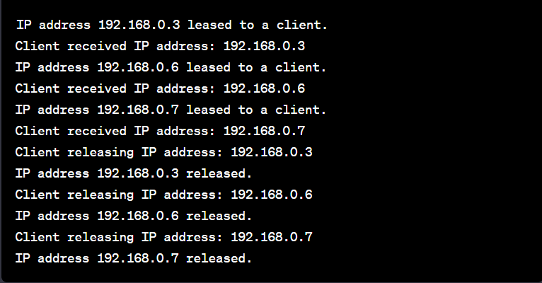
Output

