NGUYEN
Huy-Hai Vincent

Database Principle
Pizza restaurant

The database of this project represents the structure of a regular restaurant with a total of six tables.
- Members contains the information of the different kind of members possible such as the administrator of the website, the drivers in charge of delivering the orders and the clients.
- Ingredients is a simple table containing the name of each ingredient used.
- Pizzas consists of the name of the pizza, an url to its image, and its price.
- Contain is used to list all the ingredients of each individual pizza in the database.
- Orders contains the client’s id, the driver’s id, the date of order and of delivery, and the id a bill. This id is used in the following table.
- Associate, as of Contain will link the Orders table with the Pizzas table, allowing an order to have multiple pizzas.
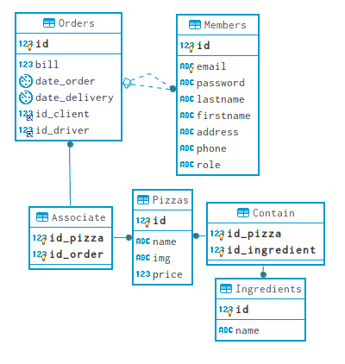

Home page
The home page of the website shows general statistical information such as the different kind of pizza available, the most ordered one, or the total number of clients who has already ordered.
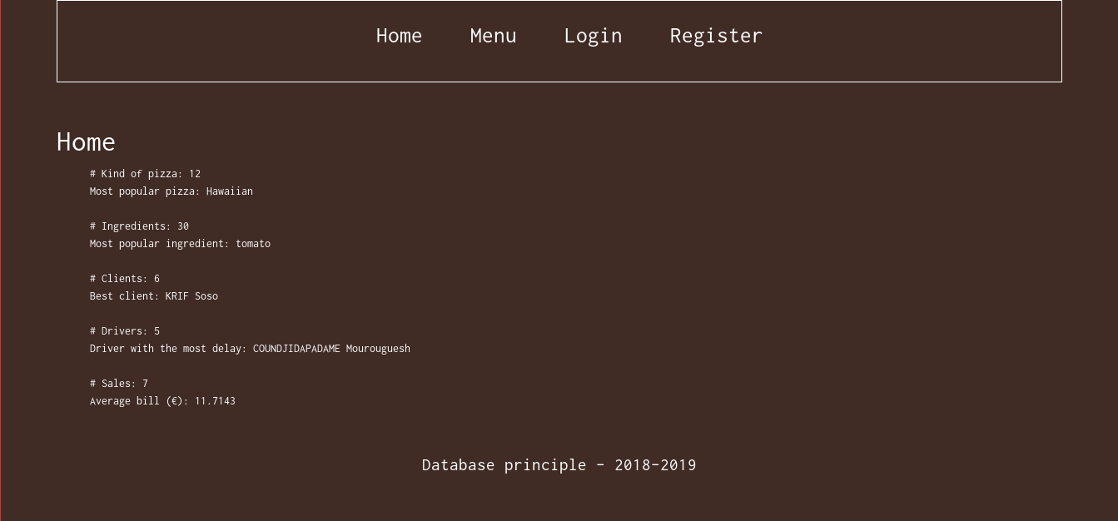
Each of these line fetch the result with the following query:

# Kind of pizza: 12
SELECT COUNT(*) FROM Pizzas;

Most popular pizza: Hawaiian
SELECT name, COUNT(Pizzas.id)
FROM Pizzas
NNER JOIN Associate ON id_pizza = Pizzas.id
GROUP BY Pizzas.id
ORDER BY COUNT(Pizzas.id) DESC LIMIT 1 OFFSET 0;
# Ingredients: 30
SELECT COUNT(*) FROM Ingredients;

Most popular ingredient: tomato
SELECT name, COUNT(Ingredients.id)
FROM Ingredients
INNER JOIN Contain ON Contain.id_ingredient = Ingredients.id
GROUP BY Ingredients.id
ORDER BY COUNT(Ingredients.id) DESC LIMIT 1 OFFSET 0;
# Clients: 6
SELECT COUNT(*) FROM Members WHERE role = 'Client';

Best client: KRIF Soso
SELECT lastname, firstname, SUM(bill)
FROM Orders
INNER JOIN Members ON id_client = Members.id
GROUP BY id_client
ORDER BY SUM(bill) DESC LIMIT 1 OFFSET 0;
# Drivers: 5
SELECT COUNT(*) FROM Members WHERE role = 'Driver';

Driver with the most delay: COUNDJIDAPADAME Mourouguesh
SELECT lastname, firstname, COUNT(Members.id)
FROM Members
INNER JOIN Orders ON id_driver = Members.id
WHERE TIMESTAMPDIFF(MINUTE, date_order, date_delivery) > 30
GROUP BY Members.id
ORDER BY COUNT(Members.id) DESC LIMIT 1 OFFSET 0;
# Sales: 7
SELECT COUNT(*) FROM Orders;

Average bill (€): 11.7143
SELECT AVG(bill) FROM Orders;

Menu page
The menu page contains the list of all the pizza available with an image of the pizza and the list of all ingredients in each pizza. If a client is logged in, they can order a pizza by clicking on the button Add under each pizza.
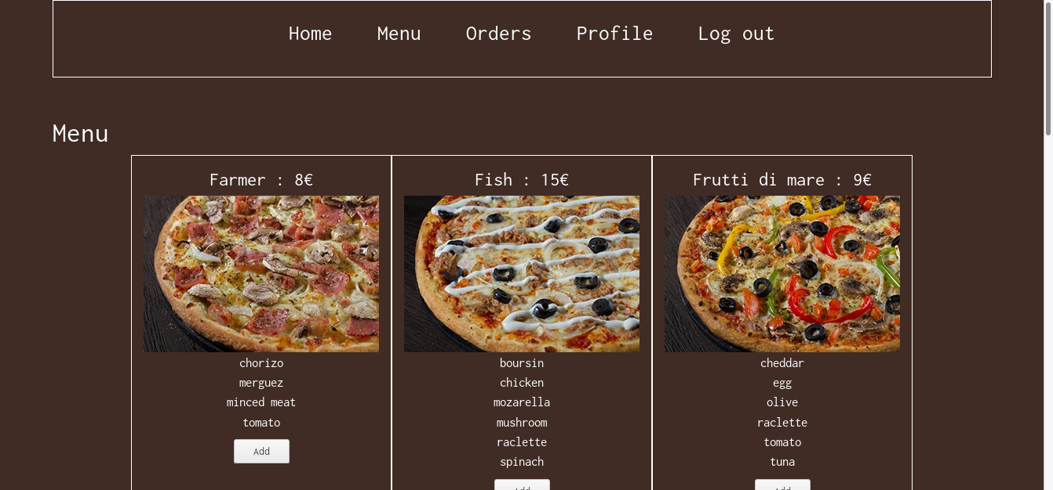
In order to get the list of all the pizzas in the database the following query was used.
SELECT * FROM Pizzas ORDER BY name;

And for each pizza this query will retrieve the corresponding ingredients.
SELECT Ingredients.name AS n
FROM Pizzas
INNER JOIN Contain ON Pizzas.id = id_pizza
INNER JOIN Ingredients ON id_ingredient = Ingredients.id
WHERE Pizzas.name = '$pizza_name'
ORDER BY n;

