Tutorial 1 — Networks, concepts, and object classes
Urban Network Analysis (UNA) models the built environment as a spatial network: a system of path segments along which pedestrians or cyclists can travel. Three things describe the network completely: (i) the edges you can move along, (ii) the nodes where edges meet (intersections, dead-ends), and (iii) the point objects attached to edges — origins and destinations — that serve as the sources and sinks of the analysis. This tutorial introduces the concepts and conventions.
- The network as a graph
- 3D structures — overpasses and underpasses
- Origin and destination points
- Edge attributes — objective vs. perceived length
- Overview of UNA analyses
- Summary

The network as a graph
A network is a set of edges (line segments — typically sidewalks, streets, paths, or corridors) connected at nodes (the shared endpoints of edges). UNA reads any GIS line layer and treats every LineString as one edge. For the engine to route trips through an intersection, every edge that meets there must terminate at exactly the same coordinate — they must share an endpoint. Curves that merely cross visually without a shared endpoint are not connected as far as routing is concerned.
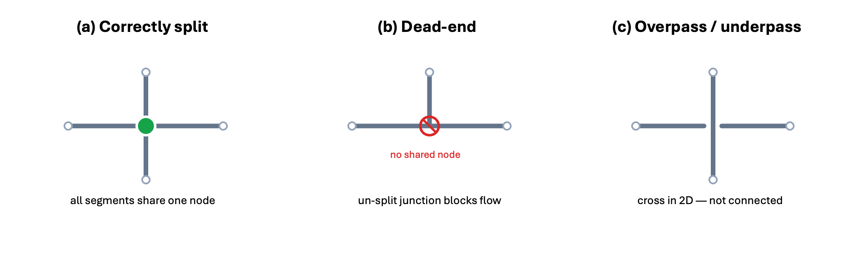
Three topology cases. (a) Correctly split — all segments share an endpoint and trips can flow. (b) A T-junction where one curve dead-ends on another that wasn’t split: trips cannot pass through. (c) Two curves crossing without a shared node — interpreted as an overpass/underpass, not a connection.
Before any UNA analysis, the network must be cleaned so that every visual intersection is also a topological one — the curves split at the crossing and sharing an endpoint there. It is normal to have dead-ends at the boundary of the study area (cul-de-sacs, network edge); the problem is unintentional dead-ends mid-network caused by un-split crossings. Pre-cleaning the network is the user’s responsibility, typically done in QGIS, ArcGIS Pro, Rhinoceros 3D, or CAD software.

3D structures — overpasses and underpasses
Real street networks are not perfectly flat. Bridges, tunnels, pedestrian skybridges, and grade separations let two routes cross in plan view without actually meeting. UNA represents these by exploiting the topology rule above: two crossing curves that do not share an endpoint at the crossing are interpreted as an overpass/underpass — they cross in 2D but are not connected. No separate Z-coordinate is needed to model this; the absence of a shared node is enough. If you do have elevation data on the network (z-values), UNA can additionally apply an elevation penalty to uphill walking — but that is a cost adjustment, not a topology mechanism (see Elevation and turn penalties).

Origin and destination points
Beyond the network itself, every UNA analysis takes two classes of point objects:
- Origins — where trips begin: residential buildings, household locations, transit boarding points, analysis grid cells.
- Destinations — where trips end: jobs, shops, transit alighting points, parks, schools.
Each point is automatically snapped onto the nearest network edge at runtime; you do not pre-snap them. What you do provide is an optional weight attribute — a numeric column quantifying how much the point matters: an origin’s residents, a destination’s jobs, floor area, or seating capacity, etc. Weights enter the math directly: a destination with weight 25 attracts five times as much gravity-model flow as one with weight 5 at the same distance.
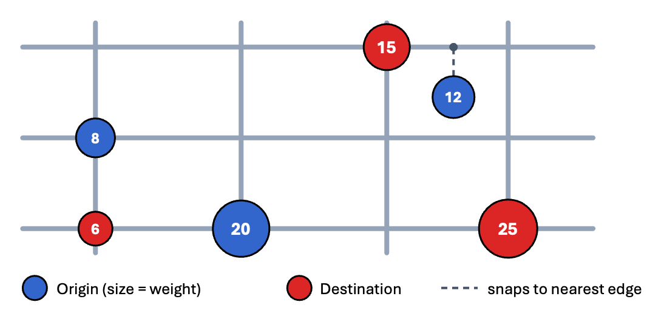
A small network with origin points (blue squares) and destination points (red circles). Symbol size and the number inside each marker show the point’s weight. Both classes snap to the nearest edge automatically.

Edge attributes — objective vs. perceived length
Every edge carries a cost attribute — the value the routing algorithm minimizes when computing shortest paths. By default this is the segment’s geometric length in meters. But the cost column does not have to be geometric length: you can substitute a perceived length — meters as the pedestrian experiences them, not as the surveyor measures them. Perceived lengths are a powerful way of folding route attributes (sidewalk presence and width, trees, ground floor businesses, traffic noise, heat) into segment costs.
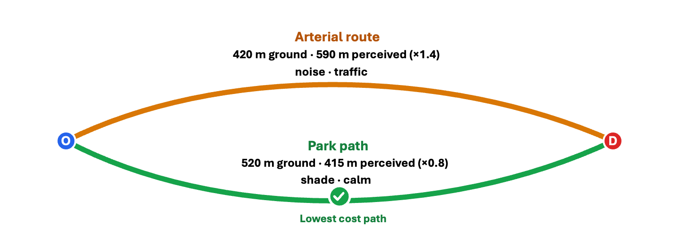
Two routes between an origin O and a destination D. The arterial is shorter in ground meters but feels longer because of noise, traffic, and pollution. The park path is geometrically longer but feels shorter. With perceived length as the cost attribute, the engine prefers the park path even though it is physically further.
Perceived length is typically computed by multiplying each segment’s geometric length by a quality factor derived from the street’s pedestrian environment. A pleasant tree-lined street might score 0.8 (each meter feels like 0.8 m); a noisy arterial 1.4. UNA does not prescribe how you derive the factors — typically from pedestrian route-choice studies estimating Willingness To Walk, Distance Equivalence, or Value of Distance for different route attributes — but it routes correctly on whatever cost column you supply. Configure it via /user_guide/settings_reference:network_weight_column, which defaults to "Geometric" (ground length).
See also
For literature reference on measured perceived cost factors of different street attributes for pedestrians, see:
- Sevtsuk, A., Li, X., Basu, R., & Kalvo, R. (2021). A big data approach to understanding pedestrian route choice preferences — Evidence from San Francisco. Travel Behaviour and Society, 25(October), 41–51. https://doi.org/10.1016/j.tbs.2021.05.010
- Basu, R., & Sevtsuk, A. (2022). How do street attributes affect willingness-to-walk? City-wide pedestrian route choice analysis using big data from Boston and San Francisco. Transportation Research Part A, 163, 1–19. https://doi.org/10.1016/j.tra.2022.06.007
- Sevtsuk, A., & Basu, R. (2022). The role of turns in pedestrian route choice: a clarification. Journal of Transport Geography. https://doi.org/10.1016/j.jtrangeo.2022.103392
- Basu, R., Colaninno, N., Alhassan, A., & Sevtsuk, A. (2024). Hot and Bothered: Exploring the Effect of Heat on Pedestrian Behavior and Accessibility. Cities, 155. https://doi.org/10.1016/j.cities.2024.105435

Overview of UNA analyses
With the network, point objects, and edge weights described above, UNA’s engines can (i) compute fine-grain pedestrian or bike accessibilities, (ii) output origin-destination cost matrices, and (iii) estimate pedestrian or cycling flows over networks.
Accessibility — “what can each origin reach?” UNA computes a numeric accessibility score at every origin point, summarizing how well-connected that location is to surrounding destinations within a chosen walking or biking radius. Three indices are provided:
- Reach counts the number (or summed weights) of destinations within a radius — a “cumulative opportunities” index.
- Gravity weights each destination by an inverse function of its network distance, so nearby destinations contribute more.
- KNN accessibility looks at the k nearest destinations of each type (e.g. the 3 closest grocery stores, the closest school) and can combine them into one composite score (using the UNA_Batch function) — conceptually similar to a WalkScore-style index.
Flow estimation — “which streets are the trips likely to use?” Given trips from origins to destinations, UNA’s flow analysis computes how many pass through each network edge, producing a per-segment flow estimate. OD pairs can represent any trip purpose: homes to schools, homes to transit, employees to lunch, tourists to landmarks. The result is a network map where every edge carries its expected traffic load — the basis for identifying high-traffic corridors, targeting pedestrian-friendly investment, and revealing which routes would gain or lose flow with changes to the built environment. Flow analysis can also output flow at network nodes, and return directional estimates for segments (A>B versus B>A, where A refers to the start of segment geometry).
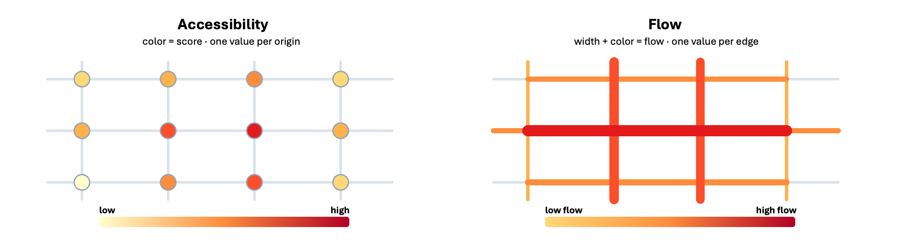
The two families of UNA outputs. Left: per-origin accessibility scores (color = score; one number per point). Right: per-edge flow (thickness and color = trip volume; one number per edge).
From estimates to calibrated predictive models. Estimated flows are descriptive on their own, but become predictive when calibrated against observed pedestrian or bicycle counts — a morning of intercept surveys or a week of automated counter data. Once calibrated, the same model answers scenario questions: how would volumes change if nearby land uses changed, or if a street upgrade changed its perceived length? These are the “what-if” questions planning agencies need.
See also
For examples of pedestrian volume models with calibrated flows based on observed pedestrian counts, see:
- Sevtsuk, A., Basu, R., Liu, L., Alhassan, A., & Kollar, J. (2026). Spatial Distribution of Foot-traffic in New York City and Applications for Urban Planning. Nature Cities. https://doi.org/10.1038/s44284-025-00383-y
- Sevtsuk, A., Kollar, J., Pratama, D., Haddad, J., Basu, R., Alhassan, A., Chancey, B., Makhlouf, R., Halabi, J., & Abou-Zeid, M. (2024). Pedestrian-Oriented Development in Beirut: A Framework for Estimating Urban Design Impacts on Pedestrian Flows through Modeling, Participatory Design, and Scenario Analysis. Cities. https://doi.org/10.1016/j.cities.2024.104927
- Sevtsuk, A., Basu, R., & Chancey, B. (2021). We shape our buildings, but do they then shape us? A longitudinal analysis of pedestrian flows and development activity in Melbourne. PLOS ONE. https://doi.org/10.1371/journal.pone.0257534
- Sevtsuk, A. (2021). Estimating pedestrian flows on street networks: revisiting the betweenness index. Journal of the American Planning Association, 87(4), 512–526. https://doi.org/10.1080/01944363.2020.1864758

Summary
The network is a graph of edges joined at shared endpoints; crossings without shared endpoints become overpasses/underpasses; weighted origins and destinations are point objects that snap to edges; and the edge cost can be either ground length or a perceived length capturing the pedestrian experience of the street. These four concepts are the foundation for every accessibility and flow analysis in Tutorial 2 — Accessibility step-by-step (Boston), Tutorial 3 — Foot-traffic flow analysis in Cambridge, and Tutorial 4 — Evaluating a design intervention.

