Tutorial 2 — Accessibility step-by-step (Boston)
This tutorial builds an accessibility analysis on the Boston inner-core data in nine progressive steps. Each step changes one or two settings and shows what happens to the result. Open UNA_Workspace.py in VS Code with the una conda environment active; modify the script in place and rerun python UNA_Workspace.py after each variation.
The data files live in una-2.5.5/Boston/:
- Network (steps a–f, h): 20260703_PercLenNetwork_InnerCore.geojson — 69,957 pedestrian-network edges covering the Boston inner core (Cambridge + Boston core), 2D.
- Network (step g, elevation): 20260703_PercLenNetwork_InnerCore_3D.geojson — the same network with elevation sampled at every vertex (x, y, z).
- Origins (steps a–e): MIT_SAP_Harvard_GSD.geojson — two points: the MIT School of Architecture + Planning and the Harvard Graduate School of Design.
- Destinations: MA_transit_stations.geojson — 6,919 transit stops across the MBTA region, with a weekly_departures attribute.
- Origins (steps f–h): Cambridge_building_centroids.geojson — 14,751 building centroids across Cambridge.
Each step below shows only the settings that change relative to the previous step.
- (a) Reach to transit stops — two origins, radius 400 m
- (b) Add destination weights (weekly_departures)
- (c) Add Gravity (exponential), β = 0.001
- (d) Add Gravity (logistic), midpoint = 500 m
- (e) Add KNN access — knn_weights = (1.0,)
- (f) Scale up — all 14,751 Cambridge building centroids
- (g) Enable elevation, penalty = 4
- (h) Enable turns, threshold = 45°, penalty = 35
- (i) WalkScore-style composite with UNA_Batch.py
- What we covered

(a) Reach to transit stops — two origins, radius 400 m
The simplest possible accessibility analysis: count transit stops reachable within a 400 m network walk, with no destination weighting.
from source import UNA
una = UNA()
una.settings.data_folder = r"Boston"
una.settings.network_file = "20260703_PercLenNetwork_InnerCore.geojson"
una.settings.origins_file = "MIT_SAP_Harvard_GSD.geojson"
una.settings.destinations_file = "MA_transit_stations.geojson"
una.settings.search_radius = 400
una.settings.calculate_reach = True
una.settings.calculate_exponential_gravity = False
una.settings.calculate_logistic_gravity = False
una.settings.calculate_knn_access = False
una.settings.origin_weight_column = "Count"
una.settings.destination_weight_column = "Count"
una.RunAccessibility()
Origin | Reach
MIT_SAP | 7.00
Harvard_GSD | 9.00
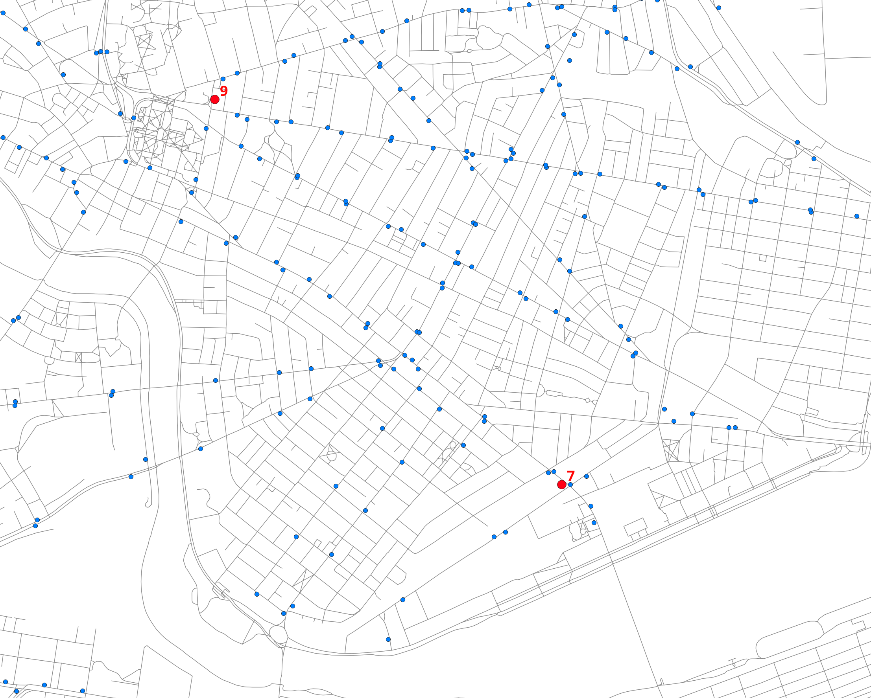
Within a 400 m walk, MIT_SAP reaches 7 transit stops and Harvard_GSD reaches 9 — raw counts, every stop contributing 1.

(b) Add destination weights (weekly_departures)
Weight each stop by its weekly departures — a proxy for service frequency. Reach becomes a weighted sum rather than a raw count.
una.settings.destination_weight_column = "weekly_departures"
Origin | Reach
MIT_SAP | 3,456.00
Harvard_GSD | 3,427.00
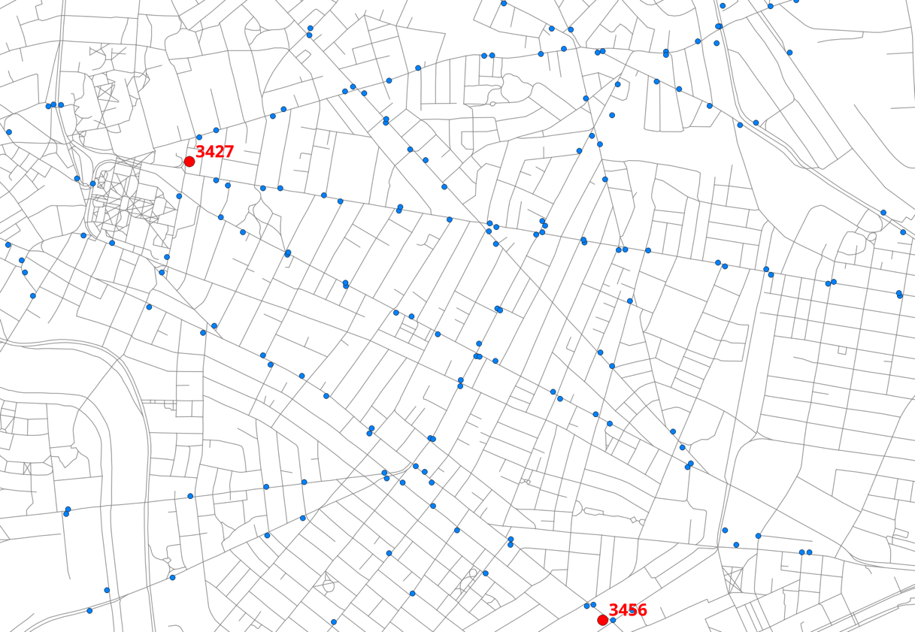
MIT_SAP’s fewer stops turn out to carry almost the same aggregate service level as Harvard’s more numerous ones.

(c) Add Gravity (exponential), β = 0.001
Gravity additionally penalizes distance — each destination contributes weight × exp(−β·d). See Gravity and decay models.
una.settings.calculate_exponential_gravity = True
una.settings.gravity_beta = 0.001
Origin | Reach | Gravity (exp)
MIT_SAP | 3,456.00 | 2,969.86
Harvard_GSD | 3,427.00 | 2,762.70
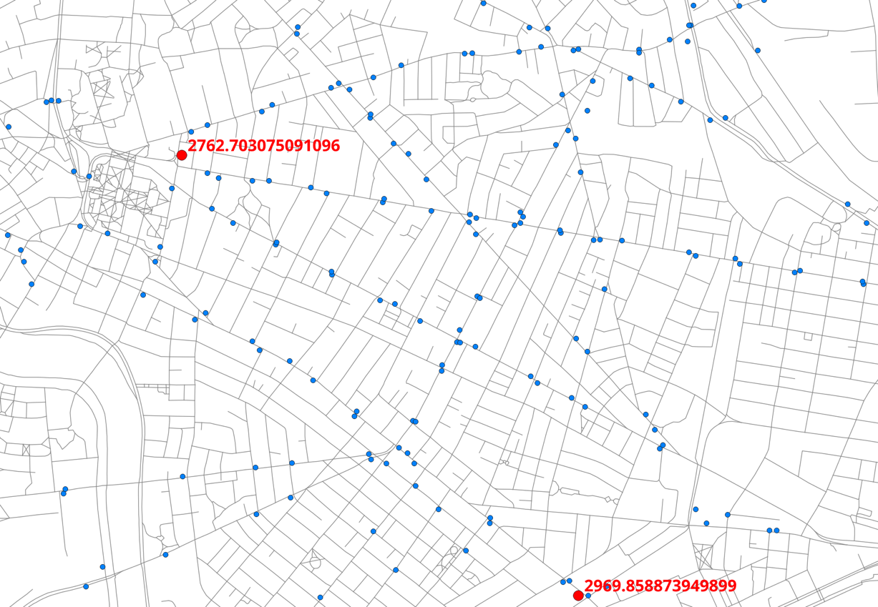
Gravity is always ≤ Reach because exp(−β·d) < 1 for any d > 0. With β = 0.001 the half-distance is ln(2)/β ≈ 693 m. Harvard’s gravity falls off more because its stops are on average farther away.

(d) Add Gravity (logistic), midpoint = 500 m
The logistic (S-shape) decay stays close to 1.0 below the midpoint and falls off rapidly past it — often a better fit for walking behavior: close is close, far is far, with a fairly sharp threshold in between.
una.settings.calculate_logistic_gravity = True
una.settings.gravity_logistic_midpoint = 500
Origin | Reach | Gravity (exp) | Gravity (log)
MIT_SAP | 3,456.00 | 2,969.86 | 3,279.87
Harvard_GSD | 3,427.00 | 2,762.70 | 3,105.15
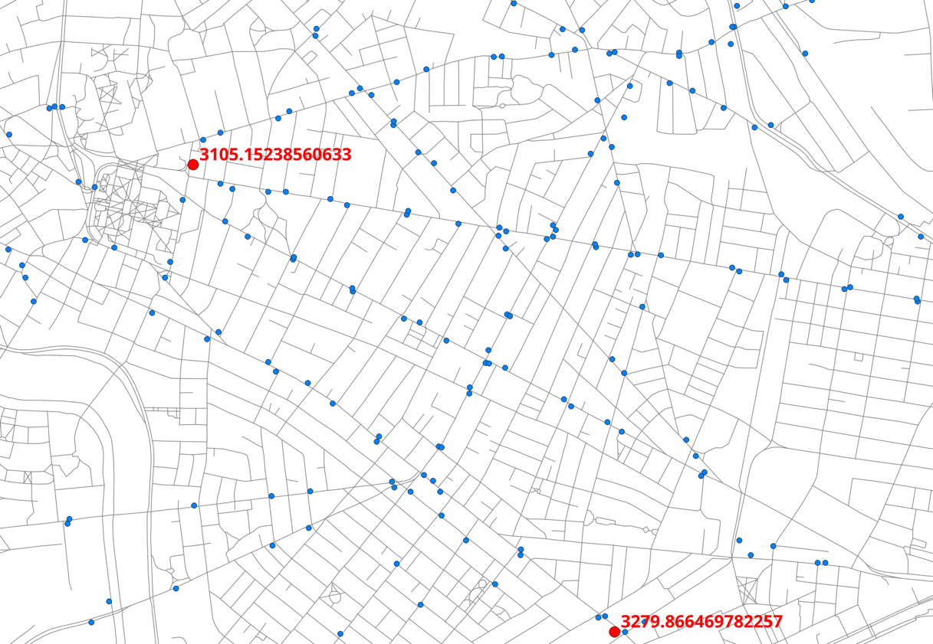
The logistic values sit between Reach and exponential gravity because at 0–400 m the logistic curve is still near its plateau.

(e) Add KNN access — knn_weights = (1.0,)
The K-Nearest-Neighbor index limits the analysis to only the K nearest destinations. K is set by the length of the knn_weights tuple, each element’s value by its contribution weight.
Warning
Even for a single weight, the trailing comma is required: (1.0,) is a one-element tuple, while (1.0) is just a parenthesized float and the setting will silently misbehave.
una.settings.calculate_knn_access = True
una.settings.knn_decay = "logistic"
una.settings.knn_weights = (1.0,) # ← note the trailing comma
Origin | Reach | Gravity (exp) | Gravity (log) | KNN
MIT_SAP | 3,456.00 | 2,969.86 | 3,279.87 | 157.70
Harvard_GSD | 3,427.00 | 2,762.70 | 3,105.15 | 617.80
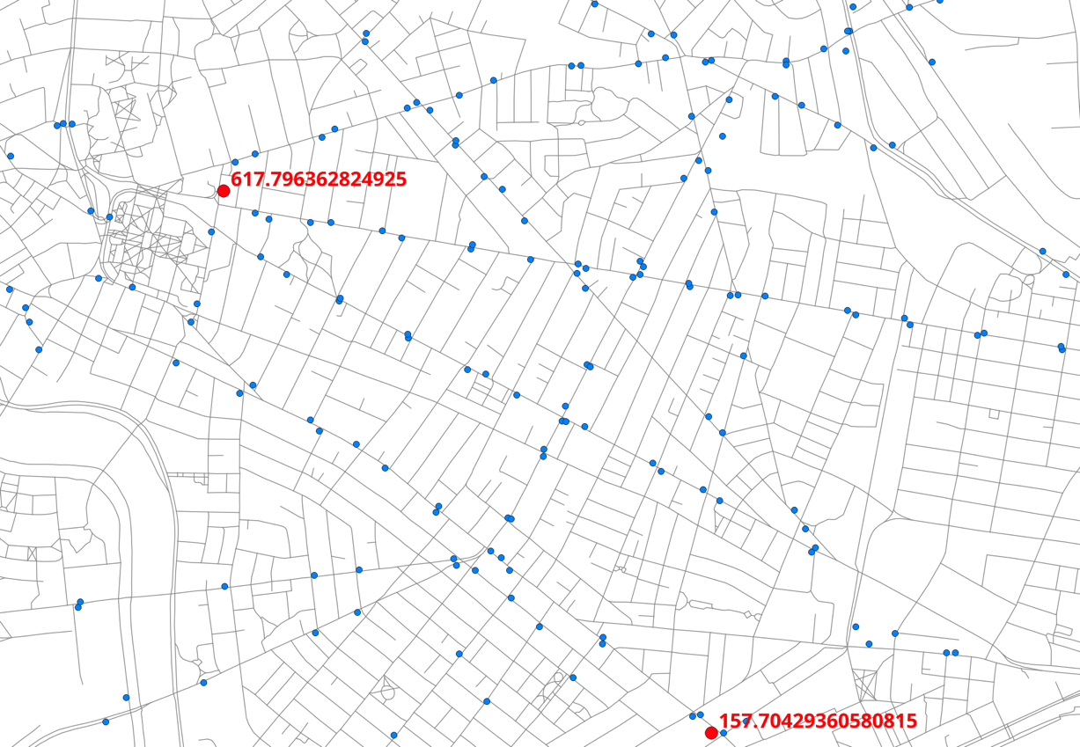
KNN is dominated by the single nearest stop: Harvard’s nearest stop has far higher weekly departures than MIT’s, so despite nearly identical Reach and Gravity totals, the KNN scores diverge sharply.

(f) Scale up — all 14,751 Cambridge building centroids
Same settings as (e), but computed for every building in Cambridge.
una.settings.origins_file = "Cambridge_building_centroids.geojson"
Metric | n with access | Mean | Median | p90 | Max
Reach | 13,135 | 3,197.96 | 2,490.00 | 5,986.00 | 20,027.00
Gravity (exp) | 13,135 | 2,451.64 | 1,864.02 | 4,572.85 | 16,457.07
Gravity (log) | 13,135 | 2,774.99 | 2,110.67 | 5,154.10 | 18,397.42
KNN access | 13,135 | 515.74 | 356.19 | 876.46 | 7,959.39
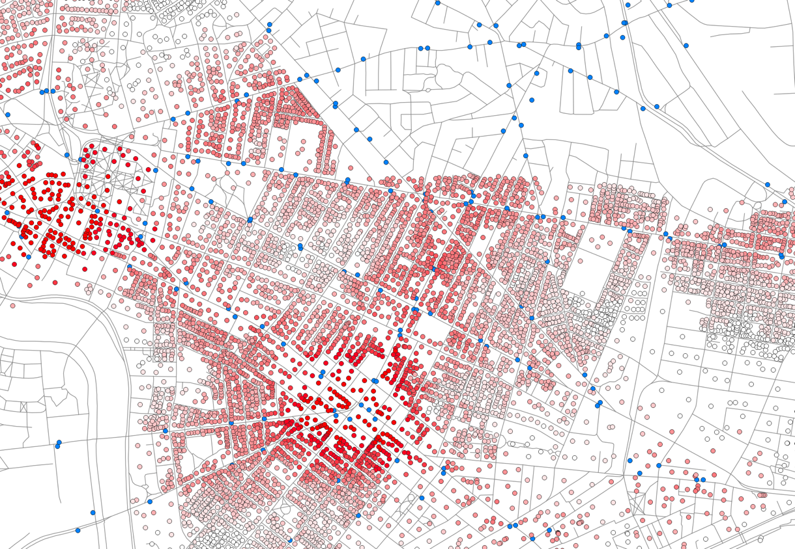
Gravity (exponential) per building centroid, visualized in QGIS.
About 89 % of buildings have at least one stop within a 400 m walk. The maxima belong to buildings near Harvard Square, Central Square, and Kendall Square where multiple bus and rail lines converge.

(g) Enable elevation, penalty = 4
Uphill walking accrues 4 extra cost-units per meter of rise. Swap in the 3D network (same 69,957 segments with SRTM 30 m z-values; elevation range −13 to 194 m):
una.settings.network_file = "20260703_PercLenNetwork_InnerCore_3D.geojson"
una.settings.elevation = True
una.settings.elevation_penalty = 4
Metric | n with access | Mean | Median | p90 | Max
Reach | 12,897 | 2,967.93 | 2,241.00 | 5,548.20 | 19,934.00
Gravity (exp) | 12,897 | 2,277.92 | 1,726.00 | 4,313.34 | 16,027.12
Gravity (log) | 12,897 | 2,577.42 | 1,936.88 | 4,825.26 | 18,082.06
KNN access | 12,897 | 513.70 | 356.12 | 878.19 | 7,959.39
Served buildings drop ~1.8 % and mean Reach ~7 %, driven by uphill routes near Beacon Hill, Copp’s Hill, Bunker Hill, and the terrain rises in Somerville and Cambridge. MIT_SAP (flat river bank) is essentially unchanged; Harvard_GSD’s Reach falls ~15 % as some 400 m walks now climb toward the Radcliffe Yard rise.

(h) Enable turns, threshold = 45°, penalty = 35
Any deviation from straight-ahead by more than 45° at a node adds 35 cost-units. The turn-aware engine builds a line graph internally and is slower — expect a few minutes for all 14,751 origins. The tables below use the 2D network so they compare directly to step (f):
una.settings.network_file = "20260703_PercLenNetwork_InnerCore.geojson"
una.settings.elevation = False
una.settings.turns = True
una.settings.turn_threshold = 45
una.settings.turn_penalty = 35
Metric | n with access | Mean | Median | p90 | Max
Reach | 12,723 | 2,831.80 | 2,100.00 | 5,296.60 | 19,934.00
Gravity (exp) | 12,723 | 2,164.42 | 1,619.11 | 4,169.19 | 16,218.53
Gravity (log) | 12,723 | 2,455.62 | 1,831.23 | 4,713.00 | 18,281.50
KNN access | 12,723 | 513.13 | 353.85 | 872.96 | 7,951.62
Mean Reach falls ~11 % with turns enabled. Paths that look short on a map can become inaccessible once realistic pedestrian routing costs are applied — and turns + elevation stack additively if you also switch back to the 3D network.

(i) WalkScore-style composite with UNA_Batch.py
Steps (a)–(h) measured accessibility to one destination type at a time. A WalkScore-style composite sums accessibility across many destination categories — schools, transit, food, healthcare, parks — into one number per origin. UNA_Batch.py does this from a single pairings CSV: one row per category, each with its own destinations_file, search_radius, knn_weights, decay parameters and flags. The Boston table (Boston/Boston_KNN_pairings.csv) lists 10 categories (arts, bus, food & beverage, health, metro, parks, personal services, public institutions, retail, schools), each with batch_composite_output = TRUE and composited on knn_access.
The full UNA_Batch.py script — edit the three path constants and the analysis type at the top, everything else stays as shipped:
from source import UNA
# --------------------------------------------------------------
# EDIT THESE THREE VALUES
# --------------------------------------------------------------
DATA_FOLDER = r"Boston"
PAIRINGS_FILE = r"Boston/Boston_KNN_pairings.csv"
OUTPUT_FOLDER = r"Boston/Results"
# Which analysis to run per row — must match the metric in your
# pairings CSV:
# "accessibility" — for reach / gravity_* / knn_access composites
# "flow" — for edge_flow or node_flow composites
ANALYSIS = "accessibility"
# --------------------------------------------------------------
# Run the batch (per-row files + optional composite file)
# --------------------------------------------------------------
una = UNA()
una.settings.data_folder = DATA_FOLDER
una.settings.output_folder = OUTPUT_FOLDER
una.RunBatch(ANALYSIS, pairing_file=PAIRINGS_FILE)
All the per-category settings — destinations_file, search_radius, knn_weights, decay parameters, calculate_* flags, batch_composite_output, batch_composite_result_column — come from the pairings CSV rows, not from the script. Run it with:
python UNA_Batch.py
The script builds the topology once per row, runs the accessibility engine per category, and — because rows set batch_composite_output = TRUE — assembles a single joint output with one row per origin building whose final composite_sum column adds the 10 category KNN scores into one WalkScore-style number. Compositing is built into UNA.RunBatch — see Project workflow — RunBatch() for the mechanics and /user_guide/settings_reference:name for per-row naming.
Note
Composites are grouped by origins layer. All 10 rows here share the same origins file, so the batch writes a single composite file. A pairing table whose rows use several different origin layers (e.g. “Homes to …” and “Jobs to …” rows) produces one composite file per origin layer, each with its own composite_sum column — see Project workflow — RunBatch().
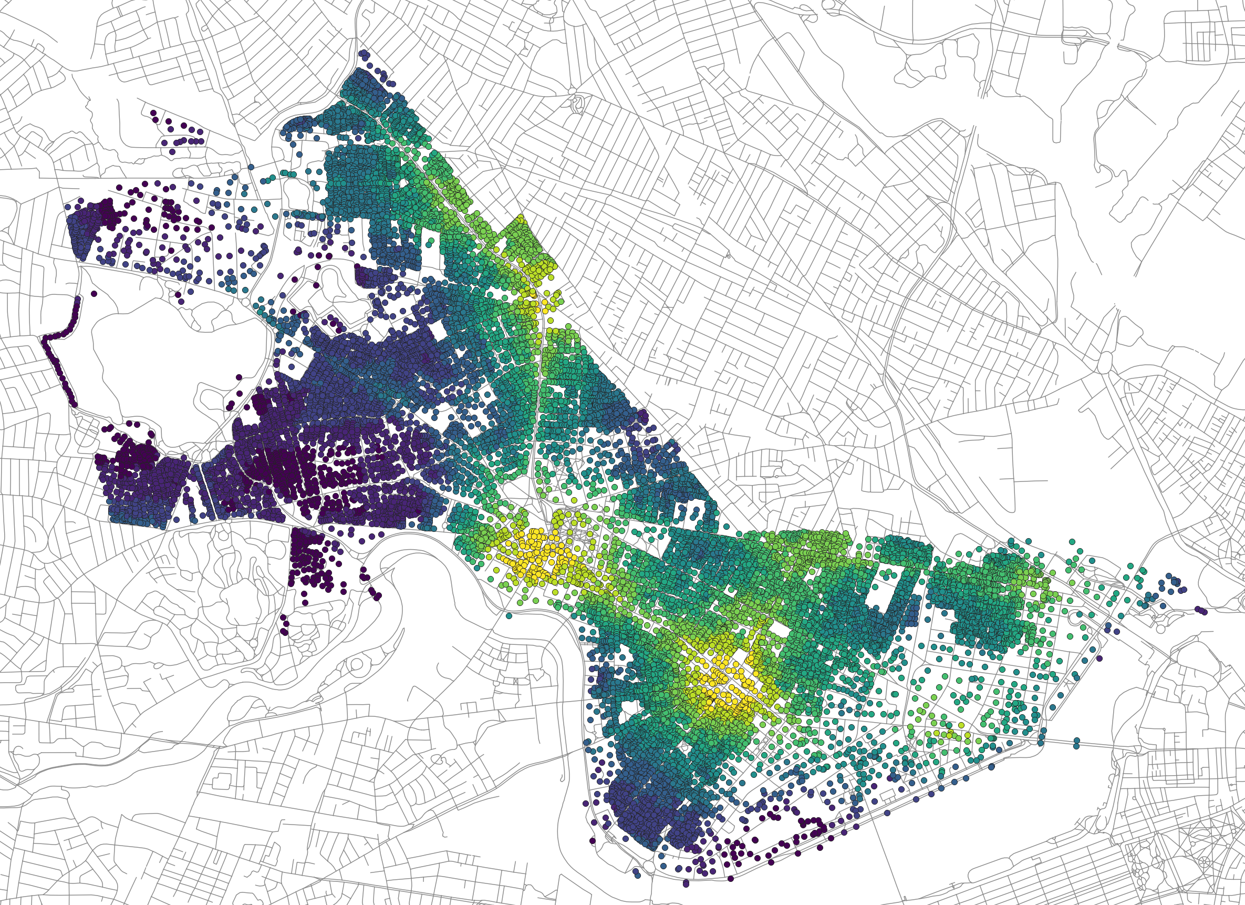
K-Nearest-Neighbor composite (WalkScore-style) for Cambridge building centroids. Highest scores near Harvard Square and Central Square.
Adapting the pairings table is the main editorial workflow: add a row for a new category, tweak a radius or knn_weights vector, rerun — no Python editing required. With turns=TRUE and elevation=TRUE (3D network) the full 10-row run takes 30–60 minutes on a laptop; with both FALSE, 5–10 minutes.

What we covered
Reach (a–b), Gravity under two decay shapes (c–d), KNN access (e), city scale (f), elevation (g), turns (h), and a CSV-driven composite (i). The same settings combine freely — try a different radius, a sharper logistic midpoint, or knn_weights = (1.0, 1.0, 0.5) and watch each change ripple through the result columns.
Next: Tutorial 3 — Foot-traffic flow analysis in Cambridge — from accessibility scores to per-edge pedestrian flows.

