Tutorial 3 — Foot-traffic flow analysis in Cambridge
This tutorial examines the una.RunFlow() engine for modeling active-mobility trips over networks, using walking trips in Cambridge, MA. Steps (a)–(i) use a single origin (MIT_SAP) and two named destinations; step (j) scales to every Cambridge building centroid; step (k) automates multiple flows from a pairings CSV.
Data files (in una-2.5.5/Boston/):
- Network (a–h): 20260703_PercLenNetwork_InnerCore.geojson — 69,957 pedestrian-network edges (2D; a 3D twin is used in step g).
- Origin (a–h): MIT_SAP_flow_origin.geojson — MIT School of Architecture + Planning, a single point with weight = 100.
- Destinations (a–h): HarvardHC_and_GSD.geojson — two points: Harvard_HousingCtr (2,195.1 m from MIT_SAP along the network, weight 1) and Harvard_GSD (2,585.6 m, weight 3).
- Step (i): Cambridge_building_centroids.geojson (14,751 buildings) → Cambridge_metro_stations.geojson (18 rapid-transit stations, weighted by weekly_departures).
Note
Two flow engines. Since v2.5.5, UNA ships two flow engines selected by /user_guide/settings_reference:flow_engine. The default is "aggregate_flow" — a scalable engine that spreads each trip across the full detour envelope without enumerating discrete paths (see Aggregate flow (gradient-overlap method)). Steps (a)–(h) teach the K-alternative-routes engine, so the script sets flow_engine = "k_alternatives" explicitly; step (i) switches to the aggregate engine on identical inputs, and steps (j)–(k) continue with it. All concepts introduced here — decay, weights, Huff destination choice, detour envelope — apply to both engines.
- (a) Shortest path only — one simple trip
- (b) Add distance decay, β = 0.001
- (c) Add origin weight — 100 residents at MIT_SAP
- (d) Loosen the envelope — detour_ratio = 1.2
- (e) Include both destinations
- (f) Huff destination choice — destination weights on
- (g) Enable elevation, penalty = 4
- (h) Enable turns, threshold = 45°, penalty = 35
- (i) Switching to the aggregate-flow engine
- (j) Many-to-many — 14,751 buildings → 18 metro stations
- (k) Automating multiple flows with UNA_Batch.py
- What we covered

(a) Shortest path only — one simple trip
Emit ONE trip from MIT_SAP to its closest reachable destination along the shortest path. A useful sanity check before adding realism.
from source import UNA
una = UNA()
una.settings.data_folder = r"Boston"
una.settings.network_file = "20260703_PercLenNetwork_InnerCore.geojson"
una.settings.origins_file = "MIT_SAP_flow_origin.geojson"
una.settings.destinations_file = "HarvardHC_and_GSD.geojson"
una.settings.search_radius = 4000
una.settings.flow_engine = "k_alternatives" # explicit — v2.5.5 defaults to "aggregate_flow"
una.settings.flow_detour_ratio = 1.0 # shortest path only
una.settings.use_nearest_destination = True # nearest destination only
una.settings.flow_decay = False
una.settings.flow_origin_weights = False
una.settings.flow_destination_weights = False
una.settings.turns = False
una.settings.elevation = False
una.RunFlow()
Metric | Value
Max flow (edge) | 1.0000
Edges with flow > 0 | 49 (of 69,957)
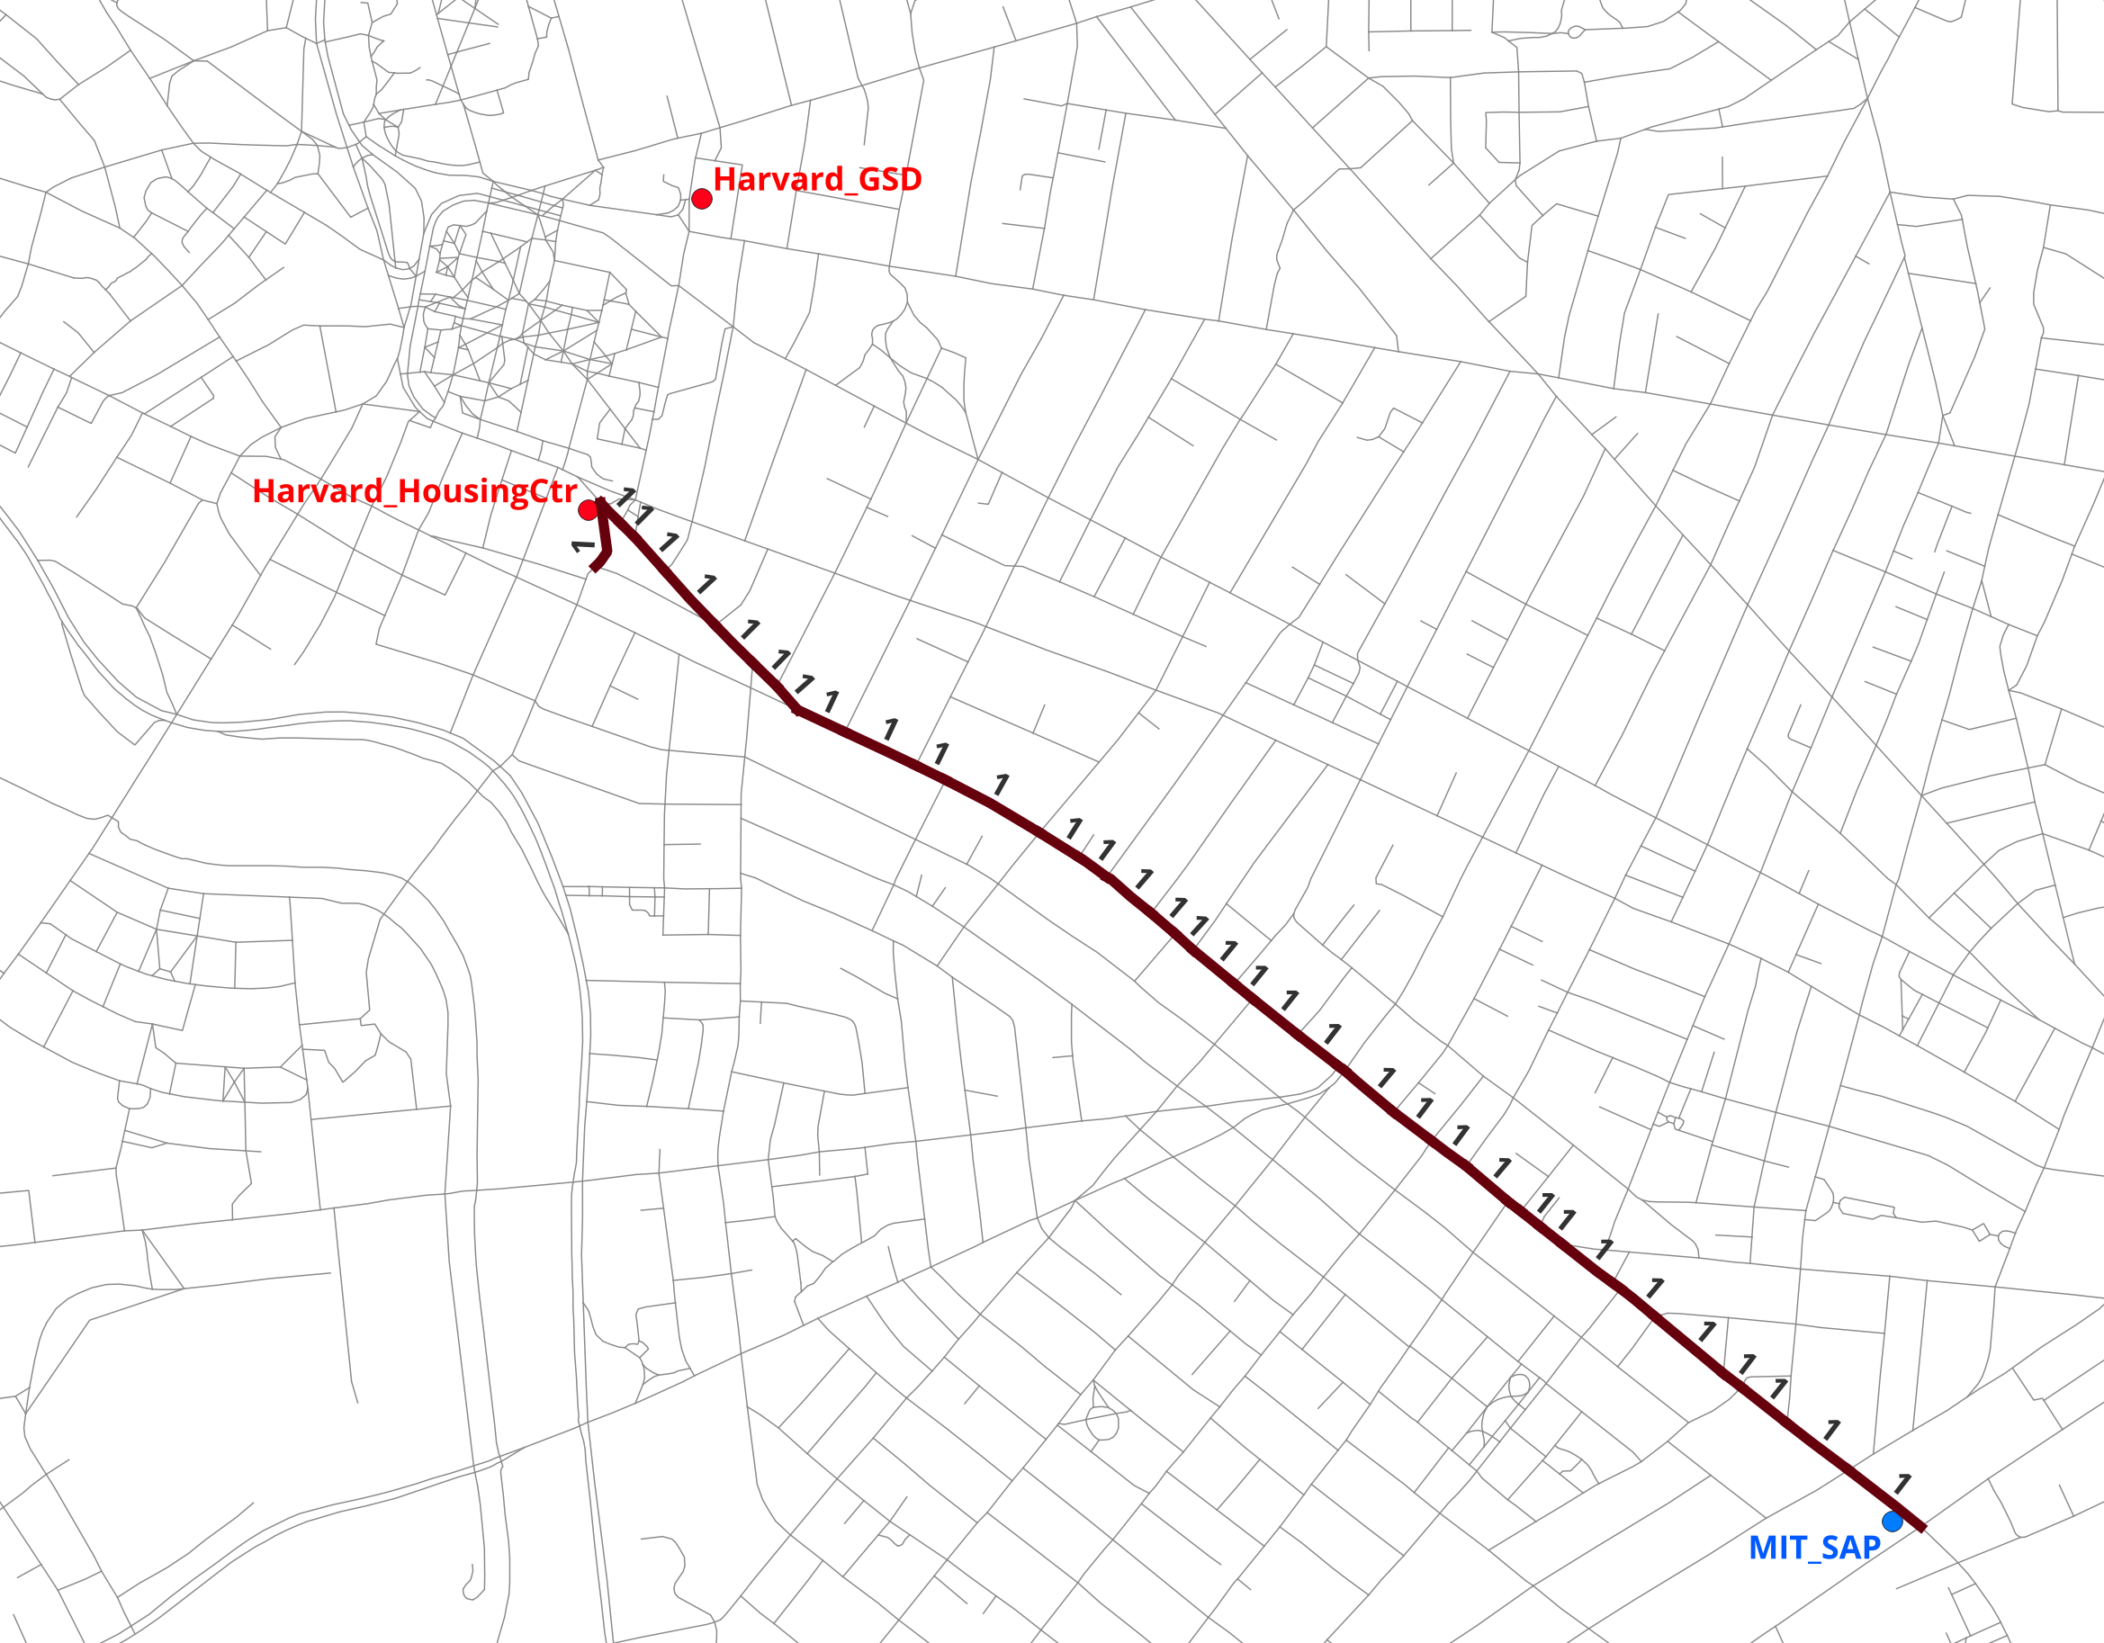
49 edges form the shortest path to Harvard_HousingCtr (the closer destination); each carries exactly one trip’s worth of flow. Harvard_GSD is ignored because use_nearest_destination=True restricts the analysis to the single closest destination.

(b) Add distance decay, β = 0.001
The trip volume is reduced by exp(−β·d) = exp(−0.001 × 2,168) ≈ 0.114.
una.settings.flow_decay = True
una.settings.flow_decay_curve = "exponential"
una.settings.gravity_beta = 0.001
Metric | Value
Max flow (edge) | 0.114
Edges with flow > 0 | 49
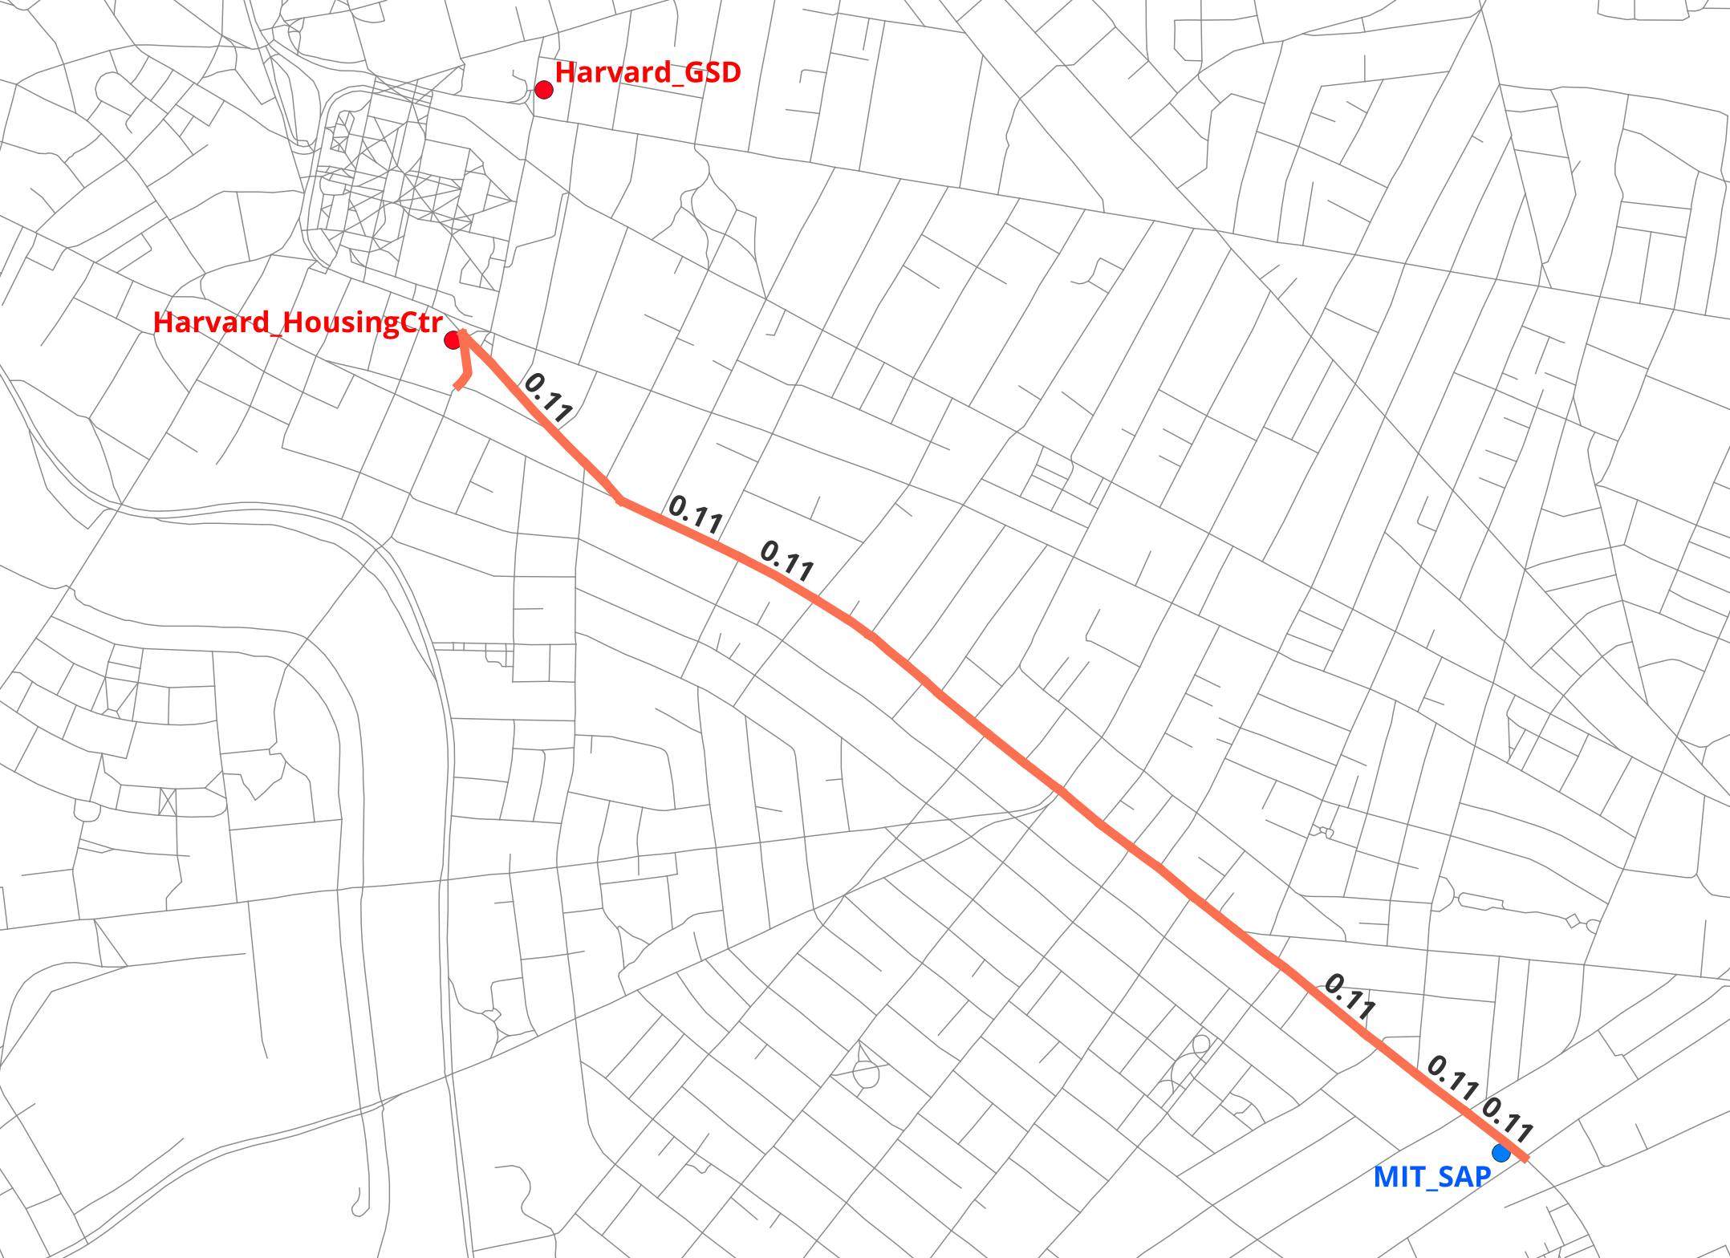
Same 49-edge path; every edge now carries ~11 % of a trip.

(c) Add origin weight — 100 residents at MIT_SAP
una.settings.flow_origin_weights = True
una.settings.origin_weight_column = "weight"
Metric | Value
Max flow (edge) | 11.42
Edges with flow > 0 | 49
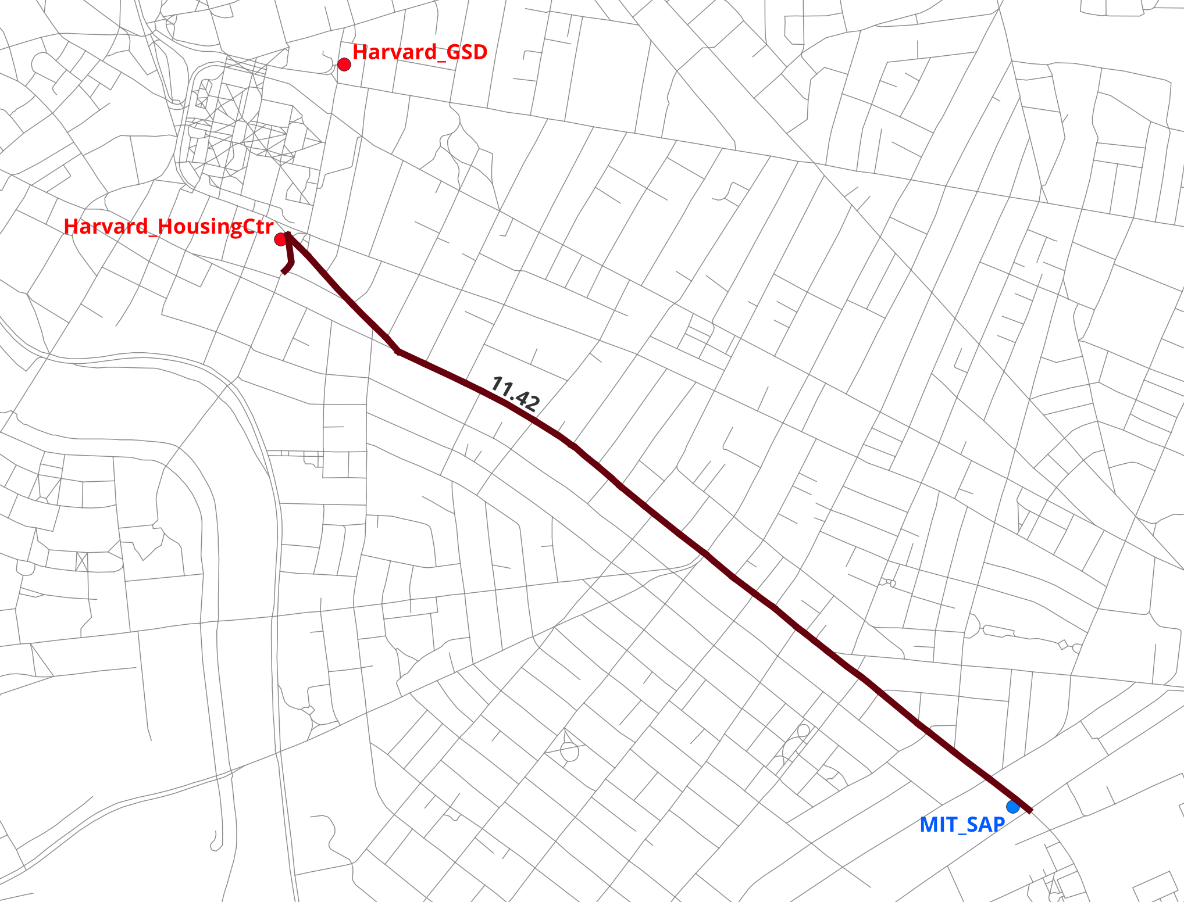
Max flow jumps to 100 × 0.114 = 11.42 — origin weights are a pure multiplier on trips generated.

(d) Loosen the envelope — detour_ratio = 1.2
Allow alternatives up to 20 % longer than shortest. Trip volume stays constant but splits across K alternative routes.
una.settings.flow_detour_ratio = 1.2
Metric | Value
Max flow (edge) | 11.42 (trunk edges)
Edges with flow > 0 | 114
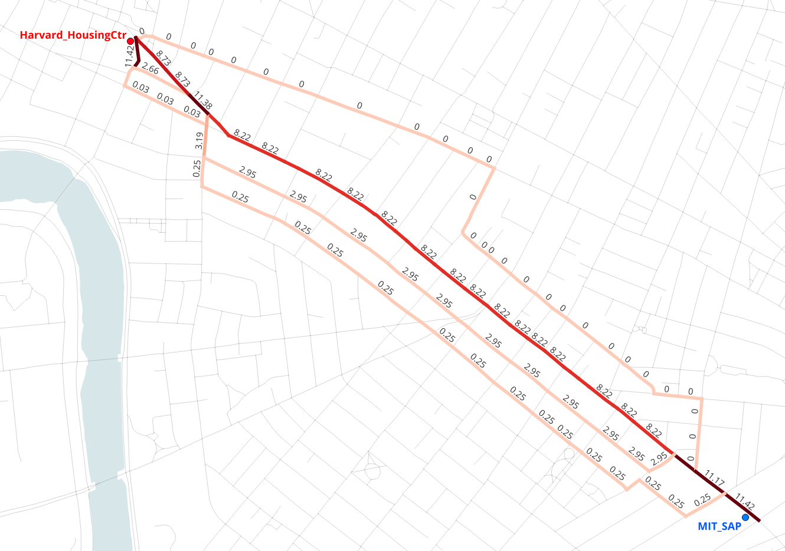
2.3× as many edges carry flow, concentrated along the Massachusetts Avenue corridor shared by multiple alternatives.

(e) Include both destinations
una.settings.use_nearest_destination = False
Metric | Value
Max flow (edge) | 11.42
Edges with flow > 0 | 214
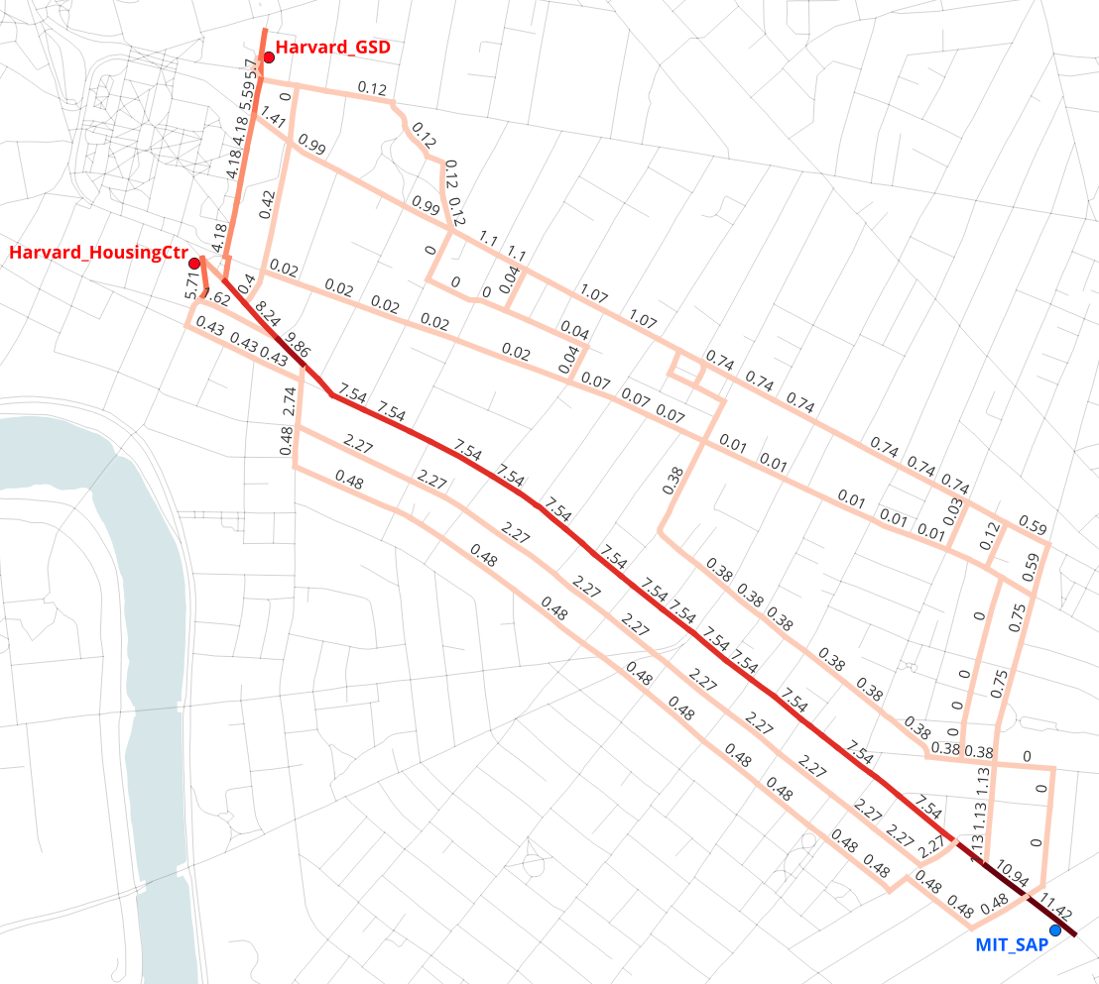
Harvard_GSD now receives flow too. Both destinations carry unit weight, so Harvard_HousingCtr’s shorter distance (decay 0.111 vs 0.075) gives it the larger share.

(f) Huff destination choice — destination weights on
Harvard_GSD is 3× more attractive (weight 3 vs 1). Allocation follows gravity[d] = weight[d] × exp(−β·d), normalized across destinations.
una.settings.flow_destination_weights = True
una.settings.destination_weight_column = "weight"
Destination | gravity | trip share
Harvard_HousingCtr | 1 × 0.111 = 0.111 | ≈ 33 %
Harvard_GSD | 3 × 0.075 = 0.226 | ≈ 67 %
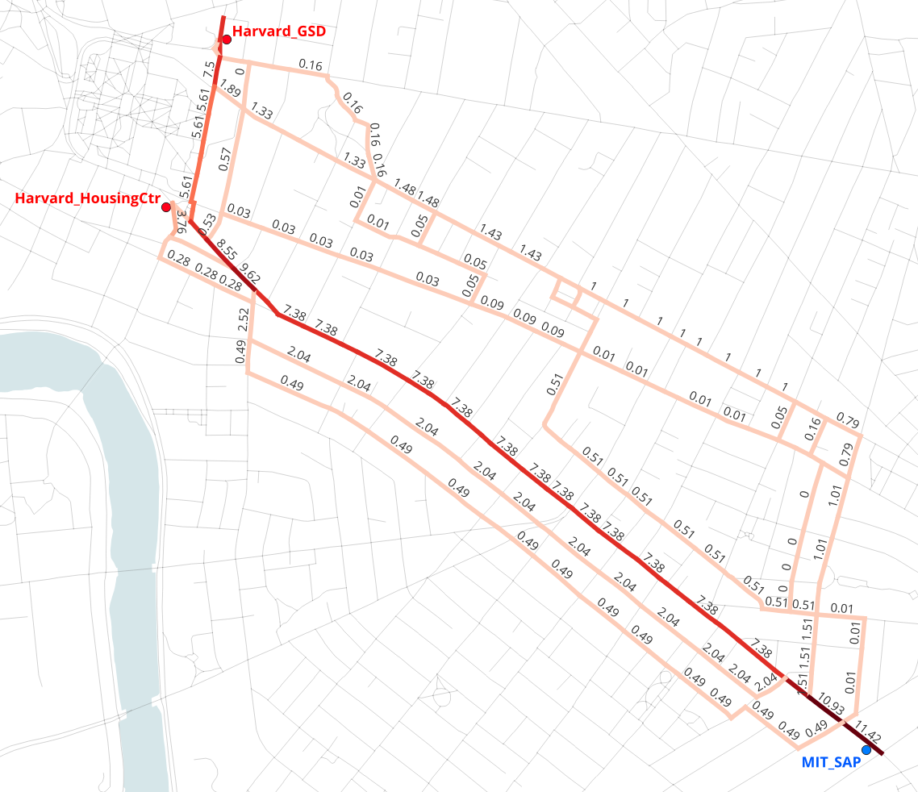
Max edge flow stays constant at 11.42, but more flow now ends up at the GSD and less at the Housing Center. This is Huff destination choice in action: the 3× weight overcomes the 18 % distance penalty.

(g) Enable elevation, penalty = 4
una.settings.network_file = "20260703_PercLenNetwork_InnerCore_3D.geojson"
una.settings.elevation = True
una.settings.elevation_penalty = 4
Metric | Value
Max flow (edge) | 9.93
Edges with flow > 0 | 212
Max flow falls from 11.42 to 9.93 (~13 %): uphill segments on the routes toward Harvard raise the perceived distance to both destinations, so the distance-decay factor drops and fewer trips are generated. The set of routes barely changes (214 → 212 edges) — Cambridge is comparatively flat along this corridor — but every route carries proportionally less volume. Subtler than Beacon Hill would be, but measurable.

(h) Enable turns, threshold = 45°, penalty = 35
una.settings.turns = True
una.settings.turn_threshold = 45
una.settings.turn_penalty = 35
Metric | Value
Max flow (edge) | 9.93
Edges with flow > 0 | 179
Nonzero edges drop from 212 to 179 — turn penalties eliminate the twisty alternatives, leaving the straight-through routes along Massachusetts Avenue. Flow concentrates on fewer edges: the corridors pedestrians actually walk when minimizing turns are much narrower than raw topology suggests.

(i) Switching to the aggregate-flow engine
Everything so far enumerated K discrete alternative routes per OD pair. UNA’s second engine — aggregate_flow, the default since v2.5.5 — models the same trips without enumerating paths: each trip’s volume is spread continuously over every network segment that can lie on a route within the detour envelope, weighted by how much of a detour passing through that segment implies (see Aggregate flow (gradient-overlap method)). Keeping every input from (h) identical, the switch is one line:
una.settings.flow_engine = "aggregate_flow"
una.RunFlow()
Metric | k_alternatives (h) | aggregate_flow (i)
Max flow (edge) | 9.93 | 9.93
Edges with flow > 0 | 179 | 986
The maximum is identical — both engines conserve trip volume, so the trunk segments near the origin and destinations carry the same full load. The difference is coverage: instead of loading K discrete routes, the aggregate engine loads the entire feasible envelope — 986 edges versus 179 — with volume tapering smoothly from the shortest path outward.
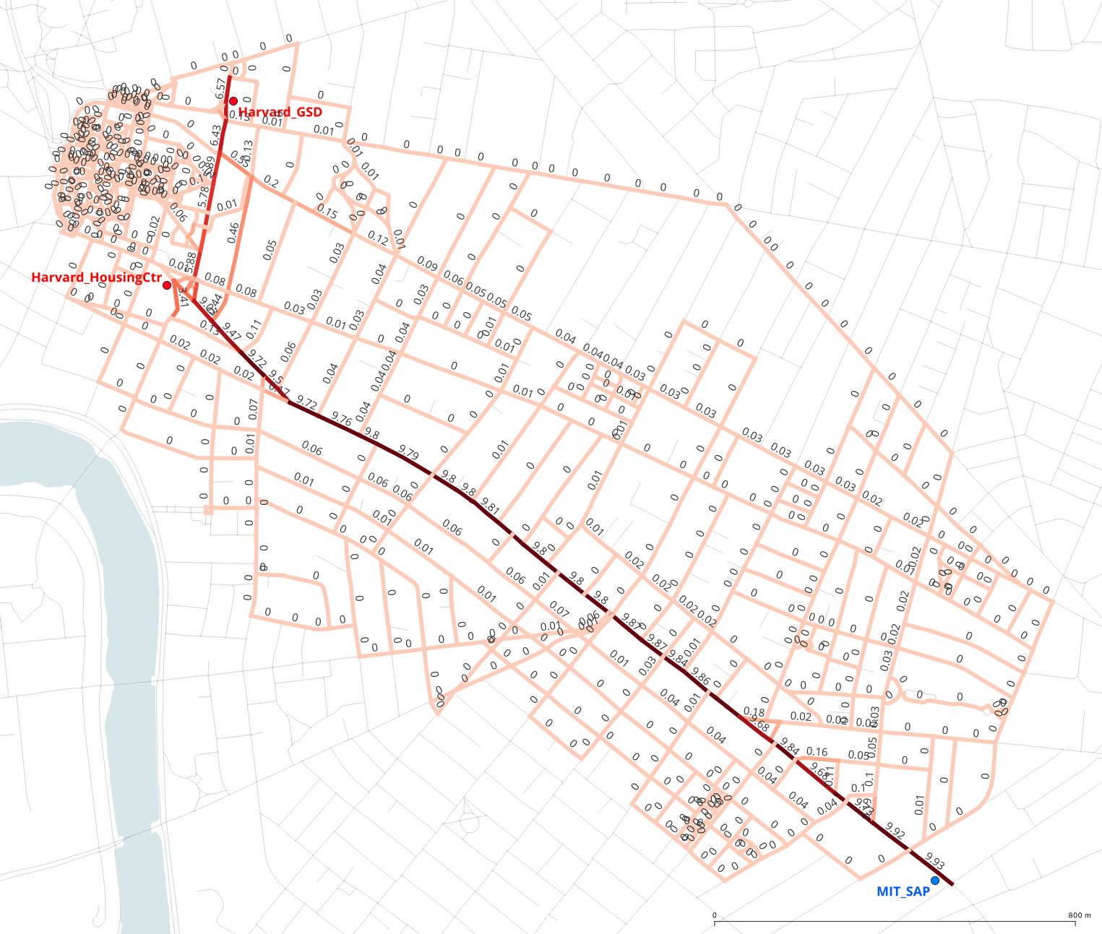
Aggregate flow from MIT_SAP to the two Harvard destinations with inputs identical to (h). The shortest-path trunk carries nearly the full 9.93 trip volume end to end, while flow tapers off across the surrounding detour envelope — hundreds of segments carry small fractions of a trip instead of K discrete routes carrying all of it.
How sharply the flow tapers is governed by /user_guide/settings_reference:flow_path_detour_penalty (default "logistic", midpoint /user_guide/settings_reference:flow_route_enumeration_logistic_midpoint); a stronger penalty concentrates flow near the shortest route, a weaker one spreads it evenly across the envelope.
Two practical notes. The aggregate engine scales far better with origin count — it needs no per-path enumeration — which is why the remaining steps use it. And it produces no discrete routes, so the route-geometries export of /user_guide/settings_reference:flow_output_routes requires k_alternatives.

(j) Many-to-many — 14,751 buildings → 18 metro stations
Scale to every Cambridge building reaching every rapid-transit station within a 600 m walk — the configuration an agency would use to map “which streets carry the most foot traffic from homes to transit?” (turns and elevation off for fast iteration; the engine stays aggregate_flow from step (i) — exactly the workload it is built for):
una.settings.origins_file = "Cambridge_building_centroids.geojson"
una.settings.origin_weight_column = "Count"
una.settings.destinations_file = "Cambridge_metro_stations.geojson"
una.settings.destination_weight_column = "weekly_departures"
una.settings.search_radius = 600
una.settings.turns = False
una.settings.elevation = False
Metric | 1k-building sample | Full 14,751 (estimate)
Run time | ~2 s | well under a minute on a laptop
Edges with flow > 0 | 937 | ≈ 6,000–8,000 (~9–11 %)
Max edge flow | 51.26 | ~750
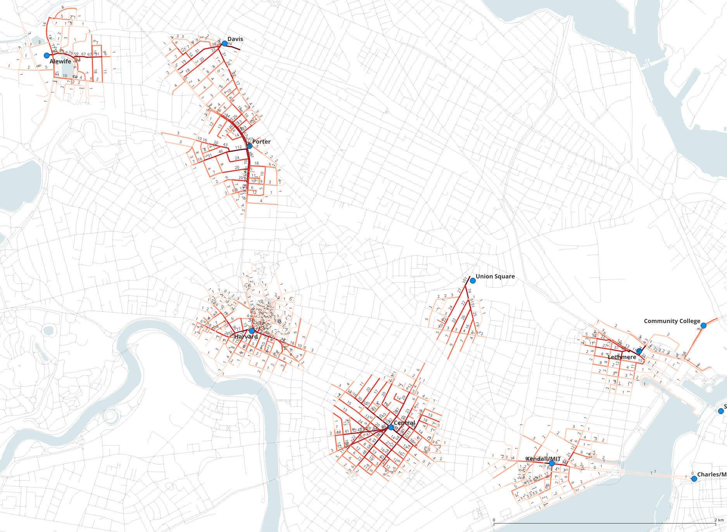
Building-to-transit flows across Cambridge. Each station collects walking trips from the buildings within its 600 m envelope, forming a distinct catchment; flow intensifies along the approach corridors toward each station entrance — Porter, Harvard, and Central show the strongest trunk loads.
The classic long-tailed distribution of pedestrian flow: trunk corridors — Massachusetts Avenue, Broadway, Cambridge Street — dominate, surrounded by a much larger network of low-flow neighborhood streets. (With k_alternatives the same sample takes ~6× longer and loads fewer edges — the aggregate engine’s envelope coverage and speed are exactly why it is the default at this scale.)

(k) Automating multiple flows with UNA_Batch.py
A planning study typically wants the same analysis run on several origin/destination pairs. UNA_Batch.py lists every flow as a row in a pairings CSV; internally it calls una.RunBatch("flow", pairing_file=...), which runs each row and — because rows set batch_composite_output = TRUE — merges every flow’s per-edge result into a composite output.
The Boston pairings CSV (Boston/Boston_Flow_pairings.csv) has two flows:
name | origins (weight) | destinations (weight) | radius
homes_to_transit | Cambridge_building_centroids_pop2020 (pop2020) | Cambridge_transit_stations (weekly_departures) | 600 m
schools_to_transit | schools_cambridge (weight) | Cambridge_transit_stations (weekly_departures) | 400 m
Note the destination layer: unlike step (j), which used only the 18 rapid-transit (metro) stations, both rows here target Cambridge_transit_stations.geojson — 434 stops including bus stops as well as metro stations, each weighted by its weekly_departures. That is why the resulting flow map covers nearly the whole city rather than a handful of station catchments.
Shared columns across rows include flow_decay = TRUE, flow_decay_curve = exponential, gravity_beta = 0.001, flow_detour_ratio = 1.2, batch_composite_output = TRUE, and batch_composite_result_column = edge_flow. Rows without a flow_engine column run the default aggregate_flow engine; the flow_n_alternatives and flow_alternative_penalty_factor columns in the CSV apply only when a row sets flow_engine = k_alternatives.
The full UNA_Batch.py script — edit the three path constants and the analysis type at the top, everything else stays as shipped:
from source import UNA
# --------------------------------------------------------------
# EDIT THESE THREE VALUES
# --------------------------------------------------------------
DATA_FOLDER = r"Boston"
PAIRINGS_FILE = r"Boston/Boston_Flow_pairings.csv"
OUTPUT_FOLDER = r"Boston/Results"
# Which analysis to run per row — must match the metric in your
# pairings CSV:
# "accessibility" — for reach / gravity_* / knn_access composites
# "flow" — for edge_flow or node_flow composites
ANALYSIS = "flow"
# --------------------------------------------------------------
# Run the batch (per-row files + composite edge-flow file)
# --------------------------------------------------------------
una = UNA()
una.settings.data_folder = DATA_FOLDER
una.settings.output_folder = OUTPUT_FOLDER
una.RunBatch(ANALYSIS, pairing_file=PAIRINGS_FILE)
All the per-flow settings — origin/destination files and weights, search_radius, decay parameters, flow_detour_ratio, batch_composite_output — come from the pairings CSV rows, not from the script. Run it with:
python UNA_Batch.py
Per-row outputs land in Results/<name>_<timestamp>/; the composite file has one edge-flow column per row plus a final composite_sum column — ideal for QGIS overlays that toggle between flow types or compare their sum/difference per edge. (node_flow also works as the composited metric for intersection-level composites.) See Project workflow — RunBatch().
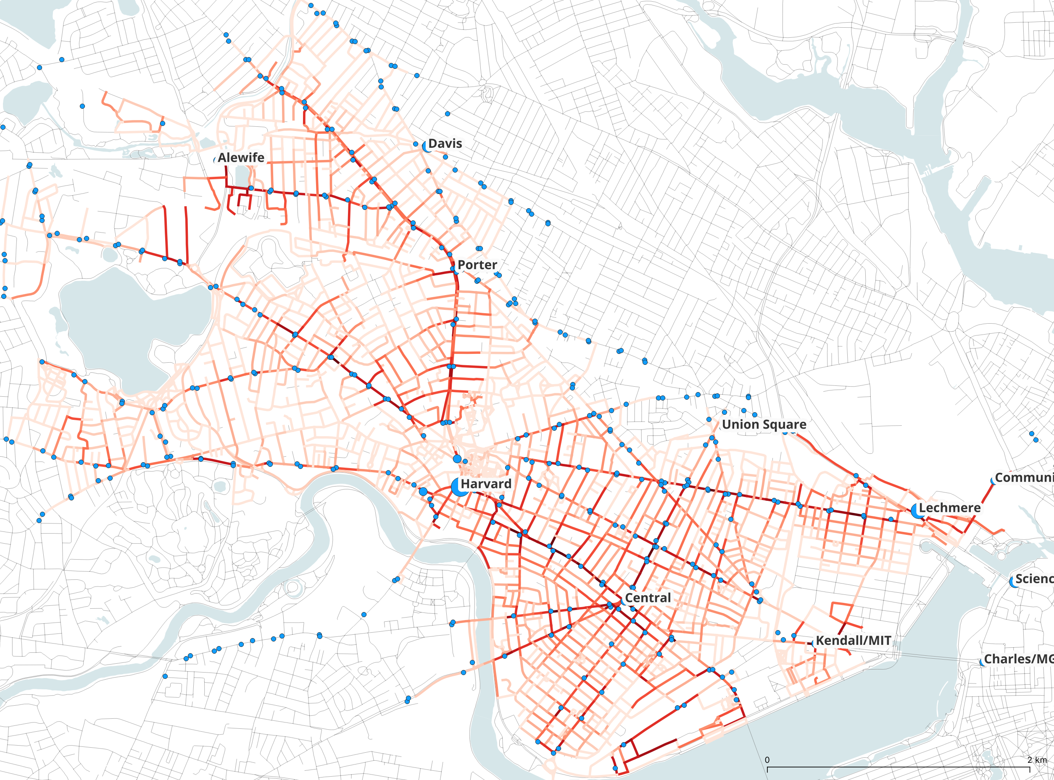
The batch’s composite_sum rendered in QGIS: homes-to-transit and schools-to-transit flows summed per edge across all of Cambridge. Because the destination set now includes all 434 bus and metro stops, flow covers nearly the whole street network instead of a handful of station catchments — while still concentrating along Massachusetts Avenue through Porter, Harvard, and Central, and on the approach streets to Kendall/MIT and Lechmere.

What we covered
From one trip on one shortest path to a city-scale model: shortest path (a), distance decay (b), origin weights (c), alternative paths (d), multiple destinations (e), Huff destination choice (f), elevation (g), turns (h), the aggregate-flow engine (i), many-to-many (j), and CSV-driven batching (k). The same parameters mean the same things at every scale — only run time and output size change.
Next: Tutorial 4 — Evaluating a design intervention — using flow to evaluate a concrete urban-design intervention. For the scalable engine behind the new default, see Aggregate flow (gradient-overlap method).

