Tutorial 5 — Facility allocation and patronage estimation in Cambridge
This tutorial examines the una.RunFacilityAllocation() engine — UNA's tool for choosing the best locations for new facilities among candidate sites, and for estimating the patronage that facilities (existing or proposed) draw from surrounding demand. It corresponds to what ArcGIS Network Analyst calls location-allocation, with UNA's problem types mapping to ESRI's Maximize Attendance (max_access), Maximize Coverage + Minimize Facilities (min_facilities), and, approximately, Maximize Market Share (max_patronage). All travel is computed over the pedestrian network, towards the facility, with the same impedance machinery as every other UNA engine.
Scenario. The City of Cambridge wants to open after-school community learning centers, hosted in existing school buildings. Three schools already run such programs — King Open School, Peabody Elementary School, and Cambridge Rindge & Latin — and the city asks: how well do these three serve residents today, where should additional centers go, how many would it take to serve everyone, and how many users can each location expect? Demand is the residential population of every building; the service cutoff is an 800 m walk.
Lineage. Users of the UNA Rhino toolbox will recognize this engine's ancestry: an evaluation run of max_access corresponds to the Rhino Closest Facility tool (each origin allocated once to its nearest facility; demand_served = Reach at the facility, access_captured = Gravity), and max_patronage descends from the Find Patronage tool's Huff model (Huff 1963; Sevtsuk & Kalvo 2017). One convention differs: the Rhino tool either split one inelastic trip per origin (Decay=Off) or decayed each destination's trips individually (Decay=On — preserved in the flow engines as flow_decay_method="destination_decay"); max_patronage instead uses the monotonic gravity-cap participation model, which a siting objective requires. New here is the optimization layer: choosing which facilities to open.
Data files (in docs/Boston/ in the UNA repository):
- Network: 20260703_PercLenNetwork_InnerCore.geojson — 69,957 pedestrian edges (as in Tutorials 2–4).
- Demand (origins): Cambridge_building_centroids_pop2020.geojson — 14,751 buildings; column pop2020 holds 118,705 residents in total (many non-residential buildings carry 0).
- Candidates (destinations): Cambridge_school_candidates.geojson — 60 school locations with columns name, employees (staff size), existing (1 for the three schools already operating a center, 0 otherwise), and attract (employees ÷ their mean — the normalized attractiveness used in step (h)).
Note. The candidates layer illustrates the general input convention: demand comes in as the origins layer, candidate facilities as the destinations layer, and already-operating facilities are marked by 1/TRUE/yes values in the column named by fa_existing_facilities_column. Existing facilities are always kept open — the optimizer sites new facilities around them.

(a) Baseline — how well do the three existing centers serve Cambridge?
With the default fa_new_facilities = 0, the engine performs an evaluation run: no siting, just the allocation of demand to the existing facilities as they stand. Access is measured with exponential distance decay (β = 0.002 — the decay factor falls to about 0.20 at the 800 m cutoff).
from urban_network_analysis import UNA
una = UNA()

una.settings.data_folder = r"...\docs\Boston"
una.settings.network_file = "20260703_PercLenNetwork_InnerCore.geojson"
una.settings.origins_file = "Cambridge_building_centroids_pop2020.geojson"
una.settings.origin_weight_column = "pop2020"
una.settings.destinations_file = "Cambridge_school_candidates.geojson"
una.settings.fa_existing_facilities_column = "existing"

una.settings.search_radius = 800 # service cutoff (meters)
una.settings.flow_decay = True
una.settings.flow_decay_curve = "exponential"
una.settings.gravity_beta = 0.002

# Both lines below are the defaults, written out for clarity:
una.settings.fa_problem_type = "max_access"
una.settings.fa_new_facilities = 0 # evaluation run - no new siting

una.RunFacilityAllocation()
Note. Because this run uses max_access, the facilities output reports decay-weighted access_captured — assuming that everyone visits their nearest available destination, how much demand would accrue to each destination facility, with the given distance decay applied. This is different from expected patronage estimated with the Huff probability model. Patronage estimation requires the max_patronage problem type and its trip-generation cap, introduced in steps (e)–(f), where this same baseline is re-evaluated in trip units.
The run writes three outputs: Results_facilities.* (all 60 candidates with selection columns), Results_facilities_selected.* (only the open facilities — drag this into QGIS to map the configuration), and Results_demand.* (every building with its assigned facility, network distance, access value, and covered flag), plus a Results_summary.json. The “demand_served” column in the Results_facilities.* file shows that only 24.6% of Cambridge residents (29,189 of 118,705 total in Cambridge) live within the 800 m cutoff of an existing center. The “avvess_captured” column in the Results_facilities.* file shows that of the 11,233 residents for whom the Cambridge Rindge & Latin School is the nearest existing facility, only 3,986 would be captured by that facility, with the difference lost due to the distance decay that lowers the likelihood of further residents to actually walk to the facility.
Note. The “Results” stem of these file names comes from una.settings.output_file_name (default “Results”). Setting a distinct name per run — e.g. “baseline”, “plus3” — keeps the outputs of this tutorial’s successive steps apart.

Existing center | demand_served (residents) | access_captured
Cambridge Rindge & Latin | 11,233 | 3,986
King Open School | 10,163 | 3,855
Peabody Elementary School | 7,793 | 2,725

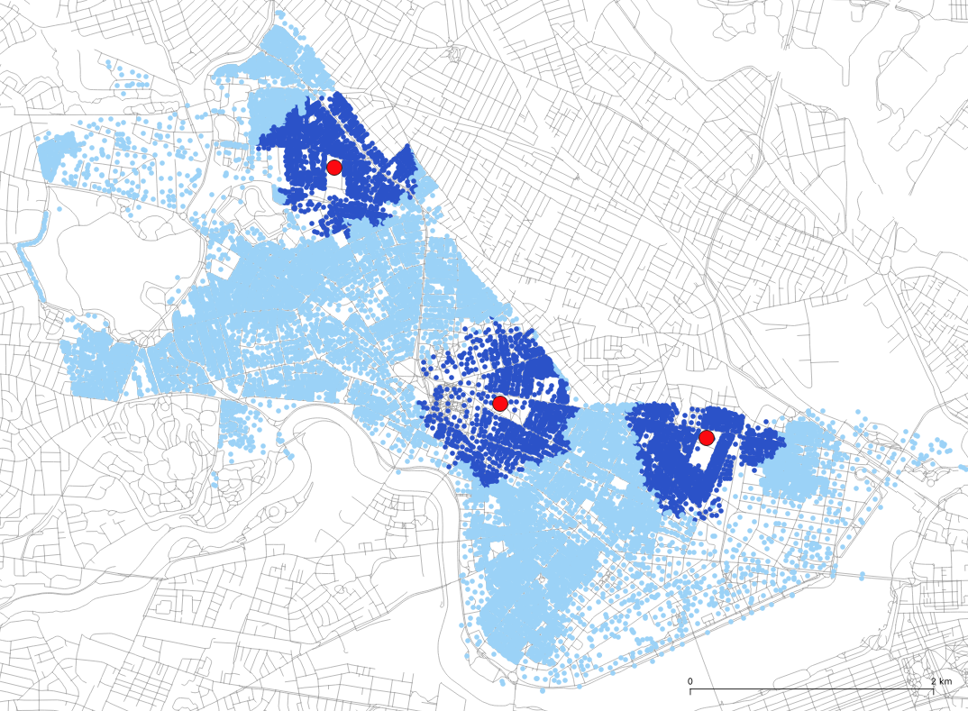
[MAP 1 — Demand layer colored by 'covered' with the three existing centers symbolized; uncovered areas visibly concentrated in East Cambridge, Cambridgeport, and North/West Cambridge]

(b) Site three new centers — max_access, greedy
If we wanted to site three additional centers, what would be the best locations for them so that residents' decay-weighted access to their nearest open center is maximized? Only two lines change:
una.settings.fa_problem_type = "max_access" # (default)
una.settings.fa_new_facilities = 3
una.RunFacilityAllocation()
The greedy solver adds facilities one at a time, each pick maximizing the marginal gain given everything already open: pick 1 = James F Farr Academy (East Cambridge), pick 2 = Graham & Parks Elementary (West Cambridge), pick 3 = Martin Luther King After School (Cambridgeport). The total access_captured rises from 10,566 to 24,442 (+131%) and demand_served from 24.6% to 53.4% of Cambridge residents. Note that even though the Martin Luther Kind and James F. Farr Academy 800m walksheds overlap due to the proximity of the two facilities, the max_access assigns every demand point to its closest facility, effectively shrinking the catchment areas to points that are truly nearest to them. The rank column records the pick order — and because greedy picks are nested, this single run also answers the p = 1 and p = 2 questions: the best single addition is Farr Academy alone, followed by Graham & Parks Elementary.

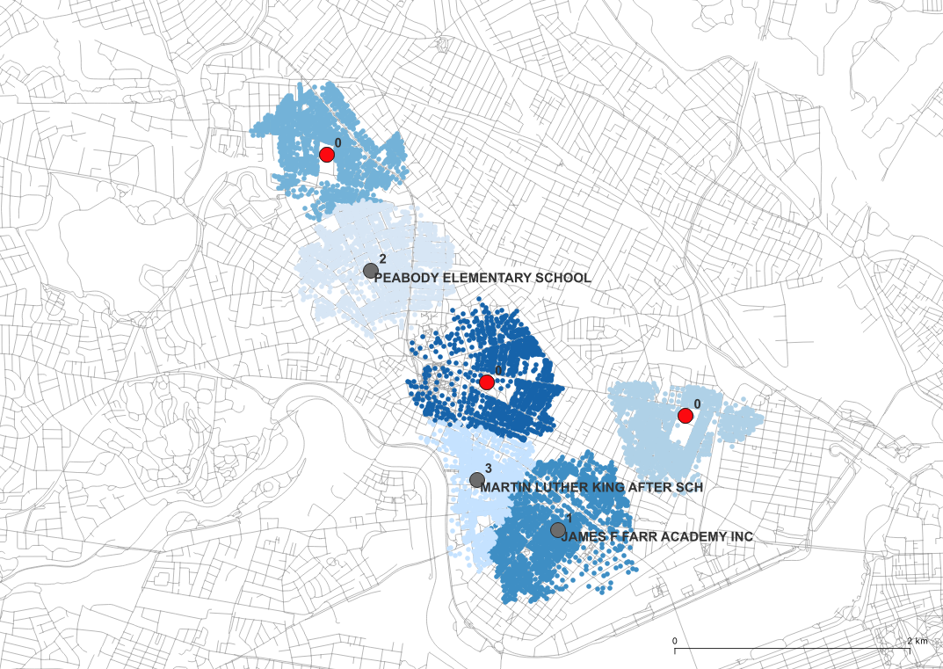
[MAP 2 — Selected facilities (rank labels 1–3) with existing centers in a second symbol; demand colored by assigned facility or by access value]

(c) Verify with the exact solver
una.settings.fa_solver = "exact"
una.RunFacilityAllocation()
The exact solver formulates the whole problem as a mixed-integer program (HiGHS via scipy) and proves its answer optimal. Here it returns the same objective, 24,442 — greedy was already optimal — but names two different facilities. Look closely: the schools layer contains co-located duplicate points (two Peabody entries, two Martin Luther King entries at the same addresses), so several distinct-looking facility sets are exactly equivalent. Multiple optima are common in siting problems; the objective value, not the name list, is what the two solvers agree on.
Note. How do Greedy and Exact solvers differ? Greedy opens the best facility first, locks it in, and repeats — fast at any scale, providing a near-optimal result with a proven worst-case bound, and its pick order is itself useful. The Exact solver weighs all combinations jointly and returns a provably best set, at a computational cost that grows steeply with problem size (with automatic fallback to greedy when the problem becomes too large). max_patronage (steps f–h) always uses greedy — its saturating objective does not fit the linear form the exact solver needs.

(d) How many centers are needed to serve everyone? — min_facilities
Now, let’s turn the question around: what is the smallest number of centers needed to cover every resident within a maximum allowable walk length? Coverage is a yes/no question, so distance decay is switched off; fa_new_facilities is ignored — we can not know in advance how many facilities to ask for, this number itself is the answer to this problem.
una.settings.fa_problem_type = "min_facilities"
una.settings.flow_decay = False
una.settings.fa_solver = "greedy" # then repeat with "exact"
una.RunFacilityAllocation()
Greedy needs 24 new centers (27 sites in total with the existing three) to cover 85.7% of residents — everyone who lives within 800 m of any school at all; the remaining 14.3% are unservable at this cutoff from any candidate—since the facility allocations are limited to only the candidate locations, there are no candidate location given here that can reach all residents in Cambridge at a max 800m walk. The engine reports this in a warning. The exact solver does one better: 23 new centers achieve the same complete coverage — an example of how the exact solver beats greedy, worth the extra compute when the recommendation is for a real decision.
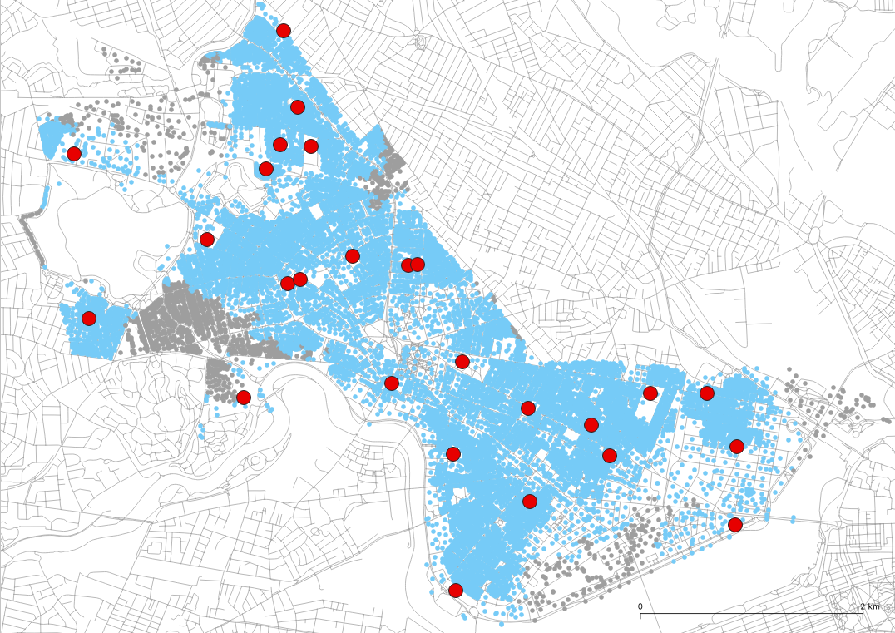
[MAP 3 — The 23-facility exact solution; unservable buildings in a muted color. Pls note in caption that the gray dots are unserved, blue dots are served, and red are all 23 exact facilities.]

(e) From access to patronage — the trip-generation model
Note. The two problem types also differ in HOW demand is allocated. In max_access, each building gives its entire demand (population here) to the single most accessible open center — effectively the nearest by network distance, since destination weights are ignored in that mode — and exactly zero to every other, even one that is just a few meters farther; a center that is second-nearest to everyone captures nothing. In max_patronage, demand from each building is split fractionally across all open centers in reach, by Huff shares proportional to destination attractiveness × distance decay — a larger center slightly farther away receives a larger share, and can even be a building's primary destination. Neither mode double-counts: the per-facility columns always partition the demand and facility allocations sum to the given demand totals. Choose by behavior: strictly-nearest services (elementary schools, polling places) fit max_access; destinations people split visits among, where size matters (libraries, retail, parks), fit max_patronage.
Access scores rank locations, but a planner budgeting staff wants expected users. UNA’s max_patronage problem type uses the same gravity-cap trip-generation model as the flow engines (Tutorial 3): each building generates trips in proportion to min(1, G/cap), where G is its total gravity to all open facilities — participation grows with accessibility until it saturates at the cap — and trips split among open facilities by Huff shares. This tutorial uses the simplest defensible cap: cap = 1. With unit attractiveness, a building’s gravity to a single center is just its decay value, which equals 1 only at distance zero — so cap = 1 says full participation requires standing at the facility’s door, and everyone else participates with probability equal to their decayed accessibility. (Calibrated studies replace 1 with an empirically derived cap — see the gravity-cap conventions in the flow documentation — but the cap must then be pinned across all compared scenarios, and the logic below is unchanged.)
One empirical remark grounds the door-logic here: across Cambridge, the largest baseline gravity to an existing center is 0.855 — no building stands at a center’s door, so at cap = 1 nobody participates fully in the baseline.

(f) Baseline patronage of the three existing centers
una.settings.fa_problem_type = "max_patronage"
una.settings.fa_new_facilities = 0 # evaluation run, examine only existing
una.settings.flow_gravity_cap = 1.0
una.settings.flow_decay = True
una.RunFacilityAllocation()
The three existing centers can expect roughly 10,566 user-trips in total — and that number should look familiar: it is exactly run (a)’s objective. With cap = 1 and non-overlapping catchments, each building’s participation factor is min(1, decay/1) = decay itself, so patronage reproduces access_captured from (a) exactly for each facility. The two problem types measure the same thing in this case — the comparison below is the proof, and the divergence begins only in step (g), when catchments start to overlap.
Existing center | demand_served | patronage (trips)
Cambridge Rindge & Latin | 11,233 | 3,986
King Open School | 10,163 | 3,855
Peabody Elementary School | 7,793 | 2,725

Note. Where does the decay act? Only once, in both modes. In max_access, an origin’s value is decay(d) for trips assigned strictly to their single nearest center (the “closest” convention). In max_patronage, the same decay terms are summed over ALL reachable centers and passed through min(1, G/cap); generated trips are then allocated in full — no second decay is applied. At cap = 1, a single reachable center gives factor = decay exactly, which is why (f) equals (a). The models part ways only where catchments overlap: an origin that can reach two centers sums both decays — something max_access never does, since it only looks at the nearest destination — so additional nearby capacity raises trip generation with max_patronage and generates genuinely new trips. Step (g) illustrates this.

(g) Add three centers under the patronage objective
una.settings.fa_new_facilities = 3
una.RunFacilityAllocation()
Total expected trips rise from 10,566 to 28,376 (+169%). Picks 1 and 2 are familiar from the access run (James F. Farr Academy, Martin Luther King School), but the third pick changes: instead of Graham & Parks in the west, the patronage objective chooses Violeta Montessori, close to already-served central neighborhoods. This demonstrates the doubling-up mechanism mentioned above: residents whom one center only half-activates are worth reinforcing — a second nearby center sums into their Gravity score and lifts their participation toward 1 — and that can beat reaching a whole new, but less accessible center (which is all that max_access solver values). Compare the two runs’ maps to see how the max_access and max_patronage logics disagree.
The outputs also quantify how the opening of new centers can reduce patronage at existing centers: King Open’s catchment pool shrinks from 10,163 to 7,184 residents (and Rindge’s from 11,233 to 9,297) as the new centers split their shares — visible directly by comparing demand_served between runs (f) and (g). Note their patronage does NOT fall: the pooled residents now participate more because their demand is elastic with respect to destination access—better access increases demand, offsetting the smaller shares.
[MAP 4 — max_access picks vs max_patronage picks side by side; highlight the Graham & Parks vs Violeta Montessori difference]

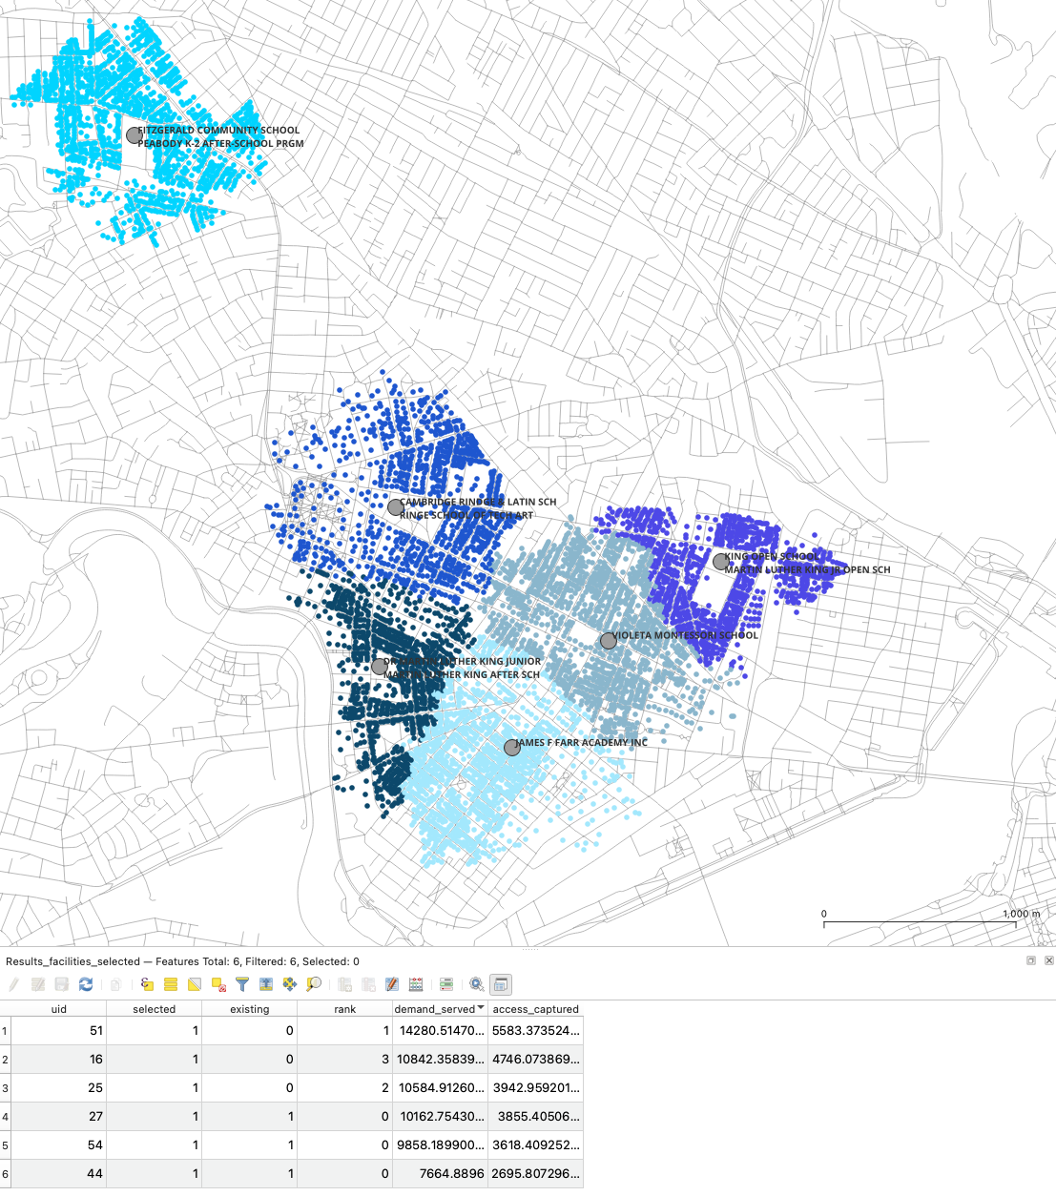
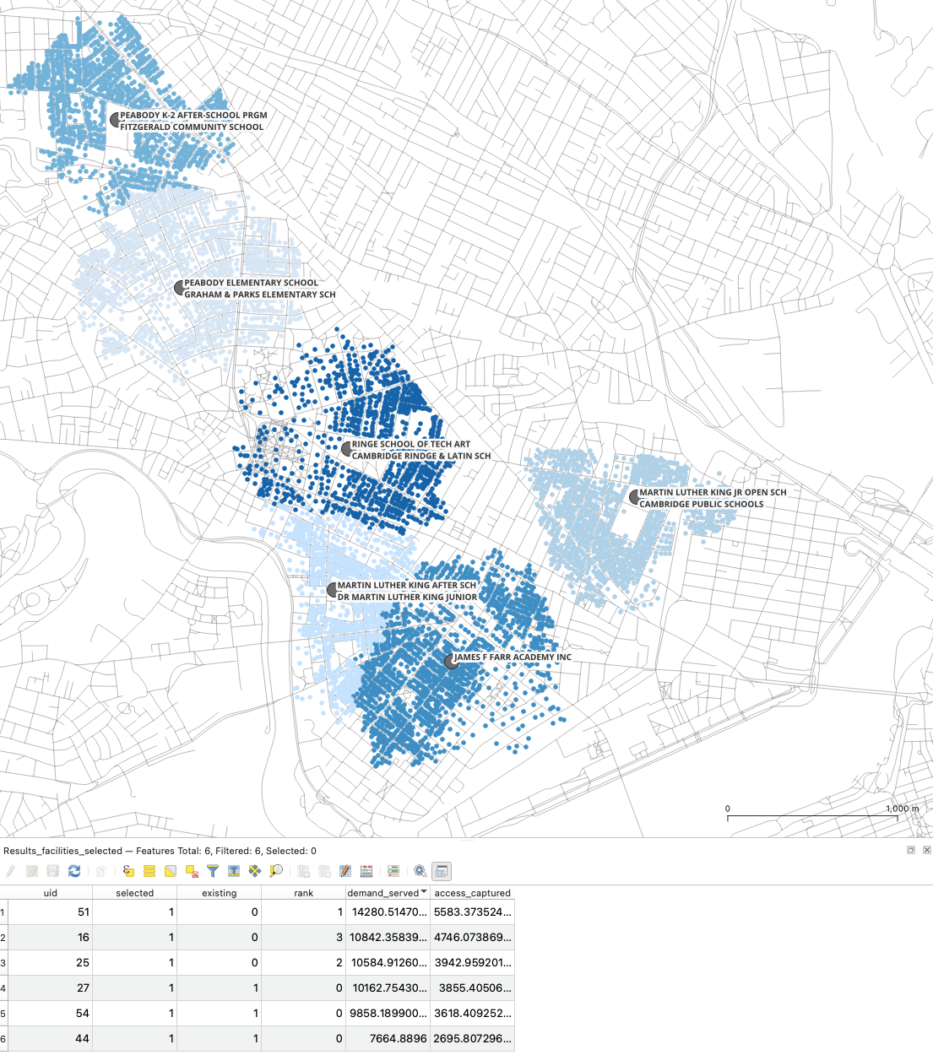

(h) Facility size as attractiveness
So far every candidate was equally attractive. In max_patronage, the destinations layer’s weight column can also supply facility attractiveness — the role destination weights play in the flow engines’ Huff destination choice model. But a caution first: the cap = 1 door-logic BREAKS if raw weights that vary by destination are used, because a building at a facility’s door then has gravity equal to the facility’s weight, not 1 — with staff counts in the hundreds, everyone near any school would saturate instantly and the model would degenerate to coverage. The fix is to normalize attractiveness to a mean of 1: the candidates layer’s attract column is employees ÷ 70.6 (the candidate mean), so Rindge & Latin carries 4.96, the largest school 14.2, and cap = 1 now reads “as well-served as standing at the door of an average-sized facility.” The same units discipline applies with calibrated caps: derive the cap under the same weighting you run with. (Note that an alternative approach would be to instead set the gravity_cap value to reflect the average staff count).
una.settings.destination_weight_column = "attract"
una.settings.flow_gravity_cap = 1.0 # unchanged
una.RunFacilityAllocation()
The picks change again — Graham & Parks, Prospect Hill Charter, Fletcher Maynard Academy — and total trips rise to 36,095, because large schools now activate their surroundings faster. The starkest line in the table is Rindge & Latin: at ≈5× average attractiveness it fully saturates its catchment — patronage 11,071 ≈ its entire demand pool (100%) is patronizing the destination. Size steers both which sites win and how trips split. Use this variant when you can defend the attractiveness values (floor area, program capacity), and compare totals with run (g) only loosely — the choice sets and weighting differ even though the normalization keeps the units aligned.

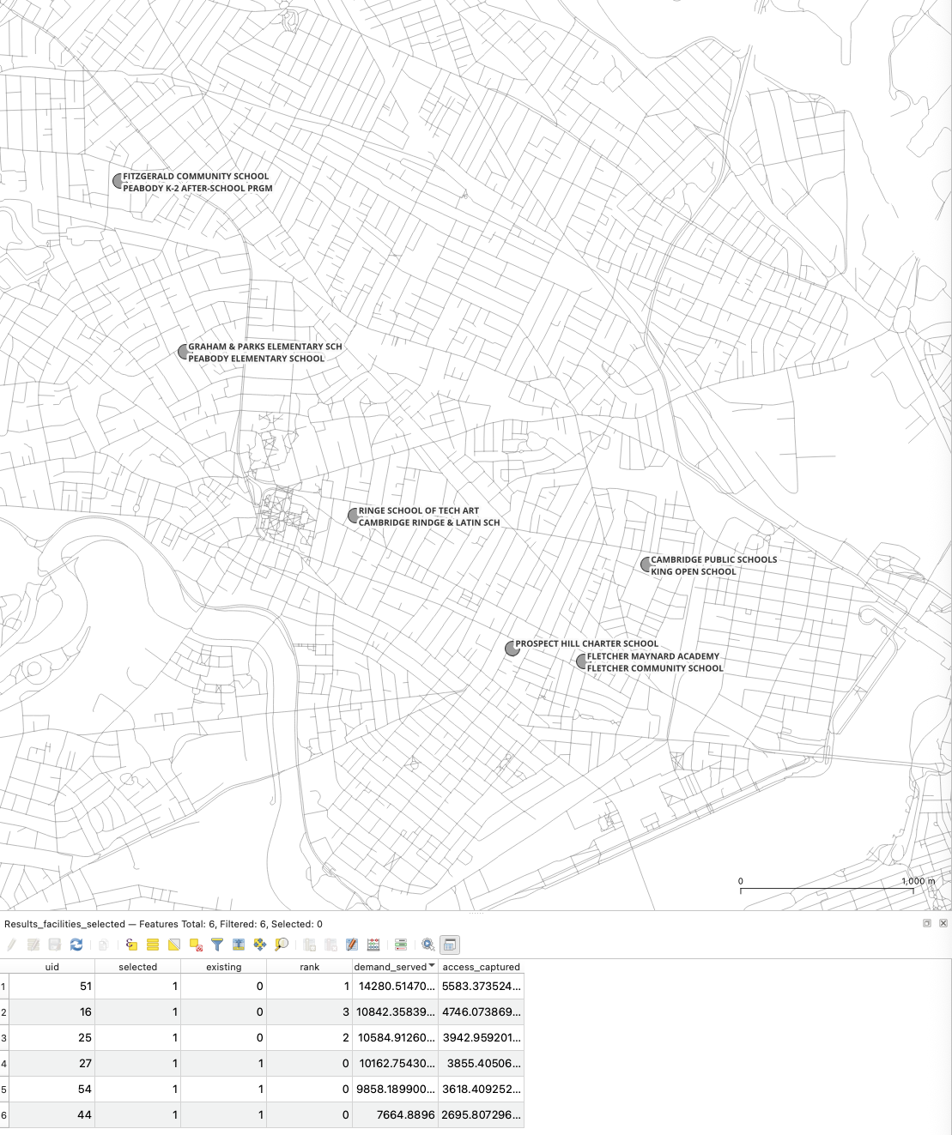

(i) From chosen sites to street-level flows
The selected facilities are just a destinations layer, so the chosen configuration can be fed straight into RunFlow() (Tutorial 3) to estimate which streets the walk-to-center trips will use — siting and footfall from one impedance model. We carry forward the configuration the tutorial ends on, run (h): its ..._facilities_selected.geojson output is directly usable as the flow run’s destinations. The consistency rule is to mirror the siting run’s full behavioral model — the same trip-generation method ("gravity_cap" after max_patronage; "closest" would follow a max_access siting), the same pinned cap, and the same destination weights feeding the Huff split:
una.settings.destinations_file = r"...\Results\...\Results_facilities_selected.geojson" # from run (h)
una.settings.flow_engine = "aggregate_flow"
una.settings.flow_decay_method = "gravity_cap" # matches (h)
una.settings.flow_gravity_cap = 1.0 # pinned, as in (h)
una.settings.destination_weight_column = "attract" # same attractiveness as (h)
una.RunFlow()
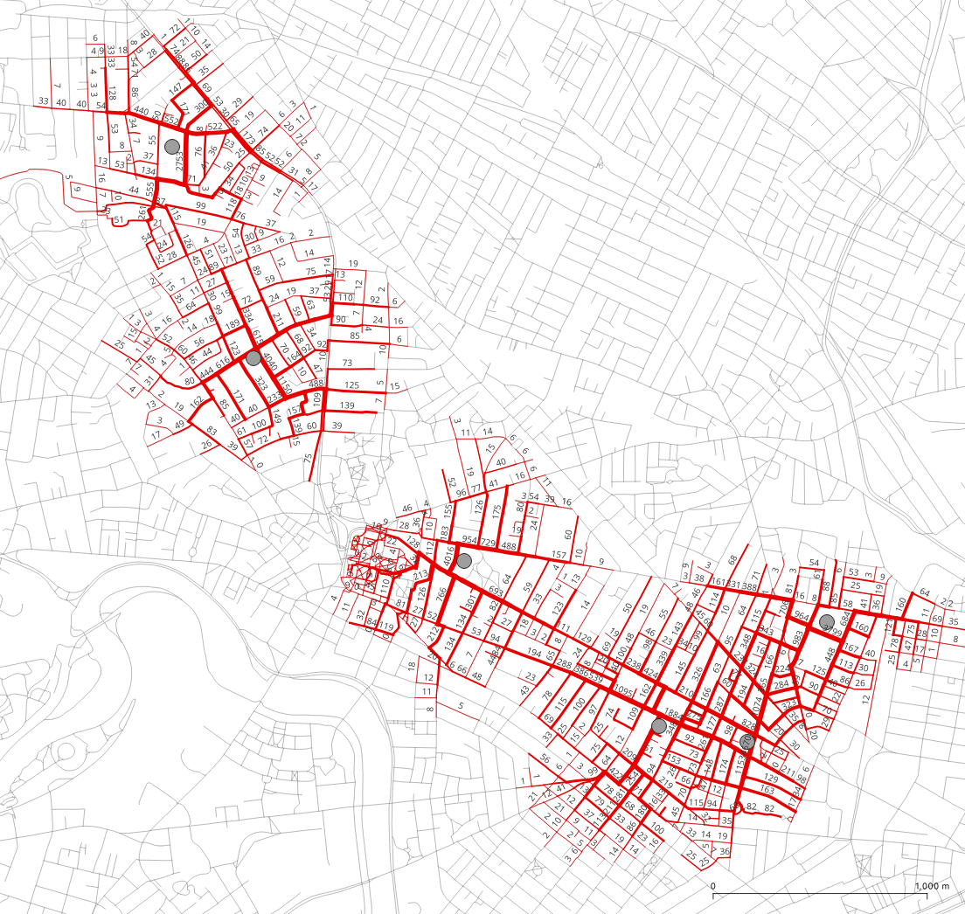
[MAP 5 — Aggregate pedestrian flows to run (h)’s six open centers, edge width by edge_flow; note the heavier approaches to the large (high-attract) schools]
The ready-to-edit file examples/UNA_FacilityAllocation.py wraps this whole two-part workflow (Part 1 siting, Part 2 flow) into a single script.

What we covered
The evaluation run (the default, fa_new_facilities = 0) measures how existing facilities serve demand; max_access sites new facilities to maximize decay-weighted proximity; min_facilities finds the smallest number and placement of facilities that covers all coverable demand; max_patronage maximizes expected trips under the gravity-cap participation model, with destination choice Huff splitting, overlap accounting, and optional facility attractiveness. Greedy solved gives fast, nested, near-optimal answers and a pick-order ranking; the exact solver gives precisely optimal results that are sound for decision-making (and found a smaller min_facilities answer here), but the optimal solver is computationally more costly on large datasets. Throughout, the Facility Allocation engine reused UNA conventions you already know: origins/destinations layers, search_radius as cutoff, distance decay from the flow engine, and outputs that join back onto your input layers — plus a selected-facilities layer that can be directly connected to flow analysis.
Exercises: (1) Re-run (b) with p = 5 — where do picks 4 and 5 go, and how much does each add? (2) Lower the cutoff to 600 m in (d): how many centers does full coverage now take? (3) In (g), replace β = 0.002 with the logistic curve — do the picks change? (4) Using runs (f) and (g), compute each existing center's activation rate before and after the additions.

