|  |
| --- |
|  |
| Proposed Fiber Expansions |
| City Of Macon |
|  |
| **Kerry Hatcher** |
| **11/12/2012** |

|  |
| --- |
|  |

Proposed Fiber Expansions

# Overview

Continued expansion of the City of Macon’s critical fiber infrastructure is absolutely necessary to support the needs of users and constituents. These proposed expansions would cover 78% of the Macon Police Department and 30.00% of the Macon-Bibb Fire Department.

This includes three separate projects, Northwest, Southwest, and Northeast. A summary and an interactive map is available at [fiber.macon.ga.us](http://fiber.macon.ga.us)

* Northwest
  + Four Fire Stations
  + One Police Precinct
* Southwest
  + One Fire Station
  + One Police Precinct
  + Crime Lab
  + Drug Unit
* Northeast
  + One Fire Station
  + One Police Precinct
  + Middle Georgia Regional Commission

In addition to these, there are schools and libraries along these routes that could make great use of low cost, high speed connectivity.

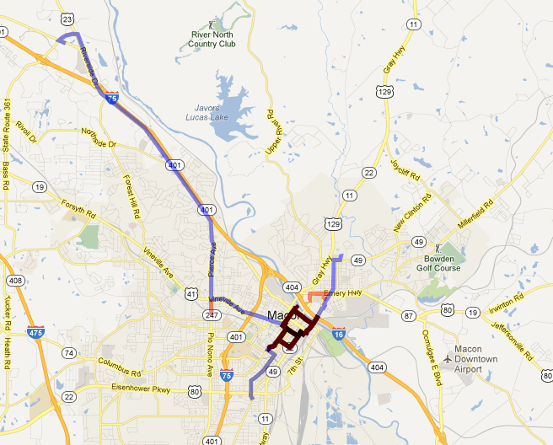These projects will allow the City to save money on connectivity costs from an internet service provider (ISP). A onetime investment will provide future expansion capability that would be much too costly to acquire from a provider.

All of the costs represented in this document are estimates based on $30,000 per mile. It is recommended that a fiber installer be consulted to get a more accurate cost analysis. That would include state highway right of way, pole attachments, pole to building, and ancillary costs that this does not address.

This report also does not include building equipment costs, strictly fiber.

# Northwest

The Northwest project is the most ambitious of the three projects. Included are two different options. Option A is a direct run, however it is only slightly less costly than Option B and connects less than half of the buildings.

## Option A

This option runs directly up riverside drive to the new fire station under construction near the Shoppes at River Crossing. Along the route is one other fire station.

Estimated length of run is approximately 10 miles, at a rough estimate of $300,000.00

### Buildings

#### Fire Station 11

#### Fire Station 109

## Option B

This option runs north from City Hall up Hardeman and turns down Pierce to Riverside, and then follows the same path as previous option. A small spur connects Precinct 3 and Fire Station 6

Estimated length of run is approximately 10.5 miles, at a rough estimate of $315,000.00

### Buildings

#### Precinct 3

#### Fire Station 2

#### Fire Station 6

#### Fire Station 11

#### Fire Station 109

# Southwest

This run would start (terminate) at the Fire Administration Building located at 1191 First St. Then it would run aerial via poles to Hazel and turn south down 2nd St all the way to the Crime Lab located at the intersection of 2nd and Houston Ave (2654 Houston Avenue).

Estimated length of run is approximately 2 miles, at a rough estimate of $60,000.

## Buildings

### Precinct 2

2654 Houston Avenue

### Fire Station 5

2285 Second Street

# Northeast

This run would make use of preexisting fiber that was run across the river to the Centraplex a few years ago. It would terminate at the end of that fiber. Then it would cut across the neighborhood to the east of Coliseum Drive along Church St, connecting to Fort Hill St. and then on the shopping center on the other side of Shurling Dr. A spur would then connect MGRC and Fire Station 1.

Estimated length of run is approximately 2.5 Miles, at a rough estimate of $75,000.

## Buildings

### Fire Station 1

195 Coliseum Drive

### Precinct 1

660 Shurling Drive