Scorecard for Urban Building Energy Modeling (UBEM) by Archetypes
City |  | Singapore |  |  | Climatic zone |  |  | A
Archetype |  | 21_Restaurant |  |  | Type |  |  | Others
Built year |  | All |  |  | Support |  |  | -
Data Sources |  | This scorecard is based on 3 sources: (1) BCA Green Mark for Restaurants; (2) Shoebox template model inputs / outputs; and (3) Detailed zoned template model inputs / outputs.
Purpose and Usage |  | The scorecards provide standardized references of building energy performance by archetype for modeling, analysis, and reporting. The data may be used unaltered for research or publication, provided the original source is credited.
 | Data |  | Symbol | Unit |  | Actual |  | Shoebox Model | Zoned Model
Geometry | Levels |  | L | - |  | - |  | - | 1
 | Underground levels |  | L_under | - |  | - |  | - | -
 | Floor-to-floor height |  | H_ff | m |  | - |  | - | 4
 | Height |  | H | m |  | - |  | - | 4
 | Footprint area |  | A_fp | m² |  | - |  | - | 349.78
 | Gross floor area |  | GFA | m² |  | - |  | - | 349.78
 | Main Zone / Function |  | GFA | m² |  | Eating/drinking area
 | Actual Images |  |  | Shoebox Template |  |  | Detailed Zoned Template
 | 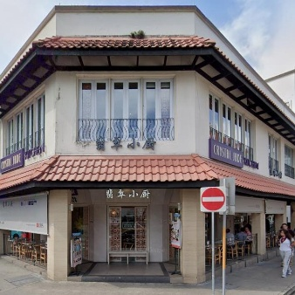 |  |  | 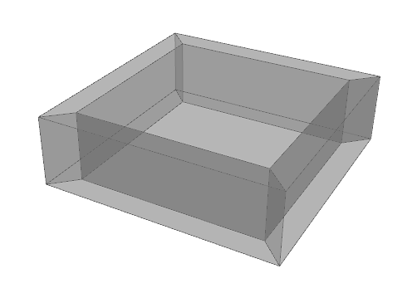  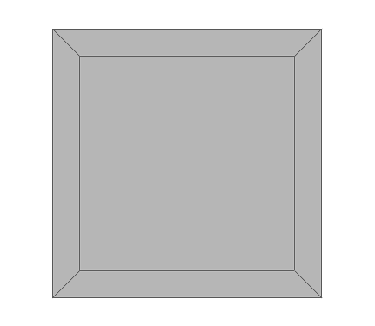 |  |  | 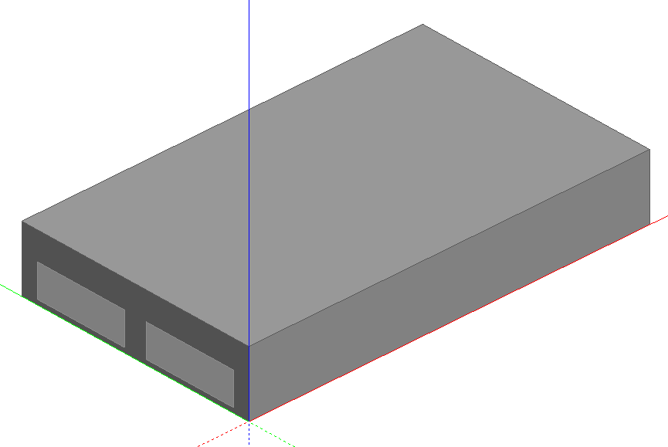  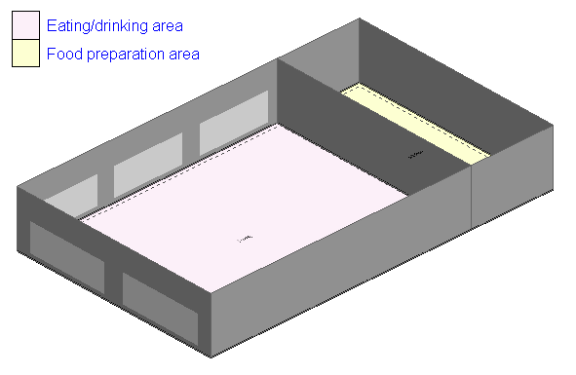

Operational Carbon Modeling
 | Data |  | Symbol | Unit | Actual | Shoebox Model | Zoned Model
Envelope | Window to wall ratio |  | WWR | % | - | 40 | 16.52
 | Window to wall ratio - north |  | WWR_n | % | - | - | 29.81
 | Window to wall ratio - south |  | WWR_s | % | - | - | 0.00
 | Window to wall ratio - east |  | WWR_e | % | - | - | 0.00
 | Window to wall ratio - west |  | WWR_w | % | - | - | 38.44
 | Shading type |  | - | - | - | - | Slatted blinds
 | Roof thickness |  | t_roof | m | - | 0.2-0.25 | 0.323
 | Roof U-Value |  | U_roof | W/(m²·K) | - | 0.5 | 0.346
 | Roof Thermal Capacitance |  | C_roof | kJ/K/m²· | - | 215.04-268.8 | -
 | Façade thickness |  | t_wall | m | - | 0.125 | 0.2922
 | Façade U-Value |  | U_wall | W/(m²·K) | - | 2.424-3.808 | 0.351
 | Façade Thermal Capacitance |  | C_wall | kJ/K/m²· | - | 134.4 | 134.8
 | Partition thickness |  | t_part | m | - | 0.1-0.2 | 0.15
 | Partition U-Value |  | U_part | W/(m²·K) | - | 0.8-1.6 | 1.639
 | Partition Thermal Capacitance |  | C_part | kJ/K/m²· | - | 73.6-147.2 | -
 | Slab thickness |  | t_slab | m | - | 0.2-0.25 | 0.2
 | Slab U-Value |  | U_slab | W/(m²·K) | - | 1.212-2.38 | 2.422
 | Slab Thermal Capacitance |  | C_slab | kJ/K/m²· | - | 215.04-268.8 | 176.4
 | External Floor thickness |  | t_floor | m | - | 0.2-0.25 | 0.1739
 | External Floor U-Value |  | U_floor | W/(m²·K) | - | 1.212-2.38 | 0.275
 | External Floor Thermal Capacitance |  | C_floor | kJ/K/m²· | - | 358.4-560 | -
 | Ground Slab thickness |  | t_gslab | m | - | 0.2-0.25 | -
 | Ground Slab U-Value |  | U_gslab | W/(m²·K) | - | 5.768-7.21 | -
 | Ground Slab Thermal Capacitance |  | C_gslab | kJ/K/m²· | - | 358.4-560 | -
 | Ground Wall thickness |  | t_gwall | m | - | 0.125 | -
 | Ground Wall U-Value |  | U_gwall | W/(m²·K) | - | 11.536 | -
 | Ground Wall Thermal Capacitance |  | C_gwall | kJ/K/m²· | - | 224-280 | -
 | Air Changes per Hour |  | ACH | h-1 | - | 10 | -
0Building Program | Occupancy density |  | O_c | person/m² | - | 0.6667 | 0.05-0.2
 | Metabolic Rate |  | Met | Met | - | 1.3197034 | 0.9
 | Clothing |  | Clo | Clo | - | 0.57 | 0.5
 | Latent fraction |  | f_l | - | - | 0.3 | -
 | Lighting power density |  | LPD | W/m² | - | 10 | 5
 | Illuminance target |  | E_t | Lux | - | 500.0 | 500
 | Radiant fraction for lighting |  | f_l,r | - | - | 0.2 | -
 | Visible fraction for lighting |  | f_l,v | - | - | 0.7 | -
 | Equipment power density |  | EPD | W/m² | - | 154 | 0-10 (by zones)
 | Radiant fraction for equipment |  | f_e,r | - | - | 0.5 | -
 | Peak equipment power density |  | EPD_peak | W/m² | - | - | -
 | Hot water coefficient of performance |  | COP_water | - | - | 3.2 | 3.2
 | Hot water flow intensity |  | HWFI | m³ / (s·m²) | - | - | -
 | Inlet Water Temperature |  | T_inlet | ℃ | - | 28 | 28
 | Water Supply Temperature |  | T_supply | ℃ | - | 60 | 60
 | Water Flow Rate Per Person |  | V_p,water | m³/h/person | - | 0.0007274 | -
HVAC | Air-Conditioned Floor Area |  | GFA_ac | m² | - | - | 349.78
 | Air-Conditioned Floor Area Percentage |  | GFA_acp | % | - | - | 100
 | Cooling Setpoint |  | T_cool | ℃ | - | 22 | 26
 | HVAC system type |  | - | - | - | DOAS + Chilled Water FCU | VAV, water-cooled Chiller, Air-side HR, Outdoor air reset
 | Coefficient of Performance |  | COP | - | - | 4.0 | 5
 | Chilled Water System Efficiency |  | η_CW | kW/RT | - | - | -
 | Air-side Efficiency |  | η_air | kW/RT | - | - | -
 | Min Fresh Air Person |  | V_p,min | L/s/person | - | 5.1 | -
 | Min Fresh Air Area |  | V_a,min | L/s/m² | - | 3.4 | -
 | Relative humidity setpoint |  | RH_set | % | - | 40 | 40
 | Dehumidification setpoint |  | RH_dehum | % | - | 70 | 70
 | DHW system type |  | - | - | - | - | Instantaneous hot water only
Generation | Total electric generation |  | E_gen | kWh | - | - | -
 | Roof photovoltaic electricity generation |  | E_gen | kWh | - | - | -
 | Roof photovoltaic area |  | A_pv | m² | - | - | -
 | Roof photovoltaic installed capacity |  | P_inst | kW | - | - | -
Energy use | Energy use intensity |  | EUI | kWh/m²/y | 330 | 327.25 | 397.06
 | Gas use intensity |  | GUI | kWh/m²/y | - | -
 | Cooling energy use |  | E_cool | % | - | 75.96 | 70.49
 | Lighting energy use |  | E_light | % | - | 8.45 | 13.56
 | Equipment energy use |  | E_equip | % | - | 7.04 | 3.10
 | Hot water energy use |  | E_water | % | - | 11.40 | 13.44
Bold |  | Data with detailed charts provided below

Geometry Figures
Gross floor area | Air-Conditioned Floor Area Percentage
N/A | N/A
HVAC Figures
HVAC system type | Chilled Water System/Air-side Efficiency
N/A | N/A
Energy Figures
Energy use intensity | Breakdown energy use
N/A | 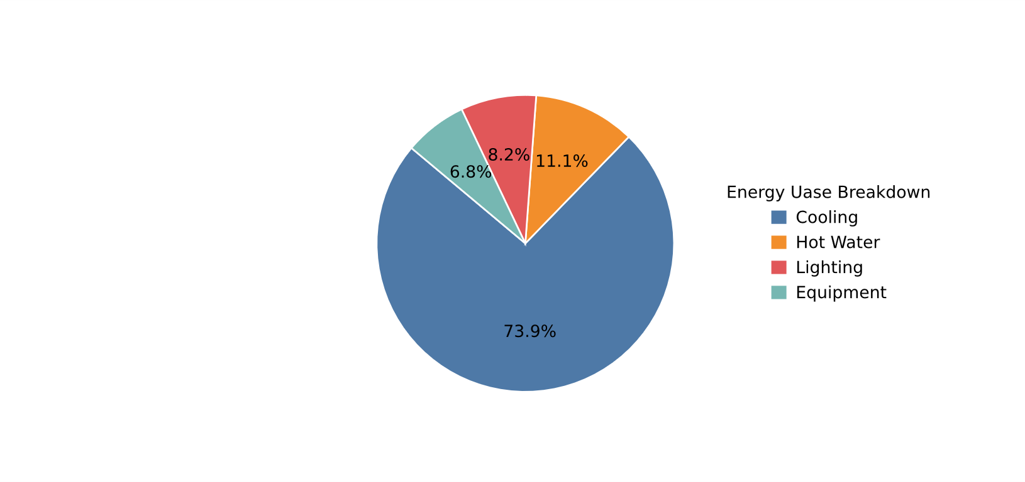

Embodied Carbon Modeling
 | Data | Symbol | Unit | Baseline | Asia Only | PAMC
General | EC Intensity | EC | kg CO2e/m²·year | - | - | -
 | Fitted Distribution | - | - | - | - | -
 | Distribution Parameters | - | - | - | - | -
Material  Intensity | Material Intensity Concrete | MI_concrete | kg/m² | - | - | -
 | Material Intensity Steel | MI_steel | kg/m² | - | - | -
 | Material Intensity Glass | MI_glass | kg/m² | - | - | -
 | Material Intensity Aluminium | MI_al | kg/m² | - | - | -
 | Material Intensity Bricks | MI_brick | kg/m² | - | - | -
Weighting  Factor | Weighting Factor Concrete | WF_concrete | kg CO2e/kg | - | - | -
 | Weighting Factor Steel | WF_steel | kg CO2e/kg | - | - | -
 | Weighting Factor Glass | WF_glass | kg CO2e/kg | - | - | -
 | Weighting Factor Aluminium | WF_al | kg CO2e/kg | - | - | -
 | Weighting Factor Bricks | WF_brick | kg CO2e/kg | - | - | -
Onsite | Onsite emissions | E_site | kg CO2e/m² | - | - | -

Material Intensity & Weighting Factor
Baseline / Asia Only Scenario | PAMC Scenario
N/A | N/A
Embodied Carbon MCS Results
N/A

