**Assignment Front Cover Sheet**

**TITLE PAGE**

**Programme of Study: Foundation Degree in Applied Computing**

**ASSIGNMENT**

**NAME OF STUDENT: Mark Hiscock YEAR OF STUDY 2**

**College Email Address:**

**Unit code: LP20552A1 Unit Title Mobile Technologies**

**Unit Tutor Danielle Vass danielle.vass@bathcollege.ac.uk**

**ASSIGNMENT TITLE:**

**LP20539A1: App Development**

**WORD COUNT: 1595 DATE SUBMITTED: 03.11.2015**

**(May not exceed +/- 10% of limit) (Late submissions may be penalised)**

**CHEATING AND PLAGIARISM DECLARATION**

**I confirm the following**

*I have read and understood the following sources that explain cheating and plagiarism;*

*the University of Bath website at* <http://www.bath.ac.uk/library/help/infoguides/plagiarism.html>

*and my programme handbook*

*To the best of my knowledge, my work does not contain plagiarised material.*

**SIGNATURE: mhiscock**

Ensure that you have completed your work as specified by the deadline date and time (**Thursdays 4pm**)

You must submit one electronic copy of your work to the relevant location as detailed in the assignment brief and/or the Regulations for Submitting Assignments document.

You must keep a copy (electronic and paper) of this assignment for your own records.

|  |  |  |  |  |  |  |
| --- | --- | --- | --- | --- | --- | --- |
| bath college MONO copy | | Assessment feedback form Students must attach this form and the assessment brief to work submitted for assessment | | | | UoB_logo-blu-xs |
| Hand out date: | | *(as per assessment plan)* | Hand in date: | | | *(as per assessment plan)* |
| Assessor: | | Danielle Vass | Date received: | | |  |
| Assessor’s comments Task 1: Presentation about the past, present and future of mobile apps (20%)  Task 2: Mobile app (70%  Task 3: Demonstrate of the app (10%) | | | | | | |
| Percentage mark awarded |  | | | Contribution to Unit Marks | | 60% |
| Unit Outcomes | * Analyse and recommend an appropriate mobile solution for the workplace. * Demonstrate an understanding of a variety of mobile technologies (e.g. Mobile-device based languages, operating systems, internet browsers and environments). * Produce a mobile application for a given specification. * Research current developments in emerging mobile device techniques. | | | | | |
| Assessor’s signature |  | | | | Date |  |
| Moderator’s signature |  | | | | Date |  |

# Aims

This assignment aims to provide evidence for the learning outcomes of the unit. (See above).

It will demonstrate your ability to do the following:

* Use GUI design and visual programming skills in a given language.
* Show good problem solving skills, Time management and Planning and prioritisation of tasks.
* Prepare high quality reports and documentation to support applications.
* Present information appropriately.
* Perform user demonstrations and prepare questionnaires to aid critical evaluation of products.

# Scenario

You are tasked by a specialist subject teacher to create a **questionnaire Android app**.

The app will test how much information students already know using short questions. For example, a geography teacher might want to establish if students know flags, or capital cities for countries in the World. Students will be given a final score which can be used by the teacher to evaluate their prior knowledge.

You must also come up with at least one additional feature of your own choice e.g. more questions, or question topics.

To achieve the highest marks possible your app should also connect to an API online to retrieve questions. The method of which must be discussed prior to the app submission.

Finally, you must demonstrate a good HCI and incorporate some Material Design aspects into your app.

Your app is required to run on Android 5.0 (SDK 21) and above. It is not necessary to have a real Android device yourself, as Android Studio will provide an emulator to use.

Tasks

1. Create a presentation (with detailed notes) about past, present and future developments in mobile technologies. You are not going to do present this task, it will be submitted electronically. So the presentation should be written to be meaningful to the assessor. The presentation should be approximately 15 minutes of material.
2. A working mobile application that meets the brief, plus fully commented code. (60%)
3. A demonstration of the app 1-1 where students defend their work

# SubMISSION

You should submit via a GitHub repository:

* Folder with all source code for your Android app
* Folder for presentation in a .ptx format (not .pptx)

# Grading Criteria

|  |  |  |  |
| --- | --- | --- | --- |
| **Element** | **Wt.** | **Criteria** | **Mark** |
| Task 1: Presentation about the past, present and future of mobile apps | 20% | Standard of English | 0 – 5 |
| Multiple Operating Systems mentioned (Android, iOS, Blackberry, Windows Mobile) | 0 – 8 |
| Future tech | 0 – 7 |
| Task 2: Mobile app | 70% | Profile or About Interface | 0-5 |
| Introduction Interface | 0-5 |
| Questions Interface | 0-10 |
| High Scores Interface | 0-10 |
| Persistant Storage of High Scores | 0-5 |
| Questions retrieved from Internet API | 0-15 |
| Bonus feature of your choice | 0-15 |
| HCI and material design | 0-5 |
| Task 3: Demonstrate of the app | 10% | Defence and justification of how app works | 0-10 |

Mobile Technologies

The Past, Present, and Future

**Mark Hiscock**

**Computing Student : City of Bath College (FdSc Year 2)**

# Table of Contents

[Abstract 2](#_Toc436667389)

[Introduction 2](#_Toc436667390)

[Smartphone Features Evolution 2](#_Toc436667391)

[Mobile Operating Systems 3](#_Toc436667392)

[Android 4](#_Toc436667393)

[IOS 4](#_Toc436667394)

[Windows Phone 4](#_Toc436667395)

[BlackBerry 4](#_Toc436667396)

[The Future 5](#_Toc436667397)

[Conclusion 6](#_Toc436667398)

[References 7](#_Toc436667399)

[Appendix A - Android Versions 9](#_Toc436667400)

[Appendix B – Presentation Slides 10](#_Toc436667401)

# Abstract

This presentation style report discusses the past, present, and future of mobile technologies. Early mobile devices evolved to become smartphones with a rich set of features. This report discusses market share of today’s smartphone operating systems including Android, IOS, Windows, and BlackBerry. Future tech such as virtual reality and augmented reality is also discussed, concluding that mobile devices will continue to play an ever-increasing role within our everyday lives. (The accompanying slides to the presentation can be seen in Appendix B – Presentation Slides)

# Introduction

The first mobile phone call was made on April 3rd 1973 and approximately ten years later the first commercial mobile phone was made available for sale in the USA. However, these early devices were large and expensive when compared to the devices of today. Mobile phones did not become prevalent with consumers until the 1990’s, when advances in technology enabled the phones to be smaller in size and therefore more portable. In addition, the phones became more affordable to the general population (Goodwin, 2015).

In the preceding years, mobile phones evolved rapidly in terms of both technological capabilities and usage. With advances in computing, devices became more powerful and third-party developers were able to build a wide variety of applications for these devices which later became known as ‘smart phones’. In 2014, estimates showed that there were actually more mobile devices in the world than people (The Independent, 2014).

In addition, a new type of portable computing device became available known as a tablet, which is typically flat and bigger than a mobile phone, and somewhat bridged the gap between smart phones and laptop PCs. One of the first and most successful tablet devices was the iPad, which was released by Apple in early 2010 (Eaton, 2010).

# Smartphone Features Evolution

Mobile technologies revolutionised the way users interacted with devices, typically with a touchscreen control system, virtual keyboard and a rich GUI (Graphical User Interface). Features such as a camera and microphone have become standard with ever increasing quality over time.

Other standard features include Bluetooth and connectivity to the internet via 3G/4G mobile broadband or WIFI, which enables users to browse the internet, send and receive emails, and store files in the cloud. Some devices support tethering which allows other devices to connect to them, allowing the host device to act as a WIFI router. An accelerometer is also common with mobile devices, which enables developers to detect and measures movement. Voice recognition software is also improving allowing users to give instructions to their devices verbally rather than the more traditional input methods. This is particularly useful in terms of accessibility.

In addition, GPS (Global Positioning System) can detect the longitude and latitude coordinates of devices (Garmin, n.d.), allowing applications and services to be localised. The combination of these mobile features and capabilities enabled developers to build new and interesting types of applications that were not possible before.

For instance, during the recent terror attacks in Paris, Facebook used GPS technology which automatically detected users who were currently in the city, and enabled them to notify other Facebook users that they were safe and well (Time, 2015).

# Mobile Operating Systems

Early smartphone operating systems included Windows Mobile, BlackBerry, and Symbian. However, the usage of these has greatly diminished today.

|  |  |  |  |  |  |
| --- | --- | --- | --- | --- | --- |
| **Period** | **Android** | **iOS** | **Windows Phone** | **BlackBerry OS** | **Others** |
| 2015Q2 | 82.8% | 13.9% | 2.6% | 0.3% | 0.4% |
| 2014Q2 | 84.8% | 11.6% | 2.5% | 0.5% | 0.7% |
| 2013Q2 | 79.8% | 12.9% | 3.4% | 2.8% | 1.2% |
| 2012Q2 | 69.3% | 16.6% | 3.1% | 4.9% | 6.1% |

Figure - Global Market Share (IDC, 2015)

Four different operating systems (Android, IOS, Windows Phone and BlackBerry) have dominated the global market is recent years, with Android currently being the most widely used. Windows Phone and BlackBerry have a small market share when compare with Android and IOS (Figure 1)..

|  |  |  |  |  |  |
| --- | --- | --- | --- | --- | --- |
| **Region** | **Android** | **iOS** | **Windows Phone** | **BlackBerry OS** | **Others / Unknown** |
| Africa | 57.7% | 4.7% | 2.1% | 5.5% | 40.0% |
| Asia | 67.7% | 11.5% | 1.7% | 1.0% | 18.1% |
| Europe | 63.8% | 28.4% | 4.0% | 1.7% | 2.1% |
| North America | 50.9% | 45.6% | 1.8% | 0.7% | 0.1% |

Figure - Market Share by Region as of June 2015 (Areppim, 2015)

However, there are cultural differences as IOS tends to have a greater market share in the developed world regions of North America and Europe (Figure 2). These differences could be attributed to the greater affordability of the more expensive models within wealthier nations.

## Android

Android is developed by Google and the source code is open source. This helps to reduce the cost to users, and allows phone manufacturers to freely modify the code to suit their requirements. Different versions of Android are codenamed after desserts and sweats, with the first public release being named Cupcake in 2009 (Ducrohet, 2009). There is an active community of application developers consisting of both enthusiasts and professionals. The Android SDK (Standard Development Kit) is made available to developers on desktop platforms such as Windows, Mac OS, and Linux, free of charge.

The current version of Android is Marshmallow. One of the main features Google has introduced is a memory manager as performance was one of the areas that faced criticism in previous versions, in particular on lower-end models (Williams, 2015). As always with mobile devices battery life is crucial, and therefore by improving efficiency will enable the devices to run for longer periods without needing to be recharged. In addition, Marshmallow supports fingerprint authentication (For a full list of Android versions please see ‘Appendix A – Android Versions’).

## IOS

The first iPhone was released by Apple in 2007 and used the Mac based operating system OSX. The iPhone was able to connect to the internet using WIFI and had full integration with iTunes (music and video). In addition, there was revolutionary user interface and a multi-touch feature was introduced, which enabled users to zoom in and out by using a pinching like movement with their fingers (Honan, 2007).

The latest Apple operation system is IOS 9, which includes the ‘Apple Pay’ feature. This enables users to easily pay for items and services utilising contactless technology and fingerprint recognition software (Apple, 2015)

One of the more notable Apple releases was IOS 7 in 2013. The user interface was redesigned to move away from a skeuomorphism philosophy which tries to mimic real life objects. A flatter and minimalistic design was implemented with the intention of increasing usability (Marshall, 2013).

## Windows Phone

Microsoft has a surprisingly small percentage of users in the mobile operating system market when compared with their dominance in the PC market. The latest operating is Windows 10, with the aim of creating greater unification with Xbox services and non-mobile versions of the operating system.

One of the main criticisms of Windows phones is the lack of available applications available for download by users when compared to IOS or Android. However, this may be a ‘chicken-and-egg’ situation, as developers are reluctant to build Windows phone applications due to the comparatively low user base.

## BlackBerry

BlackBerry was an early pioneer of the smart phone industry. Aimed primarily at the business market, BlackBerry devices came with a keyboard, and enabled users to easily send and receive emails (Hill, 2013).

However, with the release of the iPhone and Android, BlackBerry failed to adapt to a rapidly changing market and as a result has rapidly declined in usage over recent years.

# The Future

With further advances in technology, mobile devices will have greater CPU and GPU capabilities. Devices such as the Oculus Rift could enable virtual reality (VR) to be available to the mass consumer market in the near future. Users will be able to wear a headset to play games, watch immersive VR movies, or virtually visit famous destinations around the world (Oculus Rift, 2015). In addition, this could change the face of gaming over the upcoming years by immersing players in virtual worlds, increasing realism and increasing user experience to new levels.

Augmented Reality (AR) is when computer graphics are superimposed on top of real world objects and scenes. This could have many potential benefits and may see considerable growth within the IT industry. For example, an empty room could be filled with computer generated furniture to allow users to see how the room would look, depending on what and where they could potentially furnish or decorate the room with. AR could also have more serious benefits such as helping to train military personnel or determining the visual impact on the environment due to a proposed development or construction project.

As technology allows mobile devices to become smaller and more efficient, wearable tech devices such as the Apple Watch could become more prevalent in the future. In addition, such devices could be synced with smartphones to improve health by helping to monitor blood pressure, heartrate or sugar levels for diabetics (Levy, 2014).

# Conclusion

Developments in mobile technologies have advanced beyond all recognition from the early devices of the 1990’s. Mobile phones have become mobile personal computers with ever increasing capabilities in terms of CPU, GPU and storage, enabling users to perform a wide variety of tasks as standard.

The use of mobile technologies is becoming increasingly integrated into everyday life and society, and many users have already become dependent on these so called smartphones to perform many of their everyday activities. Acting as a virtual personal assistant in both professional and personal capacities, mobile technologies have almost become a necessity within the developed world, as consumers are increasingly demanding constant information from anywhere.

Mobile devices will continue to push boundaries in the future with manufacturers providing the means for third-party developers to produce increasingly creative and ingenious applications, utilising the technology in order to increase the usefulness and capabilities of mobile technologies even further.

# References

Android, 2015. *The Android Story.* [Online]   
Available at: https://www.android.com/history/  
[Accessed 11 11 2015].

Anon., 2015. [Online]   
Available at: http://socialcompare.com/en/comparison/android-versions-comparison  
[Accessed 28 11 2015].

Apple, 2015. [Online]   
Available at: http://www.apple.com/uk/apple-pay/  
[Accessed 21 11 2015].

Areppim, 2015. *Mobile OS (Operating System) Percent Market Share.* [Online]   
Available at: http://stats.areppim.com/stats/stats\_mobiosxtime.htm  
[Accessed 2015 11 13].

BlackBerry, 2015. *BlackBerry Smartphones.* [Online]   
Available at: http://uk.blackberry.com/smartphones.html  
[Accessed 11 11 2015].

Ducrohet, 2009. *Android 1.5 is here!.* [Online]   
Available at: http://android-developers.blogspot.co.uk/2009/04/android-15-is-here.html  
[Accessed 14 11 2015].

Eaton, 2010. *The iPad/tablet PC market defined?.* [Online]   
Available at: http://blog.seattlepi.com/microsoft/2010/03/22/the-ipad-tablet-pc-market-defined/  
[Accessed 13 11 2015].

Garmin, n.d. *What is GPS?.* [Online]   
Available at: http://www8.garmin.com/aboutGPS/  
[Accessed 14 11 2015].

Goodwin, 2015. *The History of Mobile Phones From 1973 To 2008: The Handsets That Made It ALL Happen.* [Online]   
Available at: http://www.knowyourmobile.com/nokia/nokia-3310/19848/history-mobile-phones-1973-2008-handsets-made-it-all-happen  
[Accessed 19 11 2015].

Hill, 2013. *The 11 moments that defined BlackBerry's rise and fall.* [Online]   
Available at: http://www.techradar.com/news/phone-and-communications/mobile-phones/the-10-moments-that-defined-blackberry-s-rise-and-fall-1175428  
[Accessed 21 11 2015].

Honan, 2007. *Apple unveils iPhone.* [Online]   
Available at: http://www.macworld.com/article/1054769/iphone.html  
[Accessed 11 11 2015].

IDC, 2015. *Smartphone OS Market Share, 2015 Q2.* [Online]   
Available at: http://www.idc.com/prodserv/smartphone-os-market-share.jsp  
[Accessed 21 11 2015].

Levy, 2014. *High-Tech Devices Help Patients Manage Diabetes, High Blood Pressure.* [Online]   
Available at: http://www.healthline.com/health-news/mobile-health-apps-for-diabetes-072914  
[Accessed 11 11 2015].

Marshall, 2013. *iOS 7 vs iOS 6: how different are they?.* [Online]   
Available at: http://www.techradar.com/news/phone-and-communications/mobile-phones/ios-7-vs-ios-6-what-s-different--1179663  
[Accessed 2015 11 11].

Microsoft, 2015. *The smartphone, reinvented.* [Online]   
Available at: https://www.microsoft.com/en-gb/windows/phones  
[Accessed 11 11 2015].

Oculus Rift, 2015. *Next-generation virtual reality.* [Online]   
Available at: https://www.oculus.com/en-us/rift/  
[Accessed 11 11 2015].

The Independent, 2014. *There are officially more mobile devices than people in the world.* [Online]   
Available at: http://www.independent.co.uk/life-style/gadgets-and-tech/news/there-are-officially-more-mobile-devices-than-people-in-the-world-9780518.html  
[Accessed 13 11 2015].

Time, 2015. *This Facebook Feature Kept People Connected During the Paris Attacks.* [Online]   
Available at: http://time.com/4112882/facebook-safety-check-paris/  
[Accessed 21 11 2015].

Williams, 2015. *Android 6.0 Marshmallow features: What's new?.* [Online]   
Available at: Android 6.0 Marshmallow features: What's new?  
[Accessed 11 11 2015].

# Appendix A - Android Versions

|  |  |  |  |  |
| --- | --- | --- | --- | --- |
| **Codename** | **Release Date** | **Version** | **API** | **Features** |
| Apple Pie | Sep 2008 | 1.0 | 1 | Web browser, Camera. Google Contacts, Google Mail. |
| - | Feb 2009 | 1.1 | 2 | Ability to save MMS attachments. |
| Cupcake | Apr 2009 | 1.5 | 3 | Bluetooth, Soft keyboard with text prediction. |
| Donut | Sep 2009 | 1.6 | 4 | Gesture framework |
| Éclair | Oct 2009 | 2.0, 2.1 | 5,6,7 | Bluetooth 2.1, digital zoom, MS Exchange support. |
| Froyo | May 2010 | 2.2 | 8 | Speed improvements, USB tethering. |
| Gingerbread | Dec 2010 | 2.3 | 9,10 | Updated UI, Social networking features, VoIP, Video call support. |
| Honeycomb | Feb 2011 | 3.0, 3.1, 3.2 | 11, 12, 13 | Mice, gamepads, joystick support. UI improvements, Multi-core support. Tablet support. |
| Ice Cream Sandwich | Oct 2010 | 4.0 | 14, 15 | New lock screen actions, Better voice recognition, Improved text input and spell-checking. |
| Jelly Bean | Jul 2012 | 4.1, 4.2, 4.3 | 16, 17. 18 | Accessibility gesture mode, 360 degree images with photo sphere. 4K resolution support. |
| KitKat | Oct 2013 | 4.4 | 19, 20 | Screen recording, Translucent UI. |
| Lollipop | Nov 2014 | 5.0, 5.1 | 21, 22 | Multiple SIM card support, Lock protect, HD voice call. |
| Marshmallow | Oct 2015 | 6.0 | 23 | Fingerprint authentication, Longer battery life, MIDI support. |

(Android, 2015), (Social Compare, 2015)

# Appendix B – Presentation Slides

## Slide 1

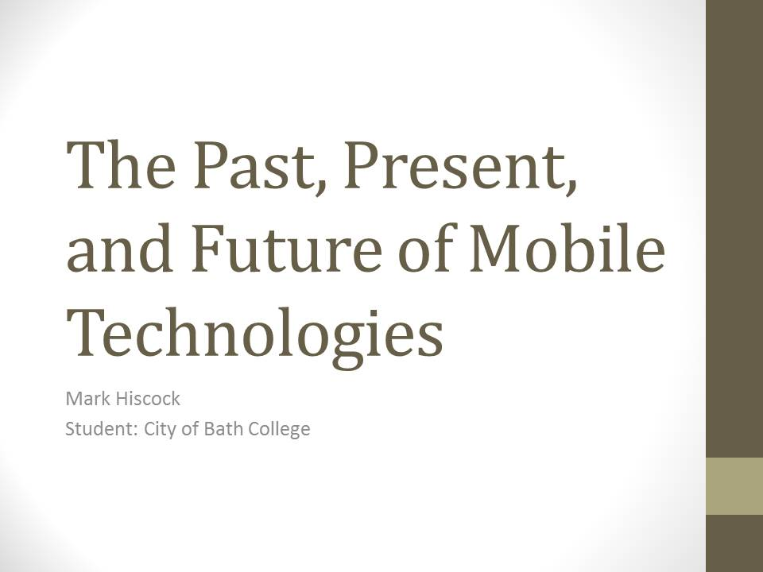

## Slide 2

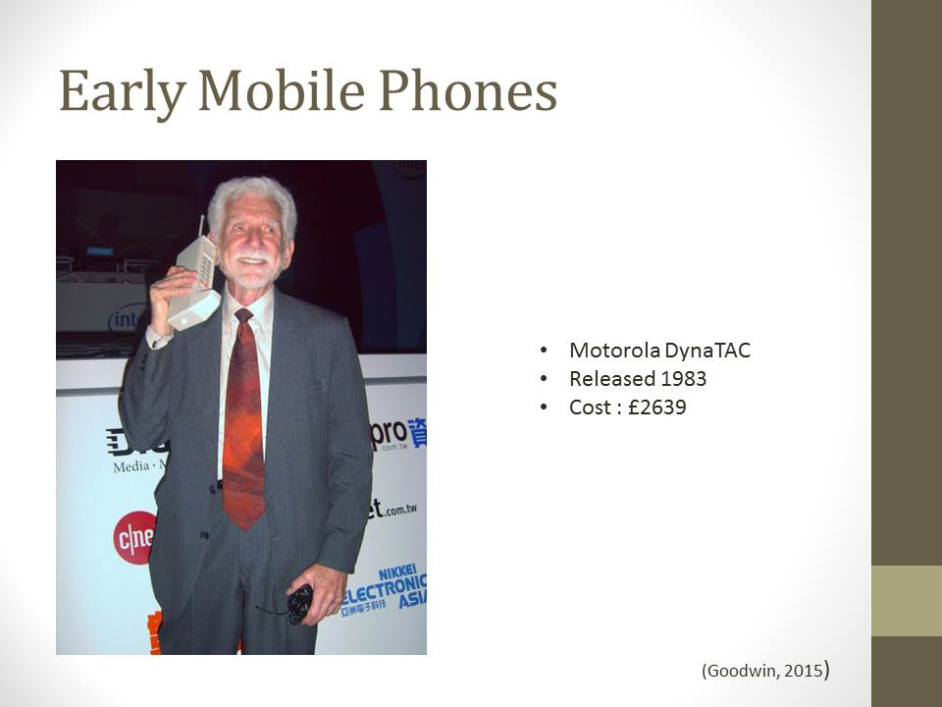

## Slide 3

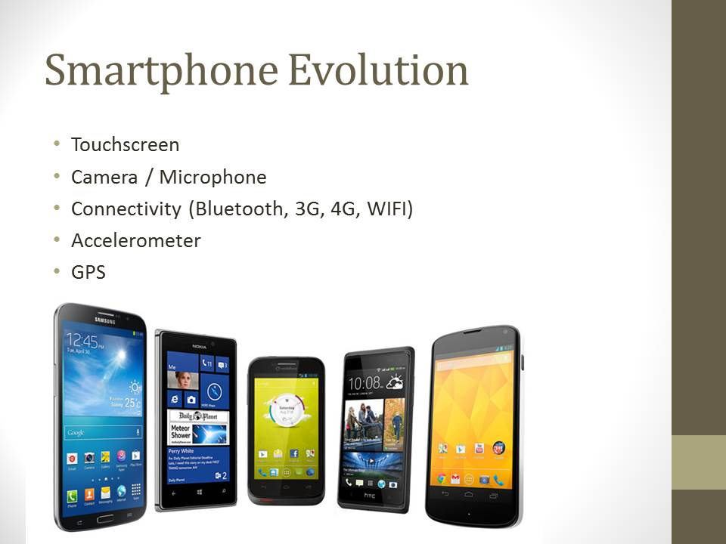

## Slide 4

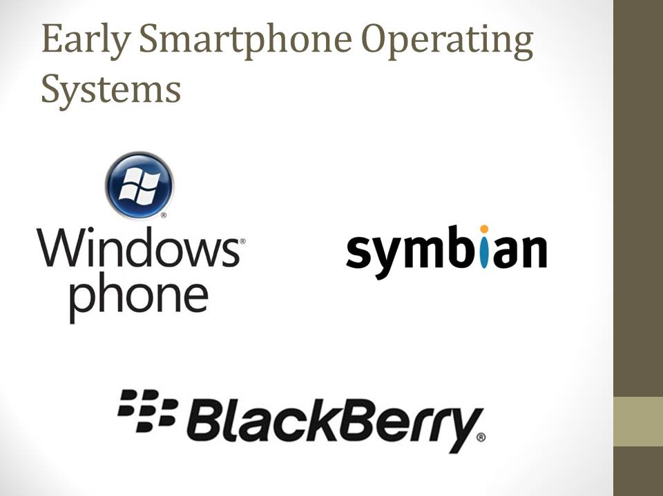

## Slide 5

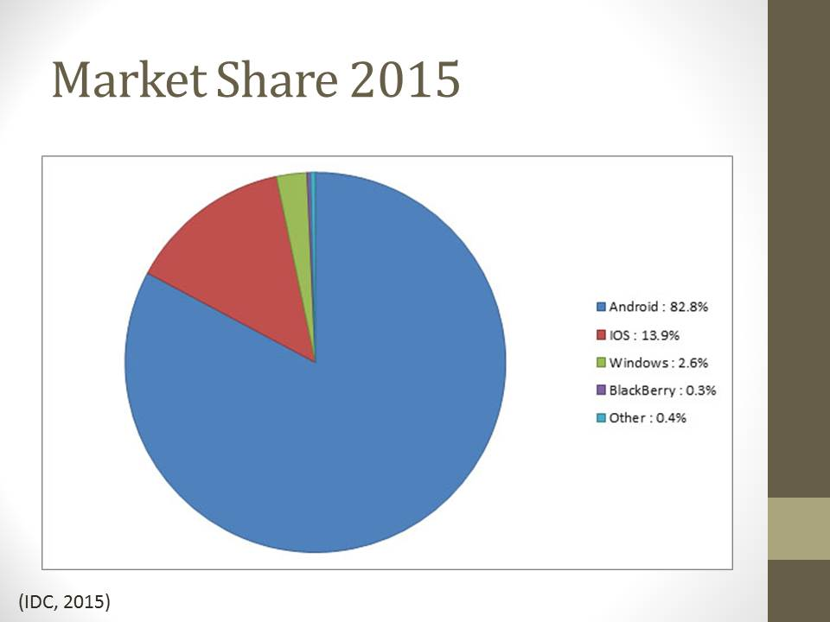

## Slide 6

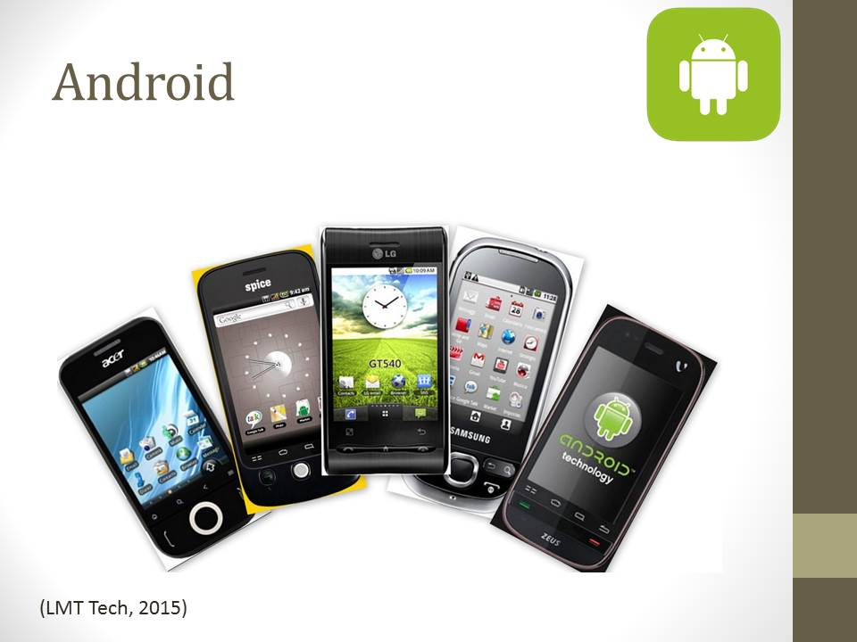

## Slide 7

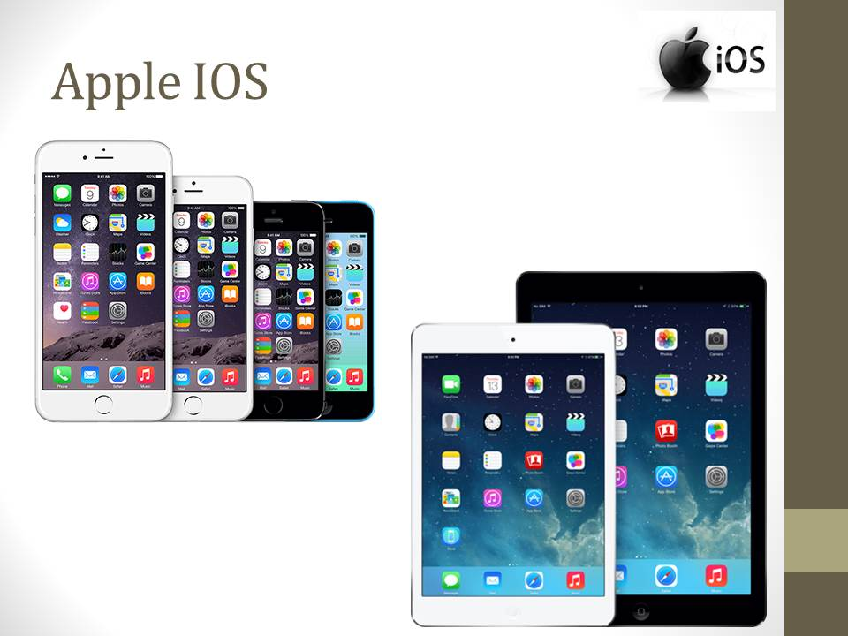

## Slide 8

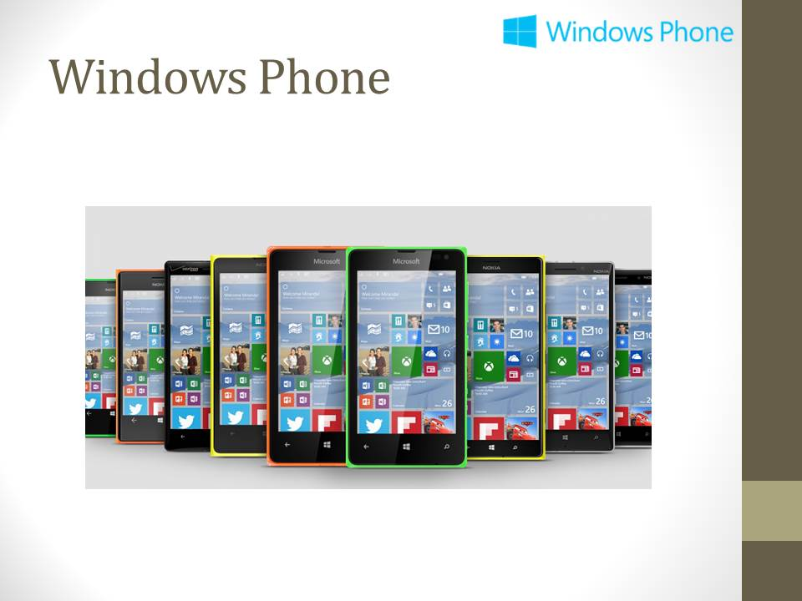

## Slide 9

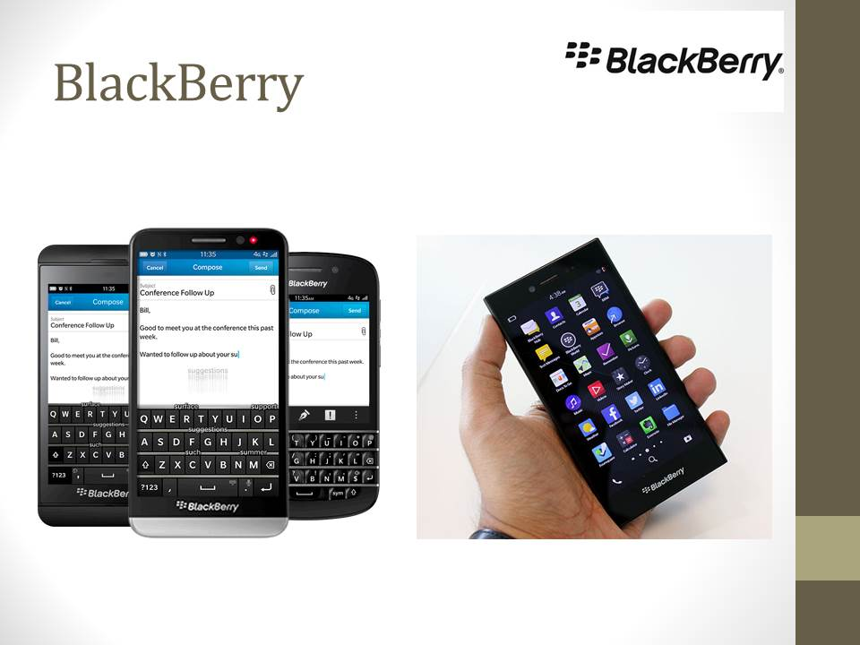

## Slide 10

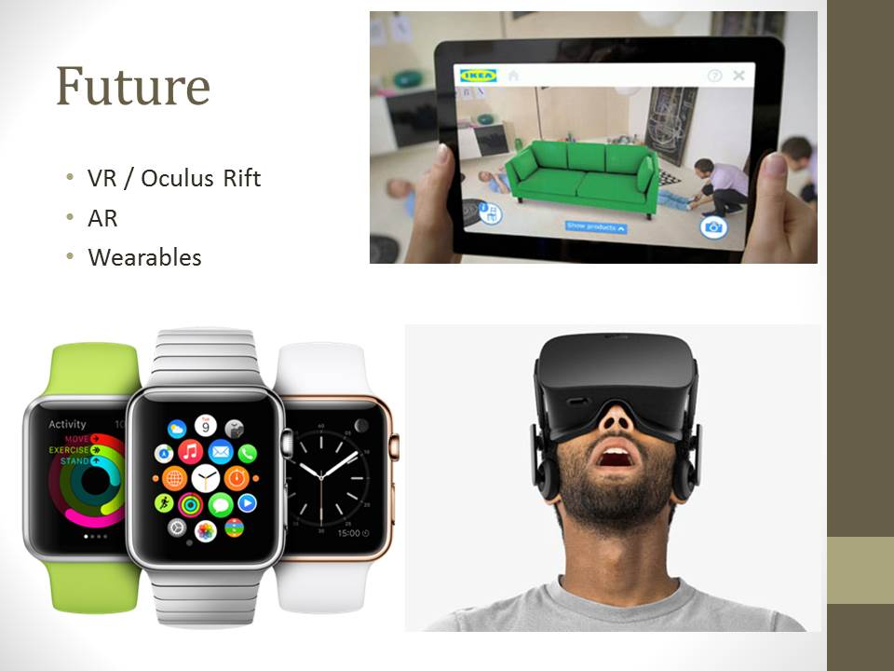

## Slide 11

