Takoma Park Police Arrest Data Analysis

August 13, 2021

Table of Contents

# Introduction

Between 2015 and 2020, the City of Takoma Park’s Police Department had 1,911 recorded encounters in which officers arrested someone or issued them a criminal citation.

The data here includes two types of arrests made by Takoma Park Police officers. The criminal and traffic offenses that lead to the arrests are varied. The data includes criminal citations and arrests, and traffic stops leading to an arrest.

The Police Department prepared these datasets by reviewing all reports involving arrests from 2015 to 2020, as well as judicial records associated with these arrests.

The Police Department also participates in the Uniform Crime Reporting Program–a [national program maintained by the FBI](https://www.fbi.gov/services/cjis/ucr) to collect standardized data from local police departments around the country–and has reported UCR data in its annual reports through 2020.

Comparing UCR data and the dataset prepared by the Police Department shows some differences. This is because of:

1. *Differences in what types of arrests are reported as part of the UCR.* For instance, warrant-service arrests for cities other than Takoma Park and traffic arrests (other than DUIs) are not reported to the UCR but included in this dataset.
2. *Changes in how the Department reported data as part of the UCR program.* Prior to 2018, the Department did not report civil citations as part of the UCR.

This data is organized into three sections:

1. *An overall analysis, of data on criminal and traffic arrests*
2. *A race-disaggregated analysis of criminal and traffic arrests*
3. *A race-disaggregated analysis of criminal and traffic arrests of Takoma Park residents.* This includes population data from the Census’s 2015-2019 American Community Survey.

Key findings include:

***Overall:***

1. **Total arrests have declined significantly since 2015**, both traffic and criminal.
2. **Residents of Takoma Park represent 18.8% of criminal arrests and 8.4% of traffic arrests.** All but 7.8% of other arrests were of residents of Prince George’s County, Montgomery County other than Takoma Park, and DC.
3. **Among Takoma Park residents, 55% of police arrests were of Ward 5 and 6 residents.**
4. **Based on officer coding of how arrests were initiated, 66.8% of criminal arrests were public initiated and 63.9% of traffic arrests officer-initiated.** The share of officer-initiated criminal arrests has declined since 2015.
5. **By specific type, the most common arrests were full-custody arrests, representing 39.8% of criminal arrests and 68.3% of traffic arrests.** Warrant-service arrests were second most common, followed by criminal citations.
6. **Criminal-arrest offenses were fairly evenly distributed**, with the most common for warrant service at 21.9% and disorderly conduct offenses at 10.1%. **40.6% of traffic arrests were for DUI offenses and 22.6% for warrant-service**, with the rest more evenly distributed.

***By race:***

1. **Black people represented 52.7% of all arrests, and Hispanic people 33.6%, compared to 13.3% of white people.**
2. **Arrest of all races have declined over time, although relative differences by race in arrest rates remain.**
3. **Differences in arrest rates by race are largely unchanged for Takoma Park residents, and relative differences by race in arrest rates remain.**

# Overall analysis

## Overall

Criminal arrests represent the greatest share of arrests at 78.2%, followed by traffic stop arrests at 21.8%.

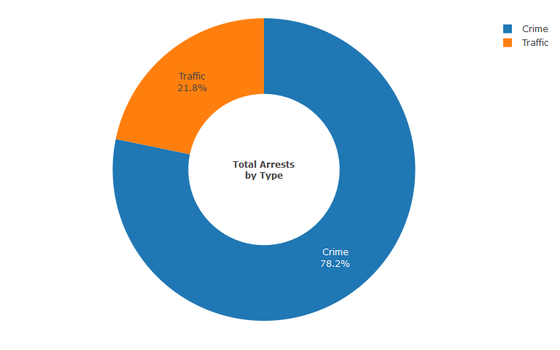

Total arrests of all types have declined since 2015. Criminal arrests declined the most in absolute terms, from 328 in 2015 to 161 in 2020.

The Police Department has provided the following possible reasons for potential decreases in arrests, over the last three years:

1. **Refocus on criminal enforcement** - in 2018 the department moved away from focusing on low level, non-public safety of life offenses. We focused our criminal enforcement to address serious and quality of life crimes; burglaries, robberies, auto thefts, theft from autos, domestic violence etc. We utilized real time crime intel to place officers in problem areas to address crime trends and criminal activity. This led to targeted criminal enforcement that helped address problem areas in the city. While the number of overall arrests made were reduced the quality and impact of the arrests improved. Crime data from 2015-2020 shows an overall 14% decrease UCR part 1 in crime in the city.
2. **Revamping of the Evaluation and Reward System** - in 2018 we changed our evaluation system to focus on community engagement and problem solving over criminal and traffic enforcement. This led to officers not feeling pressured to make low level non-public safety related arrests. This was consistent with promoting quality targeted enforcement, not quantity enforcement.

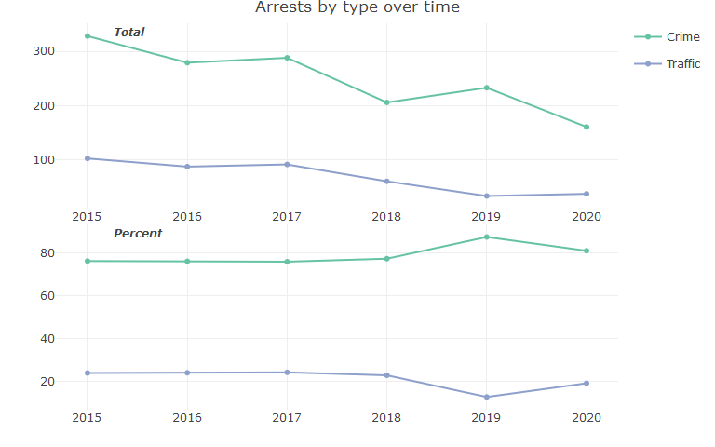

## Gender

Men represented 83.3% of overall arrests. Women represented 16.7% of overall arrests.

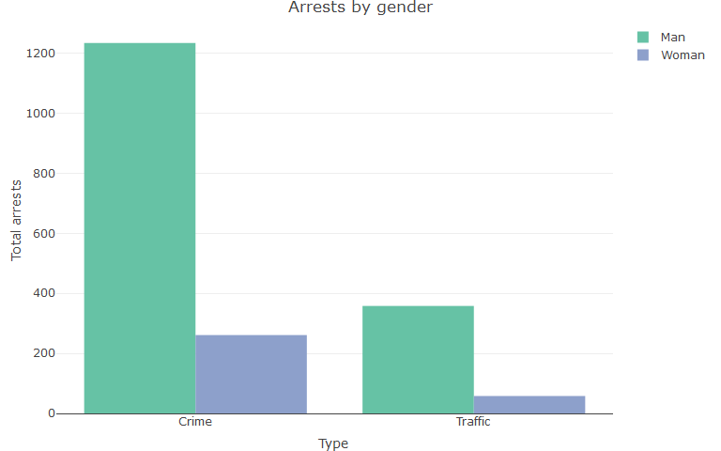

## Age

People aged 18-29 and 30-39 were issued criminal arrests (representing 38.9% and 22.5% of arrests, respectively) and traffic arrests (representing 45.2% and 31% respectively) most frequently by police among all age groups.

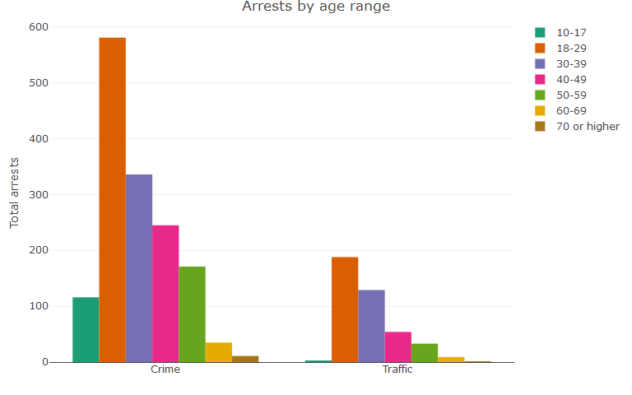

## Residency

Broken down by city and type of arrest, Takoma Park residents represented 18.8% of criminal arrests and 8.4% of traffic arrests. It should be noted that this excludes 3.3% of arrests of people living in unincorporated areas with a listed mailing address of Takoma Park (e.g., Takoma Towers) in Montgomery County, and 1.1% in Prince George’s County. This limits the comparability of arrests of Takoma Park residents with other places, because the Department cannot identify addresses in other cities with the city’s mailing address that are outside the city’s borders (e.g., people with a Silver Spring mailing address outside Silver Spring’s actual borders).

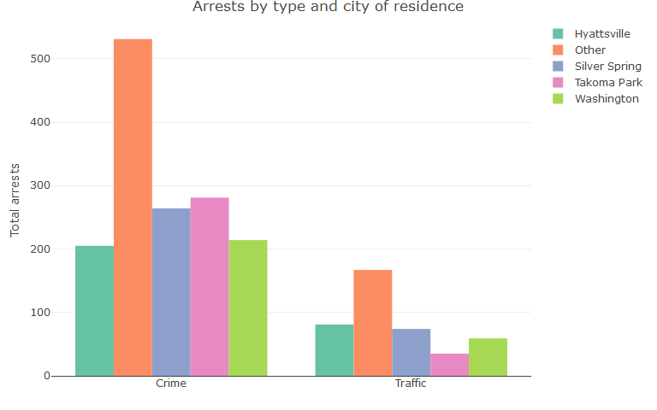

*Note: Takoma Park in this graph excludes 85 arrests of people who live in unincorporated areas with a city of address of Takoma Park. Percentages exclude arrests with an unknown city of address, representing 6.9% of arrests. Other includes all arrests involving residents of cities with less than 10% of arrests (the next biggest city was Adelphi, representing 2.3% of arrests).*

Of all arrests with a known city of residence, 17.8% of arrests police made were of Takoma Park residents. Silver Spring, DC, and Hyattsville were the most common arrests from other cities, and no other city exceeded 2.3% of arrests.

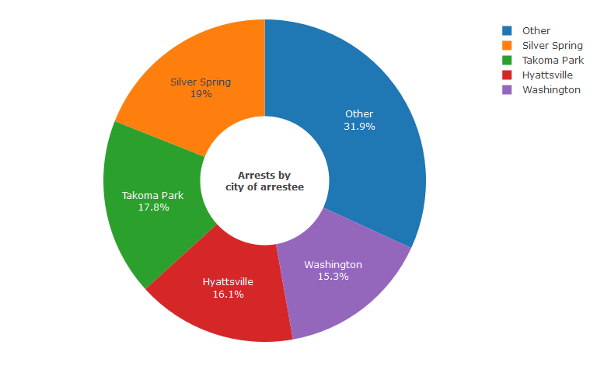

*Note: Takoma Park in this graph excludes 85 arrests of people who live in unincorporated areas with a city of address of Takoma Park. Percentages exclude arrests with an unknown city of address, representing 6.9% of arrests. Other includes all arrests involving residents of cities with less than 10% of arrests (the next biggest city was Adelphi, representing 2.3% of arrests).*

By county, a plurality of arrests were of Montgomery County residents at 46.8% of arrests with a known county, followed by Prince George’s County at 30.1% and DC at 15.4%. Residents of Montgomery County outside of Takoma Park represented 29% of arrests. 1.7% of arrests were of out of state residents other than DC.

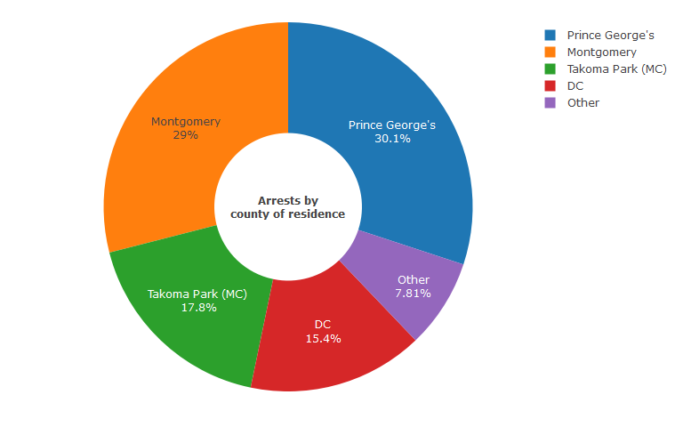

*Note: Takoma Park (MC) excludes 85 arrests of people with a Takoma Park mailing address living in unincorporated areas outside of the city’s boundaries. Percentages exclude arrests with an unknown county of address, representing 6.9% of arrests. Other includes all arrests involving residents of counties with 5% or fewer arrests (the next biggest county was 0.9%).*

Among all arrests of Takoma Park residents, police arrested/cited residents of Ward 5 and 6 the most at 27.8% and 27.2% of arrests respectively, and residents of Ward 1 the least at 4.7% of all arrests.

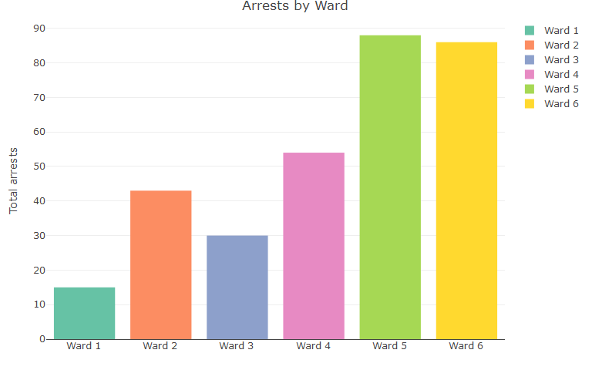

## Initiation

In reviewing police reports to prepare this dataset, the Takoma Park Police Department judged how arrests were initiated. The Department coded arrests as officer-initiated; public-initiated (e.g., responding to a call); self-initiated (e.g., the person turned themselves in); and detail-initiated (“contact with the arrestee was initiated by LEO intelligence, or general complaints made by the public”).

The data shows 66.8% of criminal arrests were public-initiated, while 63.9% of traffic arrests were officer-initiated. Detail-initiated arrests represent 21.4% of traffic arrests and 6.8% of criminal arrests.

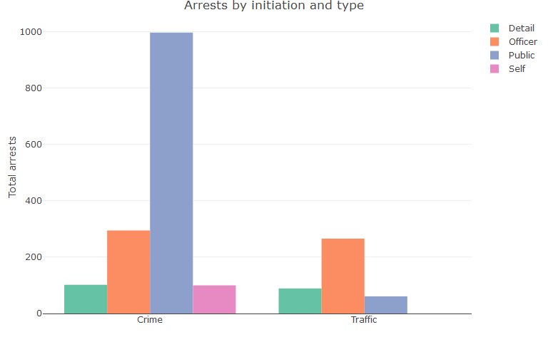

Reviewing arrests by year and type, initiations of all types have declined since 2015 with declining arrests overall. Due to different rates of decline, public-initiated criminal arrests represented 91.3% of criminal arrests in 2020.

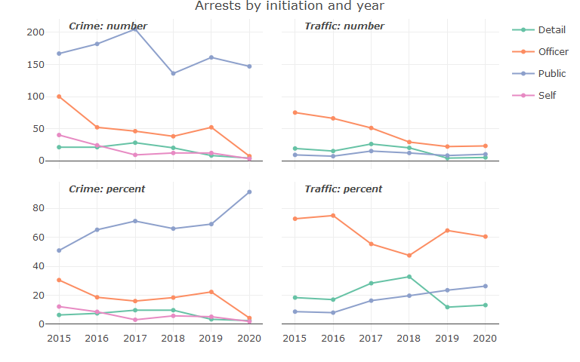

## Type-specific

By specific type, the most common arrests were full-custody arrests, representing 39.8% of criminal arrests and 68.3% of traffic arrests. Warrant-service arrests were second most common at 21.9% of criminal arrests and 22.4% of traffic, followed by criminal citations at 15.9% of criminal and 6.2% of traffic arrests.

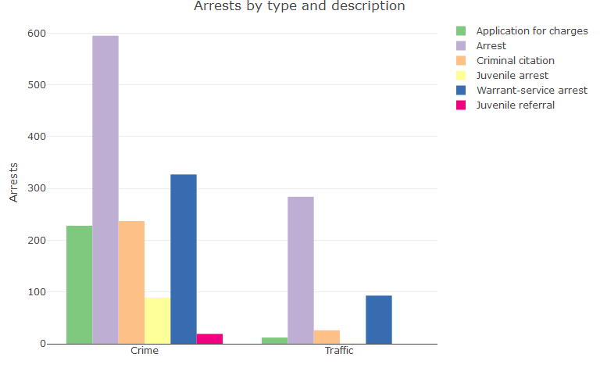

All specific types of arrests have declined with overall arrests. Different rates of decline have led to an increased share of full-custody arrests as a proportion of all specific-types of arrests–from 65% of traffic arrests and 32.9% of criminal in 2015 to 81.6% traffic and 54% criminal in 2020–and a declining proportion of warrant-service arrests, from 24.3% of traffic arrests and 28% of criminal in 2015 to 15.8% traffic and 9.3% criminal in 2020.

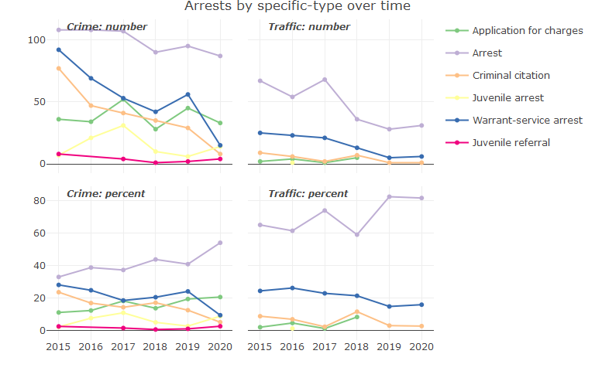

## Offense

By offense, arrests of persons for outstanding warrants represented the most common kind of criminal arrest at 21.9% and the second most common type of traffic arrest at 22.6%. DUIs represented the most common traffic arrest at 40.6%.

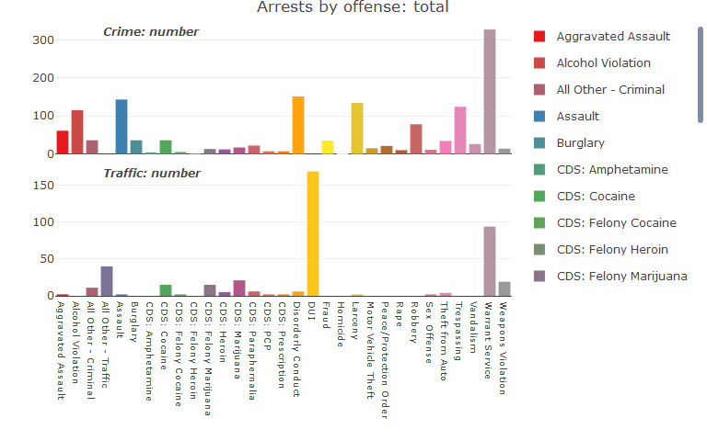

Together, controlled dangerous substances arrests represented 8.3% of criminal arrests.

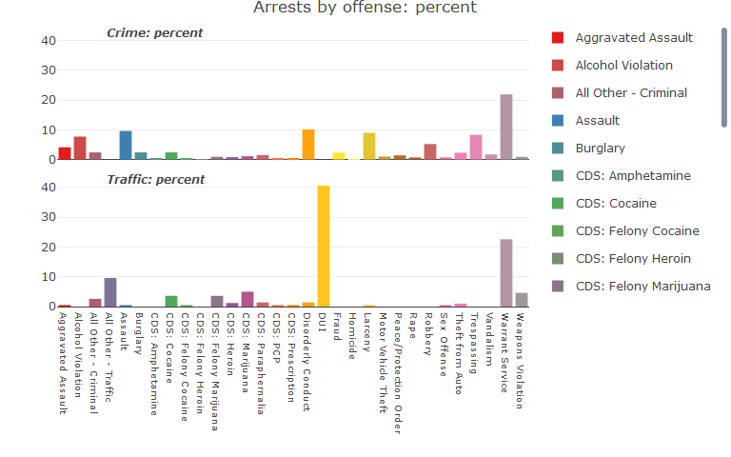

# Race

## Race overall

Black people made up 52.7% of arrests, Hispanic people made up 33.6%, and white people made up 13.3%.

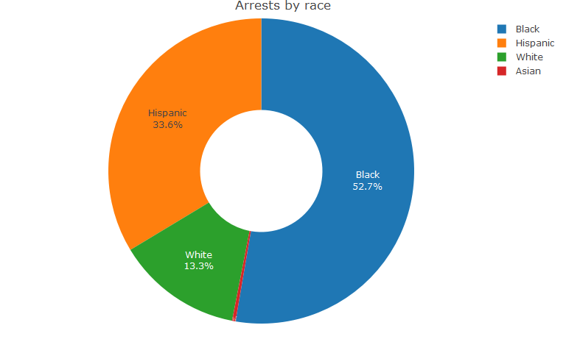

Arrests of all races have declined since 2015, although relative disparities in arrest rates remain.

Arrests of Black people declined from 189 in 2015 to 122 in 2020.

Arrests of Hispanic people declined from 174 in 2015 to 40 in 2020.

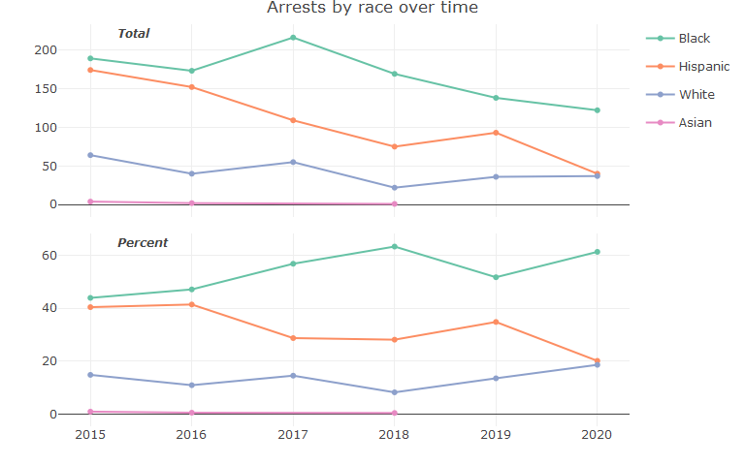

## Type and race

Black people represented 55.5% of all criminal arrests and 42.8% of traffic arrests. Hispanic people represented 46.4% of all traffic arrests, and 30.1% of all criminal arrests. Police issued arrests of all types to white people at similar rates, representing 10.8% of traffic arrests and 14% of criminal arrests.

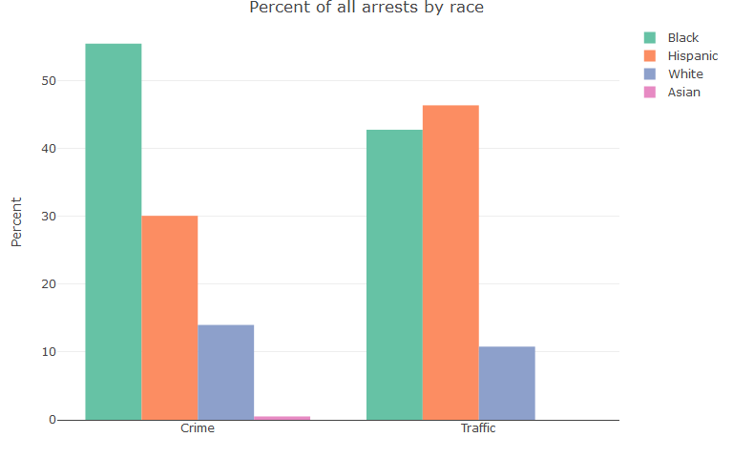

Trends in arrests by type and race over time largely follow overall trends, with a few exceptions.

The yearly percentage of traffic arrests of Black people remained relatively stable even as the number declined; while the number of criminal arrests of Black people also declined, the percentage increased from 44.2% in 2015 to 66.5% in 2020. Relatedly, the decline in the percentage of arrests of Hispanic people seems to mostly be driven by a large decline in criminal arrests, from 38.1% of yearly arrests in 2015 to 14.9% in 2020.

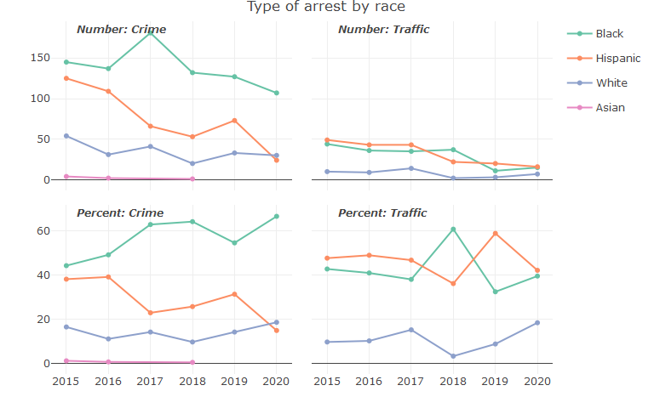

## Gender and race

Police arrested Black men and women within genders at rates of 51.9% and 56.4% respectively. Hispanic men represented 37.8% of arrests of men, and Hispanic women represented 13.2% of arrests of women. White people represented 10% of arrests of men, and 29.8% of arrests of women.

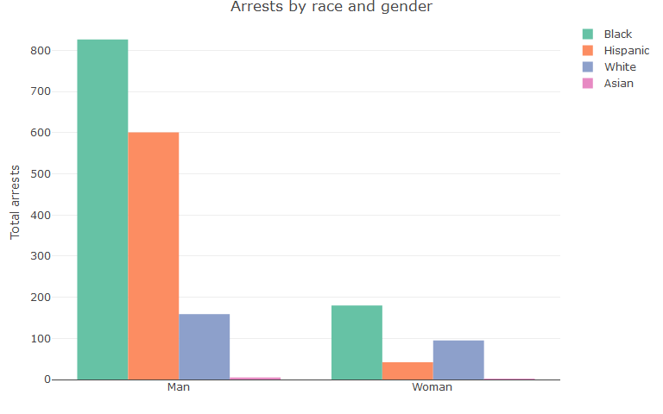

## Age and race

Differences in arrest rates by race persist across the age spectrum. Black people were arrested at the highest volume of all age groups followed by Hispanic people and white people. Police made more criminal arrests of Hispanic people than white people in all age groups except ages 60-69 and 70+. Hispanic people aged 30-39 represented 37.5% of criminal arrests of people aged 30-39, and 39.6% of all criminal arrests of people aged 40-49.

For traffic arrests, police arrested Black or Hispanic people at the highest-rates in all age groups with more than one total arrest. Police arrested more Hispanic people aged 30-39 compared to other races–representing 54.3% of traffic arrests for people aged 30-39–and Black people aged 18-29 compared to other races, representing 46.8% of arrests for the 18-29 age group.

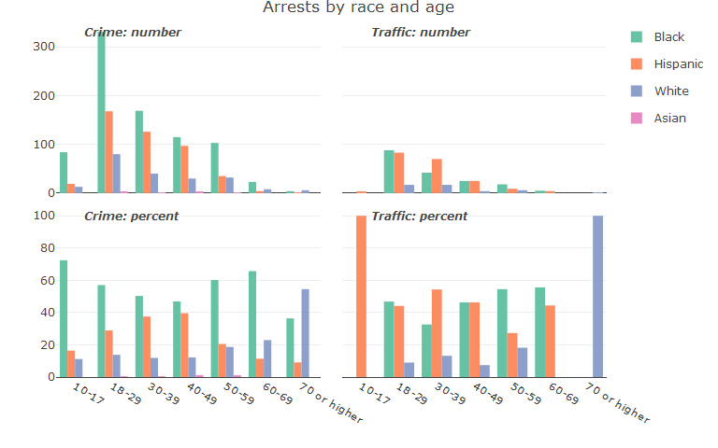

## Age and gender and race

Involving arrests of men only, police arrested and issued the highest number of criminal citations to Black men followed by Hispanic men and white men. With arrests involving women only, police arrested and issued the highest number of criminal citations to Black women followed by white women and Hispanic women.

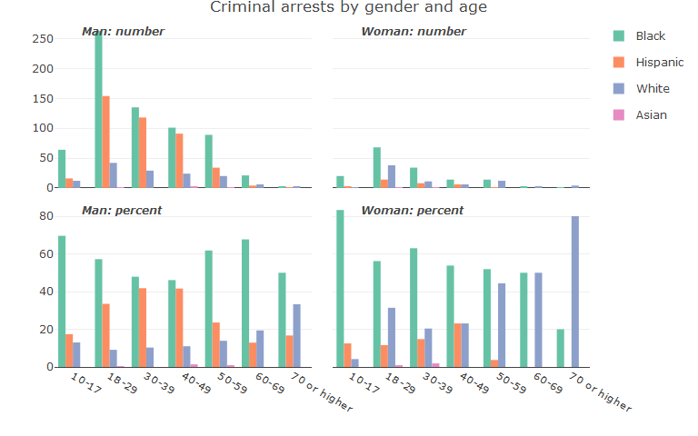

Police made traffic arrests of Hispanic men and Black men across the age spectrum at the highest rates followed by Black women and white men. Due to the lower numbers of traffic arrests for women it is harder to draw conclusions about age-based differences in arrest rates of different races.

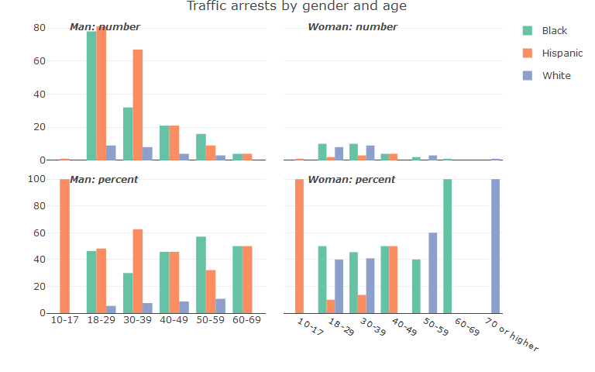

## Initiation and race

Based on officer coding of initiation status, arrests by initiation show high relative rates of publicly-initiated criminal arrests for Black people and high relative rates of officer-initiated arrests for Hispanic people. Black people had the highest number of arrest initiation-types, followed by Hispanic people, and white people.

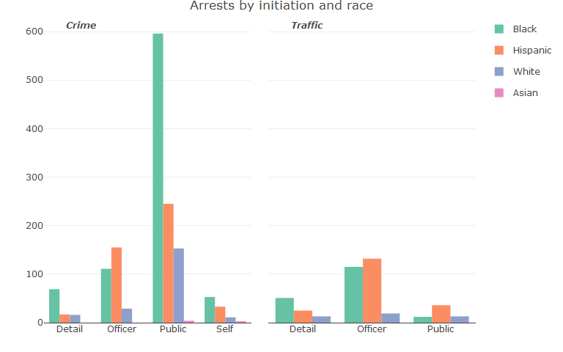

## Specific-type and race

Black people had the highest arrest totals of specific-types of arrests, followed by Hispanic people and white people.

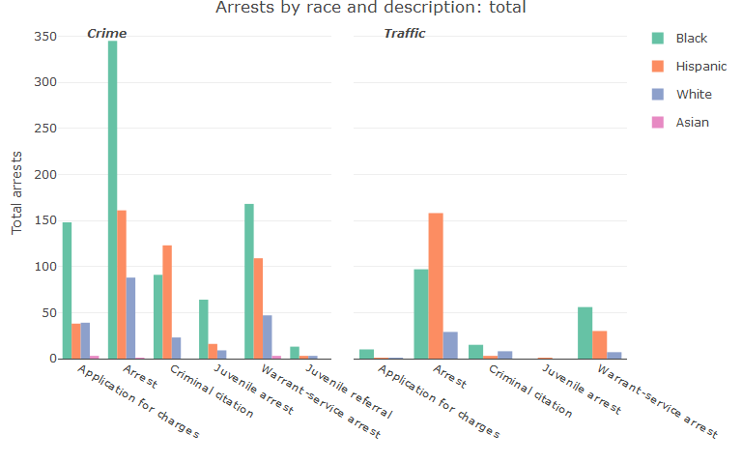

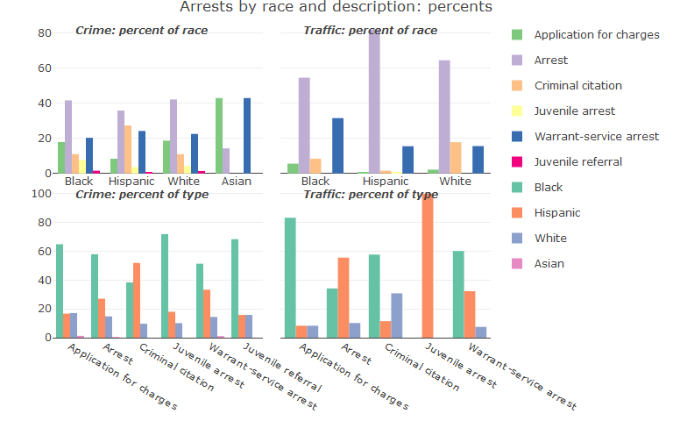

## Offense and race

Comparing criminal arrests of Black, Hispanic, and white people, police issued the most arrests to Black people in 21 of the 23 offense categories; the most to Hispanic people in 3 of the offense categories; and the least to white people in 17 of the offense categories.

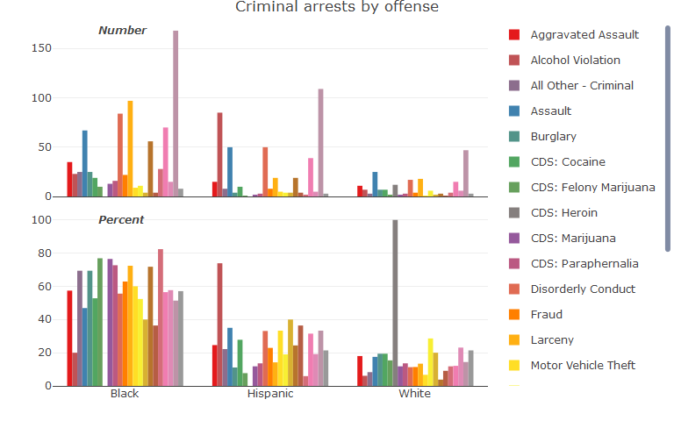

*Note: Due to the low number of arrests of Asian people, arrests of Asian people are omitted from the chart above. The chart is also limited to offenses with at least 10 arrests.*

A similar trend follows for traffic arrests. Police made more traffic arrests of Black or Hispanic people across all traffic offense categories with at least 10 arrests. Between arrests of Black, Hispanic, and white people, police issued the most traffic arrests to Black people in 5 of the 8 offense categories; the most to Hispanic people in 3 of the offense categories; and the least to white people in 7 of the offense categories.

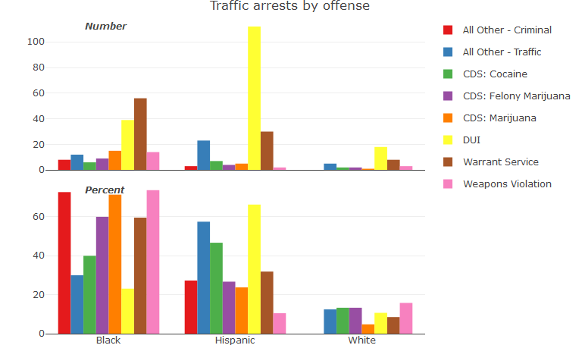

*Note: Due to the low number of arrests of Asian people, arrests of Asian people are omitted from the chart above. The chart is also limited to offenses with at least 10 arrests.*

# Takoma Park Residents by Race

## Takoma Park residents by race overall

52.7% of all police arrests were of Black people, and 56.3% of police arrests of Takoma Park residents were of Black people. Hispanic people represented 33.6% of all arrests and 23.4% of arrests of Takoma Park residents, and white people represented 13.3% of all arrests and 20.3% of arrests of Takoma Park residents.

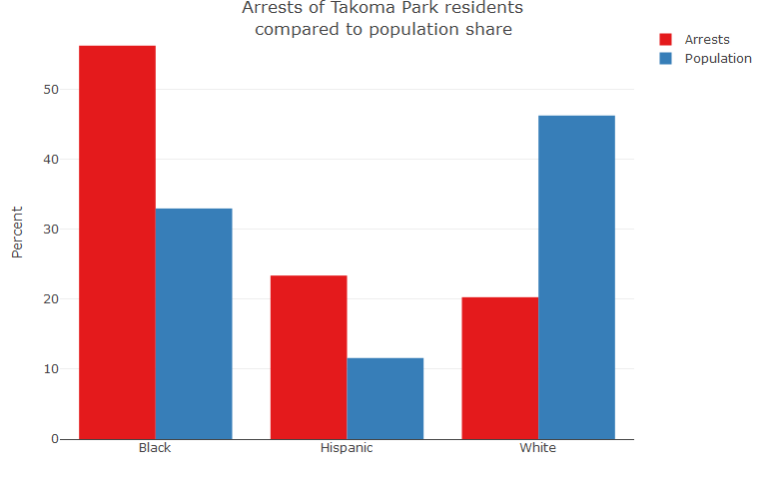

Arrests by type of Takoma Park residents also follow similar patterns as overall arrests by type, except traffic arrests of Black people represent the highest share of traffic arrests and Hispanic people a slightly-lower share of traffic arrests than white people.

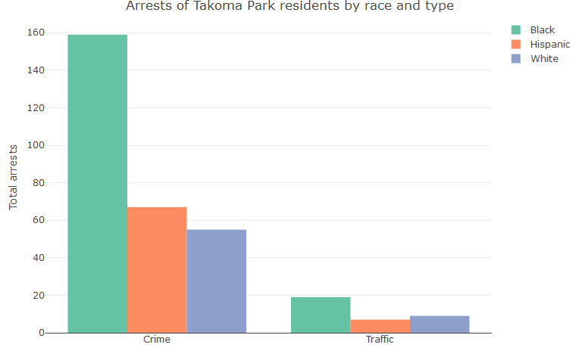

## Takoma Park residents by race and gender

By gender and race, arrests similarly mirror overall arrest rates. Men are arrested more frequently than women but within genders similar differences in arrest rates remain, except that Hispanic men are arrested at higher rates than Hispanic women.

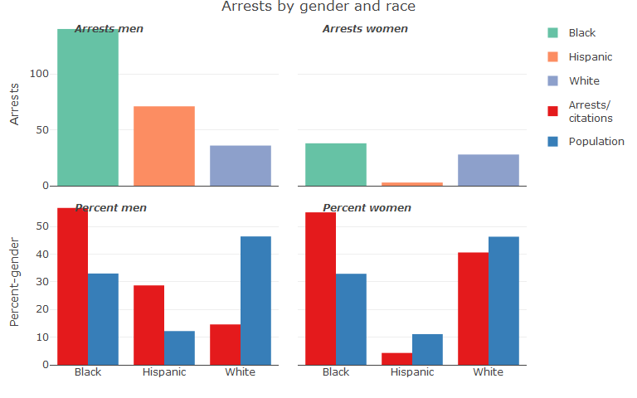

## Takoma Park residents by Ward

Differences in arrests by race carry to Wards. The City does not have precise information on the racial demographics of its Wards, but does publish an [interactive demographic map](https://www.arcgis.com/apps/View/index.html?appid=1be78451f182406d915c7ab1385c1ceb&extent=-77.0229,38.9687,-76.9816,38.9928) with information on the percent of people of color in Census block groups.

