Takoma Park Police Traffic Stops Analysis

August 13, 2021

Table of Contents

# Introduction

## Overview

The City of Takoma Park Police Department maintains two datasets on traffic incidents involving the Police Department: a “Stops” dataset on police traffic stops between 2015 and 2020, and a “CAD” dataset on traffic incidents involving Computer-Aided Dispatcher (CAD) calls between 2018 and 2020. **We analyzed these datasets to identify total traffic stops, total stops by type, reasons for stops, stops by race, gender, age, and stop-locations.**

The City’s Police Department views the purpose of traffic enforcement as to promote public safety by stopping a violation, reducing crashes, and enhancing public safety and enjoyment. At the same time, it deters other drivers from committing an infraction and historically changes behavior of the ticketed driver and onlookers. Education and behavior change are the key components.

There are three major sections to this document:

1. *Overall findings on traffic stops*
2. *Traffic stop data broken out by race*
3. *Analysis and mapping of dispatcher-call data*

## Data Highlights

***Overall***

1. Total traffic stops declined significantly between 2015 and 2020, from 8,074 stops in 2015 to 1,593 in 2020, with the biggest decrease coming in citations.
2. People outside of Montgomery County made up 50% of stops.
3. Men represented 64.7% of stops, and people aged 20-39 represented 50.8% of stops.
4. The most common reason for stops was “Special Stops Required” (e.g., failure to stop at a stop sign) at 22.1%, followed by “Title and Registration” at 14.8%.

***By race***

1. 47.2% of all traffic stops were of Black people, 25.5% of traffic stops were of Hispanic people, and 20.7% of traffic stops were of white people.
2. Stops of all races have declined with overall stops. Total stops of Black people declined from 3,911 in 2015 to 663 in 2020, and total stops of Hispanic people declined from 1,903 in 2015 to 511 in 2020.
3. Relative differences in stop-rates by race persisted. As a share of total yearly stops, stop-rates of Black people declined from 48.4% in 2015 to 41.6% in 2020. Stop-rates of Hispanic people increased from 23.6% in 2015 to 32.1% in 2020. Stop-rates of white people remained stable.
4. Black people pulled over by police between 2015 and 2020 were slightly more likely to have a stop end in a repair order, and in 2020 Hispanic people were more likely to have a stop end in a citation.

## Background on TPPD Traffic Data/Data Methods

The first dataset, “Stops,” includes data from 2015 to 2020, and records all stops in which an officer issues a citation, repair order, or warning. **All traffic stops recorded were the result of observable traffic violations, response to traffic accidents, or investigations.** Data comes from the statewide ticketing database E-tix, and there are instances in E-tix where a citation, warning, or SERO may be issued that are not related to traffic stops - per say - because they were issued for other various reasons, such as an accident investigation, investigatory stop based on criminal violations, or sobriety checkpoint.

The Department provided the following five possible outcomes to a traffic stop, three of which appear in this dataset:

1. *Verbal Warning* - an officer can issue a verbal warning for a violation. **Note:** This would not appear in the dataset because race, gender, and residency are not recorded in these stops.
2. *Written Warning* - an officer can issue a written warning. Written warnings are tracked through the statewide database E-tix, and appear in the dataset.
3. *State Citation* - an officer can issue a state citation. State citations are tracked through the statewide database E-tix, and appear in the dataset.
4. *Safety Equipment Repair Order (SERO)* - an officer can issue a SERO. SERO stops do not involve moving violations. They are related to the safety of the vehicle on the road. Examples of SERO’s are: headlight out, broken windshield, and broken brake lights. No fine or points are associated with SERO’s. It is a written notice to repair an equipment issue within a prescribed time frame. Failure to do so in the prescribed time frame can lead to possible suspension of the involved vehicle’s registration. These appear in the dataset.
5. *Arrest (traffic, warrant, or criminal)* - traffic stops can result in an arrest for traffic violations (driving under the influence and other serious driving offenses), a warrant arrest (an individual is stopped and the resulting status check reveals they have an outstanding arrest warrant), or a criminal arrest (a criminal offense is discovered during the course of the traffic stop). **Note:** These do not appear in the dataset, because they are tracked in a separate system. There are stops in the dataset that involve an arrest, but they cannot be distinguished. For example, if an officer stopped someone for speeding, discovered they had an outstanding warrant, and arrested them, they would enter a citation for speeding in the ticketing system and write an arrest report in a different system; in this dataset, the incident would show up as a citation for speeding.

Each row in the dataset represents a reason for a stop resulting in a citation, written warning, or repair order; e.g., one stop could have three rows if it results in two warnings and a citation for three separate reasons. The dataset contains information on the race, gender, and age of the person stopped, the date of the stop, the general location of the stop, the state and county of residence of the person stopped, and the reason for the stop.

The second dataset, “CAD,” runs from 2018 to 2020, and contains information on Computer-Aided Dispatch (CAD) calls (incidents in which an officer called a dispatcher; e.g., to run someone’s plates). Calls for service that come through the County 911 system are entered into CAD by Montgomery County dispatchers and routed to the TPPD for service. Upon receiving a call, Montgomery County dispatchers create an incident and code it as a traffic stop, a motorist assist, or an accident. The system records the exact location of the incident, as well as the amount of time the dispatcher was on the call. It also includes information on the beat of the officer who responded. It does not include demographic information on persons involved in the incident.

There is a mismatch between the total dispatcher calls coded as traffic stops identified in the CAD data, and the total stops in the traffic stop data. The two datasets are not linked; of the 11,551 events in the CAD data, only 707 had an associated report. Some reasons for the mismatch include:

1. *Different definitions of traffic stops:* The traffic stops data defines stops as incidents in which a warning, repair order, or citation are recorded in the ticketing system based on a stop. If none of these are recorded, they are excluded from the dataset. The CAD dataset automatically records all calls as incidents, and leaves it to the discretion of the county dispatcher to code an incident as a stop; therefore, incidents in which a warning, citation, or repair order are not issued (and therefore don’t appear in the traffic stops dataset) may be recorded as stops in the CAD system. It’s also likely that in some instances, County dispatchers inadvertently coded motorist assistance or accident calls as stops (although this could also go the other way, in dispatchers incorrectly coding stops as other incidents).
2. *Multiple events in the CAD data for the same stop*: In at least a few instances, the CAD data may have recorded multiple events for the same incident. For instance, multiple incidents will appear for the same officer in too short an amount of time for the officer to have had multiple incidents.

# Stops Overall

## Stops by Outcome and Over-Time

**Between 2015 and 2020, the City of Takoma Park’s Police Department made 22,392 traffic stops involving a warning, repair order, or citation.** Citations made up a plurality of stops, representing 49.4% of stop outcomes, followed by warnings at 32.8% of stops. In some instances, there were multiple outcomes associated with one stop; we associated a stop with the most severe outcome (i.e., citations, then repair orders, then warnings) so that data in the table below represents unique stops.

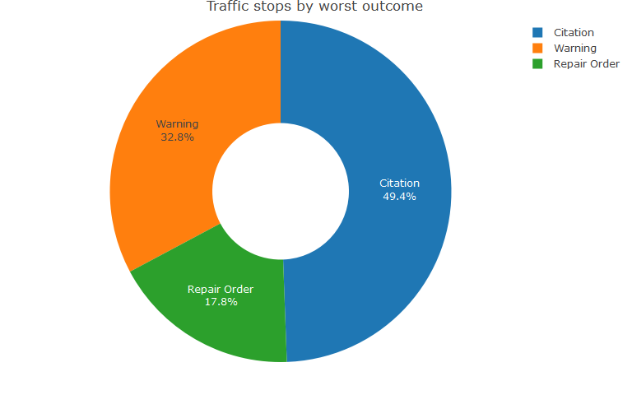

**Traffic stops consistently declined between 2015 and 2020,** decreasing 80.3% over the five years of available data from 8,074 in 2015 to 1,593 in 2020.

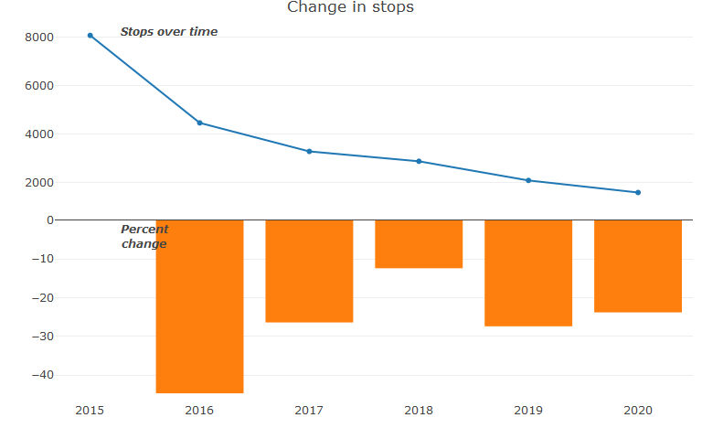

**All types of traffic stops declined between 2015 and 2020, but the biggest decline in worst-outcomes occurred for citations,** which decreased from 4,010 in 2015 to 642 in 2020. Since 2018, citations have also decreased in relative terms while warnings have increased, with citations declining from 53% of traffic stop worst-outcomes in 2018 to 40.3% in 2020, as warnings increased from 32.4% of worst-outcomes in 2018 to 47.3% of worst-outcomes in 2020.

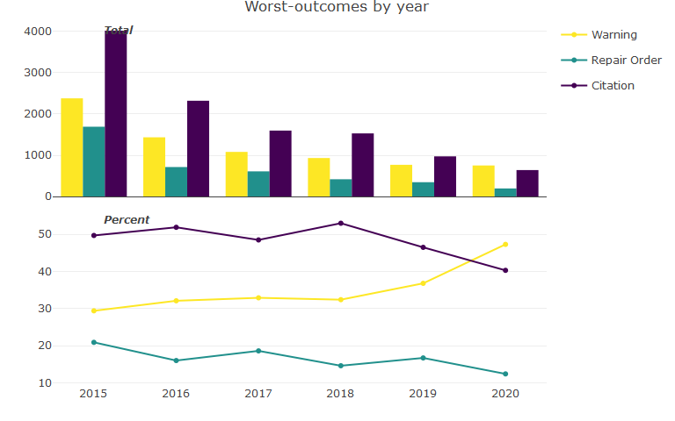

The Police Department has provided the following possible reasons for potential decreases in stops over the last three years:

1. **Refocus on traffic enforcement**- in 2018 the department moved away from random traffic enforcement to targeted enforcement. Utilizing traffic collision data and resident complaints, we focused departmental traffic enforcement in problem areas in the city. This led to quality traffic stops that helped address problem areas in the city. While the number of overall stops were reduced the quality and impact of the stops improved. Collision data over the three years, 2018-2020, shows a reduction in overall collisions in the city compared to 2015-2017.
2. **Revamping of the Evaluation and Reward System**- in 2018 we changed our evaluation system to focus on community engagement and problem solving over traffic and criminal enforcement. This led to officers not feeling pressured to make non-impactful traffic stops and arrests. This was consistent with promoting quality targeted enforcement, not quantity enforcement.
3. **Expanding the efficiency of the city’s speed cameras** - in 2020 the police department renegotiated the safe speed contract with our service provider. Part of the new contract involved installing new equipment throughout the city. This increased the efficiency of the units and expanded coverage area for all cameras on our main roadway in the city, New Hampshire Avenue. Coverage area increased from one lane of traffic to cover all three lanes increasing coverage area and reducing our need for manned traffic enforcement in certain areas.

## Stops by Residence

The City only has partial residency information for people stopped by Takoma Park police, with state, county, and zip-code information. **Half of residents stopped are from Montgomery County (50%), with the second-most residents stopped from Prince George’s County at 28.2%**, and third most from Howard County at 1.2%. The remaining stops were either other counties in Maryland (3.4%) or out-of-state residents (17.3%).

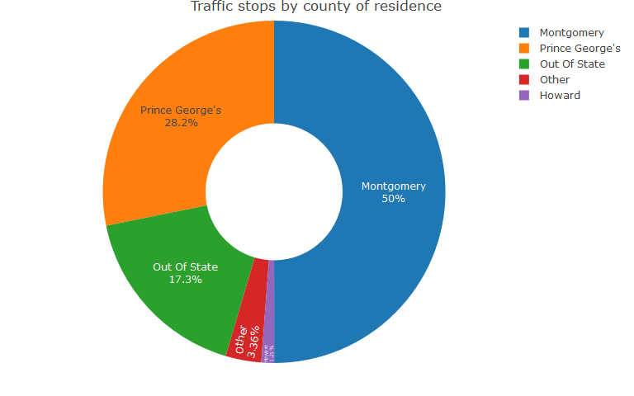

## Stops by Reason

**The most common reason police cited for pulling someone over was “special stops required” (e.g., failure to stop at a stop sign)–representing 22.1% of reasons cited–followed by “title and registration,”** representing 14.8%. Officers can cite multiple reasons for a stop, so the data below shows the percentage of times a reason was cited among all reasons, not that a stop was made.

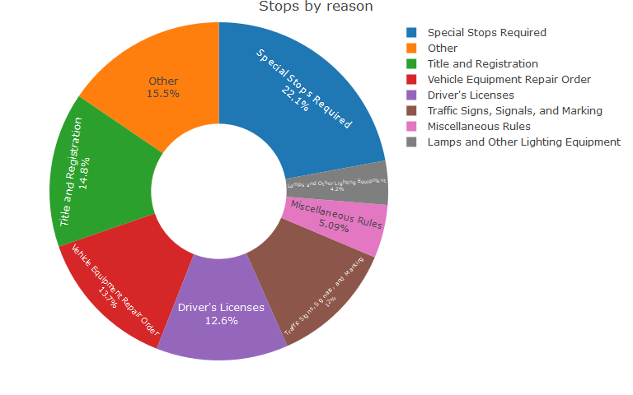

*Note: The “Other” category above includes all reasons that represented below 4% of uses. These include (in order of frequency, with the highest representing 2.2% of uses of reasons): Driving on Right Side of Roadway, Passing, and Use; Speed Restriction; Signals on Stopping, Turning, and Starting; Other Equipment; Reckless, Negligent, Aggressive, or Impaired Driving; Fleeing or Eluding; Right of Way; Required Security; Accidents and Accident Reports; Motor Carrier Safety Inspection Regulations; Stopping, Standing, or Parking; Antitheft Laws; Operation of Motorcycles; Pedestrians Rights and Rules; Rules of the Road - General Provisions; Brakes; Disposition of Abandoned Vehicles; Equipment of Vehicles - Scope and Effect of Equipment Provisions; For Rental Vehicles; Hazardous Materials Violations; Inspection of Used Vehicles and Warnings for Defective Equipment; Licensing of Businesses and Occupations; Maryland Transit; Motor Vehicle Administration; Noise Abatement Program; Operation of Bicycles or Play Vehicles; Operation of Vehicles on Certain Toll Facilities; Parties and Procedures on Citation, Arrest, Trial, and Appeal; Size, Weight, and Load: Highway Preservation; and Size, Weight, and Load; Highway Preservation*

Aside from a relative increase–not an absolute increase, because stops overall declined–in use of “special stops required,” a relative increase in use of “title and registration,” and a relative decrease in use of “vehicle equipment issues,” there do not appear to be clear trends in changes in the reasons for stops over time.

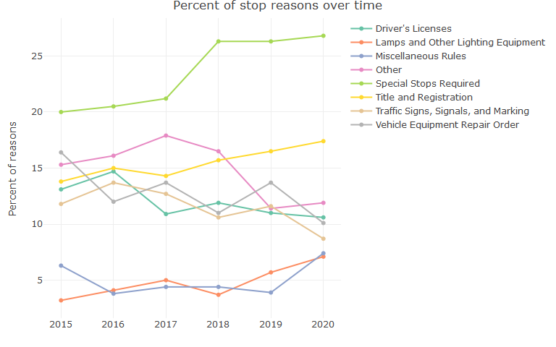

*Note: The “Other” category above includes all reasons that represented below 4% of uses. These include (in order of frequency, with the highest representing 2.2% of uses of reasons): Driving on Right Side of Roadway, Passing, and Use; Speed Restriction; Signals on Stopping, Turning, and Starting; Other Equipment; Reckless, Negligent, Aggressive, or Impaired Driving; Fleeing or Eluding; Right of Way; Required Security; Accidents and Accident Reports; Motor Carrier Safety Inspection Regulations; Stopping, Standing, or Parking; Antitheft Laws; Operation of Motorcycles; Pedestrians Rights and Rules; Rules of the Road - General Provisions; Brakes; Disposition of Abandoned Vehicles; Equipment of Vehicles - Scope and Effect of Equipment Provisions; For Rental Vehicles; Hazardous Materials Violations; Inspection of Used Vehicles and Warnings for Defective Equipment; Licensing of Businesses and Occupations; Maryland Transit; Motor Vehicle Administration; Noise Abatement Program; Operation of Bicycles or Play Vehicles; Operation of Vehicles on Certain Toll Facilities; Parties and Procedures on Citation, Arrest, Trial, and Appeal; Size, Weight, and Load: Highway Preservation; and Size, Weight, and Load; Highway Preservation*

## Stops by Gender

**Police stopped men most often,** representing 64.7% of all stops.

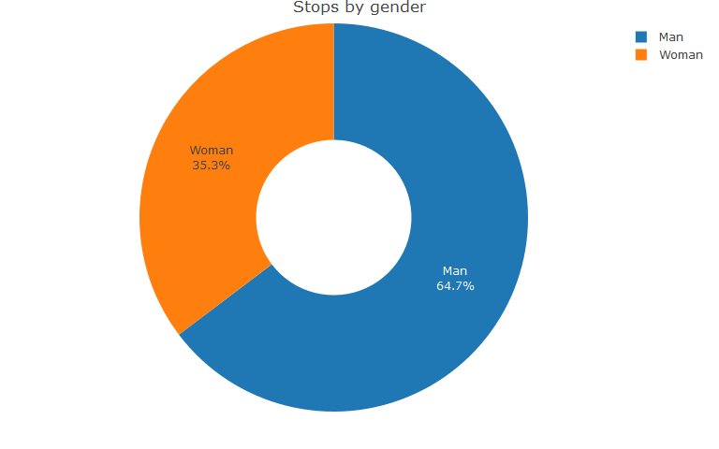

## Stops by Age

Examining stops by age, police stopped people aged 30-39 most frequently between 2015 and 2020 (6,010 times), followed by people aged 20-29 (5,355 times).

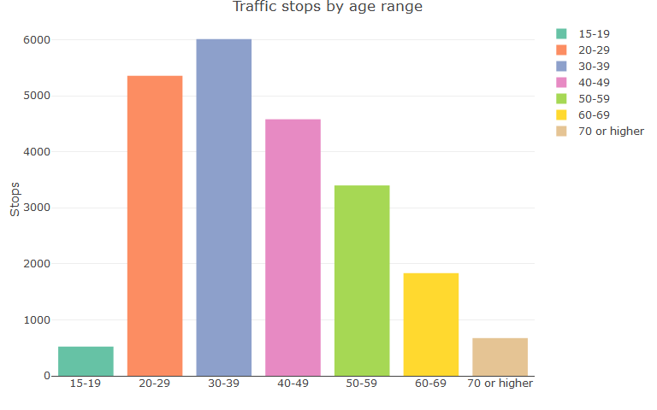

*Note: There were 21 age values that were miscoded in the data (over 100 or under 15, some of which were negative), and they are excluded from the above chart.*

# Stops by Race

## Outcomes and Stops Over Time

Black people were stopped by police most often–representing 10,568 stops and 47.2% of all stops–and Hispanic people second most often, representing 5,699 stops and 25.5% of all stops. Police stopped 4,636 white people, representing 20.7% of stops.

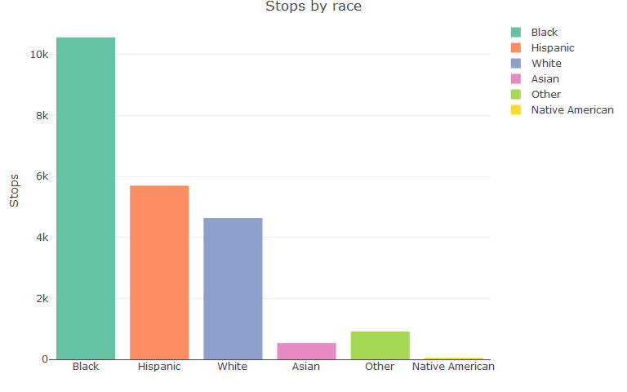

**Stops of each racial group have declined significantly over time.** In 2015, police stopped 3,911 Black people and 1,903 Hispanic people, compared to 663 Black people and 511 Hispanic people in 2020. While relative stop-rates of Black people were less in 2020 than 2015–with Black people representing 48.4% of stops in 2015 and 41.6% in 2020–the decline corresponded with a higher portion of stops of Hispanic people, representing 23.6% of stops in 2015 and 32.1% in 2020. The proportion of white stops in 2015 and 2020 were about the same, representing 21.3% of stops in 2015 and 20.8% in 2020.

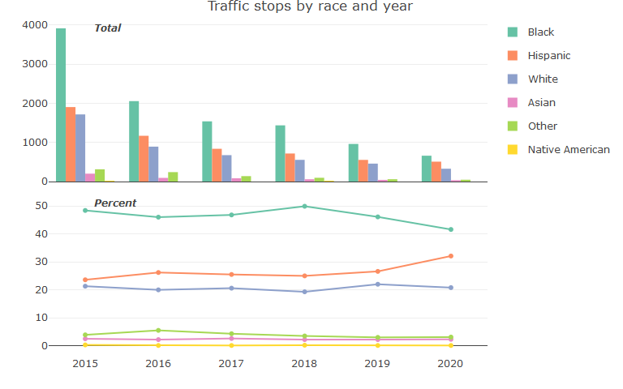

## Stops by Outcome

As a result of differences in stop-rates, Black people had the most stops ending in citations, warnings, and repair orders, followed by Hispanic people, and then white people.

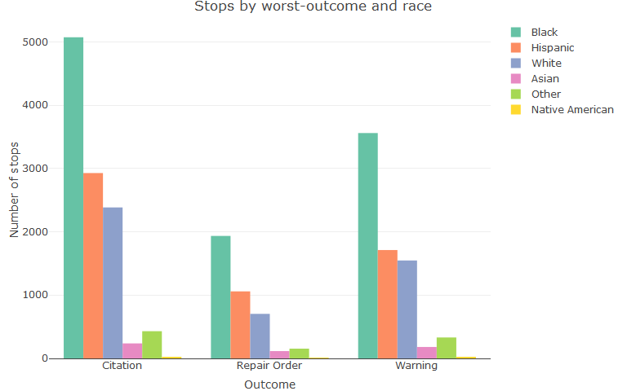

There are not many notable trends in traffic stop outcomes by race over time.

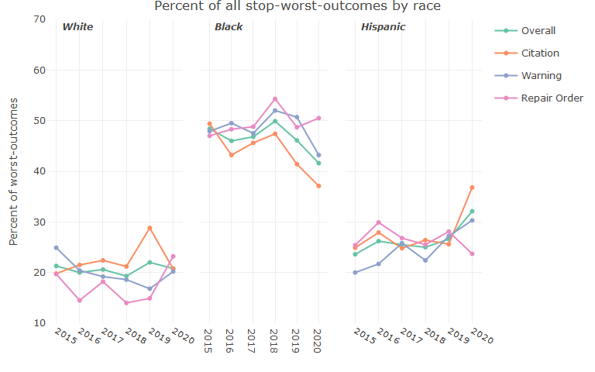

Police filed the most violations per stop for Hispanic people at 1.83, followed by Black people at 1.7; white people had the fewest at 1.42. Examining average numbers of violations by type involving stops with at least one outcome of that type (i.e., for citations, the average citations issued in stops involving at least one citation), Hispanic and Black people in particular were more likely to have multiple citations issued than white people. In stops involving at least one citation, police issued stopped Hispanic people an average of 1.93 citations per stop and Black people 1.74, compared to 1.29 for white people.

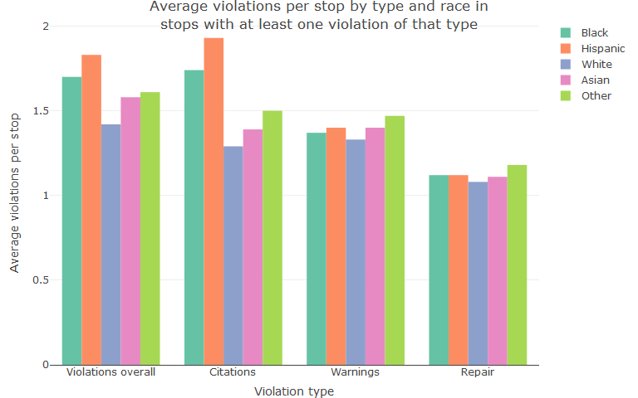

*Note: Due to the low number of stops of Native Americans overall (38), averages for stopped Native Americans are omitted from the above chart.*

## Stop Reasons

To identify potential differences in reasons for stops by race, we calculated the percentage of reasons people of each race were stopped, and then identified differences in that percentage from stops of white people. Below, we display the breakdown of reasons for stops by race for reasons that had:

1. A greater than 2% difference between the percentage of stops for white people, and the percentage of stops for any other race.
2. More than 10 uses of the reason for any race.

It is also worth noting that officers may cite multiple reasons for a stop, so the chart below shows differences in the percentage of times officers cited a reason in a stop, not differences in the percentage of stops for a reason.

**This analysis shows seven reasons with higher rates of stops of people of color under these criteria:**  Stopped Hispanic people and Black people had a greater share of their stops for “Driver’s License Issues,” representing 17% of stop-reasons for Hispanic people and 13% of stop-reasons for Black people compared to 6.6% of stop-reasons for white people. Stopped Hispanic people also had a higher share of stops for “Reckless, Negligent, Aggressive, or Impaired Driving; Fleeing or Eluding”, representing 4.2% of stop-reasons for Hispanic people compared to 0.9% of stop-reasons for white people. Stopped Black people also had a higher share of “Title and Registration” stop-reasons, representing 16.9% of reasons compared to 14.1% of reasons for white people.

People of all races other than white were more likely to be stopped for “Lamps and Other Lighting Equipment”, and Hispanic people more likely for “other equipment.” Finally, 16.7% of reasons-used in stops of Asian people and 14% of reasons-used in stops of people with a race of “other” were for “Vehicle Equipment Repair Order,” compared to 12.8% of white people.

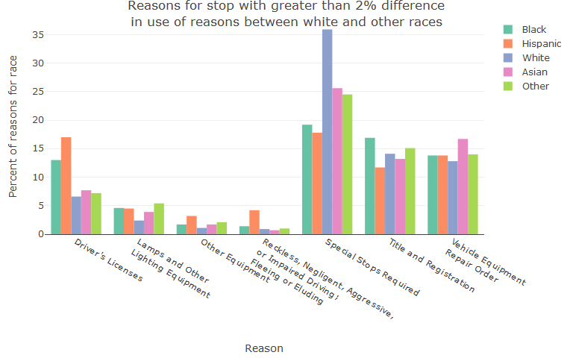

*Note: Stops of Native Americans are excluded from the above chart because the low number of stops of Native Americans makes the percentages potentially misleading. The chart is limited to stop-reasons with at least 10 uses for a race.*

## Race by Gender

**Racial disparities do not vary substantially within genders,** except that stops of Hispanic people represented 28.6% of stops of all men compared to 19.7% of stops of women, and stops of white people represented 25.8% of stops of women compared to 18% of stops of men.

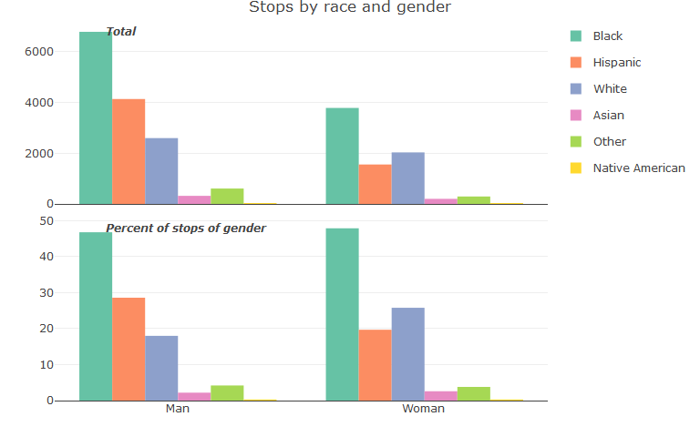 *Note: The chart above excludes 8 stops with an unknown gender, representing less than 0.1% of stops.*

## Race by Age

**Differences in stop-rates by race show up across age groups.** In all age-groups except ages 15-19–representing just 2.3% of all stops–Black people were stopped by police between 42.7% and 50.4% of all stops of the age group, similar to the overall percentage of stops of Black people of 47.2%. Police were especially likely to stop Hispanic people in age groups between 15 and 49; the overall percentage of stops of Hispanic people was 25.5%, and stops in these age groups ranged between 26.6% and 39.7%.

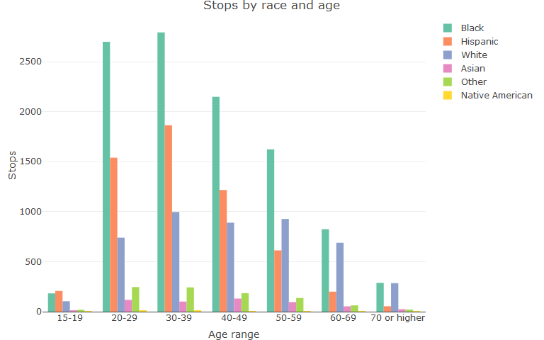

*Note: There were 21 age values that were miscoded in the data (over 100 or under 15, some of which were negative), and they are excluded from the above chart.*

## Stops by Race, Age, and Gender

**Differences in stops by race hold after breaking the data out by race, age, and gender.** Police stopped Black men aged 20-39 and then Hispanic men aged 20-39 the most among any combination of age, race/ethnicity, and gender groups. Police stopped Black women aged 20-39 the most of any age/race combination among women, and more than any age/gender combination of white people.

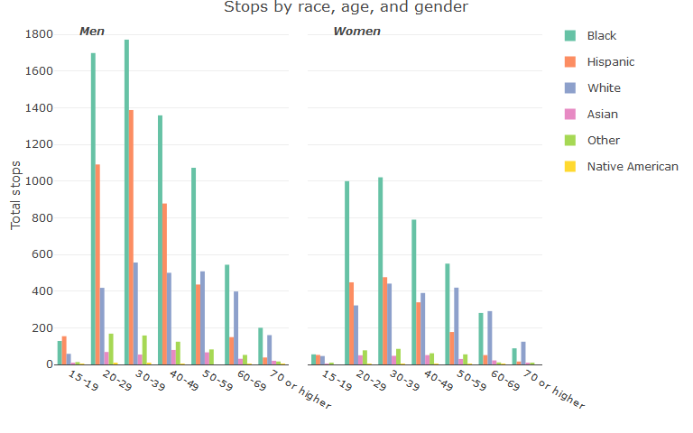

**Within genders, differences in stop rates by race between white people and other races are highest among men, and highest in the earlier-spectrum of age groups.** White women represent a higher share of stops of women across the age spectrum than white men. Within genders, Black women are stopped at a similar rate as Black men up until 40-49, and then decline as a share of stops of women while Black men occupy a similar share at increasing ages. Hispanic men are consistently stopped as a higher share of men than Hispanic women across the age spectrum, and are stopped especially more often earlier in the age-group spectrum.

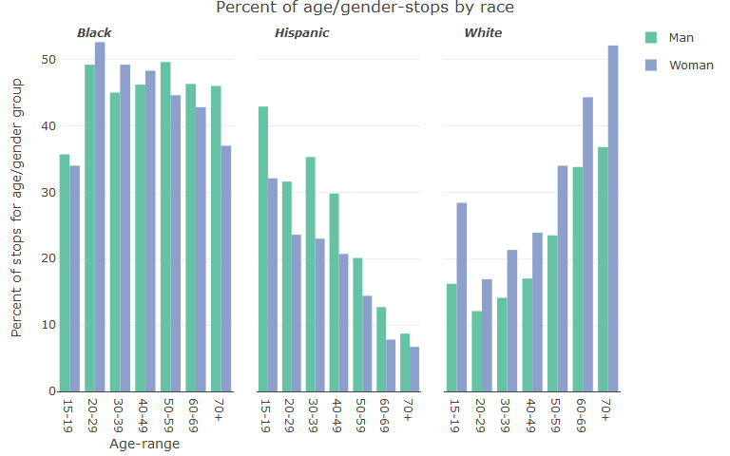

# Computer Aided Dispatch (CAD) Data

Below, we visualize data on CAD calls in each year, and by each type. Between 2018-2020, there were 11,551 calls to CAD dispatchers about traffic incidents. As discussed in the introduction, it should be noted there is a mismatch between the number of stops in the traffic stops data, and the number of incidents with the type “traffic stop” in the CAD data.

**Across the three years of available data, traffic stops were the most frequent incident dispatchers coded at 7,301 incidents–representing 63.2% of incidents–followed by parking problems/motorist assistance incidents at 4,205 incidents.** There were only 45 accident incidents in the dispatcher-call system across the three years of data, representing 0.4% of incidents.

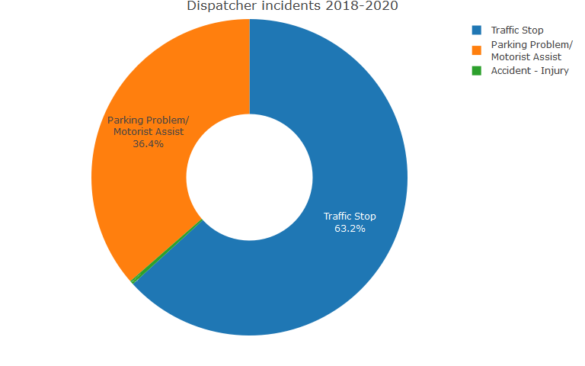

Both traffic stop and parking problem/motorist assist incidents declined in the dispatcher-assist system since 2018; traffic stops from 3,216 incidents in 2018 to 1,741 in 2020, and parking problem/motorist assist incidents declined from 1,717 incidents in 2018 to 1,005 incidents in 2020.

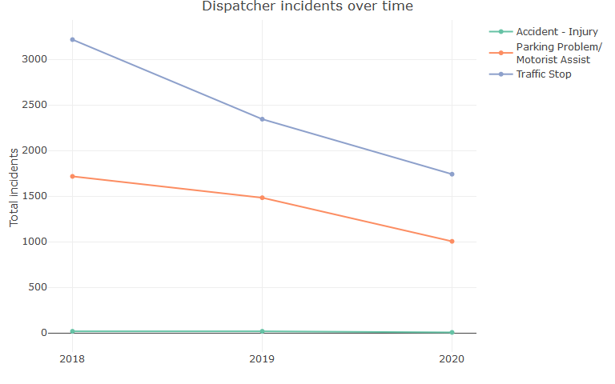

**Below, we provide an interactive map of all incidents appearing in the CAD system, broken out by type and year.** Incidents are automatically clustered by the frequency of incidents as you zoom in and out. Mousing over a cluster will show the geography covered by the cluster. You can also click on clusters to automatically break them up and zoom in. When you get to the smallest cluster (e.g., multiple stops at the same spot), clicking on the cluster will break it up into each incident. Mousing over an incident will provide a set of descriptive information about the incident, including the date and beat of a responding officer. You can turn layers on and off by clicking the box next to them.

In 295 cases, multiple officers were involved in an incident.

