 |  |  | CERTIFICATE OF CONFORMANCE  Calibration with NIST Traceable Certification
 | Customer | York |  |  |  |  |  |  | Date: | 8/13/2026
 | Cust Ref # |  |  |  |  |  |  |  | Examiner: | TP
 | Instrument | DPT810
 | Inst. SN. | A010007031 |  |  |  |  |  |  | Ambient Temperature: | 21.1℃
 |  |  |  |  |  |  |  |  | Relative Humidity | 54%RH
 | Comments & Observations:
 | Test point Number | NIST Traceable Standard ℃ dp |  |  | Analyzer Under Test mA |  |  | Data Traceable to  NIST Certified1  Chilled Mirror,  Buck Research  Model CR-1A  Serial #07  Measuring range:  (-110.0℃ to 20.0℃)
 | 1 | -89.00 |  |  | 6.58
 | 2 | -80.12 |  |  | 7.62
 | 3 | -70.81 |  |  | 8.75
 | 4 | -60.23 |  |  | 10.14
 | 5 | -50.82 |  |  | 11.27
 | 6 | -40.91 |  |  | 12.65
 | 7 | -30.45 |  |  | 13.78
 | 8 | -21.90 |  |  | 14.86
 | 9 | -12.26 |  |  | 16.03
 | 10 | 10.25 |  |  | 18.80
We herby certify that the analyzer detailed above has been tested and calibrated by the
Undersigned, and its performance was found to meet our specifications unless noted otherwise in the comments section.
For and on behalf of PhyMetrix Ltd
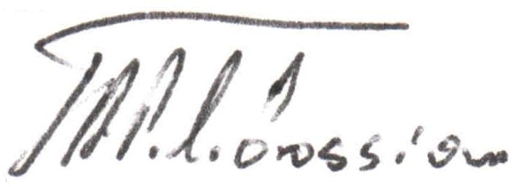

For Quality Assurance Manager

Note: 1.For Chilled Mirror Certificate refer to the attached Manufacturer’s Certificate

PhyMetrix Ltd. 120 West Beaver Creek Road #19, Richmond Hill, ON L4B 1L2 tel: (905)762-1616

