3/16

Target: city planner and building manager

Baseline survey? With data.

What changes to make? In this place it is easy to improve a way of traveling because of the bus stops etc. data like how

Two years

Monitor the target

Discuss with the building by the alerts.

Context of local area, characteristics of the local authorities.

Unique new building with people inside.

Start by imagine a new development, shopping centre, traveling plans. Put it in somewhere in London.

Any point of London.

Planning system, targets.

Day 1 of occupation, baseline survey: walking, driving, cycling, public transport proportion.

Every trip or some of them, track the phone, methods for the building managers to do.

How big the slice/proportion should be.

An office for example, more specific: when to do what

What make a location where is easier to increase the proportion.

Different criteria.

Data on accessibility and new development of London. Ltds

Basic survey and measure methods

How to prove your methods

3/17

Tombolo digital connector

Try to find how do we make people on the street to walk.

Walk need reward or punishment

Think about if they are isolate by bike 自行车在city centre 是被使用的，当时对于outside London来说，get reward from biking would promote the way.

24 hours 2 pounds many times as you want

10 cycling trip get one bus trip; 20 get tube trips

Active time

Dft traffic counts, one number a few thousand points, people count, average traffic on that point in a year. Fractional ? good estimation;

2011 census: travel to work

User

How to assess it

An increase of travel time, make the extra amout of people to use active travel

Data: use dataset from digital connector;

Objectives – **the key goals** that the travel plan seeks to achieve

Targets – **a means of measuring** the achievement of objectives

Measures – **the initiatives** that will be introduced to achieve the targets set. This should also include remedial measures and actions that will be taken if the travel plan targets are not met

Management – it is essential that there is an individual identified to oversee implementation, monitoring and review of the travel plan. Adequate resourcing should be made with an appropriate amount of the individual’s time allocated

Action plan – a programme for delivering **the measures and a means of** communicating the above to site users, including identification of who will oversee delivery of the travel plan

Securing – it is important that the travel plan is effectively secured through legal mechanisms

Monitoring and review – must be undertaken to **ensure the travel plan achieves the targets** it set out to achieve

1. Full address of the development: place (Inner London: Promote healthy travel, targets to increase walking and cycling should be set (in preference to public transport, especially in Inner/central London where over capacity is an issue)) Westminster,
2. Brief description of **the nature and context** of the proposed development: a company…

Demolition of existing building at 82-84 Piccadilly, 29 Bolton Street, 1-5 Clarges Street and 6-12 Clarges Street, and redevelopment to provide development over **four blocks**. Block A: Construction of a building comprising three basement levels, ground and nine upper floors and roof level plant room, containing plant, car parking, retail and/or art gallery and/or car showroom use and residential uses. Block B: Construction of new office building comprising of two basement levels, ground and six upper floors plus roof level plant and retail and/or art gallery and/or restaurant at part ground and part basement levels. Block C: Construction of new building of basement, ground, plus four upper floors for use as a club to include offices, member's

1. Key parameters by land use class eg number of units, floor area, number of cycle and car parking spaces etc

Units:47; floor area: 18945; Postcode: W1J 8JB; start date: 2014-03-24; end date: 2018-12-31

car parking: Yes;

1. Details of associated travel including **number of staff** expected on site, **numbers of visitors**, **residents** and key details about delivery and servicing activity
2. The scope of the travel plan eg **employees, visitors,** those making deliveries and servicing the site
3. **Benefits** of a travel plan for the site – including benefits of managing deliveries and servicing

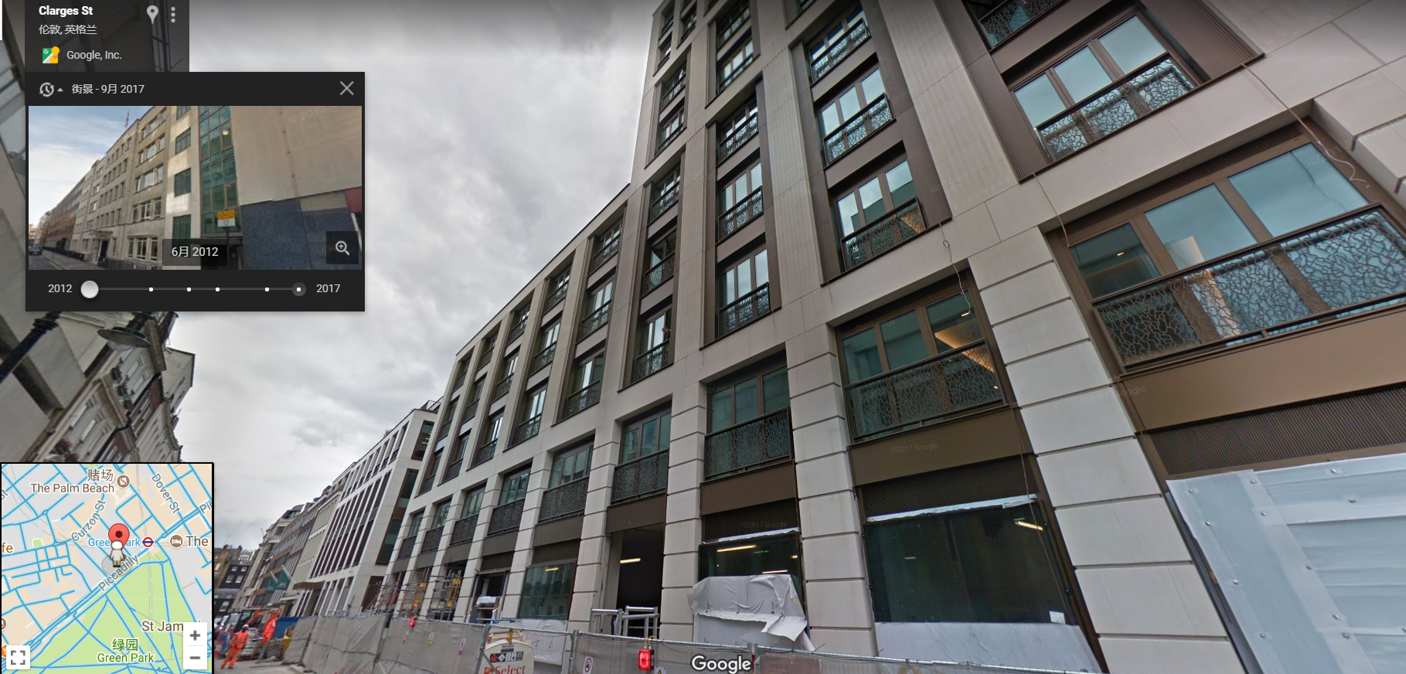

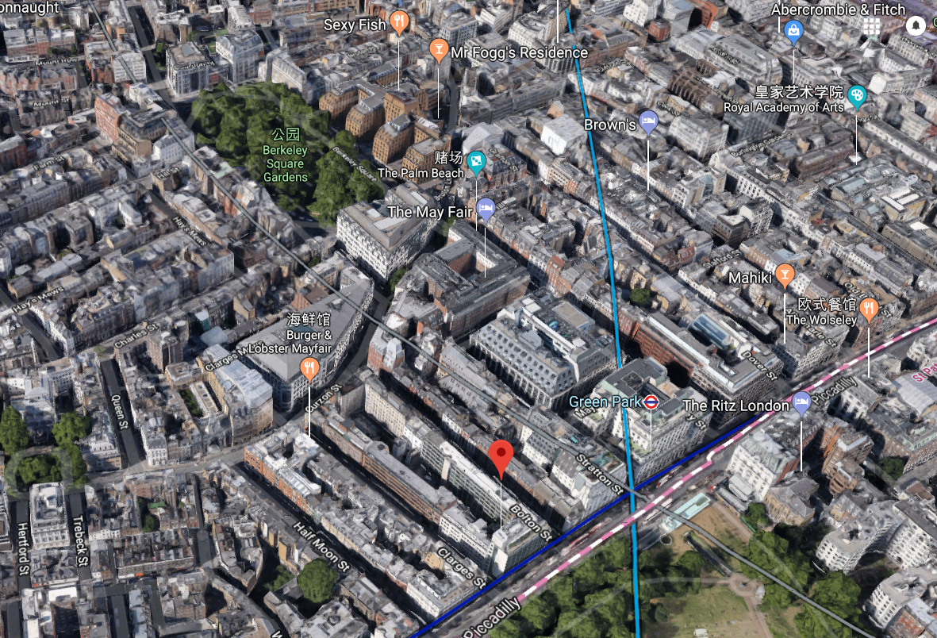

Site assessment:

1. **Location** of the development including **boundaries and access points for all transport modes** including delivery/servicing access points
2. **Key infrastructure** which will be delivered in the surrounding area as part of the development
3. Include **maps and site plans** where useful
4. **Pedestrian and cycling access points and routes to the site, to local transport and other amenities**
5. Details of **Pedestrian Environmental Review** audit results (where applicable)
6. **Quality and availability** of infrastructure around the site – consider **how amenable** local roads are to walking and cycling
7. **Details of infrastructure** to be introduced as part of the development eg **cycle and pedestrian routes, cycle parking**
8. **Organisational policies** and **other initiatives** that will influence active travel and public transport use eg **tax-free cycle purchase scheme**s, **cycle training**, **season ticket loans** etc
9. Car-related initiatives in place eg car park management policies, car clubs in the local area, **car sharing**, pool cars etc
10. **Public transport facilities and services** including routes, hours of operation and service frequency
11. **Quality** of stops and stations including **lighting, cleanliness, cover, realtime information** etc
12. **Site design** and operational considerations in respect to deliveries and servicing
13. Amenities/facilities in the surrounding area that can be reached by walking/cycling, reducing the need to travel by car eg at lunchtime
14. Provision **for disabled site users**

Baseline travel data :

1. based on **travel survey data** if there are existing site users
2. (where there are no existing site users) on **the transport assessment or comparator data** drawn from TRAVL, TRICS14 or census data

Space Syntax OpenMapping © 2018 Space Syntax Limited