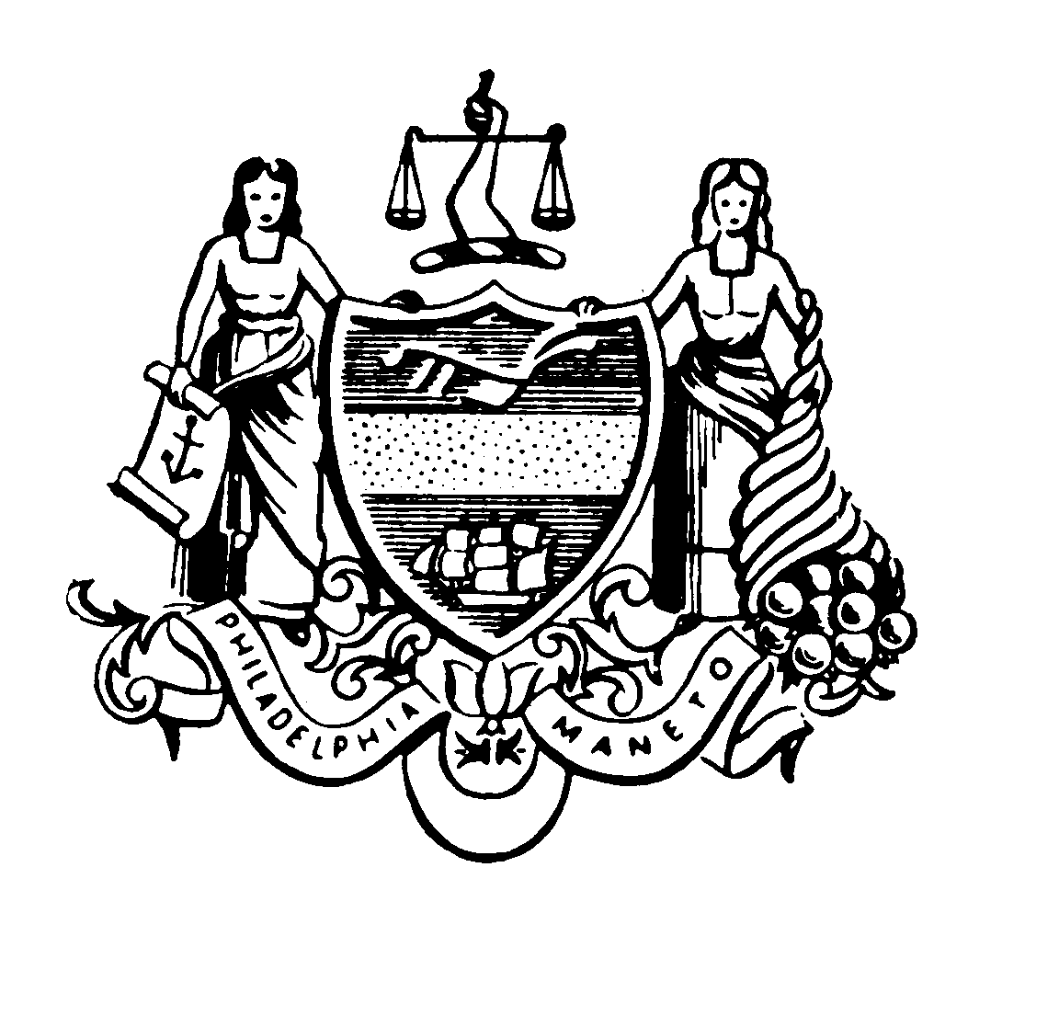City of Philadelphia OFFICE OF SUSTAINABILITY
One Parkway Building
1515 Arch Street
13th Floor
Philadelphia, PA 19102

M E M O R A N D UM

TO: James Leonard, Records Commissioner

FROM: Christine Knapp, Director, Office of Sustainability

DATE: April 9, 2020

SUBJECT: OFFICE OF SUSTAINABILITY AMENDED REGULATIONS ADDRESSING DEADLINES FOR ENERGY/WATER USE BENCHMARKING DURING THE COVID-19 EVENT

Please find attached for filing amendments to the Office of Sustainability’s Regulation on Energy and Water Use Benchmarking. These regulations are to be effective immediately as a temporary regulation while the remaining procedures and formalities of Section 8-407 of the Philadelphia Home Rule Charter are followed, consistent with Mayor Kenney’s March 11, 2020 Declaration of Extraordinary Circumstance: Suspending the Formal Regulatory Process for Regulations Concerning a Novel Coronavirus. Also, please find attached a memorandum from the Law Department approving these amendments.

Thank you for your assistance in this matter.

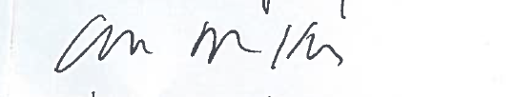____________________________________
Christine Knapp
Director, Office of Sustainability

