Home page:
- Join interest-based groups that cater to your specific interests.

Registration: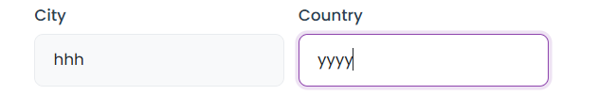
- This cannot be manual; it does not speak well of the platform

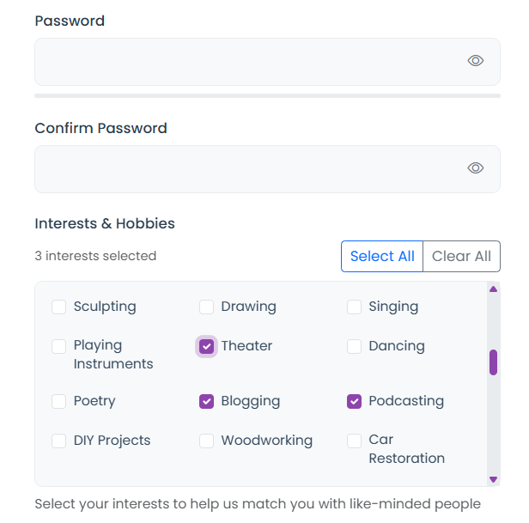
- Interests & Hobbies should come before the password, not the password coming first.

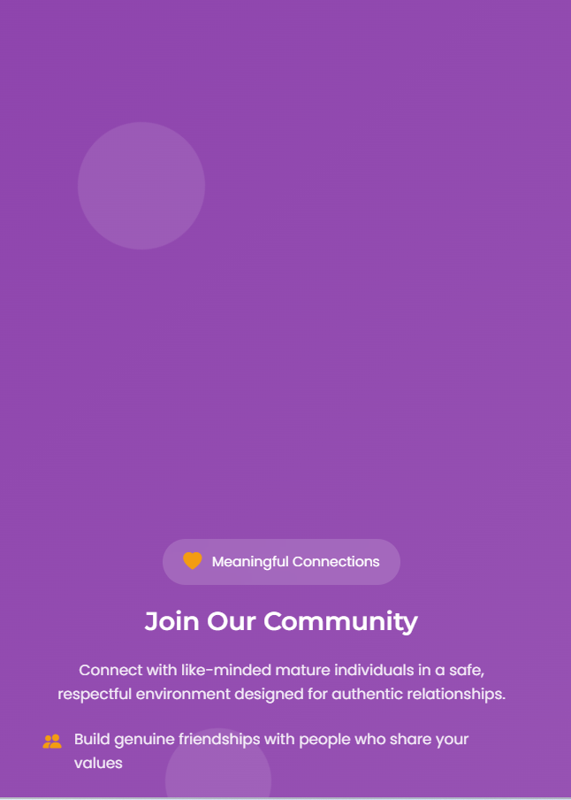
- The space above the write-up is too much; remove the space a little.

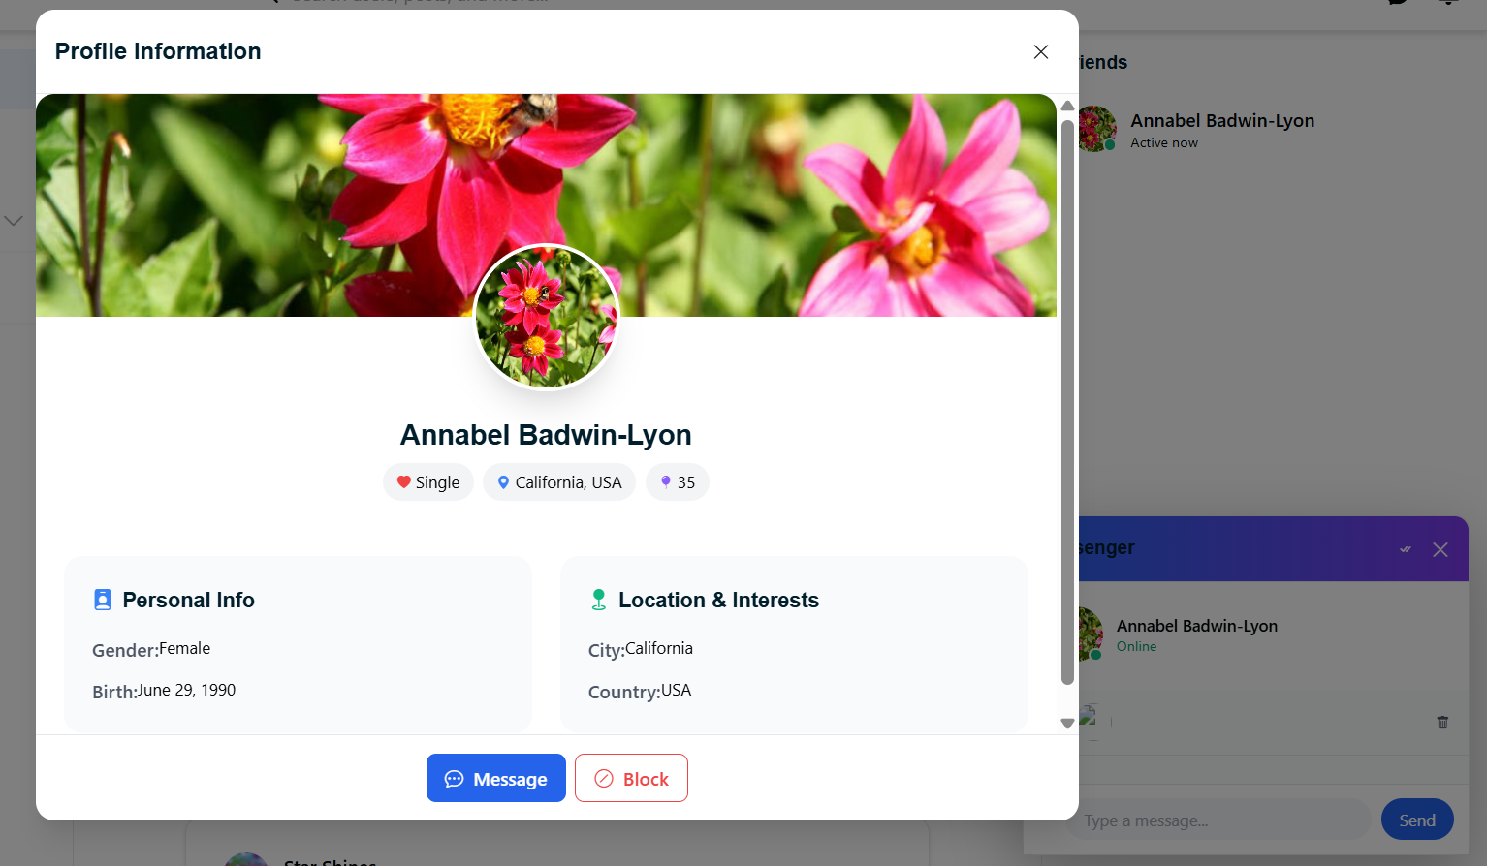
- I clicked on the message to chat, the chat box opened, as you can see, but this page is supposed to go away automatically once the chat box opens, not me manually removing it.
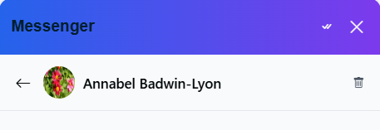
- I clicked on her name or picture to have a glance at her profile and to see her feeds, posts. or other things she has shared, such as pictures, but it doesn’t work. IT IS SUPPOSED TO WORK. I am supposed to see her feed as we are friends.
There should be a way to see the posts my friend has shared once I click on her profile. I am unable to see her posts.
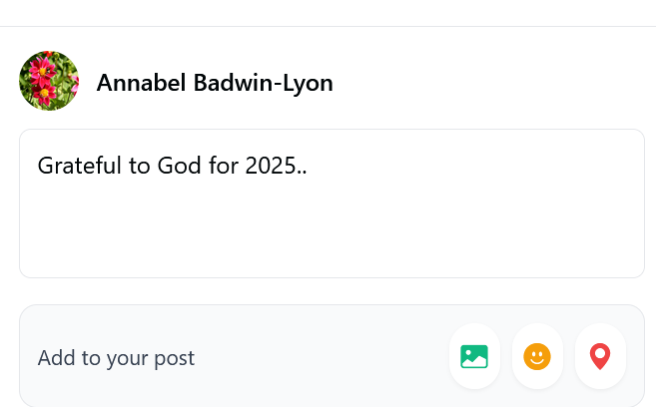
- Emoji and location should be working, but they are not.

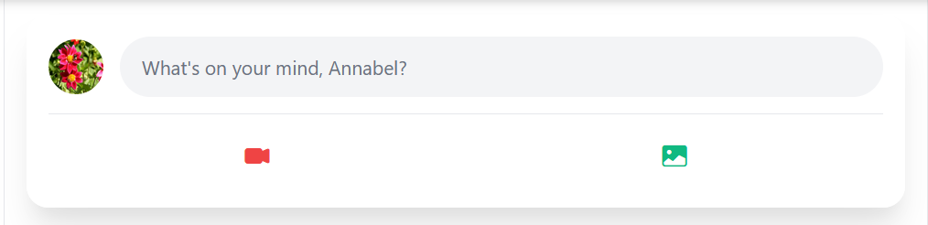
- Live Video, Video, Photo, and Emoji. You can add others, such as GIFs, so the place isn’t looking too plain and has a modern feel.

- You need to increase this panel so the logo is not looking squeezed, and it should appear bolder.

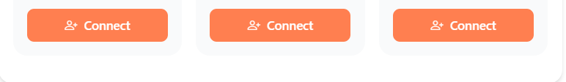
- For this connect part, this is not the colour of the logo. Use the color of the logo, which is #f76f69

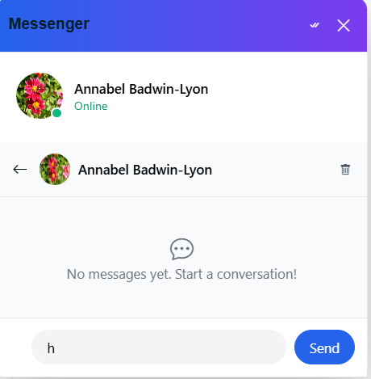
- Chat cannot be only words alone. Include emojis, GIFs, and others as shown below: Note: use these belong to another website, so don’t reuse them. These are also gotten from a website, not an app.
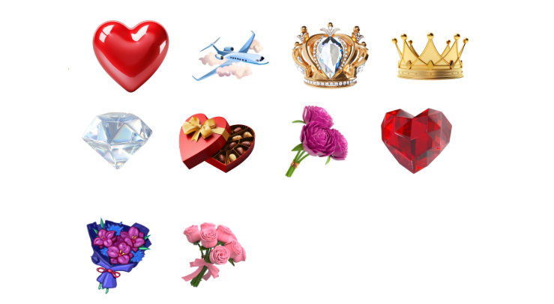
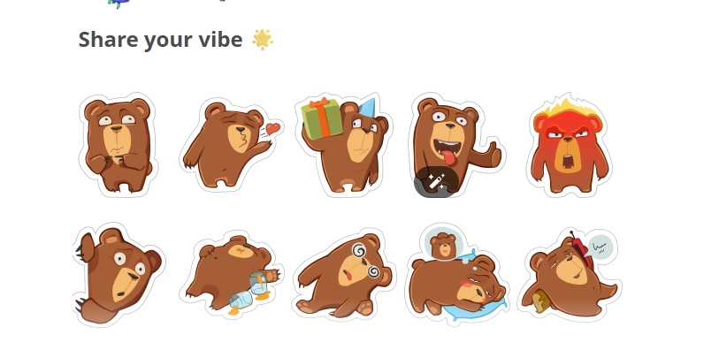
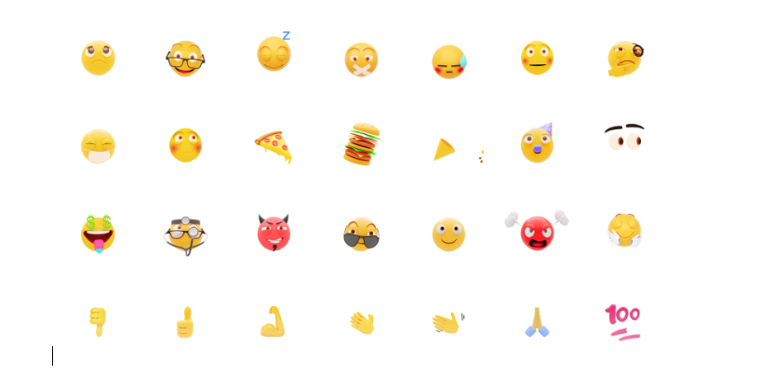

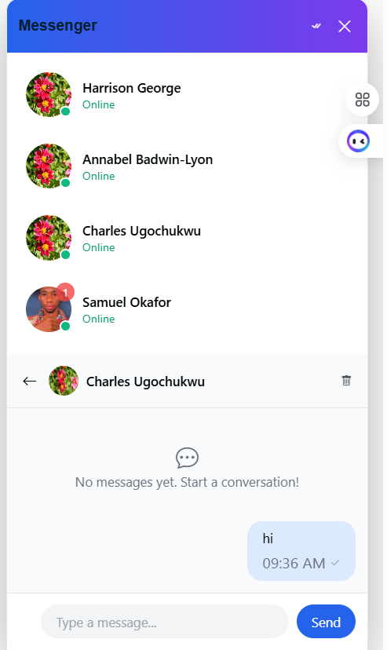
- I clicked only on one person to chat, but it brings our everyone. Please change it. If I click on a particular person, let me see that person alone.

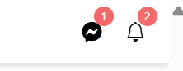
13. Even when I have read all messages and notifications, this still shows this way.

- Remember that, for the groups and in general, users are supposed to help manage the platform by reporting anonymously any disturbing post or person. I have not seen any feature for anonymous reporting.
- Birthday or special events notifications.
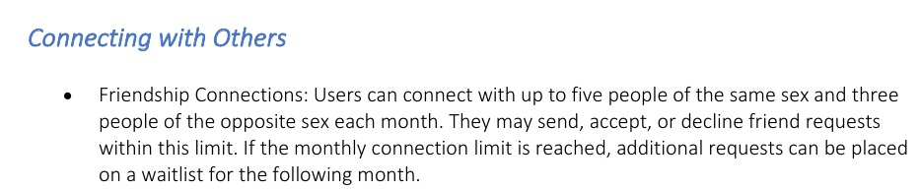
- Although we changed it to 5 people for each gender per month
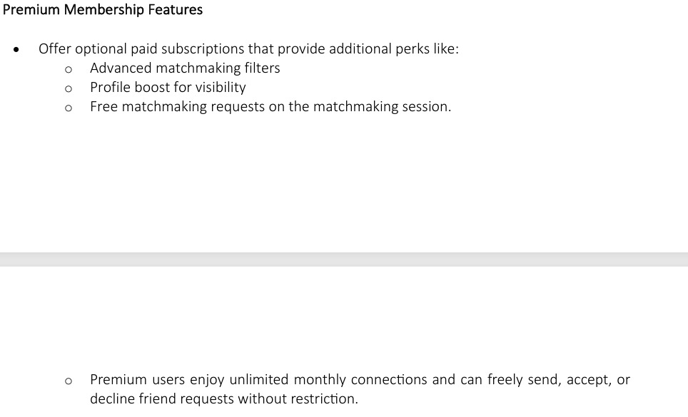

- Remove LinkedIn and replace it with Twitter (X).


- Inverted-looking or squeezed logos

ADS
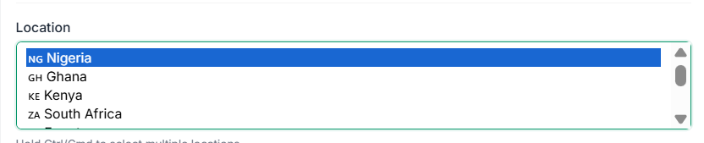
Location cannot be manual. And users need to filter properly for an effective ad: Nigeria- Lagos- Ketu
Only a few countries are here. Many countries are missing. The country selection cannot be manual.
Give options for mobile phone users to select all countries at once.
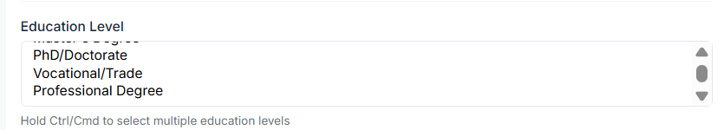
Let the education match what is on the registration form and give options for mobile phone users to select all.
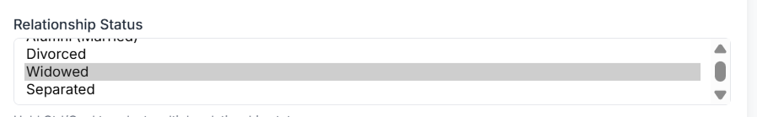
Either you use 'divorced' or 'separated', this needs to align with what’s on the registration form.
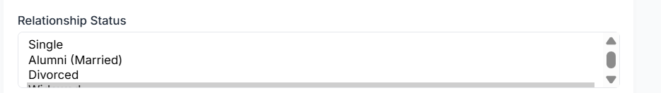
Alumni should be “now married”, not “married”.

MATCH MAKING
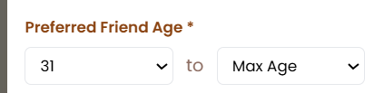
The age restriction is too strict. Use a filter. Users should select their preferred ages, not this, or you add more numbers. If I wanted 31 to 35, that would not be possible, as it is.

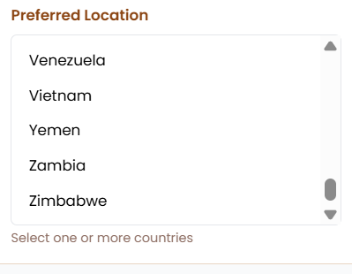
Selection should be country and location. The country alone is too large for this. I live in Lagos, and I would want my search limited to Lagos, not the whole of Nigeria.

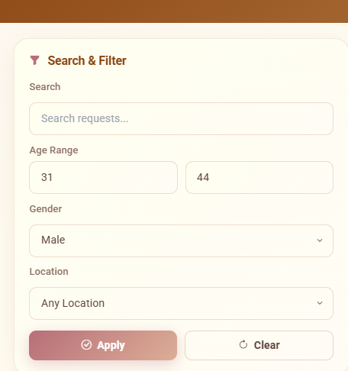
Under Browse Match Making Request, the location needs to be worked on seriously, as mentioned previously.

MARKET PLACE
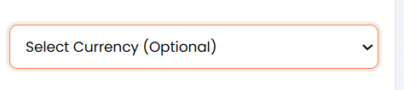
Since payment is in dollars alone, this may need modification.

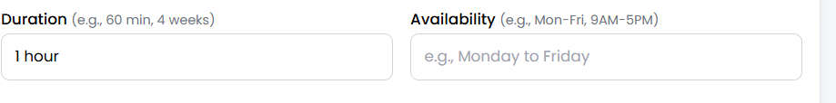
Pricing for Services should be per hour. E.g., 2 dollars per hour. This duration part needs to reflect it. That is, find a way to explain to users that the charges go with the duration. 3 dollars/hour, 2 dollars/hour, etc.

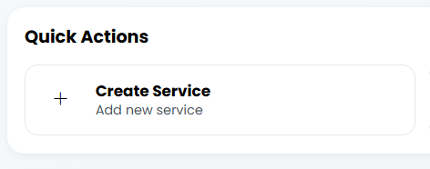
Change to Sell
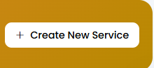
Change to Sell
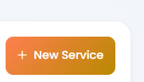
Change to sell or New Service/ Product
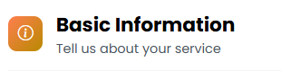
Tell us about your service/product
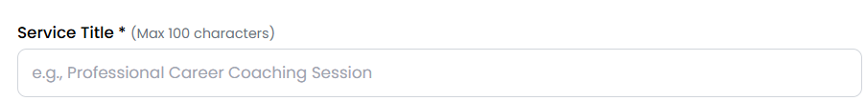
Title alone not service title

