

THE REPUBLIC OF ICENIA

Coat of Arms

This document, last compiled by CreepilyCreep,
includes all legislation enacted and amended
up to and including the Coat of Arms Act
passed on 9th September 2025.

Coat of Arms
- The Coat of Arms of the Third Republic of Icenia shall be as follows:
"Argent, a hurt. For the crest, on a wreath Argent and Azure, an isopod statant Argent. For the supporters, dark oak branches Proper, fructed Or. For the motto, "SNEED!" The date of the Declaration of Independence of the First Republic of Icenia "VII•VIII", on the dexter, and "MMXV", on the sinister."
- The Coat of Arms of the Third Republic of Icenia shall be considered an official National Symbol –alongside the Icenian Flag.
- All shields provided to the military of Icenia shall be crafted as to bear the official shield of Icenia, as described by §1: "Argent, a hurt" and by the annexed construction sheet.

Appendix
Appendix 1: Coat of Arms


Appendix 2: Coat of Arms Construction Sheet
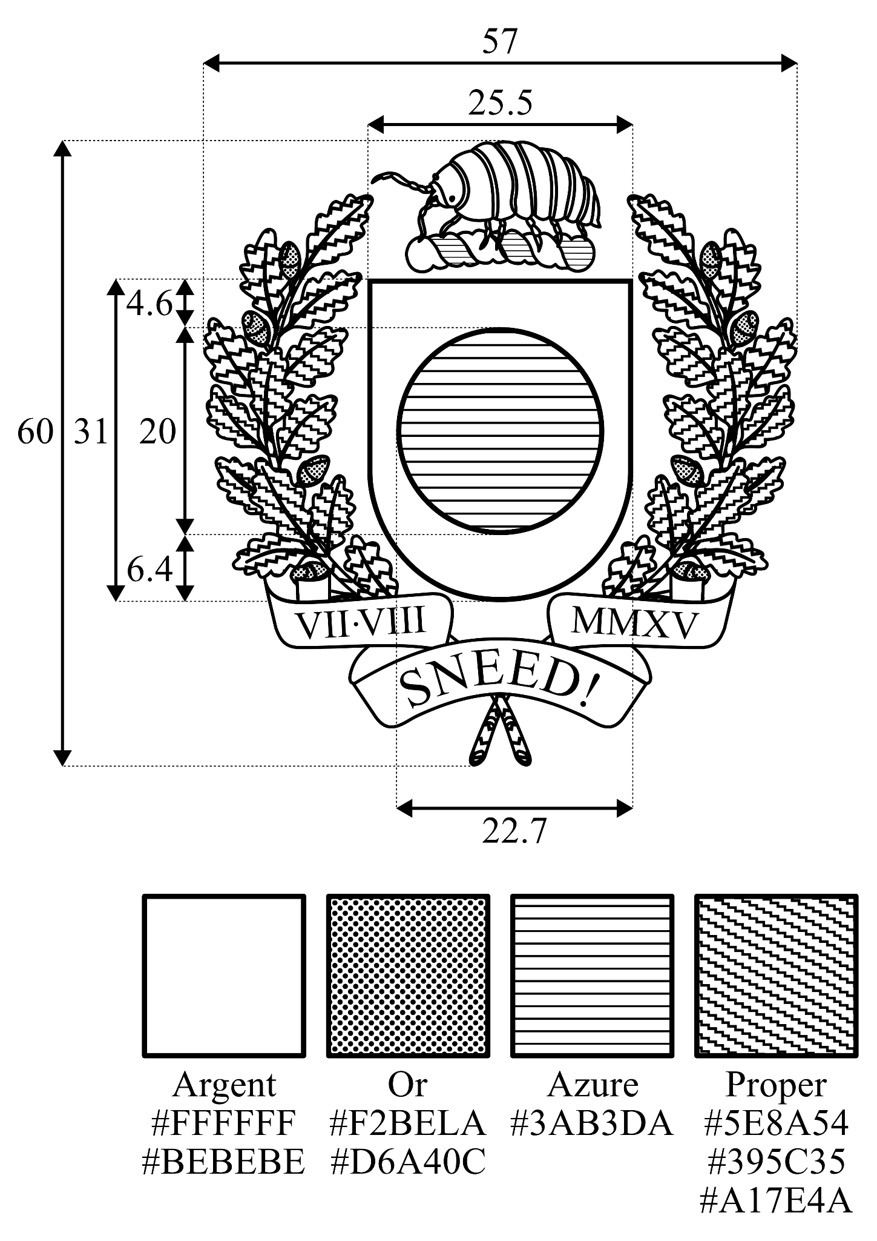

Appendix 3: White Institutional Version of the Coat of Arms for Github
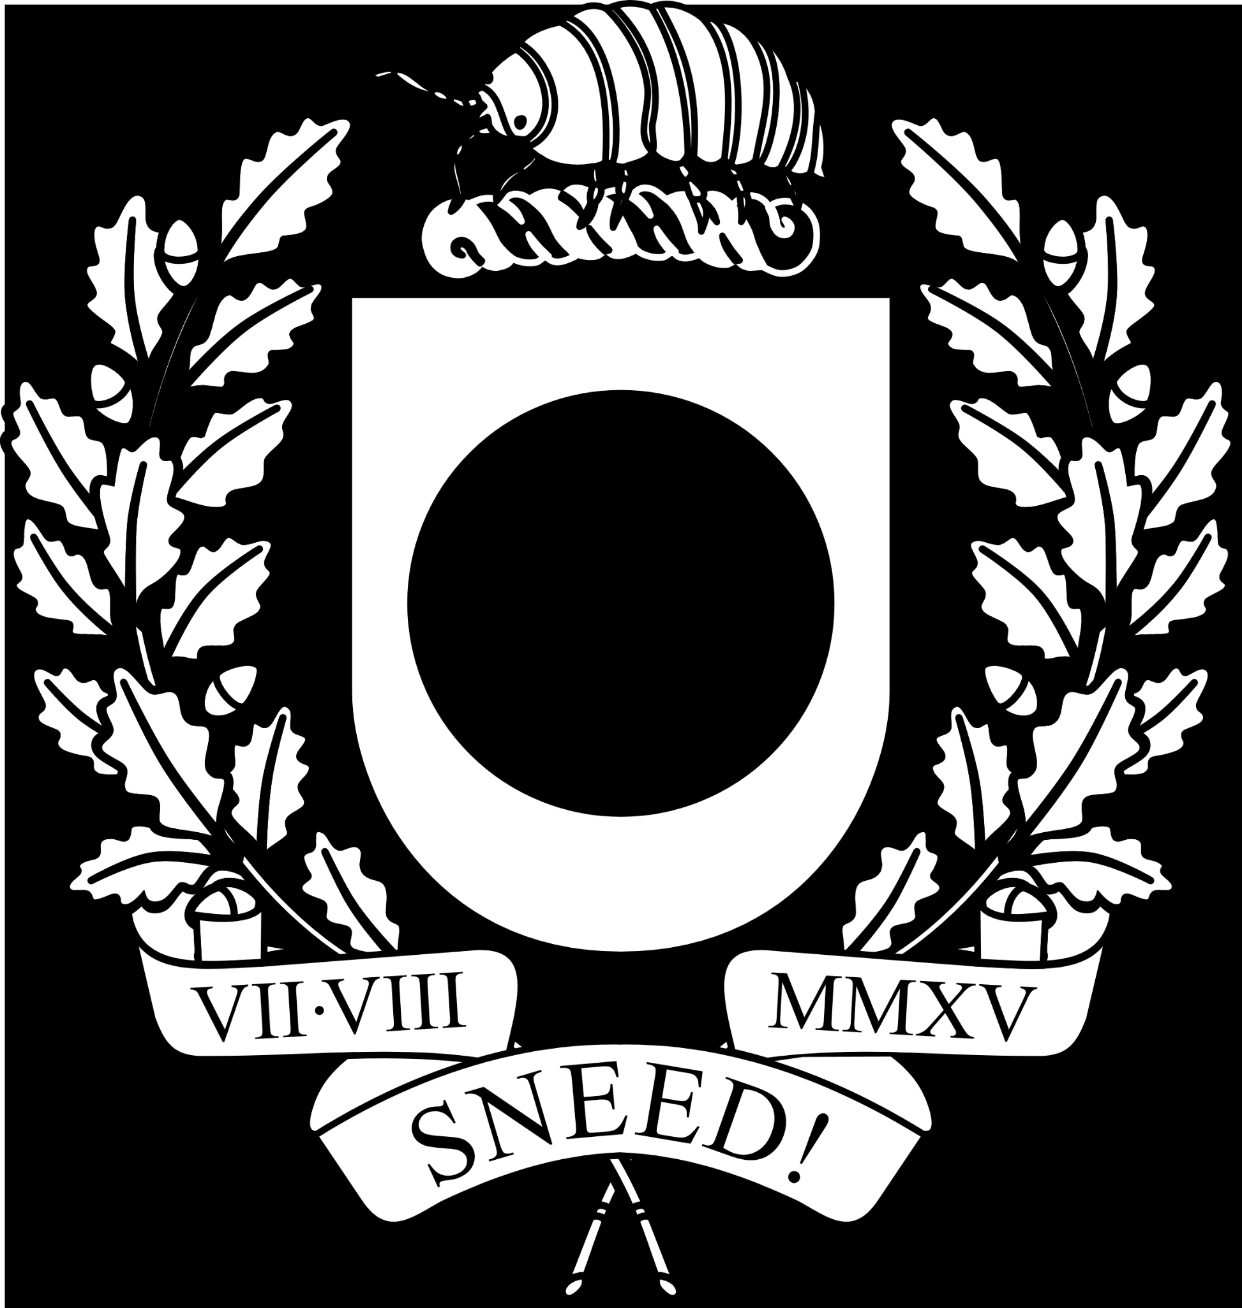

Appendix 4: Construction Sheet for Icenian Shields
