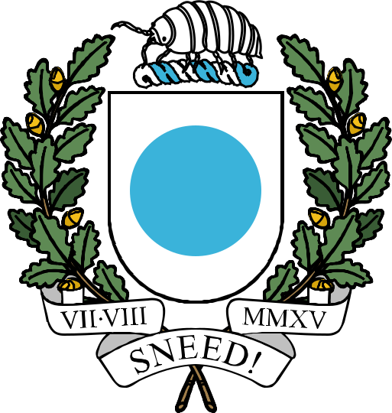

THE REPUBLIC OF ICENIA

Icenian Flag Act

This document, last compiled by CreepilyCreep,
includes all legislation enacted and amended
up to and including the Icenian Flag Bill
passed on 12th July 2024.

Icenian Flag Act

COLOURS
The colour hereon referred to as "Light Blue" of Icenia is to be defined as twenty-two point seven percent red, seventy point two percent green, and eighty-five point five percent blue, represented by the following common values:

HEX: #3AB3DA
RGB: 58, 179, 218
CMYK: 73, 18, 0, 15
HSL: 194.6°, 68.4, 54.1
HSV: 194.6°, 73.4, 85.5

The color hereon referred to as "White" of Icenia is to be defined as one hundred percent red, one hundred percent green, and one hundred percent blue, represented by the following common values:

HEX: #FFFFFF
RGB: 255, 255, 255
CMYK: 0, 0, 0, 0
HSL: 0°, 0, 100
HSV: 0°, 0, 100

DESIGN
The flag of Icenia is to follow the construction sheet in the attached image and flown vertically by rotating ninety degrees clockwise.

Figure one represents the flag of Icenia after this bill is passed, it is a two-to-one ratio white field with a light blue dot one quarter of the height of the flag. Figure two is the construction sheet of the flag of Icenia, displaying all of the required information to recreate it. Figure three shows the vexillological symbols to indicate the characteristics of the flag of Icenia, from left to right; this is the observe side of the flag, the flag's reverse side is identical to its observe side, and the flag's vertical state is a rotation of the original.

﻿﻿


