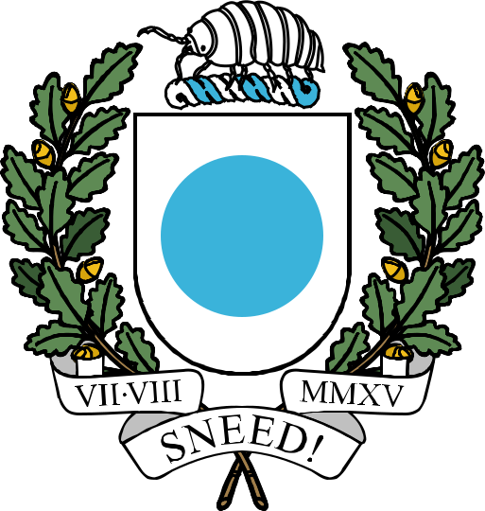

THE REPUBLIC OF ICENIA

Political Parties Act

This document, last compiled by CreepilyCreeo,
includes all legislation enacted and amended
up to and including the Political Parties Amendment Bill
passed on 6th October 2024.
Political Parties Act

A political party is defined as a political organization which operates exclusively in Icenia. The party needs to provide a platform in their own thread in #democracy-forum. Additionally, the President is barred from joining any political party.

