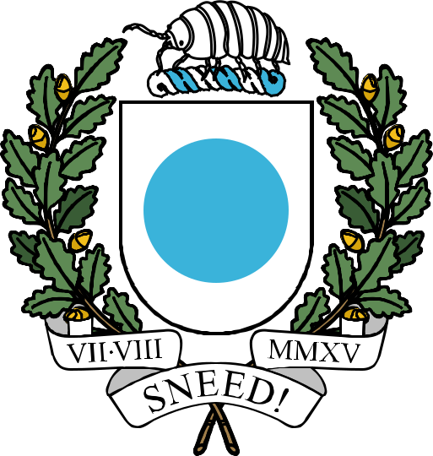

THE REPUBLIC OF ICENIA

Recruitment
Incentivization
Initiative

This document, last compiled by CreepilyCreep,
includes all legislation enacted and amended
up to and including the Newfriend Recruitment Adjustment of August 2025
passed on 8th October 2025.
Recruitment Incentivization Initiative

Recruitment of a newfriend to the nation of Icenia who ranks up to Citizen will be rewarded with 10d.
If a recruited newfriend ranks up to Patrician, the recruiter will be rewarded with 35d.
All payments must be processed by the SoT.

