

THE REPUBLIC OF ICENIA

Street Naming
and Signage Act

This document, last compiled by Creepily,
includes all legislation enacted and amended
up to and including the Street Naming & Signage Act
passed on 22nd November 2025.

- The public streets of Icenia City shall be officially named in accordance with the map and list provided in Appendix A.
  - Street names may be changed in the future by a simple act of the City Council, without requiring an amendment to this ordinance.
- All public street names shall be displayed using standardized signage: warped signs with glowing white text.
- All future public streets within city limits shall be named at the time of construction, either by the constructing party or by an act of the City Council.

Appendix A: Existing Street Map & List of Names
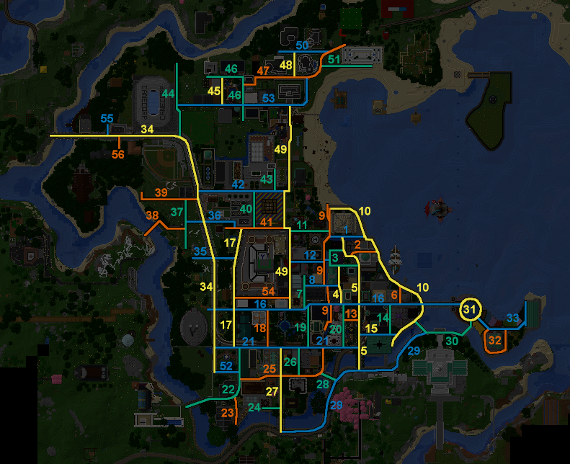
- Unnamed ICARUS WAY
- Unnamed TRIANGLE ALLEY
- SNEED ST GREG ST
- Unnamed QUANTONIMO ST
- BLOOM ST JAH ST
- STONE WAY
- Unnamed OLD OAK PL
- Unnamed SINKHOLE ALLEY
- Unnamed CANAL ROW
- OCEAN AVE MICHIGAN AVE
- GARDEN RD GARDEN LN
- BLOOM STREET ST CHUNGUS ST
- Unnamed ENRON ST
- Unnamed CHRISPIE ST
- Unnamed STATION ST
- WEST LN / BUTTERNUT WAR VETERANS MEMORIAL DR / TRAP ROW SNEED ROAD & LIBERTY BRIDGE
- COUNTY LN / MARKET ST COUNCIL ST
- Unnamed PARK PL
- OAK ROW MEMORIAL AVE
- Unnamed CONSTITUTION ST
- ESPERMA ST / PEARLS ST PEARL ST
- Unnamed CHURCH ST
- Unnamed OLD MARKET WALK
- Unnamed KINGSWELL PL
- SOUTHERN LN
- ARCH ALLEY
- RIVERWALK AVE
- Unnamed BAGI ONSEN BRIDGE
- Unnamed OPERATION ROARING BLENDER MEMORIAL DR
- Unnamed CAPITOL PROMENADE
- Unnamed VICTORY CIR
- Unnamed STATUE CIR
- Unnamed REPUBLIC WAY
- BLOOM BLVD
- NEWPORT ST
- FLAGPOLE ST
- Unnamed GNOME ROW
- Unnamed DRURY LANE
- CHIEFTAIN ST
- REVOLUTION ST
- COUNTY LN BUNKER ST
- JUDICIARY ST
- Unnamed SIRBOSS CT
- BACONHAIR ST
- Unnamed LAST GUEST LN
- Unnamed ROYALS ROW
- Unnamed MARKSTEFER RD
- Unnamed CABBIT DR
- MONTGOMERY BLVD / NEGRA ARROYO LN NEGRA ARROYO LN
- Unnamed HAWK TUAH DR
- Unnamed GAMBLING ADDICTION DR
- BOAR ST
- Unnamed NEWFRIEND ST
- SECOND INNING AVE UTAH ST
- WEST SIDE DR
- CHOLESTEROL ST

