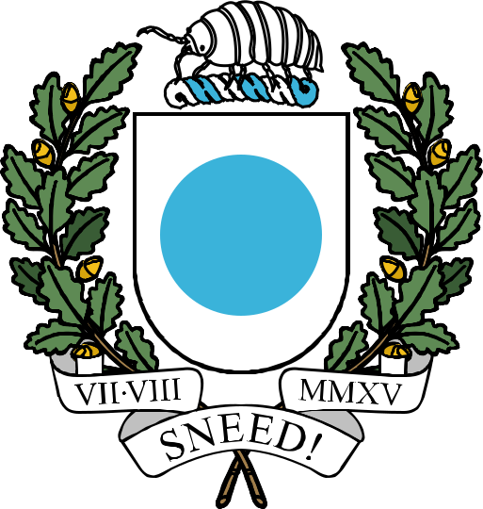

THE REPUBLIC OF ICENIA

Subway Surfers Act

This document, last compiled by Creepily,
includes all legislation enacted and amended
up to and including the Subway Surfers Act
passed on 1st December 2025.

Subway Surfers Act

Section 1. Decommissioning of the Sirboss Metro
- The historic subway system, also known as the Sirboss Metro, shall be decommissioned and replaced with a new subway system, known as the Icenia City Metro.
- Materials and structures from the Sirboss Metro may be repurposed for the Icenia City Metro, where feasible.
- The following stations on the Sirboss Metro shall be remodeled, renamed, and integrated into the Icenia City Metro: 1) West Icenia and 2) Arts District.
- The following stations on the Sirboss Metro shall be fully decommissioned and salvaged: b) Jah Park and b) Undercity.

Section 2. Construction of the Icenia City Metro
- The Icenia City Metro shall be initially constructed along the routes and stations detailed in Appendix A.
- An initial allocation of 250 diamonds from the City Treasury shall be designated to fund map art signage for the Metro system.

Section 3. Capital Transit Authority
- The Icenia City Metro shall be controlled, regulated, and maintained by the Capital Transit Authority (CTA), which is hereby established as a municipal department under the city government in accordance with Section 2(a) of the Icenia City Charter.
- The CTA shall be led by a Commissioner, appointed by the Mayor. The Commissioner shall continue to serve across mayoral and Council transitions, and shall not be removed except by formal resignation, dismissal by the Mayor, or by a majority vote of the City Council. The Commissioner need not be a member of the City Council.
- The CTA shall regulate access to the "Icenia-Metro" namelayer, on which all Metro facilities shall be reinforced.
Section 3. Regulation
- No new stations, rail connections, access points, or other facilities shall be constructed on the Icenia City Metro system by unauthorized personnel without approval from the Capital Transit Authority.
- Should any unauthorized stations, rail connections, access points, or other facilities be constructed on the Icenia City Metro system, the unauthorized construction may be demolished and removed immediately, without Council approval or any formal dereliction process.
- The Capital Transit Authority may pursue litigation against violators in accordance with city and federal law.
- A rail connection to HoldenVCaulfield's "Countryside Metro” is hereby authorized at the Riverwalk station.

